Mia Watts April 23, 2024

**MATLAB**



**MATLAB Results Report**

After following the MATLAB Onramp tutorial, I was able to create the following graphs within the console to mirror those created in Java. This results report will explain and show, in detail, the results of plotting, salting, and smoothing data in MATLAB rather than Java. The formulas used within the Java code are the same for consistency purposes. These formulas are calculated and/or written as follows:

* 0.1x2 – 0.5x – 2
* sin(2x)
* 3cos(x) – 5cos(2x) – 2cos(3x) – cos(4x)

These formulas are entered into MATLAB and y-values are calculated based on a range given to x, which in this case is -50 to 50 for all formulas. The salted values are calculated by generating a random number to multiply the y-value by for each value in the range calculated originally, and the smoothed values are calculated using the movmean function indicated within MATLAB documentation:

* <https://www.mathworks.com/help/matlab/ref/movmean.html>

The random number generation was done using the rand function learned about in the Onramp tutorial. For reference, the following link is where official documentation on the function from MATLAB can be found:

* <https://www.mathworks.com/help/matlab/ref/rand.html>

I also used the figure function which creates separate graphs when inside one file.

* <https://www.mathworks.com/help/matlab/ref/figure.html>

**Results**

The result after plotting, salting, and smoothing the first formula in MATLAB is:

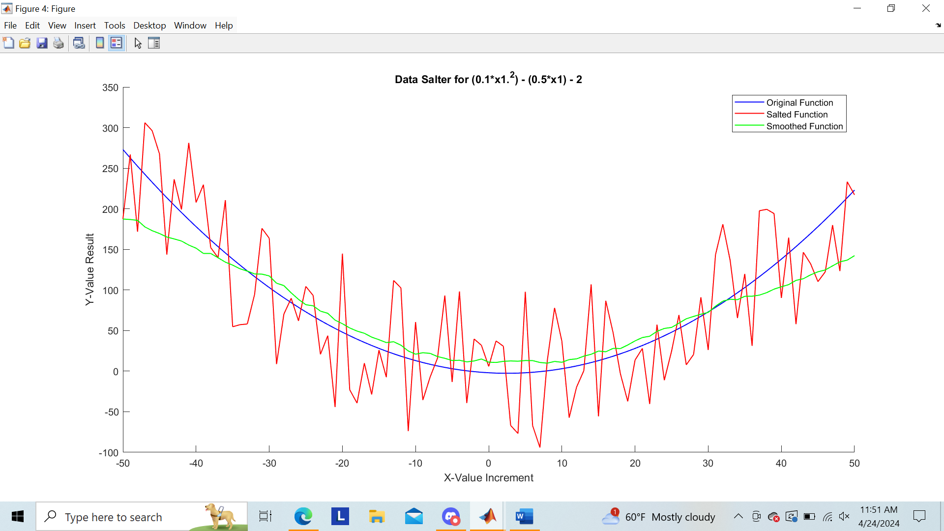

As shown in the legend, the blue line represents the original function, the red line represents the salted function, and the green line represents the function after it was smoothed. ***This will be true for ALL formulas plotted using MATLAB.***

The result after plotting, salting, and smoothing the second formula in MATLAB is:

The result after plotting, salting, and smoothing the third formula is:

