Mia Watts

**Pokémon Card Game Program Documentation / User Manual**

The first part of this document will be descriptions of the methods and classes implemented in the Pokémon Card Game section of the entire project. The second part of this document will be a user manual describing how to use the Pokémon 2-player game. Enjoy!

*Disclaimer: Because of the rough semester I’ve had thus far, the base game is extremely simple. I am stating this up front. The winning condition is whether the active singular Pokémon has run out of HP for either player. I would like to work on this project more, but for the sake of time and having to balance multiple classes, this is the best I could do for now. I hope everyone understands for the time being. I apologize for not being able to do more. Thank you for reading!*

**Documentation**

**Attackable Interface**

This interface is used for each Pokémon, their classes requiring that they use the methods described within the interface itself. The methods here include the following:

* attackOne() – Takes a parameter that represents a Pokémon target. The parameter is of type PokemonInheritance. The attack method, when implemented within a Pokémon class, can define what the attack does.
* attackTwo() – This method also takes a parameter that represents a Pokémon target and is identical to the previous method minus the fact that it represents the second attack a Pokémon may have.

**Bulbasaur**

Represents Bulbasaur, a grass-type Pokémon implemented in this card game. The main constructor initializes Bulbasaur with an HP of 70 and implements its first attack, Leech Seed. Leech Seed deals 20 damage to a target Pokémon and heals Bulbasaur with the amount of damage dealt if Bulbasaur’s HP is less than 50 (the total cannot exceed 70). The second attack method is not used because the Bulbasaur we implemented for the case of this project only has one attack.

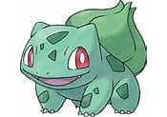

**Card**

The Card class is used to save a String variable that represents a card’s name. This class is the extension class for Trainer cards, Energy cards, Pokémon cards, and Rare Candy cards.

**Chimchar**

Represents Chimchar, a fire-type Pokémon that was added to my repository by Garret Chmielewski. The main constructor initializes Chimchar’s HP to 50 and implements its first attack which deals 10 damage to a target Pokémon. The first attack is called Scratch. The second attack method is not implemented because Chimchar does not have a second attack in this case.

**Energy**

Implements the Energy cards which have general properties for the case of this card game. The Energy class extends class Card and is used to build decks and hands in the main game. The cards can be of type Fire, Grass, Water, etc., and can change certain game elements. However, for this game and for simplicity, the card simply represents Energy and nothing else.

**Fennekin**

Represents Fennekin, my favorite Pokémon (including all subsequent evolutions)! The main constructor initializes Fennekin with an HP of 70. Two attacks are implemented in the Fennekin class, the first being Live Coal and the second being Rear Kick. Fennekin is a fire-type Pokémon. The first attack deals 10 damage to the target Pokémon and the second attack deals 20 damage.

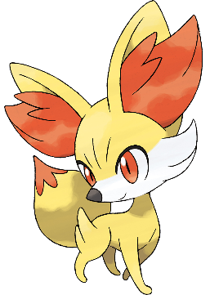

**Nest Ball**

This class implements the Nest Ball Trainer card which searches the entire deck for all Basic Pokémon, selects a random one for the player to add to their bench, and reshuffles the rest of the Pokémon back into the deck. This class and all other implemented Trainer cards follow the Trainer Actions interface which has each Trainer add the playable method to its class.

**Pikachu**

This class represents Pikachu, an electric-type Pokémon. The main constructor sets Pikachu’s HP to 70, adding two attacks, the first being Quick Attack and the second being Electro Ball. Quick Attack deals 10 damage to the target Pokémon, and Electro Ball deals 60 damage to the target Pokémon.

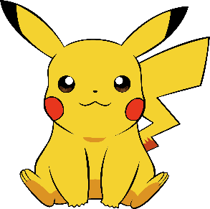

**Player**

The Player class represents a player object which will be used to play the 2-player game. Each player is given a hand, a prize pile, a deck, a discard pile, and a bench, along with an active Pokémon slot that can be used to play whichever card is in the slot. The main constructor initializes these items and gives the player 60 cards in the deck, 7 cards in a hand, and 6 cards in a prize pile. The player wins when their prize pile runs out or when the other person has a bricked deck. Player methods include the following:

* buildDeck() – Builds a base deck with all Pokémon implemented along with all trainers (Pikachu, Bulbasaur, Fennekin, Chimchar, Leon, Lillie, Nest Ball, and Professor’s Research) and generics.
* buildHand() – Builds a base hand for the player with all Pokémon created in the classes.
* buildSimpleHand1() – Builds the hand for the first player. For the case of my game, the first player is always given a Fennekin, but in future implementations, the Pokémon can be changed.
* buildSimpleHand2() – Builds the hand for the second player. For the case of my game, the player is always given a Chimchar, but in future implementations, the Pokémon can be changed.
* buildPrizePile() – Adds cards to a prize pile for each player. The prize pile can only have 6 cards, and in the case of this game the pile is filled with generic Pokémon, Energy, and Trainer cards.
* Multiple getter and setter methods for decks, active Pokémon, the bench, a player hand, and more.

**Pokémon**

This class represents all cards of type Pokémon, extending the Card class.

**Pokémon Card Game**

This class contains all methods associated with the 2-player game. The methods here include the following:

* Getter and setter methods for all array lists containing cards. This includes the deck, prize pile, discard pile, hand, active Pokémon, bench, Pokémon damage, and more.
* buildDeck() – Builds a base deck. This includes generic Pokémon, Trainer, and Energy cards along with a further implementation including Trainers Leon, Lillie, Professor’s Research, and Nest Ball and Pokémon Pikachu, Bulbasaur, Fennekin, and Chimchar.
* playNestBall() – Plays the Nest Ball Trainer card. This method makes it so the deck is searched for all Basic Pokémon, one is taken from the bunch and is added to the bench, and the remaining Pokémon are added back to the deck and shuffled.
* nestPlay() – Run method for the Nest Ball Trainer card.
* printDeck() – Prints the current running deck.
* printHand() – Prints the current running hand.
* printInstructions() – Prints the instructions for the game, including what to do and how to play.
* newDeckOnePokemon() – Creates a deck for the purpose of the first Monte Carlo, adding one Pokémon to the deck and adding the rest as Energy cards.
* newDeckMultiplePokemon() – Creates a deck for the purpose of the first Monte Carlo, adding multiple Pokemon to the deck depending on the number passed to the parameter. Any space left is where Energy cards are added.
* drawCard() – Draws a single card after randomly selecting one from the deck or hand.
* evaluateOpeningHand() – Evaluates the opening hand and determines whether there is a Pokémon card in it. If not, the method returns false. If there is a Pokémon, the method returns true.
* evaluateBench() – Evaluates the bench to see if there is a Pokémon card in it.
* evaluateActive() – Evaluates the active Pokémon to see if there is a Pokémon in the active position (used for the case of determining whether a player has won).
* evaluateActive2() – Evaluates the active Pokémon of the second player to see if there is a Pokémon in the spot.
* checkIfWinner() – Checks to see if either player has won based on the HP of their current Pokémon. Future implementations will check to see if their prize pile has run out or if separate conditions have been met.
* playGame() – Runs the actual 2-player game by cycling through checking whether either of the players is the winner and letting a player play if no one has won.
* player1Turn() – Gives the player a Fennekin partner to work with. The player can indicate “1” for Fennekin’s first attack, Live Coal, or “2” for Fennekin’s second attack, Rear Kick. Damage is dealt if the player enters the correct value and throws an error or skips their turn otherwise. Whether they’ve won is printed along with the damage done and the HP dealt to the opponent’s Pokémon partner.
* player2Turn() – Gives the player a Chimchar partner to work with. The player can indicate “1” for Chimchar’s first attack, Scratch. Damage is dealt if the player enters the correct value and throws an error or skips their turn otherwise. Whether they’ve won is printed along with the damage done and the HP dealt to the opponent’s Pokémon partner.

**Pokémon Inheritance**

The Pokémon Inheritance class implements the HP for Pokémon and all getter and setter methods. The HP is initialized and has getter and setter methods, the attack names are initialized and have getter and setter methods, and the damage values dealt by Pokémon are initialized and have getter and setter methods.

**Professor’s Research**

The Professor’s Research Trainer card states that players must put back and redraw their hand when this card is played and is implemented as such. The current game state is passed as a parameter, so the redrawn hand is drawn properly and placed back into the deck with no issues.

**Rare Candy**

The Rare Candy class is an extension of Card class, being used in the second Monte Carlo assignment along with having the ability to be implemented in the 2-player game. For the case of this assignment, these items will not be playable in the game due to a lack of current Pokémon cards. In the actual card game, Rare Candies can be used to evolve Pokémon. For example, if there is a Pokémon in a player’s hand that can be evolved, they can play a Rare Candy if they have one which can either level up their Pokémon or evolve them immediately.

**Test Pikachu**

The Test Pikachu class was one designed to test certain attacks and methods created within the Pokémon Inheritance and Pokémon card classes. In this test example, Pikachu and Bulbasaur attack each other, with Bulbasaur using Leech Seed and Pikachu using Quick Attack. The game ends when the opponent’s Pokémon has an HP that is either 0 or less.

**Test Pokémon Card Game**

This is the class that tests the Pokémon card game methods implemented within the PokemonCardGame class. Here, the Player objects are created, and they will be used to play the game. The playGame() method is also called in this class which plays the 2-player game. More information on how everything works can be found in the section called “Pokémon Card Game.”

**Trainer**

The Trainer class is used to implement anything associated with the Trainer cards. This is the main class that contains a playable method that isn’t used since the Trainer cards are separately implemented, including more methods that contain getters and setters for certain developments that need the Rare Candy Trainer card. These include returning the damage for Trainer Leon, who can allow a Pokémon to attack another with 30 more damage.

**Trainer Actions**

This is an interface that implements the playable method. Each trainer, including Nest Ball, Professor’s Research, Rare Candy, Leon, and Lillie, must implement this method even if it isn’t used (like for the case of the Rare Candy which is simply used for the second Monte Carlo and nothing else). The playable method takes the current state of the game as a parameter even if it is not used for the case of maintaining the proper game progress. The rest of the Trainer cards each have their own individual implementation of the method, and each card must implement the Trainer Actions interface.

**Trainer Leon**

This Trainer card adds 30 damage to the damage dealt by a Pokémon. For example, for Pikachu’s Electro Ball attack, it originally does 60 damage, but with this Trainer card played along with it, Pikachu can do 90 damage. The method within the Leon class makes sure the current turn is still going, and if it is, it adds 30 damage to a Pokémon’s attack.

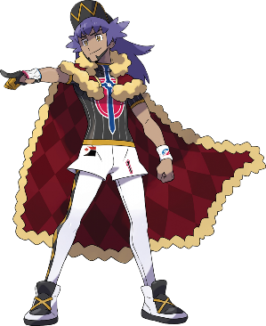

**Trainer Lillie**

This Trainer card lets the player draw cards until their hand reaches a certain number of cards. If it’s the first turn, the player can play this card and draw cards until they have 8 in their hand. If it’s not the first turn, the player can play this card and draw cards until they have 6 in their hand. The program checks to make sure their hand size doesn’t exceed these values before drawing cards because the player is not allowed to draw cards if they already have a card amount that is higher than the drawn card amount shown on the Trainer card.

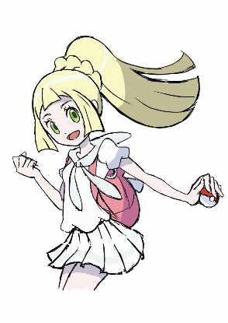

**User Instruction Manual (How to Play)**

**Pokémon Card Game 2-Player Game**

*Written and programmed by: Mia Watts*



**HOW TO PLAY**

Welcome to the Pokémon Card Game program user manual! Here, you will find instructions on how to play the simplest form of the base 2-player game. Make sure you refer to the GitHub repository and load all files into your IDE before playing (<https://github.com/CybErr404/pokemon-gaming-project1>). The steps to play are as follows:

1. Start the program. Once the program files are loaded into an IDE and are runnable, be sure to run the program from the “TestPokemonCardGame” class. This class runs the 2-player game method.
2. Read the instructions found within the console before playing! A representation of what is shown when the program is run is as follows:

Once the program is running, as shown in the image, the first player is given an option to pick either Fennekin’s first attack or Fennekin’s second attack.

1. Enter either 1 or 2 into the console using your keyboard. The proper attack will be used if the correct number is entered. If a letter is entered, an error is thrown, and the program will need to be restarted. If a number other than the choices shown is entered, the program skips your turn and starts the next player’s turn sequence.

1. Once the first player’s turn is over, the second player can choose their attack. For this simple example, only one attack is available for the second player, but more can be implemented.

1. A player wins when their opponent’s Pokémon faints. Try to beat your opponent before they beat you!

**Player 1 winning:**

**Player 2 winning:**

**Have fun!**

