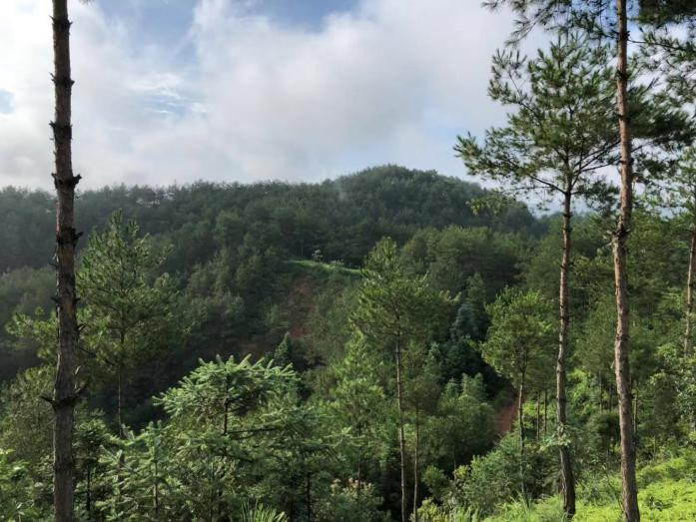

From July 27th to August 4th, I went on a field research to a village called Pengkou in the west of Fujian province with professor Chen Zhibiao, a prestigious experienced scholar in soil erosion mitigation and ecosystem restoration who has took part in national projects about the recovering of the environment in west Fujian since more than twenty years ago and is also one of the first researchers to work on water logging mitigation nationwide, and his four graduates from the institute of geography of the Fujian Normal University. The main purpose of the research is to collect soil samples containing rare earth. There are two groups of soil samples to collect: one group is excavated from a hill which had experienced rare earth mining several years ago, while the other group is excavated form another hill next to the previous one which has not involved in rare earth mining. Therefore, what we collect will help researchers to form a deeper and more overall understanding of the impact of rare earth mining on the environment by processing those samples with scientific approaches like cooking them in acidic environment and high temperature to extract rare earth elements and comparing the results of samples from different areas.

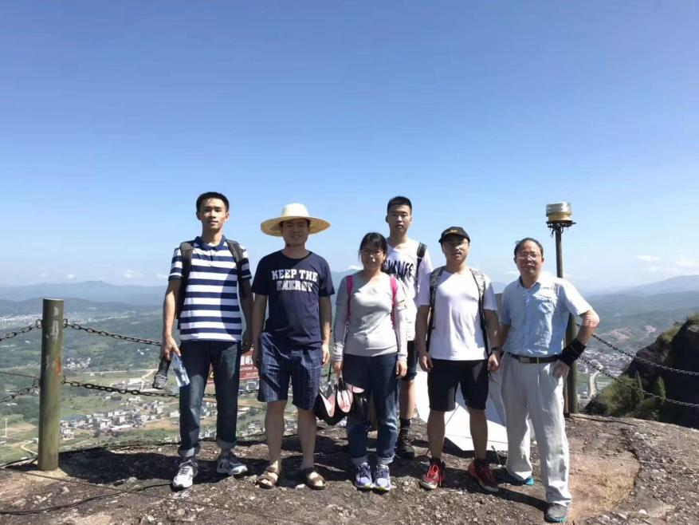

The kind of rare earth in Fujian is called ionic rare earth, or heavy rare earth, unlike the mineral rare earth, or light rare earth in northern provinces which is exist as ores, it is stored in soil as ions and much more valuable than the other kind. To extract rare earth elements from soils, people equip pipes inside the mine hill and pull ammonia sulfate solution into those pipes, when the solution permeate out the pipes, it replaces the rare earth ions from the soil. Then solution containing rare earth will gather in a huge pool at the mountain foot through those pipes. This is the method of situ leaching mining.

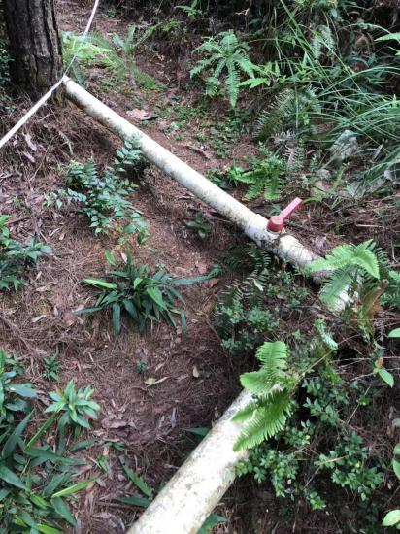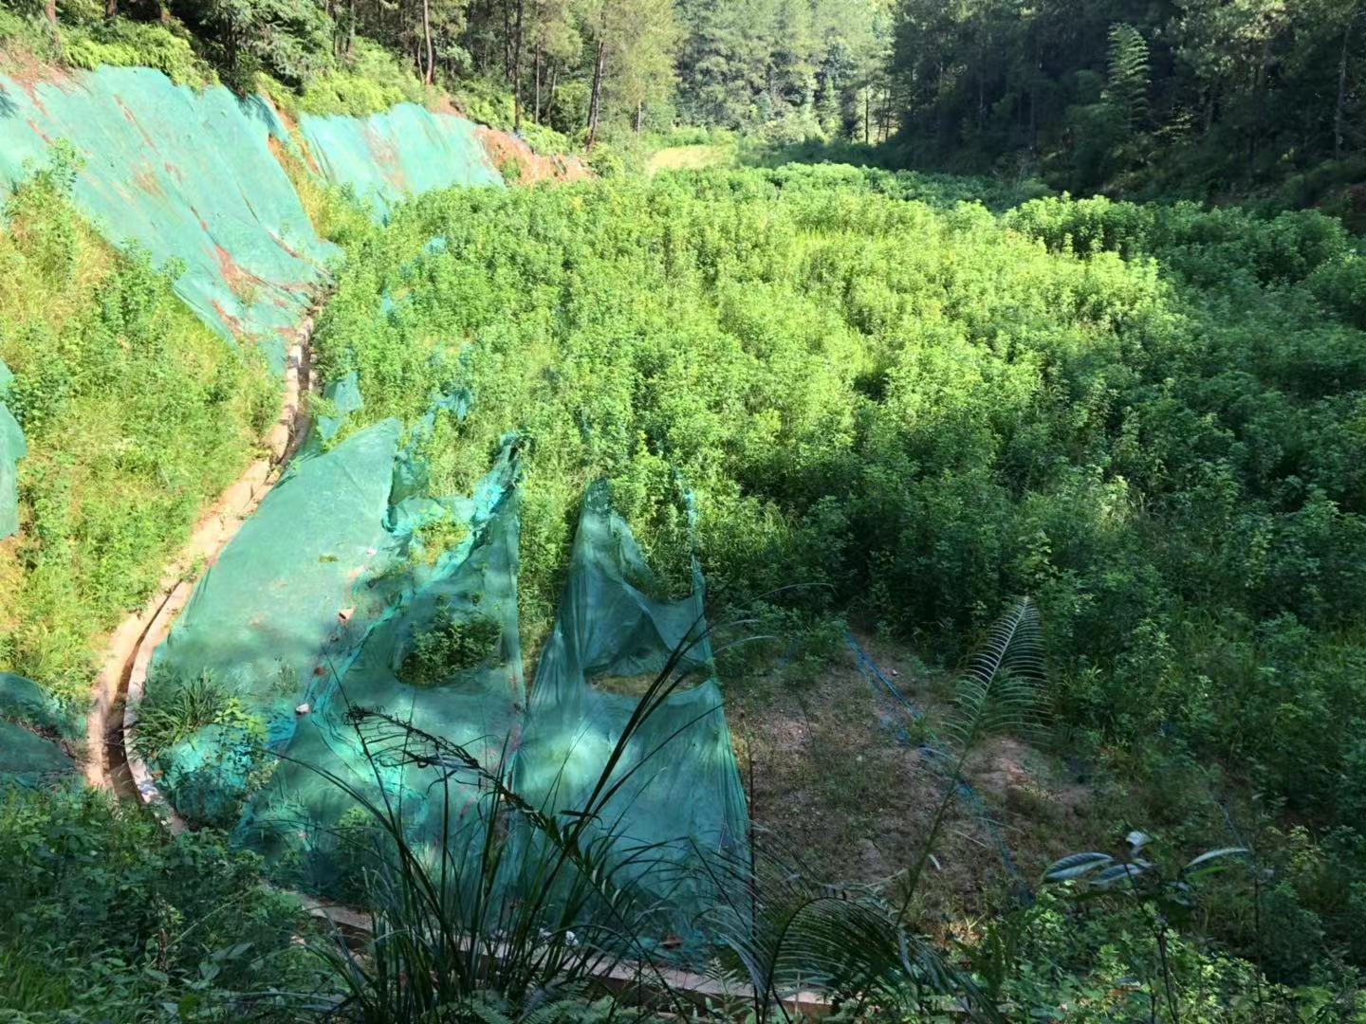

Due to the fact that a large amount of chemicals have soaked the whole hill during this process, residue of harmful chemicals inevitably deteriorates the local environment and cause serious problems on local organisms. For instance, while working in the wild, we met an aged farmer lived nearby who had witnessed the horrific effect of rare earth mining on agriculture. According to what he said, the rice cultivated by local residents expressed abnormal features after the mining starts: the stems and leaves of rice grew incredibly strong while the yield of rice declined greatly with only about 20 percent of rice became ripe enough to be harvest. As a matter of fact, what happened on these plants exactly corresponds to the consequence of nitrogen fertilizer overuse, which means the ammonia sulfate used in mining is very likely to be responsible for the dramatic decrease in crop output.

Avoiding the unbearable hot at noon, we usually got up early at about 6 am and drove to the target areas after quick simple breakfast. Our job starts with measuring the distance from the summit to the bottom of the hill with a tape, and we marked five points which divided the distance into four parts with the same size with red ropes tied on trees. Around these five points, we located several relatively flat places, cleaned the shrubs there away with tiny iron hoe, and put our drilling machine there.

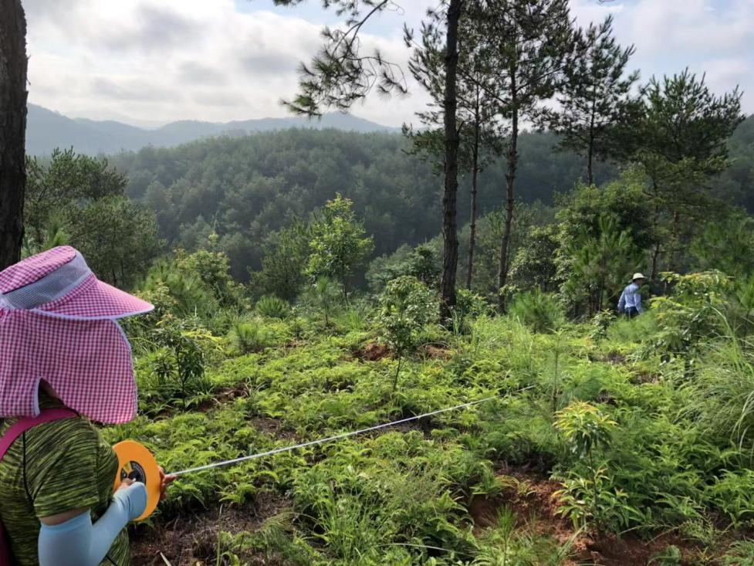

The machine was imported from America, about ten or more kilograms weigh, and it can have many hollow iron tubes of 50cm long connected between the motor and the broach. The tubes can be combined and separated, enabling us to alter the maximum depth the driller can reach freely. When the machine is operating, other members and I hold it tightly, keeping it vertical to the ground, assisting the driller to penetrate the soil deep underground. When reaching particular depth, we took the tubes out, take away the soil inside, add more tubes together, and put them back in the hole created previously.

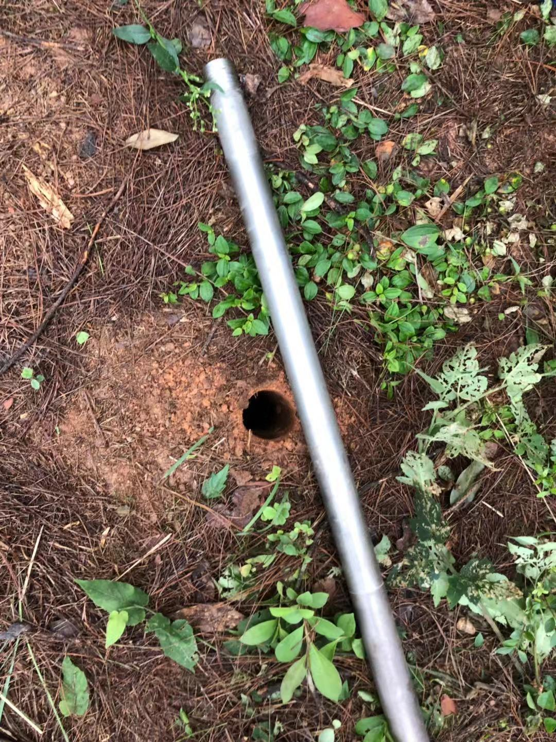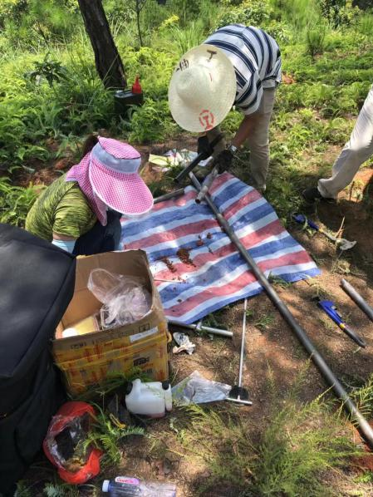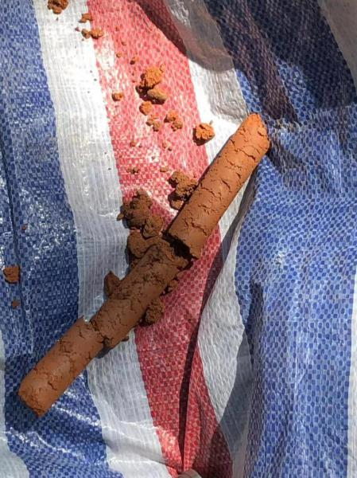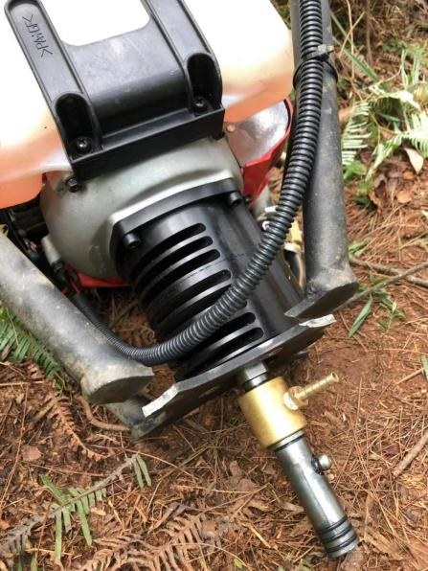

Although the tubes can be used in high flexibility, they still became a problem. When the driller arrived at more 5 meters deep, which required more than 11 tubes, it was really a hard job to pull them out of the hole. Take the deepest one we dug as an instance, we drilled to about 10 meters deep, exploiting 21 tubes which is so heavy that four of us can hardly pull it out together. To solve that, we dismembered the tubes into three parts and take them out in sequence

.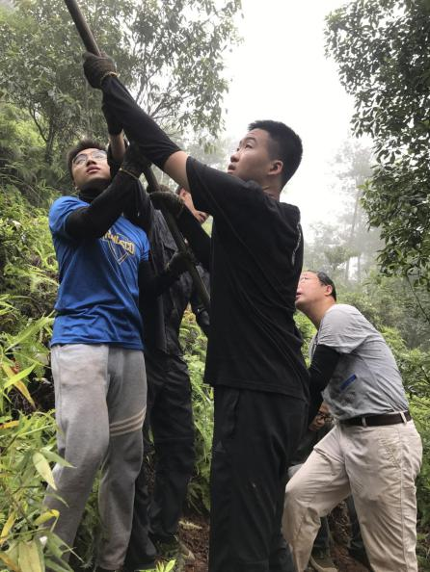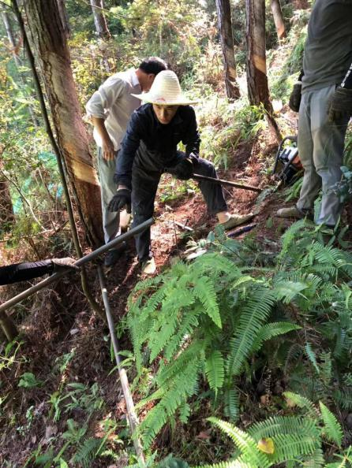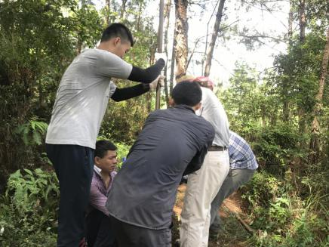

Our work went more and more difficult as we dug deeper. This situation can be partly attributed to the driller. Actually, it was designed to collect rock samples not soil samples. Stone may be harder than dirt, but due to the local heavy rainfall, wet dirt, or clay exerts much more resistance on the driller when it is rotating, even force it to stop its rotation. To overcome the great resistance, the machines kept trembling, hurting our hands which were scraping the frame of the machine. In the first two day of our investigation, three of us got some pieces of skins removed from hands—even we had our thick gloves worn. Recognizing the inherit weakness of machines, we discovered that the power of machines and the power of human body should be effectively combine to finish the gathering. The final version of our excavating method is to enlarge the holes we dig and weaken the structure of underground soil with machines, then go through the rest part of dirt with human power—raise the tubes and drop them down by hand.

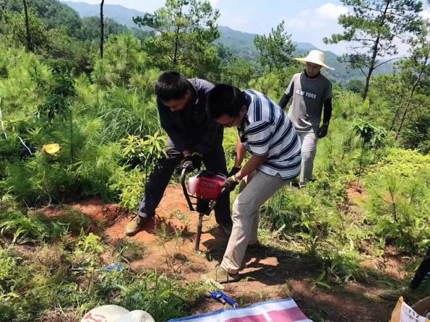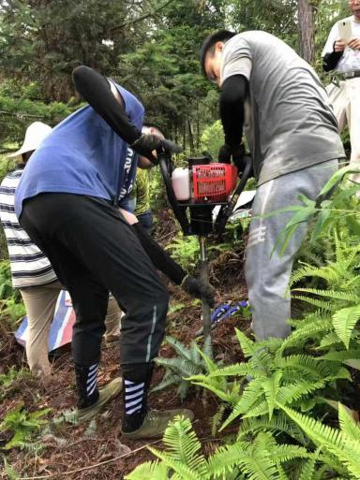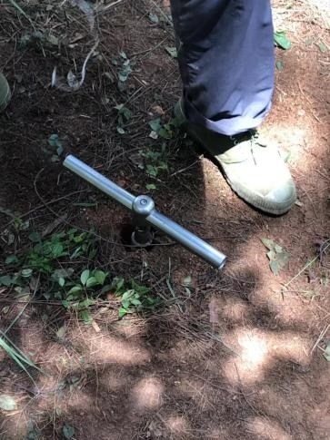

Another issue triggered by humid dirt is that it sticks in the tubes so strongly that we had to brainstorm for ideas to drag it out of the tube. The way we find out with highest efficiency proved to be pretty painful for human body: we hit one tube with another one to shake the mud out. Not only our arms got hurt but also our hearing got damaged by the harsh noise of metal items punching each other.

Returning to hotel with clothing soaked by sweat mud and skin doted by mosquito bites for all these eight days, what I experienced was not only hard work of being field researchers, but also great satisfaction--The professor mentioned many times that the samples we get are quiet precious, as they can provide researchers in the near future with detailed overall information about the change happened on ecosystem after rare earth mining.

