**2022 Programme of the 4th International Conference**

**on Trauma Surgery Technology**

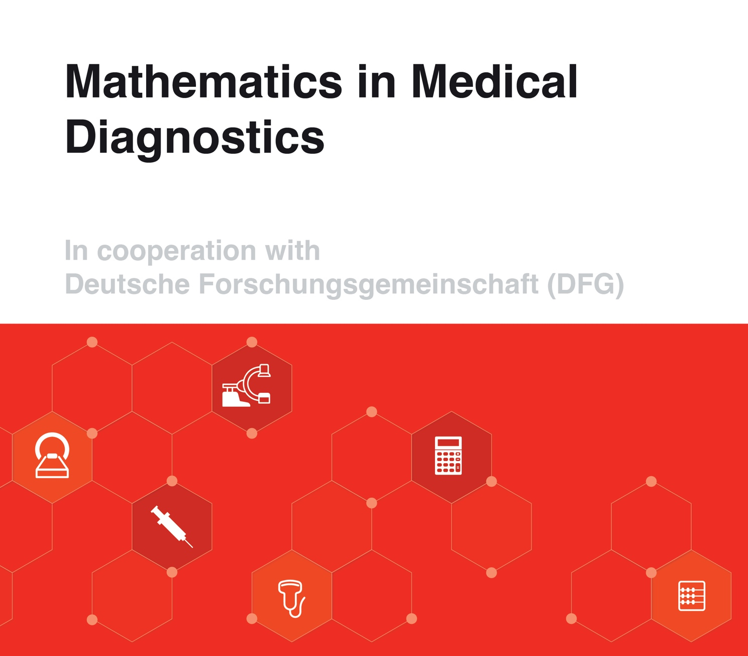**This year’s focus topic: Mathematics in Medical Diagnostics**

**Date 23 April 2022, start time 1 pm (CEST)**

**Location:**

**Max-Planck Dioscuri Centre in Topological Data Analysis,**

Polish Academy of Sciences,

Institute of Mathematics

Sniadeckich 8

Warsaw, Poland

**Virtual log in details on zoom:**

<https://us02web.zoom.us/j/3907697241?pwd=SmdlVCtGOXNnSnJXQ2VWU0V5c1NVQT09>

Meeting ID: 390 769 7241

Passcode: 3EqzkF

**Instructions for speakers**

We are looking forward to your talk. Please aim to speak no longer than 15 min.

**Sessions overview**

**Opening session**

Starting 1 pm

* **Dlotko, Pawel, Dioscuri Centre for Topological Data Analysis, Warsaw, Poland**

Welcome message, technical details and workshop structure

How to see multiple clinical parameters acting together?

* **Group photo 2022 on zoom (participation non mandatory)**

**Session 1 – Topological data analysis, Chair: Bosbach, Wolfram A**

Starting 1.30 pm

* **Senge, Jan, Department of Mathematics and Computer Science, University of Bremen, Germany**

Analysis of synchrotron images of human femoral heads and extraction of their topological characteristics

* **Hellmer, Niklas, Dioscuri Centre for Topological Data Analysis, Warsaw, Poland**Bottleneck Profiles and Prokhorov Metrics for Persistence Diagrams
* **Gurnari, Davide, Dioscuri Centre for Topological Data Analysis, Warsaw, Poland**

Analysis of medical images using Euler characteristic curves (and profiles)

**Coffee break 15 min**

**Session 2 – Non-TDA works, Chair: Dlotko, Pawel**

Starting 2.45 pm

* **Tindall, Marcus J, Department of Mathematics and Statistics & Institute of Cardiovascular and Metabolic Research, University of Reading, UK**

Mathematical modelling of bacterial chemotactic systems – The Rhodobacter sphaeroides case example

* **Burfitt, Matthew, Department of Mathematics, University Aberdeen, UK**

A projective model for fast field cycling MRI images

* **Bosbach, Konstantin E, Medical Department, University of Freiburg, Germany**

Investigating in vivo Detectability of the Neurotransmitter GABA in Magnetic Resonance Spectroscopy with the Monte Carlo method

**Coffee break 15 min**

**Session 3 – Medical applications, Chair: TBD**

Starting 4.00 pm

* **Bosbach, Wolfram A, Department of Diagnostic, Interventional and Paediatric Radiology (DIPR), Inselspital, Bern University Hospital, University of Bern, Switzerland**

VBA simulations of hospital operations – case study on Covid-19 vaccine rollout schemes

* **Ramedani, Saied, Graduate School of Cellular and Biomedical Sciences, University of Bern, Switzerland**

Automated Evaluation of the Whole Body's Muscle-fat Composition by Machine Learning for Magnetic Resonance Images (MRI)

* **Maryanski, Marek, Institute of Nanotechnology and Material Science, Gdansk University of Technology, Poland**

Towards automatic comparison between planned stereotactic radiosurgery dose distributions and those measured from high-definition 3D gel dosimetry images

* **Haupt, Fabian, Department of Diagnostic, Interventional and Paediatric Radiology (DIPR), Inselspital, Bern University Hospital, University of Bern, Switzerland**

Educational presentation of state of the art imaging of congenital vascular malformations

**Past events:**

**3rd (virtual) conference: Multifunctional trauma surgery implants**

DFG grant BO 4961/6-1

17 Oct 2020

Proceedings DOI [/10.17863/CAM.60559](https://doi.org/10.17863/CAM.60559)

**2nd conference: Vibration in oncological and antibacterial therapy**

DFG grant BO 4961/3-1

11 - 13 Oct 2019

Proceedings DOI [/10.17863/CAM.45844](https://doi.org/10.17863/CAM.45844)

**1st conference: Patient centred technology design in traumatology**

DFG grant BO 4961/4-1

16 - 18 Nov 2018

Proceedings DOI [/10.17863/CAM.34582](https://doi.org/10.17863/CAM.34582)