CybOXTM Version 2.1.1 Part 03: Core

Working Draft 01

15 December 2015

Technical Committee:

[OASIS Cyber Threat Intelligence (CTI) TC](https://www.oasis-open.org/committees/cti/)

Chair:

Richard Struse ([Richard.Struse@HQ.DHS.GOV](mailto:Richard.Struse@HQ.DHS.GOV)), [DHS Office of Cybersecurity and Communications (CS&C)](http://www.dhs.gov/office-cybersecurity-and-communications)

Editors:

Desiree Beck ([dbeck@mitre.org](mailto:ikirillov@mitre.org)), [MITRE Corporation](http://www.mitre.org/)

Trey Darley ([trey@soltra.com](mailto:trey@soltra.com)), [Soltra](http://www.soltra.com/)

Ivan Kirillov ([ikirillov@mitre.org](mailto:ikirillov@mitre.org)), [MITRE Corporation](http://www.mitre.org/)

Rich Piazza ([rpiazza@mitre.org](mailto:ikirillov@mitre.org)), [MITRE Corporation](http://www.mitre.org/)

Additional artifacts:

This prose specification is one component of a Work Product which consists of:

* *CybOX™ Version 2.1.1 Part 01: Overview. [URI]*
* *CybOX™ Version 2.1.1 Part 02: Common. [URI]*
* *CybOX™ Version 2.1.1 Part 03: Core.* (this document)
* *CybOX™ Version 2.1.1 Part 04: Default Extensions. [URI]*
* *CybOX™ Version 2.1.1 Part 05: Default Vocabularies. [URI]*
* *CybOX™ Version 2.1.1 Part 06: UML Model. [URI]*
* *CybOX™ Version 2.1.1 Part 07: API Object. [URI]*
* *CybOX™ Version 2.1.1 Part 08: ARP Cache Object. [URI]*
* *CybOX™ Version 2.1.1 Part 09: AS Object. [URI]*
* *CybOXTM Version 2.1.1 Part 10: Account Object. [URI]*
* *CybOXTM Version 2.1.1 Part 11: Address Object. [URI]*
* *CybOXTM Version 2.1.1 Part 12: Archive File Object. [URI]*
* *CybOXTM Version 2.1.1 Part 13: Artifact Object. [URI]*
* *CybOXTM Version 2.1.1 Part 14: Code Object. [URI]*
* *CybOXTM Version 2.1.1 Part 15: Custom Object. [URI]*
* *CybOXTM Version 2.1.1 Part 16: DNS Cache Object. [URI]*
* *CybOXTM Version 2.1.1 Part 17: DNS Query Object. [URI]*
* *CybOXTM Version 2.1.1 Part 18: DNS Record Object. [URI]*
* *CybOXTM Version 2.1.1 Part 19: Device Object. [URI]*
* *CybOXTM Version 2.1.1 Part 20: Disk Object. [URI]*
* *CybOXTM Version 2.1.1 Part 21: Disk Partition Object. [URI]*
* *CybOXTM Version 2.1.1 Part 22: Domain Name Object. [URI]*
* *CybOXTM Version 2.1.1 Part 23: Email Message Object. [URI]*
* *CybOXTM Version 2.1.1 Part 24: File Object. [URI]*
* *CybOXTM Version 2.1.1 Part 25: GUI Dialogbox Object. [URI]*
* *CybOXTM Version 2.1.1 Part 26: GUI Object. [URI]*
* *CybOXTM Version 2.1.1 Part 27: GUI Window Object. [URI]*
* *CybOXTM Version 2.1.1 Part 28: HTTP Session Object. [URI]*
* *CybOXTM Version 2.1.1 Part 29: Hostname Object. [URI]*
* *CybOXTM Version 2.1.1 Part 30: Image File Object. [URI]*
* *CybOXTM Version 2.1.1 Part 31: Library File Object. [URI]*
* *CybOXTM Version 2.1.1 Part 32: Link Object. [URI]*
* *CybOXTM Version 2.1.1 Part 33: Linux Package Object. [URI]*
* *CybOXTM Version 2.1.1 Part 34: Memory Object. [URI]*
* *CybOXTM Version 2.1.1 Part 35: Mutex Object. [URI]*
* *CybOXTM Version 2.1.1 Part 36: Network Connection Object. [URI]*
* *CybOXTM Version 2.1.1 Part 37: Network Flow Object. [URI]*
* *CybOXTM Version 2.1.1 Part 38: Network Packet Object. [URI]*
* *CybOXTM Version 2.1.1 Part 39: Network Route Entry Object. [URI]*
* *CybOXTM Version 2.1.1 Part 40: Network Route Object. [URI]*
* *CybOXTM Version 2.1.1 Part 41: Network Socket Object. [URI]*
* *CybOXTM Version 2.1.1 Part 42: Network Subnet Object. [URI]*
* *CybOXTM Version 2.1.1 Part 43: PDF File Object. [URI]*
* *CybOXTM Version 2.1.1 Part 44: Pipe Object. [URI]*
* *CybOXTM Version 2.1.1 Part 45: Port Object. [URI]*
* *CybOXTM Version 2.1.1 Part 46: Process Object. [URI]*
* *CybOXTM Version 2.1.1 Part 47: Product Object. [URI]*
* *CybOXTM Version 2.1.1 Part 48: SMS Message Object. [URI]*
* *CybOXTM Version 2.1.1 Part 49: Semaphore Object. [URI]*
* *CybOXTM Version 2.1.1 Part 50: Socket Address Object. [URI]*
* *CybOXTM Version 2.1.1 Part 51: System Object. [URI]*
* *CybOXTM Version 2.1.1 Part 52: URI Object. [URI]*
* *CybOXTM Version 2.1.1 Part 53: URL History Object. [URI]*
* *CybOXTM Version 2.1.1 Part 54: Unix File Object. [URI]*
* *CybOXTM Version 2.1.1 Part 55: Unix Network Route Entry Object. [URI]*
* *CybOXTM Version 2.1.1 Part 56: Unix Pipe Object. [URI]*
* *CybOXTM Version 2.1.1 Part 57: Unix Process Object. [URI]*
* *CybOXTM Version 2.1.1 Part 58: Unix User Account Object. [URI]*
* *CybOXTM Version 2.1.1 Part 59: Unix Volume Object. [URI]*
* *CybOXTM Version 2.1.1 Part 60: User Account Object. [URI]*
* *CybOXTM Version 2.1.1 Part 61: User Session Object. [URI]*
* *CybOXTM Version 2.1.1 Part 62: Volume Object. [URI]*
* *CybOXTM Version 2.1.1 Part 63: Whois Object. [URI]*
* *CybOXTM Version 2.1.1 Part 64: Win Computer Account Object. [URI]*
* *CybOXTM Version 2.1.1 Part 65: Win Critical Section Object. [URI]*
* *CybOXTM Version 2.1.1 Part 66: Win Driver Object. [URI]*
* *CybOXTM Version 2.1.1 Part 67: Win Event Log Object. [URI]*
* *CybOXTM Version 2.1.1 Part 68: Win Event Object. [URI]*
* *CybOXTM Version 2.1.1 Part 69: Win Executable File Object. [URI]*
* *CybOXTM Version 2.1.1 Part 70: Win File Object. [URI]*
* *CybOXTM Version 2.1.1 Part 71: Win Filemapping Object. [URI]*
* *CybOXTM Version 2.1.1 Part 72: Win Handle Object. [URI]*
* *CybOXTM Version 2.1.1 Part 73: Win Hook Object. [URI]*
* *CybOXTM Version 2.1.1 Part 74: Win Kernel Hook Object. [URI]*
* *CybOXTM Version 2.1.1 Part 75: Win Kernel Object. [URI]*
* *CybOXTM Version 2.1.1 Part 76: Win Mailslot Object. [URI]*
* *CybOXTM Version 2.1.1 Part 77: Win Memory Page Region Object. [URI]*
* *CybOXTM Version 2.1.1 Part 78: Win Mutex Object. [URI]*
* *CybOXTM Version 2.1.1 Part 79: Win Network Route Entry Object. [URI]*
* *CybOXTM Version 2.1.1 Part 80: Win Network Share Object. [URI]*
* *CybOXTM Version 2.1.1 Part 81: Win Pipe Object. [URI]*
* *CybOXTM Version 2.1.1 Part 82: Win Prefetch Object. [URI]*
* *CybOXTM Version 2.1.1 Part 83: Win Process Object. [URI]*
* *CybOXTM Version 2.1.1 Part 84: Win Registry Key Object. [URI]*
* *CybOXTM Version 2.1.1 Part 85: Win Semaphore Object. [URI]*
* *CybOXTM Version 2.1.1 Part 86: Win Service Object. [URI]*
* *CybOXTM Version 2.1.1 Part 87: Win System Object. [URI]*
* *CybOXTM Version 2.1.1 Part 88: Win System Restore Object. [URI]*
* *CybOXTM Version 2.1.1 Part 89: Win Task Object. [URI]*
* *CybOXTM Version 2.1.1 Part 90: Win Thread Object. [URI]*
* *CybOXTM Version 2.1.1 Part 91: Win User Account Object. [URI]*
* *CybOXTM Version 2.1.1 Part 92: Win Volume Object. [URI]*
* *CybOXTM Version 2.1.1 Part 93: Win Waitable Timer Object. [URI]*
* *CybOXTM Version 2.1.1 Part 94: X509 Certificate Object. [URI]*

Related work:

This specification is related to:

* *STIXTM Version 1.2.1 (placeholder)*

Abstract:

The Cyber Observable Expression (CybOX) is a standardized language for encoding and communicating high-fidelity information about cyber observables, whether dynamic events or stateful measures that are observable in the operational cyber domain. By specifying a common structured schematic mechanism for these cyber observables, the intent is to enable the potential for detailed automatable sharing, mapping, detection and analysis heuristics. This specification document defines the Core data model, which is one of the fundamental data models for CybOX content.

Status:

This [Working Draft](https://www.oasis-open.org/policies-guidelines/tc-process#dWorkingDraft) (WD) has been produced by one or more TC Members; it has not yet been voted on by the TC or [approved](https://www.oasis-open.org/policies-guidelines/tc-process#committeeDraft) as a Committee Draft (Committee Specification Draft or a Committee Note Draft). The OASIS document [Approval Process](https://www.oasis-open.org/policies-guidelines/tc-process#standApprovProcess) begins officially with a TC vote to approve a WD as a Committee Draft. A TC may approve a Working Draft, revise it, and re-approve it any number of times as a Committee Draft.

URI patterns:

Initial publication URI:  
http://docs.oasis-open.org/cti/stix/v1.2.1/csd01/part9-coa/stix-v1.2.1-csd01-part9-coa.docx

Permanent “Latest version” URI:  
http://docs.oasis-open.org/cti/stix/v1.2.1/stix-v1.2.1-part9-coa.docx

(Managed by OASIS TC Administration; please don’t modify.)

Copyright © OASIS Open 2016. All Rights Reserved.

All capitalized terms in the following text have the meanings assigned to them in the OASIS Intellectual Property Rights Policy (the "OASIS IPR Policy"). The full [Policy](https://www.oasis-open.org/policies-guidelines/ipr) may be found at the OASIS website.

This document and translations of it may be copied and furnished to others, and derivative works that comment on or otherwise explain it or assist in its implementation may be prepared, copied, published, and distributed, in whole or in part, without restriction of any kind, provided that the above copyright notice and this section are included on all such copies and derivative works. However, this document itself may not be modified in any way, including by removing the copyright notice or references to OASIS, except as needed for the purpose of developing any document or deliverable produced by an OASIS Technical Committee (in which case the rules applicable to copyrights, as set forth in the OASIS IPR Policy, must be followed) or as required to translate it into languages other than English.

The limited permissions granted above are perpetual and will not be revoked by OASIS or its successors or assigns.

This document and the information contained herein is provided on an "AS IS" basis and OASIS DISCLAIMS ALL WARRANTIES, EXPRESS OR IMPLIED, INCLUDING BUT NOT LIMITED TO ANY WARRANTY THAT THE USE OF THE INFORMATION HEREIN WILL NOT INFRINGE ANY OWNERSHIP RIGHTS OR ANY IMPLIED WARRANTIES OF MERCHANTABILITY OR FITNESS FOR A PARTICULAR PURPOSE.

Portions copyright © United States Government 2012-2016.  All Rights Reserved.  
  
STIX™, TAXII™, AND CybOX™ (STANDARD OR STANDARDS) AND THEIR COMPONENT PARTS ARE PROVIDED “AS IS” WITHOUT ANY WARRANTY OF ANY KIND, EITHER EXPRESSED, IMPLIED, OR STATUTORY, INCLUDING, BUT NOT LIMITED TO, ANY WARRANTY THAT THESE STANDARDS OR ANY OF THEIR COMPONENT PARTS WILL CONFORM TO SPECIFICATIONS, ANY IMPLIED WARRANTIES OF MERCHANTABILITY, FITNESS FOR A PARTICULAR PURPOSE, OR FREEDOM FROM INFRINGEMENT, ANY WARRANTY THAT THE STANDARDS OR THEIR COMPONENT PARTS WILL BE ERROR FREE, OR ANY WARRANTY THAT THE DOCUMENTATION, IF PROVIDED, WILL CONFORM TO THE STANDARDS OR THEIR COMPONENT PARTS. IN NO EVENT SHALL THE UNITED STATES GOVERNMENT OR ITS CONTRACTORS OR SUBCONTRACTORS BE LIABLE FOR ANY DAMAGES, INCLUDING, BUT NOT LIMITED TO, DIRECT, INDIRECT, SPECIAL OR CONSEQUENTIAL DAMAGES, ARISING OUT OF, RESULTING FROM, OR IN ANY WAY CONNECTED WITH THESE STANDARDS OR THEIR COMPONENT PARTS OR ANY PROVIDED DOCUMENTATION, WHETHER OR NOT BASED UPON WARRANTY, CONTRACT, TORT, OR OTHERWISE, WHETHER OR NOT INJURY WAS SUSTAINED BY PERSONS OR PROPERTY OR OTHERWISE, AND WHETHER OR NOT LOSS WAS SUSTAINED FROM, OR AROSE OUT OF THE RESULTS OF, OR USE OF, THE STANDARDS, THEIR COMPONENT PARTS, AND ANY PROVIDED DOCUMENTATION. THE UNITED STATES GOVERNMENT DISCLAIMS ALL WARRANTIES AND LIABILITIES REGARDING THE STANDARDS OR THEIR COMPONENT PARTS ATTRIBUTABLE TO ANY THIRD PARTY, IF PRESENT IN THE STANDARDS OR THEIR COMPONENT PARTS AND DISTRIBUTES IT OR THEM “AS IS.”

Table of Contents

1 Introduction 7

1.1 CybOXTM Specification Documents 7

1.2 Document Conventions 7

1.2.1 Fonts 7

1.2.2 UML Package References 8

1.2.3 UML Diagrams 8

1.2.3.1 Class Properties 8

1.2.3.2 Diagram Icons and Arrow Types 8

1.2.4 Property Table Notation 9

1.2.5 Property and Class Descriptions 9

1.3 Terminology 10

1.4 Normative References 10

2 Background Information 11

2.1 Cyber Observables 11

2.2 Objects 11

2.3 Events and Actions 11

3 CybOX Core Data Model 12

3.1 Primary Classes 12

3.1.1 ActionType Class 12

3.1.1.1 ActionArgumentType Class 16

3.1.1.2 ActionPertinentObjectPropertyType Class 17

3.1.1.3 ActionRelationshipType Class 17

3.1.1.4 ActionReferenceType Class 18

3.1.1.5 AssociatedObjectType Class 19

3.1.2 EventType Class 20

3.1.2.1 EventPropertiesType Class 22

3.1.2.2 CompositeEventType Class 23

3.1.2.3 EventDetailsType Interface 23

3.1.3 ObjectType Class 24

3.1.3.1 DomainSpecificObjectPropertiesType Class 26

3.1.3.2 RelatedObjectType Class 26

3.1.4 ObservableType Class 28

3.1.4.1 ObservableDetailsType Interface 31

3.1.4.2 ObservableCompositionType Class 32

3.1.4.3 PatternFidelityType Class 32

3.1.4.4 ObfuscationTechniqueType Class 33

3.1.5 FrequencyType Class 33

3.2 Content Aggregation Classes 34

3.2.1 ActionAliasesType Class 34

3.2.2 ActionArgumentsType Class 35

3.2.3 ActionPertinentObjectPropertiesType Class 35

3.2.4 ActionRelationshipsType Class 35

3.2.5 ActionsType Class 36

3.2.6 AssociatedObjectsType Class 36

3.2.7 KeywordsType Class 37

3.2.8 ObfuscationTechniquesType Class 37

3.2.9 ObservablesType Class 37

3.2.10 PropertiesType Class 38

3.2.11 RelatedObjectsType Class 39

3.2.12 ValuesType Class 39

3.3 Pool Classes 39

3.3.1 PoolsType Class 40

3.3.2 EventPoolType Class 41

3.3.3 ActionPoolType Class 41

3.3.4 ObjectPoolType Class 41

3.3.5 PropertyPoolType Class 42

3.4 Defined Effect Classes 42

3.4.1 DefinedEffectType Class 42

3.4.2 StateChangeEffectType Class 43

3.4.3 DataReadEffectType Class 44

3.4.4 DataWrittenEffectType Class 44

3.4.5 DataSentEffectType Class 45

3.4.6 DataReceivedEffectType Class 45

3.4.7 PropertyReadEffectType Class 45

3.4.8 PropertiesEnumeratedEffectType Class 46

3.4.9 ValuesEnumeratedEffectType Class 46

3.4.10 SendControlCodeEffectType Class 46

3.5 Enumerations 47

3.5.1 ActionStatusTypeEnum Enumeration 47

3.5.2 ActionContextTypeEnum Enumeration 48

3.5.3 EaseOfObfuscationEnum Enumeration 48

3.5.4 EffectTypeEnum Enumeration 48

3.5.5 NoisinessEnum Enumeration 49

3.5.6 OperatorTypeEnum Enumeration 49

3.5.7 TrendEnum Enumeration 50

4 Conformance 51

Acknowledgments 52

Appendix A. Revision History 53

# Introduction

[All text is normative unless otherwise labeled]

The Cyber Observable Expression (CybOXTM) provides a common structure for representing cyber observables across and among the operational areas of enterprise cyber security. CybOX improves the consistency, efficiency, and interoperability of deployed tools and processes, and it increases overall situational awareness by enabling the potential for detailed automatable sharing, mapping, detection, and analysis heuristics.

This document serves as the specification for the CybOX Core Version 2.1.1 data model, which is one of two fundamental data models for CybOX content.

In Section **1.1,** we discuss additional specification documents, in Section **1.2,** we provide document conventions, and in Section **1.3,** we provide terminology. References are given in Sections **1.4**. In Section **2**, we give background information necessary to fully understand the Core data model. We present the Core data model specification details in Section **3** and conformance information in Section **4**.

## CybOXTM Specification Documents

The CybOX specification consists of a formal UML model and a set of textual specification documents that explain the UML model. Specification documents have been written for each of the individual data models that compose the full CybOX UML model.

CybOX has a modular design comprising two fundamental data models and a collection of Object data models. The fundamental data models – CybOX Core and CybOX Common – provide essential CybOX structure and functionality. The CybOX Objects, defined in individual data models, are precise characterizations of particular types of observable cyber entities (e.g., HTTP session, Windows registry key, DNS query).

Use of the CybOX Core and Common data models is required; however, use of the CybOX Object data models is purely optional: users select and use only those Objects and corresponding data models that are needed. Importing the entire CybOX suite of data models is not necessary.

The *CybOX Version 2.1.1 Part 1: Overview* document provides a comprehensive overview of the full set of CybOX data models, which in addition to the Core, Common, and numerous Object data models, includes a set of default controlled vocabularies. *CybOX Version 2.1.1 Part 1: Overview* also summarizes the relationship of CybOX to other externally defined data models, and outlines general CybOX data model conventions.

## Document Conventions

The following conventions are used in this document.

### Fonts

The following font and font style conventions are used in the document:

* Capitalization is used for CybOX high level concepts, which are defined in *CybOX Version 2.1.1 Part 1: Overview*.

Examples: Action, Object, Event, Property

* The Courier New font is used for writing UML objects.

Examples: ActionType, cyboxCommon:BaseObjectPropertyType

Note that all high level concepts have a corresponding UML object. For example, the Action high level concept is associated with a UML class named, ActionType.

* The ‘*italic’* font (withsingle quotes) is used for noting actual, explicit values for CybOX Language properties. The *italic* font (without quotes) is used for noting example values.

Example:  *‘HashNameVocab-1.0,’ high, medium, low*

### UML Package References

Each CybOX data model is captured in a different UML package (e.g., Core package) where the packages together compose the full CybOX UML model. To refer to a particular class of a specific package, we use the format package_prefix:class, where package_prefix corresponds to the appropriate UML package. *CybOX Version 2.1.1 Part 1: Overview*contains the full list of CybOX packages, along with the associated prefix notations, descriptions, and examples.

Note that in *this* specification document, we do not explicitly specify the package prefix for any classes that originate from the Core data model.

### UML Diagrams

This specification makes use of UML diagrams to visually depict relationships between CybOX Language constructs. Note that the diagrams have been extracted directly from the full UML model for CybOX; they have not been constructed purely for inclusion in the specification documents.  Typically, diagrams are included for the primary class of a data model, and for any other class where the visualization of its relationships between other classes would be useful.  This implies that there will be very few diagrams for classes whose only properties are either a data type or a class from the CybOX Common data model.  Other diagrams that are included correspond to classes that specialize a superclass and abstract or generalized classes that are extended by one or more subclasses.

In UML diagrams, classes are often presented with their attributes elided, to avoid clutter. The fully described class can usually be found in a related diagram. A class presented with an empty section at the bottom of the icon indicates that there are no attributes other than those that are visualized using associations.

#### Class Properties

Generally, a class property can be shown in a UML diagram as either an attribute or an association (i.e., the distinction between attributes and associations is somewhat subjective). In order to make the size of UML diagrams in the specifications manageable, we have chosen to capture most properties as attributes and to capture only higher level properties as associations, especially in the main top-level component diagrams. In particular, we will always capture properties of UML data types as attributes. For example, properties of a class that are identifiers, titles, and timestamps will be represented as attributes.

#### Diagram Icons and Arrow Types

Diagram icons are used in a UML diagram to indicate whether a shape is a class, enumeration, or a data type, and decorative icons are used to indicate whether an element is an attribute of a class or an enumeration literal. In addition, two different arrow styles indicate either a directed association relationship (regular arrowhead) or a generalization relationship (triangle-shaped arrowhead). The icons and arrow styles we use are shown and described in **Table 1‑1**.

Table 1‑1. UML diagram icons

|  |  |
| --- | --- |
| **Icon** | **Description** |
|  | This diagram icon indicates a class. If the name is in italics, it is an abstract class. |
|  | This diagram icon indicates an enumeration. |
|  | This diagram icon indicates a data type. |
|  | This decorator icon indicates an attribute of a class. The green circle means its visibility is public. If the circle is red or yellow, it means its visibility is private or protected. |
|  | This decorator icon indicates an enumeration literal. |
|  | This arrow type indicates a directed association relationship. |
|  | This arrow type indicates a generalization relationship. |

### Property Table Notation

Throughout Section **3**, tables are used to describe the properties of each data model class. Each property table consists of a column of names to identify the property, a type column to reflect the datatype of the property, a multiplicity column to reflect the allowed number of occurrences of the property, and a description column that describes the property. Package prefixes are provided for classes outside of the Core data model (see Section **1.2.2**).

Note that if a class is a specialization of a superclass, only the properties that constitute the specialization are shown in the property table (i.e., properties of the superclass will not be shown). However, details of the superclass may be shown in the UML diagram.

### Property and Class Descriptions

Each class and property defined in CybOX is described using the format, “The X property verbY.” For example, in the specification for the CybOX Core data model, we write, “The id property specifies a globally unique identifier for the Action.” In fact, the verb “specifies” could have been replaced by any number of alternatives: “defines,” “describes,” “contains,” “references,” etc.

However, we thought that using a wide variety of verb phrases might confuse a reader of a specification document because the meaning of each verb could be interpreted slightly differently. On the other hand, we didn’t want to use a single, generic verb, such as “describes,” because although the different verb choices may or may not be meaningful from an implementation standpoint, a distinction could be useful to those interested in the modeling aspect of CybOX.

Consequently, we have preferred to use the three verbs, defined as follows, in class and property descriptions:

|  |  |
| --- | --- |
| **Verb** | **CybOX Definition** |
| captures | Used to record and preserve information without implying anything about the structure of a class or property. Often used for properties that encompass general content. This is the least precise of the three verbs. |
|  | *Examples*:  The Observable_Source property characterizes the source of the Observable information. Examples of details captured include identifying characteristics, time-related attributes, and a list of the tools used to collect the information.  The Description property captures a textual description of the Action. |
| characterizes | Describes the distinctive nature or features of a class or property. Often used to describe classes and properties that themselves comprise one or more other properties. |
|  | *Examples*:  The Action property characterizes a cyber observable Action.  The Obfuscation_Technique property characterizes a technique an attacker could potentially leverage to obfuscate the Observable. |
| specifies | Used to clearly and precisely identify particular instances or values associated with a property. Often used for properties that are defined by a controlled vocabulary or enumeration; typically used for properties that take on only a single value. |
|  | *Example*:  The cybox_major_version property specifies the major version of the CybOX language used for the set of Observables. |

## Terminology

The key words “MUST”, “MUST NOT”, “REQUIRED”, “SHALL”, “SHALL NOT”, “SHOULD”, “SHOULD NOT”, “RECOMMENDED”, “MAY”, and “OPTIONAL” in this document are to be interpreted as described in [RFC2119].

## Normative References

[RFC2119] Bradner, S., “Key words for use in RFCs to Indicate Requirement Levels”, BCP 14, RFC 2119, March 1997. <http://www.ietf.org/rfc/rfc2119.txt>.

# Background Information

In this section, we provide high level information about the Core data model that is necessary to fully understand the specification details given in Section **3**. The CybOX Core data model contains the data models for the core elements of CybOX (Observables, Events, Actions and Objects) as part of a framework hanging all of these elements together in an integrated, flexible and extensible manner.

## Cyber Observables

A cyber observable is a dynamic event or a stateful property that occurs, or may occur, in the operational cyber domain. Examples of stateful properties include the value of a registry key, the MD5 hash of a file, and an IP address. Examples of events include the deletion of a file, the receipt of an HTTP GET request, and the creation of a remote thread.

A cyber observable is different than a cyber indicator. A cyber observable is a statement of fact, capturing what was observed or could be observed in the cyber operational domain. Cyber indicators are cyber observable patterns, such as a registry key value associated with a known bad actor or a spoofed email address used on a particular date.

## Objects

Objects in CybOX are individual data models for characterizing a particular cyber entity, such as a Windows registry key, or an Email Message, for example. Accordingly, each release of the CybOX language includes a particular set of Objects that are part of the release. The data model for each of these Objects is defined by its own specification that describes the context-specific classes and properties that compose the Object.

## Events and Actions

Events and Actions are data models designed to characterize dynamic cyber observable activity. They support modular expression of any event made up of one or more actions with the ability to relate actions to one another and to relate actions to relevant objects. The Action data model allows expression of the nature of the action, any relevant arguments and relationships to any relevant objects including the nature of the relationship and any specific effects the action has on the object.

# CybOX Core Data Model

The CybOX Core data model defines a variety of classes. For discussion purposes, we have separated the classes into five categories (Sections **3.1** through **3.5**), and within each category, we primarily define the classes in alphabetical order below, except for the cases when a class is uniquely used in the main class, it will be defined within the same subsection. We list enumerations in Section **3.6**.

## Primary Classes

The following classes are the primary classes in CybOX and enable the capture of Actions, Events, Objects, and Observables (Stateful Measures).

### ActionType Class

The ActionType class characterizes a cyber observable Action. The UML diagram corresponding to the ActionType class is shown in Figure 3‑1.

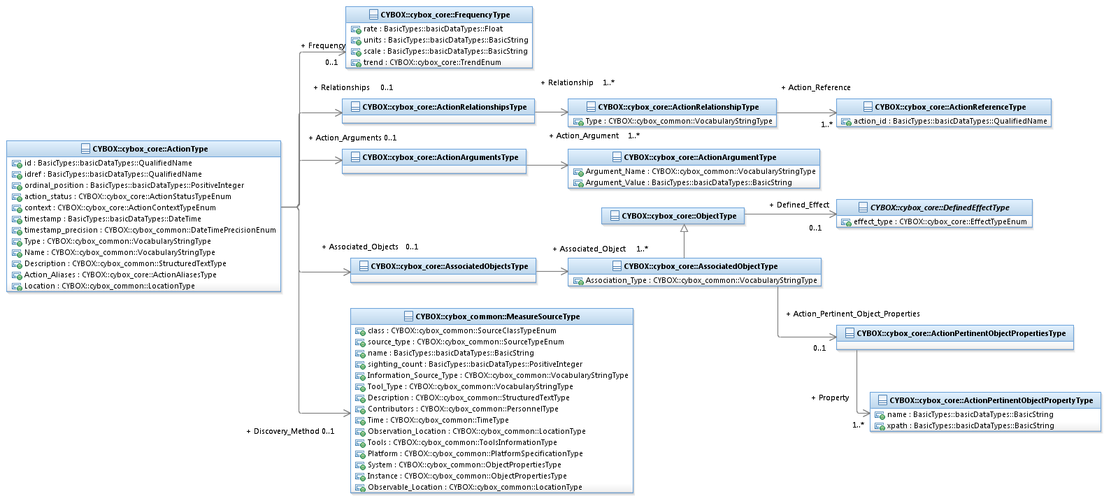

Figure 3‑1. UML diagram for the ActionType class

The property table given in **Table 3‑1** corresponds to the UML diagram shown in **Figure 3‑1**.

Table 3‑1. Properties of the ActionType class

|  |  |  |  |
| --- | --- | --- | --- |
| **Name** | **Type** | **Multiplicity** | **Description** |
| **id** | basicDataTypes:  QualifiedName | 0..1 | The id property specifies a globally unique identifier for the Action. |
| **idref** | basicDataTypes:  QualifiedName | 0..1 | The idref property specifies a globally unique identifier for an Action specified elsewhere. When the idref property is used, the id property MUST NOT also be specified and the other properties of the ActionType class SHOULD NOT hold any content. |
| **ordinal_position** | basicDataTypes:  PositiveInteger | 0..1 | The ordinal_position property specifies the order (e.g., *1*, *2*, or *3*) of the Action within a potential set of multiple Actions. If only a single Action is present, its ordinality can be assumed to be 1. If multiple Actions are present, the ordinality property SHOULD be specified with unique values for each instance. |
| **action_status** | ActionStatusTypeEnum | 0..1 | The action_status property specifies the status of the Action. |
| **context** | ActionContextTypeEnum | 0..1 | The context property specifies the broad operational context in which the Action is relevant. |
| **timestamp** | basicDataTypes:  DateTime | 0..1 | The timestamp property specifies the date and time at which the Action occurred or was observed. To avoid ambiguity, all timestamps SHOULD include a specification of the time zone. |
| **timestamp_precision** | cyboxCommon:  DateTimePrecisionEnum | 0..1 | The timestamp_precision property specifies the granularity with which the timestamp property should be considered, as specified by the DateTypePrecisionEnum enumeration (e.g., '*hour*,' '*minute*'). If omitted, the default precision is ‘*second*.’ Digits in a timestamp that are beyond the specified precision should be zeroed out. |
| **Type** | cyboxCommon:  VocabularyStringType | 0..1 | The Type property specifies the type of the Action that was performed. Examples of potential types include *compress, replicate*, and *suspend* (these specific values are only provided to help explain the property; they are neither recommended values nor necessarily part of any existing vocabulary). The content creator may choose any arbitrary value or may constrain the set of possible values by referencing an externally-defined vocabulary or leveraging a formally defined vocabulary extending from the cyboxCommon:ControlledVocabularyStringType data type. The CybOX default vocabulary class for use in the property is ‘*ActionTypeVocab-1.0*’. |
| **Name** | cyboxCommon:  VocabularyStringType | 0..1 | The Name property specifies the name of the Action that was performed. Examples of potential names include *add user, connect to socket*, and *monitor registry key* (these specific values are only provided to help explain the property; they are neither recommended values nor necessarily part of any existing vocabulary). The content creator may choose any arbitrary value or may constrain the set of possible values by referencing an externally-defined vocabulary or leveraging a formally defined vocabulary extending from the cyboxCommon:ControlledVocabularyStringType data type. The CybOX default vocabulary class for use in the property is ‘*ActionNameVocab-1.1*’. |
| **Description** | cyboxCommon:  StructuredTextType | 0..1 | The Description property captures a textual description of the Action. Any length is permitted. Optional formatting is supported via the structuring_format property of the StructuredTextType data type. |
| **Action_Aliases** | ActionAliasesType | 0..1 | The Action_Aliases property specifies a set of one or more alias names for the Action. |
| **Action_Arguments** | ActionArgumentsType | 0..1 | The Action_Arguments property specifies a set of one or more arguments or parameters relevant to the Action. |
| **Location** | cyboxCommon:  LocationType | 0..1 | The Location property characterizes the actual physical location of the Object. A simple location name may be specified or the underlying class may be extended, in which case, the default and strongly RECOMMENDED subclass is CIQAddress3.0InstanceType, as defined in *CybOX Version 2.1.1 Part 4: Default Extensions*. |
| **Discovery_Method** | cyboxCommon:  MeasureSourceType | 0..1 | The Discovery_Method property characterizes how the Action was observed (in the case of a cyber observable Action instance) or could potentially be observed (in the case of a cyber observable Action pattern). Examples of details captured include identifying characteristics, time-related attributes, and a list of the tools used to collect the information. |
| **Associated_Objects** | AssociatedObjectsType | 0..1 | The Associated_Objects property specifies a set of one or more cyber Objects relevant to the Action (initiating or affected by). |
| **Relationships** | ActionRelationshipsType | 0..1 | The Relationships property specifies a set of one or more relationships between this Action and other Actions. |
| **Frequency** | FrequencyType | 0..1 | The Frequency property characterizes the frequency of the Action. |

#### ActionArgumentType Class

The ActionArgumentType class characterizes an argument or parameter relevant to an Action.

The property table of the ActionArgumentType class is given in **Table 3‑2**.

Table 3‑2. Properties of the ActionArgumentType class

|  |  |  |  |
| --- | --- | --- | --- |
| **Name** | **Type** | **Multiplicity** | **Description** |
| **Argument_Name** | cyboxCommon:  VocabularyStringType | 0..1 | The Argument_Name property specifies the name of the argument. Examples of potential names include *application name, base address,* and *size* (these specific values are only provided to help explain the property; they are neither recommended values nor necessarily part of any existing vocabulary). The content creator may choose any arbitrary value or may constrain the set of possible values by referencing an externally-defined vocabulary or leveraging a formally defined vocabulary extending from the cyboxCommon:ControlledVocabularyStringType data type. The CybOX default vocabulary class for use in the property is ‘*ActionArgumentNameVocab-1.0*’. |
| **Argument_Value** | basicDataTypes:  BasicString | 0..1 | The Argument_Value property specifies the value of the Action argument or parameter. |

#### ActionPertinentObjectPropertyType Class

The ActionPertinentObjectPropertyType class characterizes a property of an Object that is relevant to an Action.

The property table of the ActionPertinentObjectPropertyType class is given in **Table 3‑3**.

Table 3‑3. Properties of the ActionPertinentObjectPropertyType class

|  |  |  |  |
| --- | --- | --- | --- |
| **Name** | **Type** | **Multiplicity** | **Description** |
| **name** | basicDataTypes:BasicString | 0..1 | The name property specifies the field name for the Object property. |
| **xpath** | basicDataTypes:BasicString | 0..1 | The xpath[1] property specifies the identifying the pertinent property of the data model that corresponds to the Object’s class. Specific syntax is dependent on the particular syntactic implementation (XML, JSON, etc.) of the CybOX language and MUST be explicitly specified in a separate binding specification for that syntactic implementation (e.g. a CybOX XML Binding Specification). For example, a CybOX XML Binding Specification could specify XPath 1.0 as an appropriate choice for the syntax of the xpath property. |

#### ActionRelationshipType Class

The ActionRelationshipType class characterizes a relationship between one Action and a related Action.

The property table of the ActionRelationshipType class is given in **Table 3‑4**.

Table 3‑4. Properties of the ActionRelationshipType class

|  |  |  |  |
| --- | --- | --- | --- |
| **Name** | **Type** | **Multiplicity** | **Description** |
| **Type** | cyboxCommon:  VocabularyStringType | 0..1 | The Type property specifies the type of relationship between two actions. Examples of potential types include *dependent on, preceded by*, and *equivalent to* (these specific values are only provided to help explain the property; they are neither recommended values nor necessarily part of any existing vocabulary). The content creator may choose any arbitrary value or may constrain the set of possible values by referencing an externally-defined vocabulary or leveraging a formally defined vocabulary extending from the cyboxCommon:ControlledVocabularyStringType data type. The CybOX default vocabulary class for use in the property is ‘*ActionRelationshipTypeVocab-1.0*’. |
| **Action_Reference** | ActionReferenceType | 1..* | The Action_Reference property captures a reference to the related Action. |

The ActionReferenceType class is defined because in some cases it is not appropriate to define an Action *only* in the context of another Action, and in those cases, an otherwise defined Action should be referenced.

#### ActionReferenceType Class

The ActionReferenceType class captures a reference to a related Action.

The property table of the ActionReferenceType class is given in **Table 3‑5**.

Table 3‑5. Properties of the ActionReferenceType class

|  |  |  |  |
| --- | --- | --- | --- |
| **Name** | **Type** | **Multiplicity** | **Description** |
| **action_id** | basicDataTypes:QualifiedName | 0..1 | The action_id property specifies the globally unique identifier of the Action referenced. |

#### AssociatedObjectType Class

The AssociatedObjectType class characterizes a cyber observable Object associated with a given cyber observable Action (i.e., an Object that is initiated by or affected by the Action). It extends the ObjectType superclass (see Section **3.1.3**).

The UML diagram corresponding to the AssociatedObjectType class is shown in **Figure 3‑2**.

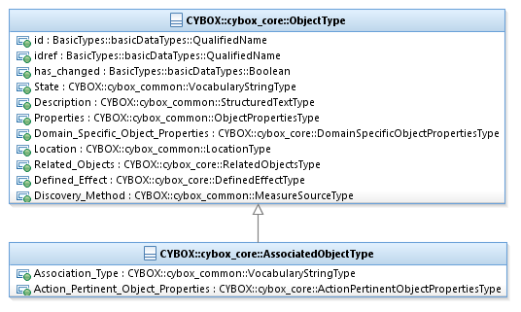

Figure 3‑2. UML diagram of the AssociatedObjectType class

The property table given in **Table 3‑6** corresponds to the UML diagram shown in **Figure 3‑2**.

Table 3‑6. Properties of the AssociatedObjectType class

|  |  |  |  |
| --- | --- | --- | --- |
| **Name** | **Type** | **Multiplicity** | **Description** |
| **Association_Type** | cyboxCommon:  VocabularyStringType | 0..1 | The Association_Type property specifies types of Action-Object associations. Examples of potential types include *initiating, affected*, and *utilized* (these specific values are only provided to help explain the property: they are neither recommended values nor necessarily part of any existing vocabulary). The content creator may choose any arbitrary value or may constrain the set of possible values by referencing an externally-defined vocabulary or leveraging a formally defined vocabulary extending from the cyboxCommon:ControlledVocabularyStringType data type. The CybOX default vocabulary class for use in the property is ‘*ActionObjectAssociationTypeVocab-1.0’*. |
| **Action_Pertinent_**  **Object_Properties** | ActionPertinent  ObjectPropertiesType | 0..1 | The Action_Pertinent_Object_Properties property specifies a set of one or more properties of the Object that are pertinent to the Action. |

### EventType Class

The EventType class characterizes a cyber observable Event, which is a set of specific Action(s) involving specific cyber relevant Objects. Examples of Events include: a file is deleted, a registry key is created, or an HTTP GET Request is received. The UML diagram corresponding to the EventType class is shown in Figure 3‑2.

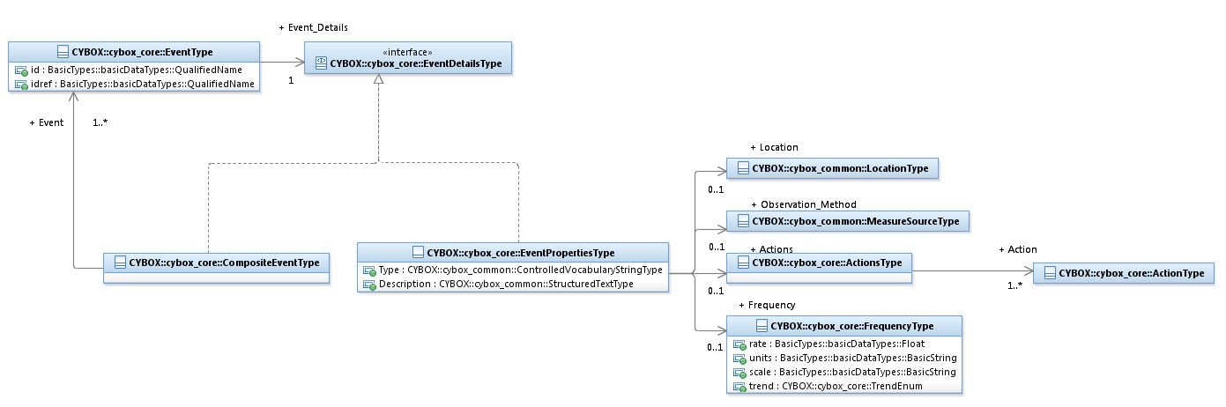

Figure 3‑3. UML diagram for the EventType class

The property table given in **Table 3‑7** corresponds to the UML diagram shown in **Figure 3‑3**.

Table 3‑7. Properties of the EventType class

|  |  |  |  |
| --- | --- | --- | --- |
| **Name** | **Type** | **Multiplicity** | **Description** |
| **id** | basicDataTypes:  QualifiedName | 0..1 | The id property specifies a globally unique identifier for the Event. |
| **idref** | basicDataTypes:  QualifiedName | 0..1 | The idref property specifies a globally unique identifier for an Event specified elsewhere. When the idref property is used, the id property MUST NOT also be specified and the other properties of the EventType class SHOULD NOT hold any content. |
| **Event_Details** | EventDetailsType | 1 | The Event_Details property specifies detailed description of the Event. The EventsDetailsType interface, can be realized using either the EventPropertiesType class or a set of other Events via the CompositeEventType. |

#### EventPropertiesType Class

The property table of the EventPropertiesType class is given in **Table 3‑8**.

Table 3‑8. Properties of the EventPropertiesType class

|  |  |  |  |
| --- | --- | --- | --- |
| **Name** | **Type** | **Multiplicity** | **Description** |
| **Type** | cyboxCommon:  VocabularyStringType | 0..1 | The Type property specifies the type of the Event. Examples of potential types include *http traffic, socket operations*, and *autorun* (these specific values are only provided to help explain the property; they are neither recommended values nor necessarily part of any existing vocabulary). The content creator may choose any arbitrary value or may constrain the set of possible values by referencing an externally-defined vocabulary or leveraging a formally defined vocabulary extending from the cyboxCommon:ControlledVocabularyStringType data type. The CybOX default vocabulary class for use in the property is ‘*EventTypeVocab-1.0.1’*. |
| **Description** | cyboxCommon:  StructuredTextType | 0..1 | The Description property captures a textual description of the Event. Any length is permitted. Optional formatting is supported via the structuring_format property of the StructuredTextType data type. |
| **Observation_Method** | cyboxCommon:  MeasureSourceType | 0..1 | The Observation_Method property characterizes how the Event was observed (in the case of a cyber observable Event instance) or could potentially be observed (in the case of a cyber observable Event pattern). Examples of details captured include identifying characteristics, time-related attributes, and a list of the tools used to collect the information. |
| **Actions** | ActionsType | 0..1 | The Actions property specifies a set of one or more Actions that compose the Event. |
| **Location** | cyboxCommon:  LocationType | 0..1 | The Location property characterizes the actual physical location of the Event. A simple location name may be specified or the underlying class may be extended, in which case, the default and strongly RECOMMENDED subclass is CIQAddress3.0InstanceType, as defined in *CybOX Version 2.1.1 Part 4: Default Extensions*. |
| **Frequency** | FrequencyType | 0..1 | The Frequency property characterizes the frequency of the Event. |

#### CompositeEventType Class

The CompositeEventType class specifies a set of one or more other Events related to this Event. Notice that there is no defined relationship between the set of events, and no explicit relationship between the original Event and the others beyond simple associativity.

The property table of the CompositeEventType class is given in **Table 3‑9**.

Table 3‑9. Properties of the CompositeEventType class

|  |  |  |  |
| --- | --- | --- | --- |
| **Name** | **Type** | **Multiplicity** | **Description** |
| **Event** | EventType | 1..* | The Event property specifies an Event asserted to be associated with the original Event. |

#### EventDetailsType Interface

The EventDetailsType interface captures the ability to specify one Event or a hierarchy of Events. An EventType can be defined either in terms of Event properties, using the EventPropertiesType class, or by a set of other Events using the CompositeEventType class. The relationships represented in this hierarchy is not explicitly specified.

### ObjectType Class

The ObjectType class characterizes a cyber-relevant Object (e.g., a file, a registry key or a process). The UML diagram corresponding to the ObjectType class is shown in **Figure 3‑4**.

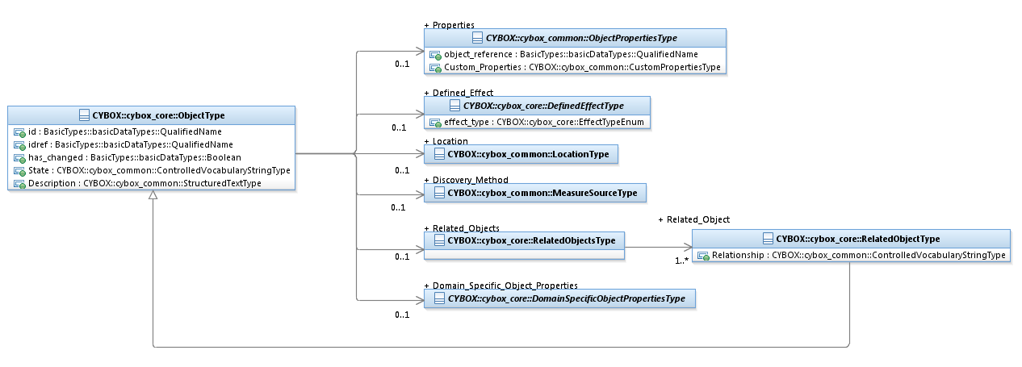

Figure 3‑4. UML diagram for the ObjectType class

The property table given in **Table 3‑10** corresponds to the UML diagram shown in **Figure 3‑4**.

Table 3‑10. Properties of the ObjectType class

|  |  |  |  |
| --- | --- | --- | --- |
| **Name** | **Type** | **Multiplicity** | **Description** |
| **id** | basicDataTypes:  QualifiedName | 0..1 | The id property specifies a globally unique identifier for the Object. |
| **idref** | basicDataTypes:  QualifiedName | 0..1 | The idref property specifies a globally unique identifier for an Object specified elsewhere. When the idref property is used, the id property MUST NOT also be specified and the other properties of the ObjectType class SHOULD NOT hold any content. |
| **has_changed** | basicDataTypes:  Boolean | 0..1 | The has_changed property specifies whether the Object has changed in some way. This property is NOT intended to be used for versioning of CybOX content. |
| **State** | cyboxCommon:  VocabularyStringType | 0..1 | The State property specifies the state of the Object. Examples of potential states include *exists, inactive*, and *locked* (these specific values are only provided to help explain the property; they are neither recommended values nor necessarily part of any existing vocabulary). The content creator may choose any arbitrary value or may constrain the set of possible values by referencing an externally-defined vocabulary or leveraging a formally defined vocabulary extending from the cyboxCommon:ControlledVocabularyStringType data type. The CybOX default vocabulary class for use in the property is ‘*ObjectStateVocab-1.0*’. |
| **Description** | cyboxCommon:  StructuredTextType | 0..1 | The Description property captures a textual description of the Object. Any length is permitted. Optional formatting is supported via the structuring_format property of the StructuredTextType data type. |
| **Properties** | cyboxCommon:  ObjectPropertiesType | 0..1 | The Properties property captures Object properties. CybOX defines a broad collection of Object data models that can be used to extend the cyboxCommon:ObjectPropertiesType superclass. Examples include the File Object data model, the Address Object data model, and the Network Packet data model. |
| **Domain_Specific_**  **Object_Properties** | DomainSpecific  ObjectPropertiesType | 0..1 | The Domain_Specific_Object_Properties property captures domain specific Object properties, defined outside of the scope of the CybOX data model. |
| **Location** | cyboxCommon:  LocationType | 0..1 | The Location property characterizes the actual physical location of the Object. A simple location name may be specified or the underlying abstract class may be extended, in which case, the default and strongly RECOMMENDED subclass is CIQAddress3.0InstanceType, as defined in *CybOX Version 2.1.1 Part 4: Default Extensions**.* |
| **Related_Objects** | RelatedObjectsType | 0..1 | The Related_Objects property specifies a set of one or more Objects related to this Object. |
| **Defined_Effect** | DefinedEffectType | 0..1 | The Defined_Effect property characterizes the effect that an Action has on an Object. Examples include DataReadEffectType and StateChangeEffectType (see Section **3.4**). |
| **Discovery_Method** | cyboxCommon:  MeasureSourceType | 0..1 | The Discovery_Method property characterizes how the Object was observed (in the case of a cyber observable Object instance) or could potentially be observed (in the case of a cyber observable Object pattern). Examples of details captured include identifying characteristics, time-related attributes, and a list of the tools used to collect the information. |

#### DomainSpecificObjectPropertiesType Class

The DomainSpecificObjectPropertiesType class is of an abstract class placeholder enabling the inclusion of domain-specific metadata for an object through the use of a custom class, which MUST be defined as an extension of this base abstract class. This enables domains utilizing CybOX such as malware analysis or forensics to incorporate non-generalized object metadata from their domains into CybOX objects. It has no properties.

#### RelatedObjectType Class

The RelatedObjectType class characterizes a relationship between one Object and a related Object. It extends the ObjectType superclass by specifying the type of the relationship.

The UML diagram corresponding to the RelatedObjectType class is shown in **Figure 3‑5**.

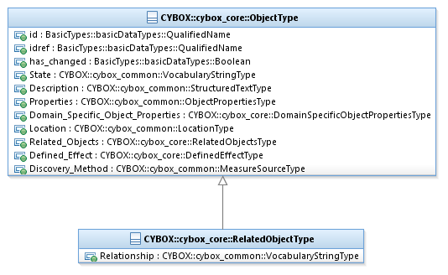

Figure 3‑5. UML diagram of the RelatedObjectType class

The property table given in **Table 3‑11** corresponds to the UML diagram shown in **Figure 3‑5**.

Table 3‑11. Properties of the RelatedObjectType class

|  |  |  |  |
| --- | --- | --- | --- |
| **Name** | **Type** | **Multiplicity** | **Description** |
| **Relationship** | cyboxCommon:  VocabularyStringType | 0..1 | The Relationship property specifies the type of relationship between two Objects. Examples of potential types include *created by, deleted by,* and *read from* (these specific values are only provided to help explain the property; they are neither recommended values nor necessarily part of any existing vocabulary). The content creator may choose any arbitrary value or may constrain the set of possible values by referencing an externally-defined vocabulary or leveraging a formally defined vocabulary extending from the cyboxCommon:ControlledVocabularyStringType data type. The CybOX default vocabulary class for use in the property is ‘*ObjectRelationshipVocab-1.1*’. |

### ObservableType Class

The ObservableType class characterizes a cyber Observable. As shown in **Figure 3‑6** and **Figure 3‑7**, a CybOX Observable can either be on a CybOX Object with type corresponding to the CybOX ObjectType class (e.g., a File with name X), a CybOX Event with type corresponding to the CybOX EventType class (an Event is typically one or more actions taken against one or more Objects; e.g., “delete the File with name X”), or an Observable Composition with type corresponding to the CybOX ObservableCompositionType class.

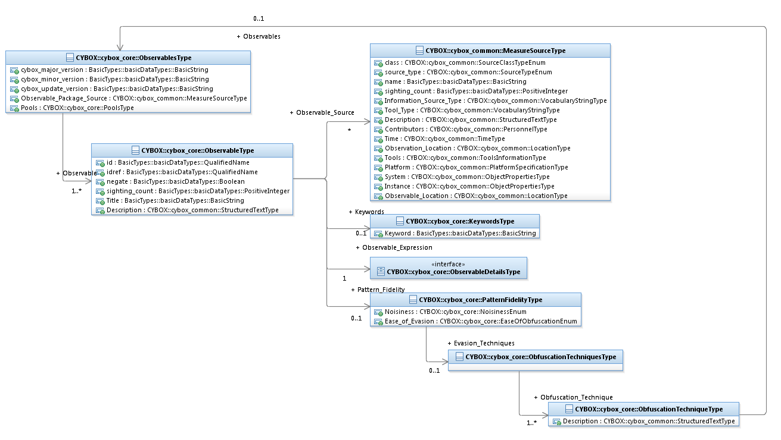

Figure 3‑6. UML diagram for the Observable class

The property table given in **Table 3‑12** corresponds to the UML diagram shown in **Figure 3‑6**.

Table 3‑12. Properties of the ObservableType class

|  |  |  |  |
| --- | --- | --- | --- |
| **Name** | **Type** | **Multiplicity** | **Description** |
| **id** | basicDataTypes:  QualifiedName | 0..1 | The id property specifies a globally unique identifier for the Observable. |
| **idref** | basicDataTypes:  QualifiedName | 0..1 | The idref property specifies a globally unique identifier for an Observable specified elsewhere. When the idref property is used, the id property MUST NOT also be specified and the other properties of the ObservableType class SHOULD NOT hold any content. |
| **negate** | basicDataTypes:Boolean | 0..1 | The negate property, when set to TRUE, specifies the absence (rather than the presence) of the Observable in a CybOX pattern. |
| **sighting_count** | basicDataTypes:  PositiveInteger | 0..1 | The sighting_count property specifies how many different (but identical) instances of the Observable have been observed. |
| **Title** | basicDataTypes:BasicString | 0..1 | The Title property captures a title for the Observable and reflects what the content producer thinks the Observable as a whole should be called. The Title property is typically used by humans to reference a particular Observable; however, it is not suggested for correlation. |
| **Description** | cyboxCommon:  StructuredTextType | 0..1 | The Description property captures a textual description of the Observable. Any length is permitted. Optional formatting is supported via the structuring_format property of the StructuredTextType data type. |
| **Keywords** | KeywordsType | 0..1 | The Keywords property captures relevant keywords for the Observable. |
| **Observable_Source** | cyboxCommon:  MeasureSourceType | 0..* | The Observable_Source property characterizes the source of the Observable information. Examples of details captured include identifying characteristics, time-related attributes, and a list of the tools used to collect the information. |
| **Observable_Expression** | ObservableDetailsType | 0..1 | The Observable_Expression property characterizes an Observable details expression. ObservableDetailsType is a UML interface, which can be realized using either the ObjectType class, the EventType class or the ObservableCompositionType class (see **Section 3.1.4.2** for more details). |
| **Pattern_Fidelity** | PatternFidelityType | 0..1 | The Pattern_Fidelity property characterizes the fidelity of the Observable pattern. |

#### ObservableDetailsType Interface

The ObservableDetailsType interface captures the ability to specify different types of details of an observable or a combination of them. An observable detail can either be an Object or Event or some combination of Objects and Events, specified using the ObservableCompositionType class.

The modeling of Observable Details is illustrated in the UML diagram in **Figure 3‑7**.

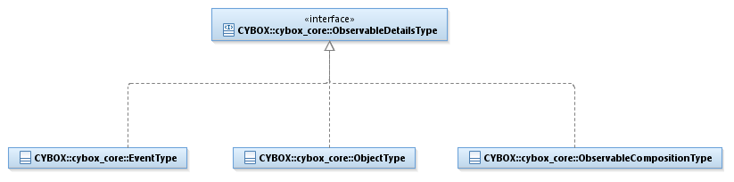

Figure 3‑7. Modelling observable details

#### ObservableCompositionType Class

The ObservableCompositionType class enables a content creator to define a composite Observable pattern expression through the specification of a single Boolean operator (the operator of the expression) and a list of simple (non-composition) Observable patterns (the operands of the expression).

More complex Observable compositions (of the ObservableCompositionType class) can be created using multiple simple Observable patterns and/or other Observable compositions. For example, it may be desired to express the Observable Composition, OCX = OA AND (EA OR EB). The Observable (OA) and each of the two Events (EA and EB) would be created individually, and then one Observable Composition would be defined as OCA = EA OR EB. This permits OCX to be rewritten as OCX = OA AND OCA. Note that this example shows just one or several possible constructions that generate OCX.

Table 3‑13. Properties of the ObservableCompositionType class

|  |  |  |  |
| --- | --- | --- | --- |
| **Name** | **Type** | **Multiplicity** | **Description** |
| **operator** | OperatorTypeEnum | 0..1 | The operator property specifies the logical operator of the Observable. |
| **Observable** | ObservableType | 0..* | The Observable property characterizes a cyber Observable. |

#### PatternFidelityType Class

The PatternFidelityType class characterizes the fidelity of an Observable pattern.

The property table of the PatternFidelityType class is given in **Table 3‑14**.

Table 3‑14. Properties of the PatternFidelityType class

|  |  |  |  |
| --- | --- | --- | --- |
| **Name** | **Type** | **Multiplicity** | **Description** |
| **Noisiness** | NoisinessEnum | 0..1 | The Noisiness property specifies the noisiness of the Observable (i.e., the false positives of the Observable). |
| **Ease_of_Evasion** | EaseOfObfuscationEnum | 0..1 | The Ease_of_Evasion property specifies the difficulty a threat actor may have obfuscating the Observable. |
| **Evasion_Techniques** | ObfuscationTechniquesType | 0..1 | The Evasion_Techniques property specifies a set of one or more potential techniques an attacker could leverage to obfuscate an Observable. |

#### ObfuscationTechniqueType Class

The ObfuscationTechniqueType class characterizes a technique an attacker could potentially leverage to obfuscate the observability of the Observable.

The property table of the ObfuscationTechniqueType class is given in **Table 3‑15**.

Table 3‑15. Properties of the ObfuscationTechniqueType class

|  |  |  |  |
| --- | --- | --- | --- |
| **Name** | **Type** | **Multiplicity** | **Description** |
| **Description** | cyboxCommon:  StructuredTextType | 1 | The Description property captures a textual description of the obfuscation technique. Any length is permitted. Optional formatting is supported via the structuring_format property of the StructuredTextType data type. |
| **Observables** | ObservablesType | 0..1 | The Observables property captures potential cyber Observables that could indicate the use of the obfuscation technique. |

### FrequencyType Class

The FrequencyType class characterizes the frequency of a given Action or Event.

The property table of the FrequencyType class is given in **Table 3‑16**.

Table 3‑16. Properties of the FrequencyType class

|  |  |  |  |
| --- | --- | --- | --- |
| **Name** | **Type** | **Multiplicity** | **Description** |
| **rate** | basicDataTypes:Decimal | 0..1 | The rate property specifies the rate of the frequency. |
| **units** | basicDataTypes:BasicString | 0..1 | The units property specifies the units of the frequency. |
| **scale** | basicDataTypes:BasicString | 0..1 | The scale property specifies the time scale of the frequency. |
| **trend** | TrendEnum | 0..1 | The trend property specifies the trend of the frequency. This property could be used as a trigger within an Event or Action pattern observable. |

## Content Aggregation Classes

A content aggregation class captures a collection of one or more CybOX objects.

### ActionAliasesType Class

The ActionAliasesType class specifies a set of one or more names of an Action.

The property table of the ActionAliasesType class is given in **Table 3‑17**.

Table 3‑17. Properties of the ActionAliasesType class

|  |  |  |  |
| --- | --- | --- | --- |
| **Name** | **Type** | **Multiplicity** | **Description** |
| **Action_Alias** | basicDataTypes:BasicString | 1..* | The Action_Alias property specifies an alias name for the Action. |

### ActionArgumentsType Class

The ActionArgumentsType class specifies a set of one or more arguments or parameters relevant to an Action.

The property table of the ActionArgumentsType class is given in **Table 3‑18**.

Table 3‑18. Properties of the ActionArgumentsType class

|  |  |  |  |
| --- | --- | --- | --- |
| **Name** | **Type** | **Multiplicity** | **Description** |
| **Action_Argument** | ActionArgumentType | 1..* | The Action_Argument property characterizes an argument or parameter relevant to the Action. |

### ActionPertinentObjectPropertiesType Class

The ActionPertinentObjectPropertiesType class specifies a set of one or more Object properties pertinent to an Action.

The property table of the ActionPertinentObjectPropertiesType class is given in **Table 3‑19**.

Table 3‑19. Properties of the ActionPertinentObjectPropertiesType class

|  |  |  |  |
| --- | --- | --- | --- |
| **Name** | **Type** | **Multiplicity** | **Description** |
| **Property** | ActionPertinentObjectPropertyType | 1..* | The Property property characterizes an Object property pertinent to the Action. |

### ActionRelationshipsType Class

The ActionRelationshipsType specifies a set of one or more relationships between one Action and other Actions.

The property table of the ActionRelationshipsType class is given in **Table 3‑20**.

Table 3‑20. Properties of the ActionRelationshipsType class

|  |  |  |  |
| --- | --- | --- | --- |
| **Name** | **Type** | **Multiplicity** | **Description** |
| **Relationship** | ActionRelationshipType | 1..* | The Relationship property characterizes a relationship between the Action and another, related Action. |

### ActionsType Class

The ActionsType class specifies a set of one or more cyber observable Actions.

The properties of the ActionsType class are given in **Table 3‑21**.

Table 3‑21. Properties of the ActionsType class

|  |  |  |  |
| --- | --- | --- | --- |
| **Name** | **Type** | **Multiplicity** | **Description** |
| **Action** | ActionType | 1..* | The Action property characterizes a cyber observable Action. |

### AssociatedObjectsType Class

The AssociatedObjectsType class specifies a set of one or more cyber Objects relevant to an Action.

The properties of the AssociatedObjectsType class are given in **Table 3‑22**.

Table 3‑22. Properties of the AssociatedObjectsType class

|  |  |  |  |
| --- | --- | --- | --- |
| **Name** | **Type** | **Multiplicity** | **Description** |
| **Associated_Object** | AssociatedObjectType | 1..* | The Associated_Object property characterizes a cyber Object associated with the Action. An associated Object may be an Object that initiated the Action, an Object that is affected by or utilized by the Action, or an Object that is returned as a result of the Action. |

### KeywordsType Class

The KeywordsType class specifies a set of one or more keywords.

The properties of the KeywordsType class are given in **Table 3‑23**.

Table 3‑23. Properties of the KeywordsType class

|  |  |  |  |
| --- | --- | --- | --- |
| **Name** | **Type** | **Multiplicity** | **Description** |
| **Keyword** | basicDataTypes:BasicString | 1..* | The Keyword property captures a keyword. |

### ObfuscationTechniquesType Class

The ObfuscationTechniquesType class specifies a set of one or more potential techniques an attacker could leverage to obfuscate an Observable.

The properties of the ObfuscationTechniquesType class are given in **Table 3‑24**.

Table 3‑24. Properties of the ObfuscationTechniquesType class

|  |  |  |  |
| --- | --- | --- | --- |
| **Name** | **Type** | **Multiplicity** | **Description** |
| **Obfuscation_Technique** | ObfuscationTechniqueType | 1..* | The Obfuscation_Technique property characterizes a technique an attacker could potentially leverage to obfuscate the Observable. |

### ObservablesType Class

The ObservablesType class characterizes a set of one or more cyber Observables.

The properties of the ObservablesType class are given in **Table 3‑25**.

Table 3‑25. Properties of the ObservablesType class

|  |  |  |  |
| --- | --- | --- | --- |
| **Name** | **Type** | **Multiplicity** | **Description** |
| **cybox_major_version** | basicDataTypes:  BasicString | 0..1 | The cybox_major_version property specifies the major version of the CybOX language used for the set of Observables. |
| **cybox_minor_version** | basicDataTypes:  BasicString | 0..1 | The cybox_minor_version property specifies the minor version of the CybOX language used for the set of Observables. |
| **cybox_update_version** | basicDataTypes:  BasicString | 0..1 | The cybox_update_version property specifies the update version of the CybOX language used for this set of Observables. This property MUST be used when using an update version of CybOX. |
| **Observable_Package_Source** | cyboxCommon:  MeasureSourceType | 0..1 | The Observable_Package_Source property characterizes the source of the Observables information. Examples of details captured include identifying characteristics, time-related attributes, and a list of the tools used to collect the information. |
| **Observable** | ObservableType | 1..* | The Observable property characterizes a cyber Observable. |
| **Pools** | PoolsType | 0..1 | The Pools property captures the Events, Actions, Objects and Properties (in a space-efficient, pooled manner) that are referenced by the cyber Observable. |

### PropertiesType Class

The PropertiesType class specifies a set of one or more properties enumerated as a result of the effect of the Action on the Object.

The properties of the PropertiesType class are given in **Table 3‑26**.

Table 3‑26. Properties of the PropertiesType class

|  |  |  |  |
| --- | --- | --- | --- |
| **Name** | **Type** | **Multiplicity** | **Description** |
| **Property** | basicDataTypes:  BasicString | 1..* | The Property property specifies a property resulting from an Action on an Object. |

### RelatedObjectsType Class

The RelatedObjectsType class specifies a set of one or more relationships between one Object and other Objects.

The properties of the RelatedObjectsType class are given in **Table 3‑27**.

Table 3‑27. Properties of the RelatedObjectsType class

|  |  |  |  |
| --- | --- | --- | --- |
| **Name** | **Type** | **Multiplicity** | **Description** |
| **Related_Object** | RelatedObjectType | 1..* | The Related_Object property specifies an Object related to the Object of focus and characterizes the relationship between the Objects. |

### ValuesType Class

The ValuesType class specifies a set of one or more values that are enumerated as a result of an Action on an Object.

The properties of the ValuesType class are given in **Table 3‑28**.

Table 3‑28. Properties of the ValuesType class

|  |  |  |  |
| --- | --- | --- | --- |
| **Name** | **Type** | **Multiplicity** | **Description** |
| **Value** | basicDataTypes:BasicString | 1..* | The Value property specifies a single value that is enumerated as a result of the Action on the Object. |

## Pool Classes

Pool classes enable observable elements – Events, Actions, Objects, and Properties – to be described in a space-efficient manner. Rather than defining identical observable elements multiple times within a set of defined Observables, observable elements are defined in type-specific pools (i.e., sets) and are then referenced by Observable structures.

### PoolsType Class

The PoolsType class captures one or more pools, each of which contains one type of observable element.

The UML diagram corresponding to the PoolsType class is shown in **Figure 3‑8**.

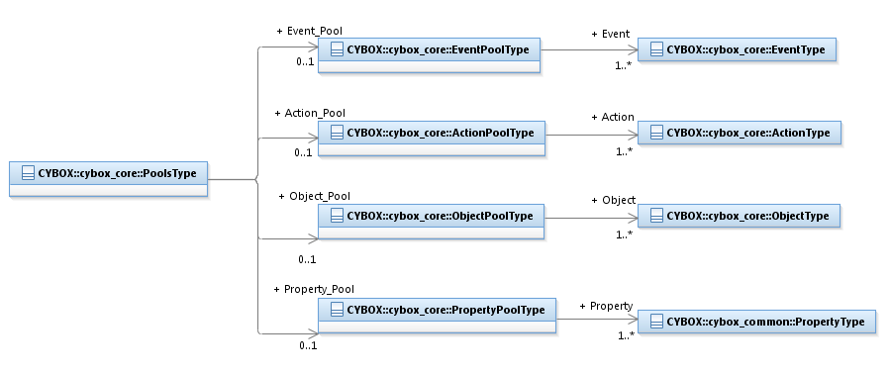

Figure 3‑8. UML diagram of the PoolsType class

The property table given in **Table 3‑29** corresponds to the UML diagram shown in **Figure 3‑8**.

Table 3‑29. Properties of the PoolsType class

|  |  |  |  |
| --- | --- | --- | --- |
| **Name** | **Type** | **Multiplicity** | **Description** |
| **Event_Pool** | EventPoolType | 0..1 | The Event_Pool property specifies a pool of one or more Events. |
| **Action_Pool** | ActionPoolType | 0..1 | The Action_Pool property specifies a pool of one or more Actions. |
| **Object_Pool** | ObjectPoolType | 0..1 | The Object_Pool property specifies a pool of one or more Objects. |
| **Property_Pool** | PropertyPoolType | 0..1 | The Property_Pool property specifies a pool of one or more Properties. |

### EventPoolType Class

The EventPoolType class specifies a pool of one or more Events.

The properties of the EventPoolType class are given in **Table 3‑30**.

Table 3‑30. Properties of the EventPoolType class

|  |  |  |  |
| --- | --- | --- | --- |
| **Name** | **Type** | **Multiplicity** | **Description** |
| **Event** | EventType | 1..* | The Event property characterizes a cyber observable Event. |

### ActionPoolType Class

The ActionPoolType class specifies a pool of one or more Actions.

The properties of the ActionPoolType class are given in **Table 3‑31.**

Table 3‑31. Properties of the ActionPoolType class

|  |  |  |  |
| --- | --- | --- | --- |
| **Name** | **Type** | **Multiplicity** | **Description** |
| **Action** | ActionType | 1..* | The Action property characterizes a cyber observable Action. |

### ObjectPoolType Class

The ObjectPoolType class specifies a pool of one or more Objects.

The properties of the ObjectPoolType class are given in **Table 3‑32**.

Table 3‑32. Properties of the ObjectPoolType class

|  |  |  |  |
| --- | --- | --- | --- |
| **Name** | **Type** | **Multiplicity** | **Description** |
| **Object** | ObjectType | 1..* | The Object property characterizes a cyber-relevant Object. |

### PropertyPoolType Class

The PropertyPoolType class specifies a pool of one or more Properties.

The properties of the PropertyPoolType class are given in **Table 3‑33**.

Table 3‑33. Properties of the PropertyPoolType class

|  |  |  |  |
| --- | --- | --- | --- |
| **Name** | **Type** | **Multiplicity** | **Description** |
| **Property** | cyboxCommon:PropertyType | 1..* | The Property property characterizes an Object property. |

## Defined Effect Classes

The CybOX Core data model defines a number of classes to characterize a broad range of potential effects of an Action on an Object. Characterization is achieved through specialization of the DefinedEffectType abstract class, which is defined in Section **3.4.1**. The defined effect-type classes that specialize the DefinedEffectType class are presented in Sections **3.4.2** through **3.4.10**, which corresponds to the order that they are listed in the EffectTypeEnum enumeration (Section **3.5.4**).

### DefinedEffectType Class

The DefinedEffectType class specifies the type of the effect that an Action has on an Object. It is an abstract class, and it MUST be extended via a subclass to specify a complete effect. Use of the DefinedEffectType class enables a broad range of complex Action effects on Objects to be specified.

A UML diagram corresponding to the DefinedEffectType class is shown in **Figure 3‑9**.

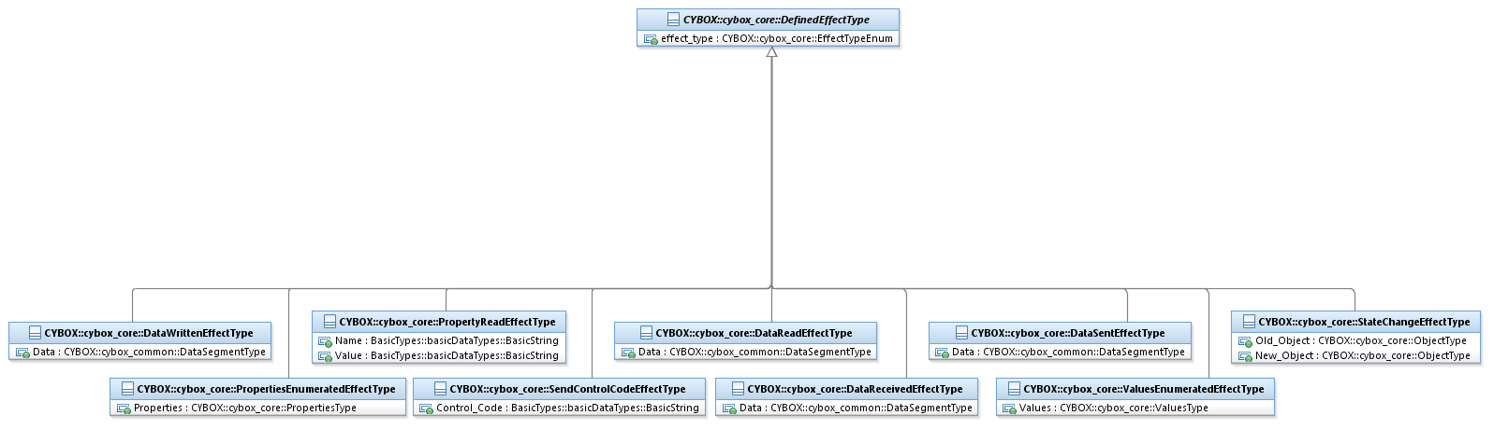

Figure 3‑9. UML diagram of the DefinedEffectType class

The property table given in **Table 3‑34** corresponds to the UML diagram shown in **Figure 3‑9**.

Table 3‑34. Properties of the DefinedEffectType class

|  |  |  |  |
| --- | --- | --- | --- |
| **Name** | **Type** | **Multiplicity** | **Description** |
| **effect_type** | EffectTypeEnum | 0..1 | The effect_type property specifies the effect of the Action on the Object. |

### StateChangeEffectType Class

The StateChangeEffectType class extends the DefinedEffectType superclass by characterizing the effects of Actions upon Objects where the state of the Object is changed.

The properties of the StateChangeEffectType specialization are given in **Table 3‑35**.

Table 3‑35. Properties of the StateChangeEffectType class

|  |  |  |  |
| --- | --- | --- | --- |
| **Name** | **Type** | **Multiplicity** | **Description** |
| **Old_Object** | ObjectType | 0..1 | The Old_Object property characterizes the Object before the state change effect occurred. |
| **New_Object** | ObjectType | 1 | The New_Object property characterizes the Object after the state change effect occurred. |

### DataReadEffectType Class

The DataReadEffectType class extends the DefinedEffectType superclass by characterizing the effects of Actions upon Objects where some data is read, such as from a file or a pipe.

The properties of the DataReadEffectType specialization are given in **Table 3‑36**.

Table 3‑36. Properties of the DataReadEffectType class

|  |  |  |  |
| --- | --- | --- | --- |
| **Name** | **Type** | **Multiplicity** | **Description** |
| **Data** | cyboxCommon:DataSegmentType | 1 | The Data property characterizes the data that was read from the Object by the Action. |

### DataWrittenEffectType Class

The DataWrittenEffectType class extends the DefinedEffectType superclass by characterizing the effects of Actions upon Objects where some data is written, such as to a file or a pipe.

The properties of the DataWrittenEffectType specialization are given in **Table 3‑37**.

Table 3‑37. Properties of the DataWrittenEffectType class

|  |  |  |  |
| --- | --- | --- | --- |
| **Name** | **Type** | **Multiplicity** | **Description** |
| **Data** | cyboxCommon:DataSegmentType | 1 | The Data property characterizes the data that was written to the Object by the Action. |

### DataSentEffectType Class

The DataSentEffectType class extends the DefinedEffectType superclass by characterizing the effects of Actions upon Objects where some data is sent, such as a byte sequence on a socket.

The properties of the DataSentEffectType specialization are given in **Table 3‑38**.

Table 3‑38. Properties of the DataSentEffectType class

|  |  |  |  |
| --- | --- | --- | --- |
| **Name** | **Type** | **Multiplicity** | **Description** |
| **Data** | cyboxCommon:DataSegmentType | 1 | The Data property characterizes the data that was sent on the Object, or from the Object, by the Action. |

### DataReceivedEffectType Class

The DataReceivedEffectType class extends the DefinedEffectType superclass by characterizing the effects of Actions upon Objects where some data is received, such as a byte sequence on a socket.

The properties of the DataReceivedEffectType specialization are given in **Table 3‑39**.

Table 3‑39. Properties of the DataReceivedEffectType class

|  |  |  |  |
| --- | --- | --- | --- |
| **Name** | **Type** | **Multiplicity** | **Description** |
| **Data** | cyboxCommon:DataSegmentType | 1 | The Data property characterizes the data that was received on the Object, or from the Object, by the Action. |

### PropertyReadEffectType Class

The PropertyReadEffectType class extends the DefinedEffectType superclass by characterizing the effects of Actions upon Objects where some specific property is read from an Object, such as the current running state of a process.

The properties of the PropertyReadEffectType specialization are given in **Table 3‑40**.

Table 3‑40. Properties of the PropertyReadEffectType class

|  |  |  |  |
| --- | --- | --- | --- |
| **Name** | **Type** | **Multiplicity** | **Description** |
| **Name** | basicDataTypes:BasicString | 0..1 | The Name property specifies the name of the property being read. |
| **Value** | basicDataTypes:BasicString | 0..1 | The Value property specifies the value of the property being read. |

### PropertiesEnumeratedEffectType Class

The PropertiesEnumeratedEffectType class extends the DefinedEffectType superclass by characterizing the effects of Actions upon Objects where some properties of the Object are enumerated, such as the startup parameters for a process.

The properties of the PropertiesEnumeratedEffectType specialization are given in **Table 3‑41**.

Table 3‑41. Properties of the PropertiesEnumeratedEffectType class

|  |  |  |  |
| --- | --- | --- | --- |
| **Name** | **Type** | **Multiplicity** | **Description** |
| **Properties** | PropertiesType | 1 | The Properties property specifies a set of one or more values that are enumerated as a result of an Action on an Object. |

### ValuesEnumeratedEffectType Class

The ValuesEnumeratedEffectType class extends the DefinedEffectType superclass by characterizing the effects of Actions upon Objects where some values of the Object are enumerated, such as the values of a registry key.

The properties of the ValuesEnumeratedEffectType specialization are given in **Table 3‑42**.

Table 3‑42. Properties of the ValuesEnumeratedEffectType class

|  |  |  |  |
| --- | --- | --- | --- |
| **Name** | **Type** | **Multiplicity** | **Description** |
| **Values** | ValuesType | 1 | The Values property specifies a set of one or more values that are enumerated as a result of an Action on an Object. |

### SendControlCodeEffectType Class

The SendControlCodeEffectType class extends the DefinedEffectType superclass by characterizing the effects of Actions upon Objects where some control code, or other control-oriented communication signal, is sent to the Object.

The properties of the SendControlCodeEffectType specialization are given in **Table 3‑43**.

Table 3‑43. Properties of the SendControlCodeEffectType class

|  |  |  |  |
| --- | --- | --- | --- |
| **Name** | **Type** | **Multiplicity** | **Description** |
| **Control_Code** | basicDataTypes:BasicString | 1 | The Control_Code property specifies the actual control code sent to the Object. |

## Enumerations

### ActionStatusTypeEnum Enumeration

The ActionStatusTypeEnum enumeration is an inventory of Action statuses. The enumeration literals are given in **Table 3‑44**.

Table 3‑44. Literals of the ActionStatusTypeEnum enumeration

|  |  |
| --- | --- |
| **Enumeration Literal** | **Description** |
| **Success** | The cyber observable Action was successful. |
| **Fail** | The cyber observable Action failed. |
| **Error** | The cyber observable Action resulted in an error. |
| **Complete/Finish** | The cyber observable Action completed or finished. This action status does not specify the result of the Action (e.g., Success, Error). |
| **Pending** | The cyber observable Action is pending. |
| **Ongoing** | The cyber observable Action is ongoing. |
| **Unknown** | The cyber observable Action has unknown status. |

### ActionContextTypeEnum Enumeration

The ActionContextTypeEnum enumeration is an inventory of Action contexts. The enumeration literals are given in **Table 3‑45**.

Table 3‑45. Literals of the ActionContextTypeEnum enumeration

|  |  |
| --- | --- |
| **Enumeration Literal** | **Description** |
| **Host** | The cyber observable Action occurred on a host. |
| **Network** | The cyber observable Action occurred on a network. |

### EaseOfObfuscationEnum Enumeration

The EaseOfObfuscationEnum enumeration is an inventory of values representing the difficulty a threat actor may have obfuscating an Observable. The enumeration literals are given in **Table 3‑46**.

Table 3‑46. Literals of the EaseOfObfuscationEnum enumeration

|  |  |
| --- | --- |
| **Enumeration Literal** | **Description** |
| **High** | The Observable is very easy to obfuscate and hide. |
| **Medium** | The Observable is somewhat easy to obfuscate and hide. |
| **Low** | The Observable is not very easy to obfuscate and hide. |

### EffectTypeEnum Enumeration

The EffectTypeEnum enumeration is an inventory of values representing the effect of an Action on an Object. The enumeration literals are given in **Table 3‑47**.

Table 3‑47. Literals of the EffectTypeEnum enumeration

|  |  |
| --- | --- |
| **Enumeration Literal** | **Description** |
| **State_Changed** | The Action changed the state of the Object. |
| **Data_Read** | The Action read data from the Object. |
| **Data_Written** | The Action wrote data to the Object. |
| **Data_Sent** | The Action sent data to the Object. |
| **Data_Received** | The Action received data from the Object. |
| **Properties_Read** | The Action read properties of the Object. |
| **Properties_Enumerated** | The Action enumerated properties of the Object. |
| **Values_Enumerated** | The Action enumerated values of the Object. |
| **ControlCode_Sent** | The Action sent control code to the Object. |

### NoisinessEnum Enumeration

The NoisinessEnum enumeration is an inventory of values for representing the noisiness of the Observable (i.e., false positives of the Observable). The enumeration literals are given in **Table 3‑48**.

Table 3‑48. Literals of the NoisinessEnum enumeration

|  |  |
| --- | --- |
| **Enumeration Literal** | **Description** |
| **High** | The Observable has a high level of noisiness (i.e., a potentially high level of false positives). |
| **Medium** | The Observable has a medium level of noisiness (i.e., a potentially medium level of false positives). |
| **Low** | The Observable has a low level of noisiness (i.e., a potentially low level of false positives). |

### OperatorTypeEnum Enumeration

The OperatorTypeEnum enumeration is an inventory of valid operator types. The enumeration literals are given in **Table 3‑49**.

Table 3‑49. Literals of the OperatorTypeEnum enumeration

|  |  |
| --- | --- |
| **Enumeration Literal** | **Description** |
| **AND** | Logical AND operator |
| **OR** | Logical OR operator |

### TrendEnum Enumeration

The TrendEnum enumeration is an inventory of valid trend types. The enumeration literals are given in **Table 3‑50**.

Table 3‑50. Literals of the TrendEnum enumeration

|  |  |
| --- | --- |
| **Enumeration Literal** | **Description** |
| **Increasing** | The trend is increasing. |
| **Decreasing** | The trend is decreasing. |

# Conformance

Implementations have discretion over which parts (components, properties, extensions, controlled vocabularies, etc.) of CybOX they implement (e.g., Observable/Object).

[1] Conformant implementations must conform to all normative structural specifications of the UML model or additional normative statements within this document that apply to the portions of CybOX they implement (e.g., implementers of the entire Observable class must conform to all normative structural specifications of the UML model regarding the Observable class or additional normative statements contained in the document that describes the Observable class).

[2] Conformant implementations are free to ignore normative structural specifications of the UML model or additional normative statements within this document that do not apply to the portions of CybOX they implement (e.g., non-implementers of any particular properties of the Observable class are free to ignore all normative structural specifications of the UML model regarding those properties of the Observable class or additional normative statements contained in the document that describes the Observable class).

The conformance section of this document is intentionally broad and attempts to reiterate what already exists in this document.

1. Acknowledgements

The following individuals have participated in the creation of this specification and are gratefully acknowledged:

|  |  |
| --- | --- |
| **Aetna**  David Crawford  **AIT Austrian Institute of Technology**  Roman Fiedler  Florian Skopik  **Australia and New Zealand Banking Group (ANZ Bank)**  Dean Thompson  **Blue Coat Systems, Inc.**  Owen Johnson  Bret Jordan  **Century Link**  Cory Kennedy  **CIRCL**  Alexandre Dulaunoy  Andras Iklody  Raphaël Vinot  **Citrix Systems**  Joey Peloquin  **Dell**  Will Urbanski  Jeff Williams  **DTCC**  Dan Brown  Gordon Hundley  Chris Koutras  **EMC**  Robert Griffin  Jeff Odom  Ravi Sharda  **Financial Services Information Sharing and Analysis Center (FS-ISAC)**  David Eilken  Chris Ricard  **Fortinet Inc.**  Gavin Chow  Kenichi Terashita  **Fujitsu Limited**  Neil Edwards  Frederick Hirsch  Ryusuke Masuoka  Daisuke Murabayashi  **Google Inc.**  Mark Risher  **Hitachi, Ltd.**  Kazuo Noguchi  Akihito Sawada  Masato Terada  **iboss, Inc**.  Paul Martini  **Individual**  Jerome Athias  Peter Brown  Elysa Jones  Sanjiv Kalkar  Bar Lockwood  Terry MacDonald  Alex Pinto  **Intel Corporation**  Tim Casey  Kent Landfield  **JPMorgan Chase Bank, N.A.**  Terrence Driscoll  David Laurance  **LookingGlass**  Allan Thomson  Lee Vorthman  **Mitre Corporation**  Greg Back  Jonathan Baker  Sean Barnum  Desiree Beck  Nicole Gong  Jasen Jacobsen  Ivan Kirillov  Richard Piazza  Jon Salwen  Charles Schmidt  Emmanuelle Vargas-Gonzalez  John Wunder  **National Council of ISACs (NCI)**  Scott Algeier  Denise Anderson  Josh Poster  **NEC Corporation**  Takahiro Kakumaru  **North American Energy Standards Board**  David Darnell  **Object Management Group**  Cory Casanave  **Palo Alto Networks**  Vishaal Hariprasad  **Queralt, Inc**.  John Tolbert  **Resilient Systems, Inc.**  Ted Julian  **Securonix**  Igor Baikalov  **Siemens AG**  Bernd Grobauer  **Soltra**  John Anderson  Aishwarya Asok Kumar  Peter Ayasse  Jeff Beekman  Michael Butt  Cynthia Camacho  Aharon Chernin  Mark Clancy  Brady Cotton  Trey Darley  Mark Davidson  Paul Dion  Daniel Dye  Robert Hutto  Raymond Keckler  Ali Khan  Chris Kiehl  Clayton Long  Michael Pepin  Natalie Suarez  David Waters  Benjamin Yates  **Symantec Corp.**  Curtis Kostrosky  **The Boeing Company**  Crystal Hayes  **ThreatQuotient, Inc.**  Ryan Trost  **U.S. Bank**  Mark Angel  Brad Butts  Brian Fay  Mona Magathan  Yevgen Sautin  **US Department of Defense (DoD)**  James Bohling  Eoghan Casey  Gary Katz  Jeffrey Mates  **VeriSign**  Robert Coderre  Kyle Maxwell  Eric Osterweil | **Airbus Group SAS**  Joerg Eschweiler  Marcos Orallo  **Anomali**  Ryan Clough  Wei Huang  Hugh Njemanze  Katie Pelusi  Aaron Shelmire  Jason Trost  **Bank of America**  Alexander Foley  **Center for Internet Security (CIS)**  Sarah Kelley  **Check Point Software Technologies**  Ron Davidson  **Cisco Systems**  Syam Appala  Ted Bedwell  David McGrew  Pavan Reddy  Omar Santos  Jyoti Verma  **Cyber Threat Intelligence Network, Inc. (CTIN)**  Doug DePeppe  Jane Ginn  Ben Othman  **DHS Office of Cybersecurity and Communications (CS&C)**  Richard Struse  Marlon Taylor  **EclecticIQ**  Marko Dragoljevic  Joep Gommers  Sergey Polzunov  Rutger Prins  Andrei Sîrghi  Raymon van der Velde  **eSentire, Inc.**  Jacob Gajek  **FireEye, Inc.**  Phillip Boles  Pavan Gorakav  Anuj Kumar  Shyamal Pandya  Paul Patrick  Scott Shreve  **Fox-IT**  Sarah Brown  **Georgetown University**  Eric Burger  **Hewlett Packard Enterprise (HPE)**  Tomas Sander  **IBM**  Peter Allor  Eldan Ben-Haim  Sandra Hernandez  Jason Keirstead  John Morris  Laura Rusu  Ron Williams  **IID**  Chris Richardson  **Integrated Networking Technologies, Inc.**  Patrick Maroney  **Johns Hopkins University Applied Physics Laboratory**  Karin Marr  Julie Modlin  Mark Moss  Pamela Smith  **Kaiser Permanente**  Russell Culpepper  Beth Pumo  **Lumeta Corporation**  Brandon Hoffman  **MTG Management Consultants, LLC.**  James Cabral  **National Security Agency**  Mike Boyle  Jessica Fitzgerald-McKay  **New Context Services, Inc.**  John-Mark Gurney  Christian Hunt  James Moler  Daniel Riedel  Andrew Storms  **OASIS**  James Bryce Clark  Robin Cover  Chet Ensign  **Open Identity Exchange**  Don Thibeau  **PhishMe Inc.**  Josh Larkins  **Raytheon Company-SAS**  Daniel Wyschogrod  **Retail Cyber Intelligence Sharing Center (R-CISC)**  Brian Engle  **Semper Fortis Solutions**  Joseph Brand  **Splunk Inc.**  Cedric LeRoux  Brian Luger  Kathy Wang  **TELUS**  Greg Reaume  Alan Steer  **Threat Intelligence Pty Ltd**  Tyron Miller  Andrew van der Stock  **ThreatConnect, Inc.**  Wade Baker  Cole Iliff  Andrew Pendergast  Ben Schmoker  Jason Spies  **TruSTAR Technology**  Chris Roblee  **United Kingdom Cabinet Office**  Iain Brown  Adam Cooper  Mike McLellan  Chris O’Brien  James Penman  Howard Staple  Chris Taylor  Laurie Thomson  Alastair Treharne  Julian White  Bethany Yates  **US Department of Homeland Security**  Evette Maynard-Noel  Justin Stekervetz  **ViaSat, Inc.**  Lee Chieffalo  Wilson Figueroa  Andrew May  **Yaana Technologies, LLC**  Anthony Rutkowski |

The authors would also like to thank the larger CybOX Community for its input and help in reviewing this document.

1. Revision History

|  |  |  |  |
| --- | --- | --- | --- |
| **Revision** | **Date** | **Editor** | **Changes Made** |
| wd01 | 15 December 2015 | Desiree Beck Trey Darley Ivan Kirillov Rich Piazza | Initial transfer to OASIS template |

1. The property name xpath is a remnant from the STIX 1.2 XML schema.