BUSINESS STRATEGY & INVESTMENT REPORT
The Social Bar Venture
Licensed On-Premise Liquor Bar — Uttarakhand & Delhi NCR (Noida)
Prepared by: AI Co-Founder / Growth Strategy Advisory
Source: Day 23 Customer & MVP Blueprint (29 July 2026)
Confidential — Founder Use Only
VERDICT: ● VALIDATE

Table of Contents
1. Blueprint Summary
2. Business Reality Check
3. Business Strategy Report
3.1 Executive Summary
3.2 Business Model Canvas
3.3 Revenue & Pricing Strategy
3.4 Go-To-Market Strategy
3.5 Customer Acquisition Strategy
3.6 First 100 Users Plan
3.7 Competitive Position & Moat
3.8 Reverse SWOT Analysis
3.9 Investor One-Liner
3.10 30-Second Founder Pitch
3.11 Founder Action Sheet — Top 10 Actions
4. Investment Scorecard (0-100)
5. Visual Dashboard
6. Sustainability Verdict

1. Blueprint Summary
The Social Bar Venture — a licensed on-premise liquor bar targeting the Noida/Delhi NCR corridor and Uttarakhand's tourism belt — is summarized below from the Day 23 Customer & MVP Blueprint.

Startup Summary (5-10 bullets)
- Concept: licensed on-premise liquor bar targeting adults 23-38 in two structurally different markets — high-income Noida/NCR and Uttarakhand tourism towns.
- Category: India's on-trade alcohol market is large and durable — not a technology-disruption / PMF risk category.
- Core gap identified: not demand for alcohol (already served by 8-10 competitors per street), but a lack of a differentiated reason to choose this venue.
- Founder-side risk is high: no license secured, no disclosed capital position, no defined customer problem, and only side-project time against a business needing daily on-site presence.
- ICP: 23-38 year-olds, middle to upper-middle income, willing to spend Rs.800-2,000/visit on food + drinks in a good-ambience venue.
- Top customer pain points span quality/consistency, overcrowding, safety, brand trust, pricing transparency, and license legitimacy concerns.
- MVP recommendation: do not build a full bar — test one differentiated concept via a low-capital guest-night/pop-up before any lease or license spend.
- Current scores: Customer Clarity 35/100, Problem Severity 55/100, PMF Potential 45/100, MVP Readiness 20/100.
- Verdict in source blueprint: Promising but Unvalidated — Conditional Go pending a 30-day validation plan.

Extracted Assumptions
Category | Assumption Extracted from Blueprint
Customer | 23-38 year-olds in NCR (15-20 min of venue) or Uttarakhand tourists; spend Rs.800-2,000/visit; discover venues via Instagram/Zomato/word-of-mouth.
MVP | A named, differentiated concept angle (craft/premium spirits, beer/wine-casual, or theme-led) tested via guest-night/pop-up inside an already-licensed venue — not a full license/lease.
Value Proposition | Consistent quality, transparent pricing, safety/hygiene, and a specific concept reason to choose this venue over 8-10 nearby competitors (currently unvalidated).
Pricing | Base ticket Rs.800-2,000/visit; premium concept anchors high end, beer/wine-casual anchors low end for volume. Needs Week-2 price-sensitivity testing.
Revenue | Single stream assumed: per-visit food + drink spend. No loyalty, events, or delivery/e-commerce revenue modeled at MVP stage (explicitly excluded).
GTM | Awareness via social/Zomato → Consideration via reviews/pricing → Purchase via event/offer trigger → Retention via consistency. Weakest link: Purchase→Retention.

2. Business Reality Check

Who pays?
Individual consumers and small friend groups aged 23-38 in the Noida/NCR catchment (15-20 min radius) and tourists passing through targeted Uttarakhand towns. There is no B2B, subscription, or platform payer in this model — 100% of revenue is per-visit consumer spend.

Why do they pay?
Today, they pay competitors because the category itself is desirable (social drinking occasions, celebrations, live sport, dates). They do not yet have a reason to specifically pay this venue — the blueprint itself states no differentiated concept has been validated. This is the single largest open question in the business.

How will they discover the product?
Primarily Instagram and Zomato discovery, word-of-mouth, and local visibility — consistent with how the persona (“Aarav, 27”) already finds venues. No paid acquisition channel, influencer strategy, or launch distribution plan exists yet in the source material.

Biggest growth risks
- Undifferentiated positioning: “a bar” is not defensible among 8-10 existing competitors on the same street.
- No proven acquisition motion beyond generic social discovery — no CAC, conversion, or channel-mix data.
- Retention is structurally the leakiest stage (Purchase→Retention) and has no stated mechanism (loyalty, CRM, regulars program) at MVP stage.

Biggest monetization risks
- Single revenue stream (per-visit spend) with high fixed costs (lease, license, staff, inventory, excise) typical of the category.
- Pricing hypothesis (Rs.800-2,000) is not yet tested for price sensitivity against the chosen concept.
- Licensing cost/timeline is unconfirmed (Rs.15L-1Cr+ all-in), so unit economics cannot yet be modeled with confidence.

Weakest assumptions to validate first
# | Assumption | Why It's Risky | How to Validate
1 | A specific concept will pull a defined segment | No concept has been named or tested; “a bar” alone is not a value proposition | 15-20 ICP interviews + Instagram/WhatsApp concept poll (300+ responses)
2 | Rs.800-2,000 ticket size holds for the chosen concept | Range is category-wide, not concept-specific | Price-sensitivity questions embedded in the Week 2 concept poll
3 | Capital and license cost are affordable | Capital position is currently undisclosed; license cost is Rs.15L-1Cr+ | Paid excise consultant quote + honest capital mapping (Week 3)
4 | Side-project time budget is sufficient | Bars require daily on-site presence; absentee ownership raises legal/operational risk | Explicit founder decision: full-time/partner vs. side project (Week 4 gate)

3. Business Strategy Report

3.1 Executive Summary
The Social Bar Venture sits in a large, durable category (India's on-trade alcohol market) but has not yet validated the one thing that determines survival in a saturated local market: a specific, differentiated reason for a customer to choose this venue over 8-10 nearby alternatives. Founder-side execution risk is currently higher than market risk — no license, no disclosed capital, and a side-project time budget against a business that requires daily on-site presence. The recommended path is a 30-day, low-capital validation sprint (concept interviews, a public concept/price poll, and a real excise-license quote) before any lease, license application, or capital commitment. This is a Validate, not an Invest or Reject, decision at this stage.

3.2 Business Model Canvas
Block | Content
Key Partners | Excise license consultant; an already-licensed host venue for the guest-night/pop-up MVP; potential daily-present co-founder/partner; F&B and beverage suppliers.
Key Activities | Concept definition and testing; customer interviews and polling; license application and compliance; venue operations once launched.
Key Resources | Founder time/capital; eventual liquor license; physical venue and lease; brand and concept identity.
Value Proposition | A specific, trustworthy, differentiated night-out concept (not yet named) with consistent quality, transparent pricing, and safety — addressing the top pain points of unbranded and undifferentiated competitors.
Customer Relationships | Discovery-led, review-driven trust; regulars/loyalty relationship once repeat visits begin; social-media-native brand voice.
Channels | Instagram, Zomato, word-of-mouth, on-ground visibility, live-event promotion (sport, DJ, live music).
Customer Segments | 23-38 year-old working professionals and young couples in Noida/NCR (15-20 min radius); leisure tourists in target Uttarakhand towns.
Cost Structure | Liquor license (Rs.15L-1Cr+ all-in), lease/premises, inventory, staff, marketing, and compliance/excise costs.
Revenue Streams | Per-visit food + drink spend (Rs.800-2,000); no other stream currently modeled.

3.3 Revenue & Pricing Strategy
The blueprint's pricing hypothesis anchors on category norms (Rs.800-2,000/visit) rather than concept-specific willingness to pay. This is a reasonable starting range but should not be finalized until Week 2 price-sensitivity testing is complete.
- Craft/premium-spirits concept: price toward the upper end (Rs.1,500-2,000) to capture the premiumization trend among the target ICP.
- Beer/wine-casual concept: price toward the lower end (Rs.800-1,200) to build volume and offset a lighter license cost.
- Single revenue stream today (per-visit spend); consider testing incremental streams post-validation — ticketed live-event nights, prepaid regulars cards, or combo/happy-hour bundles — without adding delivery/e-commerce, which the blueprint explicitly excludes.
- Do not finalize pricing before the Week 2 concept/price poll and Week 3 real excise-cost quote are both in hand — unit economics depend on both.

3.4 Go-To-Market Strategy
The GTM motion is discovery-led and social-native, matching how the target persona already finds venues. The critical weak point is the Purchase→Retention transition, where the blueprint notes most new entrants lose customers.
Stage | Strategy
Awareness | Concentrated Instagram presence, Zomato listing optimization, and local word-of-mouth seeding via the founder's own network and the ICP interview list.
Consideration | Transparent, photographed pricing and menu; credible early reviews seeded from the guest-night/pop-up cohort.
Purchase | Reduce first-visit friction directly: fast, dignified ID checks (given Delhi's LDA of 25), minimal wait times, and a strong first-15-minutes experience.
Retention | A concrete reason to return: a named concept identity, consistency in drink quality/measures, and an early regulars/loyalty mechanism.

3.5 Customer Acquisition Strategy
- Low-cost, pre-launch: ICP interviews and an Instagram/WhatsApp concept-and-price poll double as both validation and an early audience/waitlist.
- Launch-trigger acquisition: tie the opening guest-night/pop-up to a specific occasion (live sport, DJ night, launch offer) to concentrate first-visit demand.
- Trust-building acquisition: address “never heard of this place” directly by publishing the license/compliance story once secured — this is a genuine differentiator amid 2025-26 excise crackdowns.
- No paid-acquisition budget or CAC target exists yet in the source material — this should be built once the concept and price point are validated, not before.

3.6 First 100 Users Plan
Step | Action | Target
1 | Run 15-20 informal ICP interviews | Confirm one ranked, specific pain point tied to the chosen concept
2 | Run an Instagram/WhatsApp concept + price poll | 300+ responses; builds a launch waitlist
3 | Convert interviewees + poll respondents into a guest-night/pop-up invite list | Seed first paying cohort
4 | Host guest-night/pop-up inside an already-licensed venue | First 100 tracked, paying visits before any lease/license spend

3.7 Competitive Position & Moat
No moat currently exists. The blueprint is explicit that 8-10 licensed competitors already serve the same street and segment, and that alcohol demand itself is not the gap. Any defensible position must come from three compounding elements: a genuinely differentiated, named concept; operational consistency in the first 15 minutes of every visit; and a real regulars/loyalty relationship built over repeat visits. License legitimacy — increasingly scrutinized after the 2025-26 excise crackdowns — is a near-term trust lever but not a durable moat once every competitor is also compliant.

3.8 Reverse SWOT Analysis
(Reverse SWOT: examining how today's Strengths could become Weaknesses, and today's Threats could be reframed as Opportunities.)
Reversal | Insight
Strength → Weakness | “Large, durable category” can breed complacency — because demand is easy, founders under-invest in the one thing that actually matters here: differentiation. A big market does not rescue an undifferentiated venue.
Strength → Weakness | Flexibility of “side project” framing can become a liability — a business that structurally requires daily on-site presence cannot be run well as a side project, regardless of founder intent.
Weakness → Opportunity | No capital/license committed yet is currently a weakness, but reframed as an opportunity: the founder can still choose the cheapest possible validation path (guest-night/pop-up) before any irreversible spend.
Threat → Opportunity | 2025-26 excise crackdowns and license scrutiny are a threat to weak operators, but an opportunity for a venue that leads with visible, verifiable compliance as a trust signal against “never heard of this place” objections.
Threat → Opportunity | Saturated competition (8-10 venues/street) is a threat to a generic entrant, but an opportunity to niche sharply (craft/premium or beer/wine-casual) where most local competitors have not specialized.

3.9 Investor One-Liner
“A licensed social bar concept targeting India's durable on-trade alcohol market — currently pre-validation on concept, capital, and license, with a 30-day low-capital plan to prove differentiated demand before any lease or license commitment.”

3.10 30-Second Founder Pitch
“India's bar and nightlife market is large and growing, but every street has 8-10 undifferentiated options — and customers are tired of inconsistent pours, hidden bills, and forgettable venues. We're testing a specific, named concept — not just another bar — starting with a low-cost guest-night before we touch a lease or a license, so that by the time we do commit capital, we already know exactly who's coming back and why.”

3.11 Founder Action Sheet — Top 10 Actions
# | Action
1 | Write a single-sentence customer problem statement (not the licensing problem)
2 | Choose one concept angle to test first (craft/premium, beer/wine-casual, or theme-led)
3 | Visit 8-10 competitor venues in Noida/NCR and 2-3 in the Uttarakhand target town
4 | Run 15-20 informal ICP interviews on unmet needs
5 | Post a concept/price poll on Instagram or WhatsApp groups (target 300+ responses)
6 | Book a paid consultation with a local excise license consultant
7 | Get a current, real quote for license category, deposit, and timeline
8 | Map actual available capital against that number honestly
9 | Decide whether this stays a side project or needs a full-time/daily-present partner
10 | Shortlist 2-3 candidate locations only after all gates above have cleared

4. Investment Scorecard (0-100)
Dimension | Score | Reasoning
Business Viability | 34 | Durable category, but no validated concept, no confirmed capital, and no license — the venture's own viability inputs are unresolved.
Revenue Potential | 50 | Category-consistent ticket size (Rs.800-2,000) is credible, but rests on a single, untested revenue stream and an unvalidated concept-to-price fit.
GTM Strength | 40 | Discovery channels are sensible and match the persona, but there is no acquisition budget, CAC target, or tested retention mechanism yet.
Competitive Strength | 28 | Explicitly no moat today; 8-10 direct competitors already serve the same customers on the same street.
Investor Readiness | 18 | No license, no disclosed capital plan, no customer validation completed, and no resolved full-time/partner decision — pre-seed diligence would fail on execution readiness alone.

5. Visual Dashboard
The infographic below summarizes the business model, revenue streams, GTM flow, first-100-users plan, competitive moat, key risks, and investment scorecard in one view.
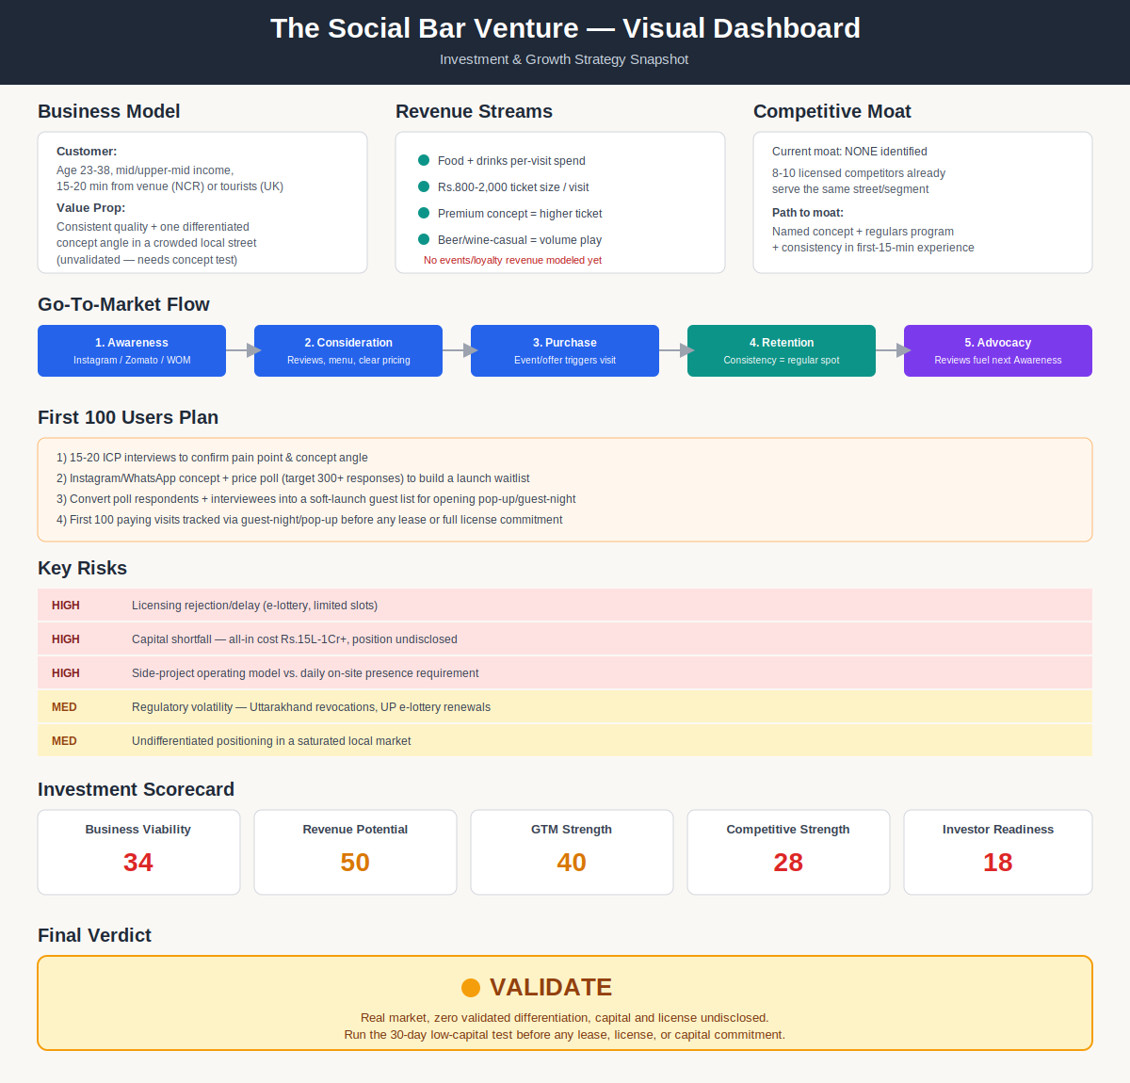

6. Sustainability Verdict
● VALIDATE
The Social Bar Venture operates in a real, durable market, but is not yet a sustainable business: it currently has no validated differentiation, no confirmed capital or license position, and no resolved operating model for a business that requires daily on-site presence. It can become sustainable only if the 30-day validation plan produces a specific, tested concept with confirmed price-sensitivity and a realistic capital-to-license match — until then, every further dollar and hour of commitment should be treated as conditional on those gates, not as a foregone conclusion.

