PYTHON

OBJECT-ORIENTED
PROGRAMMING
Complete Master Guide
From your first class to confident, clean Python design

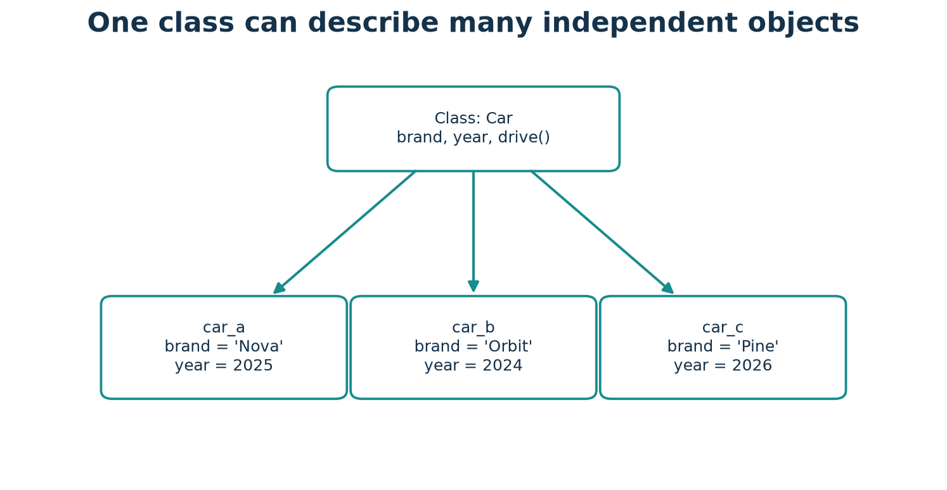
One blueprint; many independent objects.
A beginner-friendly textbook with runnable code, diagrams, projects, and practice

How to Use This Book
Read one idea at a time. Start with the analogy, study the definition, then trace the complete program line by line. Cover the output and predict it before checking. Run the code in Python 3.11 or later, change one value, and observe what changes.
- CONCEPT and REAL-WORLD EXAMPLE introduce an idea before its code.
- PYTHON CODE is complete and designed to run as shown; EXPECTED OUTPUT is kept separate.
- COMMON MISTAKE highlights a likely beginner error and a reliable correction.
- PRACTICE TIME appears before a separate answer key so you can attempt work first.
- Project diagrams use simplified flow; the code is the exact executable behavior.
- This book uses fictional, defensive cybersecurity examples only.
LEARNING LOOP Read → predict → run → change → explain. If you can teach a concept in your own words and modify its example, you are learning it.

Contents
Open in Word and choose Update Table to populate page numbers.
The clickable Word table of contents is a field. In Microsoft Word, right-click it and select Update Field → Update entire table to populate headings and page numbers. A manual chapter map follows for readers whose viewer does not update fields.
Chapter 01 Introduction to Programming and OOP
Chapter 02 Understanding Classes and Objects
Chapter 03 Attributes, Methods, and Object State
Chapter 04 The __init__() Method and Constructors
Chapter 05 Understanding self Properly
Chapter 06 Instance, Class, and Static Methods
Chapter 07 Encapsulation and Data Protection
Chapter 08 Inheritance
Chapter 09 Polymorphism
Chapter 10 Abstraction and Abstract Classes
Chapter 11 Special or Magic Methods
Chapter 12 Composition, Aggregation, and Association
Chapter 13 Object References, Identity, and Copying
Chapter 14 Properties, Validation, and Better Class Design
Chapter 15 Dataclasses and Type Hints
Chapter 16 Exception Handling Inside Classes
Chapter 17 Iterators, Generators, and Context Managers
Chapter 18 SOLID Principles and Clean OOP Design
Chapter 19 Complete OOP Mini Projects
Chapter 20 OOP Comparison and Revision
Chapter 21 Common Beginner Mistakes
Chapter 22 Practice Workbook
Chapter 23 Final Master Revision Guide

The OOP Map
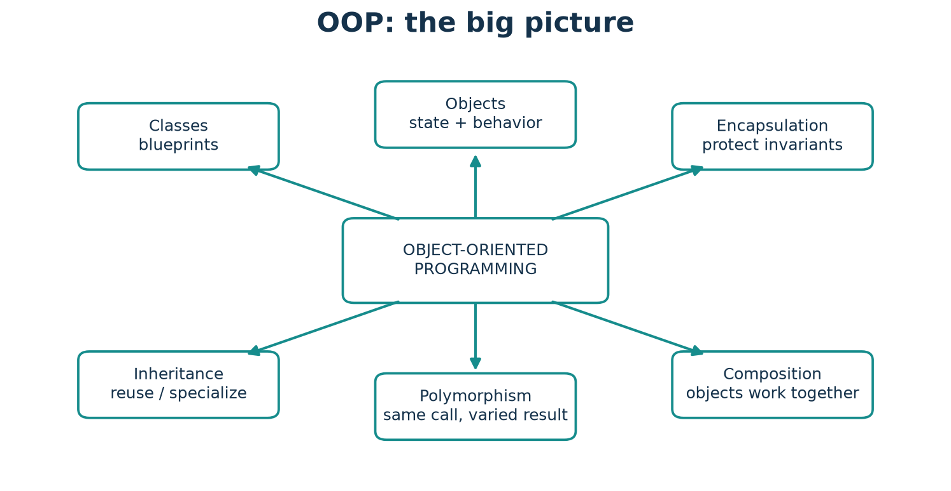
The central ideas connect: define objects, protect valid state, and make collaborators work together.
The book progresses from the idea of a class and object to the behaviors that make object-oriented programs useful. Advanced features are introduced only after their basic pieces.

PART 1 · BUILDING THE FOUNDATION

Chapter 1: Introduction to Programming and OOP
START HERE Programming means writing precise instructions a computer can follow. A programming language gives people a readable way to express those instructions. Python is a general-purpose language known for readable syntax; it is used in education, automation, web services, science, and defensive security t

Programming and Python
Programming means writing precise instructions a computer can follow. A programming language gives people a readable way to express those instructions. Python is a general-purpose language known for readable syntax; it is used in education, automation, web services, science, and defensive security tooling.

Procedural programming
A procedural program is organized mainly as steps and functions. This is an excellent fit for short scripts and simple transformations. As a program grows, related data and the functions that operate on it can become scattered.

What OOP adds
Object-Oriented Programming groups related data (state) and operations (behavior) into objects. A class describes the kind of object; each object holds its own state. OOP is a way to organize programs, not a requirement for every Python task.

Why use it—and when not to
OOP can make a large domain easier to model, reuse, test, and extend. It also adds structure and vocabulary; for a five-line calculation, a function may be clearer. Choose the simplest design that keeps the program understandable.

Procedural versus OOP
Procedural style emphasizes operations; OOP emphasizes collaborating objects. Neither style is automatically faster or better. Python supports both, and real programs often combine functions and classes.
REAL-WORLD EXAMPLE A recipe card is a plan; the baked cake is a finished thing. A class is like the recipe and an object is a particular cake made from it.

Figure: Introduction to Programming and OOP — use the arrows and labels to connect the idea to the code.

Python syntax and runnable example
PYTHON CODE
class Counter:
def __init__(self):
self.value = 0
def add_one(self):
self.value += 1
counter = Counter()
counter.add_one()
print(counter.value)

Expected output
OUTPUT
1

Code walkthrough
Counter is the class, counter is one object. add_one changes that object's value. The same task could be written with a plain integer and a function; the class becomes helpful when the counter needs more state or behavior.

The same task in procedural and OOP styles
COMPLETE COMPARISON EXAMPLE
def average(marks):
return sum(marks) / len(marks)
students = [
{"name": "Mira", "marks": [80, 90]},
{"name": "Noah", "marks": [60, 70]},
]
for student in students:
print(f"{student['name']}: {average(student['marks']):.1f}")
class Student:
def __init__(self, name, marks):
self.name = name
self.marks = marks
def average(self):
return sum(self.marks) / len(self.marks)
learners = [Student("Mira", [80, 90]), Student("Noah", [60, 70])]
for learner in learners:
print(f"{learner.name}: {learner.average():.1f}")
EXPECTED OUTPUT
Mira: 85.0
Noah: 65.0
Mira: 85.0
Noah: 65.0
Both versions solve the same problem. The first keeps records as dictionaries and behavior in a function. The second groups each student's data and average behavior in a Student object. For a tiny task either is fine; grouping can help as the model gains rules and operations.

Connect the analogy to the code
In this example, A recipe card is a plan; the baked cake is a finished thing. A class is like the recipe and an object is a particular cake made from it. The Python class and object show the same relationship in executable form.
COMMON MISTAKE Starting every tiny script with several classes can hide a simple solution. Prefer a function or a few statements until there is a clear group of state and behavior.

Key terms
Programming language: a notation for instructions. Procedure: an ordered set of steps. OOP: organizing state and behavior around objects. State: the data an object currently holds.

Remember this
- Programming and Python: know what it means and when it helps.
- Trace the example by identifying each object, its state, and the method called.
- Choose the simplest design that makes changes safe and understandable.

Practice time
- Easy: Define programming and python in your own words.
- Understanding: Explain how the example would change if there were two objects.
- Coding: Modify the program to add one new value or behavior and print the result.
- Challenge: Name one invalid input or edge case and explain how you would test it.

Chapter 2: Understanding Classes and Objects
START HERE A class defines what data and operations instances of a kind can have. It is not itself a car, student, or phone; it describes how such objects behave.

A class is a description
A class defines what data and operations instances of a kind can have. It is not itself a car, student, or phone; it describes how such objects behave.

An object is an instance
An object is a particular value created from a class. Many objects can use the same class while keeping different instance attributes.

Identity and independent state
Each object has an identity: it is a particular object in memory. Two cars can have equal data yet remain separate objects. Changing one object's instance attribute does not normally change another's.

Attributes and behavior
An attribute is a named value associated with an object or class. A method is a function defined on a class that describes behavior. A phone's model is data; calling phone.call() is behavior.

Student, car, and phone models
A Student could have a name and marks; a Car a brand and year; a Phone a model and battery level. Model only information and actions that matter to the program.
REAL-WORLD EXAMPLE A school form is a template. Each completed student record is an object with its own name and class.

Figure: Understanding Classes and Objects — use the arrows and labels to connect the idea to the code.

Python syntax and runnable example
PYTHON CODE
class Car:
def __init__(self, brand, year):
self.brand = brand
self.year = year
car_a = Car("Nova", 2025)
car_b = Car("Orbit", 2024)
print(car_a.brand, car_a.year)
print(car_b.brand, car_b.year)
print(car_a is car_b)

Expected output
OUTPUT
Nova 2025
Orbit 2024
False

Code walkthrough
Car describes a kind of object. Calling Car(...) creates one instance and passes its values to __init__. car_a and car_b refer to distinct objects, so `is` is False.

Mobile phones: same class, separate object state
COMPLETE COMPARISON EXAMPLE
class MobilePhone:
def __init__(self, model, battery):
self.model = model
self.battery = battery
def call(self, minutes):
self.battery -= minutes
return f"{self.model}: {minutes}-minute call"
phone_a = MobilePhone("Nova Mini", 90)
phone_b = MobilePhone("Orbit Max", 70)
print(phone_a.call(10))
print(phone_a.battery, phone_b.battery)
EXPECTED OUTPUT
Nova Mini: 10-minute call
80 70
MobilePhone is the class. Each phone is a separate object with its own model and battery. Calling one phone changes its instance state without changing the other phone.

Connect the analogy to the code
In this example, A school form is a template. Each completed student record is an object with its own name and class. The Python class and object show the same relationship in executable form.
COMMON MISTAKE Writing `car = Car` stores the class itself. Use parentheses, such as `car = Car('Nova', 2025)`, to make an instance.

Key terms
Class: a definition used to create instances. Instance: an object created from a class. Identity: which particular object something is. Attribute: a named value.

Remember this
- A class is a description: know what it means and when it helps.
- Trace the example by identifying each object, its state, and the method called.
- Choose the simplest design that makes changes safe and understandable.

Practice time
- Easy: Define a class is a description in your own words.
- Understanding: Explain how the example would change if there were two objects.
- Coding: Modify the program to add one new value or behavior and print the result.
- Challenge: Name one invalid input or edge case and explain how you would test it.

Chapter 3: Attributes, Methods, and Object State
START HERE An instance attribute belongs to one object. Assign it through self inside a method, or through the object from outside. Each object can hold a different value.

Instance attributes
An instance attribute belongs to one object. Assign it through self inside a method, or through the object from outside. Each object can hold a different value.

Class attributes
A class attribute is defined directly in the class body and is looked up through the class or instances. It is useful for genuinely shared facts such as a common tax rate, not per-student marks.

Methods and state changes
An instance method receives the object as its first argument by convention, then can read or update its attributes. A method that updates state should make the change clear and keep the object valid.

Class data versus per-object data
If a mutable list is placed directly on a class, all instances can see and mutate that same list. Put per-object collections in __init__ so every instance receives its own list.
REAL-WORLD EXAMPLE A classroom has one shared school name but each student's notebook is personal. Shared facts belong to the class; individual facts belong to each instance.

Figure: Attributes, Methods, and Object State — use the arrows and labels to connect the idea to the code.

Python syntax and runnable example
PYTHON CODE
class Student:
school = "Maple School"
def __init__(self, name):
self.name = name
self.marks = []
def add_mark(self, mark):
self.marks.append(mark)
ada = Student("Ada")
lin = Student("Lin")
ada.add_mark(95)
print(ada.name, ada.marks, ada.school)
print(lin.name, lin.marks, lin.school)

Expected output
OUTPUT
Ada [95] Maple School
Lin [] Maple School

Code walkthrough
school is shared class information; name and marks belong to each student. Creating `marks` inside __init__ gives Ada and Lin separate lists.

Connect the analogy to the code
In this example, A classroom has one shared school name but each student's notebook is personal. Shared facts belong to the class; individual facts belong to each instance. The Python class and object show the same relationship in executable form.
COMMON MISTAKE Do not put `marks = []` in the class body if each student needs different marks. That creates one shared list.

Key terms
Instance attribute: per-object data. Class attribute: class-level data. Method: function defined in a class. State: current attribute values.

Remember this
- Instance attributes: know what it means and when it helps.
- Trace the example by identifying each object, its state, and the method called.
- Choose the simplest design that makes changes safe and understandable.

Practice time
- Easy: Define instance attributes in your own words.
- Understanding: Explain how the example would change if there were two objects.
- Coding: Modify the program to add one new value or behavior and print the result.
- Challenge: Name one invalid input or edge case and explain how you would test it.

PART 2 · THE CORE OF PYTHON OOP

Chapter 4: The __init__() Method and Constructors
START HERE __init__ is an initializer: Python calls it after a new instance has been allocated. It commonly sets the attributes that make an object ready to use.

Initializing a useful object
__init__ is an initializer: Python calls it after a new instance has been allocated. It commonly sets the attributes that make an object ready to use.

Parameters and defaults
Initializer parameters let each instance start with different data. A default parameter makes an argument optional when that default is meaningful. Avoid mutable defaults such as `items=[]`; use None or a fresh list instead.

Creation versus initialization
Technically, __new__ creates and returns the instance; __init__ initializes it. Most everyday classes should implement __init__ only. __new__ is an advanced hook used in special cases such as immutable subclasses.

Lifecycle
The call `Car('Nova', 2025)` asks Python to construct an instance and then initialize it. The resulting reference can be stored in a variable and used to call methods.
REAL-WORLD EXAMPLE A factory first makes an empty product shell, then configures it with a model and serial number. __new__ is the rare creation hook; __init__ sets it up.

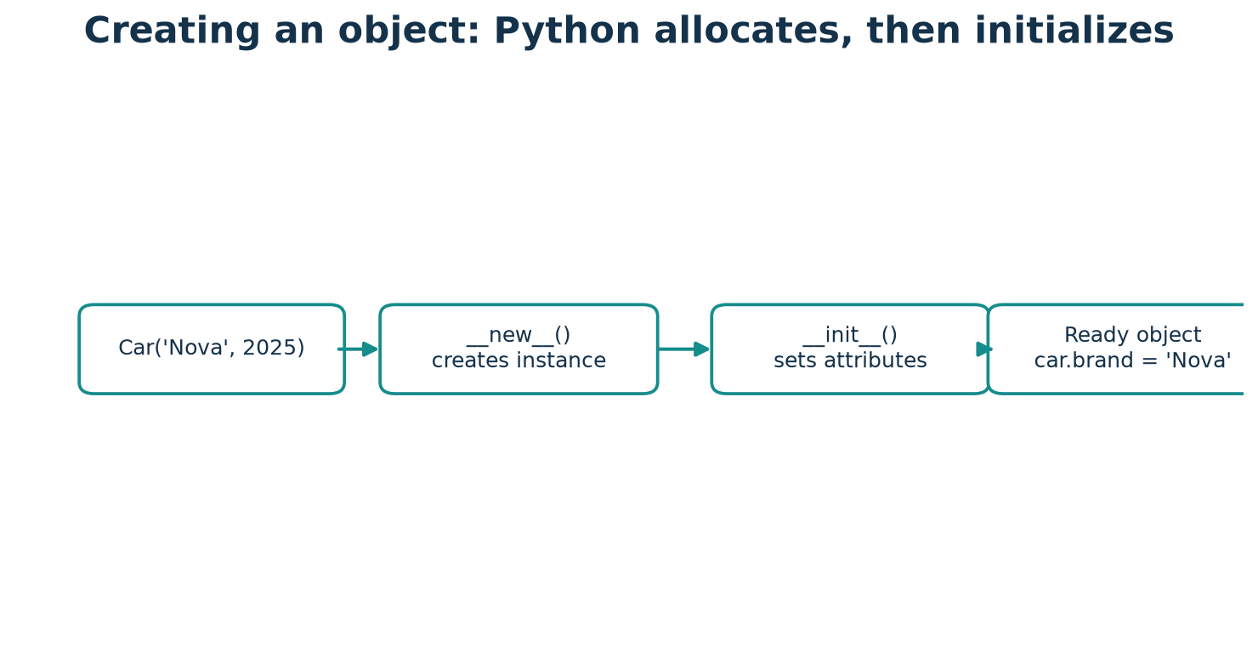
Figure: The __init__() Method and Constructors — use the arrows and labels to connect the idea to the code.

Python syntax and runnable example
PYTHON CODE
class Car:
def __init__(self, brand, year=2025):
self.brand = brand
self.year = year
new_car = Car("Nova")
older_car = Car("Orbit", 2022)
print(new_car.brand, new_car.year)
print(older_car.brand, older_car.year)

Expected output
OUTPUT
Nova 2025
Orbit 2022

Code walkthrough
Python sends `brand` and `year` into __init__. The first object uses the default year, while the second supplies one explicitly.

Connect the analogy to the code
In this example, A factory first makes an empty product shell, then configures it with a model and serial number. __new__ is the rare creation hook; __init__ sets it up. The Python class and object show the same relationship in executable form.
COMMON MISTAKE The method name must be exactly `__init__` with two underscores on each side. `__init` is a different name and will not be called automatically.

Key terms
__init__: initializer method. __new__: method that creates an instance. Default argument: a value used when a caller omits an argument. Constructor is often used informally for object setup.

Remember this
- Initializing a useful object: know what it means and when it helps.
- Trace the example by identifying each object, its state, and the method called.
- Choose the simplest design that makes changes safe and understandable.

Practice time
- Easy: Define initializing a useful object in your own words.
- Understanding: Explain how the example would change if there were two objects.
- Coding: Modify the program to add one new value or behavior and print the result.
- Challenge: Name one invalid input or edge case and explain how you would test it.

Chapter 5: Understanding self Properly
START HERE self refers to the particular instance on which an instance method is called. Python supplies it when you write `object.method(...)`. The name self is conventional, not a reserved keyword.

What self means
self refers to the particular instance on which an instance method is called. Python supplies it when you write `object.method(...)`. The name self is conventional, not a reserved keyword.

Attribute access
Use `self.name` to access the object's name. A local variable called name exists only while a function runs; `self.name` is stored on the object and can be used by later method calls.

Binding a method
When `student.describe()` is called, Python binds student as the method's first argument. The method definition includes the self parameter so it can work with that specific instance.

Why omission fails
Without the first parameter, an instance method's automatic instance argument has nowhere to go, usually causing a TypeError. Use self as the first parameter for ordinary instance methods.
REAL-WORLD EXAMPLE When a shop assistant says “this order,” the word this identifies the current order. self plays that role inside an instance method.

Figure: Understanding self Properly — use the arrows and labels to connect the idea to the code.

Python syntax and runnable example
PYTHON CODE
class Student:
def __init__(self, name):
self.name = name
def greet(self, greeting):
return f"{greeting}, I am {self.name}."
student = Student("Ada")
print(student.greet("Hello"))

Expected output
OUTPUT
Hello, I am Ada.

Code walkthrough
student.greet('Hello') is conceptually like calling Student.greet(student, 'Hello'). self is Ada's student object; greeting is the ordinary argument.

Connect the analogy to the code
In this example, When a shop assistant says “this order,” the word this identifies the current order. self plays that role inside an instance method. The Python class and object show the same relationship in executable form.
COMMON MISTAKE A method written as `def greet():` will fail when called as `student.greet()` because Python still supplies the instance. Add `self`.

Key terms
self: conventional name for the current instance parameter. Bound method: a method connected to a particular instance. Local variable: a temporary name inside a function.

Remember this
- What self means: know what it means and when it helps.
- Trace the example by identifying each object, its state, and the method called.
- Choose the simplest design that makes changes safe and understandable.

Practice time
- Easy: Define what self means in your own words.
- Understanding: Explain how the example would change if there were two objects.
- Coding: Modify the program to add one new value or behavior and print the result.
- Challenge: Name one invalid input or edge case and explain how you would test it.

Chapter 6: Instance, Class, and Static Methods
START HERE An instance method's first parameter is usually self. Use it when behavior needs the current object's attributes or needs to change that object.

Instance methods
An instance method's first parameter is usually self. Use it when behavior needs the current object's attributes or needs to change that object.

Class methods
A method decorated with @classmethod receives the class as its first parameter, conventionally cls. It can read class-level information or serve as an alternative constructor that respects subclasses.

Static methods
A @staticmethod receives no automatic self or cls. Use it for a small utility closely related to the class concept but not requiring object or class state.

Choosing the method type
If behavior needs one object's state, choose an instance method. If it needs the class or constructs an instance through cls, choose a class method. If it needs neither, a static method or module-level function may be clearer.
REAL-WORLD EXAMPLE Instance method: ask one student for their score. Class method: ask the school class to make a student record. Static method: use a related calculator that needs no student's data.

Python syntax and runnable example
PYTHON CODE
class Temperature:
unit = "C"
def __init__(self, celsius):
self.celsius = celsius
@classmethod
def from_fahrenheit(cls, value):
return cls((value - 32) * 5 / 9)
@staticmethod
def is_valid(value):
return isinstance(value, (int, float))
temp = Temperature.from_fahrenheit(68)
print(round(temp.celsius))
print(Temperature.is_valid(20))

Expected output
OUTPUT
20
True

Code walkthrough
The class method converts Fahrenheit and creates an instance through cls. The static method checks a value without needing a particular Temperature object.

Choose the method type
Method | Automatic first argument | Best fit
Instance | self | Uses one object's state
Class | cls | Uses class state or alternate constructor
Static | none | Related utility needs neither object nor class

Connect the analogy to the code
In this example, Instance method: ask one student for their score. Class method: ask the school class to make a student record. Static method: use a related calculator that needs no student's data. The Python class and object show the same relationship in executable form.
COMMON MISTAKE Do not forget @classmethod or cls: without the decorator Python does not supply the class. Do not use @staticmethod when the method needs self.

Key terms
@classmethod and @staticmethod are decorators. Decorator: syntax that modifies or registers a function's behavior. cls: conventional class-method parameter.

Remember this
- Instance methods: know what it means and when it helps.
- Trace the example by identifying each object, its state, and the method called.
- Choose the simplest design that makes changes safe and understandable.

Practice time
- Easy: Define instance methods in your own words.
- Understanding: Explain how the example would change if there were two objects.
- Coding: Modify the program to add one new value or behavior and print the result.
- Challenge: Name one invalid input or edge case and explain how you would test it.

Chapter 7: Encapsulation and Data Protection
START HERE Encapsulation places related state and behavior together and provides a clear interface for using them. A bank account can expose deposit and withdraw rather than asking callers to edit its balance carelessly.

Encapsulation
Encapsulation places related state and behavior together and provides a clear interface for using them. A bank account can expose deposit and withdraw rather than asking callers to edit its balance carelessly.

Python visibility conventions
A public name has no leading underscore. A leading underscore, such as `_balance`, signals “internal use; callers should not rely on this.” Python does not enforce strict private access.

Name mangling
A double-leading underscore such as `__pin` triggers name mangling, which helps avoid accidental name clashes in subclasses. It is not a security boundary and can still be accessed deliberately.

Properties and validation
@property lets code use attribute-like access while a method controls reading or assignment. A setter can reject invalid data so an object remains in a valid state.

Encapsulation versus abstraction
Encapsulation concerns bundling state and behavior and controlling access. Abstraction concerns showing essential operations while hiding implementation details. They often work together but are not synonyms.
REAL-WORLD EXAMPLE A vending machine shows buttons and accepts payment, but users do not reach inside to directly change its inventory counters.

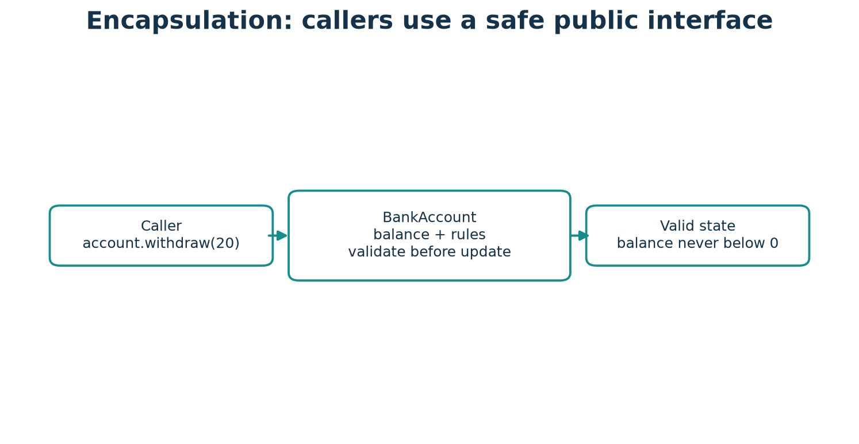
Figure: Encapsulation and Data Protection — use the arrows and labels to connect the idea to the code.

Python syntax and runnable example
PYTHON CODE
class BankAccount:
def __init__(self, balance=0):
self.balance = balance
@property
def balance(self):
return self._balance
@balance.setter
def balance(self, amount):
if amount < 0:
raise ValueError("balance cannot be negative")
self._balance = amount
def deposit(self, amount):
if amount <= 0:
raise ValueError("deposit must be positive")
self._balance += amount
account = BankAccount(50)
account.deposit(25)
print(account.balance)

Expected output
OUTPUT
75

Code walkthrough
The property validates initial balance assignments and provides a readable public balance. deposit checks its own rule before changing the internal attribute.

Double underscore and name mangling
COMPLETE COMPARISON EXAMPLE
class Locker:
def __init__(self, code):
self.__code = code
def accepts(self, candidate):
return candidate == self.__code
locker = Locker("demo-code")
print(locker.accepts("demo-code"))
print(locker._Locker__code)
EXPECTED OUTPUT
True
demo-code
Python rewrites __code to a class-qualified attribute name to reduce accidental clashes. The second line deliberately shows that this is not a privacy or secrecy boundary; never store real secrets this way.

Connect the analogy to the code
In this example, A vending machine shows buttons and accepts payment, but users do not reach inside to directly change its inventory counters. The Python class and object show the same relationship in executable form.
COMMON MISTAKE Do not claim `_balance` is truly private. It is a convention; the goal is clear API design, not secrecy.

Key terms
Encapsulation: group state and behavior with a controlled interface. Property: managed attribute access. Name mangling: renaming of double-leading-underscore attributes. Invariant: rule that should remain true.

Remember this
- Encapsulation: know what it means and when it helps.
- Trace the example by identifying each object, its state, and the method called.
- Choose the simplest design that makes changes safe and understandable.

Practice time
- Easy: Define encapsulation in your own words.
- Understanding: Explain how the example would change if there were two objects.
- Coding: Modify the program to add one new value or behavior and print the result.
- Challenge: Name one invalid input or edge case and explain how you would test it.

Chapter 8: Inheritance
START HERE Inheritance creates a specialized class from a base class. The child inherits usable behavior and can add or replace behavior. Think “Car is a Vehicle,” not merely “Car uses a Vehicle.”

Base and derived classes
Inheritance creates a specialized class from a base class. The child inherits usable behavior and can add or replace behavior. Think “Car is a Vehicle,” not merely “Car uses a Vehicle.”

Common shapes
Single inheritance has one direct parent; multilevel inheritance forms a chain; hierarchical inheritance has multiple children from one parent; multiple inheritance has more than one base class.

Overriding and super()
A subclass overrides a method by defining the same method name. `super()` delegates to the next implementation in the method resolution order, allowing a subclass to extend parent behavior without naming the parent directly.

MRO and the diamond
Python computes a Method Resolution Order (MRO) to decide where to find methods. In a diamond-shaped hierarchy, C3 linearization gives a consistent order and cooperative super() calls proceed through it.

Inheritance or composition?
Use inheritance for a genuine substitutable “is-a” relationship. If a class merely uses another object (“has-a”), composition is often simpler and more flexible.
REAL-WORLD EXAMPLE A car is a vehicle and can be used wherever a vehicle is expected. A car has an engine; that relationship is usually modeled by holding an Engine object, not inheriting from Engine.

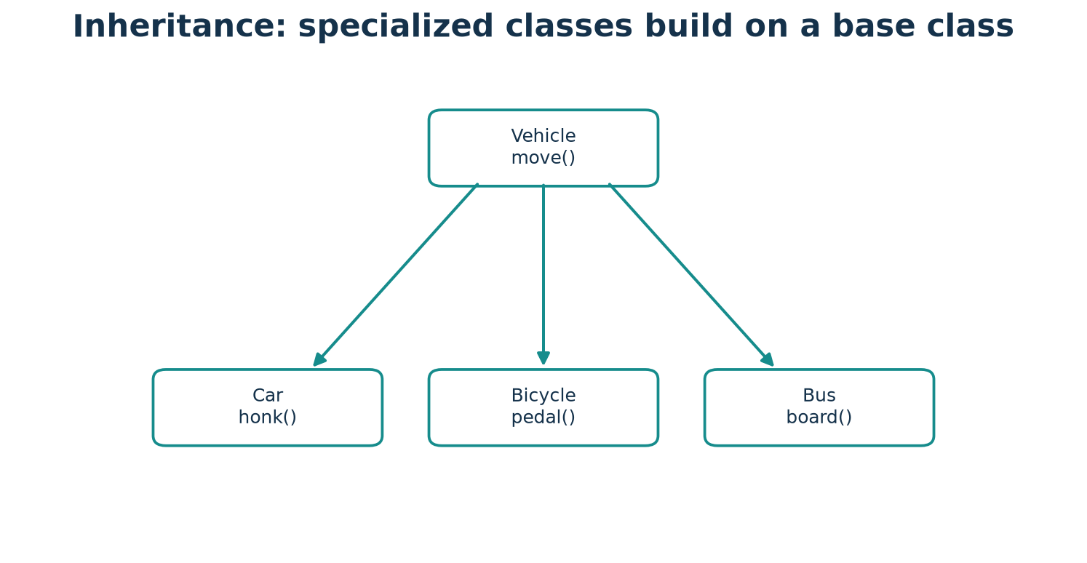
Figure: Inheritance — use the arrows and labels to connect the idea to the code.

Python syntax and runnable example
PYTHON CODE
class Vehicle:
def __init__(self, brand):
self.brand = brand
def move(self):
return f"{self.brand} moves"
class Car(Vehicle):
def move(self):
return f"{super().move()} on four wheels"
car = Car("Nova")
print(car.move())
print(Car.mro()[0].__name__, Car.mro()[1].__name__)

Expected output
OUTPUT
Nova moves on four wheels
Car Vehicle

Code walkthrough
Car inherits Vehicle's initializer. Its move method overrides Vehicle.move and calls the parent implementation with super before adding its detail. mro() shows lookup order.

The diamond and cooperative MRO
A diamond appears when two intermediate classes inherit from the same base and a child inherits from both. Python uses C3 linearization to produce one consistent MRO. When each method calls super(), control follows that MRO, so the shared base can be reached once.
DIAMOND INHERITANCE AND MRO
class Root:
def ping(self):
print("Root")
class Left(Root):
def ping(self):
print("Left")
super().ping()
class Right(Root):
def ping(self):
print("Right")
super().ping()
class Child(Left, Right):
def ping(self):
print("Child")
super().ping()
Child().ping()
print(" -> ".join(cls.__name__ for cls in Child.mro()[:4]))
EXPECTED OUTPUT
Child
Left
Right
Root
Child -> Left -> Right -> Root
Each implementation calls super(), so Python follows the cooperative MRO once through the diamond rather than repeating Root.

Single, multilevel, hierarchical, and multiple inheritance
COMPLETE COMPARISON EXAMPLE
class Device:
pass
class Phone(Device):
pass
class Rechargeable:
def charge(self):
return "charging"
class SmartPhone(Phone, Rechargeable):
pass
class Tablet(Device):
pass
print("single:", issubclass(Phone, Device))
print("multilevel:", issubclass(SmartPhone, Device))
print("hierarchical:", issubclass(Tablet, Device))
print("multiple:", len(SmartPhone.__bases__) == 2)
EXPECTED OUTPUT
single: True
multilevel: True
hierarchical: True
multiple: True
Phone has one base (single). SmartPhone extends Phone, which extends Device (multilevel). Phone and Tablet share Device (hierarchical). SmartPhone has Phone and Rechargeable as bases (multiple). Keep multiple inheritance small and cooperative.

Connect the analogy to the code
In this example, A car is a vehicle and can be used wherever a vehicle is expected. A car has an engine; that relationship is usually modeled by holding an Engine object, not inheriting from Engine. The Python class and object show the same relationship in executable form.
COMMON MISTAKE Avoid deep inheritance trees and subclasses that cannot honor the behavior promised by the parent. Prefer a composed helper when the relationship is “has-a.”

Key terms
Base/parent class: class being extended. Derived/child class: subclass. Override: replace inherited method behavior. MRO: ordered lookup path. super(): cooperative next-class access.

Remember this
- Base and derived classes: know what it means and when it helps.
- Trace the example by identifying each object, its state, and the method called.
- Choose the simplest design that makes changes safe and understandable.

Practice time
- Easy: Define base and derived classes in your own words.
- Understanding: Explain how the example would change if there were two objects.
- Coding: Modify the program to add one new value or behavior and print the result.
- Challenge: Name one invalid input or edge case and explain how you would test it.

Chapter 9: Polymorphism
START HERE Polymorphism means that a common operation can work with different kinds of objects, with each object providing appropriate behavior. For example, different alerts can each describe themselves.

One operation, varied behavior
Polymorphism means that a common operation can work with different kinds of objects, with each object providing appropriate behavior. For example, different alerts can each describe themselves.

Overriding and duck typing
Overriding supplies a subclass-specific implementation. Duck typing is Python's practice of caring about supported operations rather than requiring an object's declared class. They are related tools but not identical concepts.

Functions and loops
A function can accept any object that supports the operations it uses. This keeps callers simple and lets new compatible classes work without rewriting the loop.

Operator overloading
Special methods such as __add__ and __len__ let custom objects participate in familiar operations. Implement an operation only when its meaning for the type is clear.

Overloading terminology
Python does not offer traditional signature-based method overloading like some languages. Re-defining the same method name in a class replaces the earlier definition; optional arguments or singledispatch patterns are alternatives.
REAL-WORLD EXAMPLE A play button means “start” on a music player and a video player, even though each device starts different media.

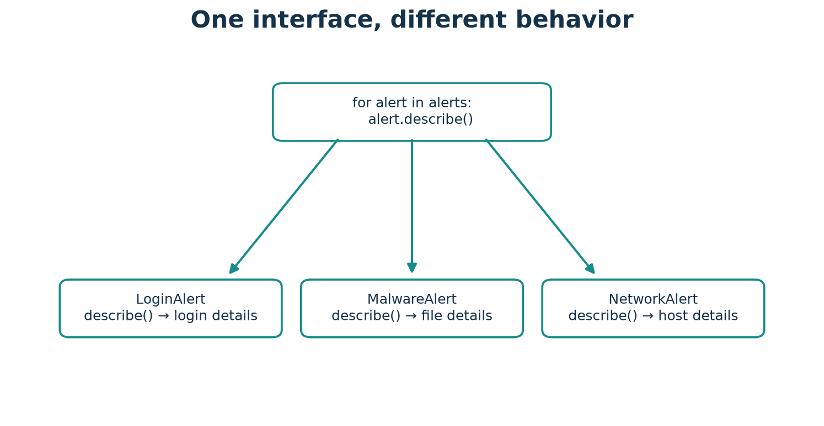
Figure: Polymorphism — use the arrows and labels to connect the idea to the code.

Python syntax and runnable example
PYTHON CODE
class LoginAlert:
def describe(self):
return "Login alert: review sign-in activity"
class FileAlert:
def describe(self):
return "File alert: review the flagged file"
def print_alert(alert):
print(alert.describe())
for item in (LoginAlert(), FileAlert()):
print_alert(item)

Expected output
OUTPUT
Login alert: review sign-in activity
File alert: review the flagged file

Code walkthrough
print_alert needs only an object with describe(). Both alert types meet that expectation and choose their own message.

Connect the analogy to the code
In this example, A play button means “start” on a music player and a video player, even though each device starts different media. The Python class and object show the same relationship in executable form.
COMMON MISTAKE Polymorphism is not simply “many classes.” The key is a shared operation or interface with behavior suitable to each object.

Key terms
Polymorphism: one interface usable with different implementations. Duck typing: compatibility based on supported behavior. Operator overloading: defining how standard operators work for a type.

Remember this
- One operation, varied behavior: know what it means and when it helps.
- Trace the example by identifying each object, its state, and the method called.
- Choose the simplest design that makes changes safe and understandable.

Practice time
- Easy: Define one operation, varied behavior in your own words.
- Understanding: Explain how the example would change if there were two objects.
- Coding: Modify the program to add one new value or behavior and print the result.
- Challenge: Name one invalid input or edge case and explain how you would test it.

Chapter 10: Abstraction and Abstract Classes
START HERE Abstraction exposes what a user of a class needs to do and leaves implementation details behind the interface. A driver uses a steering wheel and pedals without needing the engine's internal design.

Essential behavior, hidden detail
Abstraction exposes what a user of a class needs to do and leaves implementation details behind the interface. A driver uses a steering wheel and pedals without needing the engine's internal design.

Abstract contracts
The abc module provides ABC and @abstractmethod. An abstract base class can define required methods; Python normally prevents instantiating it until a concrete subclass implements them.

Abstraction and encapsulation
Abstraction simplifies what callers need to know. Encapsulation groups state and behavior and controls access to that state. One design can use both.

When useful
Use an abstract base class when several implementations must honor a meaningful contract and the shared contract improves clarity. For a small one-off script, a simple function or duck-typed object may be enough.
REAL-WORLD EXAMPLE A USB socket specifies how a device connects; a camera and keyboard can implement the connection differently.

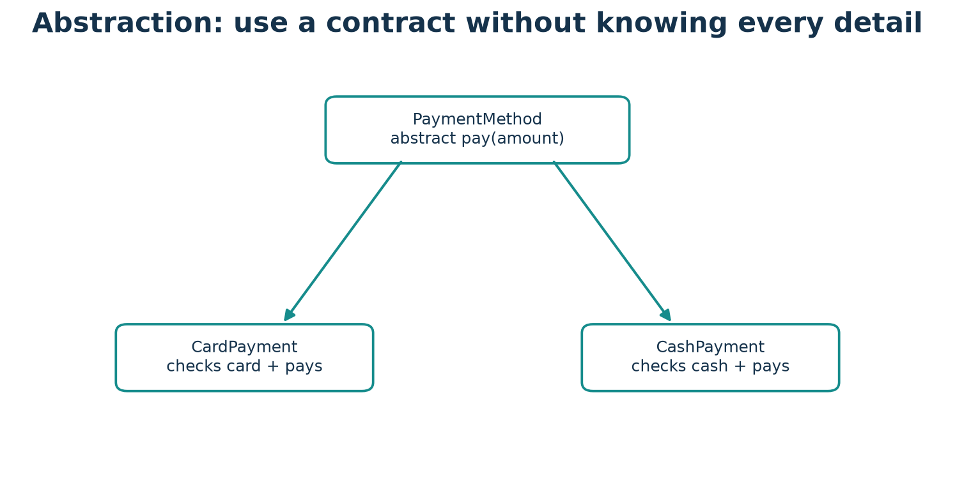
Figure: Abstraction and Abstract Classes — use the arrows and labels to connect the idea to the code.

Python syntax and runnable example
PYTHON CODE
from abc import ABC, abstractmethod
class PaymentMethod(ABC):
@abstractmethod
def pay(self, amount):
raise NotImplementedError
class CashPayment(PaymentMethod):
def pay(self, amount):
return f"Paid ${amount:.2f} in cash"
print(CashPayment().pay(12))

Expected output
OUTPUT
Paid $12.00 in cash

Code walkthrough
PaymentMethod documents the required pay operation. CashPayment fulfills it, so it can be instantiated. PaymentMethod itself is incomplete.

Connect the analogy to the code
In this example, A USB socket specifies how a device connects; a camera and keyboard can implement the connection differently. The Python class and object show the same relationship in executable form.
COMMON MISTAKE A subclass that forgets an inherited abstract method remains abstract and cannot normally be instantiated.

Key terms
Abstraction: expose essential operations and hide detail. ABC: abstract base class. @abstractmethod: marks a method subclasses are expected to implement.

Remember this
- Essential behavior, hidden detail: know what it means and when it helps.
- Trace the example by identifying each object, its state, and the method called.
- Choose the simplest design that makes changes safe and understandable.

Practice time
- Easy: Define essential behavior, hidden detail in your own words.
- Understanding: Explain how the example would change if there were two objects.
- Coding: Modify the program to add one new value or behavior and print the result.
- Challenge: Name one invalid input or edge case and explain how you would test it.

PART 3 · ADVANCED OBJECT BEHAVIOR

Chapter 11: Special or Magic Methods
START HERE Methods with double underscores at both ends are special methods. Python calls many of them in response to ordinary syntax, such as str(obj), len(obj), comparison, addition, or calling an object.

Dunder methods
Methods with double underscores at both ends are special methods. Python calls many of them in response to ordinary syntax, such as str(obj), len(obj), comparison, addition, or calling an object.

Useful methods
__init__ initializes. __str__ provides a friendly display. __repr__ aims for a useful developer representation. __len__ supports len(). __eq__ defines equality. __add__ defines +. __call__ makes an instance callable.

Use the operation, not usually the dunder call
Call `str(book)`, `len(shelf)`, or `left + right`; Python routes these operations to the corresponding special methods. Implementations should obey expected conventions, including useful return types.

Equality and representation
A class should define equality only when its notion of equal values is meaningful. A useful repr helps debugging; a useful str helps people reading output.
REAL-WORLD EXAMPLE A remote's power button is ordinary to the user; inside, a specific circuit responds. Special methods connect familiar Python operations to a class's response.

Python syntax and runnable example
PYTHON CODE
class Book:
def __init__(self, title):
self.title = title
def __str__(self):
return self.title
def __repr__(self):
return f"Book({self.title!r})"
def __len__(self):
return len(self.title)
book = Book("Python")
print(str(book))
print(repr(book))
print(len(book))

Expected output
OUTPUT
Python
Book('Python')
6

Code walkthrough
str(book) calls __str__, repr(book) calls __repr__, and len(book) calls __len__. All three special methods return the type expected by their operation.

Equality, addition, and callable objects
SPECIAL METHODS FOR EQUALITY, ADDITION, AND CALLING
class Number:
def __init__(self, value):
self.value = value
def __eq__(self, other):
return isinstance(other, Number) and self.value == other.value
def __add__(self, other):
return Number(self.value + other.value)
def __call__(self):
return self.value
print(Number(2) == Number(2))
print((Number(2) + Number(3)).value)
print(Number(4)())
EXPECTED OUTPUT
True
5
4
The ordinary operations ==, +, and calling an instance route to __eq__, __add__, and __call__. The methods return values with suitable meanings.

Connect the analogy to the code
In this example, A remote's power button is ordinary to the user; inside, a specific circuit responds. Special methods connect familiar Python operations to a class's response. The Python class and object show the same relationship in executable form.
COMMON MISTAKE Returning a number from __str__ is invalid: __str__ must return a string. Use len(obj) rather than obj.__len__() in normal code.

Key terms
Dunder: informal name for double-underscore method. __repr__: developer-oriented representation. __str__: readable string. Operator overloading: special-method behavior for operators.

Remember this
- Dunder methods: know what it means and when it helps.
- Trace the example by identifying each object, its state, and the method called.
- Choose the simplest design that makes changes safe and understandable.

Practice time
- Easy: Define dunder methods in your own words.
- Understanding: Explain how the example would change if there were two objects.
- Coding: Modify the program to add one new value or behavior and print the result.
- Challenge: Name one invalid input or edge case and explain how you would test it.

Chapter 12: Composition, Aggregation, and Association
START HERE Association is a broad relationship where objects know about or use each other. Aggregation often describes a group holding references to independently meaningful objects. Composition describes a stronger “part of” relationship.

Objects that work together
Association is a broad relationship where objects know about or use each other. Aggregation often describes a group holding references to independently meaningful objects. Composition describes a stronger “part of” relationship.

Has-a versus is-a
A library has books; a shopping cart has cart items. A Car is a Vehicle. Use composition for has-a and inheritance for a well-founded is-a relationship.

Ownership is a design idea
Python references do not automatically enforce UML-style ownership. A part can be shared, retained elsewhere, or outlive a container if another reference exists. Define lifetime and ownership expectations in the program design.

Why composition is flexible
A cart can use a pricing strategy or product objects without inheriting their behavior. Components can be replaced, tested, and reused independently.
REAL-WORLD EXAMPLE A school class roster is associated with students. A toolbox contains tools, but a tool can also be taken out and used elsewhere. These relations have different ownership strengths.

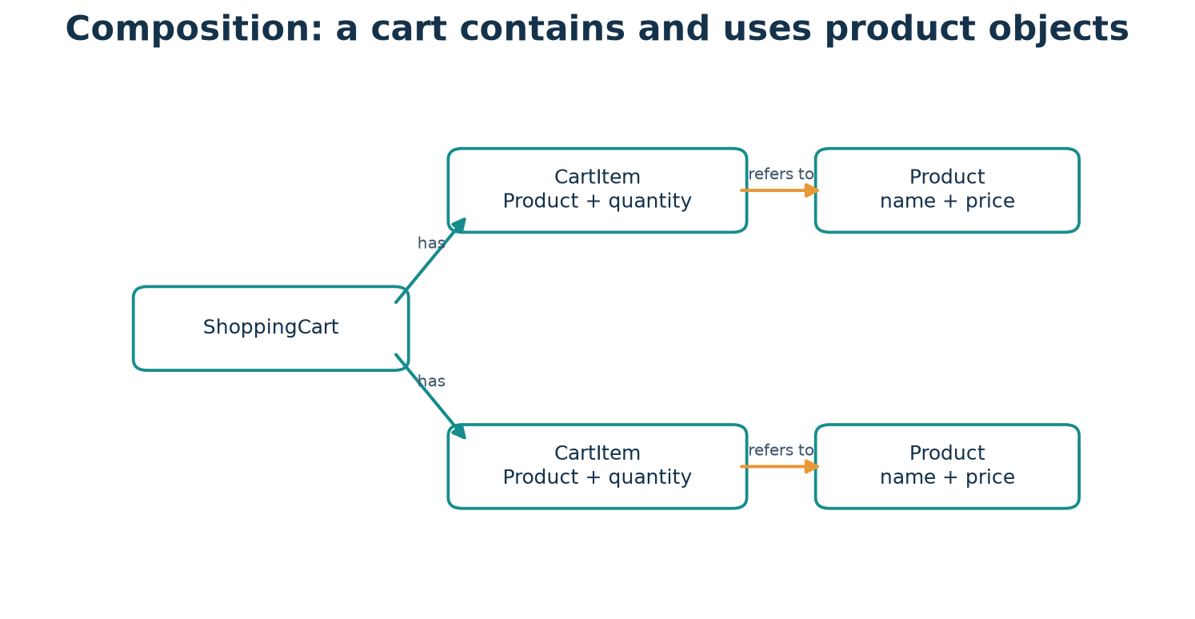
Figure: Composition, Aggregation, and Association — use the arrows and labels to connect the idea to the code.

Python syntax and runnable example
PYTHON CODE
class Product:
def __init__(self, name, price):
self.name = name
self.price = price
class Cart:
def __init__(self):
self.products = []
def add(self, product):
self.products.append(product)
def total(self):
return sum(product.price for product in self.products)
cart = Cart()
cart.add(Product("Notebook", 3.50))
cart.add(Product("Pen", 1.50))
print(f"${cart.total():.2f}")

Expected output
OUTPUT
$5.00

Code walkthrough
Cart stores references to Product objects and asks each for its price. Product does not inherit from Cart; the relationship is has-a.

Connect the analogy to the code
In this example, A school class roster is associated with students. A toolbox contains tools, but a tool can also be taken out and used elsewhere. These relations have different ownership strengths. The Python class and object show the same relationship in executable form.
COMMON MISTAKE Do not present composition and aggregation as automatically enforced Python ownership rules. They are design descriptions of relationships.

Key terms
Association: objects are related. Aggregation: weaker whole-part relationship. Composition: stronger whole-part design. Has-a: object contains or uses another object. Is-a: subtype relationship.

Remember this
- Objects that work together: know what it means and when it helps.
- Trace the example by identifying each object, its state, and the method called.
- Choose the simplest design that makes changes safe and understandable.

Practice time
- Easy: Define objects that work together in your own words.
- Understanding: Explain how the example would change if there were two objects.
- Coding: Modify the program to add one new value or behavior and print the result.
- Challenge: Name one invalid input or edge case and explain how you would test it.

Chapter 13: Object References, Identity, and Copying
START HERE A Python variable is a name bound to an object, not a box that automatically contains an independent copy. Assigning `second = first` makes both names refer to the same object.

Names refer to objects
A Python variable is a name bound to an object, not a box that automatically contains an independent copy. Assigning `second = first` makes both names refer to the same object.

Identity and equality
`is` asks whether two references point to the same object. `==` asks whether values are equal according to their equality behavior. Use `is None` for the None singleton; usually use == for values.

Mutable and immutable values
Lists and dictionaries are mutable; they can change in place. Integers and strings are immutable values. Aliasing a mutable object means a change through one name can be seen through another.

Shallow and deep copy
copy.copy makes a shallow copy: the outer container is new, but nested objects may still be shared. copy.deepcopy recursively copies nested data as far as supported. Deep copying can be expensive or inappropriate for resources.
REAL-WORLD EXAMPLE Two students can share the same notebook (aliasing) or each receive a copied notebook. A photocopy of a folder cover alone still points to the same pages inside (shallow copy).

Python syntax and runnable example
PYTHON CODE
import copy
first = [[1], [2]]
shallow = copy.copy(first)
deep = copy.deepcopy(first)
shallow[0].append(9)
print(first)
print(deep)
print(first is shallow, first == shallow)

Expected output
OUTPUT
[[1, 9], [2]]
[[1], [2]]
False True

Code walkthrough
The shallow copy has a new outer list but shares its nested lists with first, so the append is visible in first. The deep copy has independent nested lists.

Connect the analogy to the code
In this example, Two students can share the same notebook (aliasing) or each receive a copied notebook. A photocopy of a folder cover alone still points to the same pages inside (shallow copy). The Python class and object show the same relationship in executable form.
COMMON MISTAKE Do not use `is` to compare numbers or strings for value equality. Use == unless you explicitly mean object identity.

Key terms
Reference: a way to access an object. Aliasing: multiple names refer to one object. Mutable: can change in place. Shallow copy: copies outer container. Deep copy: recursively copies nested structure.

Remember this
- Names refer to objects: know what it means and when it helps.
- Trace the example by identifying each object, its state, and the method called.
- Choose the simplest design that makes changes safe and understandable.

Practice time
- Easy: Define names refer to objects in your own words.
- Understanding: Explain how the example would change if there were two objects.
- Coding: Modify the program to add one new value or behavior and print the result.
- Challenge: Name one invalid input or edge case and explain how you would test it.

Chapter 14: Properties, Validation, and Better Class Design
START HERE @property makes a method appear attribute-like. You can later add validation or computed behavior without changing callers from `student.age` to `student.get_age()`.

Properties as a stable interface
@property makes a method appear attribute-like. You can later add validation or computed behavior without changing callers from `student.age` to `student.get_age()`.

Setters, deleters, and read-only values
A property setter validates updates; a deleter can define whether removal is allowed. A property with no setter is read-only through that interface, though Python's conventions do not make all state inaccessible.

Maintain valid state
Validate at the boundary where data enters the object. Raise a clear exception for invalid input rather than silently storing a value that breaks later operations.

Design for maintainability
Give a class a focused responsibility, meaningful names, and a small public interface. Keep implementation details replaceable and avoid exposing mutable internals unnecessarily.
REAL-WORLD EXAMPLE A school office accepts a student's age only after checking it is sensible; the student record stays valid after every update.

Figure: Properties, Validation, and Better Class Design — use the arrows and labels to connect the idea to the code.

Python syntax and runnable example
PYTHON CODE
class Student:
def __init__(self, age):
self.age = age
@property
def age(self):
return self._age
@age.setter
def age(self, value):
if not isinstance(value, int) or value < 0:
raise ValueError("age must be a non-negative integer")
self._age = value
student = Student(15)
student.age = 16
print(student.age)

Expected output
OUTPUT
16

Code walkthrough
Both initialization and later assignment pass through the same setter. Valid ages are stored as _age; invalid values raise ValueError.

A property setter and deleter
COMPLETE COMPARISON EXAMPLE
class Profile:
def __init__(self, nickname):
self.nickname = nickname
@property
def nickname(self):
return self._nickname
@nickname.setter
def nickname(self, value):
if not value.strip():
raise ValueError("nickname cannot be blank")
self._nickname = value
@nickname.deleter
def nickname(self):
self._nickname = None
profile = Profile("Mira")
del profile.nickname
print(profile.nickname)
EXPECTED OUTPUT
None
The setter validates assignments; the deleter defines what `del profile.nickname` means for this class. Here it resets the value rather than removing the internal field.

Connect the analogy to the code
In this example, A school office accepts a student's age only after checking it is sensible; the student record stays valid after every update. The Python class and object show the same relationship in executable form.
COMMON MISTAKE A setter that assigns `self.age = value` calls itself repeatedly. Store in a differently named internal attribute, such as `_age`.

Key terms
Property: controlled attribute-like access. Setter: property method for assignment. Read-only property: property without setter. Invariant: a condition the class preserves.

Remember this
- Properties as a stable interface: know what it means and when it helps.
- Trace the example by identifying each object, its state, and the method called.
- Choose the simplest design that makes changes safe and understandable.

Practice time
- Easy: Define properties as a stable interface in your own words.
- Understanding: Explain how the example would change if there were two objects.
- Coding: Modify the program to add one new value or behavior and print the result.
- Challenge: Name one invalid input or edge case and explain how you would test it.

Chapter 15: Dataclasses and Type Hints
START HERE A plain data record often needs an initializer, representation, and equality behavior. @dataclass can generate these methods from declared fields.

Reducing repetitive code
A plain data record often needs an initializer, representation, and equality behavior. @dataclass can generate these methods from declared fields.

Annotations and fields
Type hints document intended types and help editors and static checkers. Python generally does not enforce annotations at runtime. field() configures a dataclass field; default_factory creates a fresh value for each instance.

Mutable default trap
Do not use a shared list as a default field value. Use `field(default_factory=list)` to give every instance a new list.

Choosing a dataclass
Dataclasses are useful for records that mostly hold data. A regular class is suitable when initialization, invariants, or behavior needs a more tailored design.
REAL-WORLD EXAMPLE A standard form automatically fills common labels and formatting; the data class generates repetitive record methods from field declarations.

Python syntax and runnable example
PYTHON CODE
from dataclasses import dataclass, field
@dataclass
class Student:
name: str
marks: list[int] = field(default_factory=list)
ada = Student("Ada")
lin = Student("Lin")
ada.marks.append(95)
print(ada)
print(lin.marks)

Expected output
OUTPUT
Student(name='Ada', marks=[95])
[]

Code walkthrough
The decorator generates an initializer and useful representation. The default_factory gives ada and lin independent lists. `list[int]` documents the intended element type.

Connect the analogy to the code
In this example, A standard form automatically fills common labels and formatting; the data class generates repetitive record methods from field declarations. The Python class and object show the same relationship in executable form.
COMMON MISTAKE Annotations are not a runtime validation system. If values must be checked, add explicit validation or use a suitable validation library.

Key terms
@dataclass: decorator that generates methods. Annotation: type or meaning hint. field(): field configuration. default_factory: callable that creates a fresh default.

Remember this
- Reducing repetitive code: know what it means and when it helps.
- Trace the example by identifying each object, its state, and the method called.
- Choose the simplest design that makes changes safe and understandable.

Practice time
- Easy: Define reducing repetitive code in your own words.
- Understanding: Explain how the example would change if there were two objects.
- Coding: Modify the program to add one new value or behavior and print the result.
- Challenge: Name one invalid input or edge case and explain how you would test it.

Chapter 16: Exception Handling Inside Classes
START HERE An exception is an object that reports an unusual condition. Classes should reject invalid actions clearly instead of returning misleading success values.

Exceptions signal errors
An exception is an object that reports an unusual condition. Classes should reject invalid actions clearly instead of returning misleading success values.

Handling and raising
try contains risky work; except handles selected exception types; else runs when no exception occurred; finally runs whether or not an exception occurred. Use raise to report a violated rule.

Meaningful custom errors
A custom exception can name a domain failure, such as InsufficientFundsError. Derive it from Exception or an appropriate built-in exception and document when it is raised.

Valid object states
Check a deposit amount before updating a balance. Validate first, then mutate. This avoids leaving an object partly updated after failure.
REAL-WORLD EXAMPLE A cashier refuses a withdrawal that exceeds the account balance and explains why; the balance is not partially changed.

Python syntax and runnable example
PYTHON CODE
class InsufficientFundsError(Exception):
pass
class Account:
def __init__(self, balance=0):
self.balance = balance
def withdraw(self, amount):
if amount <= 0:
raise ValueError("amount must be positive")
if amount > self.balance:
raise InsufficientFundsError("not enough funds")
self.balance -= amount
account = Account(40)
try:
account.withdraw(50)
except InsufficientFundsError as error:
print(error)
print(account.balance)

Expected output
OUTPUT
not enough funds
40

Code walkthrough
The withdrawal detects insufficient funds before changing balance. The caller catches the specific exception and the account remains unchanged.

try, except, else, and finally
COMPLETE COMPARISON EXAMPLE
def percentage(raw):
try:
value = int(raw)
result = 100 / value
except (ValueError, ZeroDivisionError) as error:
print(f"error: {type(error).__name__}")
else:
print(f"result: {result:.1f}")
finally:
print("finished")
percentage("4")
percentage("0")
EXPECTED OUTPUT
result: 25.0
finished
error: ZeroDivisionError
finished
except handles the selected errors. else runs only when try succeeds. finally runs after either path, making it suitable for cleanup that must happen reliably.

Connect the analogy to the code
In this example, A cashier refuses a withdrawal that exceeds the account balance and explains why; the balance is not partially changed. The Python class and object show the same relationship in executable form.
COMMON MISTAKE Avoid a bare `except:` that hides unrelated bugs. Catch only errors the code can meaningfully handle.

Key terms
Exception: object representing an error condition. raise: signal an exception. try/except: handle expected errors. Custom exception: domain-specific exception class.

Remember this
- Exceptions signal errors: know what it means and when it helps.
- Trace the example by identifying each object, its state, and the method called.
- Choose the simplest design that makes changes safe and understandable.

Practice time
- Easy: Define exceptions signal errors in your own words.
- Understanding: Explain how the example would change if there were two objects.
- Coding: Modify the program to add one new value or behavior and print the result.
- Challenge: Name one invalid input or edge case and explain how you would test it.

Chapter 17: Iterators, Generators, and Context Managers
START HERE An iterator provides one value at a time. __iter__ returns an iterator; __next__ returns the next value and raises StopIteration when finished. A for loop handles the protocol for you.

Iteration protocol
An iterator provides one value at a time. __iter__ returns an iterator; __next__ returns the next value and raises StopIteration when finished. A for loop handles the protocol for you.

Generators
A generator function uses yield to produce values lazily. The next value is created when requested, which can avoid storing a whole sequence.

Context managers
A context manager defines setup and cleanup around a `with` block using __enter__ and __exit__. This is useful for files and other resources that must be released reliably.

Keep the feature appropriate
Use built-in iteration and context managers where possible. Custom protocols are useful when the object naturally represents a sequence or managed resource.
REAL-WORLD EXAMPLE A ticket dispenser hands out one numbered ticket each time someone asks. A context manager is like borrowing a library room and ensuring it is locked after use.

Python syntax and runnable example
PYTHON CODE
class CountUpTo:
def __init__(self, limit):
self.limit = limit
self.current = 0
def __iter__(self):
return self
def __next__(self):
if self.current >= self.limit:
raise StopIteration
self.current += 1
return self.current
print(list(CountUpTo(3)))

Expected output
OUTPUT
[1, 2, 3]

Code walkthrough
iter() obtains the iterator and each next() call advances current. Once it reaches limit, StopIteration tells the list constructor to stop.

Generator and context-manager example
GENERATOR AND CONTEXT-MANAGER PROTOCOLS
def squares(limit):
for number in range(1, limit + 1):
yield number * number
class Session:
def __enter__(self):
print("start")
return self
def __exit__(self, exc_type, exc, traceback):
print("close")
return False
print(list(squares(3)))
with Session():
print("inside")
EXPECTED OUTPUT
[1, 4, 9]
start
inside
close
yield produces each square when requested. The with statement calls __enter__, runs the block, then calls __exit__ even if the block exits with an exception; returning False does not suppress it.

A managed resource with the with statement
COMPLETE COMPARISON EXAMPLE
from io import StringIO
with StringIO("first line\nsecond line\n") as stream:
print(stream.readline().strip())
print(stream.closed)
EXPECTED OUTPUT
first line
True
The with block acquires the in-memory stream; leaving the block closes it automatically, including when an exception occurs. Real files use the same pattern: `with open(path) as file:`.

Connect the analogy to the code
In this example, A ticket dispenser hands out one numbered ticket each time someone asks. A context manager is like borrowing a library room and ensuring it is locked after use. The Python class and object show the same relationship in executable form.
COMMON MISTAKE An iterator that never raises StopIteration can make loops run forever. Ensure the end condition is correct.

Key terms
Iterable: object that can provide an iterator. Iterator: object that yields successive values. Generator: iterator-producing function using yield. Context manager: object that manages a with-block lifecycle.

Remember this
- Iteration protocol: know what it means and when it helps.
- Trace the example by identifying each object, its state, and the method called.
- Choose the simplest design that makes changes safe and understandable.

Practice time
- Easy: Define iteration protocol in your own words.
- Understanding: Explain how the example would change if there were two objects.
- Coding: Modify the program to add one new value or behavior and print the result.
- Challenge: Name one invalid input or edge case and explain how you would test it.

Chapter 18: SOLID Principles and Clean OOP Design
START HERE A class should have one coherent reason to change. Analogy: a librarian organizes books; a separate printer prints receipts. A class that validates students, saves files, and formats reports is hard to change safely.

S — Single Responsibility
A class should have one coherent reason to change. Analogy: a librarian organizes books; a separate printer prints receipts. A class that validates students, saves files, and formats reports is hard to change safely.

O — Open/Closed
Design so new behavior can often be added without rewriting stable code. Prefer adding a new alert type that implements describe() over editing a long if/elif chain for every new type.

L — Liskov Substitution
A subtype should work anywhere its base type is expected without surprising failures. If a subclass changes a promised operation's meaning or preconditions, callers cannot safely substitute it.

I — Interface Segregation
Prefer small, focused interfaces to one large interface that forces classes to implement irrelevant methods. A simple printer should not need scan() and fax() just because another machine has them.

D — Dependency Inversion
High-level policy should depend on a small abstraction rather than a concrete detail where that reduces coupling. A report can receive a saver object with a save() method instead of constructing a file backend inside itself.

Guidelines, not laws
SOLID is a set of design heuristics, not Python language rules. Apply a principle when it clarifies likely change; do not add layers without a real need.
REAL-WORLD EXAMPLE A charger uses a standard plug shape rather than being permanently attached to one power station; an interface keeps components replaceable.

Python syntax and runnable example
PYTHON CODE
class ConsoleSaver:
def save(self, text):
print(f"Saved: {text}")
class Report:
def __init__(self, saver):
self.saver = saver
def publish(self, text):
self.saver.save(text)
Report(ConsoleSaver()).publish("Weekly summary")

Expected output
OUTPUT
Saved: Weekly summary

Code walkthrough
Report depends on the small save() behavior, not on a specific storage implementation. A different saver can be supplied without changing Report.

Five principles: problem, improved design, and use

Single Responsibility Principle (SRP)
Poorly designed example:
LESS FLEXIBLE DESIGN
class Student:
def __init__(self, name, marks):
self.name = name
self.marks = marks
def average(self):
return sum(self.marks) / len(self.marks)
def report(self):
return f"{self.name}: {self.average():.1f}"
def email_message(self):
return f"Sending report for {self.name}"
student = Student("Ada", [80, 90])
print(student.report(), student.email_message())
EXAMPLE OUTPUT
Ada: 85.0 Sending report for Ada
One improved direction:
MORE FOCUSED DESIGN
class Student:
def __init__(self, name, marks):
self.name = name
self.marks = marks
def average(self):
return sum(self.marks) / len(self.marks)
class ReportWriter:
def save(self, student, path):
return f"Prepared report for {student.name} at {path}"
student = Student("Ada", [80, 90])
writer = ReportWriter()
print(f"{student.name}: {student.average():.1f}")
print(writer.save(student, "report.txt"))
EXPECTED OUTPUT
Ada: 85.0
Prepared report for Ada at report.txt
The first class has record, file, and messaging responsibilities. Separate the student model from output work. Useful when unrelated reasons for change are accumulating in one class.

Open/Closed Principle (OCP)
Poorly designed example:
LESS FLEXIBLE DESIGN
class Alert:
def __init__(self, kind):
self.kind = kind
def describe(alert):
if alert.kind == "login":
return "Review sign-in activity"
if alert.kind == "file":
return "Review the flagged file"
return "Review network activity"
print(describe(Alert("login")))
EXAMPLE OUTPUT
Review sign-in activity
One improved direction:
MORE FOCUSED DESIGN
class LoginAlert:
def describe(self):
return "Review sign-in activity"
class FileAlert:
def describe(self):
return "Review the flagged file"
def describe(alert):
return alert.describe()
for alert in (LoginAlert(), FileAlert()):
print(describe(alert))
EXPECTED OUTPUT
Review sign-in activity
Review the flagged file
Adding each kind requires editing a growing conditional. A shared operation lets a new compatible class add behavior without rewriting the caller. Useful when new variants are expected.

Liskov Substitution Principle (LSP)
Poorly designed example:
LESS FLEXIBLE DESIGN
class Bird:
def fly(self):
return "flying"
class Penguin(Bird):
def fly(self):
raise RuntimeError("cannot fly")
print(Bird().fly())
print("A caller that assumes every Bird can fly will fail for Penguin.")
EXAMPLE OUTPUT
flying
A caller that assumes every Bird can fly will fail for Penguin.
One improved direction:
MORE FOCUSED DESIGN
class Bird:
def move(self):
return "moving"
class FlyingBird(Bird):
def fly(self):
return "flying"
class Penguin(Bird):
def swim(self):
return "swimming"
print(FlyingBird().fly())
print(Penguin().move(), Penguin().swim())
EXPECTED OUTPUT
flying
moving swimming
Code expecting every Bird to fly breaks for Penguin. Keep the base promise broad, or model flying as a more specific capability. Useful when subclasses must work anywhere the base is accepted.

Interface Segregation Principle (ISP)
Poorly designed example:
LESS FLEXIBLE DESIGN
class OfficeMachine:
def print(self):
return "printed"
def scan(self):
return "scan not supported"
def fax(self):
return "fax not supported"
device = OfficeMachine()
print(device.print(), device.scan(), device.fax())
EXAMPLE OUTPUT
printed scan not supported fax not supported
One improved direction:
MORE FOCUSED DESIGN
class Printer:
def print(self, page):
return "printed"
class Scanner:
def scan(self, page):
return "scanned"
print(Printer().print("page"), Scanner().scan("page"))
EXPECTED OUTPUT
printed scanned
A small device can support only the capability it has. Focused interfaces prevent meaningless methods. Useful when classes are forced to implement operations they never use.

Dependency Inversion Principle (DIP)
Poorly designed example:
LESS FLEXIBLE DESIGN
class FileSaver:
def __init__(self, path):
self.path = path
def write(self, text):
return f"Saved {text} to {self.path}"
class Report:
def publish(self, text):
return FileSaver("report.txt").write(text)
print(Report().publish("Weekly summary"))
EXAMPLE OUTPUT
Saved Weekly summary to report.txt
One improved direction:
MORE FOCUSED DESIGN
class Report:
def __init__(self, saver):
self.saver = saver
def publish(self, text):
return self.saver.save(text)
class ConsoleSaver:
def save(self, text):
return f"Saved: {text}"
print(Report(ConsoleSaver()).publish("Weekly summary"))
EXPECTED OUTPUT
Saved: Weekly summary
Report constructs one concrete file detail, so replacing storage or testing is harder. Pass an object with a small save() operation. Useful when high-level policy needs replaceable external details.

Connect the analogy to the code
In this example, A charger uses a standard plug shape rather than being permanently attached to one power station; an interface keeps components replaceable. The Python class and object show the same relationship in executable form.
COMMON MISTAKE Do not turn every two-line program into a framework to satisfy SOLID. The aim is change-friendly code, not maximum abstraction.

Key terms
Responsibility: a coherent job owned by a module or class. Interface: the operations a collaborator promises. Dependency: a component another component uses. Coupling: how strongly components rely on details.

Remember this
- S — Single Responsibility: know what it means and when it helps.
- Trace the example by identifying each object, its state, and the method called.
- Choose the simplest design that makes changes safe and understandable.

Practice time
- Easy: Define s — single responsibility in your own words.
- Understanding: Explain how the example would change if there were two objects.
- Coding: Modify the program to add one new value or behavior and print the result.
- Challenge: Name one invalid input or edge case and explain how you would test it.

PART 4 · PUTTING EVERYTHING INTO PRACTICE

Chapter 19: Complete OOP Mini Projects
START HERE Store student identity and marks; calculate averages; reject invalid marks; create several independent student records.

Project 1 — Student management
Store student identity and marks; calculate averages; reject invalid marks; create several independent student records.

Project 2 — Bank account simulator
Deposit and withdraw safely, retain transaction history, and raise a domain-specific error for an insufficient balance.

Project 3 — Library manager
Model books and a library; borrow only available titles; return a borrowed title; keep the book and library responsibilities distinct.

Project 4 — Online shopping cart
Represent products and quantities; add, remove, and total items. A cart contains line items referring to products.

Project 5 — Defensive security alert manager
Represent validated alerts of different severities and types; use polymorphic descriptions and filter records. This is a defensive record-keeping example, not an attack workflow.

Build-test-improve loop
For each project: clarify inputs, model objects, implement one method at a time, run normal and invalid cases, then consider extensions. No database or external service is needed.
REAL-WORLD EXAMPLE An incident desk receives standardized reports, checks that each severity is valid, and lets different report types describe their findings.

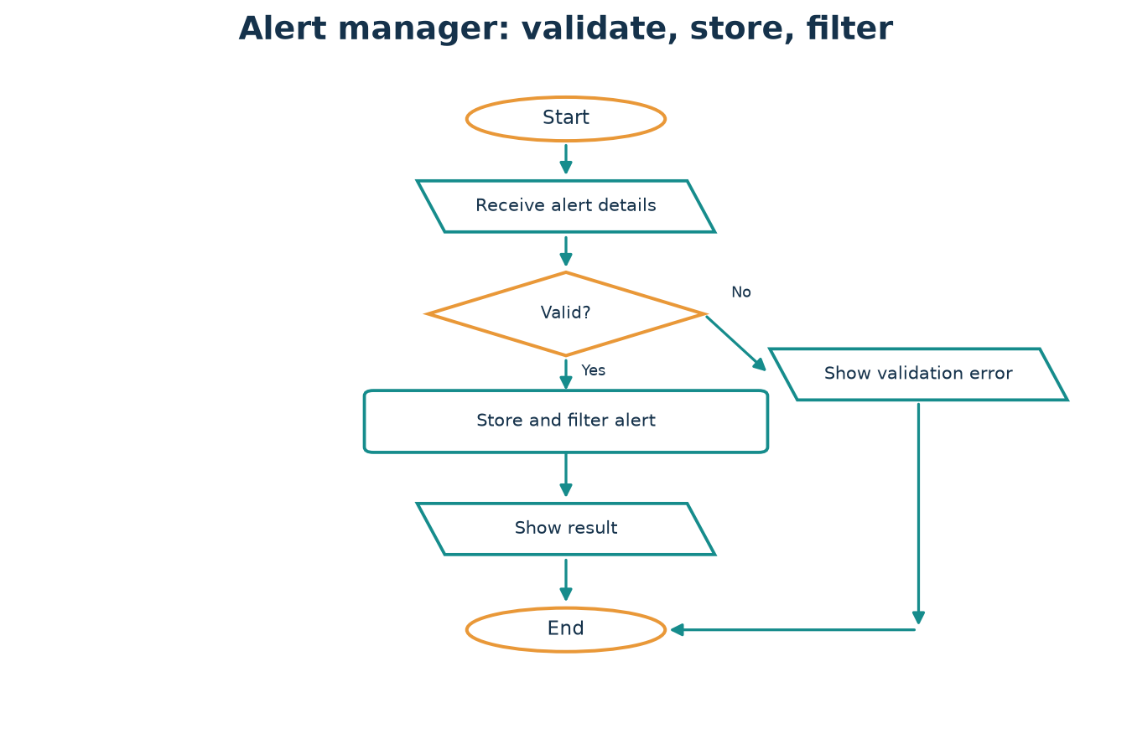
Figure: Complete OOP Mini Projects — use the arrows and labels to connect the idea to the code.

Python syntax and runnable example
PYTHON CODE
class SecurityAlert:
def __init__(self, title, severity):
allowed = {"low", "medium", "high"}
if severity not in allowed:
raise ValueError("unsupported severity")
self.title = title
self.severity = severity
def describe(self):
return f"[{self.severity.upper()}] {self.title}"
alerts = [SecurityAlert("Repeated login failures", "medium")]
for alert in alerts:
print(alert.describe())

Expected output
OUTPUT
[MEDIUM] Repeated login failures

Code walkthrough
The class validates a security record's severity. The list stores multiple objects; a loop calls the common describe() behavior. All examples are safe, defensive record handling.

Connect the analogy to the code
In this example, An incident desk receives standardized reports, checks that each severity is valid, and lets different report types describe their findings. The Python class and object show the same relationship in executable form.
COMMON MISTAKE A record of an alert is not itself a detection system. Do not confuse modeling a report with inspecting systems or performing security actions.

Key terms
Validation: checking input rules. Transaction history: ordered record of changes. Polymorphism: common operation supported by varied types. Defensive security: protecting and monitoring authorized systems.

Remember this
- Project 1 — Student management: know what it means and when it helps.
- Trace the example by identifying each object, its state, and the method called.
- Choose the simplest design that makes changes safe and understandable.

Practice time
- Easy: Define project 1 — student management in your own words.
- Understanding: Explain how the example would change if there were two objects.
- Coding: Modify the program to add one new value or behavior and print the result.
- Challenge: Name one invalid input or edge case and explain how you would test it.

PART 5 · REVISION AND MASTERY

Chapter 20: OOP Comparison and Revision
START HERE A class describes a kind of instance; an object is one concrete instance. One class can create many distinct objects.

Class versus object
A class describes a kind of instance; an object is one concrete instance. One class can create many distinct objects.

Attribute versus method
An attribute stores or exposes a value; a method performs an operation. An instance method typically receives self.

Method and data comparisons
Instance attributes belong to one object; class attributes belong to the class. self refers to an instance; cls conventionally refers to the class. Instance, class, and static methods receive different automatic arguments.

Design comparisons
Encapsulation groups data and controlled behavior; abstraction hides implementation behind essential operations. Inheritance is is-a; composition is has-a. Overriding changes inherited behavior; Python does not generally select methods by overloaded signatures.

Identity and records
`is` tests identity; `==` tests equality. A regular class permits custom behavior; a dataclass reduces boilerplate for records.
REAL-WORLD EXAMPLE Use this chapter as a map: class is the plan, object is the thing, and each design principle describes a different way objects cooperate.

Figure: OOP Comparison and Revision — use the arrows and labels to connect the idea to the code.

Python syntax and runnable example
PYTHON CODE
class Lamp:
kind = "LED"
def __init__(self, room):
self.room = room
def label(self):
return f"{self.kind} lamp in {self.room}"
desk_lamp = Lamp("study")
print(desk_lamp.label())
print(desk_lamp is Lamp("study"))
print(desk_lamp.room == "study")

Expected output
OUTPUT
LED lamp in study
False
True

Code walkthrough
kind is a class attribute, room is an instance attribute, label is an instance method. Constructing a second Lamp makes a different identity even though its room value matches.

Connect the analogy to the code
In this example, Use this chapter as a map: class is the plan, object is the thing, and each design principle describes a different way objects cooperate. The Python class and object show the same relationship in executable form.
COMMON MISTAKE Do not equate equal data with identical objects. The final two comparisons deliberately test different questions.

Key terms
Review the glossary and comparison table in the final revision guide; explain each pair in your own words and give one code example.

Remember this
- Class versus object: know what it means and when it helps.
- Trace the example by identifying each object, its state, and the method called.
- Choose the simplest design that makes changes safe and understandable.

Practice time
- Easy: Define class versus object in your own words.
- Understanding: Explain how the example would change if there were two objects.
- Coding: Modify the program to add one new value or behavior and print the result.
- Challenge: Name one invalid input or edge case and explain how you would test it.

Chapter 21: Common Beginner Mistakes
START HERE Forgetting self causes argument-count errors. Misspelling __init__ means initialization does not run. Use exact names and test by constructing an object.

Method and initializer spelling
Forgetting self causes argument-count errors. Misspelling __init__ means initialization does not run. Use exact names and test by constructing an object.

Classes, attributes, and indentation
A class is not an instance. Indentation defines Python blocks. Distinguish class-wide data from per-instance state, especially mutable values.

Inheritance and privacy assumptions
Use super() cooperatively and inherit only for a true substitutable is-a relationship. An underscore is a convention, not strict privacy.

Returns, references, and complexity
Printing displays text; returning sends a value back to a caller. Assignment aliases objects rather than copying them. Avoid adding classes when functions are simpler.
REAL-WORLD EXAMPLE A display screen shows a result to a person; a returned value hands it back to another part of the program. They are different pathways.

Python syntax and runnable example
PYTHON CODE
class Counter:
def __init__(self):
self.value = 0
def increment(self):
self.value += 1
return self.value
counter = Counter()
result = counter.increment()
print(result)
print(counter.value)

Expected output
OUTPUT
1
1

Code walkthrough
increment updates object state and also returns the new value. The caller can store the result. Without return, result would be None even though a print inside the method might display a value.

Incorrect code and corrected code

Forgetting self
Problematic example:
INCORRECT
class Greeter:
def greet():
return 'hello'
# Greeter().greet() raises TypeError
Correction:
CORRECTED
class Greeter:
def greet(self):
return 'hello'
print(Greeter().greet())
Python supplies the current instance to an instance method.

Misspelling __init__
Problematic example:
INCORRECT
class Pet:
def _init_(self, name):
self.name = name
# Pet('Milo').name raises AttributeError
Correction:
CORRECTED
class Pet:
def __init__(self, name):
self.name = name
print(Pet('Milo').name)
Use exactly two underscores on each side of init.

Confusing class and object
Problematic example:
INCORRECT
class Lamp:
def __init__(self):
self.on = False
lamp = Lamp
# lamp.on is not an instance attribute
Correction:
CORRECTED
class Lamp:
def __init__(self):
self.on = False
lamp = Lamp()
print(lamp.on)
Parentheses create an instance.

Incorrect indentation
Problematic example:
INCORRECT
class Box:
def open(self):
print('open')
Correction:
CORRECTED
class Box:
def open(self):
print('open')
The method body must be indented inside the method.

Mixing class and instance data
Problematic example:
INCORRECT
class Player:
score = 0
# Updating Player.score changes shared class data
Correction:
CORRECTED
class Player:
def __init__(self):
self.score = 0
first = Player()
second = Player()
first.score += 1
Put per-player state on each instance.

Sharing a mutable class list
Problematic example:
INCORRECT
class Team:
members = []
# Every team appends to the same list
Correction:
CORRECTED
class Team:
def __init__(self):
self.members = []
Create a fresh list in __init__ for each team.

Misusing super()
Problematic example:
INCORRECT
class Parent:
def __init__(self, name): self.name = name
class Child(Parent):
def __init__(self, name):
super().__init__()
Correction:
CORRECTED
class Parent:
def __init__(self, name): self.name = name
class Child(Parent):
def __init__(self, name):
super().__init__(name)
Pass the arguments the parent initializer requires.

Inheriting for a has-a relationship
Problematic example:
INCORRECT
class Engine:
pass
class Car(Engine):
pass
Correction:
CORRECTED
class Engine:
pass
class Car:
def __init__(self):
self.engine = Engine()
A car has an engine; it is not an engine.

Assuming underscore means private
Problematic example:
INCORRECT
class User:
def __init__(self):
self._name = 'Ada'
# _name is still accessible by convention
Correction:
CORRECTED
class User:
def __init__(self, name):
self._name = name
@property
def name(self):
return self._name
Treat underscore as an internal-use convention and expose a clear interface.

Forgetting to return
Problematic example:
INCORRECT
class Score:
def double(self, value):
value * 2
result = Score().double(4)
print(result) # None
Correction:
CORRECTED
class Score:
def double(self, value):
return value * 2
print(Score().double(4))
An expression is not returned automatically.

Confusing print with return
Problematic example:
INCORRECT
class Greeter:
def greet(self):
print('hello')
message = Greeter().greet()
# message is None
Correction:
CORRECTED
class Greeter:
def greet(self):
return 'hello'
print(Greeter().greet())
Use return to give a value to the caller; print is for visible output.

Misunderstanding references
Problematic example:
INCORRECT
first = [1, 2]
second = first
second.append(3)
# first is also changed
Correction:
CORRECTED
first = [1, 2]
second = first.copy()
second.append(3)
print(first, second)
Assignment creates another reference. Copy when an independent outer list is needed.

Overcomplicating a simple task
Problematic example:
INCORRECT
class Doubler:
def double(self, value):
return value * 2
print(Doubler().double(4))
Correction:
CORRECTED
def double(value):
return value * 2
print(double(4))
A plain function is clearer when no object state or family of behavior is needed.

Connect the analogy to the code
In this example, A display screen shows a result to a person; a returned value hands it back to another part of the program. They are different pathways. The Python class and object show the same relationship in executable form.
COMMON MISTAKE Avoid mutable class attributes for per-object state, `is` for value comparisons, and broad except clauses that hide programming errors.

Key terms
Return value: result given back to the caller. Print: output to a stream. Aliasing: multiple names for one object. super(): next implementation in MRO.

Remember this
- Method and initializer spelling: know what it means and when it helps.
- Trace the example by identifying each object, its state, and the method called.
- Choose the simplest design that makes changes safe and understandable.

Practice time
- Easy: Define method and initializer spelling in your own words.
- Understanding: Explain how the example would change if there were two objects.
- Coding: Modify the program to add one new value or behavior and print the result.
- Challenge: Name one invalid input or edge case and explain how you would test it.

Chapter 22: Practice Workbook
START HERE Try each prompt before reading the answer key. For output questions, trace object creation, method calls, and mutations in order. For code tasks, run normal and invalid cases.

How to practice
Try each prompt before reading the answer key. For output questions, trace object creation, method calls, and mutations in order. For code tasks, run normal and invalid cases.

Explain before you code
For design problems, list the objects, their responsibilities, the data each owns, and the messages they need to exchange. A short sketch prevents unnecessary inheritance.

Use the answer key to learn
An answer key gives one reasonable solution, not the only possible design. Compare reasoning and test alternative implementations.
REAL-WORLD EXAMPLE Practice is like learning a sport: first watch a demonstration, then predict and perform, and finally check feedback.

Python syntax and runnable example
PYTHON CODE
class Score:
def __init__(self, points):
self.points = points
def passed(self):
return self.points >= 50
print(Score(72).passed())

Expected output
OUTPUT
True

Code walkthrough
Score stores points; passed answers a question about that object's state. Predict the Boolean first, then compare it with the output.

Connect the analogy to the code
In this example, Practice is like learning a sport: first watch a demonstration, then predict and perform, and finally check feedback. The Python class and object show the same relationship in executable form.
COMMON MISTAKE Do not read the answer key before attempting the task. The recall attempt is part of learning.

Key terms
Prediction: reason about output without running. Debugging: locate and correct an error. Challenge: a task combining several concepts.

Remember this
- How to practice: know what it means and when it helps.
- Trace the example by identifying each object, its state, and the method called.
- Choose the simplest design that makes changes safe and understandable.

Practice time
- Easy: Define how to practice in your own words.
- Understanding: Explain how the example would change if there were two objects.
- Coding: Modify the program to add one new value or behavior and print the result.
- Challenge: Name one invalid input or edge case and explain how you would test it.

Chapter 23: Final Master Revision Guide
START HERE class defines instances · object owns state · self is the current instance · __init__ initializes · methods define behavior · properties validate access · inheritance is-a · composition has-a · polymorphism shares an operation · exceptions report invalid actions.

One-page cheat sheet
class defines instances · object owns state · self is the current instance · __init__ initializes · methods define behavior · properties validate access · inheritance is-a · composition has-a · polymorphism shares an operation · exceptions report invalid actions.

Glossary and syntax
Review the glossary, syntax reference, decorators, and special-method table at the end. In Python, naming conventions communicate intent; only language keywords are reserved.

Self-assessment
Can you create and explain a class, preserve valid state, choose composition or inheritance, predict object identity, handle invalid input, and test a small OOP program? If not, revisit the matching chapter.

14-day revision plan
Days 1–2: classes, objects, state. Days 3–4: self, initialization, method types. Days 5–6: properties and exceptions. Days 7–8: inheritance, polymorphism, abstraction. Days 9–10: composition, references, copying. Days 11–12: dataclasses, protocols, SOLID. Day 13: build one project. Day 14: workbook review and self-explanation.
REAL-WORLD EXAMPLE Revisit the map before an exam: recognize the main concepts first, then connect each one to an example and a program.

Figure: Final Master Revision Guide — use the arrows and labels to connect the idea to the code.

Python syntax and runnable example
PYTHON CODE
class Reminder:
def __init__(self, topic):
self.topic = topic
def remember(self):
return f"Blueprint → object; state + behavior: {self.topic}"
print(Reminder("OOP").remember())

Expected output
OUTPUT
Blueprint → object; state + behavior: OOP

Code walkthrough
Use this final reminder as a compact mental model: classes describe, objects hold state, methods act, and collaborating objects make a program.

Connect the analogy to the code
In this example, Revisit the map before an exam: recognize the main concepts first, then connect each one to an example and a program. The Python class and object show the same relationship in executable form.
COMMON MISTAKE Memorizing terms without writing or tracing code is fragile. Explain one example aloud and modify it to check understanding.

Key terms
Cheat sheet: compact reference. Glossary: definitions of key terms. Revision plan: spaced review schedule.

Remember this
- One-page cheat sheet: know what it means and when it helps.
- Trace the example by identifying each object, its state, and the method called.
- Choose the simplest design that makes changes safe and understandable.

Practice time
- Easy: Define one-page cheat sheet in your own words.
- Understanding: Explain how the example would change if there were two objects.
- Coding: Modify the program to add one new value or behavior and print the result.
- Challenge: Name one invalid input or edge case and explain how you would test it.

Chapter Practice — Answer Hints
These are model answer directions for the short practice prompts in each chapter. Your exact implementation may differ; focus on correct reasoning and a testable result.

Chapter 1: Introduction to Programming and OOP
- Easy: Programming means writing precise instructions a computer can follow. A programming language gives people a readable way to express those instructions. Python is a general-purpose language known for readable syntax; it is used in education, automation, web services, science, and defensive security tooling.
- Understanding: A second instance has its own identity and normally its own instance state. Shared class data is the exception when explicitly used.
- Coding: Extend the example around programming and python; add one well-named attribute or method and print its result.
- Challenge: Starting every tiny script with several classes can hide a simple solution. Prefer a function or a few statements until there is a clear group of state and behavior. A good test includes one ordinary value and one boundary or invalid case.

Chapter 2: Understanding Classes and Objects
- Easy: A class defines what data and operations instances of a kind can have. It is not itself a car, student, or phone; it describes how such objects behave.
- Understanding: A second instance has its own identity and normally its own instance state. Shared class data is the exception when explicitly used.
- Coding: Extend the example around a class is a description; add one well-named attribute or method and print its result.
- Challenge: Writing `car = Car` stores the class itself. Use parentheses, such as `car = Car('Nova', 2025)`, to make an instance. A good test includes one ordinary value and one boundary or invalid case.

Chapter 3: Attributes, Methods, and Object State
- Easy: An instance attribute belongs to one object. Assign it through self inside a method, or through the object from outside. Each object can hold a different value.
- Understanding: A second instance has its own identity and normally its own instance state. Shared class data is the exception when explicitly used.
- Coding: Extend the example around instance attributes; add one well-named attribute or method and print its result.
- Challenge: Do not put `marks = []` in the class body if each student needs different marks. That creates one shared list. A good test includes one ordinary value and one boundary or invalid case.

Chapter 4: The __init__() Method and Constructors
- Easy: __init__ is an initializer: Python calls it after a new instance has been allocated. It commonly sets the attributes that make an object ready to use.
- Understanding: A second instance has its own identity and normally its own instance state. Shared class data is the exception when explicitly used.
- Coding: Extend the example around initializing a useful object; add one well-named attribute or method and print its result.
- Challenge: The method name must be exactly `__init__` with two underscores on each side. `__init` is a different name and will not be called automatically. A good test includes one ordinary value and one boundary or invalid case.

Chapter 5: Understanding self Properly
- Easy: self refers to the particular instance on which an instance method is called. Python supplies it when you write `object.method(...)`. The name self is conventional, not a reserved keyword.
- Understanding: A second instance has its own identity and normally its own instance state. Shared class data is the exception when explicitly used.
- Coding: Extend the example around what self means; add one well-named attribute or method and print its result.
- Challenge: A method written as `def greet():` will fail when called as `student.greet()` because Python still supplies the instance. Add `self`. A good test includes one ordinary value and one boundary or invalid case.

Chapter 6: Instance, Class, and Static Methods
- Easy: An instance method's first parameter is usually self. Use it when behavior needs the current object's attributes or needs to change that object.
- Understanding: A second instance has its own identity and normally its own instance state. Shared class data is the exception when explicitly used.
- Coding: Extend the example around instance methods; add one well-named attribute or method and print its result.
- Challenge: Do not forget @classmethod or cls: without the decorator Python does not supply the class. Do not use @staticmethod when the method needs self. A good test includes one ordinary value and one boundary or invalid case.

Chapter 7: Encapsulation and Data Protection
- Easy: Encapsulation places related state and behavior together and provides a clear interface for using them. A bank account can expose deposit and withdraw rather than asking callers to edit its balance carelessly.
- Understanding: A second instance has its own identity and normally its own instance state. Shared class data is the exception when explicitly used.
- Coding: Extend the example around encapsulation; add one well-named attribute or method and print its result.
- Challenge: Do not claim `_balance` is truly private. It is a convention; the goal is clear API design, not secrecy. A good test includes one ordinary value and one boundary or invalid case.

Chapter 8: Inheritance
- Easy: Inheritance creates a specialized class from a base class. The child inherits usable behavior and can add or replace behavior. Think “Car is a Vehicle,” not merely “Car uses a Vehicle.”
- Understanding: A second instance has its own identity and normally its own instance state. Shared class data is the exception when explicitly used.
- Coding: Extend the example around base and derived classes; add one well-named attribute or method and print its result.
- Challenge: Avoid deep inheritance trees and subclasses that cannot honor the behavior promised by the parent. Prefer a composed helper when the relationship is “has-a.” A good test includes one ordinary value and one boundary or invalid case.

Chapter 9: Polymorphism
- Easy: Polymorphism means that a common operation can work with different kinds of objects, with each object providing appropriate behavior. For example, different alerts can each describe themselves.
- Understanding: A second instance has its own identity and normally its own instance state. Shared class data is the exception when explicitly used.
- Coding: Extend the example around one operation, varied behavior; add one well-named attribute or method and print its result.
- Challenge: Polymorphism is not simply “many classes.” The key is a shared operation or interface with behavior suitable to each object. A good test includes one ordinary value and one boundary or invalid case.

Chapter 10: Abstraction and Abstract Classes
- Easy: Abstraction exposes what a user of a class needs to do and leaves implementation details behind the interface. A driver uses a steering wheel and pedals without needing the engine's internal design.
- Understanding: A second instance has its own identity and normally its own instance state. Shared class data is the exception when explicitly used.
- Coding: Extend the example around essential behavior, hidden detail; add one well-named attribute or method and print its result.
- Challenge: A subclass that forgets an inherited abstract method remains abstract and cannot normally be instantiated. A good test includes one ordinary value and one boundary or invalid case.

Chapter 11: Special or Magic Methods
- Easy: Methods with double underscores at both ends are special methods. Python calls many of them in response to ordinary syntax, such as str(obj), len(obj), comparison, addition, or calling an object.
- Understanding: A second instance has its own identity and normally its own instance state. Shared class data is the exception when explicitly used.
- Coding: Extend the example around dunder methods; add one well-named attribute or method and print its result.
- Challenge: Returning a number from __str__ is invalid: __str__ must return a string. Use len(obj) rather than obj.__len__() in normal code. A good test includes one ordinary value and one boundary or invalid case.

Chapter 12: Composition, Aggregation, and Association
- Easy: Association is a broad relationship where objects know about or use each other. Aggregation often describes a group holding references to independently meaningful objects. Composition describes a stronger “part of” relationship.
- Understanding: A second instance has its own identity and normally its own instance state. Shared class data is the exception when explicitly used.
- Coding: Extend the example around objects that work together; add one well-named attribute or method and print its result.
- Challenge: Do not present composition and aggregation as automatically enforced Python ownership rules. They are design descriptions of relationships. A good test includes one ordinary value and one boundary or invalid case.

Chapter 13: Object References, Identity, and Copying
- Easy: A Python variable is a name bound to an object, not a box that automatically contains an independent copy. Assigning `second = first` makes both names refer to the same object.
- Understanding: A second instance has its own identity and normally its own instance state. Shared class data is the exception when explicitly used.
- Coding: Extend the example around names refer to objects; add one well-named attribute or method and print its result.
- Challenge: Do not use `is` to compare numbers or strings for value equality. Use == unless you explicitly mean object identity. A good test includes one ordinary value and one boundary or invalid case.

Chapter 14: Properties, Validation, and Better Class Design
- Easy: @property makes a method appear attribute-like. You can later add validation or computed behavior without changing callers from `student.age` to `student.get_age()`.
- Understanding: A second instance has its own identity and normally its own instance state. Shared class data is the exception when explicitly used.
- Coding: Extend the example around properties as a stable interface; add one well-named attribute or method and print its result.
- Challenge: A setter that assigns `self.age = value` calls itself repeatedly. Store in a differently named internal attribute, such as `_age`. A good test includes one ordinary value and one boundary or invalid case.

Chapter 15: Dataclasses and Type Hints
- Easy: A plain data record often needs an initializer, representation, and equality behavior. @dataclass can generate these methods from declared fields.
- Understanding: A second instance has its own identity and normally its own instance state. Shared class data is the exception when explicitly used.
- Coding: Extend the example around reducing repetitive code; add one well-named attribute or method and print its result.
- Challenge: Annotations are not a runtime validation system. If values must be checked, add explicit validation or use a suitable validation library. A good test includes one ordinary value and one boundary or invalid case.

Chapter 16: Exception Handling Inside Classes
- Easy: An exception is an object that reports an unusual condition. Classes should reject invalid actions clearly instead of returning misleading success values.
- Understanding: A second instance has its own identity and normally its own instance state. Shared class data is the exception when explicitly used.
- Coding: Extend the example around exceptions signal errors; add one well-named attribute or method and print its result.
- Challenge: Avoid a bare `except:` that hides unrelated bugs. Catch only errors the code can meaningfully handle. A good test includes one ordinary value and one boundary or invalid case.

Chapter 17: Iterators, Generators, and Context Managers
- Easy: An iterator provides one value at a time. __iter__ returns an iterator; __next__ returns the next value and raises StopIteration when finished. A for loop handles the protocol for you.
- Understanding: A second instance has its own identity and normally its own instance state. Shared class data is the exception when explicitly used.
- Coding: Extend the example around iteration protocol; add one well-named attribute or method and print its result.
- Challenge: An iterator that never raises StopIteration can make loops run forever. Ensure the end condition is correct. A good test includes one ordinary value and one boundary or invalid case.

Chapter 18: SOLID Principles and Clean OOP Design
- Easy: A class should have one coherent reason to change. Analogy: a librarian organizes books; a separate printer prints receipts. A class that validates students, saves files, and formats reports is hard to change safely.
- Understanding: A second instance has its own identity and normally its own instance state. Shared class data is the exception when explicitly used.
- Coding: Extend the example around s — single responsibility; add one well-named attribute or method and print its result.
- Challenge: Do not turn every two-line program into a framework to satisfy SOLID. The aim is change-friendly code, not maximum abstraction. A good test includes one ordinary value and one boundary or invalid case.

Chapter 19: Complete OOP Mini Projects
- Easy: Store student identity and marks; calculate averages; reject invalid marks; create several independent student records.
- Understanding: A second instance has its own identity and normally its own instance state. Shared class data is the exception when explicitly used.
- Coding: Extend the example around project 1 — student management; add one well-named attribute or method and print its result.
- Challenge: A record of an alert is not itself a detection system. Do not confuse modeling a report with inspecting systems or performing security actions. A good test includes one ordinary value and one boundary or invalid case.

Chapter 20: OOP Comparison and Revision
- Easy: A class describes a kind of instance; an object is one concrete instance. One class can create many distinct objects.
- Understanding: A second instance has its own identity and normally its own instance state. Shared class data is the exception when explicitly used.
- Coding: Extend the example around class versus object; add one well-named attribute or method and print its result.
- Challenge: Do not equate equal data with identical objects. The final two comparisons deliberately test different questions. A good test includes one ordinary value and one boundary or invalid case.

Chapter 21: Common Beginner Mistakes
- Easy: Forgetting self causes argument-count errors. Misspelling __init__ means initialization does not run. Use exact names and test by constructing an object.
- Understanding: A second instance has its own identity and normally its own instance state. Shared class data is the exception when explicitly used.
- Coding: Extend the example around method and initializer spelling; add one well-named attribute or method and print its result.
- Challenge: Avoid mutable class attributes for per-object state, `is` for value comparisons, and broad except clauses that hide programming errors. A good test includes one ordinary value and one boundary or invalid case.

Chapter 22: Practice Workbook
- Easy: Try each prompt before reading the answer key. For output questions, trace object creation, method calls, and mutations in order. For code tasks, run normal and invalid cases.
- Understanding: A second instance has its own identity and normally its own instance state. Shared class data is the exception when explicitly used.
- Coding: Extend the example around how to practice; add one well-named attribute or method and print its result.
- Challenge: Do not read the answer key before attempting the task. The recall attempt is part of learning. A good test includes one ordinary value and one boundary or invalid case.

Chapter 23: Final Master Revision Guide
- Easy: class defines instances · object owns state · self is the current instance · __init__ initializes · methods define behavior · properties validate access · inheritance is-a · composition has-a · polymorphism shares an operation · exceptions report invalid actions.
- Understanding: A second instance has its own identity and normally its own instance state. Shared class data is the exception when explicitly used.
- Coding: Extend the example around one-page cheat sheet; add one well-named attribute or method and print its result.
- Challenge: Memorizing terms without writing or tracing code is fragile. Explain one example aloud and modify it to check understanding. A good test includes one ordinary value and one boundary or invalid case.

Chapter 19 Project Lab — Five Complete Mini Projects
Each project is intentionally dependency-free. The code can be copied into a .py file and run with Python 3.11+. Begin with the requirement, inspect the flow diagram, then run the program and test an invalid case.

Project 1 — Student Management System
PROBLEM Maintain multiple student records and calculate each student's average and result.

Requirements
Store name and marks; accept only marks from 0 through 100; calculate average; display a pass/follow-up message; create multiple students.

Algorithm
- Receive a student's name and marks.
- Reject blank names, empty marks, or marks outside 0–100.
- Create one Student object per valid record.
- Compute the average from that object's marks and display its report.
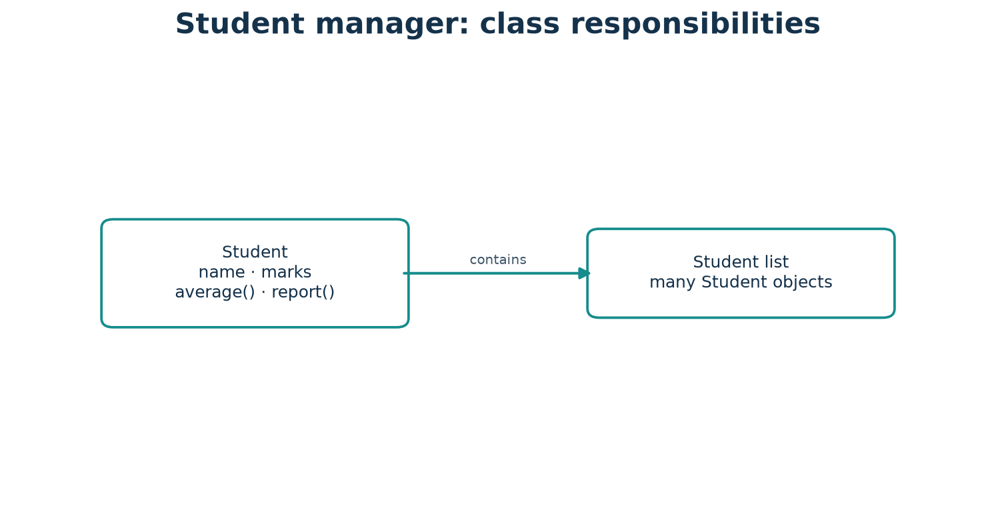
Class diagram: Project 1 — Student Management System — responsibilities and object relationships.
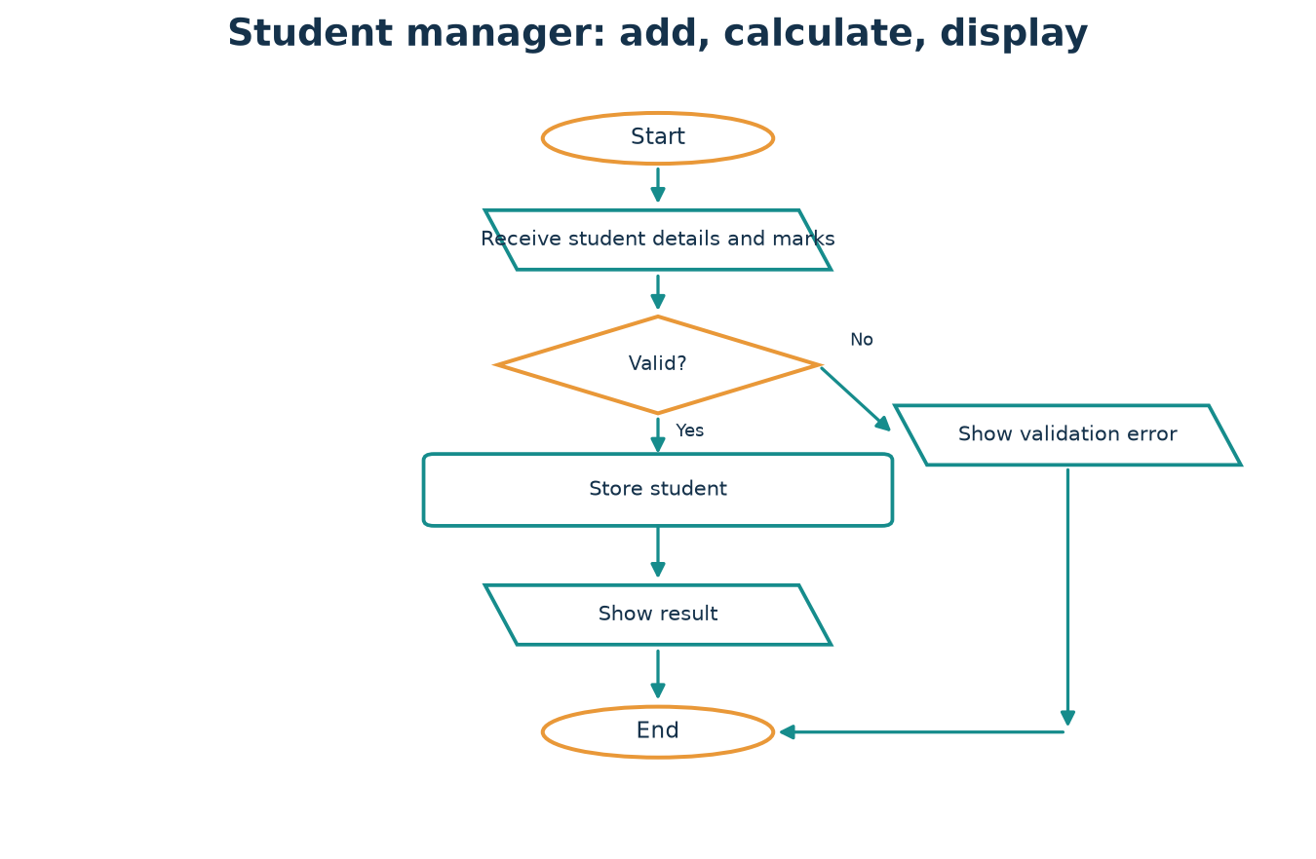
Flowchart: Project 1 — Student Management System — simplified request-to-result path.

Complete source code
PYTHON CODE
class Student:
def __init__(self, name, marks):
if not name.strip():
raise ValueError("name cannot be blank")
if not marks or any(not 0 <= mark <= 100 for mark in marks):
raise ValueError("marks must be from 0 to 100")
self.name = name
self.marks = list(marks)
def average(self):
return sum(self.marks) / len(self.marks)
def report(self):
result = "Pass" if self.average() >= 50 else "Needs practice"
return f"{self.name}: average {self.average():.1f} — {result}"
students = [
Student("Mira", [82, 90, 76]),
Student("Noah", [45, 54, 49]),
]
for student in students:
print(student.report())

Sample output
EXPECTED OUTPUT
Mira: average 82.7 — Pass
Noah: average 49.3 — Needs practice

Walkthrough
Each Student owns a fresh marks list. average calculates from that object's marks; report formats the average and uses a simple threshold. Invalid records fail before creation completes.

Testing examples
Try an empty name, an empty marks list, a mark of 101, and two students with different marks. Confirm one record never changes another.
MODIFICATION CHALLENGE Add a method that returns the highest mark, and a class that stores students and finds a student by name.

DESIGN NOTE Class diagram in words: each named class owns the data and behavior described above; arrows in the flowchart show the order of actions, not hidden external services.

Project 2 — Bank Account Simulator
PROBLEM Model deposits, withdrawals, current balance, and a transaction history while preventing invalid actions.

Requirements
Reject negative starting balances and non-positive transactions; reject withdrawals larger than the balance; record each successful transaction.

Algorithm
- Create an account with a non-negative starting balance.
- Receive a deposit or withdrawal request.
- Validate amount and available funds before changing state.
- Update the balance and append a transaction only after success.
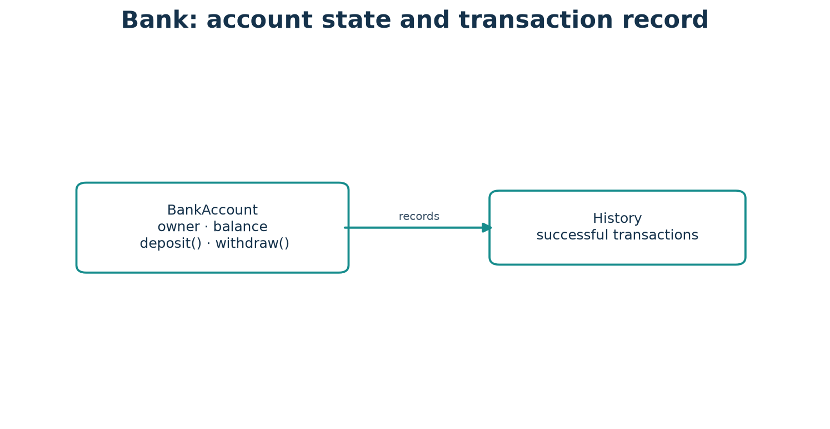
Class diagram: Project 2 — Bank Account Simulator — responsibilities and object relationships.
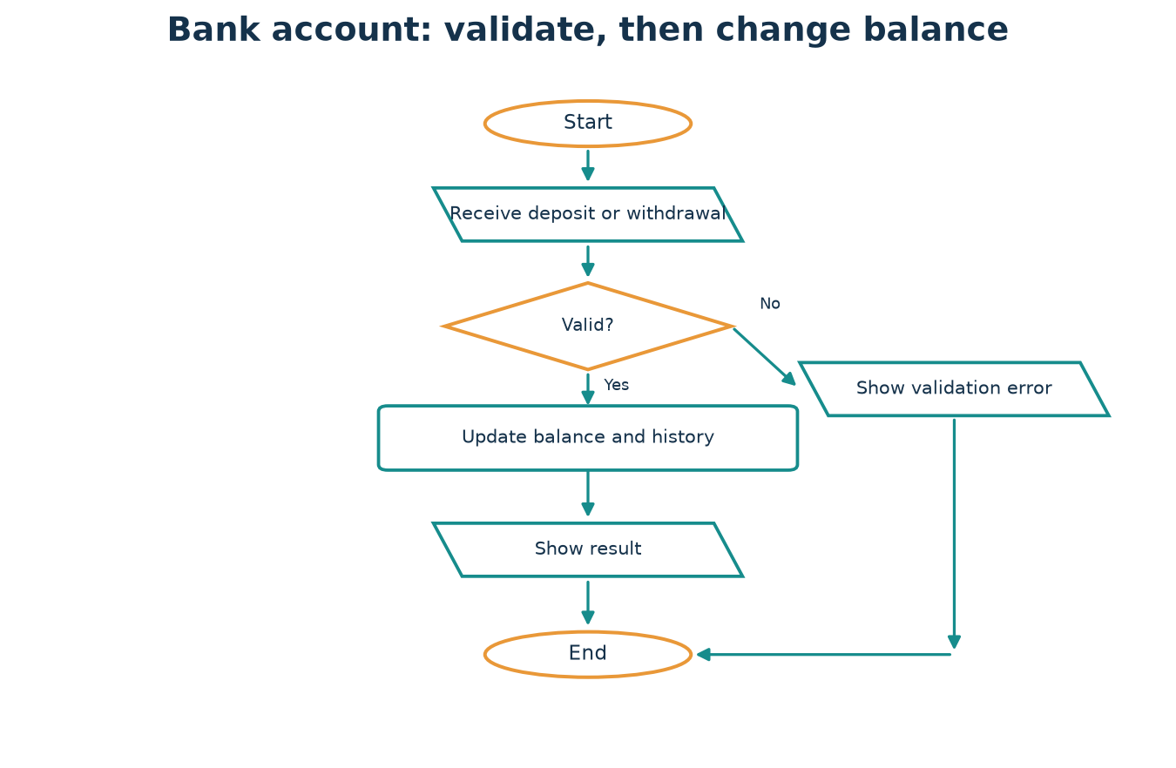
Flowchart: Project 2 — Bank Account Simulator — simplified request-to-result path.

Complete source code
PYTHON CODE
class InsufficientFundsError(Exception):
pass
class BankAccount:
def __init__(self, owner, balance=0):
if balance < 0:
raise ValueError("starting balance cannot be negative")
self.owner = owner
self._balance = balance
self.history = []
@property
def balance(self):
return self._balance
def deposit(self, amount):
if amount <= 0:
raise ValueError("deposit must be positive")
self._balance += amount
self.history.append(f"deposit +{amount:.2f}")
def withdraw(self, amount):
if amount <= 0:
raise ValueError("withdrawal must be positive")
if amount > self._balance:
raise InsufficientFundsError("not enough funds")
self._balance -= amount
self.history.append(f"withdraw -{amount:.2f}")
account = BankAccount("Mira", 100)
account.deposit(25)
account.withdraw(40)
print(account.balance)
print(account.history)

Sample output
EXPECTED OUTPUT
85
['deposit +25.00', 'withdraw -40.00']

Walkthrough
The account validates before mutating. `_balance` is internal by convention and exposed through a read-only property. Each successful transaction adds an entry to history.

Testing examples
Test valid deposit and withdrawal, zero amount, a negative amount, and insufficient funds. Confirm failed transactions do not alter balance or history.
MODIFICATION CHALLENGE Add a transfer method that withdraws from one account and deposits to another, handling failure without losing funds.

DESIGN NOTE Class diagram in words: each named class owns the data and behavior described above; arrows in the flowchart show the order of actions, not hidden external services.

Project 3 — Library Management System
PROBLEM Track a collection of books and whether each one is available to borrow.

Requirements
Book objects hold title, author, and availability; Library can add, borrow, and return books; reject unknown or unavailable titles.

Algorithm
- Add Book objects to the Library collection.
- Find the requested title and verify it is available.
- Mark it borrowed or returned only when the requested transition is valid.
- Report the resulting availability or a clear error.
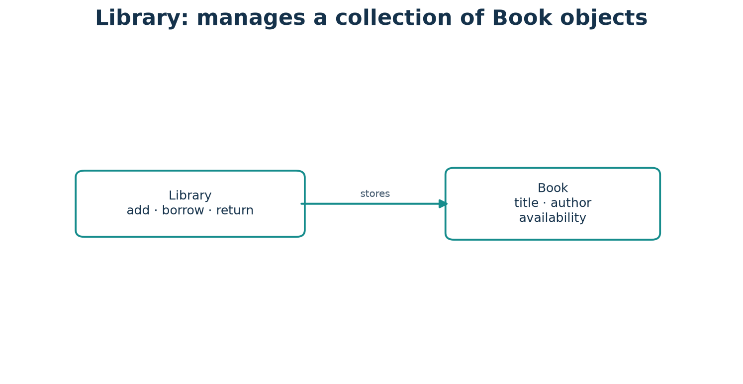
Class diagram: Project 3 — Library Management System — responsibilities and object relationships.
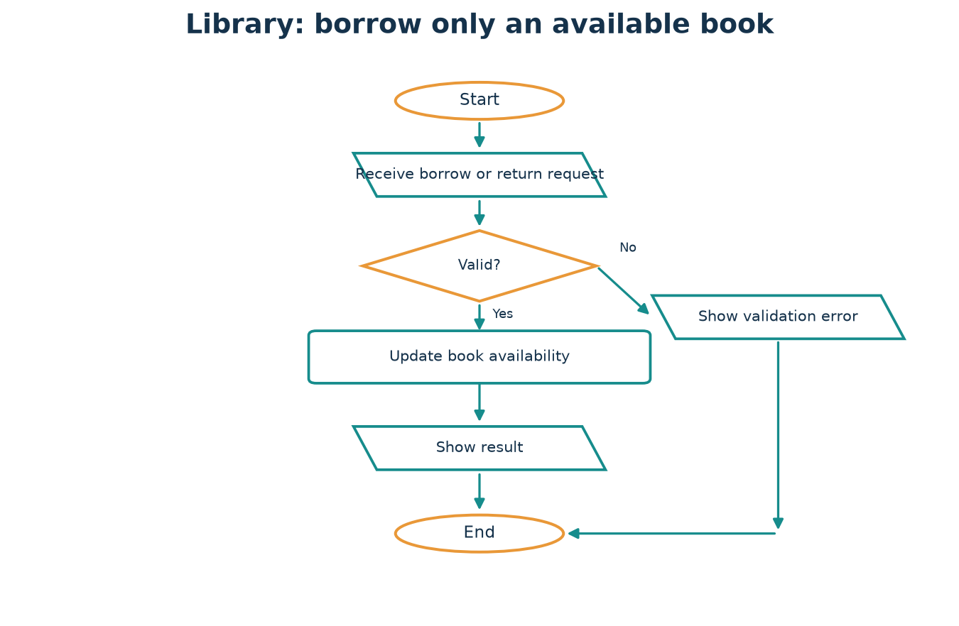
Flowchart: Project 3 — Library Management System — simplified request-to-result path.

Complete source code
PYTHON CODE
class Book:
def __init__(self, title, author):
self.title = title
self.author = author
self.available = True
class Library:
def __init__(self):
self.books = {}
def add(self, book):
self.books[book.title] = book
def borrow(self, title):
book = self.books.get(title)
if book is None:
raise KeyError("book not found")
if not book.available:
raise ValueError("book is already borrowed")
book.available = False
return book
def return_book(self, title):
book = self.books.get(title)
if book is None:
raise KeyError("book not found")
if book.available:
raise ValueError("book was not borrowed")
book.available = True
library = Library()
library.add(Book("The Blue Planet", "A. Rao"))
borrowed = library.borrow("The Blue Planet")
print(borrowed.title, borrowed.available)
library.return_book("The Blue Planet")
print(library.books["The Blue Planet"].available)

Sample output
EXPECTED OUTPUT
The Blue Planet False
True

Walkthrough
Library stores references to Book instances. Borrow changes the selected book's state; returning changes it back. The library and book have distinct responsibilities.

Testing examples
Borrow once, try borrowing again, return once, try returning again, and request a missing title.
MODIFICATION CHALLENGE Add a search method that returns available titles containing a chosen word.

DESIGN NOTE Class diagram in words: each named class owns the data and behavior described above; arrows in the flowchart show the order of actions, not hidden external services.

Project 4 — Online Shopping Cart
PROBLEM Represent products and quantities, allow cart updates, and calculate a total.

Requirements
Product validates non-negative price; cart combines quantities for the same product; reject non-positive quantities; calculate total from item lines.

Algorithm
- Receive a Product and positive quantity.
- Update that product's cart quantity.
- For removal, ensure the requested quantity exists before changing it.
- Calculate total as the sum of price multiplied by quantity.
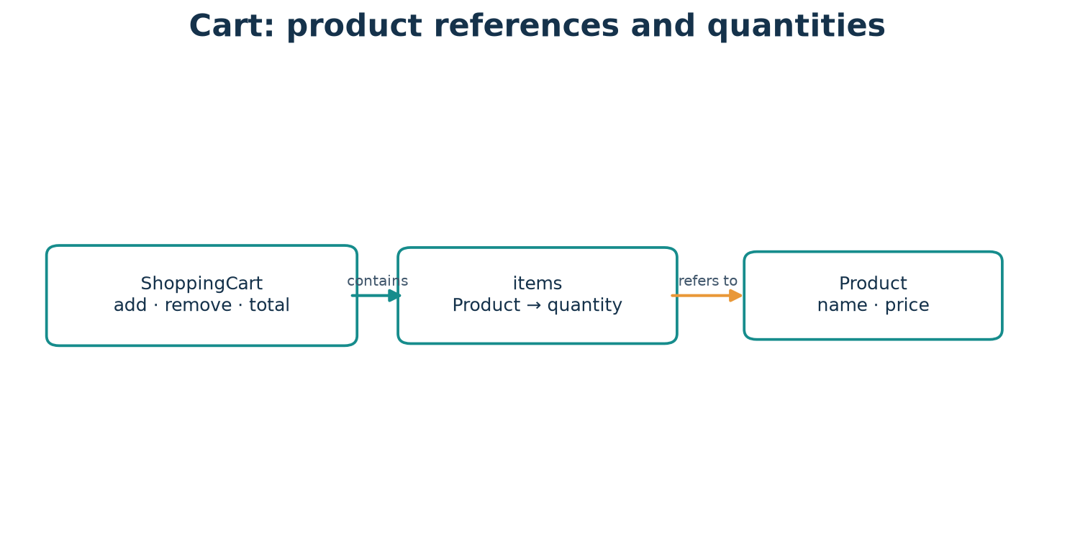
Class diagram: Project 4 — Online Shopping Cart — responsibilities and object relationships.
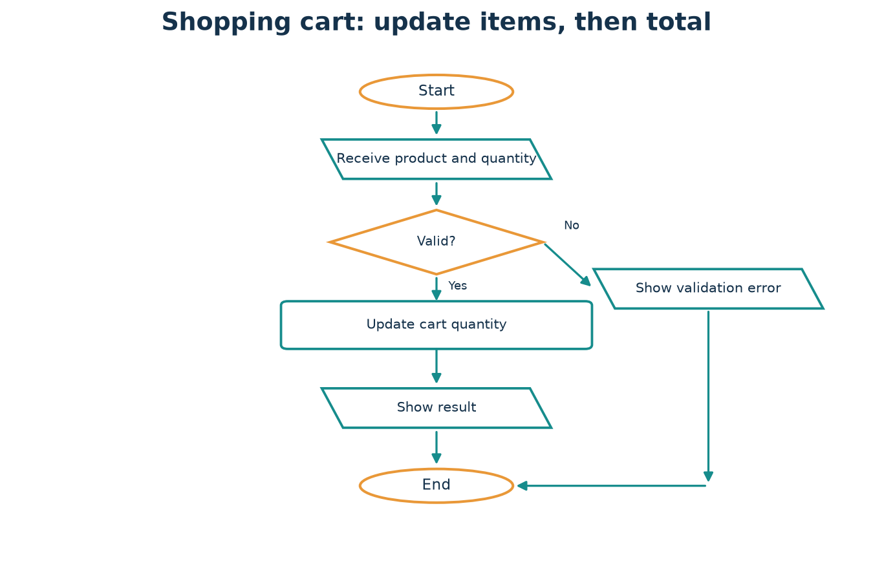
Flowchart: Project 4 — Online Shopping Cart — simplified request-to-result path.

Complete source code
PYTHON CODE
class Product:
def __init__(self, name, price):
if price < 0:
raise ValueError("price cannot be negative")
self.name = name
self.price = price
class ShoppingCart:
def __init__(self):
self.items = {}
def add(self, product, quantity=1):
if quantity <= 0:
raise ValueError("quantity must be positive")
self.items[product] = self.items.get(product, 0) + quantity
def remove(self, product, quantity=1):
if quantity <= 0 or self.items.get(product, 0) < quantity:
raise ValueError("invalid removal quantity")
remaining = self.items[product] - quantity
if remaining:
self.items[product] = remaining
else:
del self.items[product]
def total(self):
return sum(product.price * quantity
for product, quantity in self.items.items())
pen = Product("Pen", 1.50)
cart = ShoppingCart()
cart.add(pen, 3)
cart.remove(pen)
print(f"${cart.total():.2f}")

Sample output
EXPECTED OUTPUT
$3.00

Walkthrough
ShoppingCart holds Product references and quantities. add and remove check quantities; total multiplies each product price by the quantity.

Testing examples
Add the same product twice, remove part and all of its quantity, and try invalid removal and a negative-price product.
MODIFICATION CHALLENGE Add a discount method or a separate pricing policy without placing checkout logic in Product.

DESIGN NOTE Class diagram in words: each named class owns the data and behavior described above; arrows in the flowchart show the order of actions, not hidden external services.

Project 5 — Defensive Cybersecurity Alert Manager
PROBLEM Store and summarize defensive security alerts with a validated severity and source.

Requirements
Represent alert records; support specialized descriptions; filter by severity; use safe static example data only.

Algorithm
- Receive fictional alert fields from an authorized local record source.
- Validate title, source, and severity against the allowed set.
- Store the alert object in the manager.
- Filter by severity and call each matching object's describe method.
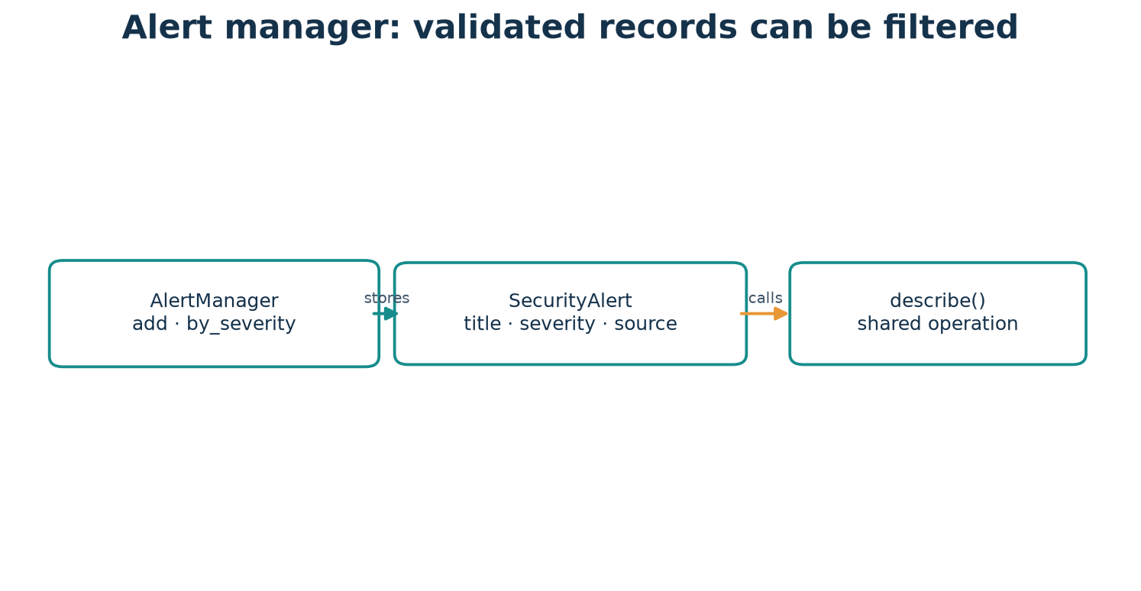
Class diagram: Project 5 — Defensive Cybersecurity Alert Manager — responsibilities and object relationships.
Flowchart: Project 5 — Defensive Cybersecurity Alert Manager — simplified request-to-result path.

Complete source code
PYTHON CODE
class SecurityAlert:
ALLOWED = {"low", "medium", "high", "critical"}
def __init__(self, title, severity, source):
if severity not in self.ALLOWED:
raise ValueError("invalid severity")
if not title.strip() or not source.strip():
raise ValueError("title and source are required")
self.title = title
self.severity = severity
self.source = source
def describe(self):
return f"[{self.severity.upper()}] {self.title} ({self.source})"
class EndpointAlert(SecurityAlert):
def describe(self):
return f"{super().describe()} — review endpoint inventory"
class AlertManager:
def __init__(self):
self.alerts = []
def add(self, alert):
self.alerts.append(alert)
def by_severity(self, severity):
return [alert for alert in self.alerts
if alert.severity == severity]
manager = AlertManager()
manager.add(SecurityAlert("Repeated login failures", "medium", "lab-log"))
manager.add(EndpointAlert("Outdated endpoint", "medium", "inventory"))
for alert in manager.by_severity("medium"):
print(alert.describe())

Sample output
EXPECTED OUTPUT
[MEDIUM] Repeated login failures (lab-log)
[MEDIUM] Outdated endpoint (inventory) — review endpoint inventory

Walkthrough
SecurityAlert validates an incident record; EndpointAlert specializes its description while preserving the base behavior with super(). AlertManager stores and filters both types through a shared describe() operation. This is defensive data modeling using fictional local examples, not instructions for unauthorized activity.

Testing examples
Test each allowed severity, an invalid severity, blank fields, and filtering when no alerts match.
MODIFICATION CHALLENGE Create a subclass for a different alert category that overrides describe(), then display mixed alert types through the same method.

DESIGN NOTE Class diagram in words: each named class owns the data and behavior described above; arrows in the flowchart show the order of actions, not hidden external services.

Quick Comparison Tables
Concept A | Concept B | A | B
Class | Object | description / template | particular instance with identity and state
Attribute | Method | named data or computed value | operation defined on a class
Instance attribute | Class attribute | per-object data | class-level data; beware shared mutables
self | cls | current instance parameter | current class parameter by convention
Instance method | Class method | uses self | @classmethod receives cls
Class method | Static method | uses class; often alternate constructor | no automatic self/cls
Encapsulation | Abstraction | bundle state/behavior; manage access | expose essentials; hide implementation
Inheritance | Composition | is-a specialization | has-a collaborator relationship
Overriding | Overloading | subclass replaces inherited method | Python does not dispatch by signature in the usual OOP sense
is | == | identity | equality according to value behavior
Shallow copy | Deep copy | new outer container, nested references shared | recursively copies nested structure when supported
Regular class | Dataclass | custom control and behavior | convenient generated record methods

Chapter 22 Workbook — Exercises
Attempt the questions before consulting the answer key. For output questions, predict exact output including spaces and line breaks. For debugging, state the error and make the smallest correct change.

A. 25 conceptual questions
- Define a class and an object in one sentence each.
- Why can two instances of the same class have different state?
- What is the difference between an instance attribute and a class attribute?
- What does self refer to inside an instance method?
- Is self a Python keyword? Explain.
- What is the difference between __new__ and __init__?
- When is a class method useful?
- What does a leading underscore communicate in Python?
- What does name mangling do, and what does it not do?
- Explain encapsulation and abstraction without treating them as synonyms.
- Give an example of an is-a relationship and a has-a relationship.
- What does method overriding mean?
- What is the purpose of super()?
- What is method resolution order?
- Explain polymorphism using a method shared by two classes.
- How is duck typing different from inheritance?
- Why does a class with an unimplemented abstract method remain abstract?
- What does __len__ allow an object to support?
- What is the difference between association and composition?
- What does is test, and what does == test?
- What is aliasing?
- How does a shallow copy differ from a deep copy?
- Why use default_factory for a list field in a dataclass?
- Why should a class raise an exception before changing invalid state?
- What is one case where a function is clearer than a class?

B. 15 output-prediction questions

Output 1
PREDICT THE OUTPUT
class Box:
def __init__(self, value): self.value = value
first = Box(3)
second = Box(7)
print(first.value + second.value)
Write the exact output before checking the answer key.

Output 2
PREDICT THE OUTPUT
class Tally:
def __init__(self): self.n = 0
def add(self): self.n += 1
t = Tally()
t.add()
t.add()
print(t.n)
Write the exact output before checking the answer key.

Output 3
PREDICT THE OUTPUT
class Plant:
kind = 'fern'
a = Plant()
b = Plant()
a.kind = 'rose'
print(a.kind, b.kind, Plant.kind)
Write the exact output before checking the answer key.

Output 4
PREDICT THE OUTPUT
class A:
def name(self): return 'A'
class B(A):
def name(self): return 'B'
print(B().name())
Write the exact output before checking the answer key.

Output 5
PREDICT THE OUTPUT
class Item:
def __init__(self, name): self.name = name
one = Item('pen')
two = one
print(one is two)
Write the exact output before checking the answer key.

Output 6
PREDICT THE OUTPUT
class Word:
def __init__(self, text): self.text = text
def __len__(self): return len(self.text)
print(len(Word('cat')))
Write the exact output before checking the answer key.

Output 7
PREDICT THE OUTPUT
class Score:
def __init__(self, n): self.n = n
def passed(self): return self.n >= 50
print(Score(49).passed())
Write the exact output before checking the answer key.

Output 8
PREDICT THE OUTPUT
class Base:
value = 4
class Child(Base): pass
print(Child.value)
Write the exact output before checking the answer key.

Output 9
PREDICT THE OUTPUT
class C:
def __init__(self): self.items = []
a = C(); b = C(); a.items.append(1)
print(a.items, b.items)
Write the exact output before checking the answer key.

Output 10
PREDICT THE OUTPUT
class Label:
def __str__(self): return 'ready'
print(str(Label()))
Write the exact output before checking the answer key.

Output 11
PREDICT THE OUTPUT
class A:
def f(self): return 'a'
class B(A): pass
print(B().f())
Write the exact output before checking the answer key.

Output 12
PREDICT THE OUTPUT
class A:
def __init__(self, x=2): self.x = x
print(A().x, A(5).x)
Write the exact output before checking the answer key.

Output 13
PREDICT THE OUTPUT
class P:
def __init__(self, x): self.x = x
p = P(4)
print(p.x == 4, p is P(4))
Write the exact output before checking the answer key.

Output 14
PREDICT THE OUTPUT
class Add:
def __add__(self, other): return 'together'
print(Add() + Add())
Write the exact output before checking the answer key.

Output 15
PREDICT THE OUTPUT
class C:
def __init__(self): self.x = 1
c = C()
c.x = 8
print(c.x)
Write the exact output before checking the answer key.

C. 20 coding exercises
- Create a `Book` class with a title and author.
- Add a method to `Book` that returns a readable label.
- Create two `Student` objects with independent mark lists.
- Write a `Rectangle` class that calculates area.
- Add validation to reject a negative rectangle side.
- Create a class attribute shared by every `Employee` instance.
- Write a class method that constructs a `Point` from a pair.
- Write a static method that checks whether a value is positive.
- Create a read-only property for a circle's diameter.
- Create `Animal` and `Bird` classes; let Bird extend an inherited description.
- Create two payment classes with the same `pay` method and use them in a loop.
- Create an abstract `Shape` with an abstract `area` method.
- Implement __str__ for a `Student` object.
- Create a shopping cart that totals product price times quantity.
- Create a custom iterator yielding numbers from 1 through n.
- Create a dataclass for a to-do item with a fresh tags list per instance.
- Raise a custom `OutOfStockError` when an item cannot be borrowed.
- Use composition to model a computer containing a processor object.
- Write a defensive alert class that rejects an unsupported severity.
- Build a small class with an `add` operation and test both success and invalid input.

D. 10 debugging exercises

Debug 1
FIND AND FIX THE PROBLEM
class Cat:
def __init(name):
name = name
c = Cat('Milo')
print(c.name)

Debug 2
FIND AND FIX THE PROBLEM
class Dog:
def __init__(self, name):
self.name = name
d = Dog
print(d.name)

Debug 3
FIND AND FIX THE PROBLEM
class Box:
def __init__(self):
self.items = []
def add(self, item):
self.items.append(item)
b = Box()
print(b.add(2))

Debug 4
FIND AND FIX THE PROBLEM
class A:
def __init__(self):
self.value = 1
def get(self):
return value
print(A().get())

Debug 5
FIND AND FIX THE PROBLEM
class Team:
members = []
def add(self, name): self.members.append(name)

Debug 6
FIND AND FIX THE PROBLEM
class Parent:
def __init__(self, name): self.name = name
class Child(Parent):
def __init__(self, name): self.name = name

Debug 7
FIND AND FIX THE PROBLEM
class A:
def __init__(self, value): self.value = value
a = A(1)
b = a
b.value = 9
print(a.value)

Debug 8
FIND AND FIX THE PROBLEM
class Account:
def __init__(self): self.balance = 0
def deposit(self, amount): self.balance += amount
Account().deposit(-5)

Debug 9
FIND AND FIX THE PROBLEM
class Greeting:
def __str__(self): return 5
print(Greeting())

Debug 10
FIND AND FIX THE PROBLEM
class Lamp:
def __init__(self): self.on = False
def switch_on(self): self.on = True
lamp = Lamp
lamp.switch_on()

E. 10 real-world design questions
- A school needs student records with subject marks. What classes and responsibilities would you choose?
- A library lends books to members. Which objects need relationships?
- A game has many characters with different ways to move. How could polymorphism help?
- A cart includes products and quantities. Why is composition preferable to inheritance?
- A bank account must not become negative. Where should validation happen?
- Several file formats can export a report. How could abstraction help?
- A security team records alerts from different sources. How can one report them safely?
- A phone has a battery component. How would you model that relationship?
- A class has five unrelated jobs. What would you do?
- A tiny script doubles a number once. Should it use an OOP hierarchy?

F. 5 combined-concept challenges
- Build a school system with Student, Course, and Enrollment objects; enforce that a student cannot enroll twice in the same course.
- Create a shape collection that totals area for circles and rectangles without checking each concrete type in the loop.
- Design a bank transfer that is safe if the receiving account rejects a deposit.
- Build a defensive alert application with polymorphic alert types, validation, filtering, and a replaceable output sink.
- Model a library with multiple copies of a title, a borrower, and a return history; explain object relationships.

Chapter 22 Answer Key and Explanations

A. Conceptual answers
- A class describes a kind; an object is one particular instance.
- Each instance has its own attributes, so different values can be stored independently.
- Instance attributes belong to one object; class attributes are found on the class and can be shared.
- self refers to the instance on which the bound method was called.
- No. self is a conventional parameter name, not a reserved keyword.
- __new__ creates and returns an instance; __init__ initializes that already-created instance.
- When behavior needs the class or an alternate constructor should use cls.
- It signals an internal-use convention; it does not enforce strict privacy.
- It changes the attribute name to reduce accidental subclass clashes; it is not a security lock.
- Encapsulation groups state and behavior and manages access; abstraction exposes essentials and hides details.
- Example: Car is a Vehicle (is-a); Car has an Engine object (has-a).
- A subclass defines a method with the inherited method's name to provide specialized behavior.
- super() calls the next implementation in the MRO, supporting cooperative inheritance.
- MRO is Python's ordered method lookup path for a class and its bases.
- Different alert classes can each implement describe(), and callers can invoke describe() uniformly.
- Duck typing checks supported behavior; inheritance describes a declared subtype relationship.
- It still lacks required behavior, so it cannot normally be instantiated.
- It lets len(obj) ask the object for its length.
- Association is a general relationship; composition describes a stronger whole-part design.
- is tests whether references identify the same object; == tests equality.
- Aliasing means multiple names refer to one object.
- A shallow copy makes a new outer object but may share nested values; a deep copy recursively copies nested structures.
- default_factory creates a fresh list per instance instead of sharing one mutable list.
- Checking first prevents a failed action from leaving partial or invalid state.
- A one-time calculation or simple transformation with no meaningful state is often clearer as a function.

B. Output answers

Output 1
ANSWER
10
first.value is 3 and second.value is 7; the program adds the two independent attributes.

Output 2
ANSWER
2
The same Tally object is incremented twice, so n moves from 0 to 2.

Output 3
ANSWER
rose fern fern
Assigning a.kind creates an instance attribute that shadows the class value; b and Plant still see the class value.

Output 4
ANSWER
B
B supplies its own name method, so method lookup finds that override first.

Output 5
ANSWER
True
second and first are aliases for the same Box instance.

Output 6
ANSWER
3
len(obj) calls Word.__len__, which returns the number of characters in 'cat'.

Output 7
ANSWER
False
49 is below the inclusive threshold of 50, so passed returns False.

Output 8
ANSWER
4
Child inherits the class attribute value from Base.

Output 9
ANSWER
[1] []
Each C initializer creates a distinct list; only a.items receives the append.

Output 10
ANSWER
ready
str(Label()) invokes __str__ and prints the returned string.

Output 11
ANSWER
a
B inherits A.f unchanged, so the method returns 'a'.

Output 12
ANSWER
2 5
The first instance uses the default x=2; the second uses the supplied x=5.

Output 13
ANSWER
True False
p.x == 4 compares values and is True; p is P(4) compares two distinct instances and is False.

Output 14
ANSWER
together
The + operator invokes Add.__add__, which returns the string 'together'.

Output 15
ANSWER
8
The assignment changes the same object's x attribute from 1 to 8.

C. Coding exercise model solutions
These are runnable example solutions. Other implementations are valid if they meet the stated requirements and preserve the same invariants.

Exercise 1: Create a `Book` class with a title and author.
MODEL SOLUTION
class Book:
def __init__(self, title, author):
self.title = title
self.author = author
print(Book("Python", "A. Rao").title)
EXPECTED OUTPUT
Python
The initializer stores both values on each Book instance.

Exercise 2: Add a method to `Book` that returns a readable label.
MODEL SOLUTION
class Book:
def __init__(self, title, author):
self.title = title
self.author = author
def label(self):
return f"{self.title} by {self.author}"
print(Book("Python", "A. Rao").label())
EXPECTED OUTPUT
Python by A. Rao
label reads this instance's attributes and returns a string.

Exercise 3: Create two `Student` objects with independent mark lists.
MODEL SOLUTION
class Student:
def __init__(self, name):
self.name = name
self.marks = []
ada = Student("Ada")
lin = Student("Lin")
ada.marks.append(95)
print(ada.marks, lin.marks)
EXPECTED OUTPUT
[95] []
The fresh list is created inside __init__, so each student owns a different list.

Exercise 4: Write a `Rectangle` class that calculates area.
MODEL SOLUTION
class Rectangle:
def __init__(self, width, height):
self.width = width
self.height = height
def area(self):
return self.width * self.height
print(Rectangle(4, 3).area())
EXPECTED OUTPUT
12
The area method uses the dimensions stored on the same object.

Exercise 5: Add validation to reject a negative rectangle side.
MODEL SOLUTION
class Rectangle:
def __init__(self, width, height):
if width < 0 or height < 0:
raise ValueError("sides cannot be negative")
self.width = width
self.height = height
print(Rectangle(4, 3).width)
EXPECTED OUTPUT
4
Both values are checked before either becomes object state; invalid dimensions raise ValueError.

Exercise 6: Create a class attribute shared by every `Employee` instance.
MODEL SOLUTION
class Employee:
company_name = "Maple Labs"
def __init__(self, name):
self.name = name
print(Employee("Ada").company_name)
EXPECTED OUTPUT
Maple Labs
company_name is shared class information; name belongs to each instance.

Exercise 7: Write a class method that constructs a `Point` from a pair.
MODEL SOLUTION
class Point:
def __init__(self, x, y):
self.x = x
self.y = y
@classmethod
def from_pair(cls, pair):
return cls(pair[0], pair[1])
point = Point.from_pair((2, 5))
print(point.x, point.y)
EXPECTED OUTPUT
2 5
The class method receives cls and creates the instance through it.

Exercise 8: Write a static method that checks whether a value is positive.
MODEL SOLUTION
class NumberCheck:
@staticmethod
def is_positive(value):
return value > 0
print(NumberCheck.is_positive(4))
EXPECTED OUTPUT
True
The check needs neither per-object state nor class state, so it is static.

Exercise 9: Create a read-only property for a circle's diameter.
MODEL SOLUTION
class Circle:
def __init__(self, radius):
self.radius = radius
@property
def diameter(self):
return self.radius * 2
print(Circle(3).diameter)
EXPECTED OUTPUT
6
The property computes a read-only value from radius without a setter.

Exercise 10: Create `Animal` and `Bird` classes; let Bird extend an inherited description.
MODEL SOLUTION
class Animal:
def describe(self):
return "An animal"
class Bird(Animal):
def describe(self):
return f"{super().describe()} that can be a bird"
print(Bird().describe())
EXPECTED OUTPUT
An animal that can be a bird
Bird overrides describe and extends the parent behavior with super().

Exercise 11: Create two payment classes with the same `pay` method and use them in a loop.
MODEL SOLUTION
class CardPayment:
def pay(self, amount):
return f"card: {amount}"
class CashPayment:
def pay(self, amount):
return f"cash: {amount}"
for method in (CardPayment(), CashPayment()):
print(method.pay(10))
EXPECTED OUTPUT
card: 10
cash: 10
Both classes offer pay, so the loop can use either without checking its concrete type.

Exercise 12: Create an abstract `Shape` with an abstract `area` method.
MODEL SOLUTION
from abc import ABC, abstractmethod
class Shape(ABC):
@abstractmethod
def area(self):
raise NotImplementedError
class Square(Shape):
def __init__(self, side):
self.side = side
def area(self):
return self.side ** 2
print(Square(4).area())
EXPECTED OUTPUT
16
Shape declares the contract; Square implements area and can then be instantiated.

Exercise 13: Implement __str__ for a `Student` object.
MODEL SOLUTION
class Student:
def __init__(self, name):
self.name = name
def __str__(self):
return f"Student: {self.name}"
print(Student("Mira"))
EXPECTED OUTPUT
Student: Mira
__str__ must return a human-readable string.

Exercise 14: Create a shopping cart that totals product price times quantity.
MODEL SOLUTION
class Product:
def __init__(self, price):
self.price = price
class Cart:
def __init__(self):
self.items = []
def add(self, product, quantity):
self.items.append((product, quantity))
def total(self):
return sum(product.price * quantity for product, quantity in self.items)
cart = Cart()
cart.add(Product(2.5), 2)
print(cart.total())
EXPECTED OUTPUT
5.0
The cart composes product references with quantities and computes extended prices.

Exercise 15: Create a custom iterator yielding numbers from 1 through n.
MODEL SOLUTION
class CountUp:
def __init__(self, limit):
self.limit = limit
self.current = 0
def __iter__(self):
return self
def __next__(self):
if self.current >= self.limit:
raise StopIteration
self.current += 1
return self.current
print(list(CountUp(3)))
EXPECTED OUTPUT
[1, 2, 3]
The iterator advances its state and ends by raising StopIteration.

Exercise 16: Create a dataclass for a to-do item with a fresh tags list per instance.
MODEL SOLUTION
from dataclasses import dataclass, field
@dataclass
class Task:
title: str
tags: list[str] = field(default_factory=list)
one = Task("read")
two = Task("write")
one.tags.append("school")
print(one.tags, two.tags)
EXPECTED OUTPUT
['school'] []
default_factory provides a new mutable list for each task.

Exercise 17: Raise a custom `OutOfStockError` when an item cannot be borrowed.
MODEL SOLUTION
class OutOfStockError(Exception):
pass
class Shelf:
def __init__(self, count):
self.count = count
def borrow(self):
if self.count == 0:
raise OutOfStockError("no copies available")
self.count -= 1
return self.count
print(Shelf(2).borrow())
EXPECTED OUTPUT
1
The domain exception is raised before an unavailable item could change state.

Exercise 18: Use composition to model a computer containing a processor object.
MODEL SOLUTION
class Processor:
def start(self):
return "processor started"
class Computer:
def __init__(self, processor):
self.processor = processor
def start(self):
return self.processor.start()
computer = Computer(Processor())
print(computer.start())
EXPECTED OUTPUT
processor started
Computer has a Processor and delegates work to it: composition, not inheritance.

Exercise 19: Write a defensive alert class that rejects an unsupported severity.
MODEL SOLUTION
class SecurityAlert:
ALLOWED = {"low", "medium", "high"}
def __init__(self, severity):
if severity not in self.ALLOWED:
raise ValueError("unsupported severity")
self.severity = severity
print(SecurityAlert("high").severity)
EXPECTED OUTPUT
high
The class checks the allowed values before storing severity.

Exercise 20: Build a small class with an `add` operation and test both success and invalid input.
MODEL SOLUTION
class Accumulator:
def __init__(self):
self.value = 0
def add(self, amount):
if amount <= 0:
raise ValueError("amount must be positive")
self.value += amount
return self.value
counter = Accumulator()
assert counter.add(3) == 3
try:
counter.add(0)
except ValueError as error:
print(counter.value, str(error))
EXPECTED OUTPUT
3 amount must be positive
The assertion tests success; invalid input raises a clear error without changing the stored value.

D. Debugging corrections

Debug 1
Original problem:
INCORRECT
class Cat:
def __init(name):
name = name
c = Cat('Milo')
print(c.name)
Add self to __init__ and assign self.name = name.
CORRECTED
class Cat:
def __init__(self, name):
self.name = name
cat = Cat("Milo")
print(cat.name)
EXPECTED OUTPUT
Milo
The initializer needs self and must assign the value to self.name.

Debug 2
Original problem:
INCORRECT
class Dog:
def __init__(self, name):
self.name = name
d = Dog
print(d.name)
Create an instance with Dog('Rex'); d currently refers to the class.
CORRECTED
class Dog:
def __init__(self, name):
self.name = name
dog = Dog("Rex")
print(dog.name)
EXPECTED OUTPUT
Rex
Dog without parentheses refers to the class; Dog('Rex') creates an instance.

Debug 3
Original problem:
INCORRECT
class Box:
def __init__(self):
self.items = []
def add(self, item):
self.items.append(item)
b = Box()
print(b.add(2))
The method changes state but returns None. Print b.items or explicitly return the updated list/value.
CORRECTED
class Box:
def __init__(self):
self.items = []
def add(self, item):
self.items.append(item)
box = Box()
box.add(2)
print(box.items)
EXPECTED OUTPUT
[2]
add mutates state but has no return statement; print the state rather than the method result.

Debug 4
Original problem:
INCORRECT
class A:
def __init__(self):
self.value = 1
def get(self):
return value
print(A().get())
Use self.value; value is not a local variable in get.
CORRECTED
class A:
def __init__(self, value):
self.value = value
def get(self):
return self.value
print(A(3).get())
EXPECTED OUTPUT
3
The instance attribute must be accessed through self inside get.

Debug 5
Original problem:
INCORRECT
class Team:
members = []
def add(self, name): self.members.append(name)
For independent teams, define self.members = [] in __init__.
CORRECTED
class Team:
def __init__(self):
self.members = []
def add(self, name):
self.members.append(name)
first = Team()
second = Team()
first.add("Ada")
print(first.members, second.members)
EXPECTED OUTPUT
['Ada'] []
The per-team list is initialized on each object rather than shared as a class attribute.

Debug 6
Original problem:
INCORRECT
class Parent:
def __init__(self, name): self.name = name
class Child(Parent):
def __init__(self, name): self.name = name
Calling super().__init__(name) is a clearer way to reuse parent initialization when it fits.
CORRECTED
class Parent:
def __init__(self, name):
self.name = name
class Child(Parent):
def __init__(self, name):
super().__init__(name)
print(Child("Mira").name)
EXPECTED OUTPUT
Mira
super().__init__ must receive the required name argument.

Debug 7
Original problem:
INCORRECT
class A:
def __init__(self, value): self.value = value
a = A(1)
b = a
b.value = 9
print(a.value)
Output is 9 because a and b alias the same object. Copy explicitly if independent state is required.
CORRECTED
first = [1, 2]
second = first.copy()
second.append(3)
print(first, second)
EXPECTED OUTPUT
[1, 2] [1, 2, 3]
copy creates a separate outer list for these scalar elements; simple assignment would alias the same list.

Debug 8
Original problem:
INCORRECT
class Account:
def __init__(self): self.balance = 0
def deposit(self, amount): self.balance += amount
Account().deposit(-5)
Validate amount > 0 before changing balance and raise ValueError for an invalid deposit.
CORRECTED
class Account:
def __init__(self):
self.balance = 0
def deposit(self, amount):
if amount <= 0:
raise ValueError("deposit must be positive")
self.balance += amount
account = Account()
account.deposit(5)
print(account.balance)
EXPECTED OUTPUT
5
Validate before mutating so invalid deposits cannot make the balance negative.

Debug 9
Original problem:
INCORRECT
class Greeting:
def __str__(self): return 5
print(Greeting())
__str__ must return a string; return '5' rather than integer 5.
CORRECTED
class Greeting:
def __str__(self):
return "5"
print(Greeting())
EXPECTED OUTPUT
5
__str__ must return a string, not an integer.

Debug 10
Original problem:
INCORRECT
class Lamp:
def __init__(self): self.on = False
def switch_on(self): self.on = True
lamp = Lamp
lamp.switch_on()
Instantiate with lamp = Lamp() before calling an instance method.
CORRECTED
class Lamp:
def __init__(self):
self.on = False
def switch_on(self):
self.on = True
lamp = Lamp()
lamp.switch_on()
print(lamp.on)
EXPECTED OUTPUT
True
Instantiate Lamp before invoking its instance method.

E. Design answer guides
- A Student can own identity and marks and calculate its average; a roster/School can manage a collection if collection operations are needed.
- Library manages books; Book tracks availability; Member can represent a borrower. Keep lending rules in a focused service or library method.
- Define a common move operation and let each character implement its own movement; the game loop calls move() on each.
- A cart has products; it is not a product. Store product references and quantity data.
- In the account's withdrawal operation before the balance is changed; expose a clear error for invalid requests.
- Define a small exporter contract or shared export operation; provide one implementation per format.
- Normalize validated fields in alert objects, expose a shared describe method, and keep examples defensive and authorized.
- Phone contains or refers to a Battery object: a has-a relationship modeled with composition.
- Split responsibilities into focused collaborators and have a coordinating component depend on their small interfaces.
- Probably not; a plain function is clearer until there is meaningful object state or a family of behaviors.

F. Challenge solution approaches
- Use a set or search in Course/Enrollment state, validate before inserting, and keep identity rules explicit.
- Give each shape an area method and sum shape.area(); each class supplies its own calculation.
- Validate both accounts and amount before mutation; define a clear transaction approach and preserve balances if an operation fails.
- Use a base contract or duck typing, validate records, filter by fields, and inject a small writer collaborator.
- Use BookCopy instances and borrower references or loan records; distinguish titles from physical copies and document lifecycle.

Chapter 23 Final Master Revision Guide

One-page OOP cheat sheet
REMEMBER Class = blueprint; object = instance; attributes = state; methods = behavior; self = current instance; __init__ = initialization; property = managed attribute; inheritance = is-a; composition = has-a; polymorphism = common operation, varied behavior.

Complete glossary
Term | Meaning
Abstraction | Expose essential operations while hiding implementation details.
Abstract base class | A class that describes a contract and may contain abstract methods.
Aggregation | A whole-part design relationship with relatively independent parts.
Aliasing | Two or more names referring to the same object.
Attribute | A named value associated with an object or class.
Class | A definition from which instances can be created.
Class attribute | An attribute defined on a class rather than separately per instance.
Class method | A method decorated with @classmethod and conventionally receiving cls.
Composition | A stronger whole-part relationship, typically implemented with object references.
Dataclass | A class decorated with @dataclass to generate common data-record methods.
Duck typing | Using an object based on the operations it supports.
Encapsulation | Grouping state and behavior and presenting a controlled interface.
Exception | An object used to report an error or unusual condition.
Identity | The distinction of one particular object from another.
Inheritance | Creating a specialized class from one or more base classes.
Instance | An object created from a class.
Instance attribute | A value associated with one particular object.
Instance method | A method that conventionally receives the current instance as self.
Invariant | A condition that a well-designed object keeps true.
MRO | The method resolution order used to search classes for attributes.
Method | A function defined in a class and accessed through the class or its instances.
Mutable | Able to change in place.
Object | A value with identity, type, and associated state or behavior.
Polymorphism | Using a common operation with objects that provide different implementations.
Property | A managed attribute interface defined with @property.
Reference | A way a name or object can access another object.
Shallow copy | A copy of an outer object that may share nested references.
Special method | A method such as __len__ that Python uses to implement an operation.
Static method | A @staticmethod with no automatic instance or class argument.
Type hint | An annotation describing intended value types; not generally runtime enforcement.

Syntax reference
PYTHON CODE
class Name:
shared_value = "class attribute"
def __init__(self, value):
self.value = value
def instance_method(self):
return self.value
@classmethod
def from_value(cls, value):
return cls(value)
@staticmethod
def helper(value):
return value
@property
def display(self):
return str(self.value)

Important keywords and built-ins
Keyword / built-in | Purpose
class | Define a class.
def | Define a function or method.
self | Conventional parameter name for an instance; not a Python keyword.
return | Send a value back to the caller.
super() | Access the next implementation in the method resolution order.
is | Test object identity; commonly used with None.
raise | Raise an exception.
try / except / else / finally | Handle errors and define success and cleanup paths.
for / in | Iterate over an iterable.
with | Use a context manager around a block.
yield | Produce a value from a generator function.
isinstance(value, Type) | Check whether a value is an instance of a type or its subclass.
len(value) | Ask an object for its length via __len__.
sum(values) | Add numeric values from an iterable.
property | Built-in decorator used to define a property interface.
ABC / abstractmethod | Names from abc for abstract base class contracts; not Python keywords.

Important decorators and special methods
Name | Purpose
@property | managed attribute read
@classmethod | method receives cls
@staticmethod | no automatic first argument
@dataclass | generate common record methods
__init__ | initialize an instance
__str__ / __repr__ | human / developer representation
__len__ | support len(obj)
__eq__ | define equality behavior
__add__ | define + behavior
__iter__ / __next__ | iteration protocol
__enter__ / __exit__ | context-manager protocol

Self-assessment checklist
- I can distinguish a class from an instance and explain object identity.
- I can use self, initialize state, and choose instance/class/static methods.
- I can validate state with methods and properties and raise clear exceptions.
- I can explain inheritance, overriding, super(), MRO, and polymorphism.
- I can choose composition when an object has another object.
- I can reason about aliases, mutability, equality, and copying.
- I can write a small project, test invalid cases, and explain its design.

14-day revision plan
- Days 1–2: classes, objects, attributes, methods, and state.
- Days 3–4: __init__, self, class methods, and static methods.
- Days 5–6: encapsulation, properties, validation, and exceptions.
- Days 7–8: inheritance, super(), MRO, polymorphism, and abstraction.
- Days 9–10: composition, references, identity, mutability, and copying.
- Days 11–12: special methods, dataclasses, iterators, and SOLID.
- Day 13: complete a mini project and test invalid input.
- Day 14: answer workbook questions and explain the OOP map aloud.

Appendix A — Your Original OOP Learning Files
This appendix preserves the five original Python lesson files as code listings and records the output obtained by running each file in the local Python environment. The source code is shown as found; the teaching notes immediately after each listing explain terminology and correct misconceptions without silently rewriting the originals.
SOURCE PRESERVATION The original files were read and executed, not edited. The code blocks below retain their source text; explanations clarify how Python evaluates it.

Original file: class-2.py
Original location: class-2.py
What it teaches: A Student instance method that prints a greeting and the supplied name and age.
ORIGINAL SOURCE — PRESERVED
''' In this program we need to defint the function inside the class and ascess it '''
class Student:
def studentdetails(xyz,name,age):
print('Hi.. Children... ')
print(name,age)
s=Student()
s.studentdetails('abhi',16)

Actual output
CAPTURED WHEN EXECUTED
Hi.. Children...
abhi 16
EXPLANATION AND ACCURACY NOTE The first parameter `xyz` receives the instance when the method is called through `s.studentdetails(...)`. `self` is the conventional clearer name, not a keyword. The example receives values as parameters but does not store them on the object.

Incorporated into: Chapter 5: self and bound methods; source-material appendix.

Original file: class-3.py
Original location: class-3.py
What it teaches: A Car class with class-level name/color data and an instance method that prints a speed and reads attributes through self.
ORIGINAL SOURCE — PRESERVED
''' In this program we need to learn the main use of self function .
If we want to use the variables in a funtion from the class inside a function then also we use self.
'''
class Car:
name='BMW'
color='RED'
def speed(self):
print('200kmph')
print(self.name,self.color)
c=Car()
c.speed()

Actual output
CAPTURED WHEN EXECUTED
200kmph
BMW RED
EXPLANATION AND ACCURACY NOTE `self.name` and `self.color` find the values through the instance (and then the class if no instance value shadows them). The speed is hard-coded behavior in this example, not a stored per-car speed.

Incorporated into: Chapters 2–3: classes, objects, attributes, and methods; source-material appendix.

Original file: class-4.py
Original location: class-4.py
What it teaches: A Car class with shared name/color, an initializer that prints those values and a speed message, and a separate method that prints another message.
ORIGINAL SOURCE — PRESERVED
''' in this class we need to learn the __init__ constructor.
1. The __init__ constructor run code automatically when an object is created.
2. self stores the data inside object
3. When we use __init__ we do not need to call the function inside a class to print the output.
'''
# example:
class Car:
name='BMW'
color='RED'
def __init__(self):
print(self.name,self.color)
print('200kmph')
def speed(self):
print('speed is executed....')
c=Car()
c.speed()

Actual output
CAPTURED WHEN EXECUTED
BMW RED
200kmph
speed is executed....
EXPLANATION AND ACCURACY NOTE `__init__` is called automatically to initialize a newly created instance; it is not technically the method that creates the object. Printing in an initializer is possible, though initializing attributes is usually more reusable than printing there.

Incorporated into: Chapter 4: initialization; source-material appendix.

Original file: class-5.py
Original location: class-5.py
What it teaches: Two Car objects receive different name, color, and speed values; display prints each object's values.
ORIGINAL SOURCE — PRESERVED
# Creating Different objects using self, __init__
''' In this class we need to learn about the creating the different objects of a class '''
'''
1. When we use __init__ we can directly give the parameters in the object.
2. we must need to create the partion to the argument when we use __init__ like ( self.name=name )
'''
class Car():
def __init__(self,name,color,speed):
self.name=name
self.color=color
self.speed=speed
def display(self):
print(self.name)
print(self.color)
print(self.speed)
c=Car('RR','BLUE',200)
c.display()
print('\n')
c2=Car('BMW','RED',"100kmph")
c2.display()

Actual output
CAPTURED WHEN EXECUTED
RR
BLUE
200
BMW
RED
100kmph
EXPLANATION AND ACCURACY NOTE Each assignment such as `self.name = name` creates instance state. The speed values mix an integer (`200`) and a string (`'100kmph'`); consistent numeric units are easier to calculate and validate.

Incorporated into: Chapters 2–5: instance state, __init__, and self; source-material appendix.

Original file: class_1.py
Original location: class_1.py
What it teaches: A Student class with name, age, and course values, followed by creation of one instance and attribute reads.
ORIGINAL SOURCE — PRESERVED
''' In this program we need to learn the defining of a class use/ asscessing the variales in that class '''
class Student:
name='Chaithanya'
age=int(16)
course='Diploma-cse'
s1=Student()
print(s1.name)
print(s1.age)
print(s1.course)

Actual output
CAPTURED WHEN EXECUTED
Chaithanya
16
Diploma-cse
EXPLANATION AND ACCURACY NOTE The values are class attributes because they are assigned in the class body. Every instance can see them; they are not separately initialized for each student. `int(16)` is valid but unnecessary; `16` is already an integer.

Incorporated into: Chapter 3: attributes and object state; source-material appendix.

Improved versions of the original lessons
These small programs keep the original examples' familiar Student and Car ideas while demonstrating the more reusable pattern: create instance data in __init__, keep data types consistent, and return values when a caller needs to reuse a result.

Student records with per-object attributes
PYTHON CODE
class Student:
def __init__(self, name, age, course):
self.name = name
self.age = age
self.course = course
def summary(self):
return f"{self.name}, age {self.age}, studies {self.course}"
first = Student("Chaithanya", 16, "Diploma-CSE")
second = Student("Abhi", 16, "Diploma-CSE")
print(first.summary())
print(second.summary())
print(first is second)
EXPECTED OUTPUT
Chaithanya, age 16, studies Diploma-CSE
Abhi, age 16, studies Diploma-CSE
False
Both objects use one class definition but have independent instance attributes. `is` checks that the objects are distinct.

Cars with consistent speed values and reusable behavior
PYTHON CODE
class Car:
def __init__(self, name, color, speed_kmph):
if speed_kmph < 0:
raise ValueError("speed cannot be negative")
self.name = name
self.color = color
self.speed_kmph = speed_kmph
def display(self):
return f"{self.name} ({self.color}) — {self.speed_kmph} km/h"
first = Car("RR", "Blue", 200)
second = Car("BMW", "Red", 100)
print(first.display())
print(second.display())
EXPECTED OUTPUT
RR (Blue) — 200 km/h
BMW (Red) — 100 km/h
The speed is a number for both cars, making comparison and arithmetic possible. The display method formats it for people. Validation rejects an impossible negative speed.

Appendix B — Original Class and Object Infographic
The following image is rendered from the SVG infographic already present in OOPS-learning. It summarizes class as a blueprint and objects as instances with their own state. The printed code example is an introductory illustration; the full guide explains these ideas in greater detail.

Clear, print-ready summary based on the original topics
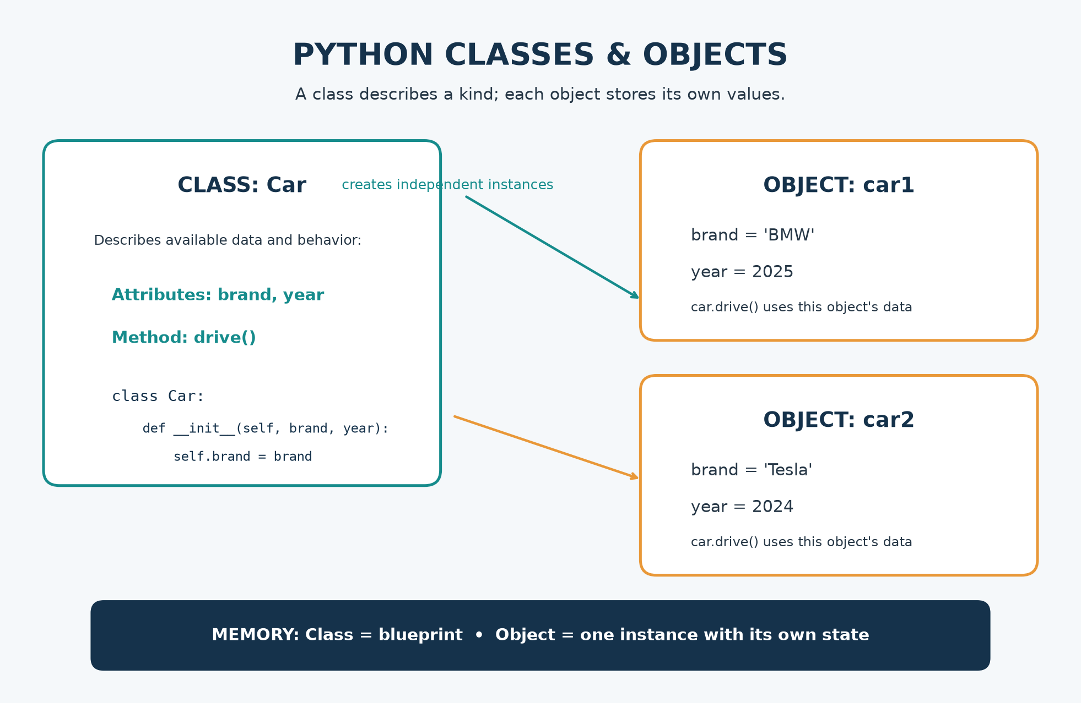
Figure B.1 — Newly redrawn class/object diagram using the ideas in the original project infographic.

Original source artwork, rendered without editing the source file
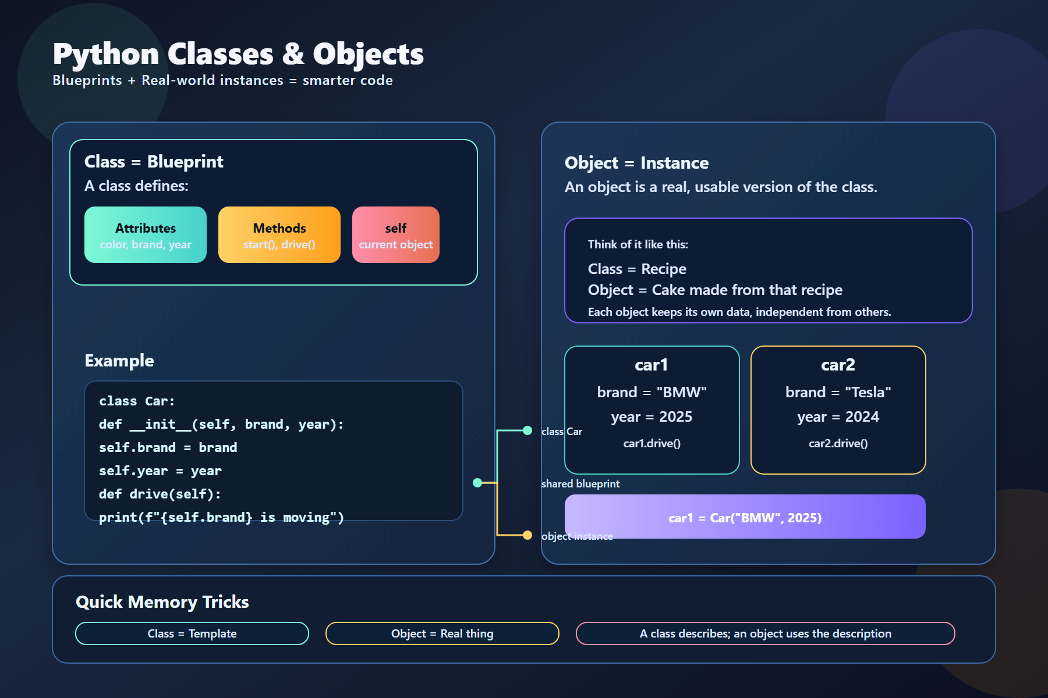
Figure B.2 — Existing `python_class_object_infographic.svg`, embedded as a local PNG rendering.
EDITORIAL NOTE The original illustration is preserved. In its rendered layout, some connector labels overlap the panels and the code line reaches the panel edge. The redrawn version above keeps the original class/object message while presenting a cleaner print layout. Also, self is a conventional method parameter representing the current instance; it is not a separate class attribute.

Appendix C — Source Material Crosswalk
Original file | Content found | Where included
class_1.py | Student class attributes and reading values | Classes/objects; attributes vs instance state
class-2.py | Instance method and its first argument | self; bound methods; method parameters
class-3.py | Car method and attribute access | Methods; attributes; self
class-4.py | Automatic initializer execution | __init__; initialization versus object creation
class-5.py | Two Car instances with different values | Instance attributes; independent object state; data consistency
python_class_object_infographic.svg | Visual comparison of class blueprint and objects | Class/object diagram, attributes, methods, self, memory cues

