Software Requirements Specification & Design Document (SRS)

Project Title: Hussain Sports E-Commerce Platform
Version: 1.0.0
Date: October 10, 2026
Author: Mohammad Hussain

1. Executive Summary & System Overview
Hussain Sports is a full-stack, single-page e-commerce web application engineered for online sports gear retailing, automated logistics tracking, client-side PDF invoicing, and secured administration management. The system streamlines customer purchasing workflows while providing store operators with real-time sales analytics and inventory control.

Key Objectives:
- Interactive Shopping Interface: Responsive catalog rendering with real-time search and multi-tier category filtering.
- Automated Parcel Tracking: Generation of unique alphanumeric tracking identifiers (HS-XXXX-PK) for transparent order lifecycle tracking.
- Obfuscated Admin Gateway: Hidden entry point protected by token-based authentication to eliminate publicly exposed admin routes.
- Dynamic Document Generation: Client-side HTML-to-PDF rendering engine for instant invoice generation.

2. Technology Stack & System Architecture
Tier | Component / Technology | Primary Role
Frontend Framework | HTML5, CSS3, JavaScript (ES6+) | Single-Page Application (SPA) User Interface
Document Processing | html2pdf.js Client Library | On-demand Tax Invoice PDF Generation
Backend Runtime | Node.js with Express.js Engine | Application Logic & RESTful API Gateway
File Systems | multer Middleware | Binary Image Processing & Local Disk Upload Storage
Data Persistence | Native JSON Storage (products.json, orders.json) | Disk-backed Lightweight Document Store

3. System Requirements Specification (SRS)

3.1 Functional Requirements (FR)
- FR-1 Product Discovery & Filtering: Users can filter inventory dynamically across primary categories (e.g., Cricket, Football) and sub-categories (e.g., Bats, Cleats, Balls).
- FR-2 Cart Management: Interactive shopping cart supporting real-time unit price calculation, quantity adjustments, and item removal.
- FR-3 Payment Option Routing: Dual payment workflow supporting Cash on Delivery (COD) and Advance Digital Payments (JazzCash / EasyPaisa / Bank Transfer) alongside direct WhatsApp ordering integration.
- FR-4 Automated Tracking Identifier: The backend assigns a unique logistics identifier (HS-XXXX-PK) to every valid transaction.
- FR-5 Customer Parcel Tracking: Customers can query parcel progression states (Pending, Shipped, Delivered, Cancelled) via the tracking tab.
- FR-6 Obfuscated Admin Gateway: Hidden access trigger activated via a triple-click user action on the brand logo followed by secret key validation (hussain123).
- FR-7 Real-time Store Analytics: The Admin Panel computes aggregate metrics including Total Revenue (PKR), Order Counts, and Top Selling Product identifiers.
- FR-8 Inventory Management: Functional capabilities to add new inventory (with image upload capabilities), adjust stock availability, and delete products.

3.2 Non-Functional Requirements (NFR)
- NFR-1 Security: Protected administrative API routes requiring payload token validation (x-admin-token) to prevent unauthorized HTTP requests.
- NFR-2 Performance & Latency: Zero page-reload single-page navigation model delivering sub-second client state updates.
- NFR-3 Usability & Ergonomics: Modern dark-themed CSS layout optimized across mobile, tablet, and desktop viewports.
- NFR-4 Data Reliability: Synchronous JSON file input/output handlers ensuring state preservation across server reboots.

4. RESTful API Endpoint Architecture

Public Client Endpoints
- GET /api/products — Retrieves all published store items.
- POST /api/orders — Submits a customer transaction and returns the assigned tracking ID.
- GET /api/track/:trackingNum — Fetches current order status by tracking ID.

Administrative Protected Endpoints
- POST /api/admin/orders — Validates admin session token and returns full order history alongside store analytics.
- POST /api/admin/orders/status — Updates parcel delivery status for a specific transaction.
- POST /api/admin/products/add — Accepts multi-part form data to create a new product entry.
- POST /api/admin/products/delete — Removes a product record from persistent storage.

5. Architectural Data Flow Diagram (DFD)

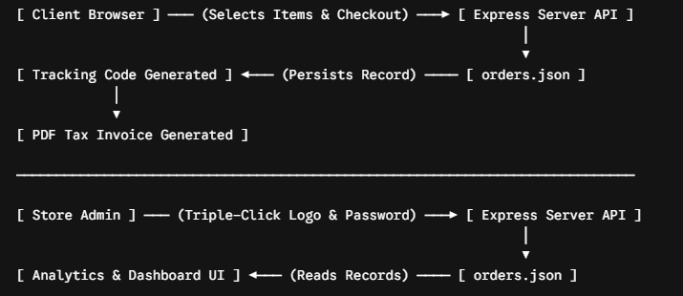

6. Deployment & Future Enhancements

Deployment Guidelines:
- Production Runtime: Node.js Web Service hosting via Cloud Platforms (e.g., Render.com, Railway.app).
- Storage Consideration: Attach persistent volume mounts to retain uploaded binary images (/public/uploads/) and JSON files.

Future Roadmap:
- Database Migration: Transitioning from local JSON file persistence to a structured database (MongoDB / PostgreSQL).
- Payment Gateway Integration: Automated online transaction verification via JazzCash / EasyPaisa API webhooks.
- Automated Customer Notifications: SMS / Email notifications triggered on order status updates.

