LAB# 9-1
Identity and access management

#Created a user and a group called admins, is it best practice to create groups and then assign permissions?
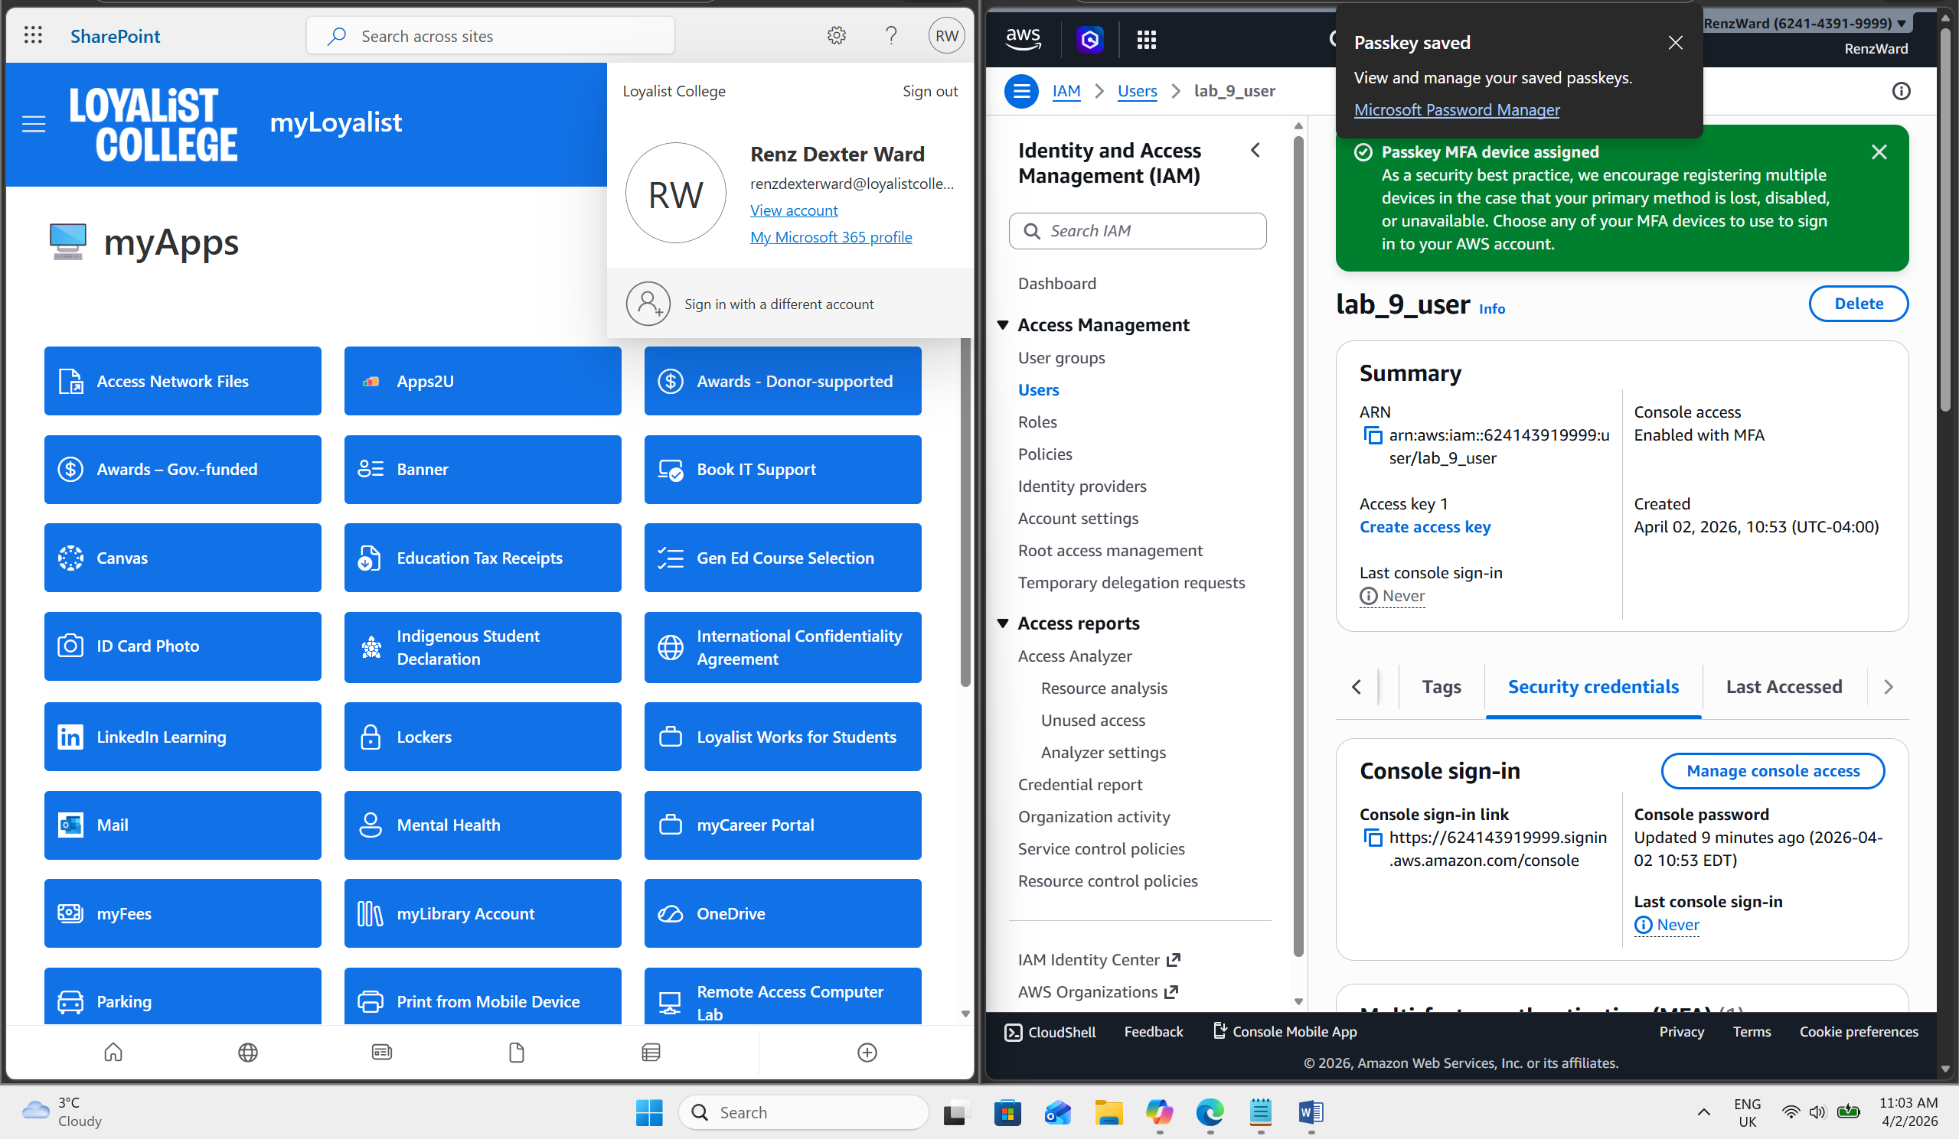
#Enabled MFA for the root user.
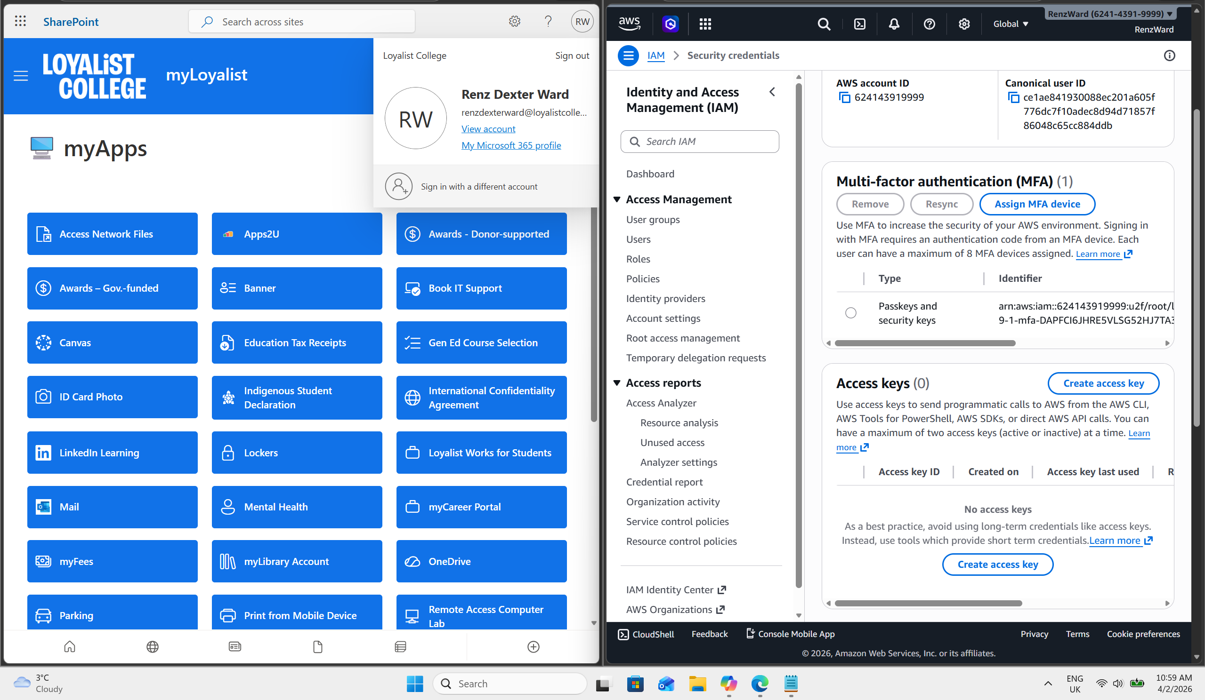

#Enabled MFA for the created new user.


#Signed-in as the lab-9-1-user
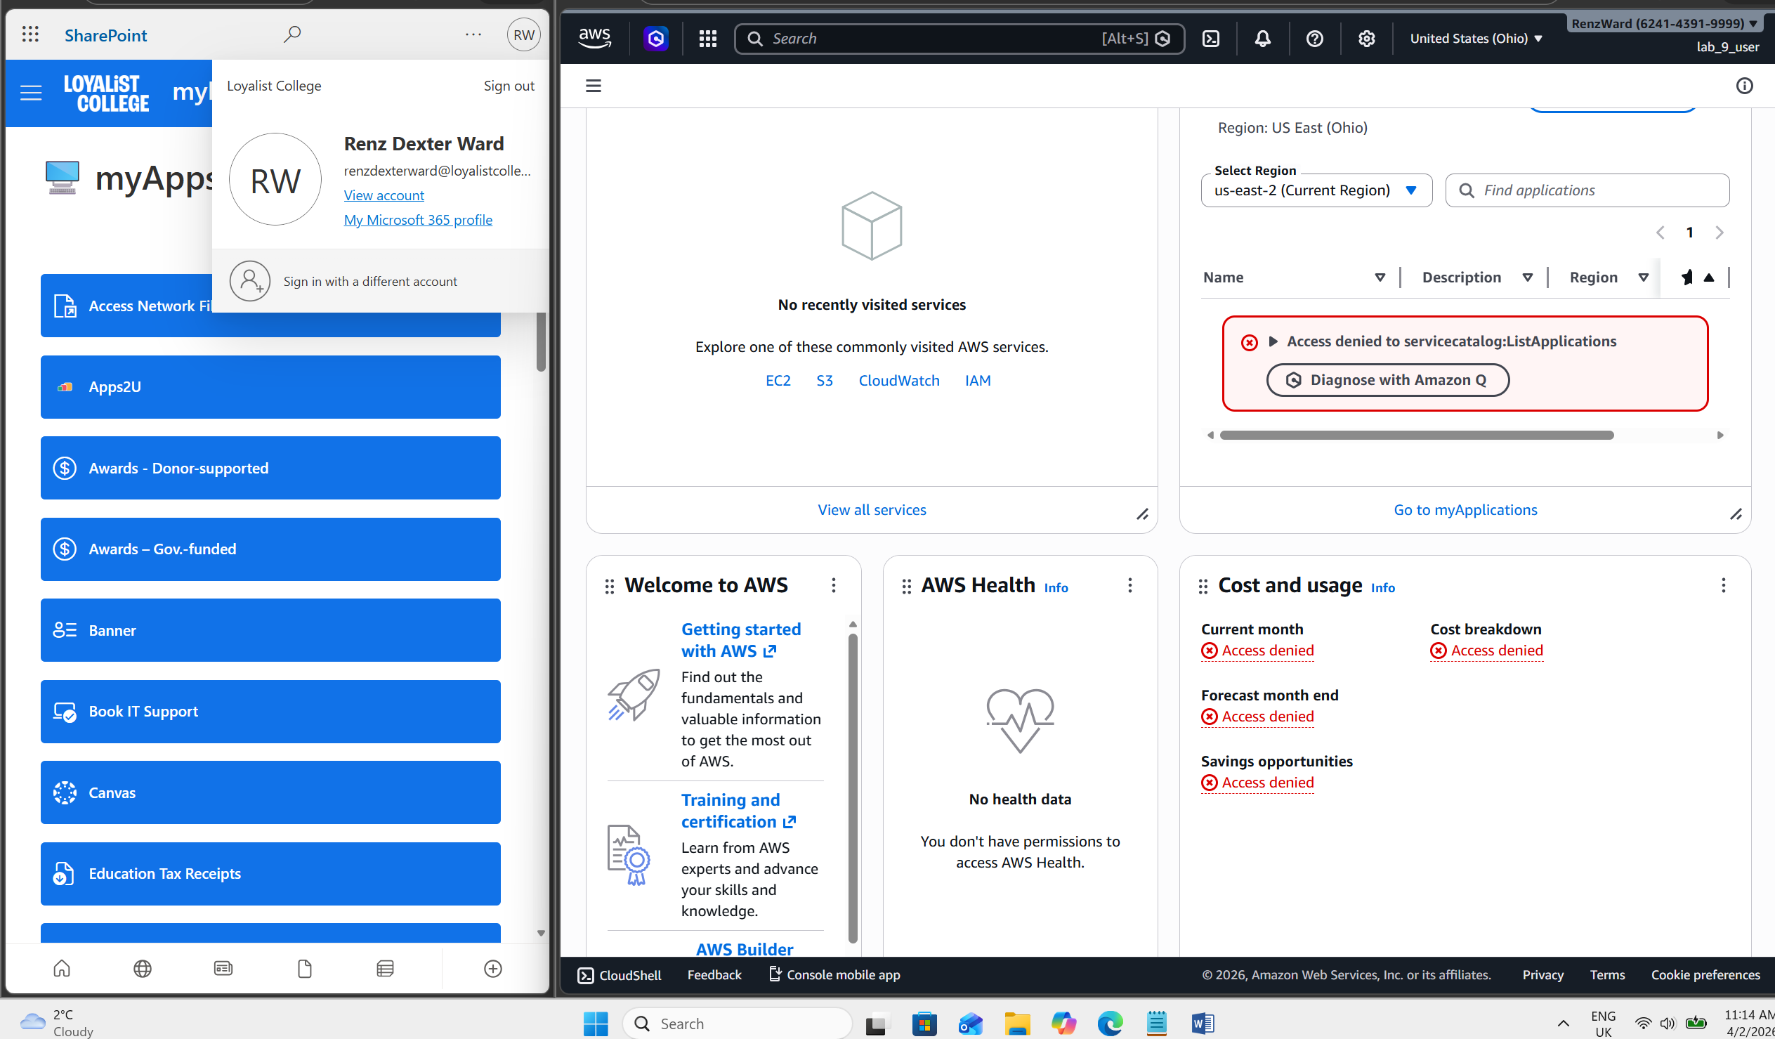

#MFA works on the new user created
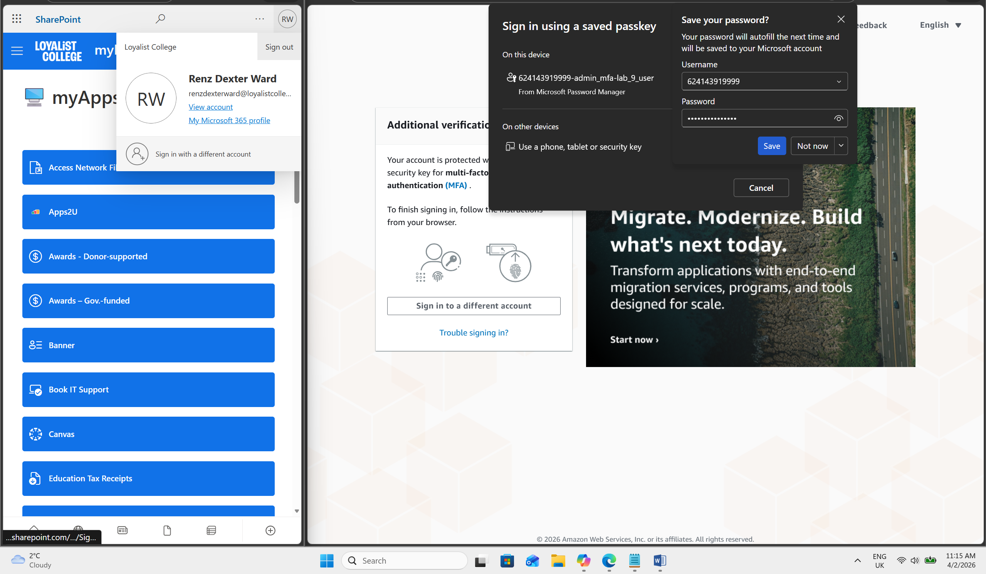

#Root user MFA works
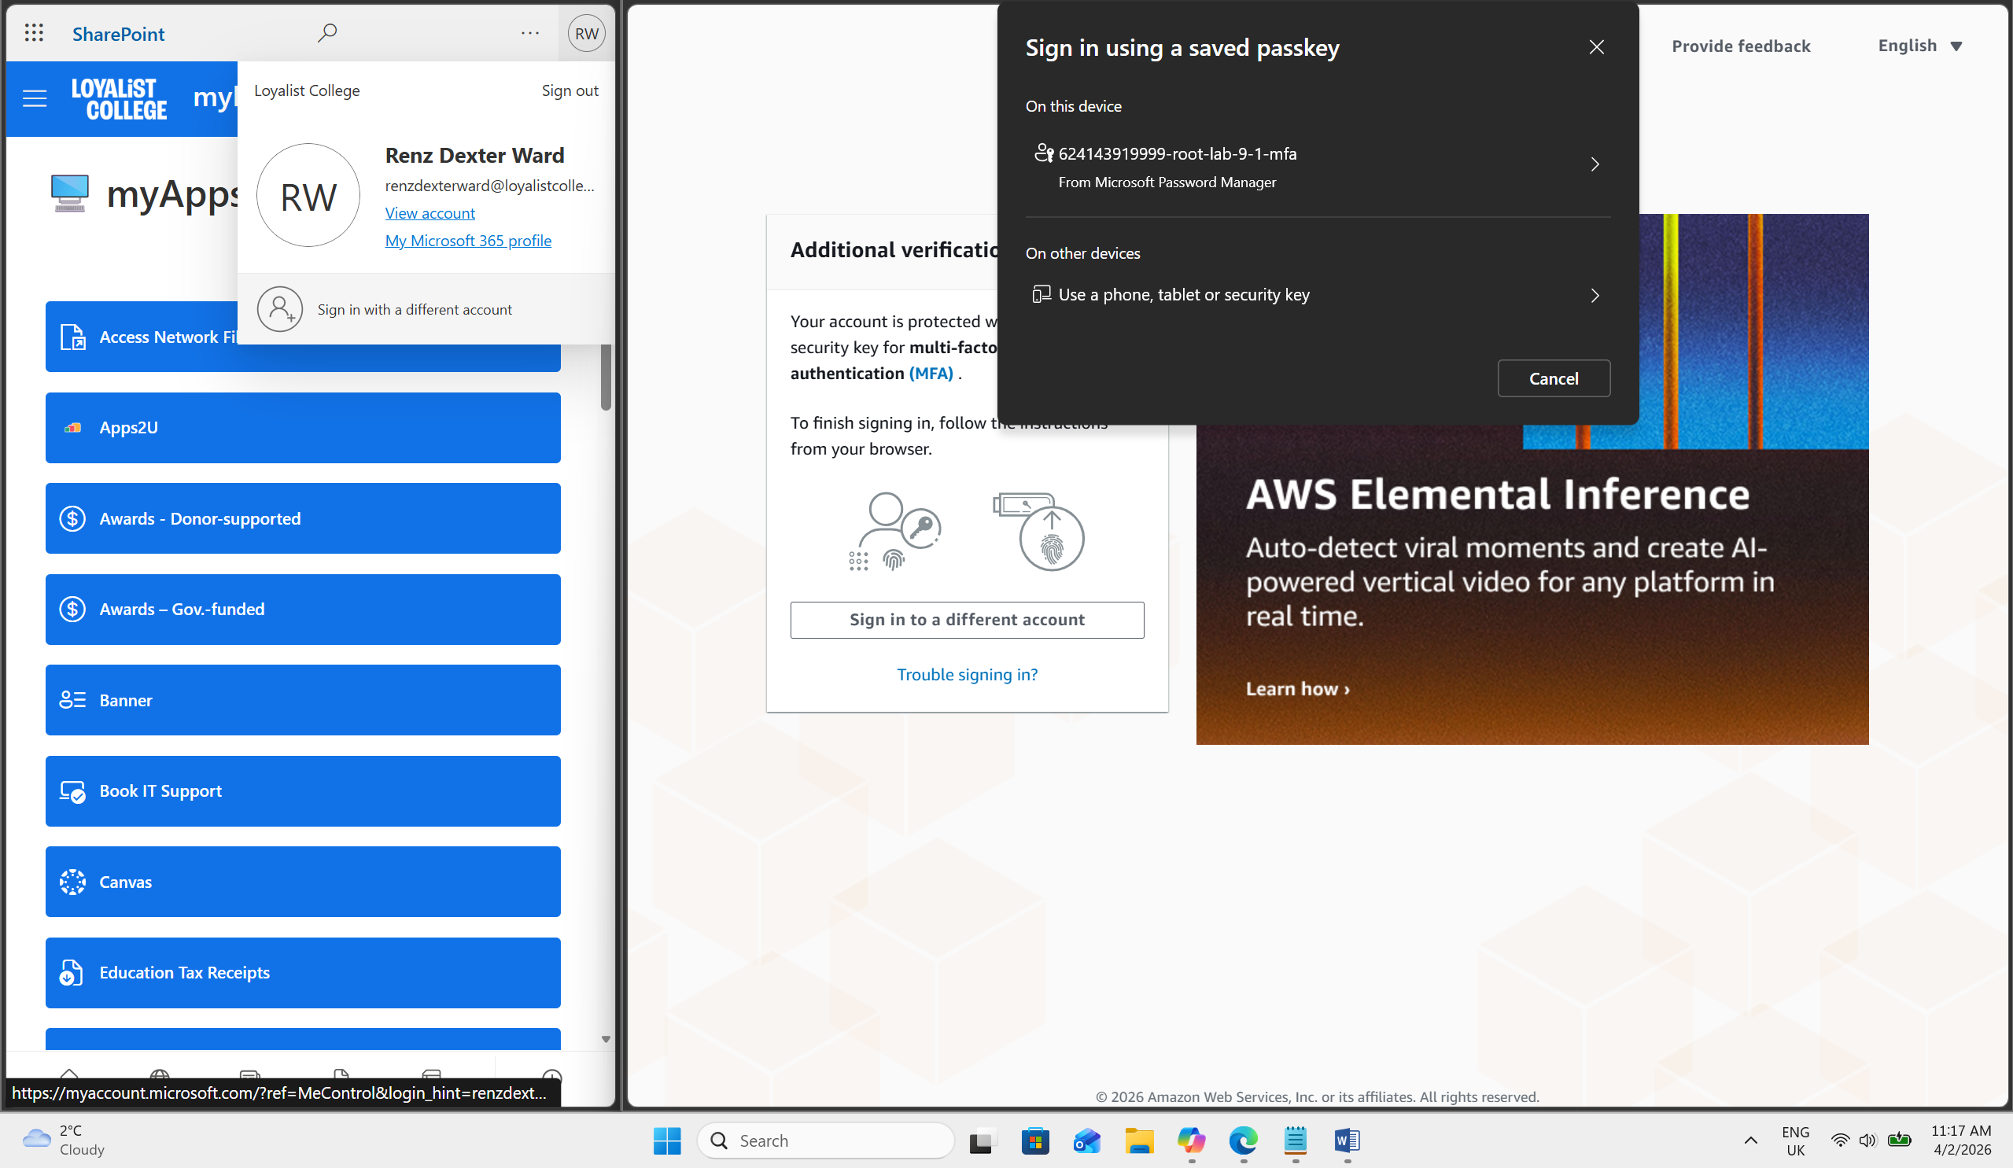

I, Renz Dexter Ward, claim this as my own personal work

