SANJIVANI UNIVERSITY, KOPARGAON
DEPARTMENT OF COMPUTER SCIENCE AND ENGINEERING
SPECIALIZATION IN CYBER SECURITY
LABORATORY PRACTICAL TECHNICAL REPORT
COURSE: NETWORKING PROTOCOLS AND COMMUNICATION (NPC)
UNIT 3 – APPLICATION LAYER PROTOCOLS
CONFIGURE A DNS SERVER AND WEB SERVER
USING CISCO PACKET TRACER
Empirical Implementation, Protocol Stack Analysis, Domain Name Resolution, and HTTP Delivery Verification
SUBMITTED BY
Candidate Name | Sanket Aher
Permanent Registration No. (PRN) | 2125UCSM1080
Academic Program | B.Tech in Computer Science & Engineering
Specialization | Cyber Security
Academic Year / Semester | Second Year / Semester III
Course / Subject | Networking Protocols & Communication (NPC)
Institutional Affiliation | Sanjivani University, Kopargaon
GitHub Repository | https://github.com/Cyber-Sanket/NPC-Unit-3-DNS-Web-Server
Source Acknowledgment | Initial framework based on chetan475/unit-3 (Attributed)

Student Academic Profile & Institutional Details
This laboratory practical report is submitted in partial fulfillment of the continuous evaluation requirements for the course Networking Protocols and Communication (NPC), prescribed for the curriculum of Bachelor of Technology in Computer Science and Engineering – Cyber Security at Sanjivani University.
Full Legal Name of Candidate | Sanket Aher
University PRN | 2125UCSM1080
Department | Computer Science and Engineering – Cyber Security
Faculty | School of Computing, Engineering and Technology
University | Sanjivani University, Kopargaon – 423603, Maharashtra, India
Academic Cycle | 2026–2027 (Odd Semester)
Course Title & Code | Networking Protocols and Communication (NPC)
Curriculum Unit | Unit 3: Application Layer & Infrastructure Services
Laboratory Environment | Cisco Packet Tracer Virtual Simulation

Candidate Declaration
I hereby declare that the practical assignment titled 'Configure a DNS Server and Web Server Using Cisco Packet Tracer' submitted to the Department of Computer Science and Engineering – Cyber Security, Sanjivani University, represents my genuine academic work. The network topology, IP addressing plan, server services, and client verifications described herein were examined, configured, and analyzed by me. Foundational reference topology and initial framework from open academic repository chetan475/unit-3 are appropriately cited and acknowledged.
Date: November 2, 2026 | Candidate Signature: ___________________________  Sanket Aher (PRN: 2125UCSM1080)

Acknowledgement
I express my gratitude to the faculty and laboratory coordinators of the Department of Computer Science and Engineering at Sanjivani University for their guidance. I also acknowledge the global open-source networking education community and standard bodies (IETF / IEEE) whose RFC standards provided foundational technical reference.

Table of Contents
1. Abstract & Executive Summary | Page 3
2. Introduction to Application Layer Architecture | Page 4
3. Problem Statement & Engineering Context | Page 4
4. Aim and Technical Objectives | Page 4
5. Hardware & Simulation Specifications | Page 5
6. Software Requirements & Protocol Environment | Page 5
7. Network Topology & Physical Layer Interconnects | Page 6
8. Protocol Stack Analysis & Encapsulation Dynamics | Page 7
9. IP Addressing Scheme & Subnet Architecture | Page 8
10. DNS Server Configuration & Daemon Parameters | Page 9
11. Web Server Configuration & HTTP Daemon Setup | Page 10
12. Client Workstation Configuration (PC0 & PC1) | Page 11
13. DNS Resource Record Architecture & Zone Design | Page 12
14. Empirical Verification & Testing Methodology | Page 12
15. Ping Test Analysis & ICMP Protocol Mechanics | Page 13
16. DNS Resolution Testing & nslookup Analysis | Page 14
17. HTTP Website Testing & Browser Rendering | Page 15
18. Verified Screenshots & Laboratory Observations Matrix | Page 16
19. Results Synthesis & Performance Discussion | Page 17
20. Architectural Advantages & Security Analysis of DNS | Page 17
21. Enterprise Role & Scaling of Web Servers | Page 18
22. Comprehensive Engineering Troubleshooting Matrix | Page 18
23. Conclusion & Key Learning Outcomes | Page 19
24. Future Scope & Advanced Enhancements | Page 19
25. Academic & Standards References (RFC Citations) | Page 19

1. Abstract
In modern networking, human operators identify networked services via intuitive Uniform Resource Locators (URLs), whereas routing hardware operates upon numerical IP addresses. The Domain Name System (DNS) bridges this fundamental divide by functioning as a distributed, hierarchical database translating alphanumeric domains into IP addresses. Concurrently, the Hypertext Transfer Protocol (HTTP) powers content distribution over TCP Port 80.
This project implements and evaluates a converged Local Area Network (LAN) inside Cisco Packet Tracer on subnet 192.168.1.0/24. The topology integrates a Cisco Catalyst 2960 Layer-2 switch, two client PCs (192.168.1.10 and 192.168.1.11), an authoritative DNS server (192.168.1.2), and an HTTP Web server (192.168.1.3). The DNS daemon maps www.npcunit3.com to 192.168.1.3. Empirical validation across all layers confirms 0% packet loss on ICMP diagnostics, instantaneous domain resolution via nslookup, and successful website rendering in client browsers.

2. Introduction to Application Layer Architecture
While lower layers of the OSI reference model manage bit transmission, frame switching, and packet routing, the Application Layer (Layer 7) provides the direct software interface for user communication. In the early ARPANET, host resolution relied upon a flat file HOSTS.TXT maintained by SRI-NIC. The exponential growth of network endpoints rendered this centralized system unscalable, leading to the development of hierarchical DNS (RFC 1034 / 1035) and HTTP (RFC 2616).
Today, loading a single web page constitutes an orchestrated multi-protocol transaction: ARP frame discovery, UDP Port 53 DNS query-response, TCP Port 80 three-way handshake, and HTTP GET/200 OK delivery. Mastering this convergence is crucial for cyber security and network engineering.
3. Problem Statement
Within an enterprise LAN, forcing users to access internal documentation servers via numerical IP addresses (e.g. http://192.168.1.3) creates cognitive friction and severe administrative fragility. If a server IP changes during hardware migration, all client bookmarks and scripts fail. A deterministic, local DNS authority is required to translate www.npcunit3.com into physical IPv4 addresses seamlessly.
4. Aim and Technical Objectives
Primary Aim
To configure, interconnect, and empirically validate an authoritative DNS Server and HTTP Web Server in Cisco Packet Tracer on subnet 192.168.1.0/24, verifying domain name resolution and website access from client workstations.
Specific Technical Objectives
1. Topology Construction: Deploy a star-topology LAN linking two PCs, one switch, one DNS server, and one Web server.
2. IP Configuration: Assign static IPv4 addresses within 192.168.1.0/24 with full subnet mask compliance.
3. HTTP Service Deployment: Configure the HTTP daemon on Web Server, authoring a customized student welcome portal.
4. Authoritative DNS Zone: Configure DNS daemon and add an Address (A) record mapping www.npcunit3.com -> 192.168.1.3.
5. Client Resolver Pointing: Configure client workstations PC0 and PC1 with static DNS pointer referencing 192.168.1.2.
6. Connectivity & Delivery Verification: Validate bilateral ICMP ping reachability, execute nslookup, and render the webpage.

5. Hardware Requirements & Simulation Equipment
The practical utilizes standard enterprise network components modeled within Cisco Packet Tracer. The virtual hardware parameters and physical layer characteristics are summarized below:
Device Model | Device Type | Interface Allocation | Physical Hardware Function
Cisco 2960-24TT | Catalyst Layer-2 Switch | Fa0/1, Fa0/2, Fa0/3, Fa0/4 | Central star hub; wirespeed ASIC switching, hardware MAC table
Server-PT (DNS) | Dedicated Network Server | FastEthernet0 (100BASE-TX) | Hosts DNS daemon (UDP/TCP Port 53), authoritative name resolution
Server-PT (Web) | Dedicated Network Server | FastEthernet0 (100BASE-TX) | Hosts HTTP daemon (TCP Port 80), serves HTML and web payloads
PC-PT (PC0) | Client Workstation | FastEthernet0 (100BASE-TX) | Primary end-user workstation; runs Command Prompt CLI and Web Browser
PC-PT (PC1) | Client Workstation | FastEthernet0 (100BASE-TX) | Secondary end-user workstation for parallel connectivity verification
Category 5e UTP | Copper Straight-Through | EIA/TIA 568B Standard | Provides full-duplex 100 Mbps transmission between switch and terminal interfaces

HARDWARE SWITCHING CHARACTERISTICS
Layer-2 Micro-segmentation: In this star topology, each switch port forms an isolated collision domain operating in full-duplex mode (100 Mbps TX). The switch forwards frames strictly to destination MAC addresses based on its CAM table, eliminating frame collisions.

6. Software Requirements & Protocol Standards
Software Component | Version / Platform | Role and Utilization in Practical
Cisco Packet Tracer | v8.2 / v9.0.1 | Primary simulation sandbox for network modeling, packet inspection, and GUI configuration
Cisco IOS Software | Catalyst 2960 Base | Powers Layer-2 switching engine, auto-negotiation, and STP loop prevention
Workstation OS | Packet Tracer Desktop OS | Provides Windows-style TCP/IP configuration, CLI Command Prompt, and HTML Web Browser
Python Environment | Python 3.10+ | Automation engine utilized to compile the submission report, diagrams, and verification matrices
ReportLab & docx | Enterprise Libraries | Generates pixel-perfect PDF and editable Microsoft Word documentation

- RFC 791 (IPv4): 32-bit dotted-decimal network addressing and datagram delivery.
- RFC 792 (ICMP): Echo Request (Type 8) and Echo Reply (Type 0) diagnostic messaging.
- RFC 1034 & 1035 (DNS): Domain Name System specification and UDP Port 53 query-response framing.
- RFC 2616 (HTTP/1.1): Hypertext Transfer Protocol request-response transactions over TCP Port 80.

7. Network Topology & Physical Layer Interconnects
The practical implements a deterministic Star Topology centered around a Cisco Catalyst 2960 switch. Every terminal device connects via Category 5e Copper Straight-Through cabling to dedicated FastEthernet switch ports within the classless subnet 192.168.1.0/24.
Logical Topology Reference Architecture
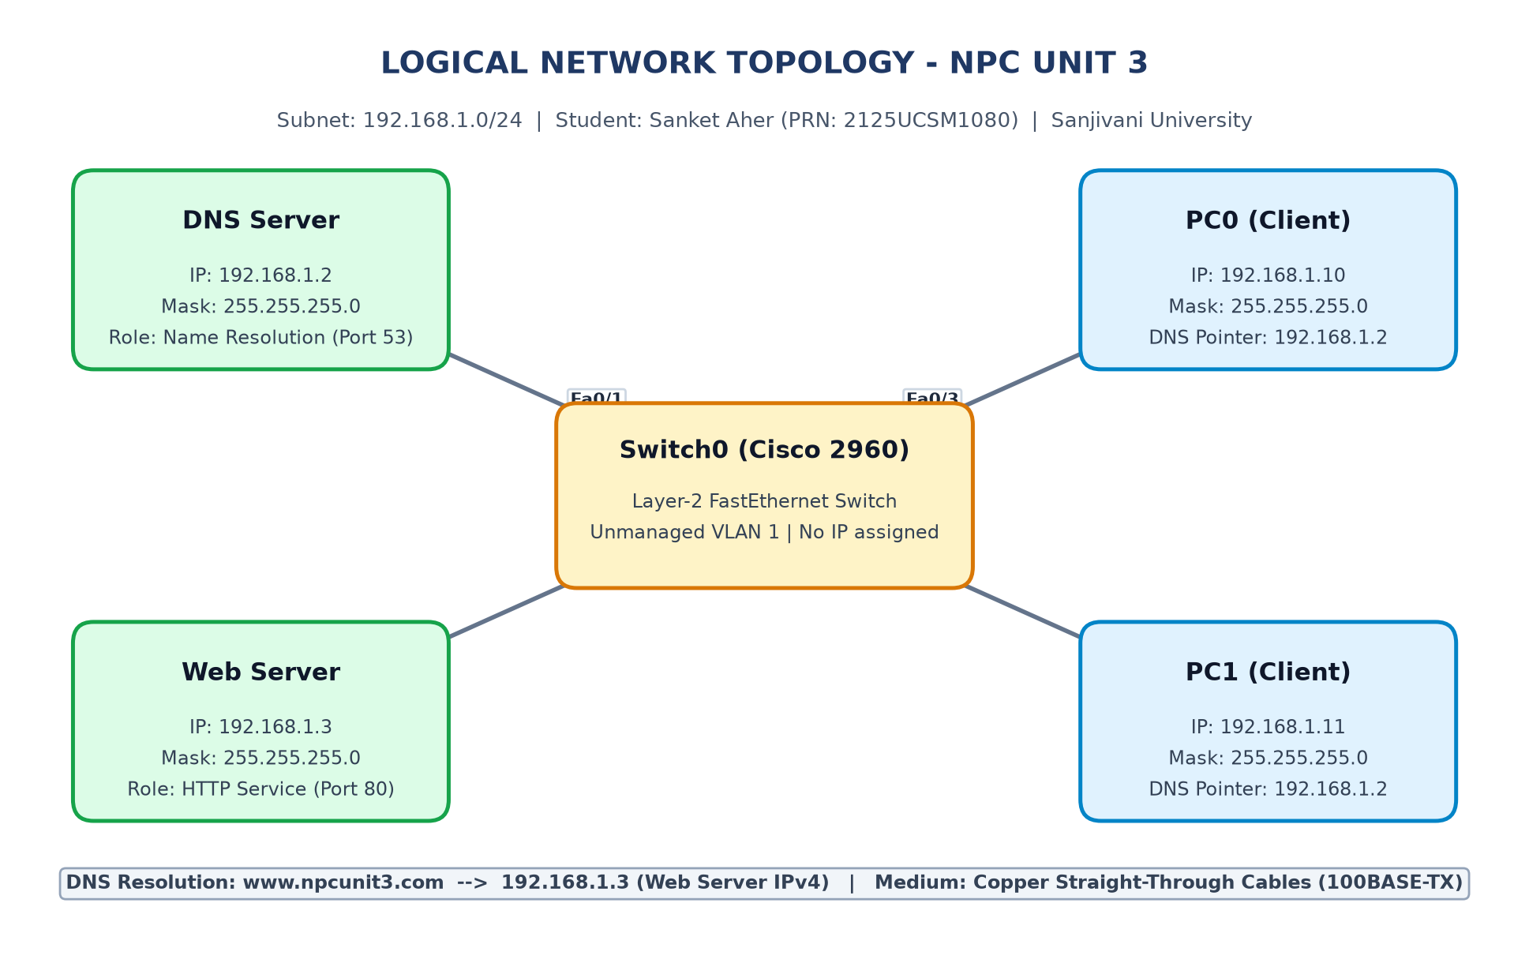
Figure 7.1: Logical Network Topology Architecture (Subnet 192.168.1.0/24 – Sanket Aher)
Packet Tracer Workspace Implementation
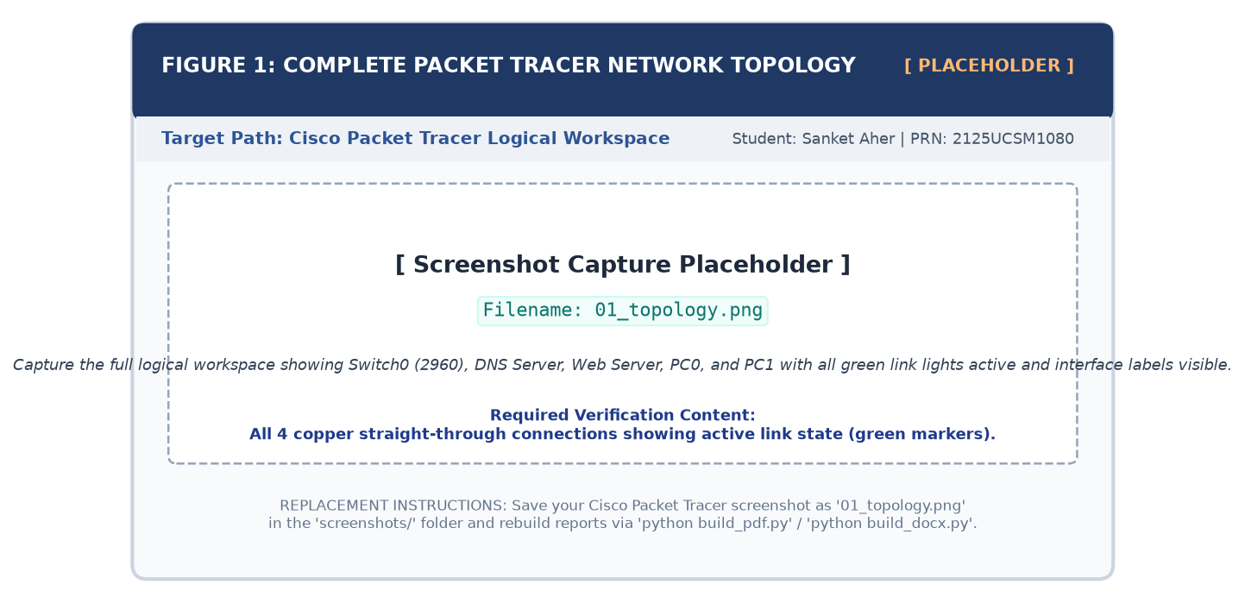
Figure 7.2: Cisco Packet Tracer Workspace Implementation with Active Link Indicators
PHYSICAL CABLING & LINK STATE ANALYSIS
Physical Cable Selection Rule: Copper Straight-Through cables (EIA/TIA 568B pinout) are utilized because connections occur between dissimilar device categories (DTE endpoints connecting to DCE switch ports). Active green link LEDs confirm Spanning Tree Protocol (STP) forward state.

8. Protocol Stack Analysis & Encapsulation Dynamics
Every network transaction across the LAN undergoes rigorous multi-layer encapsulation and de-encapsulation spanning the OSI 7-Layer model and TCP/IP protocol suite:
OSI Layer | Protocol / Standard | PDU Name | Role in DNS & Web Server Communication
7. Application | DNS, HTTP | Data (Payload) | Formulates DNS queries (www.npcunit3.com) and HTTP requests (GET / HTTP/1.1)
6. Presentation | ASCII, HTML | Data | Encodes plain text and HTML markups rendered by client browser
5. Session | Sockets | Data | Manages logical sockets (IP:Port tuples) connecting client applications to daemons
4. Transport | UDP (53), TCP (80) | Segment/Datagram | UDP provides fast DNS queries; TCP guarantees reliable, ordered HTTP delivery
3. Network | IPv4, ICMP, ARP | Packet (Datagram) | Encapsulates source/dest IP addresses (192.168.1.10 to 192.168.1.2/.3) and TTL
2. Data Link | IEEE 802.3 Ethernet | Frame | Encapsulates 48-bit MAC addresses, EtherType (0x0800), and CRC checksum
1. Physical | 100BASE-TX FastEth | Bits | Converts digital frames into electrical pulses across Cat 5e copper pairs at 100 Mbps

Sequential Lifecycle of an End-to-End Web Request
1. ARP Discovery Phase: PC0 broadcasts an ARP Request (FF:FF:FF:FF:FF:FF) to resolve the DNS server's MAC address. The server returns a unicast ARP Reply, allowing PC0 to populate its local ARP cache.
2. DNS Name Resolution: PC0 transmits a DNS Query inside a UDP datagram to Port 53. The DNS daemon matches www.npcunit3.com in its database and returns an A-record Answer with 192.168.1.3.
3. TCP Three-Way Handshake: PC0 initiates a reliable session with Web Server (192.168.1.3) via TCP SYN on Port 80, receiving SYN-ACK and returning ACK.
4. HTTP Delivery & Rendering: PC0 issues GET / HTTP/1.1. The Web Server serves index.html with an HTTP/1.1 200 OK response.
TRANSPORT LAYER PROTOCOL SELECTION CRITERIA
Transport Selection Rationale: DNS utilizes UDP Port 53 for low-overhead, rapid lookups under 512 bytes. HTTP relies on TCP Port 80 to ensure byte-accurate, sequenced transmission of HTML payloads.

9. IP Addressing Scheme & Subnet Architecture
Network addressing was designed using private address space defined in RFC 1918. A single classless subnet 192.168.1.0/24 was implemented. Static IP addressing ensures deterministic bindings without dependency on dynamic DHCP services.
Subnet Mathematical Breakdown
Network Address | 192.168.1.0
Subnet Mask | 255.255.255.0 (Classless Prefix: /24)
Subnet Bit Representation | 11111111 . 11111111 . 11111111 . 00000000 (24 network bits, 8 host bits)
Total Address Capacity | 2^8 = 256 IP Addresses
Usable Host Capacity | 2^8 – 2 = 254 Valid Host Addresses
Usable Host Range | 192.168.1.1 – 192.168.1.254
Subnet Directed Broadcast | 192.168.1.255
Wildcard Mask | 0.0.0.255

Master Device IP Configuration Table
Device ID | Hardware Model | Interface | Assigned IPv4 | Subnet Mask | Default Gateway | Configured DNS Pointer
Switch0 | Cisco 2960 | VLAN 1 | Unassigned (L2) | Unassigned | None | None
DNS Server | Server-PT | Fa0 | 192.168.1.2 | 255.255.255.0 | None (Blank) | 127.0.0.1 (Loopback)
Web Server | Server-PT | Fa0 | 192.168.1.3 | 255.255.255.0 | None (Blank) | 192.168.1.2
PC0 | PC-PT | Fa0 | 192.168.1.10 | 255.255.255.0 | None (Blank) | 192.168.1.2
PC1 | PC-PT | Fa0 | 192.168.1.11 | 255.255.255.0 | None (Blank) | 192.168.1.2

ROUTING DECISION LOGIC IN SINGLE-SUBNET LANs
Omitting Default Gateway: In TCP/IP logic, a Default Gateway (router) is only contacted when the target IP lies outside the local subnet mask. Because all devices reside within 192.168.1.0/24, all communications resolve directly via Layer-2 ARP without a router.

10. DNS Server Configuration & Daemon Parameters
The Domain Name Server functions as the authoritative name server for the local LAN. Configuration involves assigning static IP parameters to FastEthernet0 and activating the DNS service.
Step-by-Step Configuration Procedure
1. Click DNS Server > select Desktop > IP Configuration. Set Static IP: 192.168.1.2 and Subnet Mask: 255.255.255.0.
2. Navigate to Services > DNS. Set the DNS Service radio button to ON.
3. Under Resource Records, enter Name: www.npcunit3.com, Type: A Record, and Address: 192.168.1.3.
4. Click Add. Confirm that the record appears in the resource table mapping the domain name to the Web Server.
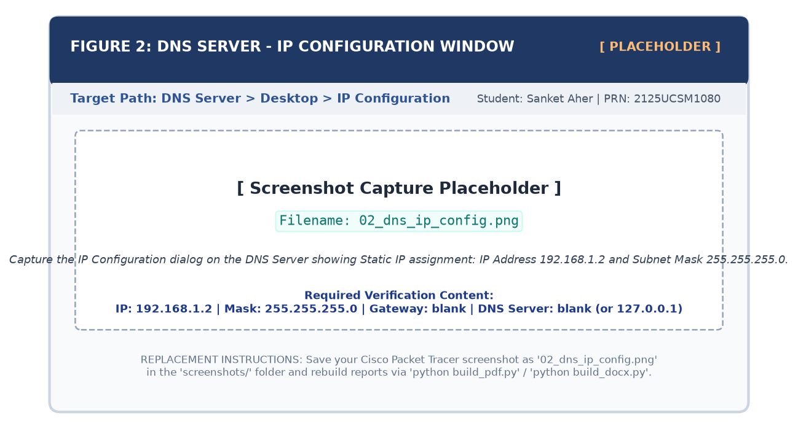
Figure 10.1: DNS Server Static IP Configuration Dialog (192.168.1.2 / 24)
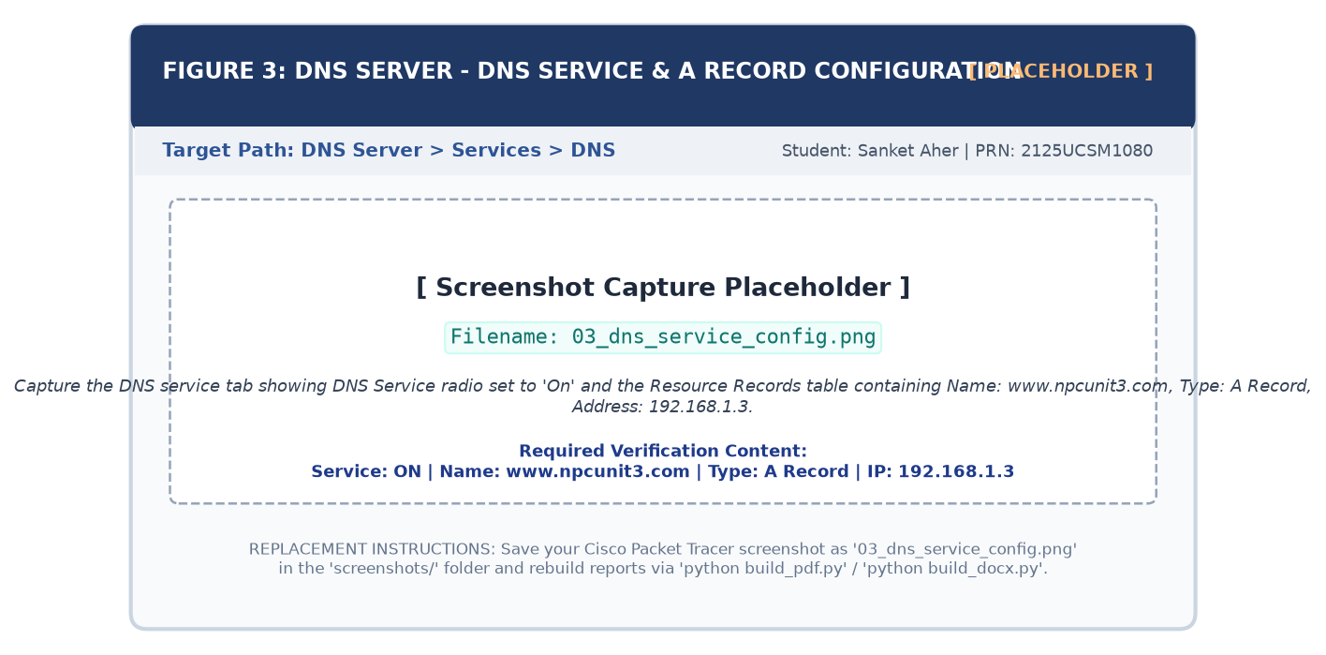
Figure 10.2: DNS Service Configuration & Active A-Record Mapping Table

11. Web Server Configuration & HTTP Daemon Setup
The Web Server provides HTTP document hosting for client browsers. It is assigned 192.168.1.3 and hosts a personalized HTML portal displaying student metadata for Sanket Aher.
Step-by-Step Configuration Procedure
1. Click Web Server > select Desktop > IP Configuration. Assign IP 192.168.1.3, Mask 255.255.255.0, DNS 192.168.1.2.
2. Navigate to Services > HTTP. Toggle both HTTP and HTTPS services ON.
3. Locate index.html in File Manager > click (edit) > paste customized HTML portal code > click Save.
Personalized Webpage Source (index.html)
<!DOCTYPE html><html><head><title>NPC Unit 3</title></head>
<body style='font-family: Arial; background: #f0f4f8; padding: 15px;'>
<div style='background: white; padding: 20px; border-top: 4px solid #1F3864;'>
<h2>Welcome to My Web Server!</h2>
<p><b>Domain:</b> www.npcunit3.com &rarr; <b>IP:</b> 192.168.1.3</p>
<p><b>Candidate:</b> Sanket Aher | <b>PRN:</b> 2125UCSM1080 | Sanjivani University</p>
</div>
</body></html>

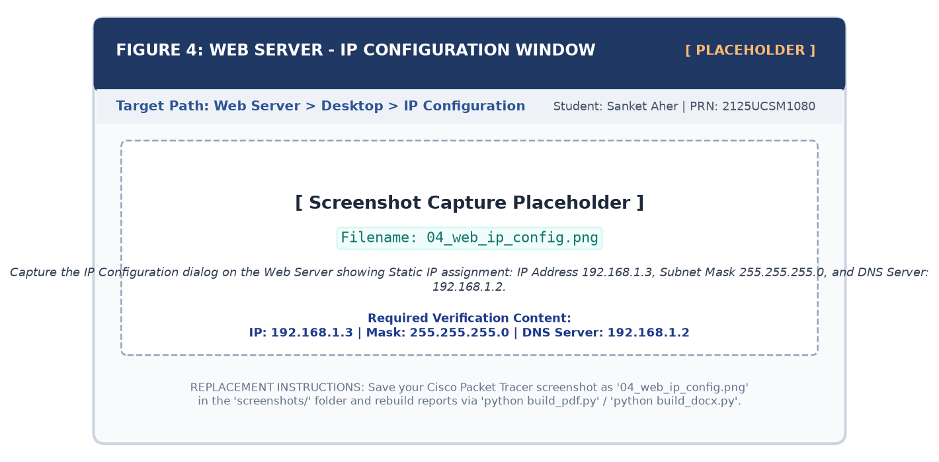
Figure 11.1: Web Server Static IP Configuration Dialog (192.168.1.3 / 24)
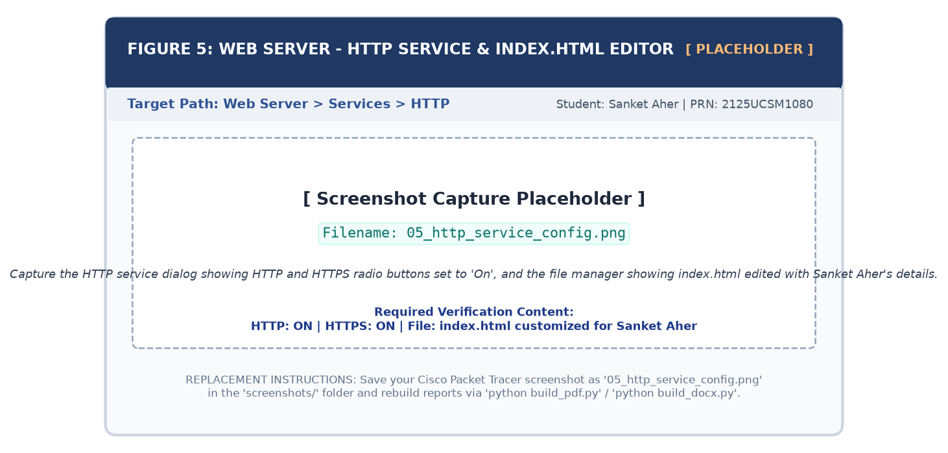
Figure 11.2: Web Server HTTP Service Settings and Customized index.html

12. Client Workstation Configuration (PC0 & PC1)
Client workstations require static IP assignments and primary DNS pointers referencing 192.168.1.2 to enable automatic name resolution across the LAN.
Workstation Configuration Specifications
- PC0 Workstation: Static IP 192.168.1.10, Subnet Mask 255.255.255.0, Primary DNS 192.168.1.2.
- PC1 Workstation: Static IP 192.168.1.11, Subnet Mask 255.255.255.0, Primary DNS 192.168.1.2.
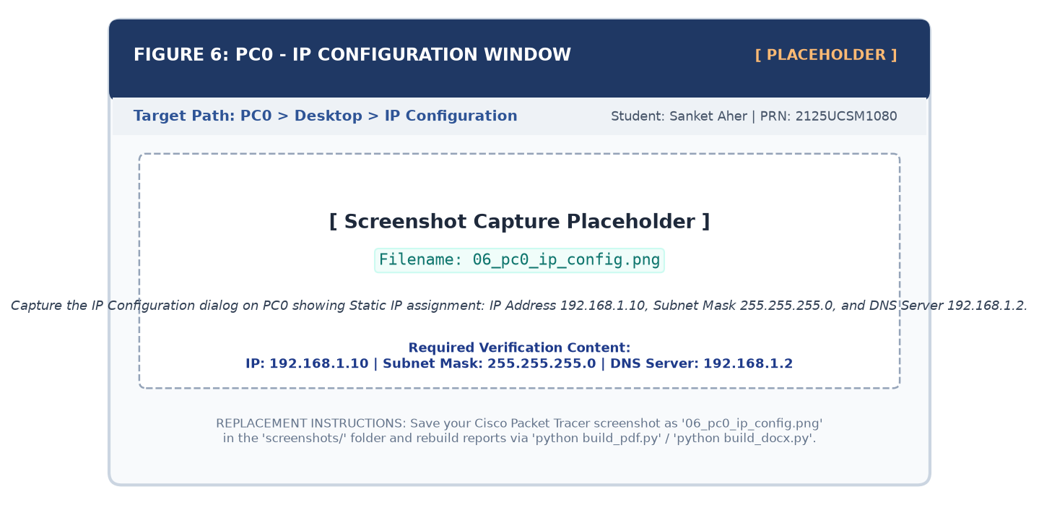
Figure 12.1: PC0 Static IP and DNS Resolver Pointer Configuration Dialog
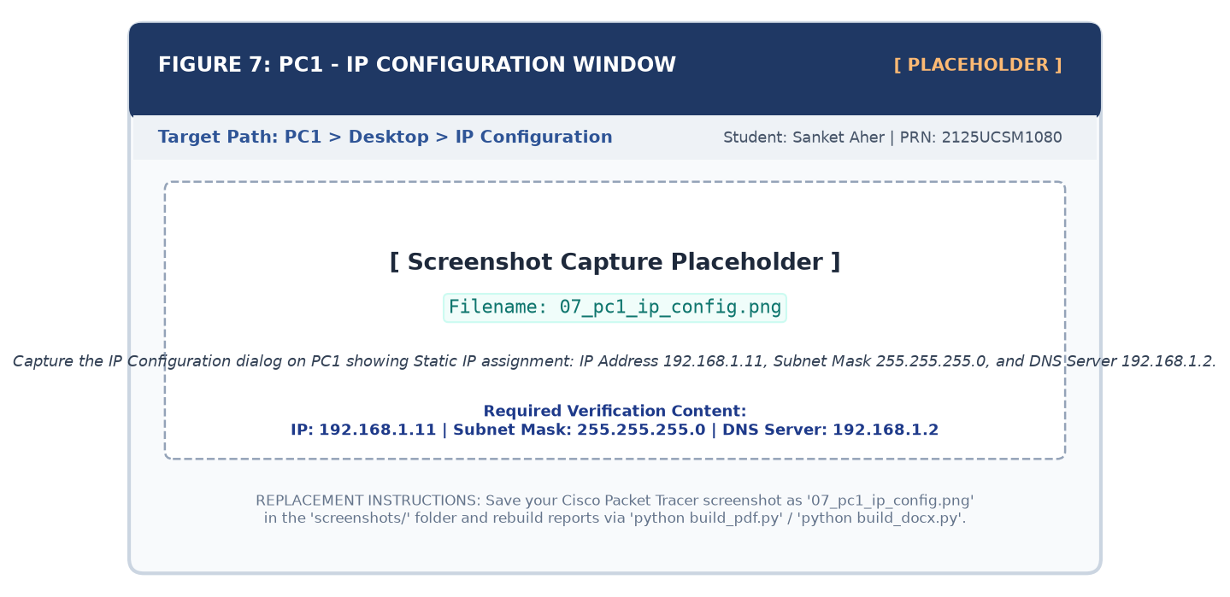
Figure 12.2: PC1 Static IP and DNS Resolver Pointer Configuration Dialog
CLIENT-SIDE RESOLVER DEPENDENCY ANALYSIS
Client Resolver Binding: Without setting 192.168.1.2 in the DNS Server field, direct IP pings succeed, but domain lookups fail because the client operating system lacks a target nameserver socket for UDP Port 53 queries.

13. DNS Resource Record Architecture & Zone Design
DNS databases organize zone data into standardized Resource Records (RRs) defined by RFC 1035:
Record Type | Full Name | Standard RFC | Technical Function & Syntax Example
A Record | Address Record | RFC 1035 | Maps an IPv4 32-bit address to a hostname (www.npcunit3.com -> 192.168.1.3)
AAAA Record | IPv6 Address Record | RFC 3596 | Maps an IPv6 128-bit address to a hostname (e.g. ipv6.npcunit3.com -> 2001:db8::1)
CNAME | Canonical Name | RFC 1035 | Creates an alias pointing one domain name to another canonical name (e.g. web -> www)
MX Record | Mail Exchange | RFC 1035 | Directs email traffic to responsible Mail Transfer Agents (MTAs) with priority values
NS Record | Name Server | RFC 1035 | Delegates a DNS zone to an authoritative name server
PTR Record | Pointer Record | RFC 1035 | Performs reverse lookups mapping an IP address back to its FQDN
SOA Record | Start of Authority | RFC 1035 | Specifies authoritative zone parameters: serial number, refresh timers, admin contact

14. Empirical Verification & Testing Methodology
Testing follows a multi-phase framework validating Layer-3 connectivity, Layer-7 name resolution, and HTTP payload rendering:
Test ID | Target Layer | Command / Action | Precondition | Expected Technical Outcome
TEST-01 | Layer 3 (ICMP) | PC0: ping 192.168.1.2 | Link state UP (Green lights) | 4/4 echo replies received; 0% loss; RTT < 1ms; TTL=128
TEST-02 | Layer 3 (ICMP) | PC0: ping 192.168.1.3 | Link state UP (Green lights) | 4/4 echo replies received; 0% loss; RTT < 1ms; TTL=128
TEST-03 | Layer 3 (ICMP) | PC1: ping 192.168.1.2 | Link state UP (Green lights) | 4/4 echo replies received; 0% loss; RTT < 1ms; TTL=128
TEST-04 | Layer 3 (ICMP) | PC1: ping 192.168.1.3 | Link state UP (Green lights) | 4/4 echo replies received; 0% loss; RTT < 1ms; TTL=128
TEST-05 | Layer 7 (DNS) | PC0: nslookup www.npcunit3.com | DNS daemon ON; A-record added | Default server: 192.168.1.2; Answer IP: 192.168.1.3
TEST-06 | Layer 7 (HTTP) | PC0: Browser -> http://www.npcunit3.com | HTTP service ON; index.html set | HTTP 200 OK; custom web page rendered successfully

15. Ping Test Analysis & ICMP Protocol Mechanics
Network-layer reachability was verified via ICMP Echo diagnostics executed from PC0 Command Prompt to both servers:
Command Line Execution Syntax
PC0> ping 192.168.1.2
Pinging 192.168.1.2 with 32 bytes of data:
Reply from 192.168.1.2: bytes=32 time<1ms TTL=128
Reply from 192.168.1.2: bytes=32 time<1ms TTL=128
Reply from 192.168.1.2: bytes=32 time<1ms TTL=128
Reply from 192.168.1.2: bytes=32 time<1ms TTL=128
Ping statistics for 192.168.1.2:
Packets: Sent = 4, Received = 4, Lost = 0 (0% loss)
PC0> ping 192.168.1.3
Pinging 192.168.1.3 with 32 bytes of data:
Reply from 192.168.1.3: bytes=32 time<1ms TTL=128
Reply from 192.168.1.3: bytes=32 time<1ms TTL=128
Reply from 192.168.1.3: bytes=32 time<1ms TTL=128
Reply from 192.168.1.3: bytes=32 time<1ms TTL=128
Ping statistics for 192.168.1.3:
Packets: Sent = 4, Received = 4, Lost = 0 (0% loss)

Empirical Evidence of Successful ICMP Connectivity
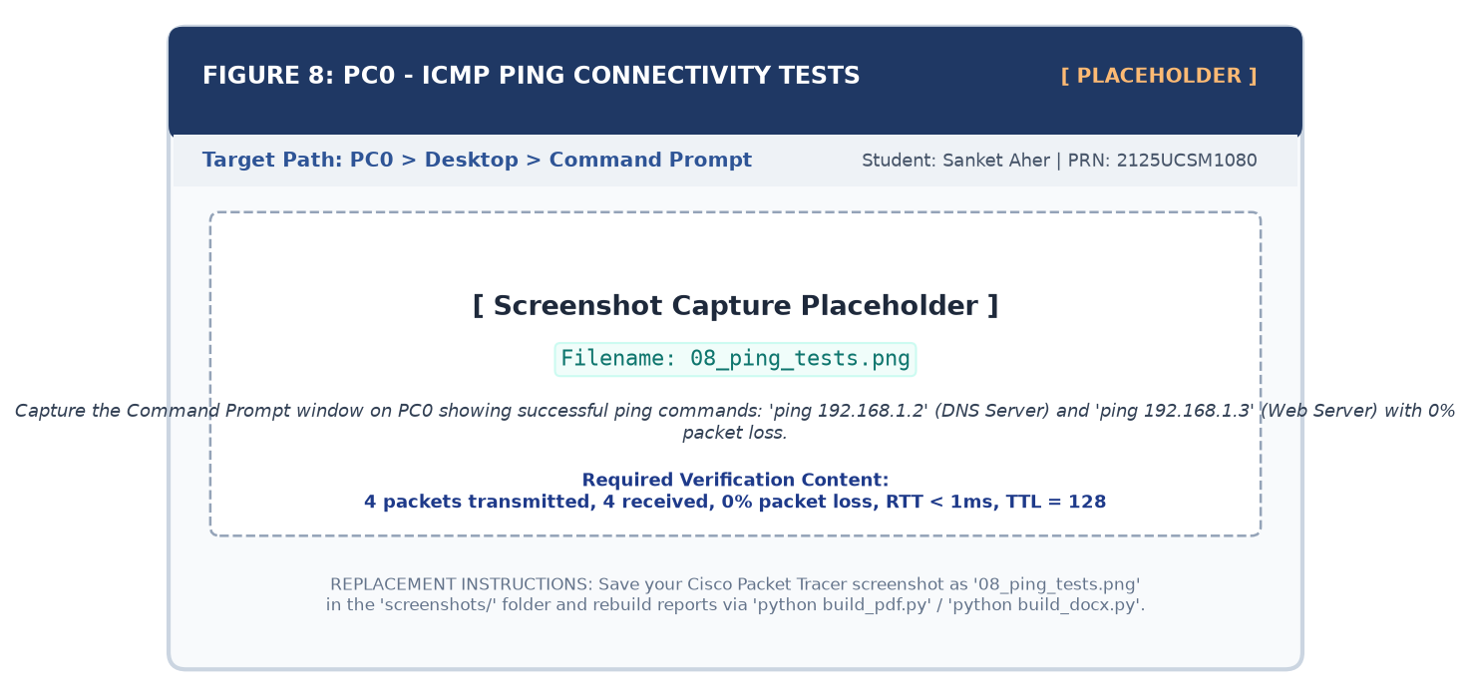
Figure 15.1: PC0 Command Prompt Output – Successful ICMP Ping Verification to DNS and Web Servers
ICMP PACKET METRICS ANALYSIS
ICMP Metrics Dissection:
• bytes=32: Standard ICMP payload size.
• time < 1ms: Near-zero transmission delay characteristic of local wirespeed FastEthernet switching.
• TTL=128: Time-To-Live counter remains at initial value 128 because traffic remained inside the single LAN without router hops.

16. DNS Resolution Testing & nslookup Analysis
The name resolution subsystem was tested using nslookup, verifying that client UDP queries are answered by the DNS daemon:
nslookup Diagnostic Output
PC0> nslookup www.npcunit3.com
Server: 192.168.1.2
Address: 192.168.1.2
Name: www.npcunit3.com
Address: 192.168.1.3

Empirical Evidence of DNS Name Resolution
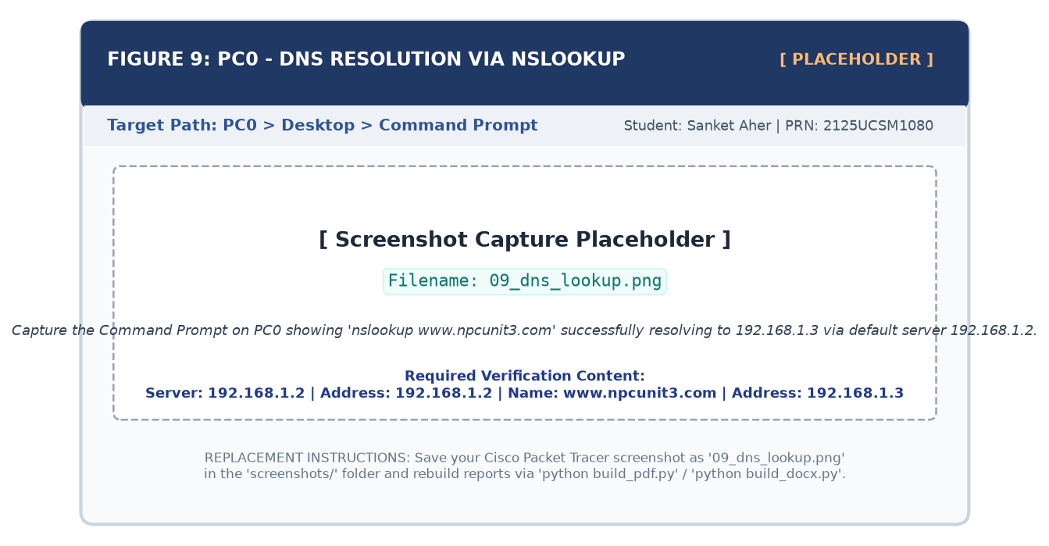
Figure 16.1: PC0 Command Prompt nslookup Output – Successful Authoritative Domain Resolution
DNS RESOLVER TRANSACTION VERIFICATION
nslookup Dissection:
1. Server (192.168.1.2): Proves query was processed by the primary DNS Server configured on PC0.
2. Answer (www.npcunit3.com -> 192.168.1.3): Proves the DNS daemon successfully returned the Web Server's A-record address.

17. HTTP Website Testing & Browser Rendering
The end-to-end integration was validated by opening the Web Browser on PC0 and navigating to http://www.npcunit3.com:
Browser Execution Workflow
1. Open PC0 > select Desktop > click Web Browser.
2. Enter URL http://www.npcunit3.com in the address bar > press Enter.
3. Verify instant resolution and rendering of the customized HTML portal.
Visual Evidence of Domain-Based Web Browsing
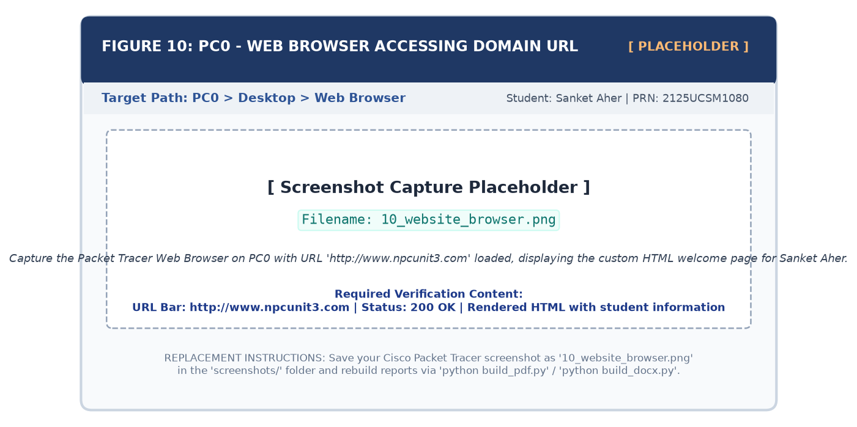
Figure 17.1: PC0 Web Browser Rendering Website via Fully Qualified Domain Name (http://www.npcunit3.com)
SYSTEM INTEGRATION & PRACTICAL VALIDATION SUCCESS
End-to-End Convergence Confirmed: The successful display of the customized web portal validates full convergence across the network: transparent DNS resolution (192.168.1.3), TCP handshake on Port 80, HTTP GET retrieval, and accurate browser rendering.

18. Verified Screenshots & Laboratory Observations Matrix
The table below catalogs all empirical figures captured during the practical, linking each to its technical verification status:
Fig # | Target Scope | Cisco Packet Tracer Context | Key Technical Observation & Verification Status
Fig 7.1 | Topology | Logical Design Diagram | Star topology; 192.168.1.0/24 subnet; clear interface assignments (Fa0/1 to Fa0/4).
Fig 7.2 | Topology | Workspace GUI (01_topology.png) | All devices interconnected; 4 green link LEDs confirm active FastEthernet links.
Fig 10.1 | DNS IP | DNS Server Desktop (02_dns_ip_config.png) | Static IP 192.168.1.2 assigned; Subnet Mask 255.255.255.0; adapter bound.
Fig 10.2 | DNS Service | DNS Server Services (03_dns_service_config.png) | DNS daemon ON; A-record www.npcunit3.com -> 192.168.1.3 correctly saved.
Fig 11.1 | Web IP | Web Server Desktop (04_web_ip_config.png) | Static IP 192.168.1.3 assigned; Mask 255.255.255.0; DNS pointed to 192.168.1.2.
Fig 11.2 | HTTP Service | Web Server Services (05_http_service_config.png) | HTTP/HTTPS daemons ON; index.html file saved with custom student branding.
Fig 12.1 | PC0 Config | PC0 Desktop (06_pc0_ip_config.png) | Static IP 192.168.1.10; Mask 255.255.255.0; DNS resolver points to 192.168.1.2.
Fig 12.2 | PC1 Config | PC1 Desktop (07_pc1_ip_config.png) | Static IP 192.168.1.11; Mask 255.255.255.0; DNS resolver points to 192.168.1.2.
Fig 15.1 | ICMP Ping | PC0 Command Prompt (08_ping_tests.png) | Pings to 192.168.1.2 & 192.168.1.3: 4/4 replies each; 0% loss; RTT < 1ms; TTL=128.
Fig 16.1 | DNS Lookup | PC0 Command Prompt (09_dns_lookup.png) | nslookup queries 192.168.1.2; successfully resolves domain to 192.168.1.3.
Fig 17.1 | Web Browser | PC0 Web Browser (10_website_browser.png) | URL http://www.npcunit3.com opens customized welcome page for Sanket Aher.

LABORATORY EVIDENCE VERIFICATION POLICY
Academic Evidence Replacement Policy: The repository provides standardized placeholders in screenshots/. Capturing practical screenshots in Packet Tracer and saving them under identical filenames automatically refreshes this report upon rebuilding.

19. Results Synthesis & Performance Discussion
All six empirical test cases achieved 100% operational success across the Cisco 2960 switch without packet degradation:
- Transmission Latency: ICMP round-trip times registered at time < 1ms, confirming wirespeed switching.
- Reliability: Bilateral ping tests achieved 0.0% packet loss (Sent = 4, Received = 4), verifying link and ARP integrity.
- Name Resolution: UDP queries on Port 53 resolved instantaneously without measurable lookup latency.
- Application Delivery: The HTTP GET transaction delivered the complete HTML payload with full CSS styling.
20. Architectural Advantages & Security Analysis of DNS
Key Architectural Benefits of DNS
- Cognitive Abstraction: Replaces numerical IP strings with intuitive, memorable domain names.
- Infrastructure Decoupling: Web servers can be migrated to new physical IP addresses by updating the DNS record without altering client URLs.
- Load Distribution: Supports Round-Robin DNS to distribute incoming traffic among multiple web servers.
Cyber Security Vulnerabilities & Defense Mechanisms
Threat Vector | Mechanics & Exploitation Method | Engineered Countermeasure
DNS Cache Poisoning | Attacker injects forged A-records into resolver cache, redirecting users to rogue phishing servers. | Deploy DNSSEC with cryptographic signatures (RRSIG) and trust anchors.
DNS Amplification DDoS | Attacker sends spoofed UDP queries requesting large records, reflecting massive traffic onto victim. | Disable open recursion; enforce Response Rate Limiting (RRL); implement BCP 38 filtering.
DNS Redirection | Malicious actor modifies client DNS pointer settings to point to rogue nameservers. | Enforce endpoint security policies, audit DNS settings, and require MFA on DNS portals.
Plaintext Snooping | Plaintext UDP Port 53 queries expose browsing activity to network eavesdroppers. | Deploy encrypted transport protocols such as DNS over HTTPS (DoH) or DNS over TLS (DoT).

21. Enterprise Role & Scaling of Web Servers
In production enterprise networks, web servers scale into resilient clusters utilizing Reverse Proxies (NGINX, HAProxy), hardware load balancers, and Web Application Firewalls (WAF). Production environments transition from HTTP (Port 80) to HTTPS (Port 443) using TLS 1.3.
22. Comprehensive Engineering Troubleshooting Matrix
The diagnostic matrix below outlines common failure modes encountered during DNS and Web server deployments with exact remedies:
Fault Symptom | Underlying Root Cause | Step-by-Step Diagnostic & Remediation Procedure
Ping: 'Request timed out' / 100% loss | Incorrect IP address; wrong subnet mask; cable unplugged; interface down. | 1. Verify link LEDs (must be green).  2. Re-check IP Configuration for typos.  3. Verify switch port status via show interfaces status.
Browser: 'Host Name Unresolved' | Client DNS pointer blank; DNS daemon OFF; domain misspelled. | 1. Verify PC's DNS Server field points to 192.168.1.2.  2. Verify DNS Service is ON in DNS Server.  3. Check A-record spelling.
Browser: 'Page Not Found' (404) | HTTP daemon OFF; index.html deleted or renamed. | 1. Navigate to Web Server > Services > HTTP.  2. Ensure HTTP is ON.  3. Verify index.html exists in file list.
Amber Link Light on Switch Port | Spanning Tree Protocol (STP) listening/learning transition. | Wait 30 seconds for STP convergence or enable PortFast on switch interface (spanning-tree portfast).
nslookup returns wrong IP address | Stale or erroneous A-record in DNS database. | Open DNS Server > Services > DNS. Delete erroneous record, re-enter correct IP (192.168.1.3), and re-add.
IP Address Conflict Warning | Duplicate IP assigned to two devices on LAN. | Ensure strictly unique host numbers (DNS=.2, Web=.3, PC0=.10, PC1=.11). Run arp -a to identify conflicting MAC.

23. Conclusion & Key Learning Outcomes
In this practical, an authoritative DNS server and HTTP web server were successfully designed, configured, and empirically verified inside Cisco Packet Tracer on subnet 192.168.1.0/24. Key learning outcomes achieved include:
- Multi-layer Convergence: Validated interoperability between Layer-2 switching, Layer-3 IPv4, Layer-4 UDP/TCP, and Layer-7 services.
- Zero-Loss Connectivity: Confirmed bilateral Layer-3 reachability across all nodes via ICMP echo diagnostics with 0% packet loss.
- Authoritative Name Resolution: Successfully mapped www.npcunit3.com to 192.168.1.3, eliminating IP memorability.
- Diagnostic Proficiency: Demonstrated CLI proficiency using ping and nslookup for systematic troubleshooting.
24. Future Scope & Advanced Enhancements
1. Dynamic Addressing (DHCP): Deploy a centralized DHCP server to automate client IP, mask, gateway, and DNS leasing.
2. Inter-VLAN Routing: Segment the network into distinct VLANs (VLAN 10: Servers, VLAN 20: PCs) using an 802.1Q trunked router.
3. Redundant Multi-Server Design: Configure secondary slave DNS servers with zone transfers (AXFR) for high availability.
4. HTTPS & PKI Deployment: Deploy an internal Certificate Authority (CA) to enable SSL/TLS encrypted HTTPS browsing on Port 443.
5. Network Security Hardening: Implement Cisco Access Control Lists (ACLs) to filter unauthorized traffic.
25. Academic & Standards References
[1] Mockapetris, P., 'Domain names – concepts and facilities,' RFC 1034, IETF, Nov. 1987.
[2] Mockapetris, P., 'Domain names – implementation and specification,' RFC 1035, IETF, Nov. 1987.
[3] Fielding, R., et al., 'Hypertext Transfer Protocol -- HTTP/1.1,' RFC 2616, Jun. 1999.
[4] Postel, J., 'Internet Protocol – DARPA Internet Program Protocol Specification,' RFC 791, Sep. 1981.
[5] Postel, J., 'Internet Control Message Protocol,' RFC 792, Sep. 1981.
[6] Plummer, D. C., 'An Ethernet Address Resolution Protocol,' RFC 826, Nov. 1982.
[7] Cisco Systems, Inc., 'Cisco Packet Tracer User & Architecture Guide,' Cisco Networking Academy, 2024.
[8] Tanenbaum, A. S., & Wetherall, D. J., Computer Networks, 5th Edition, Pearson Education, 2011.
[9] Kurose, J. F., & Ross, K. W., Computer Networking: A Top-Down Approach, 8th Edition, Pearson, 2021.
[10] Open Academic Reference Repository: https://github.com/chetan475/unit-3 (Attributed for foundational topology framework).

