Attendance Management System
Project Synopsis

1. Project Overview
Title and Purpose: Attendance Management System (AMS) is a web-based platform designed to digitize, automate, and optimize student attendance processes for educational institutions.
Problem Statement: Traditional attendance systems rely on paper registers or spreadsheets, leading to delayed reporting, transcription errors, duplicate entries, data loss, and limited transparency. Studies indicate administrative staff may spend 5–10 hours weekly consolidating attendance data in medium-sized institutions.
Solution Approach: AMS centralizes attendance recording, analytics, leave workflows, and reporting through secure web access, reducing manual workload while improving accuracy and accountability.

2. System Architecture & Technology
Technology Stack:
• Backend: PHP 7.4+
• Database: MySQL 5.7+
• Frontend: Bootstrap 5, JavaScript
• Analytics: Chart.js
Architecture Pattern: MVC (Model-View-Controller) for modular separation of business logic, interface rendering, and data handling.
Database Design: Relational schema with normalized tables (3NF where applicable).
Security Measures:
• Password hashing (bcrypt/Argon2 where supported)
• Prepared statements to prevent SQL injection
• Session management with timeout controls
• Role-based access control (RBAC)
• Input validation and CSRF protections

3. Core Features & Functionality
User Roles: Admin, Teacher, Student with distinct permissions.
Authentication:
• Secure login/logout
• Email/password validation
• Session persistence
Role-Based Dashboards:
• Admin: institution-wide overview
• Teacher: assigned class operations
• Student: personal attendance metrics

4. Admin Panel Capabilities
• CRUD management for teachers and students
• Create classes and assign faculty
• Configure holidays and system settings
• Monitor defaulters below attendance thresholds (e.g., 75%)
• Generate downloadable reports (CSV/PDF-ready workflows)

5. Teacher Panel Features
• Mark daily attendance (Present/Absent/Late)
• Bulk attendance operations
• Edit entries within configured time windows
• Approve/reject leave requests
• View low-attendance alerts and class summaries

6. Student Panel Features
• Personal dashboard with percentage trends
• Calendar-based attendance history
• Leave application submission with reasons
• Warning indicators for shortage risks

7. Attendance Management Core
Validation Rules:
• Prevent duplicate attendance for same student/date/session
• Restrict marking on holidays
• Maintain audit trails of edits
Real-Time Updates:
• Immediate database persistence
• Instant UI refresh for dashboards and reports

8. Database Schema
Key Tables:
Users, Classes, Students, Attendance, Leaves, Holidays, Settings
Relationships:
• Users ↔ Roles
• Teachers ↔ Classes
• Students ↔ Classes
• Attendance ↔ Students/Class/Date
Data Types:
INT, VARCHAR, DATE, DATETIME, TEXT, ENUM for status values.

9. User Interface & Experience
• Responsive Bootstrap 5 layouts for desktop/mobile
• Progress bars and charts for analytics
• Color-coded calendars and warnings
• Breadcrumb navigation and consistent menus
• Accessibility aligned with WCAG principles

10. Business Benefits
• Up to 70% reduction in manual attendance administration time
• Improved recording accuracy and fewer clerical errors
• Faster report generation for audits/compliance
• Better communication through alerts and notifications

11. Technical Benefits
• Scalable for growing users/classes
• Maintainable MVC codebase
• Secure against common web threats
• Optimized SQL queries and indexing
• API-ready for future integrations

12. Target Users & Deployment
Primary Users:
Schools, colleges, universities, training centers.
Deployment:
Apache/Nginx with PHP runtime and MySQL server.
Browser Support:
Chrome, Edge, Firefox, Safari (modern versions).

13. Implementation & Development
• Structured SDLC methodology
• Clean, documented PHP code
• Validation and workflow testing
• README, setup guides, admin manuals

14. Future Enhancements
• Native Android/iOS mobile apps
• Biometric attendance (fingerprint/face recognition)
• SMS/Email alerts to parents
• Predictive analytics for absenteeism trends
• Multi-language support
• AWS/Azure cloud deployment

15. Conclusion
Impact Summary: AMS transforms attendance into a reliable, data-driven process that improves efficiency, transparency, and institutional governance.
Success Metrics:
• Attendance submission turnaround time
• Error reduction rate
• Report generation speed
• User adoption and satisfaction
Sustainability: Modular architecture and standards-based technologies ensure long-term maintainability and extensibility.

IMAGES OF THE PROJECT
- Login page
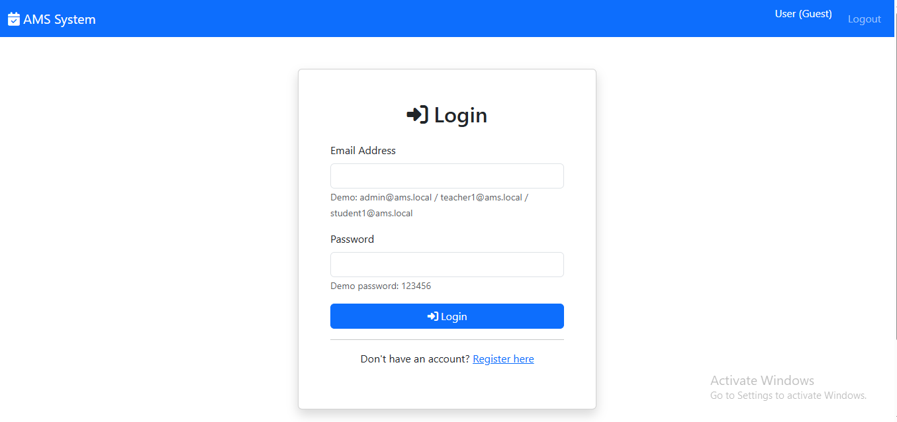

- Admin Dashboard
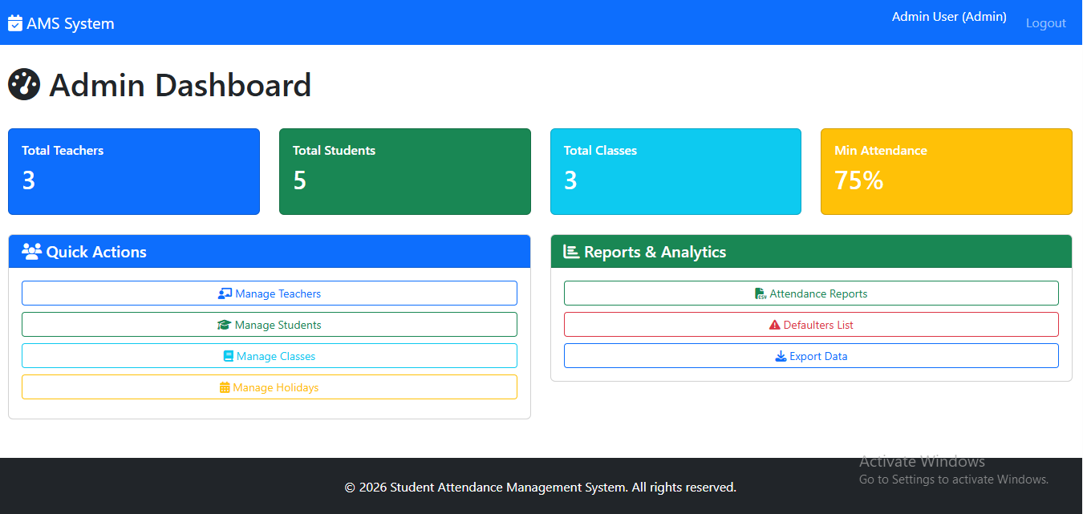

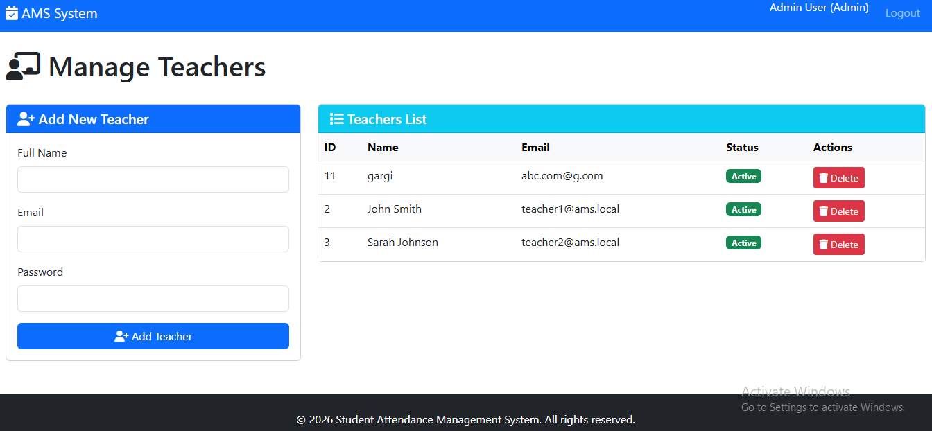

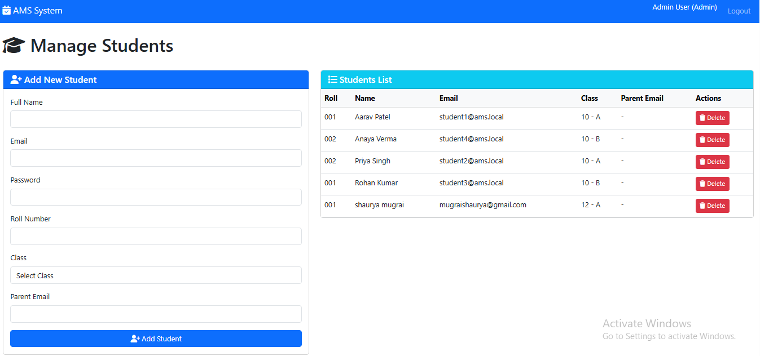

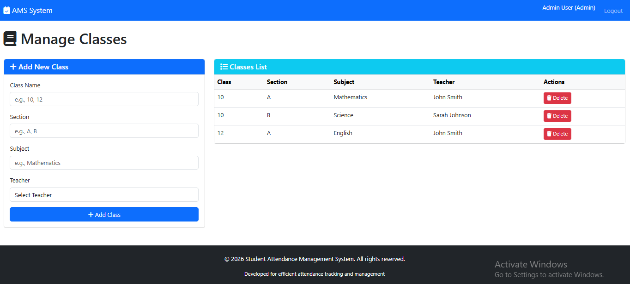

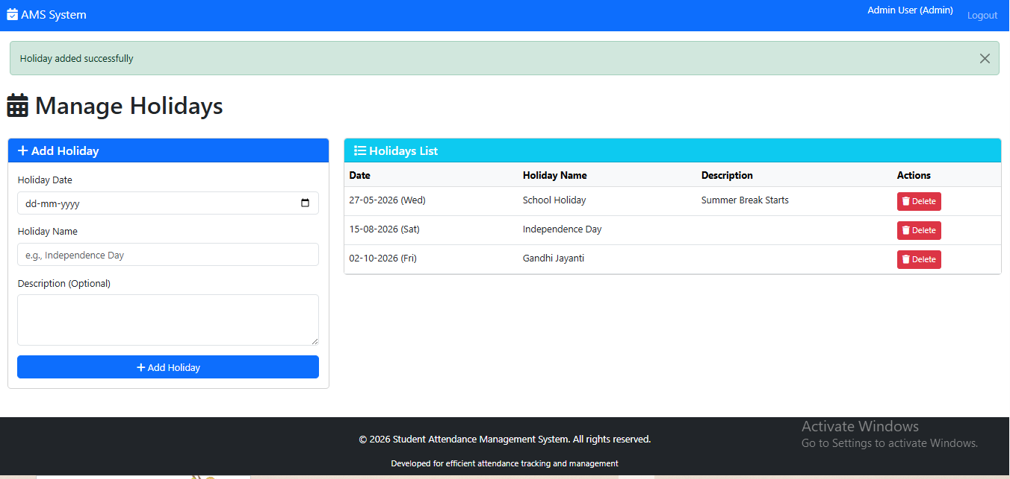

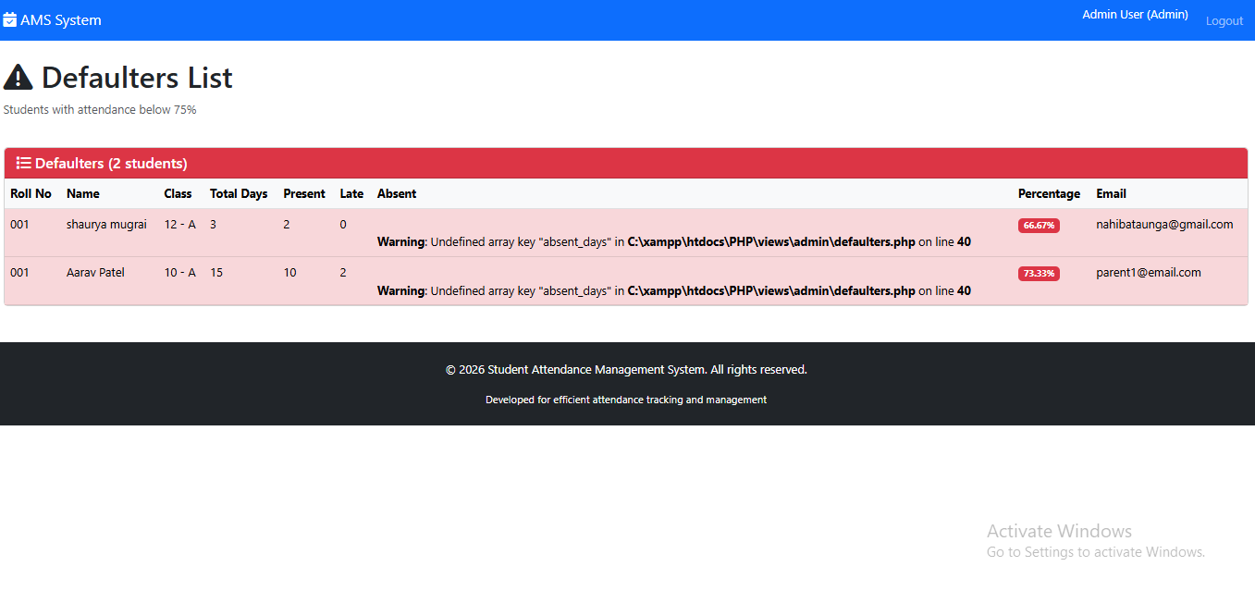
- Teacher Dashboard
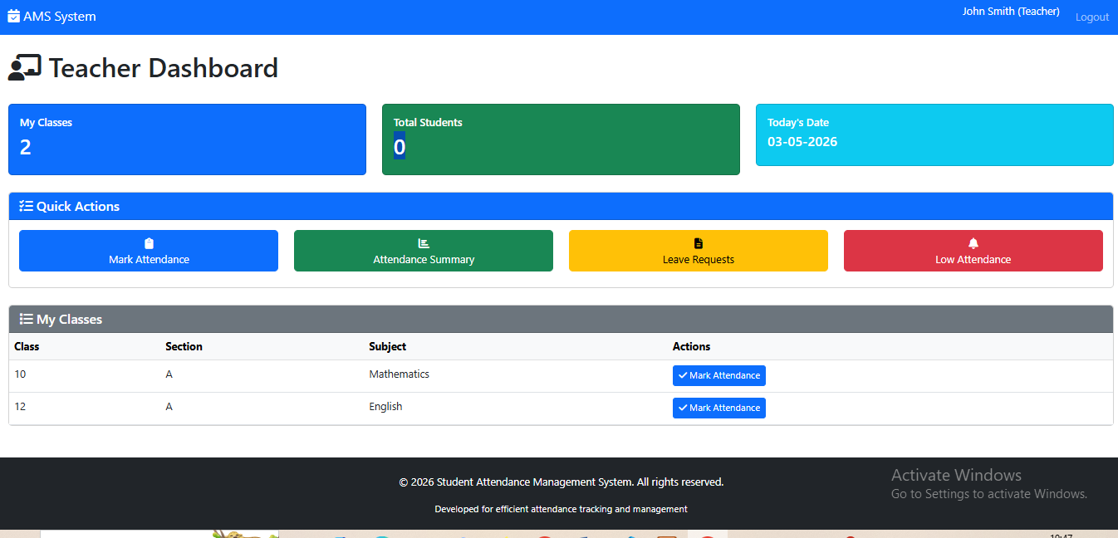

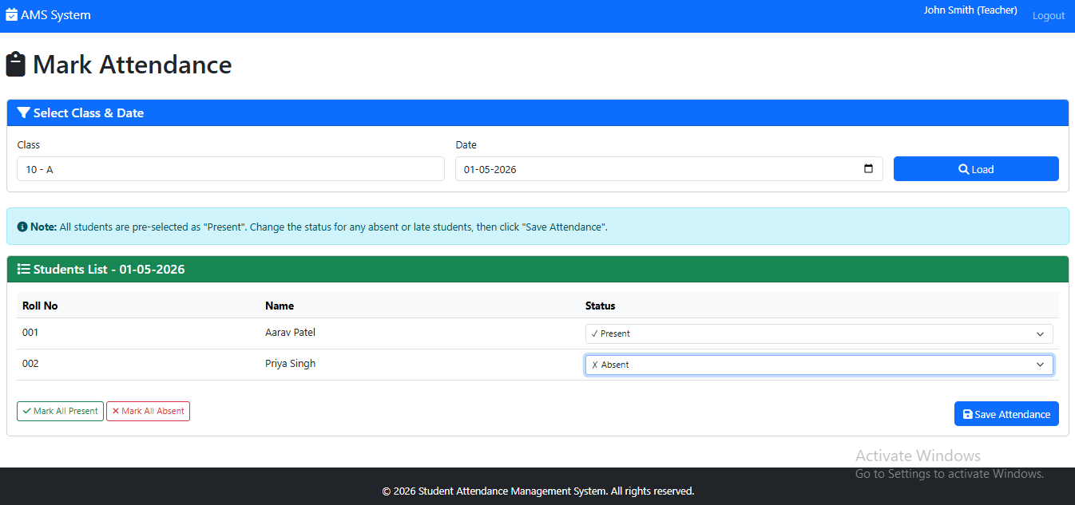

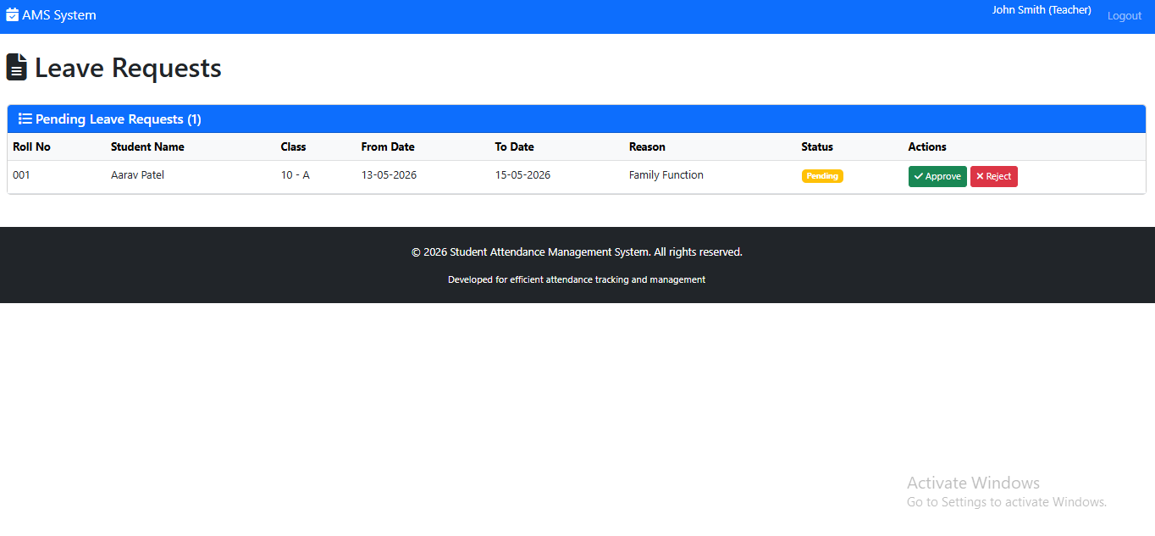

- Student Dashboard
