**PE06: Programming Exercise**

**Instruction**

**Resource:**

FastAPI (n.d.). <https://fastapi.tiangolo.com/>

Your task for this Programming Exercise is to achieve similar behavior as HOS06A using the **FastAPI** framework.

1. Follow the EC2 Flask setup steps **Create a Flask application in the local environment** and **Deploy the Service to AWS EC2** from HOS06A.

1. Instead of **Flask**, use **FastAPI** as shown in <https://fastapi.tiangolo.com/tutorial/#install-fastapi> for EC2 python backend service hosting.
   1. pip install fastapi "uvicorn[standard]"
2. Follow <https://fastapi.tiangolo.com/tutorial/first-steps/> to achieve similar results in the web browser as HOS06A
   1. Create a new main.py script on your local machine and upload it to the EC2 instance using the sftp command
   2. Edit port address in the reverse proxy (ex. your proxy rule file in the “/etc/nginx/sites-enabled” path and “sudo nano {your_ec2_instance_ip_address}”)
   3. Restart nginx reverse proxy (ex. “sudo service nginx restart”)
   4. FastAPI requires executing the uvicorn command instead of directly running the Python script. (ex. use the “uvicorn main:app --reload” to start the Python backend server)

**NOTE:** AFTER THIS MODULE ENSURE TO **TERMINATE** YOUR INSTANCE

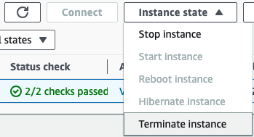

**Submit the items below to the PE submission page:**

1. The GitHub link of your FastAPI server script commits.
2. Provide a 20 to 50 words analysis or thoughts for setting up a local web application backend with the screenshot after completing task step 3.
3. Make sure the PE module number and your name are written on the file name (e.g., "*PE01_YourName.docx").*