**AI510 – AI in Cloud Computing**

**Summer 2024-25 - CityU**

**Teagan Scharlau**

**PE #06**

Frankly, this took less time than the HOS06 did, but that’s mostly because I am the queen of typos. 😊 This was super simple, and gives me a few ideas for adding an API to some of my current work projects. I’m going to have to tinker with this some more, and my teams project will also give more experience on how this works.0

**Required Screenshot:**

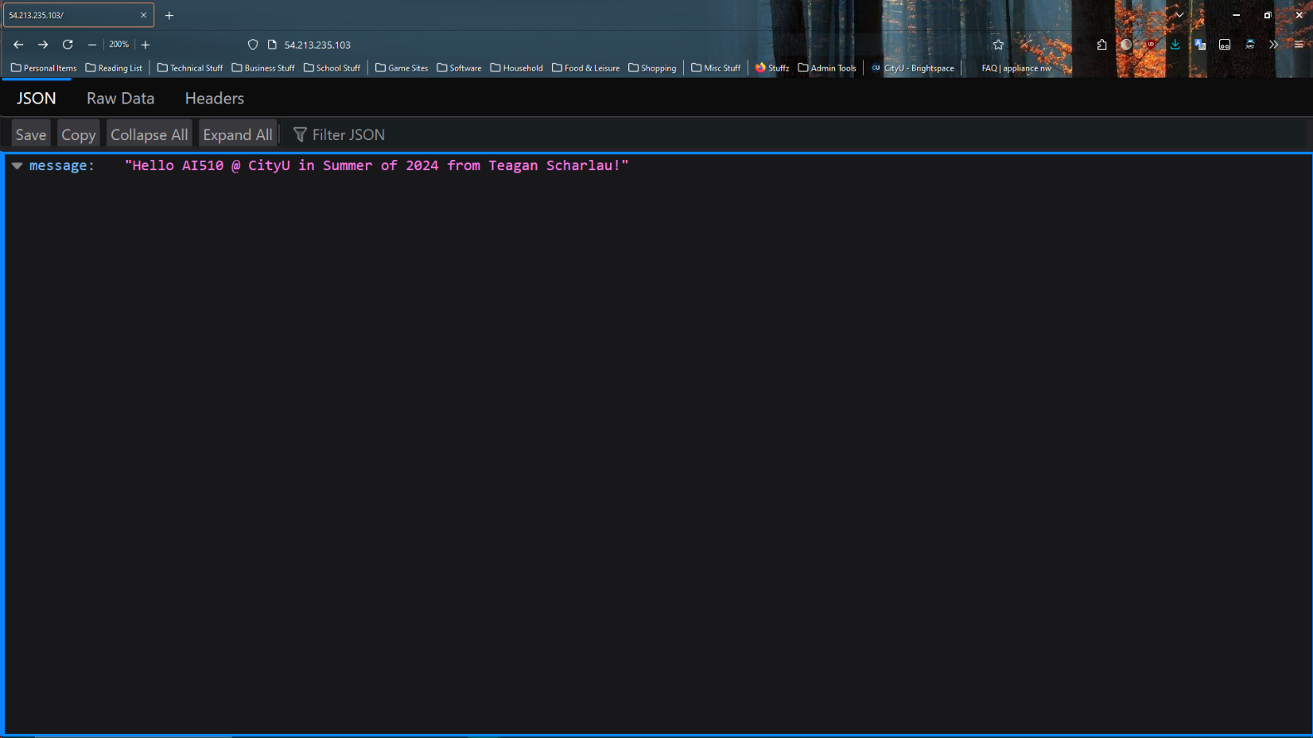

**GitHub Repo for this week:** <https://github.com/Cyber-Surfer/AI-510-summer-2024-PE06>

(As a note, the naming convention is the same each week, with just the PE## changing)