**AI510 – AI in Cloud Computing**

**Summer 2024-25 - CityU**

**Teagan Scharlau**

**PE #07**

I’m not sure if this was easier than the previous exercises ( even with the issues with install command errors, and the fact that the provided delete commands error out as well), but this went very smoothly. I’ve worked with cluster computer setups previously and so this wasn’t too unfamiliar to me, though it’s the first time I personally have set up Kubernetes clusters. I really wish that the delete command (as proper cleanup is always a good thing) had worked as advertised, but it seems at least under Windows 10 there’s something wonky.

**Required Screenshot:**

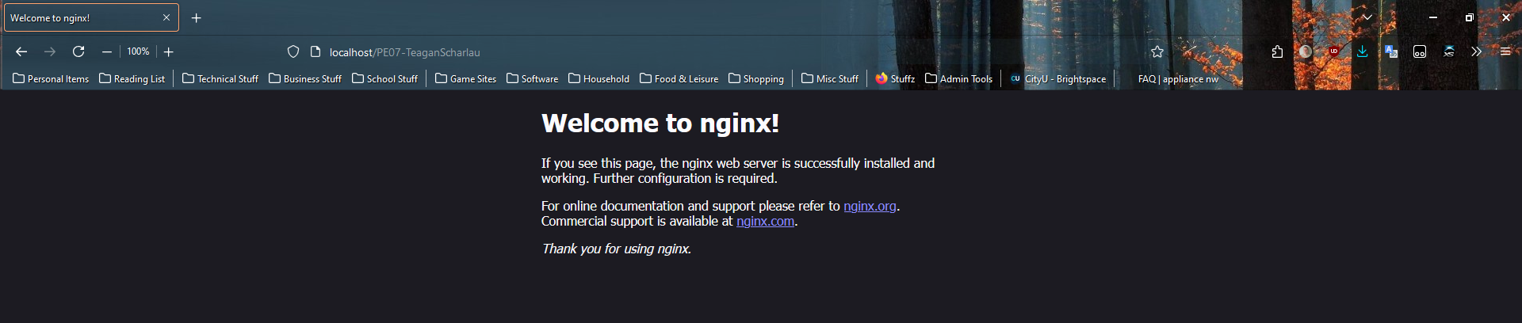

**GitHub Repo for this week:** <https://github.com/Cyber-Surfer/AI-510-summer-2024-PE07>

(As a note, the naming convention is the same each week, with just the PE## changing)