**AI510 – AI in Cloud Computing**

**Summer 2024-25 - CityU**

**Teagan Scharlau**

**PE #08**

This had some issues for me this week. It was a bit ambiguous as to what we were to do for the 3rd step. I eventually just modified the contents of the HOS08A container image and used it. Honestly, I had to be careful as I have a few local web applications running, and I think there was a conflict in the ports which I had to work around. All in all, it was interesting but a bit frustrating.

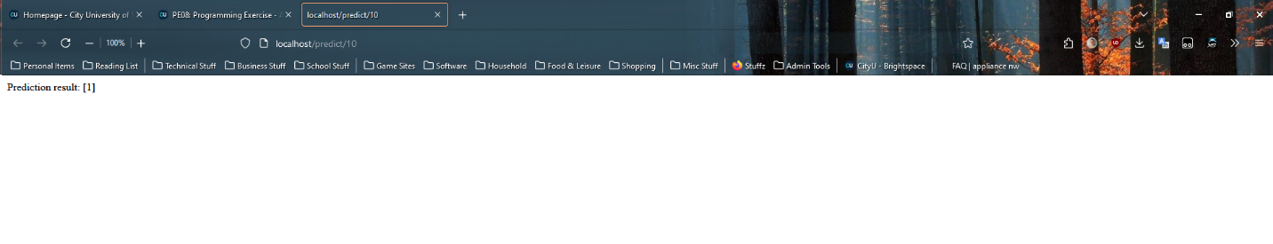

**GitHub Repo for this week:** <https://github.com/Cyber-Surfer/AI-510-summer-2024-PE08>

(As a note, the naming convention is the same each week, with just the PE## changing)