**Runway Re-declaration Tool User Guide**

1. **Features of the tool**

1.1

1.2

1.3

1.4

1.5

1.6

1.7

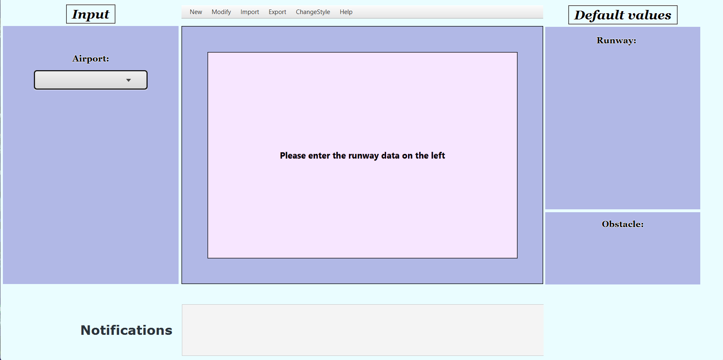

1.9

1.8

|  |  |
| --- | --- |
| **Feature** | **Index** |
| Main view | 1.1 |
| “New” tab | 1.2 |
| “Modify” tab | 1.3 |
| “Import” tab | 1.4 |
| “Export” tab | 1.5 |
| “ChangeStyle” tab | 1.6 |
| “Help” tab | 1.7 |
| Notifications | 1.8 |
| Runway visualization | 1.9 |

* 1. **Main View**

In this screen, you can see the Input window, the Values window (which will be called Results after calculations are performed), the Runway visualization window, and the Notifications window. Initially viewing this screen, no fields will be filled in as no airport and runway, and/or obstacle are selected. From here, you can choose to either create these things using the “New” tab(1.2), use the “Import” tab(1.3) to import already existing airports, runways or obstacles, or, if there are already existing airports, runways, or obstacles, you can select from any of those in a drop-down list. By default, the tool comes with 4 pre-defined obstacles. NOTE: Only one obstacle can be selected at a time. The right side of this view will display the pieces of data related to the runway and obstacle when they get selected as well as the updated values if they are re-declared.

**1.2 “New” tab**

Clicking the “New” tab in the top toolbar, you have the option to create a new Airport, Runway, or Obstacle. Selecting “Airport” will prompt you to enter a name for the airport, and clicking “Next” will then prompt you to create a new Runway automatically. Here, you have to enter the valid parameters for the runway that is to be created. Valid input detection is implemented here so parameters are always ensured to be valid. NOTE: The runway number must adhere to the correct formatting (Only numbers except for the direction character, e.g 27R/27) If there is a field that should have a value of 0, simply leave ‘0’ in the field. Clicking “Next” will bring you back to the Main View where the newly created airport and runway will already be selected. Selecting “Obstacle” instead will prompt you to fill in the required fields for a new obstacle. Again, if a field should have a value of 0, simply leave ‘0’ in the field.

**1.3. “Modify” tab**

Here, you have the option to modify either an already existing Airport, Runway, or Obstacle. Note that the subject of modification is determined by which is selected in the Main View. For example, if the Airport “Heathrow” was selected in the Main View, and you were to select “Airport” under the “Modify” tab, the airport that appears for modification will be the “Heathrow” airport. Same applies for the Runways and Obstacles. You are able to change parameters associated with those subjects, and they also have the option to delete it.

**1.4. “Import” tab**

Clicking “Import” on the toolbar will prompt you to the import menu. You are only able to import an airport xml file into the tool as an airport xml should have the runways with their respective parameters inside it as well. A file explorer window will open where you can search for the desired file to import, ending with a .xml extension.

**1.5. “Export” tab**

Clicking “Export” on the toolbar will display a drop-down list that shows the available formats that exports can be in. Selecting “XML” will prompt you to an export menu which looks similar to the import menu. This menu allows you to export a selected airport along with its runways and parameters into a single XML file. The airport that will be exported is the airport that was selected in the Main View. A file explorer window will open where you will be required to enter a desired name and to select an appropriate destination to save the file to. Selecting “JPEG” or “PNG” in the drop-down list will export the runway visualization as an image file to your desired destination. Selecting “Current Situation” will export the original runway values as well as the updated runway values if any re-declaration was required to a “.txt” file. You will also have to specify name of the file and the desired destination to save the file to.

**1.6. “Change Style” tab**

Clicking “Change Style” on the toolbar will display a drop-down list that shows two available colour schemes for the tool. By default, the tool will be in Light Mode, but there is an available Colour-Blind mode option that changes most things to a pink/red hue.

**1.7. “Help” tab**

Clicking “Help” on the toolbar will display a drop-down list that shows 5 options. Clicking any of them will open a new window that shows numbered-instructions that show you how to complete a specific action. The 5 available options are “Runway re-declaration”, “Adding new data”, “Modifying new data”, “Importing files”, and “Exporting files”.

**1.8. Notifications**

In the “Notifications” window at the bottom of the Main View, notifications that are triggered by actions will appear there. Notifications of “completed actions” will appear in green, “error notifications” will appear in red, and notifications of “selection actions” will appear in black.

**1.9. Runway Visualization**

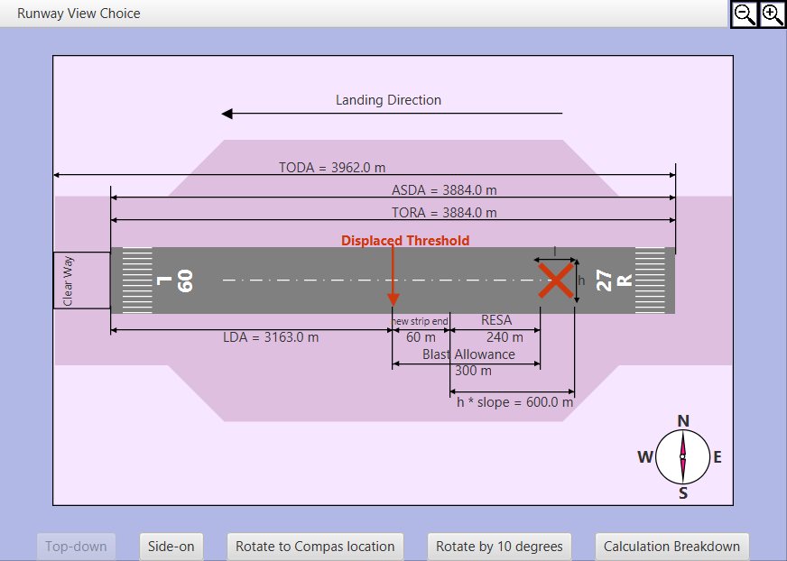

Here, you can view the individual values related to the runway as well as having several options to manipulate the view. You can view the runway from a top-down angle, side-angle, rotate the view by 10 degrees at a time, and also zoom in on the view using the buttons on top-right corner. While zoomed in, you can also move the view by clicking on it using their cursor and dragging it. Clicking “Calculation Breakdown” shows the formula related to the relevant calculations as well as the breakdown of it.

1. **Known Problems:**

* Runway Visualizations are not proportional, and should be taken as such.
* Viewing the tool on different sized screens may make some elements overlap or be far apart, but the tool still works all the same.

1. **Frequently Asked Questions:**

**Q: Can the system be used at any UK commercial airport?**

A: Yes, the system is configurable to permit its use at any UK commercial airport.

**Q: Is training required to use the runway redeclaration system?**

A: Yes, training is required to use the runway redeclaration system. Users should be trained on the proper input values and how to interpret the system’s output to ensure accurate results when using the system.

**Q: Can the tool replace the official process for re-declaring runway parameters?**

A: No, the tool should not be taken as a replacement for the official process of re-declaring runway parameters. It is simply intended to be used as an aid/guide. Official runway re-declaration system operators are still to do calculations on paper to compare with outputs obtained from the system.