CYBERSECURITY SCANNING PROJECT REPORT
STUDENT NAME : PETER ORIASOTIE
PROJECT TITLE : ADVANCED STEALTH SCANNING AND IDS EVASION TECHNIQUES IN A STIMULATED ENTERPRISE NETWORK DATE :29th SEMPTEMBER 2025

Executive Summary
This project involved simulating a covert reconnaissance attack against a segmented enterprise network protected by a SNORT IDS. Various Nmap, masscan and Hping3 stealth scanning techniques were employed to assess the IDS's detection capabilities to identify open ports and services on the target system without triggering the IDS alerts. The report details the methods that successfully evaded detection and those that triggered alerts, concluding with recommendations for enhancing IDS rule sets.
Note: Testing was conducted on a personally owned, isolated lab network.
Lab Environment & Methodology
Attacker Machine: Kali Linux [IP: 10.10.10.10]
Tools -- Running Nmap, Hping3,and masscan..
Target Machine: Metasploitable [IP: 10.10.10.20]
–- Vulnerable machine..
IDS Sensor: Ubuntu [IP: 10.10.10.30]
Tools -- Running SNORT IDS in promiscuous mode and Wireshark.
For each test we document: objective → command(s) used → expected detection behavior → actual results (alerts, pcap snippet). Keep tests atomic (one evasion technique per run).
SCANNING TECHNIQUES AND RESULTS
1) TCP SYN scan — commonly called a SYN scan
SCAN TECHNIQUE | COMMMAND USED | TOOLS
TCP SYN Stealth Scan | Nmap -sS <IP addr> | Nmap
FINDINGS : An Nmap SYN scan (-sS) checks ports by sending a SYN packet (the first step of a TCP connection). If the target replies with SYN/ACK, the port is open but If there’s no reply, the port is filtered (likely blocked by a firewall). it just tells you whether ports are open, closed, or filtered…
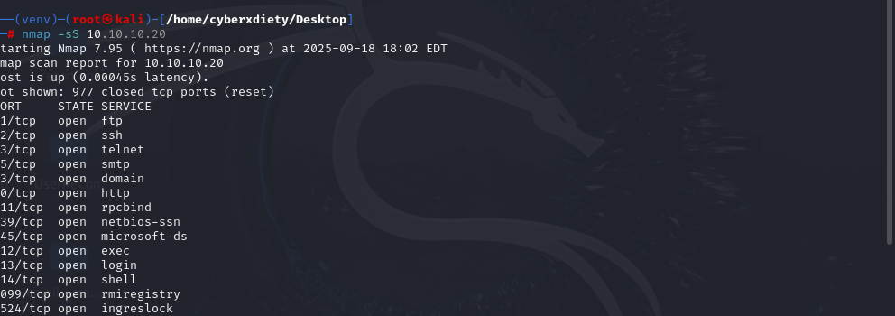
IDS RESPONSE :
Alert triggered {YES}
TCP SCAN attempted and detected {YES}
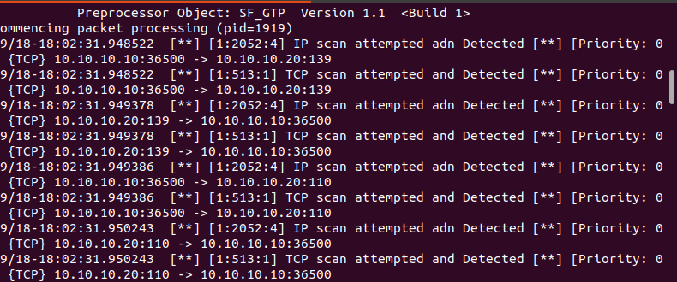
Conclusion- Detection of Nmap Scanning by Snort
During this reconnaissance phase I executed three common Nmap scan types against the lab hosts:
nmap -sS < ip addr > (SYN)
nmap -sT <ip addr > (TCP connect),
nmap -sU <ip addr > (UDP).
All three techniques were successfully detected by the Snort IDS. Snort generated corresponding alerts during each scan run, and these alerts correlate with packet captures taken at the time of testing. This result demonstrates that, in this environment and with the active ruleset/preprocessors, Snort is effective at identifying basic TCP and UDP reconnaissance activity. It indicates that an attacker using these common scanning methods would likely be noticed, allowing defenders to escalate, investigate, and respond.

2) FIN/NULL/XMAS SCAN
SCAN TECHNIQUE | COMMMAND USED | TOOLS
Fin scan technique | nmap -sF <IP addr> | Nmap / snort IDS
Null scan technique | Nmap -sN <ip addr> | Nmap / snort IDS
Xmas scan technique | Nmap -sX <ip addr> | Nmap / snort IDS

FINDINGS : NULL, FIN and XMAS scans are reconnaissance techniques used to map TCP ports while trying to be stealthier than a classic SYN scan. The goal is to discover which ports are open or closed by exploiting differences in how TCP stacks respond to unexpected flag combinations — ideally leaving less obvious footprints than a full handshake.
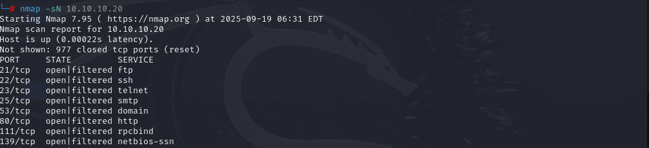
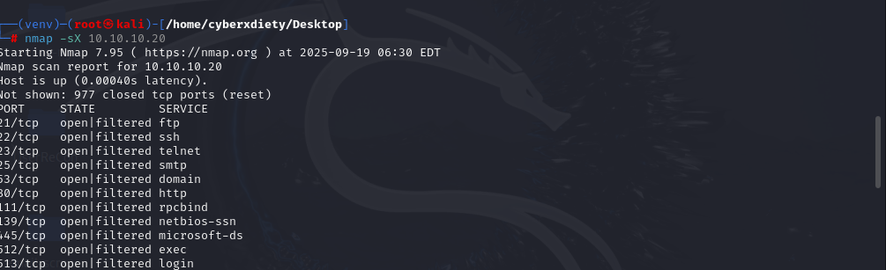

IDS RESPONSE :
Alert triggered {YES}
TCP SCAN attempted and detected {YES}
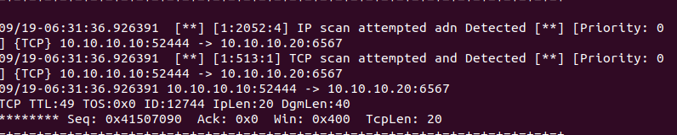
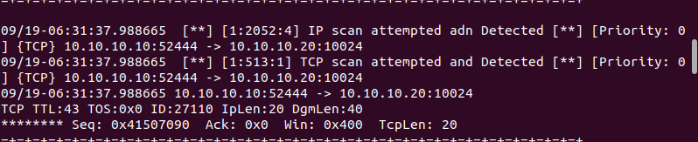

Conclusion- Detection of Nmap Scanning by Snort
During the testing I executed a set of TCP-flag stealth scans (NULL, FIN, and XMAS) against the target host using nmap -sN, nmap -sF, and nmap -sX.those techniques are used to map TCP ports while trying to be stealthier than a classic SYN scan. The goal is to discover which ports are open or closed by exploiting differences in how TCP stacks respond to unexpected flag combinations — ideally leaving less obvious footprints than a full handshake.but surprisely the lab Snort sensor detected and logged each of these scan attempts. This indicates the IDS is configured to catch TCP-flag based reconnaissance patterns and that the tested signature ruleset successfully identified the probe traffic.. Because these scans were detected, the techniques did not achieve stealth against the deployed Snort configuration in this simulated enterprise environment.

3) FRAGMENTED SYN SCAN WITH DECOY
SCAN TECHNIQUE | COMMMAND USED | ToolS
Syn scan with decoys | Nmap -sS -f -D RND:10 -oA fragmented_decoy <target ip addr> | Nmap  tcpdump

FINDINGS:: The command “ nmap -sS -f -D RND:10 -oA fragmented_decoy <ip addr> is an nmap command designed to perform a stealthy TCP SYN scan on a target IP address <10.10.10.30> with packet fragmentation and decoy IP addresses to obscure the scan's origin.
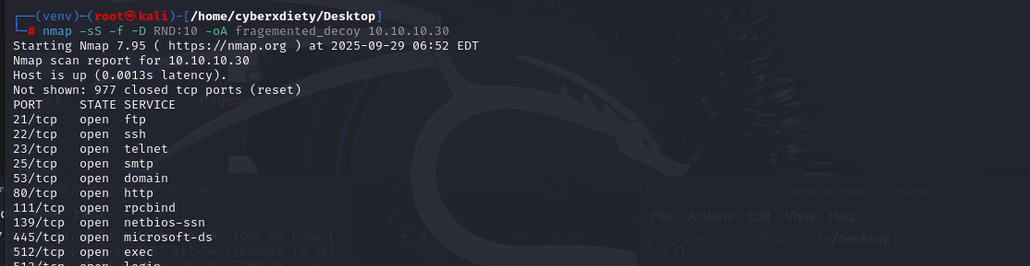
IDS RESPONSE :
Alert triggered {YES}
TCP SCAN attempted and detected {NO}
Successful Source IP Evasion During Fragmented Decoy Scan
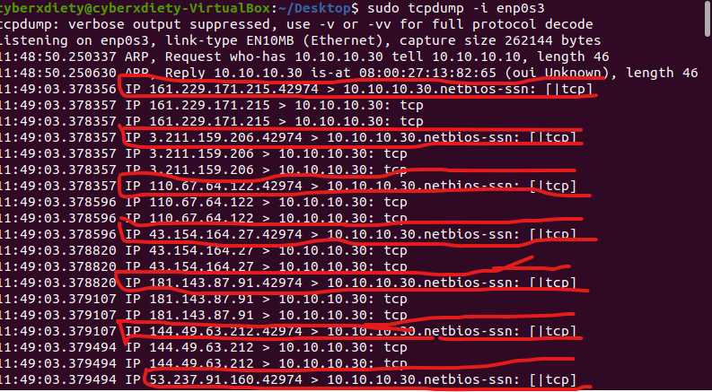
Conclusion- Detection of Scanning by Snort
Successful Source IP Evasion During Fragmented Decoy Scan
After the scan, the tcpdump capture file showed that the tool/IDS couldn’t identify the scanner’s true IP address. The file included broken-up TCP SYN packets from 10 different fake IP addresses (decoys), with no clear connection to the actual sender. In a real-world attack, this could allow adversaries to map open ports and services without triggering alerts.

4) SYN stealth scan that combines packet fragmentation, payload padding, and moderate timing
SCAN TECHNIQUE | COMMAND USED | ToolS
SYN stealth scan + fragmentation | nmap -sS -f --data-length 10 --mtu 24 -T3 -v <target> | Nmap  snort IDS
FINDINGS : nmap -sS -f --data-length 10 --mtu 24 -T3 -v <target>” is a SYN stealth scan that combines packet fragmentation, payload padding, and moderate timing. In plain terms: Nmap sends SYNs (half-open connection attempts) but splits the packets into small fragments and adds 10 bytes of padding to each probe — all while running at a moderately fast timing profile and showing verbose output.
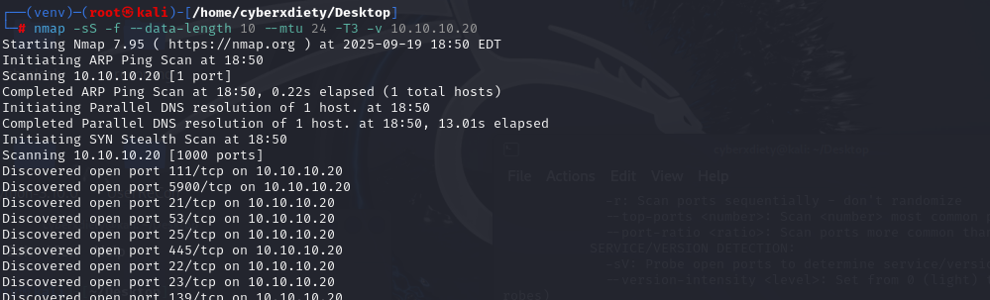
IDS RESPONSE :
Alert triggered {YES}
TCP SCAN attempted and detected {YES}
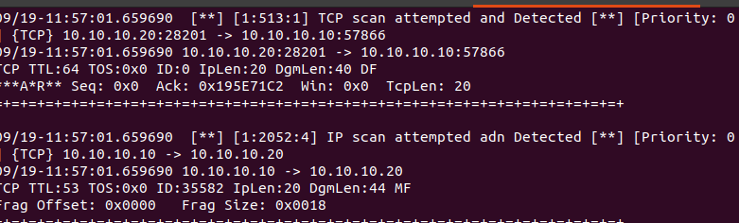

Conclusion- Detection of Nmap Scanning by Snort
The SYN scan using fragmentation, MTU forcing and payload padding (-sS -f --data-length 10 --mtu 24) was detected by the IDS. This shows the IDS’ packet reassembly and signature/preprocessor logic are effective against basic fragmentation and padding evasion techniques. However, detection alone doesn’t guarantee full coverage — tune and validate reassembly settings, ensure relevant preprocessors (IP defragmentation, TCP stream reassembly) are enabled, and review rule thresholds to reduce false negatives for more sophisticated evasions.

5) HOST DISCOVERY-- commonly called Ping scan or Ping sweep
SCAN TECHNIQUE | COMMMAND USED | ToolS
Ping scan technique | Nmap -sn <ip addr> | Nmap

FINDINGS:: nmap -sn <IP address> performs a host discovery (ping scan) to check if a target is online without scanning its ports. It uses ARP on local networks or ICMP/TCP probes on remote networks, and simply reports whether the host is up.
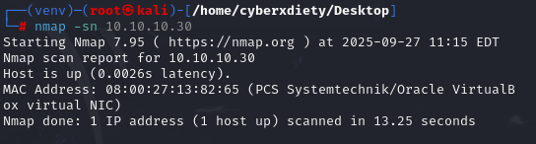

IDS RESPONSE :
Alert triggered {NO}
SCAN attempted and detected {NO}

Conclusion- Detection of Nmap Scanning by Snort
When running nmap -sn <target>, Snort IDS did not generate alerts. This is because -sn performs only host discovery (via ARP/ICMP/TCP probes) without full port scanning. On a local network, Nmap defaults to ARP requests, which Snort does not normally inspect unless configured. Additionally, a single ICMP echo or SYN probe often does not meet Snort’s detection thresholds, so such scans may evade basic IDS detection.”

6) Nmap FRAGMENTATION (MTU) scan
SCAN TECHNIQUE | COMMMAND USED | ToolS
Fragmentation technique | Nmap –mtu 16 <ip addr> | Nmap

FINDINGS:: nmap --mtu 16 <IP> forces Nmap to break its probe packets into very small IP fragments (16-byte fragments) before sending them to the target. It’s an evasion tweak which reveal port of the target — not a different scan type.
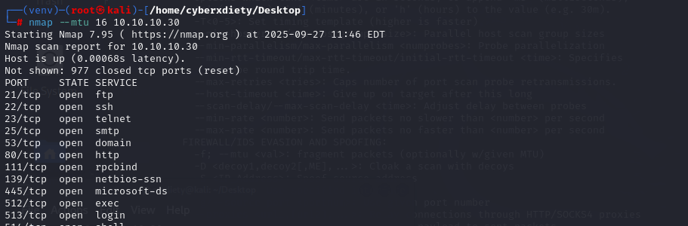
IDS RESPONSE :
Alert triggered {YES}
TCP SCAN attempted and detected {YES}
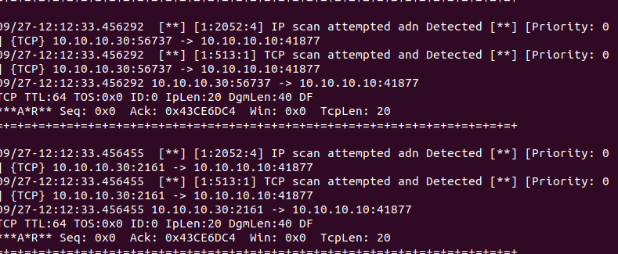

Conclusion- Detection of Nmap Scanning by Snort
After i executed nmap --mtu 16 <IP> to test fragmentation-based evasion. Snort IDS detected the activity, indicating the IDS either reassembled fragments or matched fragmentation/anomaly signatures. Fragmentation alone is not a reliable evasion vector against the current detection stack.

7) DECOY SCAN {Nmap}
SCAN TECHNIQUE | COMMMAND USED | ToolS
decoy-based IP spoofing | Nmap -sS -D RND:20 <ip addr> | Nmap  snort
Decoy scan | Nmap -D RND:20 <ip addr> | Nmap  tcpdump

FINDINGS::
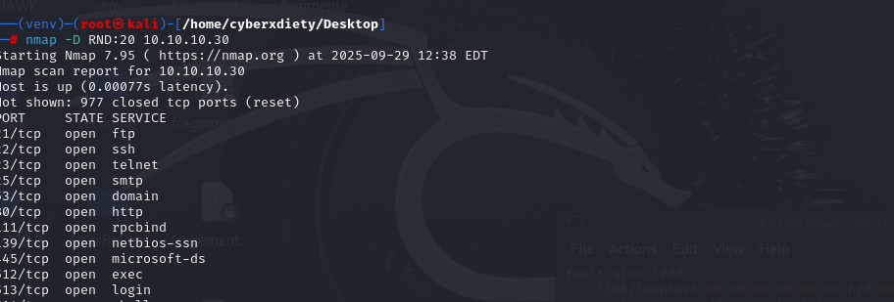

IDS RESPONSE :
Alert triggered {YES}
TCP SCAN attempted and detected {NO}
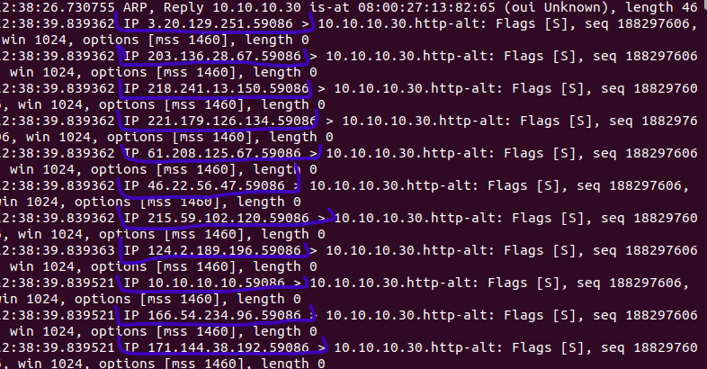

Conclusion- Detection of Scanning by Snort
Running nmap -D RND:20 <target> injected 20 randomized decoy source IPs alongside real probes; the scan returned expected port results locally while the target’s logs showed probes from many different source IPs, demonstrating noise-based attribution obfuscation.

8) SOURCE IP/PORT SPOOFING
SCAN TECHNIQUE | COMMMAND USED | ToolS
Port Spoofing | Hping3 -S -p 80 -a <spoof ip> <target Ip> | Hping3
Port Spoofing | hping3 -S -p 80 --rand-source <ip addr> | Hping3

FINDINGS:: hping3 -S -p 80 -a <spoof ip> <target Ip> utilizes the hping3 tool to send custom TCP/IP packets, specifically designed for network testing and security assessments. this command is used to simulate TCP SYN packets directed at any port of the target IP, with the source IP address spoofed to appear as <spoof ip>
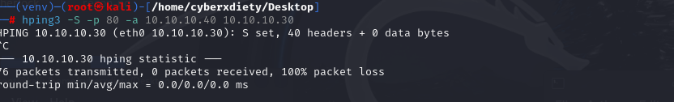

IDS RESPONSE :
Alert triggered {YES}
TCP SCAN attempted and detected {NO}
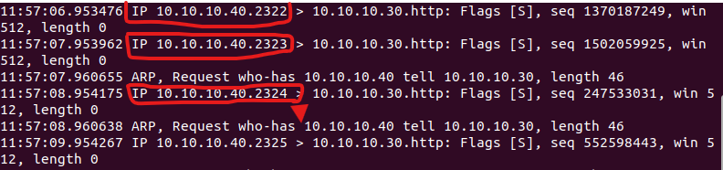
This command is particularly relevant for IDS evasion testing due to its IP spoofing capability. By forging the source IP address (-a <spoof ip>) ..

Conclusion- Detection of Scanning by Snort
The command “hping3 -S -p 80 -a <spoof ip> <target Ip> “ was run on a system with appropriate permissions, sending TCP SYN packets to port 80 of the target IP <10.10.10.30>, with the source IP spoofed to a chosen address <10.10.10.40> .. Upon executing the command, the IDS logged the incoming TCP SYN packets but attributed them to the spoofed IP address (<10.10.10.40) rather than the actual source IP of the machine running the command <10.10.10.10>.

9) SYN flood attack
SCAN TECHNIQUE | COMMMAND USED | ToolS
Syn flood attack | hping3 -S -p 80 --rand-source --flood <target ip> | Nmap  tcpdump

FINDINGS:: The command hping3 -S -p 80 --rand-source --flood <target ip> is a classic example of a TCP SYN flood attack with IP spoofing, specifically tuned for IDS evasion through traffic obfuscation and volume overload. It's not a stealthy "scan" but an aggressive DoS technique that disrupts services while challenging detection systems.

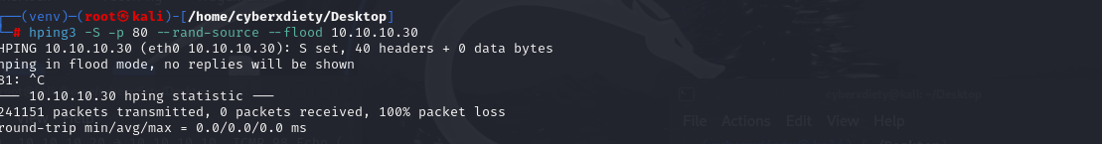

IDS RESPONSE :
Alert triggered {YES}
TCP SCAN attempted and detected {NO}
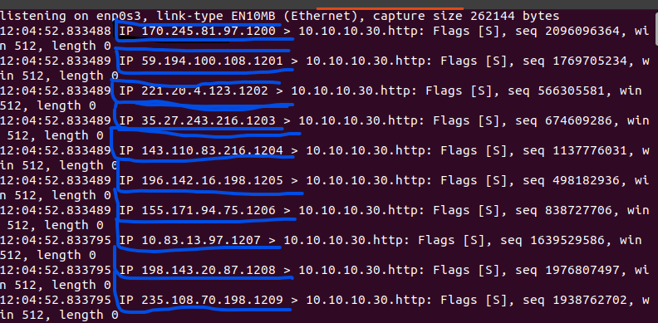
Randomized IPs can blend the malicious traffic with legitimate traffic, making it harder for Snort to distinguish between normal and suspicious activity..

Conclusion- Detection of Scanning by Snort IDS
The test demonstrated that the use of source IP randomization in conjunction with SYN flooding significantly reduced the likelihood of detection by signature-based IDS systems like Snort. This highlights a potential limitation in the current IDS configuration, particularly in detecting traffic with spoofed or frequently changing source IPs. To improve detection capabilities, it is recommended to implement enhanced Snort rules tailored to identify SYN flood patterns with spoofed IPs, complemented by behavioral analysis tools for anomaly detection. Regular testing and tuning of IDS rules are essential to ensure robust defense against evasion techniques.

10) Nmap decoy scan.
SCAN TECHNIQUE | COMMMAND USED | ToolS
Decoy scan | nmap -D <decoy ip> <decoy ip> <Me”Ip> <target Ip> | Nmap  tcpdump
FINDINGS : The “-D” option enables Nmap's decoy feature, which allows me to specify a list of IP addresses (decoys) to mask the origin of the scan. By including in the list, i instruct Nmap to include my own IP address among the decoys. This makes it appear as though the scan is coming from multiple IP addresses, potentially confusing the target's intrusion detection systems and making it harder to trace the scan back to you. The is the host or network being scanned.
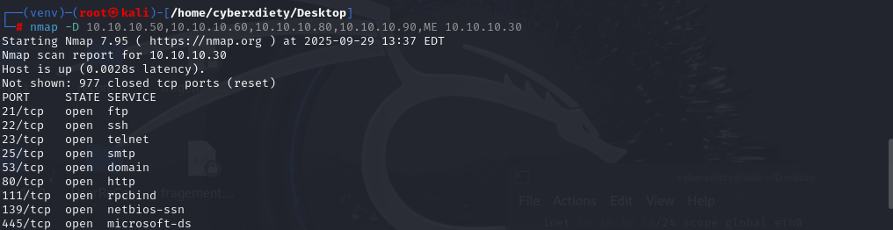

IDS RESPONSE :
Alert triggered {YES}
TCP SCAN attempted and detected {NO}

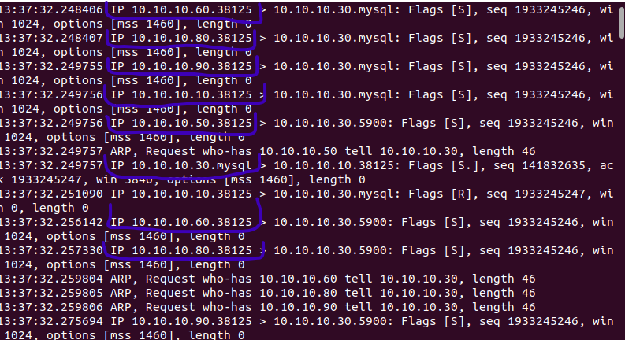
Conclusion- Detection of Scanning by Snort IDS
When use the -D option, Nmap sends packets to the target from all the specified IP addresses (both decoys and your real IP). From the target's perspective, it appears to be under a coordinated scan from multiple machines simultaneously. This makes it very difficult for their intrusion detection system (IDS) or firewall to determine which IP is the real attacker.

--------- Conclusions --------
During the scanning phase i exercised a broad set of active reconnaissance techniques against the targets within the authorized scope.most scanning technique were not recorded here because the IDS detected a lot of them…

most of the Techniques included are standard Nmap scans (SYN, TCP connect, UDP where applicable), fragmentation and MTU manipulation, packet-length/data-length adjustments, timing and rate tuning, decoy and random-source scans (-D, --rand-source), and off-path/idle (zombie) scans (-sI). Some scan choices were influenced by the need to test Snort’s detection behavior (i.e., “IDS-dictated” tests), while others were deliberate attempts to obfuscate scanner origin and evade logging and attribution (source-spoofing and decoy strategies). The results show a split: signature-based rules reliably detected many direct/noisy scans, whereas spoofing/decoy approaches materially reduced attribution and, in several cases, avoided Snort alerts entirely.
THANK YOU……

