I. CREATE DROPLET in DigitalOcian
SSH root@yourIdAddress
- change password for the first login

II. LOGIN via SSH (form you pc to DigitalOcian)
- Create SSH keys (public and private) on PC
ssh-keygen -t rsa -b 4096 -C 'server' (server is anyIdentifyer)
- This will create two file in your .ssh folder. One is id_server and another is id_server.pub
- Now we have to copy this id_server.pub content, so to do that we can write this command
- copy path and change if I have such file, example:
  - /Users/butfumes/.ssh/id_rsa CHANGE TO /Users/butfumes/.ssh/id_server
- Enter passphrase (empty for passphrase) - not need if you only one who is using this pc, so press ENTER
- SSH key is created in your PC.

- Copy id_server.pub key and PASTE INTO SERVER (.ssh/authorized_key)
- COPY to clipboard created ssh id_server.pub key
Cat id_server.pub | pbcopy
- This 'cat' command open this file and 'pbcopy' command will copy its content to your clipboard.
On server, we will go to .ssh folder and open authorized_keys file with vim
~/.ssh # vim authorized_keys
- Press “I” in order to INSERT info in opened file
- PASTE that ssh key we have copied in this authorized_keys file, then press ESC and colon (:) + w +q

- Now able to connect to server without password (ssh -i ~/.ssh/id_server root@server_IP)
TRY to login to SERVER via SSH by using this command:
ssh -i ~/.ssh/id_server root@server_IP
EXAMPLE: ssh -i ~/.ssh/id_server root@178.62.46.36

Now we have to restrict login from root user
- CREATE NEW USER
  - Create new user (add his password, details):
adduser bitfumes
  - switch to new user
sudo su bitfumes - But this user does't have any admin privilege, can’t run any sudo commands SO it will not be possible
  - Switch BACK to root user
Exit
usermod -aG admin bitfumes
sudo su bitfumes
sudo su root – now you should able to run sudo commands
cd home
cd gedamin
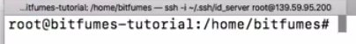

  - Allow bitfumes user to login to server via ssh
sudo su bitfumes
(root@test:/home/gedamin#)
so go to gedamin directory ……….???
For NEW USER (bitfumes ) create .ssh folder, create authorized_keys and paste id_server.pub key frol LOCAL TERMINAL
mkdir .ssh
cd .ssh
vim authorized_keys
  - COPY id_server.pub key from LOCAL TERMINAL
cd ~/.ssh
cat id_server.pub | pbcopy
#will copy in clipboard
  - GO back Server terminal and PASTE it with ssh
  - Exit from server exit, exit, exit AND login with NEW USER
ssh -i ~/.ssh/id_server bitfumes@server_IP

  - RESTRICT login as root USER (login as bitfumes ssh -i ~/.ssh/id_server bitfumes@server_IP)
5.1. In server file (/etc/ssh/sshd_config) make changes
sudo vim /etc/ssh/sshd_config
make two things as 'No' .
- press i to INSERT
PermintRootlogin no
PasswordAuthentication no
:wq
sudo service ssh restart
exit, exit from server till MAC

SO NOW if you try to login via root user, you can't. This means the only way to reach your server is via ssh with bitfumes user.
ssh -i ~/.ssh/id_server bitfumes@server_IP –able to login as user
ssh -i ~/.ssh/id_server root@server_IP – not able to login

III. INSTAL LEMP
- Login to SERVER as USER (bitfumes) via ssh
ssh -i ~/.ssh/id_server bitfumes@server_IP
- Install repositories (IOT get php7.2)
sudo apt-get update
sudo add-apt-repository ppa:nilarimogard/webupd8
sudo apt-get update
sudo apt-get install launchpad-getkeys
sudo launchpad-getkeys
sudo apt-get update
sudo apt-get install launchpad-getkeys
sudo apt-get update
- INSTAL PHP - https://gist.github.com/santoshachari/87bf77baeb45a65eb83b553aceb135a3

sudo apt-get install php7.2-cli php7.2-fpm php7.2-mbstring php7.2-mysql php7.1-mcrypt php7.2-curl
- Install MYSQL-Server
sudo apt-get install mysql-serve
AND
Sudo mysql_secure_installation
-Login to Mysql:
mysql -u root -p
SHOW DATABASES;
CREATE DATABASE blog;
Exit

sudo apt-get install mysql-serve

- INSTAL nginix
sudo apt-get install nginx
- Install Git, zip & unzip
sudo apt-get install git zip unzip
check git: git --version
- Install phpmyadmin (?)

IV. INSTALL LARAVEL via GITHUB
- Create project in PC, initiate git, move project to Github
composer create-project laravel/laravel
git init
git add .
git commit -m "My First Commit"

git remote add origin git@github.com:{github-username}/{repository-name}.git
git push -u origin master ar reikia ???
- Create SSH key for github on server
LOGIN s USER bitfumes: ssh -i ~/.ssh/id_server bitfumes@server_IP

ssh-keygen -t rsa -b 4096 -C "github"
ENTER, ENTER (the same file this time)
cat ~/.ssh/id_rsa.pub
-we will see key, which we have to --->COPY KEY<---
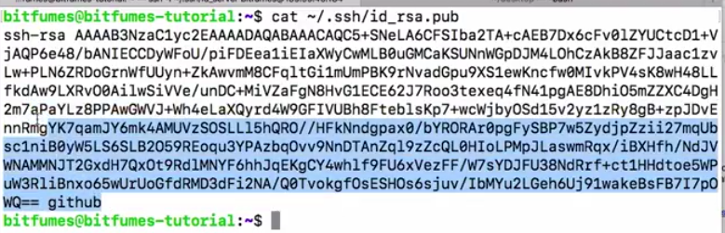
- Register ssh public key on github (PASTE KEY)
Login to github
Create repository
Upload to git (if not uploaded)
Go to settings, deploy keys and paste key
ssh –T git@github.com check if ok ssh

- Using GIT - Get project on our server
Ensure that project is in /var/www/html;
Go to /var/www and execute:
git clone git@github.com:{github-username}/{repository-name}.git html
git clone git@github.com:Cyber-gedamin/{repository-name}.git html

- Install Composer on our server
# Firstly go to html directory
cd html
# Install Composer
curl -sS https://getcomposer.org/installer | sudo php -- --install-dir=/usr/local/bin --filename=composer
# check composer install
composer -v
:~/html $ composer install --no-dev

change .env.example file of laravel to .env file only
cp .env.example .env
php artisan key:generate

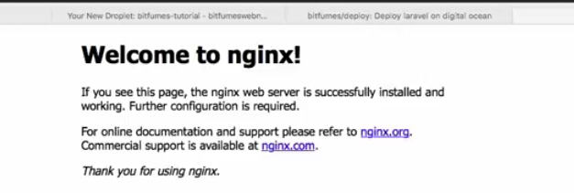

V. Edit nginx AND Deploy Laravel to DigitalOcian
1. Edit nginx for laravel IOT designate the right FOLDER fot index.php, additional uncomenent and edit for php7.2
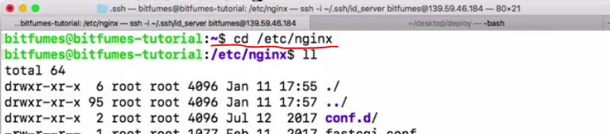
# Go to nginx folder
cd /etc/nginx
# Open default site configuration
sudo vim sites-available/default

# change from
root /var/www/html;
# to
root /var/www/html/public;

#Add server IP
server_name 107.191.44.91;

# ADD index.php after index.html
Index.php

# EDDIT loaction / {

location / {
try_files $uri $uri/ /index.php$is_args$args;
#OR
#try_files $uri $uri/ /index.php?$query_string;

}

location ~ \.php$ {
include snippets/fastcgi-php.conf;
fastcgi_pass unix:/run/php/php7.2-fpm.sock;
}

ESC
:wq
ENSURE that project in /var/www/html;

:~$ sudo service nginx restart
:~$ sudo service nginx reload
Check if nginx work properly
:~$ sudo nginx –t

# Open default site configuration
sudo vim /etc/nginx/sites-available/default
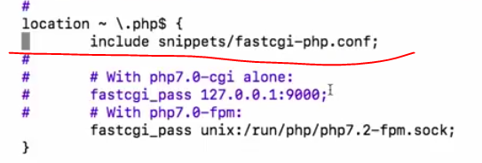
:~$ sudo service nginx restart

:/var/www/html$ sudo chmod -R 777 storage

2. make sure that project is in right folder

sudo rm –rf html
sudo mv –rf html /var/www

VI. Connect laravel to DB (edit .env file)

Create Swap File (Optional)
sudo fallocate -l 1G /swapfile
sudo mkswap /swapfile
sudo swapon /swapfile

Step 11: Install Git
We will install Git onto our server now in a folder called /var/repo/ which is near our Nginx folder of /var/www/laravel/. Let’s make the folder now.
cd /var
mkdir repo && cd repo

mkdir site.git && cd site.git
git init --bare

Step 12: Setting Up Git Hooks
cd /hooks

sudo nano post-receive
#!/bin/sh
git --work-tree=/var/www/laravel --git-dir=/var/repo/site.git checkout –f

sudo chmod +x post-receive
exit

Step 12: Set up our Local Computer to Push to Production
git remote add production ssh://root@example.com/var/repo/site.git
git push production master

Step 14: Run Composer
composer install --no-dev

Step 15: Laravel Permissions
sudo chown -R :www-data /var/www/laravel
sudo chmod -R 775 /var/www/laravel/storage
sudo chmod -R 775 /var/www/laravel/bootstrap/cache

php artisan key:generate

In config/app.php
'url' => 'http://example.com',

php artisan config:clear
php artisan config:cache
php artisan cache:clear

php artisan migrate
php artisane make:auth

