3 Models are Built to check the accuracy:-

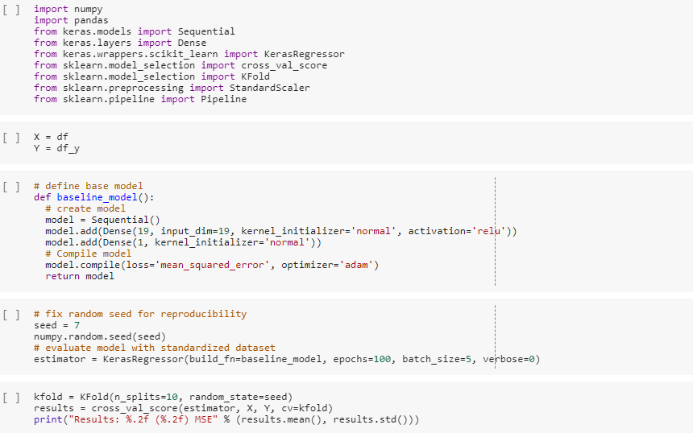Model 1:- Base Model

Result/Output:

Instructions for updating:

Use tf.cast instead.

**Results: -7.88 (17.24) MSE**

**Model 2:- Standardised Values**

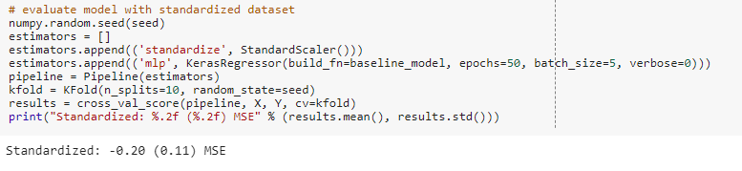

**Model 3: Large Model**

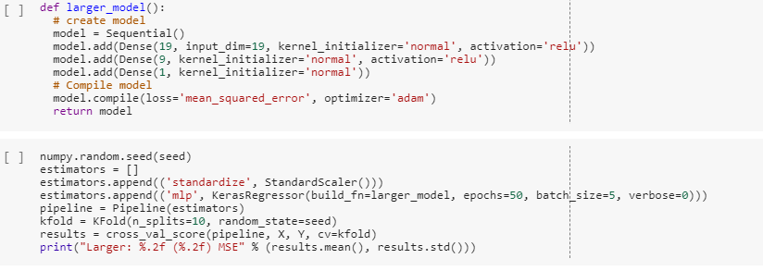

**Using R:**

