el

***Detection of Water Quality in Industrial Plants:-***

**Detailed Business Case:**

Water shortage problems in semi-arid areas have become more and more serious in recent years. Recent studies show that a lack of water resources could affect nearly 5.5 billion people in 10 years. Severe water shortages and large volumes of sewage render river and lake water pollution issues serious in arid areas. The water quality of rivers and lakes is becoming central to human and economic development. Therefore, the evaluation and estimation of water quality levels is essential for societal and economic development.

Sensors to measure water quality index parameters can help identify various key metrics, based on the values in data the variations of each parameter is keenly observed. For example, each value can help identify the quality of water and checks whether it is meeting the WHO standards on Water Resource. Also, any sudden changes in water quality index level help can generate an alert for operations team to investigate the root cause as well as can take necessary steps to prevent the chemical spill and prevent water pollution.

**Solution Design and Architecture:**

Data from interfacing sensors along with A7 GPRS and GPS Module installed in a lake will be relayed to an Arduino Genuino Ethernet. Hadoop can act as a persistent storage for the information and MapReduce/Spark can be used to crunch the information. Crunched information can be loaded to hbase/Mongo db and it can act as the source for dashboards. The crunched data is converted into the form of csv file. Using **Google COlab** an ML model is built to calculate the WQI and several tests with various parameters can be done and results are noted. Finally with the help of these calculations Water Quality model is compared to the WHO standards for the purity.

**Calculation of Water Quality Index:**

The Water Quality Index (WQI) is an extracted and estimated index that reflects the composite effects of all water quality parameters. First, each water quality parameter was assigned a weight (Wi) from a scale of 1 (lowest effect on water quality parameters) to 5 (strongest effect on water quality parameters) based on perceived effects on primary health and according to its relative importance to the surface water environment.

PO4 3−, SO2 and Cr values were assigned the highest weight due to their primary role in water quality assessments; a minimum weight was assigned to parameters Ca, Mg and Na due to their limited importance for water quality assessments. The relative weight (Wi) is computed from the following equation:



Where (Wi) is the relative weight, Wi is the weight of each parameter, and n is the number of parameters. Then, a quality rating (Qi) for each parameter is assigned by dividing its concentration in each water sample by its limit given in the WHO quality standards for surface water quality. This result is multiplied by 100.

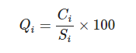

Where Qi is the quality rating, Ci is the concentration of each water quality parameter for each water sample, and Si is the surface water standard for each water quality parameter according to WHO guidelines (2008). To measure the WQI, the SIi value should be calculated first using the following equations:

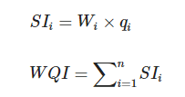 Where SIi is the water quality index of the ith

Parameter and Qi is the water quality level w.r.t ith

Water quality parameter

**Logical Data Model:**

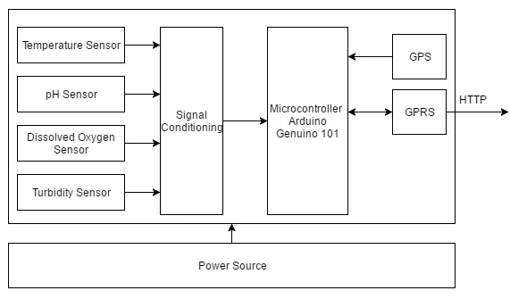

HADOOP

MAP REDUCE/SPARK

COLAB

Model Creation and Testing

Test Results

Data

Process

DataProcessin