

COURSEWORK

FACULTY OF SCIENCE AND TECHNOLOGY

PROGRAMME(S): BSF, BCS, BIT, DIT

SESSION: DAY/EVENING/WEEKEND
MODULE CODE AND TITLE:  2101 ST, 2104 ST, 2108 ST – Database Systems | LEVEL:  1.1,3.3,3.3.2
DATE:  8. January, 2024 | TIME:  24.12.2024 – 08.01.2025
DURATION:  2 WEEKS | TOTAL MARKS:  40
EXAMINER/ LECTURER:  Mr. Bazigu Alex | MODERATOR:  Dr. David Kakeeto

INSTRUCTIONS TO THE CANDIDATE/ STUDENT
1. V-class is the ONLY official examination platform.
2. Questions must be attempted in the answer booklet/sheet provided on V-class.
3. All queries should be directed to the examiner, Head of Department, or Dean.
4. You have TWO WEEKS to complete this paper. No exam answer sheet shall be accepted after the
2 WEEKS Deadline: 8TH/01/2025 - (No extension of the submission Date).
5. This is an OPEN BOOK COURSEWORK.
6. Attempt 4 Questions in total. All questions carry equal marks (40 marks).
7. All questions are COMPULSORY
8. Read each question carefully before beginning to type/write your answers.
9. Review the grades assigned to each question of the Coursework and allocate your time accordingly.
10. Review your answers carefully before submitting your Coursewoek.
11. After submitting your coursework answer sheet, Cross-Check to ensure your examination was attached and sent to V-class and received a confirmation message.
Question 1
Case Study: Real Estate Database Management System
“Crane Management Services (CMS)”, is a leading real estate management company in Uganda and a subsidiary of the Ruparelia Group, owned by Sudhir Ruparelia. It was established in 1996 specializing in managing, marketing, and providing consultancy services within the real estate sector.
The company manages a diverse portfolio comprising residential, commercial, and industrial properties overseeing up to 350 properties covering approximately 5 million square feet with 95% of these properties situated in Kampala and its surrounding suburbs. The company operates in various domains of real estate, including;
- Residential properties: Houses, apartments, and villas.
- Commercial properties: Office spaces, retail shops, and warehouses.
- Industrial properties: Factories and industrial complexes.
Their operations involve property listings, property management, client matchmaking, and overseeing transactions like sales, rentals, and leases. Currently, data is managed manually, resulting in inefficiencies like data duplication, inaccurate reporting, and delays in processing transactions.
To address operational challenges, the company plans to implement a Database Management System (DBMS) to centralize data storage, ensure data integrity, and automate reporting. The DBMS will manage property listings, track agent performance and commissions, handle client data to match preferences with properties, and log transaction details for buying, selling, and renting activities.
The database will consist of the following entities
- Properties
Attribute | Description | Data Type | Constraint
PropertyID | Unique identifier for the property | INT | PRIMARY KEY
Address | Full address of the property | VARCHAR(255) | NOT NULL
City | City where the property is located | VARCHAR(100) | NOT NULL
Type | Type of property (Residential, Commercial) | VARCHAR(50) | CHECK (Type IN ('Residential', 'Commercial', 'Industrial'))
Size | Size of the property in square feet | INT | NOT NULL
Price | Price of the property | DECIMAL(10,2) | NOT NULL
Status | Availability status (Available, Sold, etc.) | VARCHAR(20) | CHECK (Status IN ('Available', 'Sold', 'Rented'))

- Agents
Attribute | Description | Data Type | Constraint
AgentID | Unique identifier for the agent | INT | PRIMARY KEY
Name | Full name of the agent | VARCHAR(100) | NOT NULL
ContactNumber | Contact number of the agent | VARCHAR(15) | UNIQUE
CommissionRate | Commission rate in percentage | DECIMAL(5,2) | CHECK (CommissionRate > 0)

- Clients
Attribute | Description | Data Type | Constraint
ClientID | Unique identifier for the client | INT | PRIMARY KEY
Name | Full name of the client | VARCHAR(100) | NOT NULL
ContactNumber | Contact number of the client | VARCHAR(15) | UNIQUE
Email | Email address of the client | VARCHAR(100) | UNIQUE
Preferences | Property preferences (Location, Type) | TEXT | NULLABLE

- Transactions
Attribute | Description | Data Type | Constraint
TransactionID | Unique identifier for the transaction | INT | PRIMARY KEY
PropertyID | Foreign key linking to Properties table | INT | FOREIGN KEY (PropertyID) REFERENCES Properties(PropertyID) ON DELETE CASCADE
AgentID | Foreign key linking to Agents table | INT | FOREIGN KEY (AgentID) REFERENCES Agents(AgentID) ON DELETE CASCADE
ClientID | Foreign key linking to Clients table | INT | FOREIGN KEY (ClientID) REFERENCES Clients(ClientID) ON DELETE CASCADE
TransactionType | Type of transaction (Buy, Sell, Rent) | VARCHAR(10) | CHECK (TransactionType IN ('Buy', 'Sell', 'Rent'))
Date | Date of the transaction | DATE | NOT NULL
Amount | Transaction amount | DECIMAL(10,2) | NOT NULL

Questions (Required)
- With definition, discuss how a Database Management System (DBMS) can improve the operations of the real estate business described in the case study.
- Real estate businesses often deal with sensitive data like client contact details and transaction amounts. How can a DBMS help ensure data security and access control?
- Identify the types of database users and their roles/ privileges involved in the real estate business
- List and explain the role of the following database languages in the real estate DBMS;
- DDL (Data Definition Language).
- DML (Data Manipulation Language).
- DCL (Data Control Language)
- Create an Entity-Relationship (ER) Diagram for the above entities and their relationships using the Crow’s Database Notation.
- Normalize the database structure to 3NF to eliminate redundancy and ensure data integrity.
- Write SQL statements for the following tasks related to the real estate business;
- Create a properties table with appropriate constraints.
- Insert at least 10 sample records for a property .
- Retrieve all properties available for sale in a specific city.
- Update the status of a property after it has been sold.
- What happens if a transaction is recorded with a PropertyID that does not exist in the Properties table? How can constraints prevent such issues?
- Propose custom constraints for the following business rules;
- A property’s Status must be either "Available," "Sold," or "Rented."
- The CommissionRate for agents must be between 1% and 15%.
- A transaction’s Amount cannot exceed the listed Price of the property.

Question Two
Victoria University Hospital/Clinic seeks to enhance its operational efficiency and fulfill its Corporate Social Responsibility by transitioning its patient registration process from a paper-based system to a robust, database-driven system. Inspired by the success of VClass, the University’s E-Learning Portal, the University hospital seeks to adopt a similar technological approach to manage patient data effectively, especially to address the increasing cases of malaria in central Kampala.
To achieve this, a university student developed an Entity-Relationship Diagram (ERD) below using the Crow’s Foot Database Notation. This ERD is tailored specifically for managing malaria patient data, which is crucial in the central Kampala region where malaria cases are rampant.
The system is designed to integrate patient data, treatment records, laboratory tests, facility operations, and resource management into a unified framework.
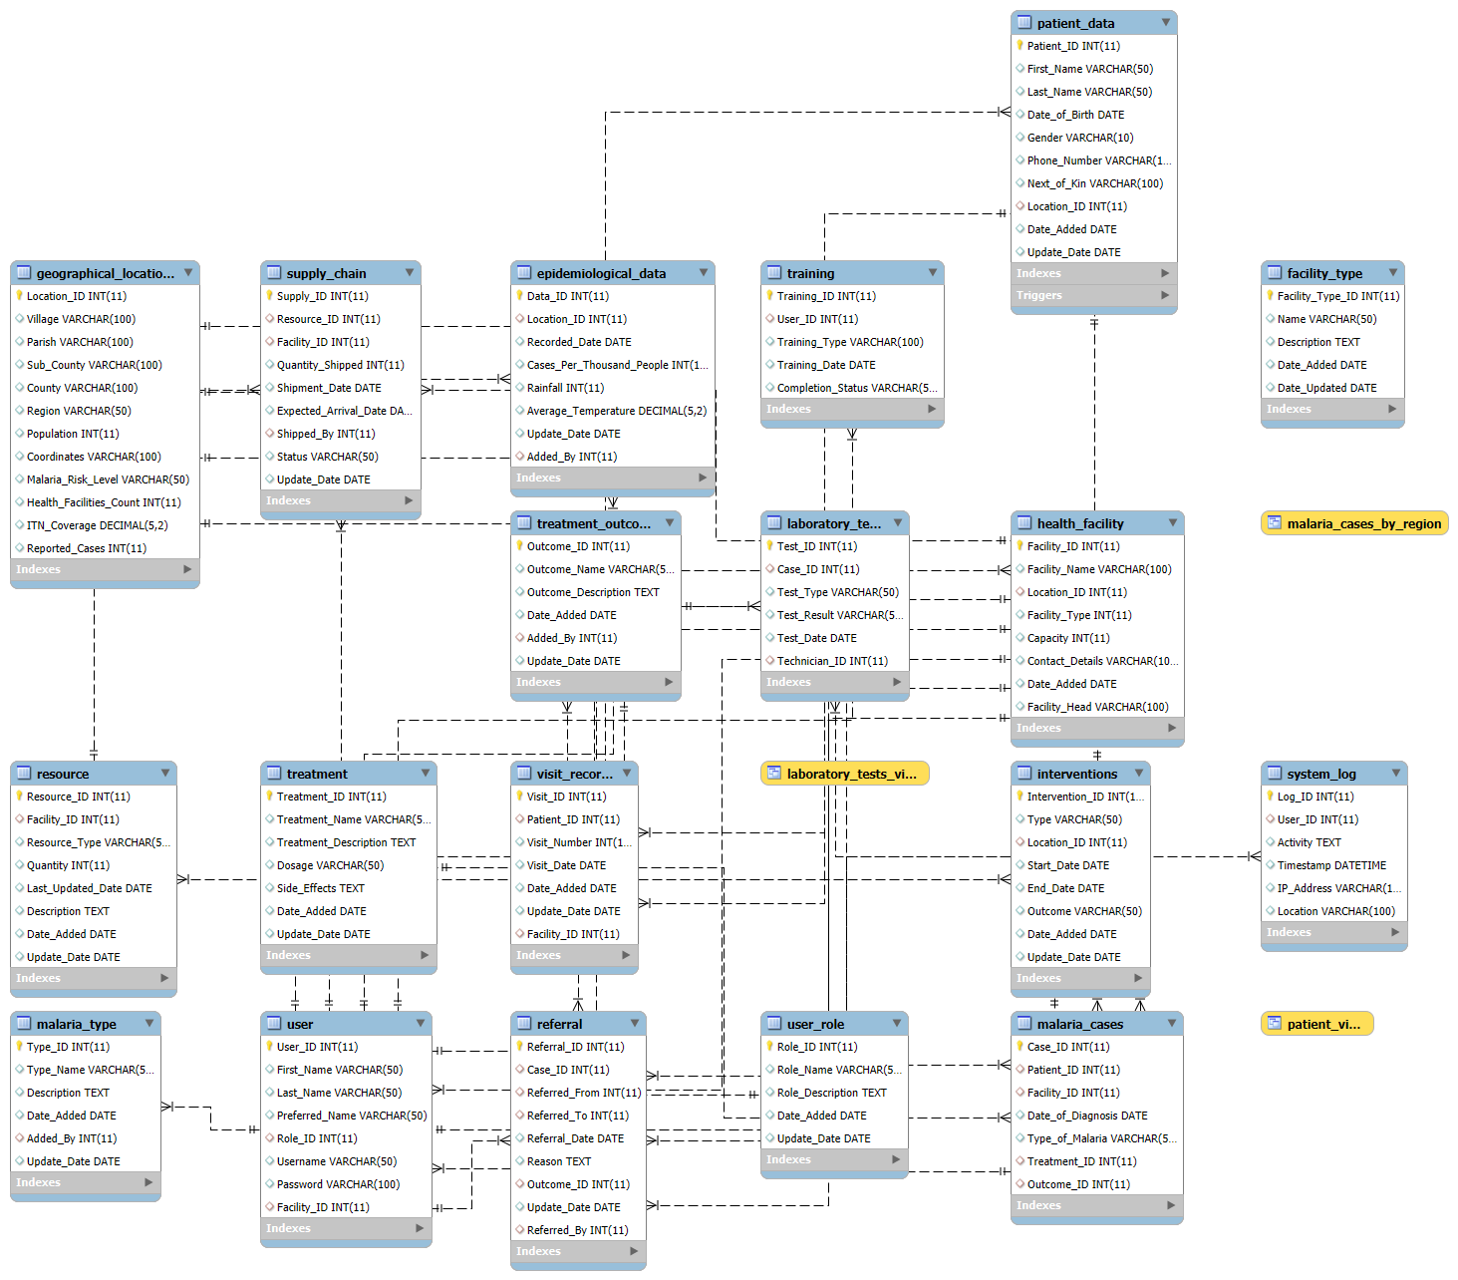
Required (parts)
- From the provided ERD, identify the primary entities and their relationships to one another.
- Based on the provided ERD, identify and explain any potential errors, inconsistencies, or missing elements. Use specific examples from the diagram to support your evaluation.
- Describe the relationship between the patient_data and visit_record tables. Why is this relationship important in a healthcare database?
- What role does the user_role table play in ensuring secure access to the system?
- If a health facility is low on medical supplies, how can the supply_chain and resource tables be used to identify and resolve the issue?
- Redraw the ERD using Chen's Database Notation. Clearly state the relationships between the identified entities, including their cardinalities and any relevant attributes.
- If the University hospital decides to expand this system to include non-malaria-related diseases, which parts of the ERD would need modifications or extensions?
- Generate the SQL code to create the database tables observed from the ERD with all constraints (e.g., primary keys, foreign keys). Include necessary data types and relationships in your script.
Requirements (Question Two – No. 6 and No. 8 )
You are required to submit your completed work as follows; -
- Submit the complete course work (Question 1 and 2) via Vclass, be precise and avoid AI generated contents.
- For question 2 No.6 and No.8.
- Upload the SQL script to your GitHub Account and include the GitHub Link to the coursework document.
- Record a video demonstrating the of the ERD (Chen Database Notation) and the SQL Script operation using ScreenPal on your laptop, upload the video to your YouTube channel, and include the YouTube link in the document.
- Ensure that your submissions adhere to the provided instructions.
- Submit one document with all your solutions not “a zipped folder” (Take This Serious)

END
A MERRY XMAS AND HAPPY NEW YEAR 2025.
Always Remember;-
The goal is to turn data into information, and information into insight. – Carly Fiorina

