PROJECT BRIEF
Secure Office Network Using VLANs and Inter-VLAN Routing
Cisco Packet Tracer | Router-on-a-Stick | Intermediate | Individual project
Prepared by: Awe Oluwasanmi Mayokun Date: October 2026 Tool: Cisco Packet Tracer

1. Overview
A small company has three departments, Human Resources (HR), Information Technology (IT) and Finance, whose staff currently share one flat network. Every broadcast reaches every device, and nothing separates sensitive records from general traffic.
This project redesigns that network in Cisco Packet Tracer. Each department gets its own VLAN, so it forms a separate broadcast domain and subnet. Two switches share the departments between them, and one router connects the VLANs through Router-on-a-Stick inter-VLAN routing. The finished network is then tested for connectivity, for behaviour when the router fails, and for how a packet is actually forwarded between VLANs.

2. Objectives
- Segment the office into three VLANs (HR, IT, Finance) with one subnet each.
- Spread every department across two switches, so the inter-switch trunk is genuinely needed.
- Configure 802.1Q trunks between the switches and between Switch1 and the router.
- Provide inter-VLAN routing with one physical router interface and three subinterfaces.
- Verify connectivity, isolation and failure behaviour with a structured test plan.
- Trace one routed packet to show how MAC addresses, VLAN tags and IP addresses behave at each hop.
- Extend the network with a shared server on its own routed subnet.

3. Scope
In scope: VLAN creation and port assignment, trunking, static host addressing, Router-on-a-Stick, the shared server, the verification commands and the packet-flow analysis.
Out of scope: DHCP, access control lists, NAT, dynamic routing protocols, port security and device hardening. These are natural next steps. This project focuses on the VLAN and routing foundation.

4. Network Design

4.1 Logical topology
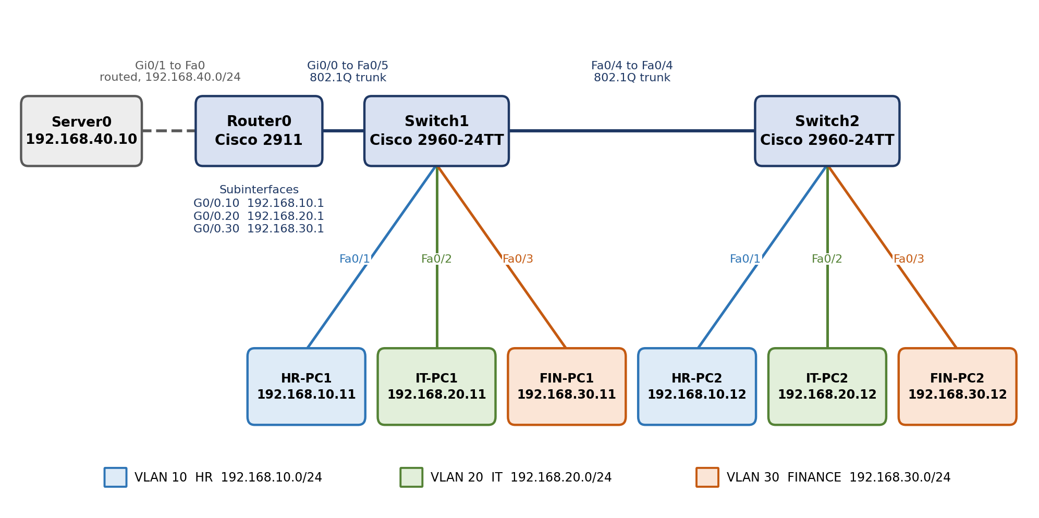
Figure 1: Logical topology, port connections and addressing

4.2 Devices
Table 1: Device inventory
Device | Model | Role | Qty
Router0 | Cisco 2911 | Inter-VLAN routing and the default gateway for every network | 1
Switch1, Switch2 | Cisco 2960-24TT | Access switching and VLAN trunking; Switch1 also carries the router uplink | 2
PCs | PC-PT | End hosts, two per department (HR-PC1/2, IT-PC1/2, FIN-PC1/2) | 6
Server0 | Server-PT | Shared server on its own routed network (extension) | 1

4.3 VLANs and subnets
Table 2: VLAN and subnet plan
VLAN | Name | Department | Network | Gateway
10 | HR | Human Resources | 192.168.10.0/24 | 192.168.10.1 (G0/0.10)
20 | IT | Information Technology | 192.168.20.0/24 | 192.168.20.1 (G0/0.20)
30 | FINANCE | Finance | 192.168.30.0/24 | 192.168.30.1 (G0/0.30)
None | Servers | Shared services (routed port) | 192.168.40.0/24 | 192.168.40.1 (G0/1)

4.4 Host addressing
Table 3: Host connections and addresses (all masks 255.255.255.0)
Device | Connected to | VLAN | IP address | Default gateway
HR-PC1 | Switch1 Fa0/1 | 10 | 192.168.10.11 | 192.168.10.1
IT-PC1 | Switch1 Fa0/2 | 20 | 192.168.20.11 | 192.168.20.1
FIN-PC1 | Switch1 Fa0/3 | 30 | 192.168.30.11 | 192.168.30.1
HR-PC2 | Switch2 Fa0/1 | 10 | 192.168.10.12 | 192.168.10.1
IT-PC2 | Switch2 Fa0/2 | 20 | 192.168.20.12 | 192.168.20.1
FIN-PC2 | Switch2 Fa0/3 | 30 | 192.168.30.12 | 192.168.30.1
Server0 | Router0 Gi0/1 | None | 192.168.40.10 | 192.168.40.1

4.5 Infrastructure links
Table 4: Links between network devices
Link | Endpoint A | Endpoint B | Mode
Switch to switch | Switch1 Fa0/4 | Switch2 Fa0/4 | 802.1Q trunk, VLANs 10, 20, 30
Router uplink | Switch1 Fa0/5 | Router0 Gi0/0 | 802.1Q trunk; the router splits it into subinterfaces .10, .20 and .30
Server link | Router0 Gi0/1 | Server0 Fa0 | Routed port, untagged

4.6 Design decisions
- One cable to the router. All three VLANs share Gi0/0. Each subinterface is numbered to match its VLAN ID (G0/0.10 for VLAN 10) so the configuration is easy to read.
- Trunks carry only what they need. The allowed-VLAN list on every trunk is limited to 10, 20 and 30.
- Same VLAN IDs on both switches. VLAN IDs and port layout are identical on Switch1 and Switch2, which keeps the two switches consistent and simple to verify.
- Server on its own routed subnet. The server sits on a separate router port rather than in a department VLAN, so every VLAN reaches it through the router.

5. Implementation Approach
The build follows eight phases. Each phase ends with a checkpoint, so a fault is found where it is introduced and not after everything is connected.
Table 5: Build phases and checkpoints
Phase | Activity | Checkpoint
1. Build topology | Place the devices and cable the links in Table 4 and Table 3 | Links come up once the router port is enabled
2. VLANs and access ports | Create VLANs 10, 20, 30 on both switches; assign Fa0/1 to Fa0/3 | show vlan brief
3. Trunks | Configure Switch1 Fa0/4 and Fa0/5, and Switch2 Fa0/4, as trunks for VLANs 10, 20, 30 | show interfaces trunk
4. Host addressing | Set IP address, mask and gateway on the six PCs | Same-VLAN pings (Test A)
5. Router-on-a-Stick | Enable Gi0/0; create subinterfaces with 802.1Q encapsulation and gateway addresses | show ip interface brief, show ip route
6. Server extension | Address Gi0/1 as 192.168.40.1/24 and configure Server0 | Ping the server from each VLAN (Test E)
7. Verification | Run Tests A to E and capture the command outputs | Screenshots of every result
8. Documentation | Write the report, troubleshooting log and conclusion; save the .pkt file | Repository-ready package

6. Testing and Verification Plan
Table 6: Test plan and expected results
Test | Purpose | Method | Expected result
A | Same-VLAN reachability | Ping the second PC of each department from the first (HR, IT, Finance) | All replies received; TTL 128 shows no router in the path
B | Inter-VLAN routing | HR-PC1 to IT-PC1, HR-PC1 to FIN-PC1, FIN-PC1 to HR-PC1 | Replies with TTL 127 (one router hop); the first request may time out while ARP resolves
C | Behaviour when the router fails | Shut down Gi0/0, repeat one same-VLAN and one inter-VLAN ping, then restore | Same-VLAN traffic still works; inter-VLAN traffic fails until Gi0/0 is restored
D | Packet-flow analysis | Simulation Mode with ARP and ICMP filters; send one ping from HR-PC1 to FIN-PC1 and inspect the PDU details at each device | Written answers to the five questions below
E | Server reachability | Ping 192.168.40.10 from a PC in each VLAN | Replies from every VLAN with TTL 127

Test C also asks why the router affects communication between VLANs but not within one. The answer lies in the layers: switches forward frames inside a VLAN by MAC address, while only a Layer 3 device can move traffic between networks.
Packet-flow analysis questions (Test D)
- How does the source PC learn the MAC address of its default gateway?
- How does the frame travel from the access switch to the router, and how are VLANs told apart on the trunk?
- How does the router decide which interface to send the packet out of?
- What happens to the source and destination MAC addresses when the router forwards the packet?
- Do the source and destination IP addresses change during ordinary routing without NAT?

7. Verification Commands
Table 7: Commands used to verify the build
Device | Command | What it confirms
Switches | show vlan brief | VLANs exist, are active, and have the right access ports
Switches | show interfaces trunk | Trunk ports, encapsulation, native VLAN and allowed VLANs
Switches | show interfaces status | Link state and whether each port is access or trunk
Switches | show mac address-table | Which MAC address each switch has learned, per VLAN and port
Switches | show running-config | The complete active configuration
Router | show ip interface brief | Interface addresses and up/up status
Router | show ip route | Directly connected networks for every subnet
Router | show interfaces | MAC address, IP address and 802.1Q VLAN ID of each interface
Router | show running-config | Subinterface encapsulation and addressing

8. Deliverables
Table 8: Project deliverables
Deliverable | Contents
Packet Tracer file | Oluwasanmi_VLAN_Routing_Project.pkt, saved with the final configuration
Topology screenshot | The complete network with all links up
VLAN and trunk evidence | show vlan brief and show interfaces trunk from both switches
Router evidence | Subinterfaces, routing table and interface details
Test results | Same-VLAN, inter-VLAN, router-failure and server pings
Packet-flow analysis | Simulation Mode captures with written answers
Troubleshooting log | Each fault met during the build, its cause and its fix
Conclusion | How VLANs improve network organisation and isolation

9. Success Criteria
- Each department's two PCs are in the same VLAN even though they sit on different switches.
- Every trunk shows trunking and allows VLANs 10, 20 and 30.
- All three router subinterfaces are up/up with the gateway addresses in Table 2.
- Every PC can reach every other PC and the server.
- With the router link down, only inter-VLAN traffic fails.
- The packet capture shows MAC addresses changing at the router while IP addresses stay the same.

10. Assumptions and Acknowledgement
- The server subnet (192.168.40.0/24) was not specified, so it follows the existing addressing pattern.
- All networks use a /24 mask, hosts are addressed statically, and the native VLAN stays at the default VLAN 1.
- Devices are referred to by their Packet Tracer labels (Switch1, Switch2, Router0).
This project is adapted from a VLAN and inter-VLAN routing exercise in Devtown’s “Networking Basics for Cybersecurity” course material. The addressing, configuration, testing and documentation set out here were carried out and extended independently, including the shared server, the verification of MAC address tables and the packet-level analysis.

