PROJECT REPORT
Secure Office Network Using VLANs and Inter-VLAN Routing
Cisco Packet Tracer | Router-on-a-Stick | Intermediate | Individual project
Prepared by: Awe Oluwasanmi Mayokun Date: October 2026 Tool: Cisco Packet Tracer
Contents
1 Executive Summary 2 Network Design 3 Implementation Guide 4 Verification of the Build 5 Functional Testing 6 Troubleshooting Log 7 Conclusion Appendix A Final Configurations Appendix B Evidence at Full Size

1. Executive Summary
This report documents the design, build and testing of a segmented office network in Cisco Packet Tracer. Three departments, Human Resources (HR), Information Technology (IT) and Finance, each have their own VLAN and subnet. Every department is spread across two switches, so the network depends on 802.1Q trunking. A single router connects the VLANs using subinterfaces on one physical port (Router-on-a-Stick), and a shared server on its own routed subnet extends the design.
All connectivity tests passed. The failure test showed that same-VLAN traffic keeps working without the router while inter-VLAN traffic stops, and a packet-level trace in Simulation Mode confirmed how MAC addresses, VLAN tags and IP addresses change at each hop. Section 3 is written as a step-by-step guide, so the network can be rebuilt from scratch.
Table 1: Results at a glance
Test | Outcome | Detail in
A. Same-VLAN | Passed: all three department pairs reachable, 4 of 4 replies, TTL 128 | Section 5.1
B. Inter-VLAN | Passed: HR to IT, HR to Finance and Finance to HR reachable, TTL 127 (one router hop) | Section 5.2
C. Router failure | Passed: same-VLAN unaffected, inter-VLAN fully blocked, restored after no shutdown | Section 5.3
D. Packet-flow trace | Completed: ARP, 802.1Q tagging, MAC rewrite and unchanged IPs all observed | Section 5.4
E. Server reachability | Passed: every VLAN reaches 192.168.40.10, TTL 127 | Section 5.5

2. Network Design

2.1 Topology
Router0 connects to Switch1 through one trunk link, and Switch1 connects to Switch2 through a second trunk. Each switch carries one PC from every department, which is why the inter-switch trunk is essential. The server connects directly to the router on its own port.
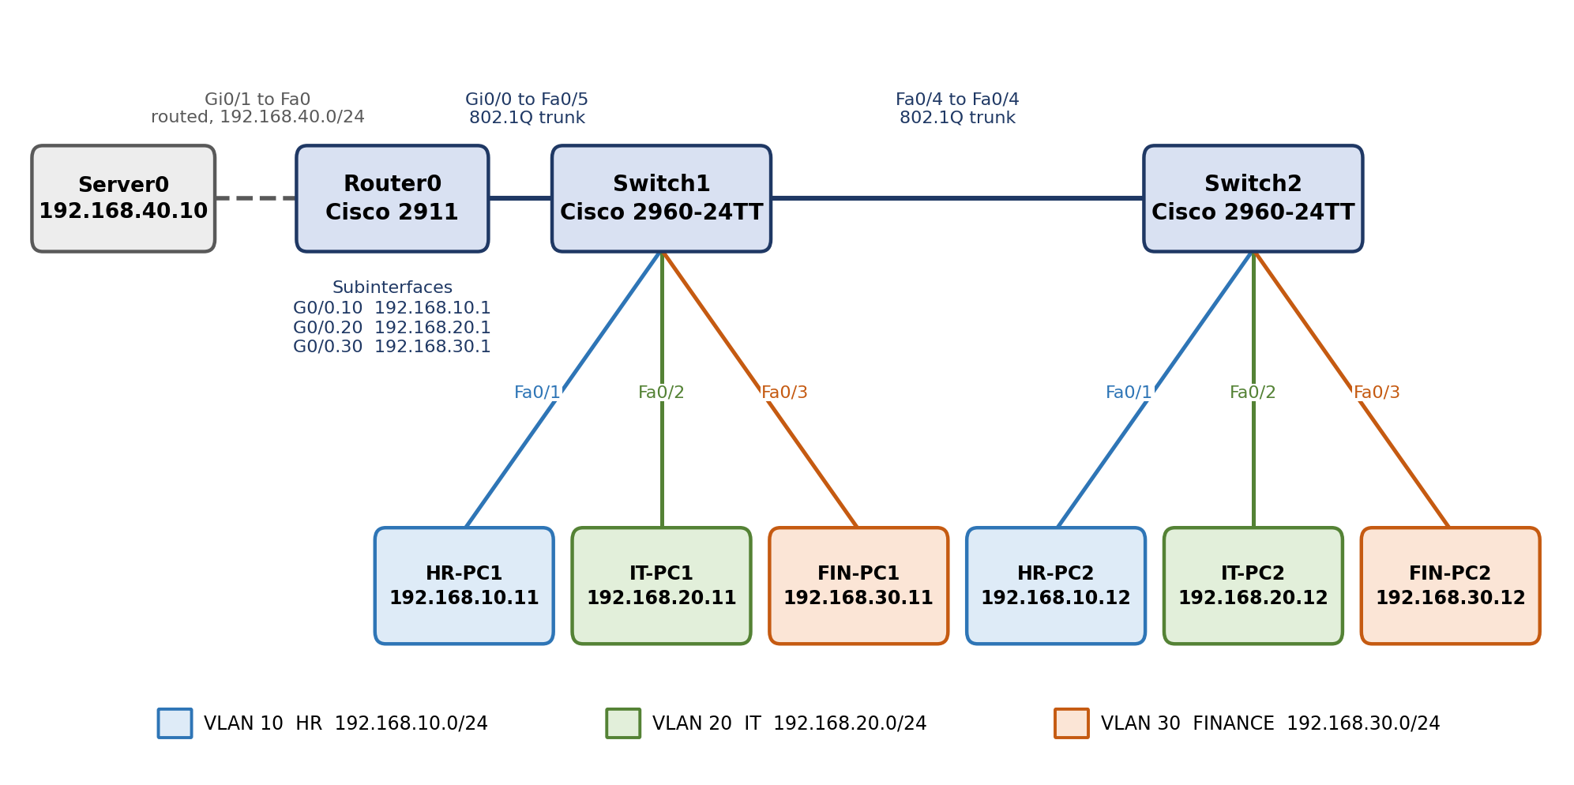
Figure 1: Logical topology with port connections and addressing
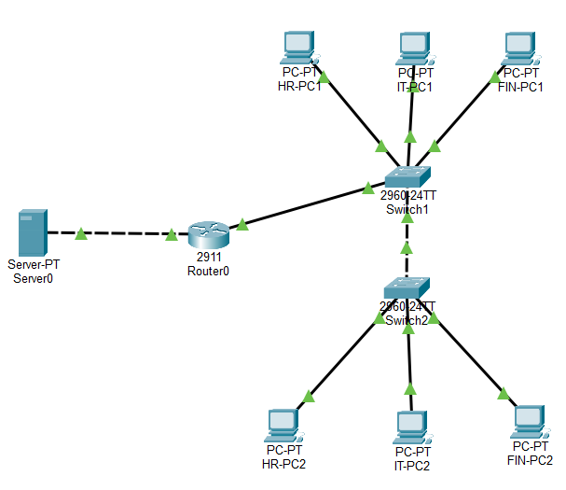
Figure 2: The completed network in Packet Tracer, all links up

2.2 VLANs and subnets
Table 2: VLAN and subnet plan
VLAN | Name | Department | Network | Gateway
10 | HR | Human Resources | 192.168.10.0/24 | 192.168.10.1 (G0/0.10)
20 | IT | Information Technology | 192.168.20.0/24 | 192.168.20.1 (G0/0.20)
30 | FINANCE | Finance | 192.168.30.0/24 | 192.168.30.1 (G0/0.30)
None | Servers | Shared services (routed port) | 192.168.40.0/24 | 192.168.40.1 (G0/1)

2.3 Host addressing
Table 3: Host connections and addresses (all masks 255.255.255.0)
Device | Connected to | VLAN | IP address | Default gateway
HR-PC1 | Switch1 Fa0/1 | 10 | 192.168.10.11 | 192.168.10.1
IT-PC1 | Switch1 Fa0/2 | 20 | 192.168.20.11 | 192.168.20.1
FIN-PC1 | Switch1 Fa0/3 | 30 | 192.168.30.11 | 192.168.30.1
HR-PC2 | Switch2 Fa0/1 | 10 | 192.168.10.12 | 192.168.10.1
IT-PC2 | Switch2 Fa0/2 | 20 | 192.168.20.12 | 192.168.20.1
FIN-PC2 | Switch2 Fa0/3 | 30 | 192.168.30.12 | 192.168.30.1
Server0 | Router0 Gi0/1 | None | 192.168.40.10 | 192.168.40.1

2.4 Cabling and port map
Table 4: Infrastructure links
Link | Endpoint A | Endpoint B | Cable | Port mode
Switch to switch | Switch1 Fa0/4 | Switch2 Fa0/4 | Cross-over | 802.1Q trunk
Router uplink | Switch1 Fa0/5 | Router0 Gi0/0 | Straight-through | 802.1Q trunk
Server link | Router0 Gi0/1 | Server0 Fa0 | Cross-over | Routed, untagged
PC links | Fa0/1 to Fa0/3 on each switch | PC FastEthernet0 | Straight-through | Access
Trunks are restricted to VLANs 10, 20 and 30. The native VLAN stays at the default (VLAN 1).

3. Implementation Guide
Follow the steps in order. Each step ends with a check, so a fault is found where it was introduced. Commands assume the default hostnames (Switch for each switch, Router for the router); the prompts in the examples are shortened accordingly.

Step 1: Build the topology
- Place one Cisco 2911 router, two Cisco 2960-24TT switches, six PCs and one server.
- Label the PCs HR-PC1, IT-PC1, FIN-PC1, HR-PC2, IT-PC2, FIN-PC2, and the switches Switch1 and Switch2.
- Cable them as in Table 4. Router interfaces are shut down by default, so the router links stay red until Step 5.

Step 2: Create the VLANs and assign access ports
Run this on both switches. The VLAN IDs and port layout are identical on each.
Switch> enable
Switch# configure terminal
Switch(config)# vlan 10
Switch(config-vlan)# name HR
Switch(config-vlan)# exit
Switch(config)# vlan 20
Switch(config-vlan)# name IT
Switch(config-vlan)# exit
Switch(config)# vlan 30
Switch(config-vlan)# name FINANCE
Switch(config-vlan)# exit
Switch(config)# interface fa0/1
Switch(config-if)# switchport mode access
Switch(config-if)# switchport access vlan 10
Switch(config-if)# exit
Switch(config)# interface fa0/2
Switch(config-if)# switchport mode access
Switch(config-if)# switchport access vlan 20
Switch(config-if)# exit
Switch(config)# interface fa0/3
Switch(config-if)# switchport mode access
Switch(config-if)# switchport access vlan 30
Switch(config-if)# end
Check: run show vlan brief. VLANs 10, 20 and 30 should be active, with Fa0/1, Fa0/2 and Fa0/3 listed under them.
The VLAN definitions are stored in the VLAN database, not in the running configuration. That is why the exported configuration files in Appendix A do not contain the vlan lines, and why this step must be repeated on any rebuilt switch.

Step 3: Configure the trunks
Switch1
Switch(config)# interface fa0/4
Switch(config-if)# description Trunk to Switch2
Switch(config-if)# switchport mode trunk
Switch(config-if)# switchport trunk allowed vlan 10,20,30
Switch(config-if)# exit
Switch(config)# interface fa0/5
Switch(config-if)# description Trunk to Router G0/0
Switch(config-if)# switchport mode trunk
Switch(config-if)# switchport trunk allowed vlan 10,20,30
Switch(config-if)# end

Switch2
Switch(config)# interface fa0/4
Switch(config-if)# description Trunk to Switch 1
Switch(config-if)# switchport mode trunk
Switch(config-if)# switchport trunk allowed vlan 10,20,30
Switch(config-if)# end

A 2960 in Packet Tracer supports only 802.1Q, so no encapsulation command is needed (and entering one gives an error). The allowed-VLAN list is optional, but it keeps unused VLANs off the trunks.
Check: run show interfaces trunk. Each trunk port should read trunking, with VLANs 10, 20 and 30 allowed.

Step 4: Address the hosts
On each PC, open Desktop, then IP Configuration, choose Static, and enter the address, mask and default gateway from Table 3. Do the same on Server0 with 192.168.40.10, mask 255.255.255.0 and gateway 192.168.40.1. Screenshots are in Appendix B.
Check: ping from HR-PC1 to HR-PC2 (192.168.10.12). It should succeed, because both are in VLAN 10 and the trunk joins the switches. Pinging a gateway will not work yet.

Step 5: Configure Router-on-a-Stick
Router> enable
Router# configure terminal
Router(config)# interface g0/0
Router(config-if)# no shutdown
Router(config-if)# exit
Router(config)# interface g0/0.10
Router(config-subif)# encapsulation dot1Q 10
Router(config-subif)# ip address 192.168.10.1 255.255.255.0
Router(config-subif)# exit
Router(config)# interface g0/0.20
Router(config-subif)# encapsulation dot1Q 20
Router(config-subif)# ip address 192.168.20.1 255.255.255.0
Router(config-subif)# exit
Router(config)# interface g0/0.30
Router(config-subif)# encapsulation dot1Q 30
Router(config-subif)# ip address 192.168.30.1 255.255.255.0
Router(config-subif)# end

- Enter encapsulation before the IP address. The router rejects an address on a subinterface that has no VLAN encapsulation yet (see the troubleshooting log).
- Leave the physical interface without an IP address. Only the subinterfaces carry addresses.
Check: run show ip interface brief. G0/0.10, G0/0.20 and G0/0.30 should show their gateway addresses as up/up. The router links in the topology turn green. Pings between VLANs now succeed.

Step 6: Configure the server network
Router(config)# interface g0/1
Router(config-if)# ip address 192.168.40.1 255.255.255.0
Router(config-if)# no shutdown
Router(config-if)# end

The server uses a routed port instead of a VLAN, so it has no tag. The brief did not specify a server subnet, so 192.168.40.0/24 was chosen to follow the existing pattern.

Step 7: Save the configuration
Switch# write memory
Router# write memory

Run this on all three devices, then save the Packet Tracer file (Ctrl+S). Without it, the running configuration is lost if a device restarts.

4. Verification of the Build
The commands below confirm each layer of the build before any traffic test. Output for each is shown in the sections that follow.
Table 5: Verification commands and what to look for
Command | What it shows | Observed result
show vlan brief (switches) | VLANs, status and access ports | VLANs 10, 20, 30 active on both switches; trunk ports not listed
show interfaces trunk (switches) | Trunk ports, encapsulation, native and allowed VLANs | Switch1 Fa0/4 and Fa0/5, Switch2 Fa0/4: trunking, 802.1q, VLANs 10, 20, 30
show interfaces status (switches) | Link state, VLAN and speed per port | Fa0/1 to Fa0/3 connected in VLANs 10, 20, 30; trunk ports connected as trunk
show mac address-table (switches) | MAC address learned per VLAN and port | Local PCs on access ports, remote PCs and the router on trunk ports
show ip interface brief (router) | Interface addresses and status | Gi0/0 up, three subinterfaces and Gi0/1 up/up with the planned addresses
show ip route (router) | Routing table | Connected and local routes for all four subnets
show interfaces (router) | MAC address, IP address and VLAN ID per interface | Subinterfaces report 802.1Q VLAN IDs 10, 20 and 30
show running-config (all) | The complete active configuration | Appendix A

4.1 VLANs
Both switches list the three VLANs with one access port each. Fa0/4 (and Fa0/5 on Switch1) are missing from the default list because trunk ports do not belong to a single VLAN.
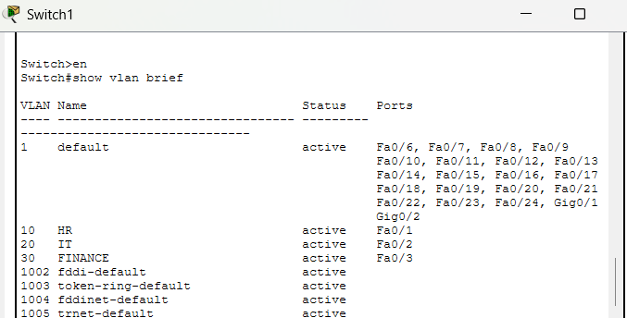
Figure 3: show vlan brief on Switch1
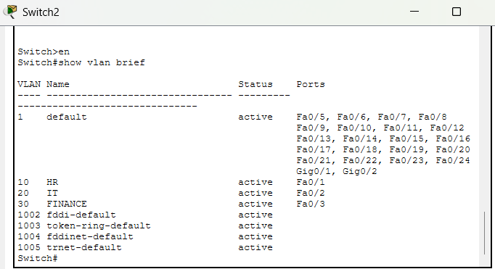
Figure 4: show vlan brief on Switch2

4.2 Trunks
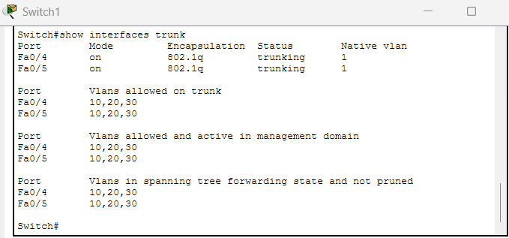
Figure 5: show interfaces trunk on Switch1 (Fa0/4 and Fa0/5)
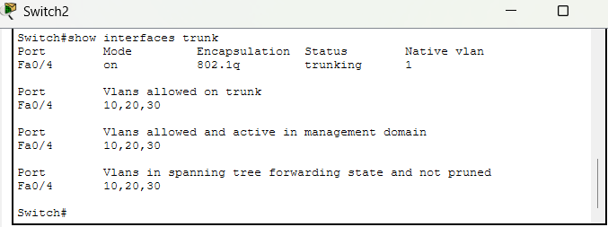
Figure 6: show interfaces trunk on Switch2 (Fa0/4)

4.3 Port status
The status output confirms the port roles: access ports show their VLAN, trunk ports show trunk, and all unused ports are notconnect in VLAN 1.
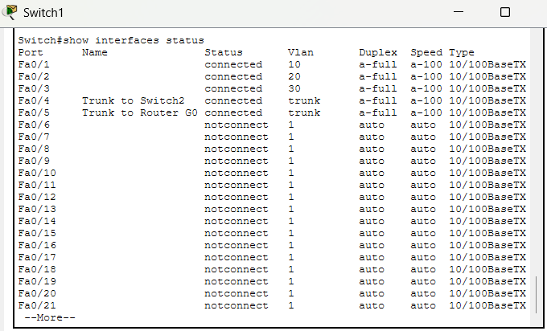
Figure 7: show interfaces status on Switch1
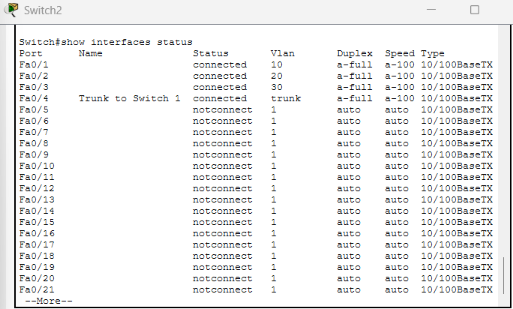
Figure 8: show interfaces status on Switch2

4.4 MAC address tables
A switch learns a source MAC address on the port the frame arrives on, separately for each VLAN. After traffic was generated, Switch1 held the entries below. The router's address appears under every VLAN on Fa0/5, because its subinterfaces share one MAC address.
Table 6: MAC addresses learned by Switch1
VLAN | MAC address | Port | Device
10 | 00e0.f9ed.9c1b | Fa0/1 | HR-PC1
10 | 00e0.a3a5.6add | Fa0/4 | HR-PC2, reached through Switch2
20 | 0060.3ea0.b8cd | Fa0/2 | IT-PC1
20 | 00e0.f908.079a | Fa0/4 | IT-PC2, reached through Switch2
30 | 0002.1625.6e22 | Fa0/3 | FIN-PC1
30 | 0040.0b8c.16c1 | Fa0/4 | FIN-PC2, reached through Switch2
1, 10, 20, 30 | 0005.5ec8.2401 | Fa0/5 | Router0 Gi0/0 and its subinterfaces
1, 10, 20, 30 | 000a.41ca.ae04 | Fa0/4 | Switch2 (its own port address, seen on the trunk)

Switch2 mirrors this: its own PCs sit on Fa0/1 to Fa0/3, while HR-PC1 and the router are learned on the trunk, Fa0/4. It does not list IT-PC1 or FIN-PC1, because a switch only learns a MAC address from frames that PC itself sends, and in these tests that traffic crossed the router.
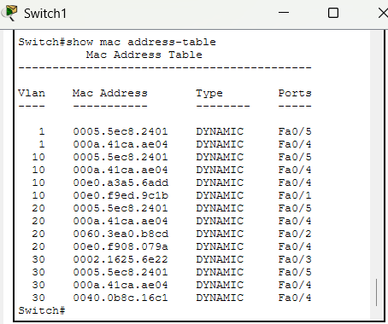
Figure 9: show mac address-table on Switch1
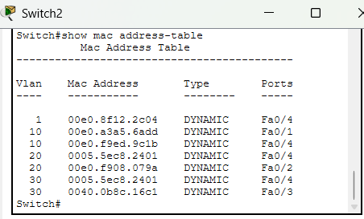
Figure 10: show mac address-table on Switch2

4.5 Router
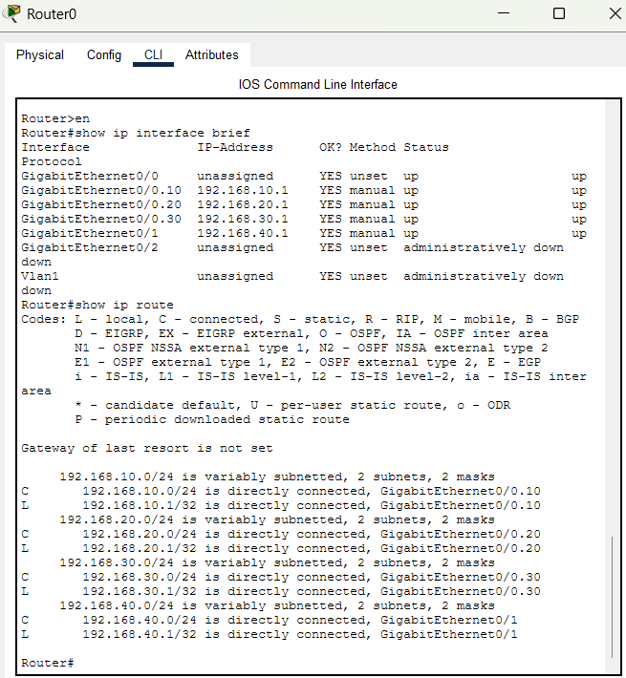
Figure 11: show ip interface brief and show ip route on Router0
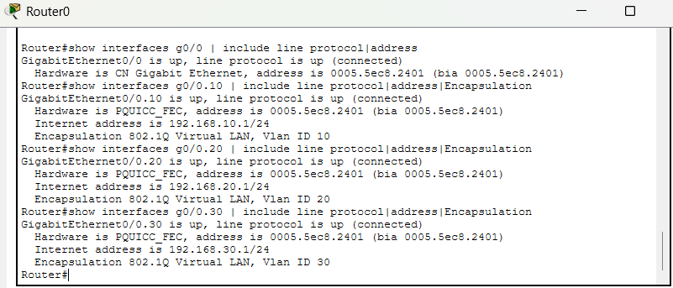
Figure 12: show interfaces (filtered to status, MAC, IP and encapsulation lines)
All four interfaces share MAC address 0005.5ec8.2401, and each subinterface reports its own 802.1Q VLAN ID. G0/1, the server port, is a separate physical interface and is not part of the trunk.

5. Functional Testing

5.1 Test A: same-VLAN communication
Each department's first PC pinged its second PC across the Switch1-Switch2 trunk. All replies arrived with TTL 128, which means no router was involved.
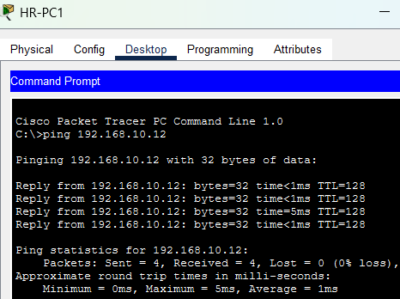
Figure 13: HR-PC1 to HR-PC2
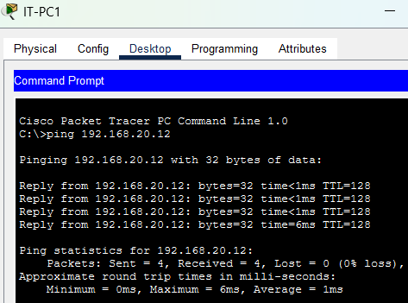
Figure 14: IT-PC1 to IT-PC2
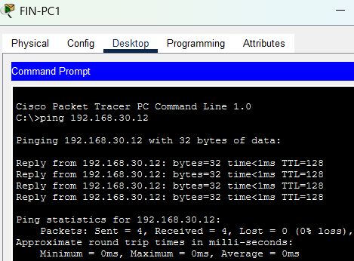
Figure 15: FIN-PC1 to FIN-PC2

5.2 Test B: inter-VLAN communication
Pings between departments went through the router. Replies show TTL 127, one less than the PC's starting value of 128, because the router decrements it. The first request in two tests timed out, which is the ARP lookup for the gateway, and the repeat ping succeeded.
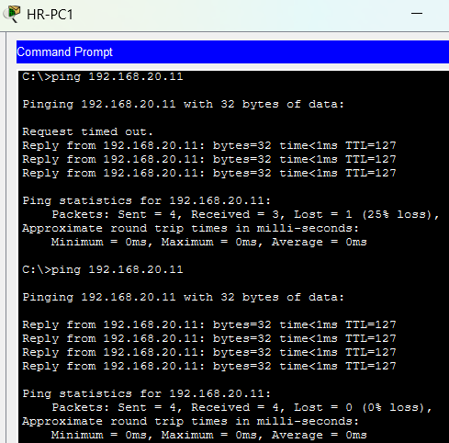
Figure 16: HR-PC1 to IT-PC1 (first request lost to ARP, then 4 of 4)
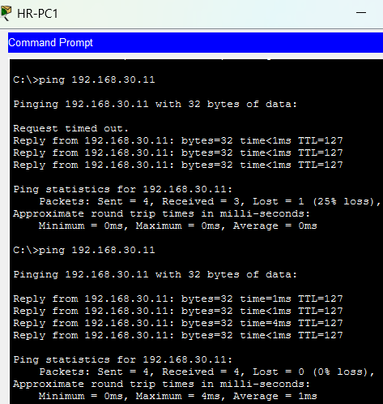
Figure 17: HR-PC1 to FIN-PC1 (first request lost to ARP, then 4 of 4)
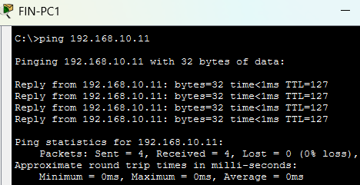
Figure 18: FIN-PC1 to HR-PC1 (4 of 4)

5.3 Test C: behaviour when the router link fails
The router's Gi0/0 interface was shut down with the shutdown command. The topology shows the link red, and the interface table shows Gi0/0 and its three subinterfaces administratively down. The server port, G0/1, stays up because it is independent of the trunk.
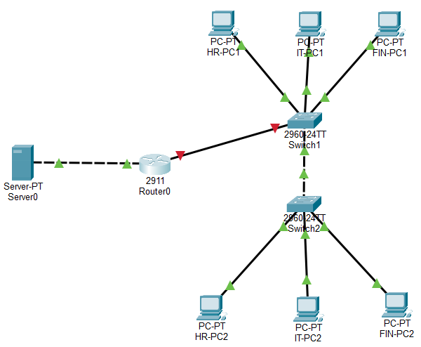
Figure 19: Router link down: Router0 to Switch1 shown red
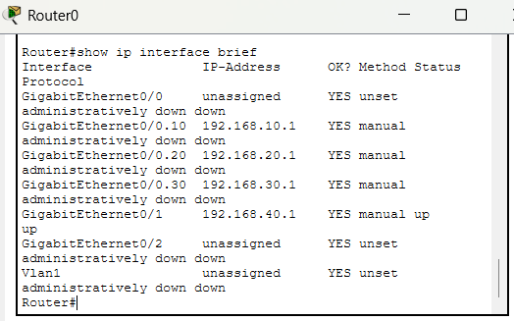
Figure 20: show ip interface brief with Gi0/0 shut down
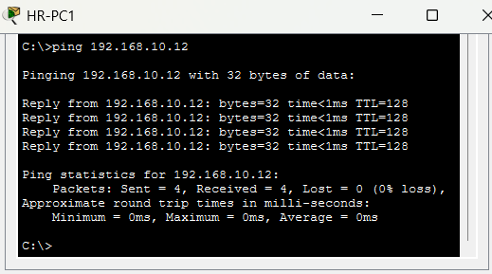
Figure 21: Same-VLAN ping still succeeds (HR-PC1 to HR-PC2, TTL 128)
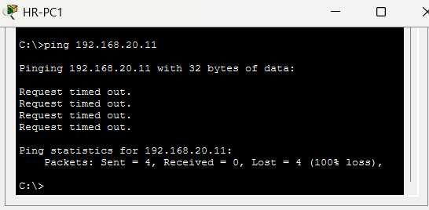
Figure 22: Inter-VLAN ping fails (HR-PC1 to IT-PC1, 100% loss)
The interface was then restored with no shutdown. The first restored ping lost two requests while the link and ARP came back, and the repeat succeeded.
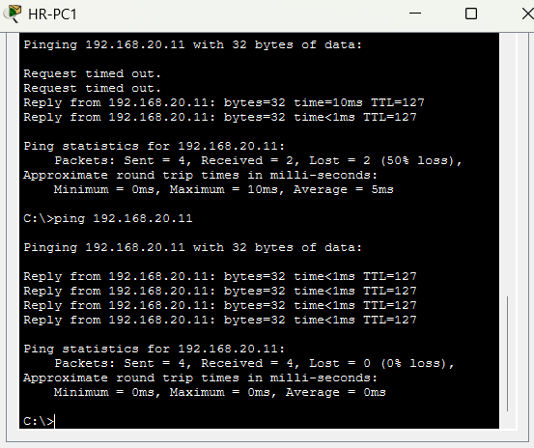
Figure 23: Inter-VLAN ping after restoring Gi0/0
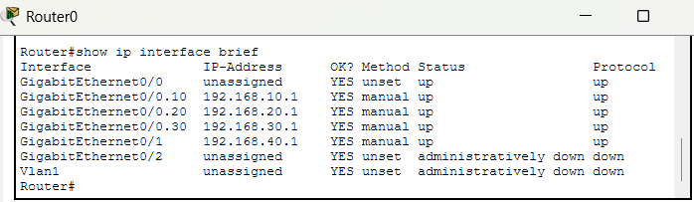
Figure 24: show ip interface brief after restoring Gi0/0, all interfaces up/up
Questions
- Can two PCs in the same VLAN still communicate? Yes. The switches forward their frames at Layer 2 using MAC addresses over the trunk, and the router is not on that path.
- Can a PC in VLAN 10 communicate with a PC in VLAN 20? No. The packet has to go to the router, and with the link down it cannot.
- Why does the router affect inter-VLAN traffic but not same-VLAN traffic? Devices in one VLAN share a network, and the switches carry their frames by MAC address. Different VLANs are separate networks, so traffic between them must be sent to the default gateway, which is the router's subinterface, and routed at Layer 3 by IP address. With the router link down the gateway is unreachable, so inter-VLAN communication fails while same-VLAN communication continues.

5.4 Test D: packet-flow analysis in Simulation Mode
Simulation Mode was used with ARP and ICMP filters and a single ping from HR-PC1 to FIN-PC1. Two captures were taken. Run 1 started with empty ARP caches, so ARP and ICMP both appear. Run 2 was ICMP only, because the caches were already filled. Full-size captures are in Appendix B.
Run 1 event sequence (request path)
Table 7: Simulation events for the ping from HR-PC1 to FIN-PC1
Time (s) | Movement | What happens
0.001 | HR-PC1 to Switch1 | ARP request for the gateway, 192.168.10.1
0.002 | Switch1 to Switch2 and Router0 | Broadcast flooded within VLAN 10 only
0.003 | Router0 to Switch1 | Router answers with its MAC address
0.004 | Switch1 to HR-PC1 | HR-PC1 learns the gateway MAC; the queued ICMP is released
0.005 to 0.006 | HR-PC1 to Switch1 to Router0 | Echo request sent to the router's MAC
0.007 | Router0 to Switch1 | Router forwards the packet toward VLAN 30
0.008 | Switch1 to FIN-PC1 | Echo request delivered
0.008 to 0.012 | FIN-PC1, Switch1, Router0 | FIN-PC1 ARPs for its own gateway, 192.168.30.1, so it can reply
0.013 to 0.016 | FIN-PC1 back to HR-PC1 | Echo reply returns through Switch1, Router0 and Switch1

No ARP request from the router appears in the list, so its ARP table already held FIN-PC1's address from earlier tests. The ARP broadcast from HR-PC1 reached only HR-PC2 and the router, and FIN-PC1's broadcast reached only FIN-PC2 and the router. That is VLAN broadcast isolation in practice.

Q1. How does the source PC learn its gateway's MAC address?
HR-PC1 compares 192.168.30.11 with its own network, 192.168.10.0/24, and sees it is remote, so the frame must go to the default gateway, 192.168.10.1. It does not know that address's MAC, so it sends an ARP request, a broadcast to FFFF.FFFF.FFFF. Switch1 floods it within VLAN 10, and Router subinterface G0/0.10 answers with a unicast ARP reply carrying 0005.5EC8.2401. HR-PC1 stores the answer and uses it as the destination MAC of the ICMP frame (Figures B.1 and B.2).

Q2. How does the frame travel from the access switch to the router?
HR-PC1 sends an ordinary untagged Ethernet frame into access port Fa0/1. Switch1 knows that port belongs to VLAN 10, so when it forwards the frame out the Fa0/5 trunk it adds an 802.1Q tag (TPID 0x8100, TCI 0x000a, which is VLAN 10). Router0 receives the tagged frame on Gi0/0 and hands it to the matching subinterface, G0/0.10 (Figures B.3 and B.4).

Q3. How does the router choose the outgoing interface?
The VLAN tag tells the router which subinterface the packet arrived on. It then reads the destination IP address, 192.168.30.11, and finds it in the directly connected route 192.168.30.0/24 on G0/0.30. It looks up FIN-PC1's MAC address in its ARP table, builds a new frame tagged for VLAN 30 (TCI 0x001e), and sends it out the same physical port (Figure B.5 and the routing table in Section 4.5).

Q4. What happens to the MAC addresses when the router forwards the packet?
Both Ethernet addresses are replaced at the router, because each hop builds a new Layer 2 frame.
Table 8: Ethernet and IP header values along the request path
Point | Source MAC | Destination MAC | VLAN tag | TTL
HR-PC1 sends | 00E0.F9ED.9C1B | 0005.5EC8.2401 | None | 255
Router0 receives | 00E0.F9ED.9C1B | 0005.5EC8.2401 | VLAN 10 | 255
Router0 sends | 0005.5EC8.2401 | 0002.1625.6E22 | VLAN 30 | 254
FIN-PC1 receives | 0005.5EC8.2401 | 0002.1625.6E22 | None | 254
The source and destination IP addresses are 192.168.10.11 and 192.168.30.11 in every row. The tag is added by Switch1 on the trunk and removed on the access port toward FIN-PC1 (Figures B.4 to B.7). The router uses the same MAC address on both sides because its subinterfaces share the physical port's address.

Q5. Do the source and destination IP addresses change?
No. Without NAT, routing leaves both IP addresses unchanged from end to end. Only the Ethernet addresses are rewritten and the TTL is reduced by one at the router. The reply (Figure B.8) swaps them, with source 192.168.30.11 and destination 192.168.10.11, and arrives at HR-PC1 with TTL 127, addressed from the router's MAC (Figure B.9).

5.5 Test E: server reachability
Each VLAN reaches the server through the router with TTL 127. HR-PC1 lost its first request to ARP and succeeded on the repeat. IT-PC1, FIN-PC1 and FIN-PC2 also reached the server (Figure B.10), and FIN-PC2 shows that traffic from the second switch crosses both trunks.
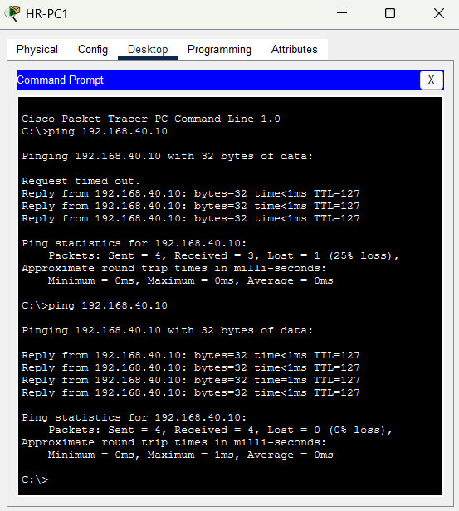
Figure 25: HR-PC1 to Server0 (192.168.40.10)

6. Troubleshooting Log
Each fault below was met during the build. The table gives the symptom, the cause and the fix. Evidence for the main faults follows the table.
Table 9: Faults, causes and fixes
# | Symptom | Cause | Resolution
1 | Router link red; Switch1 Fa0/5 notconnect although set as a trunk | Router ports are shut down by default, so the far end of the link was down | no shutdown on Router0 Gi0/0; the link turned green
2 | ip address on G0/0.20 rejected with a message about 802.1Q | The address was entered before the subinterface had an encapsulation | Set encapsulation dot1Q first, then the address
3 | G0/0.20 given encapsulation dot1Q 30 by mistake | Typing error | Re-entered encapsulation dot1Q 20, which replaces the old value; confirmed with show interfaces
4 | HR-PC1 could not ping FIN-PC1: 100% loss | The gateway addresses did not exist yet because the subinterfaces were not finished | Completed Router-on-a-Stick; Test B then passed
5 | First ping of an inter-VLAN test times out | Expected: the first packet waits for ARP to resolve the gateway | None needed; the repeat ping succeeds
6 | An empty router rip process in the router configuration | Entered unintentionally; it had no network statements, so it had no effect | Removed with no router rip, saved, and the final configuration re-exported
7 | MAC address tables showed no PC entries | Dynamic entries had aged out after a period without traffic | Generated fresh pings and re-ran the command at once
8 | Simulation Mode reported Buffer Full | The event buffer filled during capture | Cleared the event list, reset the simulation, and used a single Simple PDU stepped with Capture/Forward

Fault 1: link down before the router interface was enabled
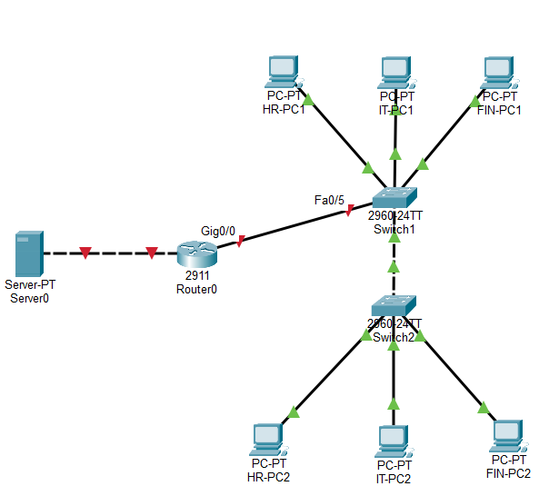
Figure 26: Router0 Gig0/0 to Switch1 Fa0/5 shown red
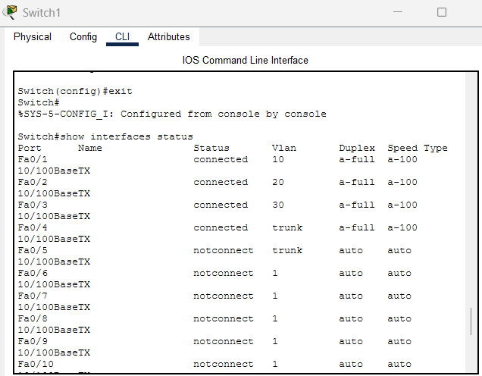
Figure 27: Switch1 Fa0/5 configured as a trunk but notconnect

Faults 2 and 3: subinterface rejected, then wrong encapsulation
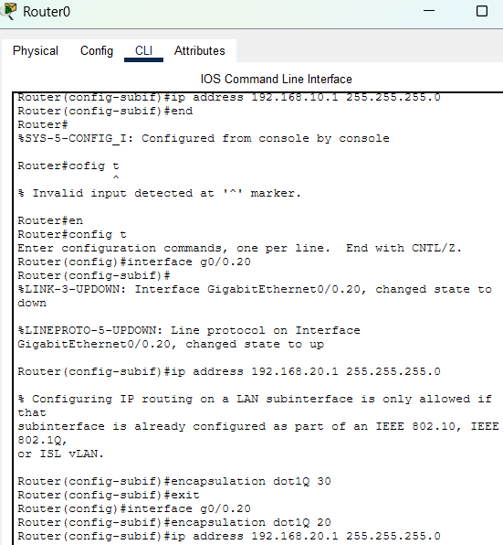
Figure 28: The rejected ip address, the dot1Q 30 typo, and the corrected dot1Q 20

Fault 4: no inter-VLAN connectivity before routing was configured
The failed ping, with HR-PC1 and the FIN-PC1 address details, is reproduced at full size as Figure B.11 in Appendix B.

Fault 6: the empty RIP process
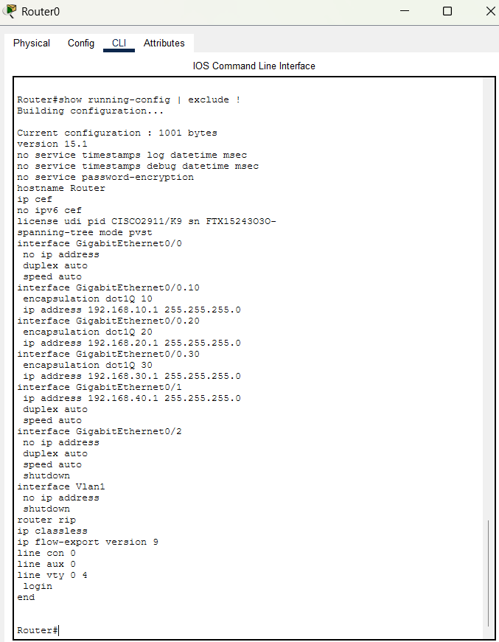
Figure 29: show running-config with the unintended router rip line

Fault 7: empty MAC tables
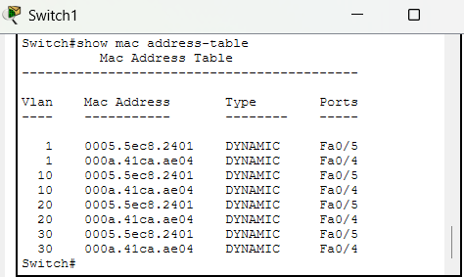
Figure 30: Switch1 MAC table before fresh traffic: no PC entries

Fault 8: simulation buffer full
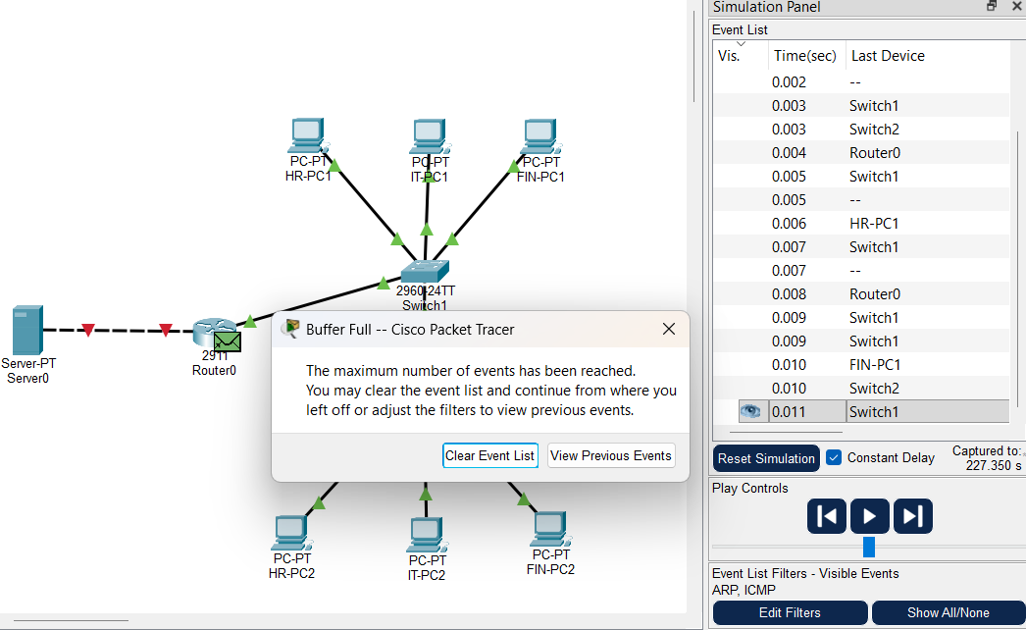
Figure 31: Packet Tracer Buffer Full message

7. Conclusion
The project met its objectives. Three departments now sit in separate VLANs and subnets, the departments are spread across two switches, and a single router link provides all inter-VLAN routing.
How VLANs improve organisation and isolation
- Logical grouping regardless of location. HR-PC1 and HR-PC2 sit on different switches yet behave as one network, because the trunk carries VLAN 10 between them.
- Smaller broadcast domains. In the packet trace, the ARP broadcast from HR-PC1 reached only the HR PC and the router, and the Finance broadcast reached only the Finance PC and the router. IT devices saw neither.
- A single control point between departments. Every packet between VLANs must pass through the router. The failure test proved this: with the router link down, departments were fully isolated from each other while each continued to work internally.
- Simple growth. A new department needs a VLAN, a subnet and one subinterface, not new cabling. The server was added in the same way, as one more routed network.
VLANs separate the networks, but this design routes freely between them. Restricting which departments may reach each other is the next step, using access control lists on the router. Other sensible hardening steps are DHCP for addressing, port security on access ports, shutting unused ports, and moving the native VLAN away from VLAN 1.
Acknowledgement
This project is adapted from a VLAN and inter-VLAN routing exercise in Devtown’s “Networking Basics for Cybersecurity” course material. The addressing, configuration, testing and documentation here were carried out and extended independently, including the shared server, the verification of MAC address tables and the packet-level analysis.

Appendix A: Final Configurations
The listings show the final saved configuration of each device, with empty interface sections and blank separator lines removed for readability. The complete exports are kept unaltered in the project repository. To rebuild a switch, apply the VLAN lines first, because the VLAN database does not appear in the running configuration.

A.1 Switch1
VLAN database (entered in Step 2, not shown by show running-config)
vlan 10
name HR
vlan 20
name IT
vlan 30
name FINANCE

Running configuration
version 15.0
no service timestamps log datetime msec
no service timestamps debug datetime msec
no service password-encryption
hostname Switch
spanning-tree mode pvst
spanning-tree extend system-id
interface FastEthernet0/1
switchport access vlan 10
switchport mode access
interface FastEthernet0/2
switchport access vlan 20
switchport mode access
interface FastEthernet0/3
switchport access vlan 30
switchport mode access
interface FastEthernet0/4
description Trunk to Switch2
switchport trunk allowed vlan 10,20,30
switchport mode trunk
interface FastEthernet0/5
description Trunk to Router G0/0
switchport trunk allowed vlan 10,20,30
switchport mode trunk
interface Vlan1
no ip address
shutdown
line vty 0 4
login
line vty 5 15
login
end

A.2 Switch2
VLAN database
vlan 10
name HR
vlan 20
name IT
vlan 30
name FINANCE

Running configuration
version 15.0
no service timestamps log datetime msec
no service timestamps debug datetime msec
no service password-encryption
hostname Switch
spanning-tree mode pvst
spanning-tree extend system-id
interface FastEthernet0/1
switchport access vlan 10
switchport mode access
interface FastEthernet0/2
switchport access vlan 20
switchport mode access
interface FastEthernet0/3
switchport access vlan 30
switchport mode access
interface FastEthernet0/4
description Trunk to Switch 1
switchport trunk allowed vlan 10,20,30
switchport mode trunk
interface Vlan1
no ip address
shutdown
line vty 0 4
login
line vty 5 15
login
end

A.3 Router0
version 15.1
no service timestamps log datetime msec
no service timestamps debug datetime msec
no service password-encryption
hostname Router
ip cef
no ipv6 cef
spanning-tree mode pvst
interface GigabitEthernet0/0
no ip address
duplex auto
speed auto
interface GigabitEthernet0/0.10
encapsulation dot1Q 10
ip address 192.168.10.1 255.255.255.0
interface GigabitEthernet0/0.20
encapsulation dot1Q 20
ip address 192.168.20.1 255.255.255.0
interface GigabitEthernet0/0.30
encapsulation dot1Q 30
ip address 192.168.30.1 255.255.255.0
interface GigabitEthernet0/1
ip address 192.168.40.1 255.255.255.0
duplex auto
speed auto
interface GigabitEthernet0/2
no ip address
duplex auto
speed auto
shutdown
interface Vlan1
no ip address
shutdown
ip classless
ip flow-export version 9
line vty 0 4
login
end

Appendix B: Evidence at Full Size
Screenshots are reproduced exactly as captured. B.1 to B.9 are the Simulation Mode captures for Test D, in the order they are cited in Section 5.4; B.10 and B.11 are referred to in Sections 5.5 and 6; B.12 to B.14 show the host addressing. Figures B.1 and B.2 and B.4 to B.8 come from Run 1, and B.3 and B.9 from Run 2. The PDU tabs named below are the tabs open in each capture.

B.1 Simulation captures (Test D)
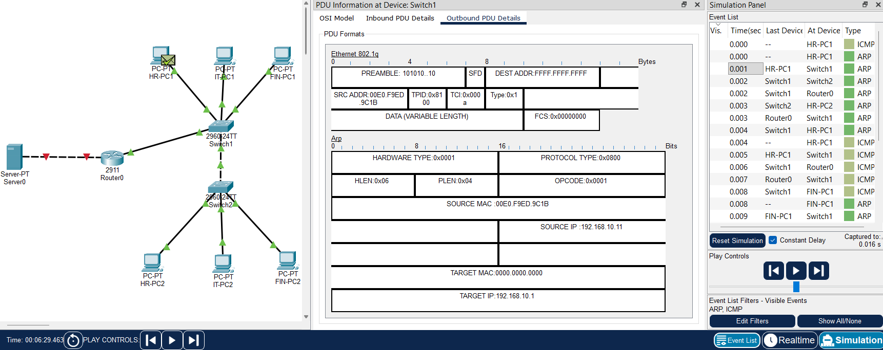
Figure B.1: Switch1, outbound PDU: ARP request for 192.168.10.1, broadcast destination FFFF.FFFF.FFFF, tagged VLAN 10
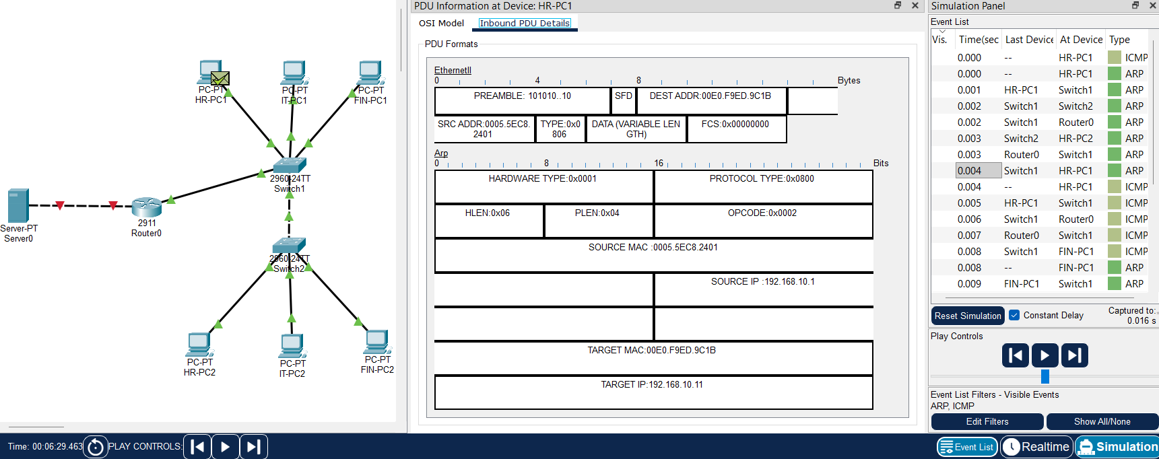
Figure B.2: HR-PC1, inbound PDU: ARP reply carrying the router's MAC address 0005.5EC8.2401
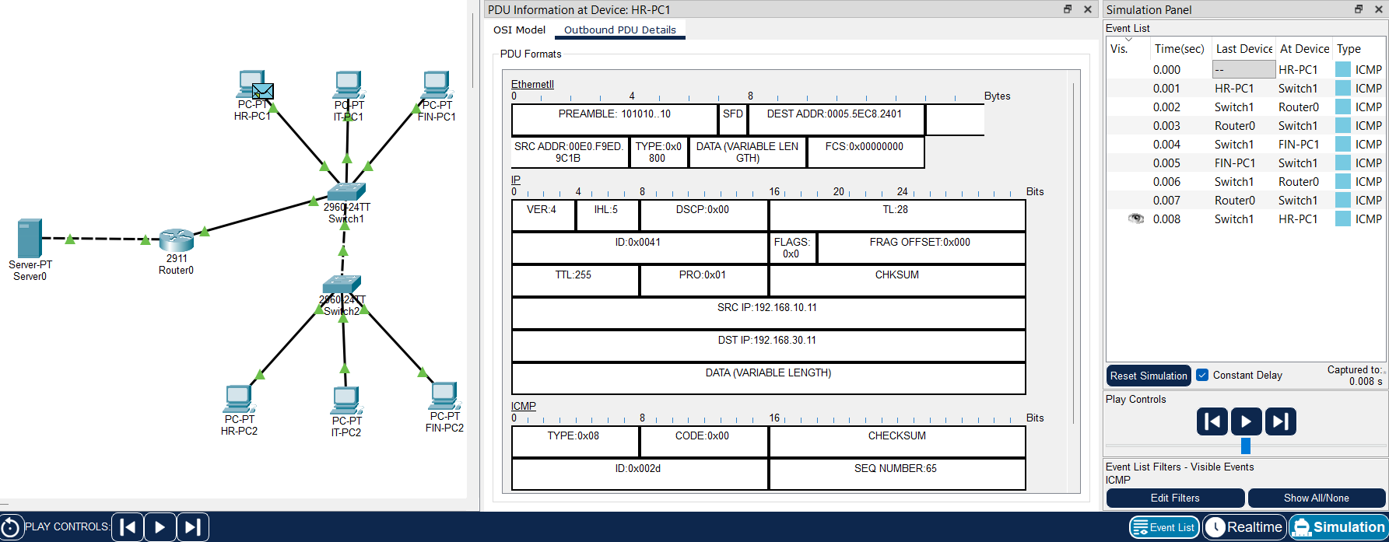
Figure B.3: HR-PC1, outbound PDU (Run 2): echo request addressed to the router's MAC, IP 192.168.10.11 to 192.168.30.11
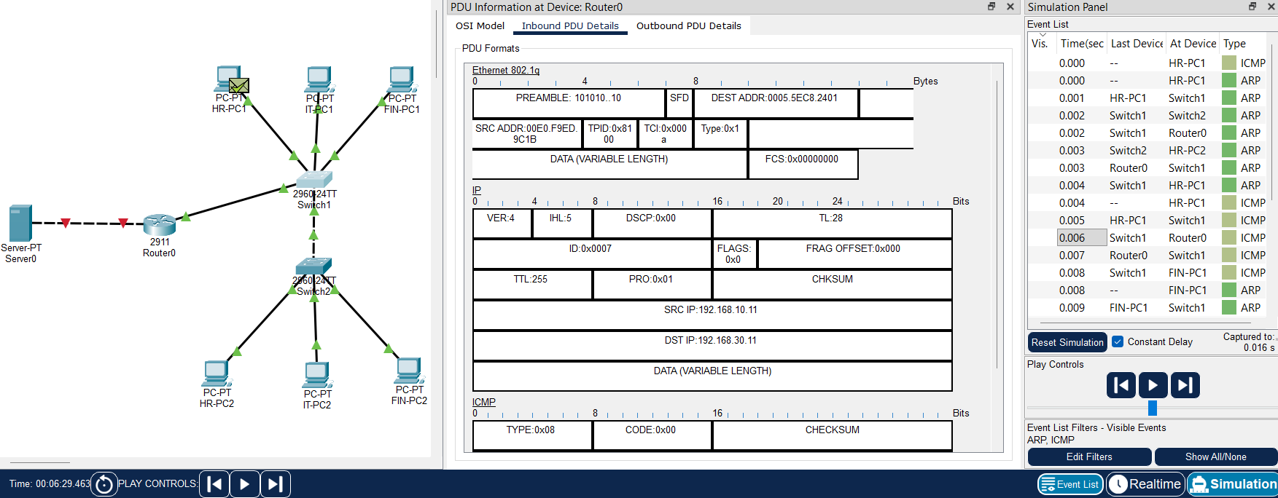
Figure B.4: Router0, inbound PDU: 802.1Q frame tagged VLAN 10 (TCI 0x000a), TTL 255
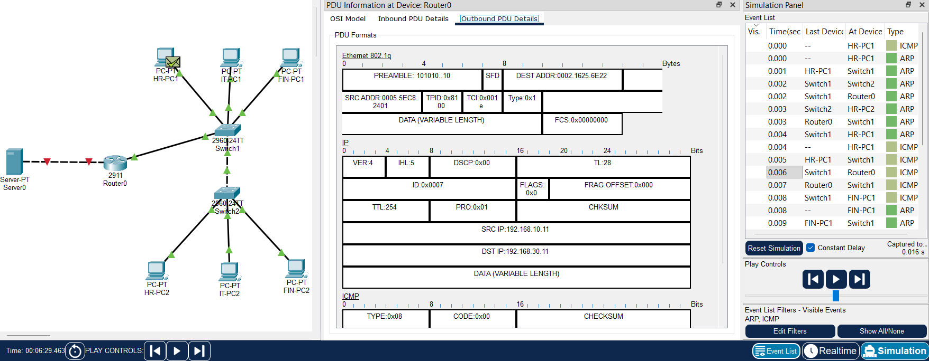
Figure B.5: Router0, outbound PDU: MACs rewritten, tagged VLAN 30 (TCI 0x001e), TTL 254
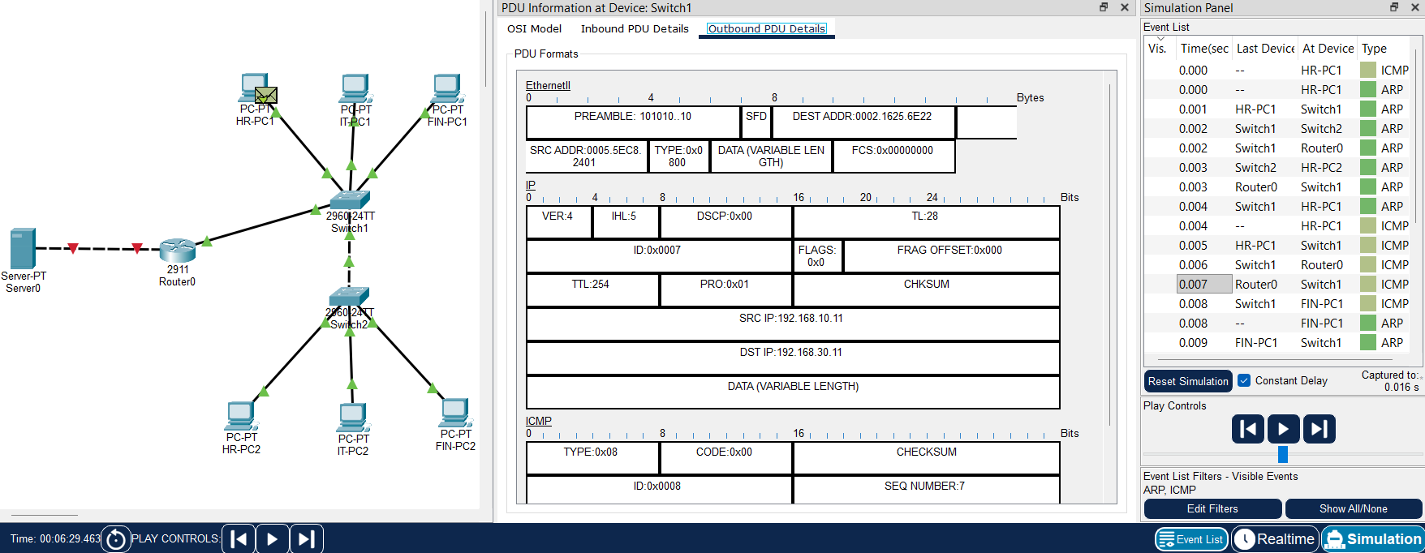
Figure B.6: Switch1, outbound PDU toward FIN-PC1: untagged Ethernet II frame
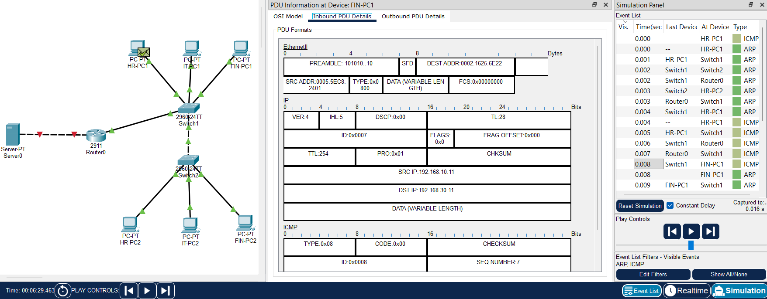
Figure B.7: FIN-PC1, inbound PDU: echo request, IP addresses unchanged
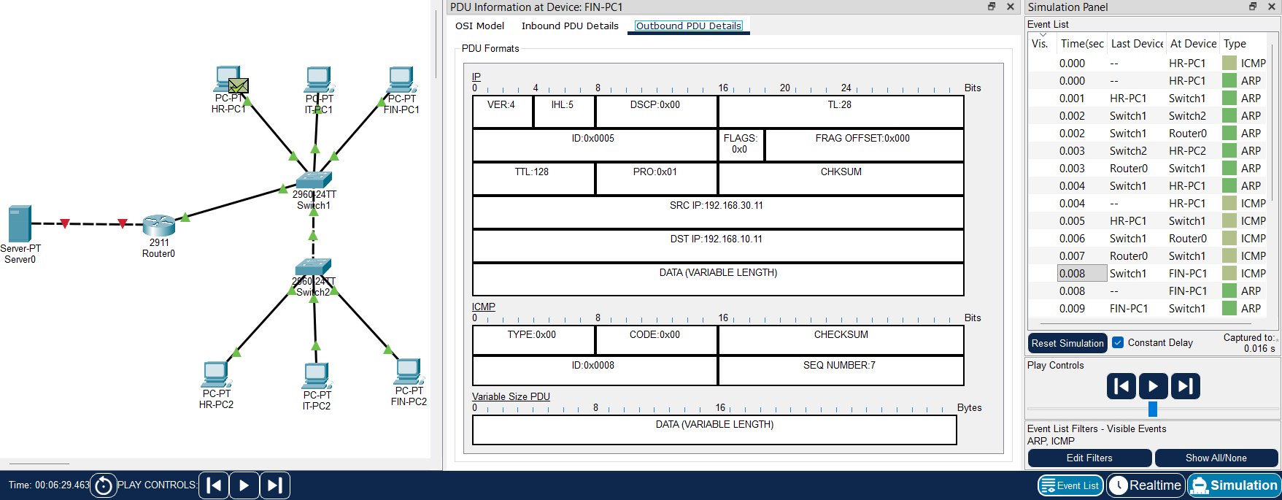
Figure B.8: FIN-PC1, outbound PDU: echo reply, source 192.168.30.11, destination 192.168.10.11
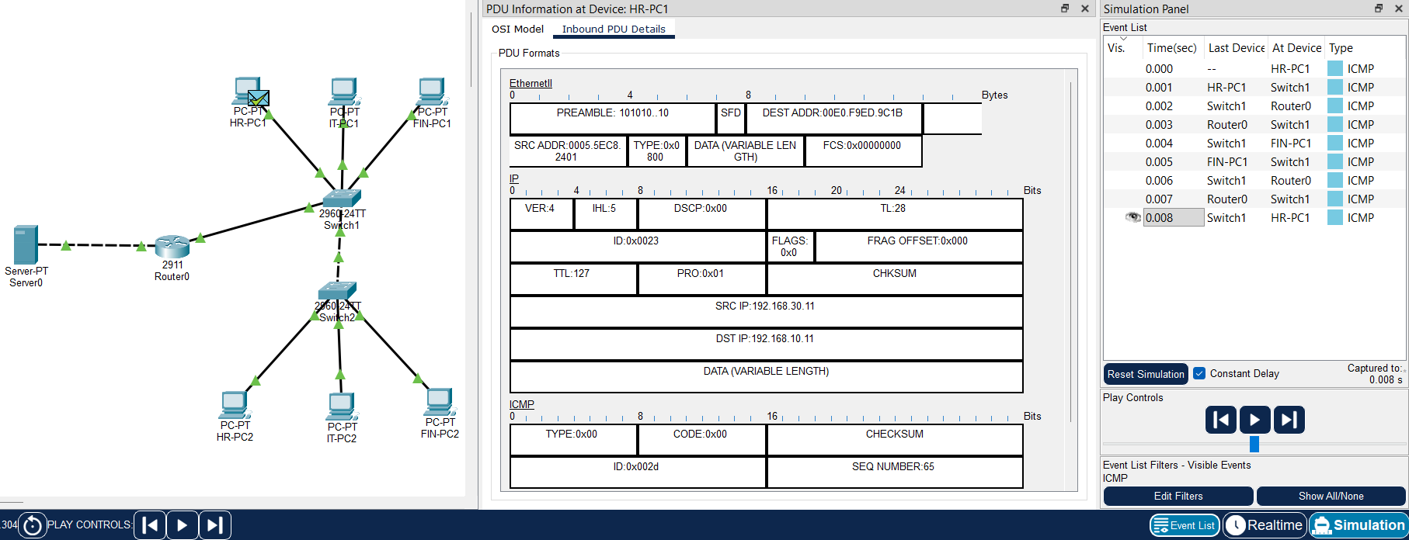
Figure B.9: HR-PC1, inbound PDU (Run 2): echo reply from the router's MAC, TTL 127

B.2 Other evidence
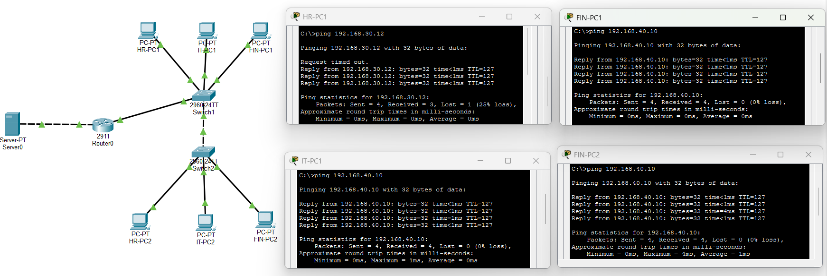
Figure B.10: Server0 reachable from IT-PC1, FIN-PC1 and FIN-PC2 (TTL 127), with an inter-VLAN ping from HR-PC1 to FIN-PC2
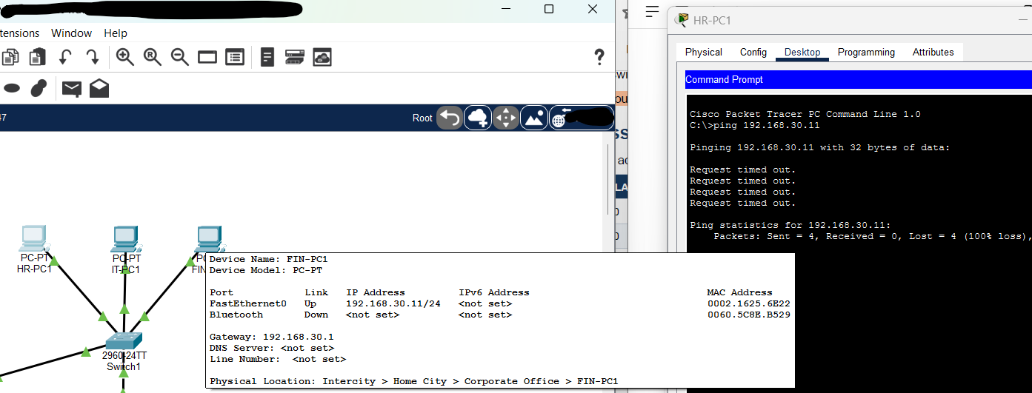
Figure B.11: Fault 4: HR-PC1 pinging FIN-PC1 with 100% loss before the router subinterfaces were configured

B.3 Host configuration screens
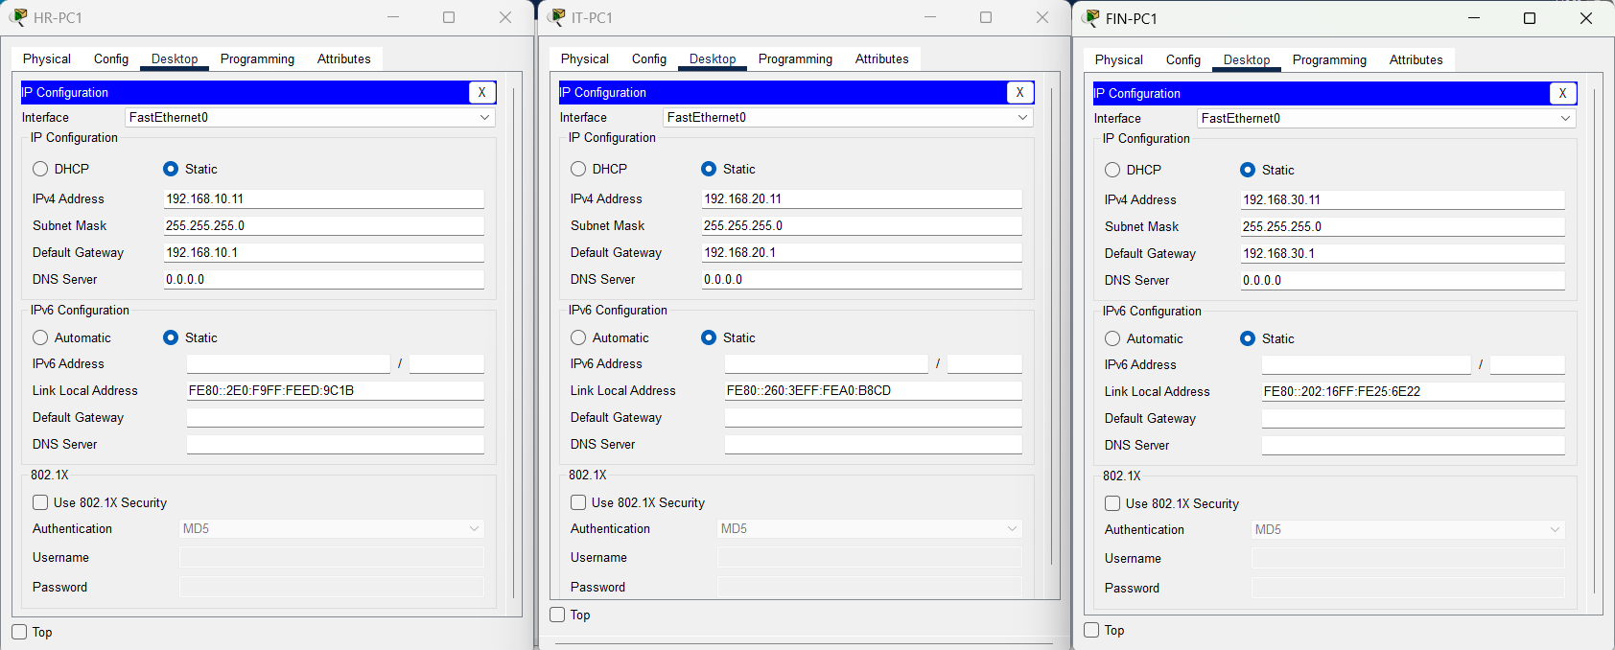
Figure B.12: IP configuration of HR-PC1, IT-PC1 and FIN-PC1
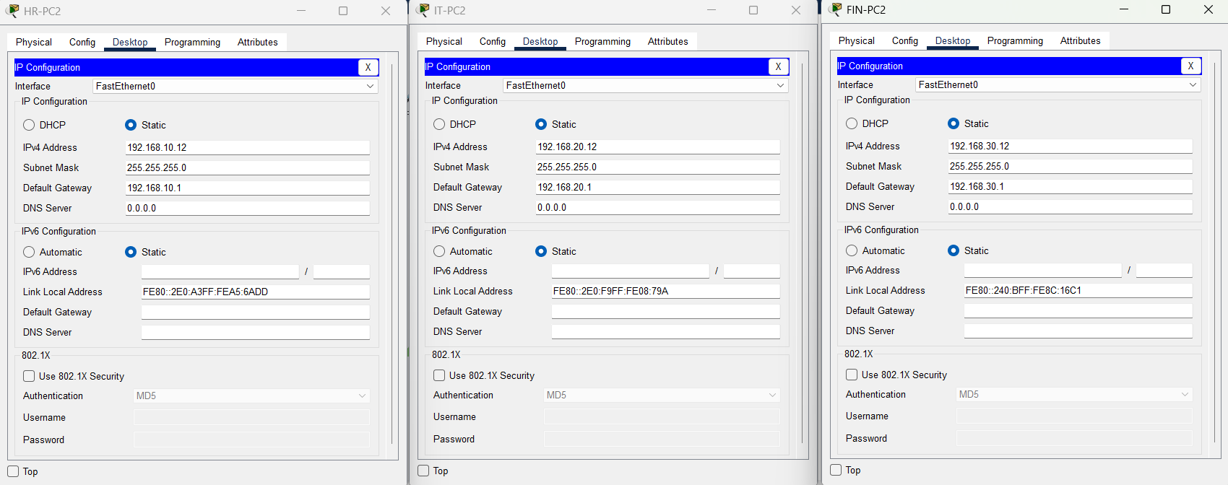
Figure B.13: IP configuration of HR-PC2, IT-PC2 and FIN-PC2
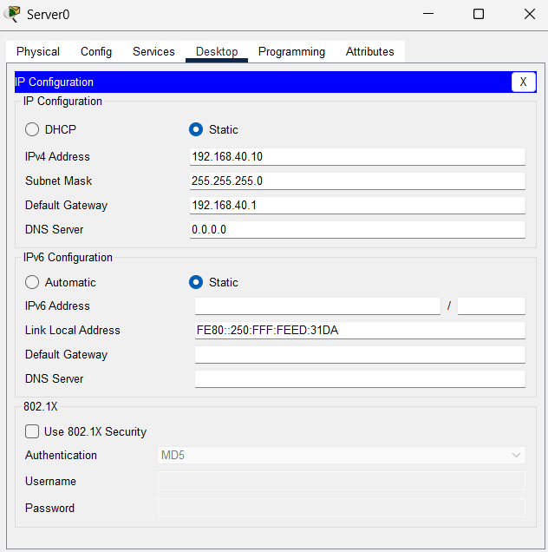
Figure B.14: IP configuration of Server0

