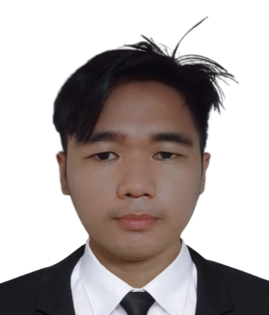
DARIUS GABRIEL




K-12 Capentry NC2 Course: Home building, 12/2018 - 12/2018
San Francisco National Highschool Nueva ecija, Philippine
EDUCATION
• Creating websites, Creating Android Applications, Creating Python Script, Creating Django Backed, Learning New Things and Language
H0BBY AND INTEREST
Determined and knowledgeable software developer who can think
outside the box.A new graduate who enjoys working with all types Of
personalities. Seeking the chance to architect new software applications,
Focused Software Developer with experience across scripting, testing
and platform design. Integrates practical full-stack engineering
knowledge for enhanced digital experiences. Adapts well to projects of
varied scopes and sizes for reliable end-to-end development.
Productive employee with proven track record of successful project
management and producing quality outcomes through leadership and
team motivation. Works with clients to determine requirements and
provide excellent service.
Talented Software Developer with proven experience delivering to
quality, time and budget constraints. Communicates complex technical
concepts clearly and concisely for optimised understanding. Proactive
and astute to develop and achieve robust, dynamic solutions.
Committed Builder with adaptable skills across plastering, plumbing and
roofing for well-rounded site support. Works to specifications, achieving
safe, secure building works. Collaborates and communicates well to
maintain good productivity.
Skilled professional with hands-on construction experience and
expertise. Forward-planner and methodical problem-solver champions
health and safety. Demonstrates Strong attention to detail and offers
range of technical skills.
Patyag Home Builder, 06/2018 - 06/2021
Labor - Nueva ecija, Philippine
• Planned and executed work with correct tools, materials and
equipment to maximise efficiency and finish jobs on time,
• Followed client specifications and directions to erect scaffolding and
structures,
• Excavated and dug trenches by removing dirt and rocks from sites to
prepare for foundation construction.
• Measured dimensions of rooms and other spaces to determine
quantities of materials needed to complete construction.
Tolman factory, 02/2018 - 05/2018
Worker - Calamba City Laguna, Philippine
• Cleaned and maintained tools to boost optimum working condition and
enhance longevity.
Rice Planter, 11/2016 • I currently work here
Planter - Nueva ecija, Philippine
• Prepared soil in fields, beds or pots by hand or machines for planting.
• Independently managed the sowing of seeds, planting bulbs and
ornamental of plants.
• Oversaw seasonal staff and production labour to meet harvesting
needs and uphold company standards.
LANGUAGE
SKILLS
Tagalog: First language
English: Intermediate
• Construction team supervision
• Structural repairs
• House refurbishments
• Bricklaying
• HTML and XML
• API design
• Software applications
• JavaScript
• Application technology knowledge
• Code design improving
• Full-stack development
• JavaScript proficient
• JQuery knowledge
• Front-end development
• Git
• CSS
• Debugging
• Java
• Code reviews
EXPERIENCE
SUMMARY
CONTACT
Nueva-Ecija, Philippine 3109
+639675173864
gabrieldarius261@gmail.com

