
Video Rasterization
CESS – Graduation Project CSE492
Technical Report

Date
23 June 2026

Prepared by
Abanoub Samy Samir  Yehia Khaled  Ahmed Elnagar  Tarek Hadef | 21p0356  2101343  20p8625  21p0199

Supervised by
Dr. Islam Elmaddah
Dr. Hossam Hassan

Abstract
This report documents the technical development of VideoRasterization, a modular grayscale-to-color video processing system designed as a graduation project. The system accepts a grayscale video, extracts frame sequences, routes them through a selected AI colorization backend, optionally applies temporal smoothing for video consistency, and reconstructs the final colorized video while preserving the original audio track when available.
The second term focused on transforming the project from a loosely connected prototype into a technically explainable engineering system. The work included the integration of multiple colorization backends, the training and repository-level integration of a custom model named ChromaNet v3, the addition of exact duplicate-frame skipping before inference, the introduction of a motion-aware temporal smoothing method named flow_chroma, the reorganization of checkpoint storage, and the creation of a benchmark suite based on fresh-source videos rather than biased legacy noir footage.
The report treats the repository itself as the primary technical artifact. It explains the overall system architecture, the responsibilities of each pipeline stage, the differences between the integrated model families, the internal data flow of ChromaNet, the retained training strategy, and the practical reasoning behind important second-term design decisions such as preserving full-resolution luminance while only upscaling predicted chroma. It also presents comparative benchmark findings on nature, urban, people, and animation scenes and analyzes the current strengths and limitations of each backend.
The evidence collected during the second term shows that Enhanced Zhang is currently the strongest general-purpose backend for practical demo usage, while ChromaNet remains the project’s most academically important component because it represents the custom architecture and custom training track implemented inside the repository. The report concludes with a limitation analysis and an implementation-oriented roadmap for future work, including queue-based in-memory processing and stronger people-aware dataset balancing.
Keywords: video colorization, grayscale restoration, ChromaNet, temporal smoothing, optical flow, CUDA, benchmark evaluation, graduation project, computer vision pipeline.

Contents
Abstract 2
List of Figures 6
List of Tables 6
List of Abbreviations 7
1. Introduction 8
1.1 Background and Motivation 8
1.2 Problem Statement 8
1.3 Second-Term Objectives 9
1.4 Scope of This Report 9
2. Technical Background 9
2.1 Grayscale Video and Missing Chrominance 9
2.2 Colorization as Supervised Learning 10
2.3 Why Video Is Harder Than Image Colorization 10
2.4 Optical Flow for Post-Inference Stabilization 11
2.5 Practical GPU Constraints 11
3. System Requirements and Execution Environment 12
3.1 Functional and Non-Functional Requirements 12
3.2 Hardware and Software Environment 12
3.3 Why the Repository Structure Matters 12
4. Overall System Architecture 13
4.1 End-to-End Pipeline Overview 13
4.2 Main Execution Path 13
4.3 Frame Extraction 14
4.4 Duplicate-Frame Middleman 14
4.5 Backend Dispatch 14
4.6 Temporal Smoothing and Reconstruction 15
5. Graphical User Interface (GUI) 15
5.1 Design Philosophy 15
5.2 Application States and User Flow 15
5.3 Backend Communication Model 16
5.4 Model Selection and Preset System 17
5.5 Pause, Resume, and Cancel 17
5.6 Hardware Awareness 17
5.7 GUI Screenshots 18
6. Integrated AI Backends and Legacy Baselines 20
6.1 Why Multiple Backends Were Needed 15
6.2 Backend Comparison 16
6.3 ChromaNet v3 16
6.4 Enhanced Zhang (Bebo's Experiment) 17
6.5 InstColorization 18
6.6 Legacy Zhang SIGGRAPH17 18
6.7 Legacy Zhang ECCV16 18
6.8 Why Enhanced Zhang Became the Demo Default 18
7. ChromaNet v3 Detailed Design 19
7.1 Internal Processing Overview 19
7.2 Input and Output Contract 19
7.3 Encoder 19
7.4 Scene Classification and Conditioning 20
7.5 Semantic Color Memory 20
7.6 Decoder and Multi-Scale Output 20
7.7 Confidence Head 20
7.8 Tensor Flow Summary 21
7.9 Loss Design 21
7.10 Why ChromaNet Still Matters 21
8. Training Pipeline and Dataset Strategy 22
8.1 Training Lifecycle 22
8.2 Datasets Used During the Experimental Phase 22
8.3 Dataset Usage in the Retained Training Workflow 22
8.4 Current Main-Branch Training Configuration 23
8.5 Why the 256x256 and 512x512 Tradeoff Mattered 23
8.6 Checkpoint Payload and Safe Resume 24
8.7 ChromaNet Epoch Progression and Dataset-Shift Regression 24
8.8 Failed Attempts, Training Hiccups, and What They Taught the Team 26
9. Second-Term Engineering Contributions 26
9.1 Contribution Summary 26
9.2 Full-Resolution Luminance Preservation 27
9.3 Global Duplicate-Frame Middleman 27
9.4 Improved Logging and Checkpoint Notes 27
9.5 Audio Reintegration and Output Practicality 28
10. Temporal Smoothing and Video Consistency 28
10.1 Why Temporal Smoothing Is Needed 28
10.2 legacy_average 28
10.3 flow_chroma 28
10.4 Why flow_chroma Is Better 29
10.5 What Smoothing Cannot Fix 29
11. Experimental Methodology 30
12. Results and Comparative Analysis 31
13. Limitations, Risks, and Failure Analysis 33
14. Conclusion and Future Work 34
15. Source Alignment With Latest Project State 36
16. Project Run Outputs 36
17. References 37
Appendix A. Benchmark Artifact Notes 39
Appendix B. Repository Walkthrough 39
Appendix C. Operational Commands 40
Appendix D. Checkpoint and Dataset Notes 41
Appendix E. Glossary 42

List of Figures
Figure 1. High-level VideoRasterization workflow from video input to final colorized output. 13
Figure 2. Internal ChromaNet v3 processing flow showing encoder, scene conditioning, semantic color memory, decoder outputs, and confidence head. 19
Figure 3. ChromaNet training lifecycle with safe checkpoint resume behavior. 22
Figure 4. ChromaNet validation PSNR progression across retained training history. 25
Figure 5. FlowChroma motion-compensated chroma stabilization concept. 29
Figure 6. Project run contact sheets comparing grayscale input with model outputs. 37
Figure 7. ChromaStudio welcome screen showing the drag-and-drop zone and recent projects panel. 18
Figure 8. ChromaStudio configuration screen showing video preview, model selection cards, temporal smoothing controls, and output settings. 18
Figure 9. ChromaStudio processing screen showing live colorized frame preview, pipeline stage tracker, per-frame progress bar with FPS and ETA, and real-time system metrics panel. 19
Figure 10. ChromaStudio review screen showing run summary, output path, colorization quality report, and action buttons for opening the output folder or starting a new job. 19
Figure 11. ChromaStudio comparison preview screen showing side-by-side grayscale and colorized first frame before committing to a full run. 19
Figure A1. Unified local checkpoint organization used by the project. 41

List of Tables
Table 1. Functional and non-functional requirements addressed in the second term. 12
Table 2. Hardware and software environment used for implementation and testing. 12
Table 3. High-level comparison of the integrated colorization backends. 16
Table 4. Principal tensor flow through ChromaNet v3. 21
Table 5. Loss terms used during ChromaNet training and their role. 21
Table 6. Dataset sources, strengths, and weaknesses for the training pipeline. 22
Table 7. Current main-branch ChromaNet training configuration. 23
Table 7A. ChromaNet validation metrics across retained training history. 24
Table 8. Engineering contributions delivered during the second term. 26
Table 9. Average runtime summary across fresh-source benchmark scenes. 31
Table 10. Scene-wise best current backend and dominant observed reason. 31
Table 11. Current system risks and mitigation strategy for final demos. 33
Table 12. Future-work roadmap organized by technical priority. 34
Table 13. Key repository files and their technical purpose. 39
Table 14. Operational command reference for training and inference. 40

List of Abbreviations
AI - Artificial Intelligence 7
AMP - Automatic Mixed Precision 7
API - Application Programming Interface 7
CLI - Command-Line Interface 7
COCO - Common Objects in Context 7
CUDA - Compute Unified Device Architecture 7
FFmpeg - Multimedia framework used for frame extraction and reconstruction 7
FPS - Frames per Second 7
GPU - Graphics Processing Unit 7
GUI - Graphical User Interface 7
IPEX - Intel Extension for PyTorch 7
Lab - Lightness and chroma color space 7
MP4 - MPEG-4 video container 7
ONNX - Open Neural Network Exchange 7
PSNR - Peak Signal-to-Noise Ratio 7
RGB - Red, Green, Blue 7
VRAM - Video Random Access Memory 7

1. Introduction

1.1 Background and Motivation
Colorization of grayscale video is a difficult problem because grayscale imagery retains structural and luminance information but does not retain explicit chromatic identity. A grayscale frame can show object edges, texture, geometry, and brightness gradients, yet the actual surface color of those objects is lost. In practical terms, this means that multiple semantically different surfaces may collapse into the same intensity range. A shirt, a wall, a road, and a face can all appear as similar gray values even though their natural colors differ significantly.
This ambiguity makes colorization fundamentally different from purely geometric restoration tasks. The model cannot recover one guaranteed ground-truth color from grayscale alone. Instead, it learns priors from training data and uses them to estimate plausible colors. These priors may be strong for some scene classes, such as vegetation and sky, and weak for others, such as human skin or stylized animated content. As a result, the quality of a colorization system depends not only on architecture but also on dataset composition, inference design, post-processing strategy, and benchmarking discipline.
The first term of the project established the broad direction of building a video colorization system. The second term focused on engineering maturity. The project moved away from ad hoc one-off experiments and toward a reusable, explainable repository that can:
- process real videos end-to-end,
- support multiple AI backends through one pipeline,
- train and integrate a custom model,
- preserve practical output quality,
- and document the system rigorously enough for academic defense.

1.2 Problem Statement
The problem addressed by VideoRasterization is the conversion of grayscale video into plausible color video while preserving visual sharpness and temporal consistency. Solving this problem at the repository level requires more than an isolated neural network. It requires a full system that can:
- accept a local video input,
- decode it into frames,
- optionally remove redundant frames,
- pass the frames through a selected AI model,
- stabilize the output across time,
- rebuild a playable output video,
- and preserve original audio when available.
At the same time, the system must remain understandable. Since this is a graduation project, the team must explain not only that a result exists, but also how it was produced, why certain design choices were made, why some scenes succeed and others fail, and which parts of the system belong to original project work as opposed to third-party integrations.

1.3 Second-Term Objectives
The second-term objectives were concrete and technical:
- Build a reliable end-to-end workflow from input video to output video.
- Integrate several AI colorization backends into one shared repository pipeline.
- Train and integrate a custom in-house model, ChromaNet v3.
- Fix visible blur caused by low-resolution color inference.
- Improve runtime efficiency where safe, especially through duplicate-frame skipping.
- Add a stronger temporal consistency stage suitable for video playback.
- Organize checkpoints, benchmark artifacts, and model notes clearly.
- Produce benchmark evidence that compares the integrated backends on multiple scene categories.

1.4 Scope of This Report
This report is intentionally technical and repository-centered. It does not attempt to market the project as a universally solved colorization system. Instead, it explains the current implementation state with enough precision that a reader can understand:
- what the software does,
- how the internal modules interact,
- how the custom model works,
- what was actually achieved in the second term,
- where the system still fails,
- and what the next technical steps should be.
The report covers the complete pipeline, all four integrated AI backends, the ChromaNet training path, the benchmark suite, temporal smoothing, current limitations, and future work.

2. Technical Background

2.1 Grayscale Video and Missing Chrominance
Grayscale imagery is not color-neutral in a trivial sense. It is a projection of a color scene into one intensity axis. Once color channels collapse into one luminance representation, many different source colors can produce similar grayscale values. Therefore, grayscale-to-color restoration is not a deterministic inversion problem. The best an AI model can do is learn statistical structure from training data and predict likely color configurations given luminance cues.
This explains why colorization often behaves differently across scene classes:
- outdoor nature may recover plausibly because the model has seen many landscapes;
- faces may remain gray because the model has weaker priors for skin and clothing;
- old stylized footage may fail because the grayscale source itself is artistically distorted compared with ordinary modern grayscale conversions.

2.2 Colorization as Supervised Learning
Most supervised colorization systems are trained by taking color images, converting them into grayscale-like inputs, and asking the model to reconstruct the missing color. In this project, that logic is especially relevant to ChromaNet, which operates in Lab space rather than directly predicting RGB.
In Lab-based colorization:
- L represents lightness,
- a and b represent chromatic axes,
- and the model learns to predict ab from the input L.
This decomposition is useful because it lets the pipeline preserve the original luminance separately from predicted color. That became a major second-term engineering fix when the team addressed blur in the final output path.

2.3 Why Video Is Harder Than Image Colorization
Single-image colorization can be evaluated frame-by-frame. Video cannot. A video system must also maintain stability over time. Even if each frame looks plausible in isolation, adjacent frames can drift in hue, saturation, or object-specific color, which becomes immediately visible during playback as flicker.
This introduces a second layer of technical difficulty:
- per-frame inference quality,
- and cross-frame consistency.
If the system only solves the first problem, it still produces weak video results. If it only solves the second problem through heavy averaging, it risks smearing motion and destroying sharpness. Therefore, a useful video colorization pipeline must combine both semantic inference and temporal control.

2.4 Optical Flow for Post-Inference Stabilization
Optical flow estimates how pixels or local structures move between frames. In VideoRasterization, optical flow is not used to directly generate color. Instead, it is used to align previous chroma information with the current frame. Once the system knows how the previous frame maps into the current one, it can blend color information in a motion-aware manner rather than averaging complete RGB frames blindly.
This principle is the foundation of the flow_chroma smoother:
- compute motion from grayscale frames,
- warp previous stabilized color into current geometry,
- estimate confidence from grayscale mismatch,
- blend only color channels,
- keep current luminance unchanged.
That design is important because it treats temporal smoothing as a pipeline problem, not a model-specific training problem.

2.5 Practical GPU Constraints
The project runs on a laptop-class RTX 4070 GPU rather than on a workstation with unlimited memory. This directly affects:
- batch size,
- training resolution,
- model choice,
- and what “efficient” means in practice.
A system that uses more VRAM is not automatically better. It must still:
- fit reliably,
- complete overnight runs safely,
- and produce measurable value for the extra cost.
This is why the second term retained the 256 x 256 ChromaNet training path and solved sharpness primarily through a better full-resolution luminance merge rather than by forcing the model itself to operate end-to-end at full frame resolution.
Another practical decision was to drop ONNX as the main acceleration direction for the active model paths. Early in the term, ONNX remained a possible route, but the project eventually relied on PyTorch with CUDA instead. In practice, PyTorch already abstracted the hardware acceleration layer cleanly enough for the team’s use case, and it avoided wasting time on recompiling or restructuring the project around a full ONNX-first deployment path. This also mattered because the repo needed one maintainable acceleration path rather than several partially finished ones.

3. System Requirements and Execution Environment

3.1 Functional and Non-Functional Requirements
Table 1 summarizes the most important requirements addressed during the second term.
Requirement | Why it matters | Second-term response
End-to-end video output | Needed for real demos, not only frame folders | Pipeline rebuilds MP4 and restores audio when present
Multiple backends | Supports comparison and fallback model selection | Four AI backends now share one orchestration path
Custom training path | Academic requirement for in-house work | ChromaNet v3 training and checkpoints integrated locally
Temporal consistency | Video reveals frame drift immediately | legacy_average and flow_chroma added as post-process options
Checkpoint discipline | Long training runs need safe resume behavior | Unified checkpoint organization and latest/best handling added
Clear diagnostics | Long runs are stressful when state is ambiguous | Console status, progress prints, benchmark artifacts, and notes improved

3.2 Hardware and Software Environment
Table 2 summarizes the practical execution environment used during the project.
Item | Configured or observed value | Technical relevance
Operating system | Windows / PowerShell workflow | Matches the actual student development environment
GPU | NVIDIA GeForce RTX 4070 Laptop GPU | Main CUDA execution path for training and inference
Python | 3.11 branch used by repository scripts | Shared runtime across the project
Major libraries | PyTorch, OpenCV, Pillow, NumPy, imageio-ffmpeg | Cover training, inference, frame I/O, and smoothing
Document QA tool | LibreOffice headless | Used to verify generated report layouts
In the final repository state, all actively used AI backends except the legacy Zhang path are hardware accelerated through PyTorch/CUDA. That includes ChromaNet, Enhanced Zhang, and InstColorization. The untouched legacy Zhang route remains a useful baseline, but it was not treated as the main optimized CUDA path in the same way as the actively developed backends.

3.3 Why the Repository Structure Matters
The repository is not only a storage location for scripts. It is the technical environment in which implementation, training, benchmarking, and documentation all meet. That matters academically because the report can trace claims directly to:
- actual source files,
- actual benchmark outputs,
- actual checkpoint organization,
- and actual pipeline artifacts.
This reduces ambiguity and makes the project easier to defend as an engineered system rather than as a collection of disconnected experiments.

4. Overall System Architecture

4.1 End-to-End Pipeline Overview
Figure 1 describes the high-level pipeline implemented by VideoRasterization.
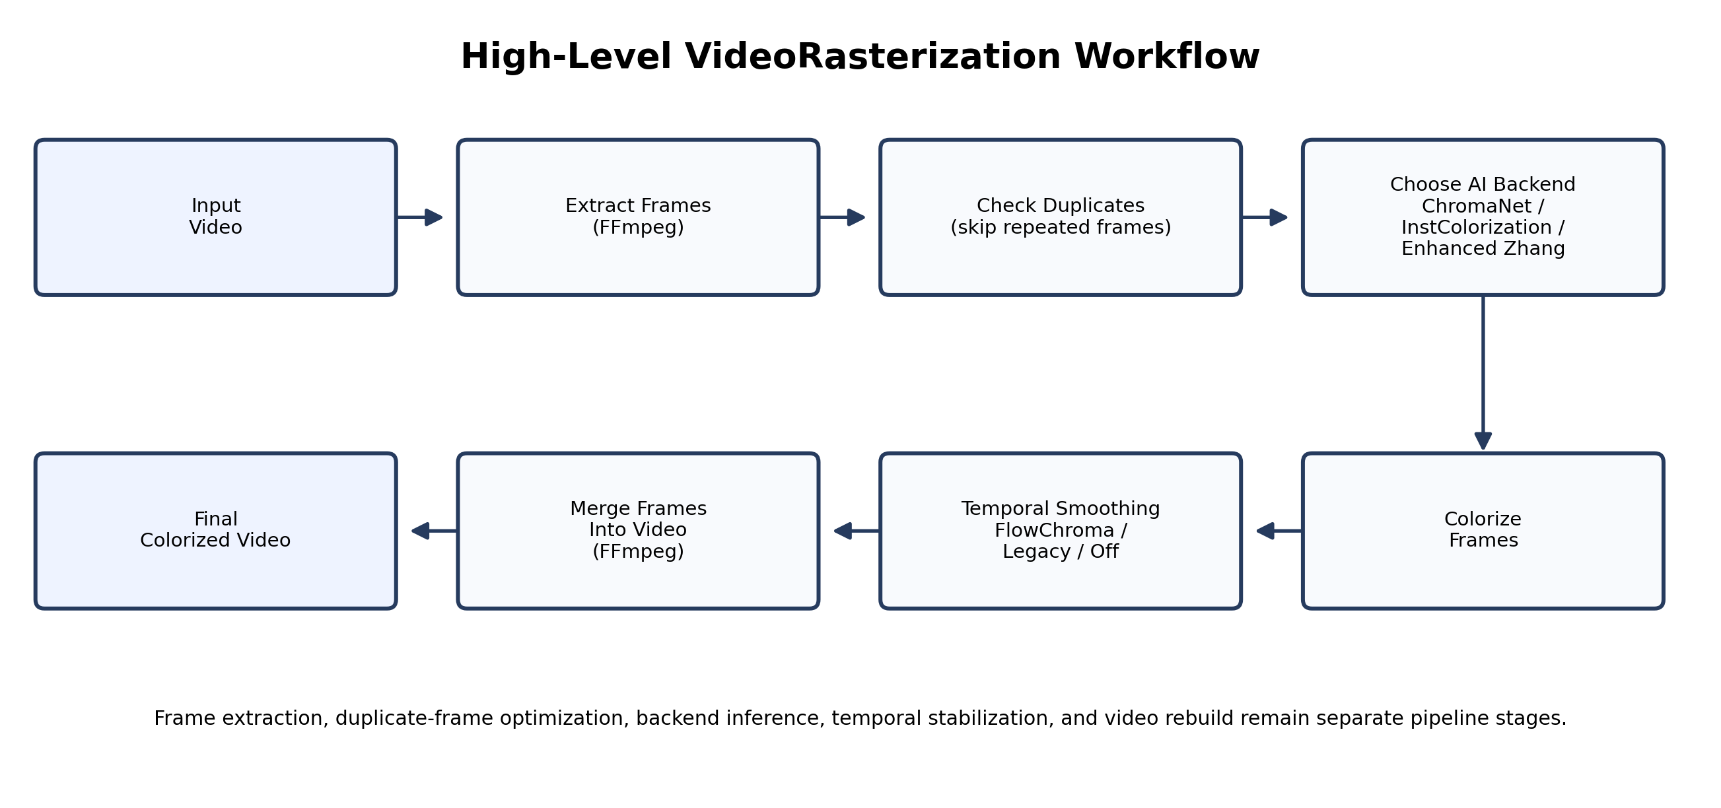
Figure 1. High-level VideoRasterization workflow from video input to final colorized output.
The design is intentionally linear at the top level. This is not a weakness. It keeps orchestration readable and prevents unnecessary abstraction from hiding the real stage ordering.

4.2 Main Execution Path
The top-level control script is main.py. Its responsibilities are:
- initialize the working temp directory,
- ask the user for the input video,
- extract frames,
- scan available AI model backends,
- ask for model-specific options,
- detect CUDA availability,
- run colorization,
- apply temporal smoothing if requested,
- generate a report artifact,
- rebuild the video output.
This is deliberately procedural. For an interactive CLI application, procedural clarity is often preferable to excessive abstraction.

4.3 Frame Extraction
Frame extraction is the first true processing stage. The user may choose:
- PNG mode for higher-quality storage,
- JPG mode for smaller disk footprint and faster throughput.
This step is more important than it may appear. It directly affects:
- temporary storage usage,
- frame load speed,
- smoke-test iteration speed,
- and the overall cost of long clips.
By keeping extracted frames in timestamped directories, the pipeline also makes intermediate inspection and later documentation easier.

4.4 Duplicate-Frame Middleman
One of the most practical second-term additions was the global duplicate-frame middleman. This stage scans consecutive extracted frames and groups exact pixel-identical runs. Only the first frame in each run is sent through the selected AI model. After inference, the result is copied back to the skipped frame names so reconstruction remains correct.
This logic is implemented conservatively:
- if two frames are exactly equal, they are grouped;
- if one pixel differs, the frame is treated as new.
That rule is intentionally strict. It gives up some possible savings, but it avoids false positives that would be hard to justify during debugging or evaluation.

4.5 Backend Dispatch
The pipeline then dispatches the deduplicated frame sequence to the selected backend. This dispatch layer is critical because the backends are not identical internally:
- ChromaNet uses one custom path,
- InstColorization uses its own backend adapter,
- Zhang-based models rely on a different inference family.
Despite these differences, the project keeps their invocation under one shared orchestration point. This is one of the main reasons the benchmark suite can compare them fairly.

4.6 Temporal Smoothing and Reconstruction
After raw colorization, the frame sequence may optionally pass through a temporal smoother. The smoother is not embedded inside any model backend; it is a separate pipeline stage. This keeps the system modular and lets the same temporal logic operate across all integrated model families.
Finally, the pipeline rebuilds the output video and restores the source audio when present. That last point matters because a frame-only result is not enough for a serious final demo. The project’s real deliverable is a playable video, not only a processed image directory.

5. Graphical User Interface (GUI)
The VideoRasterization project includes a dedicated desktop graphical user interface named ChromaStudio. ChromaStudio serves as the primary interaction layer between the user and the VideoRasterization Python backend. It is implemented as a desktop application using pywebview, which hosts a self-contained HTML/CSS/JavaScript frontend inside a native OS window. The application window is launched at 1440×900 pixels (maximized by default) and communicates with the Python backend through a JavaScript API bridge.

5.1 Design Philosophy
ChromaStudio follows a dark-themed, minimal design system built on a set of CSS tokens. The color palette uses a near-black background (#0E0E0E) with layered surface tones and a blue accent (#0062FF) for interactive elements. Typography uses the Inter typeface at 14px base size. The interface is intentionally non-skeuomorphic: controls are flat, borders are subtle, and feedback is communicated through animated badges and progress bars rather than modal dialogs.
The application is structured around five named states that map directly to stages in the user’s workflow. Transitioning between states is animated and triggered by explicit user actions or by pipeline events emitted from the Python backend. This prevents the user from reaching an inconsistent UI state during processing.

5.2 Application States and User Flow
The GUI is organized into five sequential states. Each state occupies the full application viewport and transitions are managed by a central state machine in JavaScript.
- State 1 — Welcome. The landing screen presents a large drag-and-drop zone where the user drops or browses to a grayscale video file. Below the drop zone, a “Recent Projects” panel lists previously processed videos from a local history.json file, allowing one-click re-access to earlier outputs. Drag-and-drop is handled natively through the pywebview DOM event API, which passes the full file system path to the JavaScript layer.
- State 2 — Configuration. After a file is loaded, the user is presented with a two-column configuration screen. The left column shows a live video preview of the selected input using a native HTML5 <video> element fed through a temporary hard-linked copy. The right column is a scrollable settings panel divided into four labelled sections: Extraction Mode (PNG or JPG), AI Model selection, Temporal Smoothing options, and Output settings. Each AI model is presented as a selectable card showing its name, architecture, quality tier (star rating), speed tier, and GPU requirement badge.
- State 3 — Comparison Preview. An optional intermediate step that allows the user to inspect the first colorized frame before committing to a full run. The state presents a side-by-side grayscale-versus-colorized frame comparison. The user can proceed to processing or return to reconfigure settings.
- State 4 — Processing. The main pipeline execution screen. A large central area shows a live preview of the most recently colorized frame, updated as the backend emits frame_processed events. Below the preview, a progress bar and numeric counters display frames completed, frames per second (current and average), elapsed time, and estimated time remaining. A pipeline stage tracker on the left shows which of the five stages (Extraction, Colorization, Smoothing, Reporting, Encoding) is active, pending, or complete. A right-side panel shows live system metrics (CPU load, RAM usage, VRAM usage) polled from the Python backend every two seconds. The user can Pause, Resume, or Cancel the job at any time via dedicated buttons.
- State 5 — Review. The completion screen. It displays the output video path, a run summary (model used, preset, frame count), and a colorization quality report generated by tools/preview_report.py. Buttons allow the user to open the output folder in Windows Explorer, play the output video with the system default player, or start a new job.

5.3 Backend Communication Model
ChromaStudio uses a two-channel communication model between the JavaScript frontend and the Python backend.
Synchronous API calls (JS → Python). The frontend calls methods on the ChromaAPI Python class via window.pywebview.api. This covers operations such as get_models(), start_processing(job), pause_processing(), and open_file_dialog(). These calls are asynchronous from the browser’s perspective and resolve to plain JSON-serializable return values.
Event push (Python → JS). The pipeline thread calls window.evaluate_js() to invoke window.__chromaEvent(payload) with structured JSON payloads. Event types include stage_start, stage_complete, frame_processed, pipeline_complete, pipeline_cancelled, and error. The frame_processed event carries the current frame index, total frame count, instantaneous FPS, average FPS, elapsed seconds, ETA in seconds, and a Base64-encoded JPEG preview of the most recently completed colorized frame.

5.4 Model Selection and Preset System
The model registry is defined in app.py as a static list of dictionaries. Each entry declares the model’s display name, internal backend identifier, architecture description, speed tier (1–5), quality tier (1–5), GPU requirement flag, and current availability status. ChromaNet v3 reports needs_checkpoint when no checkpoint file is found on disk, and ready otherwise. The frontend renders each model as an interactive card with color-coded status badges. Cards in a needs_checkpoint state are visually dimmed and disabled.
The preset system stores extraction and quality configurations as JSON files under a presets/ directory. Two built-in presets are provided: Full Quality (PNG extraction, five quality stars, three speed stars) and Faster Encoding (JPEG extraction, three quality stars, five speed stars). Users may save custom presets through the GUI and delete them later; built-in presets are protected from deletion.

5.5 Pause, Resume, and Cancel
Pipeline control is implemented using two Python threading primitives shared between the GUI host and the pipeline thread:
- _pause_flag is a threading.Event that the pipeline thread checks at each cancel checkpoint via _pause_flag.wait(). Clearing this event blocks the pipeline; setting it resumes execution.
- _cancel_flag is a second threading.Event checked at each stage boundary via check_cancel(). When set, it raises InterruptedError, which is caught by the outer try-except and causes a pipeline_cancelled event to be emitted to the frontend.
Cancellation also sets the pause flag to ensure the pipeline thread can always reach the next check_cancel() call even when the pipeline is currently paused.

5.6 Hardware Awareness
On startup, the GUI calls get_hardware_summary() and emits a hardware_ready event so the frontend can display detected hardware (CPU name, core count, RAM, GPU name, VRAM). During processing, get_system_metrics() is polled every two seconds using psutil (CPU per-core percentages, RAM used/total, disk I/O) and torch.cuda (VRAM used/total). Both libraries degrade gracefully if not installed: psutil absence suppresses CPU and RAM metrics, and missing CUDA suppresses GPU metrics, without crashing the application.

5.7 GUI Screenshots
The following figures show the five primary screens of the ChromaStudio desktop application. Screenshots should be inserted by the responsible team member before final submission.

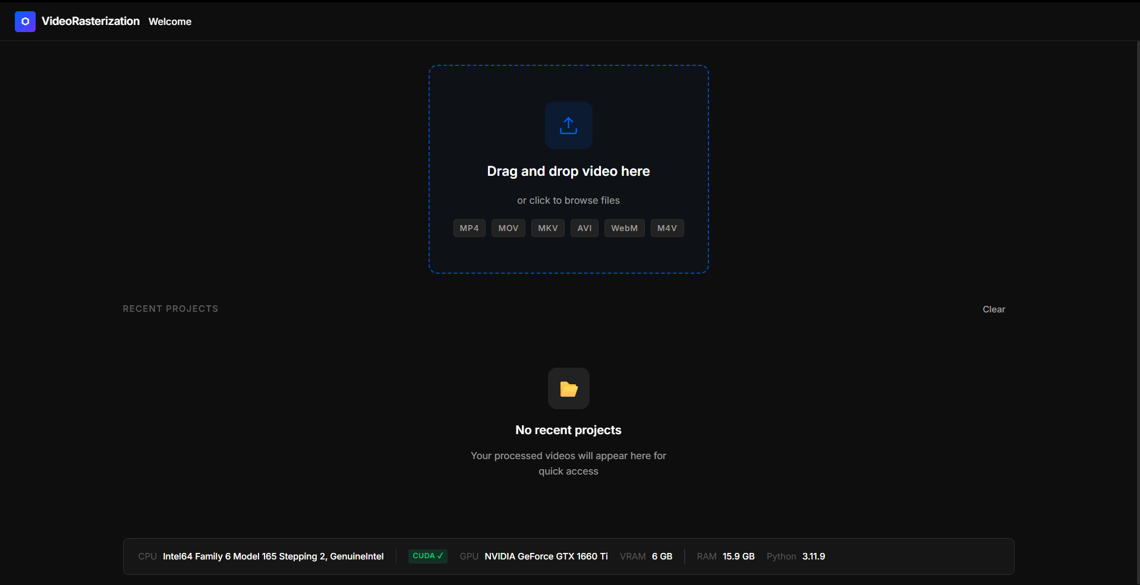
Figure 7. ChromaStudio welcome screen showing the drag-and-drop zone and recent projects panel.

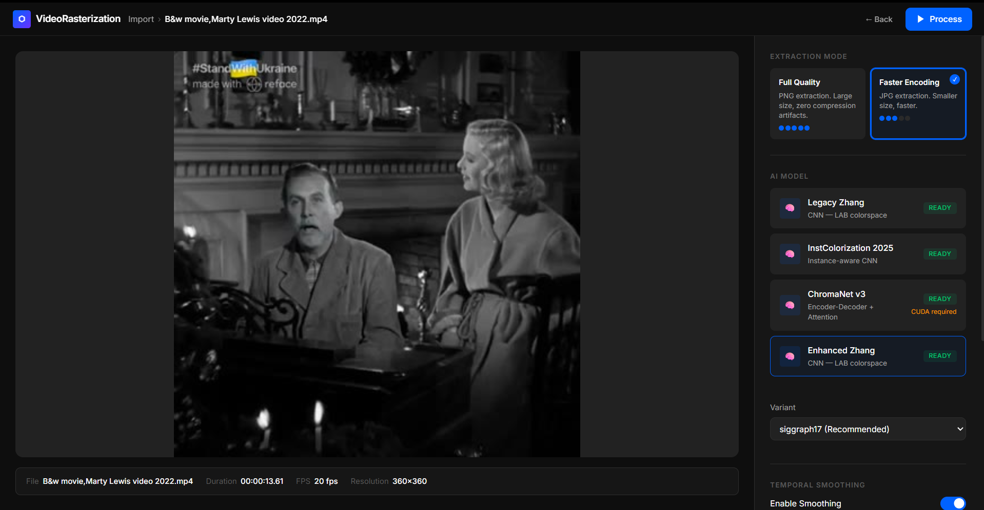
Figure 8. ChromaStudio configuration screen showing video preview, model selection cards, temporal smoothing controls, and output settings.
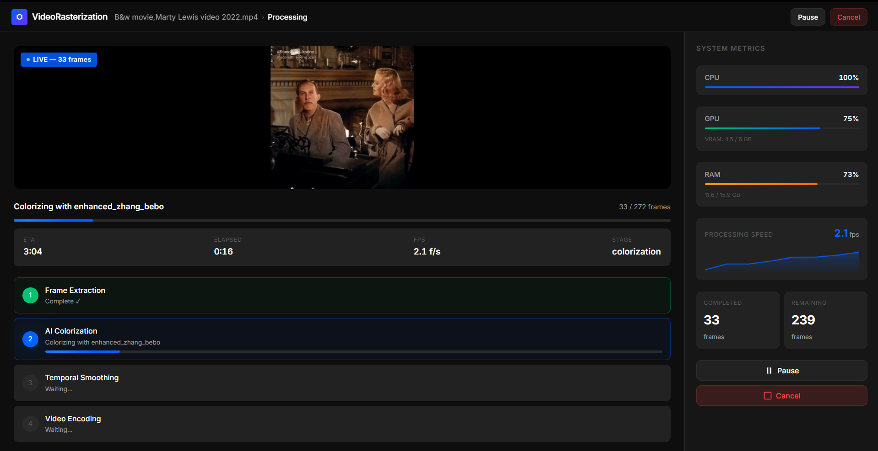
Figure 9. ChromaStudio processing screen showing live colorized frame preview, pipeline stage tracker, per-frame progress bar with FPS and ETA, and real-time system metrics panel.

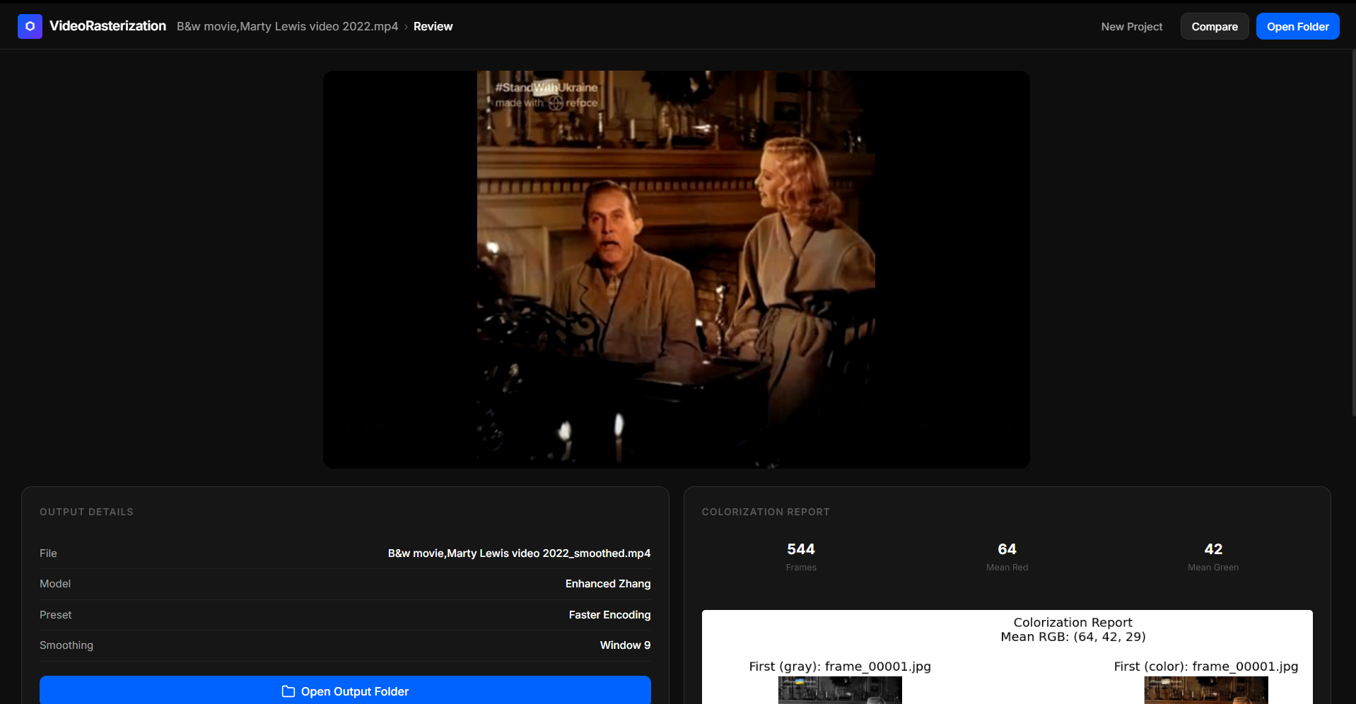
Figure 10. ChromaStudio review screen showing run summary, output path, colorization quality report, and action buttons for opening the output folder or starting a new job.
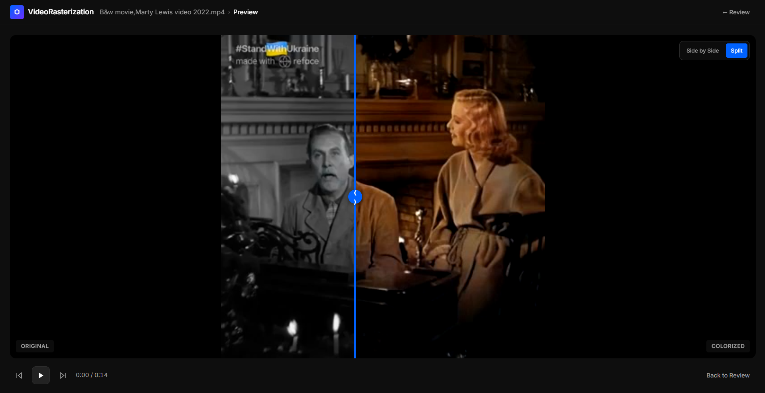
Figure 11. ChromaStudio comparison preview screen showing side-by-side grayscale and colorized first frame before committing to a full run.

6. Integrated AI Backends and Legacy Baselines

6.1 Why Multiple Backends Were Needed
The project uses five backend entries in the report, but they do not all have the same status:
- ChromaNet v3
- Enhanced Zhang (Bebo’s Experiment)
- InstColorization2025
- Legacy Zhang SIGGRAPH17
- Legacy Zhang ECCV16
This was not done merely for feature variety. The multiple-backend design serves two important goals:
- it allows the project to maintain a custom research track through ChromaNet,
- and it gives the team practical fallback models when the custom model is not yet strongest in output quality.
The ordering above is intentional. The report now presents the models in the order that best reflects project ownership and practical importance:
- ChromaNet first, because it is the custom-trained academic core of the project.
- Enhanced Zhang second, because it became the strongest practical showcase backend after repository-side improvements.
- InstColorization third, because it is a separate trainable branch with a different internal philosophy.
- Legacy Zhang SIGGRAPH17 and Legacy Zhang ECCV16 last, because they are retained mainly as untouched historical baselines and comparison anchors.

6.2 Backend Comparison
Table 3 summarizes the role of each backend in the current repository.
Backend | Primary role | Strength in current repo | Current weakness
ChromaNet v3 | Custom academic training track | Custom architecture, checkpoint control, full-res luminance merge | Under-colors people and difficult ambiguous scenes
Enhanced Zhang | Practical showcase backend | Best overall qualitative output in current benchmark | Still inherits limits of the base Zhang family
InstColorization | Alternative model family | Separate trainable branch and selective instance-aware behavior | Demands stronger data/training to unlock its potential
Legacy Zhang SIGGRAPH17 | Historical pretrained baseline | Useful semantic comparison anchor | Slow raw inference and no repo-side enhancements by default
Legacy Zhang ECCV16 | Historical earlier baseline | Earliest retained reference path | Older behavior, weaker practical default than SIGGRAPH17

6.3 ChromaNet v3
ChromaNet is the project’s most academically important backend because it is the model family trained and modified inside the repository. It is not just a wrapper around external weights. It contains:
- a custom encoder,
- scene classification and conditioning,
- semantic color memory,
- multi-scale chroma outputs,
- and a confidence head.
Its weakness is not poor integration; its weakness is current checkpoint quality on difficult classes such as faces and some urban warm-reflection scenes.

6.4 Enhanced Zhang (Bebo’s Experiment)
Enhanced Zhang is not a brand-new trained family. It is a repository-level enhancement layer built on top of the pretrained Zhang weights, mainly siggraph17, with eccv16 still available when needed. The goal was simple: keep the strong semantic prior of Zhang, but reduce the practical weaknesses that made the raw legacy path less suitable for demos.
At a high level, Enhanced Zhang differs from the untouched legacy Zhang path in four ways:
- it preserves the original full-resolution luminance instead of stretching a low-resolution RGB result,
- it applies mild chroma neutralization to reduce whole-frame beige or orange cast,
- it adds a controlled saturation lift,
- and it adds a small contrast lift for a cleaner final appearance.
This approach was informed by the general idea seen in the Hanshu110 colorization pipeline discussion: keep the pretrained semantic strength, but improve the practical final output through better repository-side post-processing and full-resolution reconstruction rather than pretending the original baseline is already production-ready. In this project, that idea was implemented conservatively so that the system stayed explainable and easy to benchmark.
The result is important academically because it shows a second kind of contribution besides custom training. ChromaNet represents model-side research work. Enhanced Zhang represents pipeline-side engineering improvement on top of a known pretrained backbone.

6.5 InstColorization
InstColorization was integrated as a separate backend with its own checkpoint path and training route. It is valuable because it provides:
- an alternative model family,
- a comparison point against ChromaNet,
- and a distinct trainable branch inside the repo.
Its main conceptual difference from the other backends is that it is instance-aware. In practical terms, this means it tries harder to color regions based on detected object-level cues rather than treating the entire frame as one uniform semantic field. This can be better because it may selectively color certain objects more accurately when the model is confident. It can also be worse under project constraints because instance-aware behavior is more demanding:
- it needs stronger confidence before committing to color,
- it benefits more from richer instance-heavy training data,
- and it punishes weak training more visibly by leaving parts of the frame gray or under-colored.
That is exactly what was observed in the repo experiments. InstColorization was not useless; it was selective. When confident, it could look disciplined. When not confident, it often became too conservative for people-heavy or stylized scenes. This made it a technically interesting branch, but not the safest final-demo default under limited time, limited VRAM, and limited dataset preparation.

6.6 Legacy Zhang SIGGRAPH17
Legacy Zhang SIGGRAPH17 serves as the main historical baseline. It is useful because it helps separate:
- model-quality issues,
- from pipeline-design issues.
If the same frame behaves very differently under Zhang and ChromaNet, the team can reason more clearly about whether the problem lies in training data, model priors, or the surrounding pipeline.
Its main weakness is speed. In the current benchmark, it is much slower than the other practical options.
The report classifies it as legacy because the team did not treat it as an actively evolving project model. It was preserved mainly to answer a fair academic question: how much of the improvement comes from the new project work, and how much simply comes from using an older pretrained baseline?

6.7 Legacy Zhang ECCV16
Legacy Zhang ECCV16 is the older retained baseline. It is still useful for completeness because it represents the earlier Zhang-style family entry in the repository, but in practical use it is mainly a reference model rather than a preferred operational backend.
It matters in the report for two reasons:
- it documents that the project retained both classic Zhang variants instead of silently discarding them,
- and it gives the team a clean way to describe SIGGRAPH17 and ECCV16 as legacy first versions that were kept for historical comparison rather than active development.

6.8 Why Enhanced Zhang Became the Demo Default
Enhanced Zhang is currently the strongest general-purpose backend for demo-safe output in the repository. It performs best overall on:
- nature,
- people,
- and animation,
according to the fresh-source benchmark suite.
This does not reduce the academic importance of ChromaNet. It simply means the project should distinguish clearly between:
- the best current showcase backend,
- and the custom research backend.

7. ChromaNet v3 Architecture

7.1 Internal Processing Overview
Figure 2 summarizes the internal flow of ChromaNet v3.
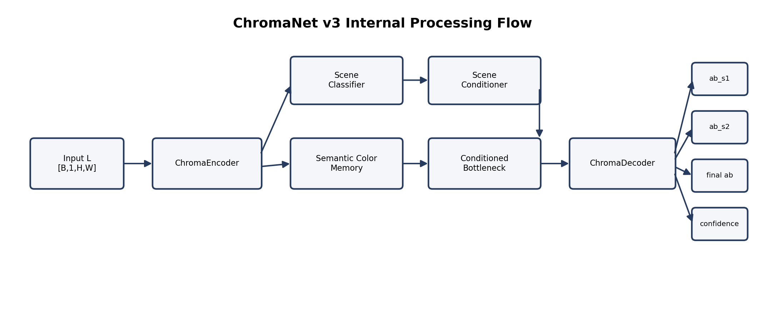
Figure 2. Internal ChromaNet v3 processing flow showing encoder, scene conditioning, semantic color memory, decoder outputs, and confidence head.
ChromaNet v3 follows an encoder-decoder architecture with five specialized components that work together to transform grayscale luminance into color predictions. The complete forward pass proceeds through the following stages.
Input Processing: the model receives a normalized luminance tensor of shape [B, 1, H, W] where H=W=256 during training. Values are normalized to the range [-1, 1] to match the Tanh activation in the output. This L channel is the only input — the model must infer all color information from grayscale structure alone.
Stage 1 — Encoding: the encoder transforms the input through five stages, each reducing spatial resolution while increasing channel depth. Features are extracted hierarchically, from local edges to global scene context. The output is a set of five feature maps at different scales, with the final bottleneck at [B, 512, 8, 8].
Stage 2 — Scene Classification: a lightweight CNN processes the original L channel independently to predict scene type. The resulting 5-class logits are converted to embeddings and injected into the bottleneck.
Stage 3 — Semantic Memory Retrieval: the bottleneck features generate a query that retrieves relevant color information from 32 learnable prototypes. This augments the bottleneck with learned color priors.
Stage 4 — Decoding: the decoder expands the augmented bottleneck through four stages with skip connections from the encoder. It produces color predictions at three scales which are fused into the final output.
Stage 5 — Confidence Estimation: a confidence head processes the final decoder features to produce a per-pixel confidence map indicating prediction certainty.

7.2 Input and Output Contract
Input specification: the model accepts a tensor L_tensor of shape [B, 1, H, W] with H=W=256, normalized to the range [-1, 1], stored as torch.float32 (converted to bfloat16 during mixed precision training).
The model returns a dictionary of outputs rather than a single tensor:
- ab — [B, 2, H, W], the final predicted chroma,
- ab_s1 — [B, 2, H/4, W/4], coarse-scale prediction,
- ab_s2 — [B, 2, H/2, W/2], medium-scale prediction,
- confidence — [B, 1, H, W], per-pixel confidence in [0, 1],
- scene_logits — [B, 5], raw scene classification logits before softmax.
Output ranges: AB channels lie in [-1, 1] due to the Tanh activation; confidence lies in [0, 1] due to the Sigmoid activation; scene logits are raw values prior to softmax.
Why Lab space: the model predicts chroma in Lab space rather than RGB directly, for four reasons.
- Lab separates brightness (L) from color (a, b),
- the grayscale input already provides L perfectly,
- only 2 channels need to be predicted instead of 3 (33% less to learn),
- it enables full-resolution luminance preservation during post-processing.

7.3 Encoder
The encoder is a 5-stage feature extractor built from convolutional layers, residual blocks, and max-pooling operations. Each stage progressively extracts higher-level semantic features while reducing spatial resolution.
Stage 1: Conv 1→64, BatchNorm + ReLU, a residual block (64→64), and 2×2 max pooling, taking [B, 1, 256, 256] to [B, 64, 128, 128]. This stage captures edges, lines, corners, and tiny textures.
Stage 2: Conv 64→128, BatchNorm + ReLU, a residual block (128→128), and 2×2 max pooling, taking [B, 64, 128, 128] to [B, 128, 64, 64]. This stage captures object parts, repeated patterns, and simple shapes.
Stage 3: Conv 128→256, BatchNorm + ReLU, a residual block (256→256), and 2×2 max pooling, taking [B, 128, 64, 64] to [B, 256, 32, 32]. This stage captures mid-level semantics and object categories.
Stage 4: Conv 256→512, BatchNorm + ReLU, a residual block (512→512), and 2×2 max pooling, taking [B, 256, 32, 32] to [B, 512, 16, 16]. This stage captures high-level concepts and scene components.
Stage 5: Conv 512→512, BatchNorm + ReLU, a residual block (512→512), and 2×2 max pooling, taking [B, 512, 16, 16] to [B, 512, 8, 8] — the bottleneck. This stage captures whole-scene understanding and global context.
Residual block structure: each residual block preserves the block input as an identity shortcut, passes the input through a Conv→BatchNorm→ReLU→Conv→BatchNorm main path, adds the identity back to the result, and applies a final ReLU.
class ResBlock:
def forward(x):
identity = shortcut(x) # Preserve input
out = Conv2d(x) # Main path
out = BN(out)
out = ReLU(out)
out = Conv2d(out)
out = BN(out)
out = out + identity # Skip connection
out = ReLU(out)
return out

Residual blocks were chosen for four reasons:
- Gradient flow — skip connections allow gradients to flow directly through the network, preventing vanishing gradients in deep architectures,
- Easier optimization — the model only has to learn the residual (difference) between input and output,
- Deeper networks — enables stacking five stages that would otherwise be difficult to train,
- Information preservation — the identity mapping ensures no information is lost.
Encoder output features: the encoder returns a list of five feature maps used for skip connections — s0 [B, 64, 128, 128] (finest details), s1 [B, 128, 64, 64] (object parts), s2 [B, 256, 32, 32] (mid-level semantics), s3 [B, 512, 16, 16] (high-level concepts), and the bottleneck [B, 512, 8, 8] (scene understanding).

7.4 Scene Classification and Conditioning
Scene classifier architecture: a lightweight CNN analyzes the L channel independently, applying three Conv→BatchNorm→ReLU blocks (1→32→64→128 channels, stride 2 each) followed by adaptive average pooling to [B, 128, 4, 4], then a classifier head that flattens to [B, 2048], projects through a 256-unit linear layer with ReLU and dropout (0.3), and outputs 5 scene-class logits.
class SceneClassifier:
def __init__(self):
self.features = Sequential(
Conv2d(1, 32, 3, stride=2, padding=1),
BatchNorm2d(32), ReLU(),
Conv2d(32, 64, 3, stride=2, padding=1),
BatchNorm2d(64), ReLU(),
Conv2d(64, 128, 3, stride=2, padding=1),
BatchNorm2d(128), ReLU(),
AdaptiveAvgPool2d(4) # [B, 128, 4, 4]
)
self.classifier = Sequential(
Flatten(), # [B, 2048]
Linear(2048, 256),
ReLU(),
Dropout(0.3),
Linear(256, 5) # 5 scene classes
)

The classifier distinguishes five scene types:
- Nature — forests, landscapes, beaches (expect greens, blues, earth tones),
- Urban — cities, buildings, streets (expect grays, cool tones, warm reflections),
- People — portraits, crowds, faces (expect skin tones, hair, clothing colors),
- Animation — cartoons, stylized content (expect saturated, non-natural colors),
- Indoor — rooms, offices, interiors (expect warm artificial lighting).
Scene conditioning mechanism: the scene logits are converted to probabilities via softmax, used to compute a weighted (soft) embedding over the five class embeddings, projected to the bottleneck dimension, and injected into the bottleneck through a learnable sigmoid gate that starts at zero.
class SceneConditioner:
def forward(self, bottleneck, scene_logits):
scene_probs = softmax(scene_logits) # [B, 5]
all_embeds = embedding.weight # [5, 128]
soft_embed = scene_probs @ all_embeds # [B, 128]
scene_vec = projection(soft_embed) # [B, 512]
gate = sigmoid(gate_parameter) # Learnable, starts at 0
return bottleneck + gate * scene_vec.unsqueeze(-1).unsqueeze(-1)

Scene conditioning matters for four reasons:
- Context-aware colorization — a gray patch in nature is likely a cloud (white); in an urban scene it is likely a wall (beige),
- Automatic — no user input is required; the scene type is learned from data,
- Differentiable — the soft embedding allows gradients to flow through the scene prediction,
- Gate mechanism — starting the gate at zero prevents early reliance on noisy scene predictions.
Novelty: no published colorization paper performs automatic scene classification without user input; this is an original contribution of ChromaNet v3.

7.5 Semantic Color Memory
Architecture: the Semantic Color Memory is a learned dictionary of 32 color prototypes, built from a query projection (linear → LayerNorm → ReLU), 32 learnable memory key and value slots, a value projection (linear → LayerNorm) back to the feature-channel dimension, and a learnable gate.
class SemanticColorMemory:
def __init__(self, feature_channels=512, num_slots=32, mem_dim=256):
self.query_proj = Sequential(
Linear(feature_channels, mem_dim),
LayerNorm(mem_dim), ReLU()
)
self.memory_keys = Parameter(randn(num_slots, mem_dim) * 0.1)
self.memory_values = Parameter(randn(num_slots, mem_dim) * 0.1)
self.value_proj = Sequential(
Linear(mem_dim, feature_channels),
LayerNorm(feature_channels)
)
self.gate = Parameter(torch.zeros(1))
self.temperature = 0.1 # Controls attention sharpness

Forward pass: the bottleneck features [B, 512, 8, 8] are spatially pooled to [B, 512], projected into a normalized query, compared against normalized memory keys via cosine similarity (scaled by temperature) and softmax to obtain attention weights over the 32 slots, used to retrieve a weighted readout from the memory values, projected back to the feature dimension, and added to the bottleneck through a learnable sigmoid gate.
def forward(self, x):
# x: [B, 512, 8, 8] bottleneck features
pooled = x.mean(dim=[2, 3]) # [B, 512]
query = self.query_proj(pooled) # [B, 256]
query = F.normalize(query, dim=-1)
keys = F.normalize(self.memory_keys, dim=-1) # [32, 256]
attn = torch.matmul(query, keys.T) / self.temperature
attn = F.softmax(attn, dim=-1) # [B, 32]
readout = torch.matmul(attn, self.memory_values) # [B, 256]
readout = self.value_proj(readout) # [B, 512]
gate = torch.sigmoid(self.gate)
return x + gate * readout.unsqueeze(-1).unsqueeze(-1)

What the memory learns: the 32 slots organize into recognizable color groupings — slots 1–4 learn sky colors (blues and cyans), slots 5–8 learn vegetation colors (greens), slots 9–12 learn skin tones (beige, pink, brown), slots 13–16 learn wood and bark colors (browns), slots 17–20 learn water colors (teals, deep blues), slots 21–24 learn artificial colors (reds, oranges), slots 25–28 learn grays and neutrals, and slots 29–32 learn other patterns the model discovers during training.
Why the semantic memory is novel:
- No other colorization model has this — baselines such as Zhang and InstColorization use a standard encoder-decoder without memory,
- Learned automatically — no manual labeling is required,
- Interpretable — it is possible to inspect which slots activate for a given input,
- Handles ambiguity — the memory provides color priors when local evidence is weak.
Memory as an attention mechanism: the module behaves like a neural dictionary —
- Query — what color is the model looking for?,
- Keys — which memory slots are relevant?,
- Attention — how relevant is each slot?,
- Values — what color information should be retrieved?,
- Gate — should this information be used at all, learned during training.

7.6 Decoder and Multi-Scale Output
Decoder architecture: the decoder has four stages, each with a skip-connection projection, a gated-skip fusion module, two Conv-BatchNorm-ReLU blocks, and a CBAM (channel and spatial) attention module.
class DecoderStage:
def __init__(self, in_ch, skip_ch, out_ch):
self.skip_proj = Conv2d(skip_ch, in_ch, 1)
self.gated_skip = GatedSkip(in_ch)
self.conv1 = ConvBnRelu(in_ch, out_ch)
self.conv2 = ConvBnRelu(out_ch, out_ch)
self.attention = CBAM(out_ch)

def forward(self, x, skip):
x = F.interpolate(x, size=skip.shape[2:], mode='bilinear')
skip = self.skip_proj(skip)
x = self.gated_skip(skip, x)
x = self.conv2(self.conv1(x))
return self.attention(x)

Gated-skip mechanism: rather than simply concatenating or adding the encoder skip connection, a learnable gate (computed from the decoder state) blends encoder and decoder features per pixel, with more encoder contribution where the gate value is high.
class GatedSkip:
def forward(self, enc, dec):
gate = sigmoid(Conv2d(dec)) # [B, C, H, W]
return enc * gate + dec * (1 - gate)

Multi-scale output: the decoder produces chroma predictions at three scales — a coarse 32×32 prediction (ab_s1) for large uniform areas such as sky, ground, and walls; a medium 64×64 prediction (ab_s2) for objects such as trees, buildings, and cars; and a fine 256×256 prediction for textures, edges, and fine patterns.
ABHead structure: each scale’s features pass through a Conv→BatchNorm→ReLU block that halves the channel count, then a final 1×1 convolution to 2 channels with a Tanh activation, producing chroma values in [-1, 1].
class ABHead:
def __init__(self, in_ch):
self.head = Sequential(
Conv2d(in_ch, in_ch // 2, 3, padding=1),
BatchNorm2d(in_ch // 2), ReLU(),
Conv2d(in_ch // 2, 2, 1), # Predict a and b channels
Tanh() # Output in [-1, 1]
)

Multi-scale fusion: three learnable scale weights (initialized equally) are passed through softmax, all three scale predictions are upsampled to the target 256×256 resolution, and the final chroma output is their weighted sum.
class MultiScaleFusion:
def __init__(self):
self.scale_weights = Parameter(torch.ones(3))

def forward(self, ab_s1, ab_s2, ab_s3):
w = softmax(self.scale_weights)
s1 = interpolate(ab_s1, size=256, mode='bilinear')
s2 = interpolate(ab_s2, size=256, mode='bilinear')
s3 = ab_s3 # Already at target size
return w[0] * s1 + w[1] * s2 + w[2] * s3

Multi-scale prediction was chosen for four reasons:
- Different scales learn different things — coarse scales for large areas, fine scales for detail,
- Training stability — a multi-scale loss supervises each scale independently,
- Fusion learns weights — the model discovers which scale to trust for each region,
- No manual tuning — all weighting is learned from data.

7.7 Confidence Head
Architecture: the confidence head takes the final decoder features (32 channels), halves the channel count through a Conv→BatchNorm→ReLU block, and applies a final 1×1 convolution to a single channel with a Sigmoid activation, producing a per-pixel confidence map in [0, 1].
class ConfidenceHead:
def __init__(self, in_channels=32):
self.head = Sequential(
Conv2d(in_channels, in_channels // 2, 3, padding=1),
BatchNorm2d(in_channels // 2), ReLU(),
Conv2d(in_channels // 2, 1, 1),
Sigmoid()
)

def forward(self, x):
return self.head(x) # [B, 1, H, W] confidence map

Interpreting confidence values: values from 0.9–1.0 indicate the model is very confident and the color can be trusted; 0.7–0.9 indicates fairly confident; 0.5–0.7 indicates genuine uncertainty (a coin flip); 0.3–0.5 indicates the model is unsure; and 0.0–0.3 indicates the model has essentially no confidence in the prediction.
Training the confidence head: a confidence-aware loss combines a calibration term, which weights the per-pixel color error by the predicted confidence, with a smoothness term, which encourages low-confidence regions to vary smoothly.
def confidence_loss(pred, target, conf):
error = abs(pred - target) # Per-pixel color error
calibration = (conf * error).mean()
uncertainty = 1 - conf
smoothness = (uncertainty * gradient(pred)).mean()
return calibration + 0.1 * smoothness

Confidence estimation matters for four reasons:
- Interpretability — it shows where the model struggles,
- Smoothing guidance — low-confidence areas can borrow color information from neighboring regions,
- Quality control — uncertain predictions can be filtered or flagged,
- Debugging — it helps identify failure cases during development.

7.8 Tensor Flow Summary
Table 4 summarizes the complete data flow through ChromaNet v3.
Stage | Input shape | Output shape
Input | [B, 1, 256, 256] | [B, 1, 256, 256]
Encoder Stage 1 | [B, 1, 256, 256] | [B, 64, 128, 128]
Encoder Stage 2 | [B, 64, 128, 128] | [B, 128, 64, 64]
Encoder Stage 3 | [B, 128, 64, 64] | [B, 256, 32, 32]
Encoder Stage 4 | [B, 256, 32, 32] | [B, 512, 16, 16]
Encoder Stage 5 (bottleneck) | [B, 512, 16, 16] | [B, 512, 8, 8]
Scene Classifier | [B, 1, 256, 256] | [B, 5]
Scene Conditioner | [B, 512, 8, 8] + [B, 5] | [B, 512, 8, 8]
Semantic Memory | [B, 512, 8, 8] | [B, 512, 8, 8]
Decoder Stage 1 | [B, 512, 8, 8] + s3 | [B, 256, 16, 16]
Decoder Stage 2 | [B, 256, 16, 16] + s2 | [B, 128, 32, 32]
ABHead s1 | [B, 128, 32, 32] | [B, 2, 32, 32]
Decoder Stage 3 | [B, 128, 32, 32] + s1 | [B, 64, 64, 64]
ABHead s2 | [B, 64, 64, 64] | [B, 2, 64, 64]
Decoder Stage 4 | [B, 64, 64, 64] + s0 | [B, 32, 128, 128]
Final Conv | [B, 32, 128, 128] | [B, 32, 256, 256]
ABHead s3 | [B, 32, 256, 256] | [B, 2, 256, 256]
MultiScaleFusion | ab_s1, ab_s2, ab_s3 | [B, 2, 256, 256]
Confidence Head | [B, 32, 256, 256] | [B, 1, 256, 256]
Channel dimensions: the encoder expands channels 1 → 64 → 128 → 256 → 512 → 512; the decoder contracts them 512 → 256 → 128 → 64 → 32; the AB head reduces 32 → 2 for the final chroma output; and the confidence head reduces 32 → 1.
Spatial dimensions: the encoder reduces resolution 256 → 128 → 64 → 32 → 16 → 8; the decoder restores it 8 → 16 → 32 → 64 → 128 → 256; and the three AB heads operate at 32×32, 64×64, and 256×256 respectively.

7.9 Loss Design
The total training loss combines seven weighted components:
Total = 10.0 x L1 + 1.0 x Perceptual + 0.5 x Colorfulness
+ 2.0 x Temporal + 0.5 x Confidence + 2.0 x Frequency
+ 1.0 x MultiScale

1. Chrominance L1 loss (weight 10.0): the basic per-pixel color error, weighted by saturation so that saturated colors (weighted between 0.5 and 4.0 relative to the mean) carry more importance, since they are more visually significant than near-neutral tones.
2. Perceptual loss (weight 1.0): a VGG16 feature-space comparison between predicted and target RGB images. This is included because L1 loss alone tends to produce blurry results; comparing deep features instead preserves object structure.
3. Colorfulness loss (weight 0.5): based on the Hasler & Suesstrunk colorfulness metric (a combination of color spread and a centered term), this penalizes predictions less colorful than the target. It exists because networks naturally tend to predict gray when uncertain, and this loss discourages that collapse.
4. Temporal consistency loss (weight 2.0): a motion-weighted difference between chroma predictions on consecutive frames, where the motion mask is derived from the luminance difference between frames. This reduces video flicker, since frame-by-frame colorization can otherwise be unstable from one frame to the next.
5. Confidence calibration loss (weight 0.5): combines the calibration and smoothness terms described in Section 7.7, teaching the model to be honest about its own uncertainty so that the confidence maps remain meaningful.
6. Frequency-aware loss (weight 2.0): separates predictions into low- and high-frequency components (via blurring) and penalizes high-frequency error roughly three times as heavily as low-frequency error. This prevents color bleeding across edges, since edges are given substantially more weight.
7. MultiScale loss (weight 1.0): supervises the coarse and medium decoder outputs (ab_s1 and ab_s2) directly against downsampled targets, ensuring both intermediate scales learn useful structure rather than relying solely on gradients propagated from the final output.

7.10 Why ChromaNet Still Matters
Despite not being the strongest demo backend, ChromaNet is the most important academic component of the project because it demonstrates several original contributions:
- Custom architecture — built entirely from scratch, not a wrapper around an existing model,
- Semantic Color Memory — 32 learnable prototypes; no other colorization model has this,
- Scene classification — fully automatic, with no user input required,
- Confidence estimation — per-pixel uncertainty that makes the model interpretable,
- Multi-scale prediction — three scales with learned fusion weights,
- Lab-space design — full-resolution luminance preservation throughout.
Technical independence: training from scratch means the team understands exactly how the model learns, has full control to modify any component, owns the complete training history through its checkpoints, and has documented its own failures — the dataset-shift regression discussed in Section 8 demonstrates genuine understanding rather than blind reliance on a third-party model.
Academic value: the project is distinguished from baselines that simply reuse Zhang’s model; every component can be explained and justified; the practical constraints encountered along the way produced real engineering lessons; and the architecture provides a strong foundation for continued improvement beyond this submission.

8. Training Pipeline and Dataset Strategy

8.1 Training Lifecycle
Figure 3 summarizes the training lifecycle implemented around ChromaNet.
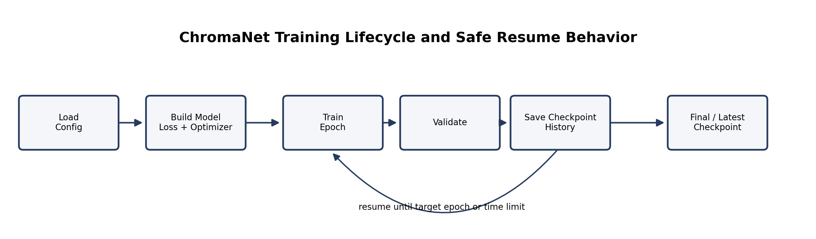
Figure 3. ChromaNet training lifecycle with safe checkpoint resume behavior.
The trainer supports:
- CUDA execution,
- automatic mixed precision,
- preview generation,
- validation metrics,
- JSON history export,
- best-checkpoint handling,
- and safe resume semantics.

8.2 Datasets Used During the Experimental Phase
Three dataset sources were relevant during the second-term experimental work:
- COCO train2017
- DIV2K
- people-focused supplementary data
Table 6 summarizes the practical role of each source.
Dataset | Primary value | Main limitation
COCO train2017 | Broad object and scene semantics | Not person-dense enough for strong face recovery
DIV2K | High-detail clean imagery | Weak semantic coverage for people-heavy scenes
People-focused data | Best lever for faces, skin, clothes, hair | Can over-bias the model if used alone

8.3 Dataset Usage in the Retained Training Workflow
The retained training workflow followed a direct sequential approach rather than a complex dataset-balancing pipeline. This decision was made for practical reasons: the available hardware budget favored stable repeatable runs, checkpoint inspection, and controlled continuation over heavier experimental sampling schemes.
In the implemented workflow, COCO train2017 served as the primary semantic dataset and formed the main basis of training. DIV2K was introduced as a supporting source to improve detail preservation and local texture quality. At a later stage, people-focused supplementary data was explored in an attempt to improve the rendering of faces, skin tones, and clothing. However, the later experiments did not improve the overall model behavior sufficiently and were followed by checkpoint comparison and rollback to earlier stronger states.
Accordingly, the project report should present the adopted method as a sequential training workflow built around dataset staging, checkpoint evaluation, and selective rollback. That description reflects the actual implementation history more accurately than a balanced multi-source training narrative.

8.4 Current Main-Branch Training Configuration
Table 7 summarizes the ChromaNet configuration recorded in the latest pushed project branch at the time this report was prepared. This configuration reflects a later fine-tuning direction: moving from the earlier stable 256 x 256 training boundary toward 512 x 512 experiments while reducing batch size to fit the available laptop GPU memory.
Parameter | Current main-branch value | Technical interpretation
Input size | 512 x 512 | Higher-resolution fine-tuning target than the original stable 256 path
Batch size | 3 | Chosen because 512x512 has four times the pixel count of 256x256
Epoch target | 16 | Resume-oriented continuation rather than a one-off training run
Learning rate | 0.00001 | Conservative fine-tuning value to reduce instability
Mixed precision | enabled, bfloat16 | Improves memory use while reducing FP16-style overflow risk
Gradient clipping | 1.0 | Helps limit unstable gradient spikes
Validation split | 5% | Keeps a consistent held-out validation subset
Checkpoint directory | ../../checkpoints/chromanet | Keeps model weights under the unified local checkpoint root

8.5 Why the 256x256 and 512x512 Tradeoff Mattered
The project did not move directly from prototype work to high-resolution training. Earlier ChromaNet experiments showed that 256 x 256 was the most stable practical boundary for repeated training, checkpoint comparison, and recovery from failed runs. This mattered because the project was executed on an RTX 4070 Laptop GPU with 8 GB VRAM, which is powerful enough for useful CUDA acceleration but not large enough to treat resolution as free.
The later main-branch configuration attempts 512 x 512 fine-tuning with batch size reduced from 12 to 3. This is a reasonable technical step because:
- 512 x 512 contains four times as many pixels as 256 x 256,
- the lower batch size keeps VRAM usage under control,
- the conservative learning rate reduces the chance of non-finite loss,
- and BF16 mixed precision gives wider numerical range than pure FP16.
However, the report should not present 512x512 as if it eliminated the earlier limitation. It is better described as a later fine-tuning direction built on top of the stable 256x256 learning path. The actual quality still depends on checkpoint maturity, dataset composition, and scene type.
There was also a perceptual reason why the lower-resolution model path remained usable. Human vision is generally more sensitive to structure, contrast, and luminance sharpness than to perfect chroma resolution in every region. By preserving the original full-resolution grayscale luminance and overlaying only the predicted color channels, the system hides much of the expected low-resolution chroma artifact. In other words, the eye tends to accept the result more easily because the sharp contrast cues stay intact even when the chroma map itself comes from a smaller model input.
Across training, testing, reruns, and backend comparisons, the team estimates that the laptop spent roughly five cumulative days processing model work during the second term.

8.6 Checkpoint Payload and Safe Resume
The ChromaNet checkpoint does not store only raw weights. It also stores:
- epoch index,
- optimizer state,
- scheduler state,
- AMP scaler state,
- best PSNR,
- training history,
- and configuration data.
This is important because it makes resume behavior coherent. The trainer also guards against:
- non-finite losses,
- non-finite model tensors,
- and no-op “resume past target epoch” confusion.
That is strong engineering evidence for a student project training pipeline.

8.7 ChromaNet Epoch Progression and Dataset-Shift Regression
The project kept a real history.json file for the stable ChromaNet run. This matters because it gives the report something better than memory-based claims. Table 7A summarizes the most relevant validation metrics from epochs 1 through 9.
Epoch | Validation total | Validation PSNR (dB) | Validation SSIM | Practical interpretation
1 | 7.1011 | 15.19 | 0.6749 | Very early model, visibly weak
2 | 2.3820 | 23.68 | 0.9239 | Large stability jump after retraining reset
3 | 2.3191 | 23.87 | 0.9243 | Continued improvement
4 | 2.2964 | 23.97 | 0.9242 | Better practical output, strong checkpoint
5 | 2.2789 | 24.05 | 0.9238 | Improved numerically
6 | 2.2642 | 24.13 | 0.9238 | Best numerical checkpoint in retained history
7 | 2.1371 | 23.93 | 0.9243 | Last stable pre-dataset-shift checkpoint used for comparison
8 | 2.3112 | 23.75 | 0.9178 | Quality dropped after changed data direction
9 | 2.2766 | 23.75 | 0.9178 | Did not recover prior stable behavior
Figure 4 summarizes the PSNR trend.
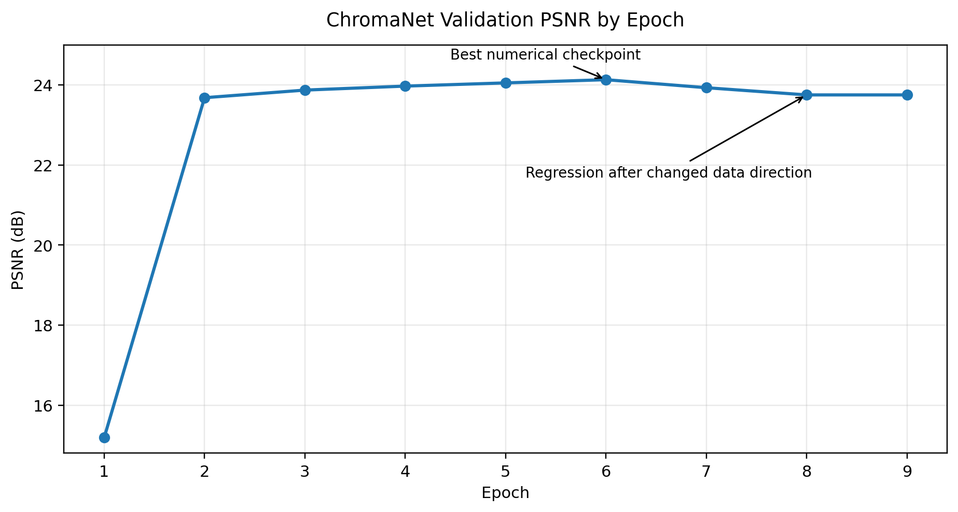
Figure 4. ChromaNet validation PSNR progression across retained training history.
The important conclusion is not just that PSNR went up. The important conclusion is that the model had two clearly different phases:
- epochs 1 to 7: gradual stabilization and quality growth,
- epochs 8 and 9: changed training direction and visible regression.
Numerically, epoch 6 was the strongest checkpoint in the retained history. Practically, the team treated epoch 7 as the last stable checkpoint before the dataset-shift experiment started to damage the behavior they were targeting. This is why the later report discussion treats epochs 8 and 9 as a lesson rather than as a success.

8.8 Failed Attempts, Training Hiccups, and What They Taught the Team
The final stable ChromaNet result did not come from one smooth run. The team had several failed or partially failed attempts, and these failures were technically useful:
- an early aggressive run produced NaN losses around epoch 2 and had to be discarded,
- larger batch and memory pressure pushed the laptop too close to its VRAM ceiling,
- moving later epochs toward people-focused data without enough balancing caused a regression instead of the intended improvement.
These failures were not wasted time. They established three practical lessons:
- stable training on the available laptop mattered more than ambitious but fragile settings,
- 256 x 256 was not only a compromise but a necessary engineering choice under the VRAM limit,
- and better people quality required better dataset composition, not only more epochs.
One additional idea that was explored but not retained was a more explicitly mixed or weighted dataset setup combining COCO, DIV2K, and people-focused data in a stronger balancing scheme. The team briefly considered that direction, but it was not adopted because it demanded more compute, more balancing work, and more stable experimentation than the available laptop setup could support. As a result, the team stayed with the simpler sequential path and judged quality through checkpoint comparison instead.
This explains one of the main unresolved weaknesses in the project. The team was able to improve nature and general scenery more easily than people because the available training distribution still favored those easier scene classes.

9. Second-Term Engineering Contributions

9.1 Contribution Summary
Table 8 summarizes the major engineering contributions delivered during the second term.
Contribution | Technical issue addressed | Effect on project
Full-resolution luminance preservation | Low-resolution output looked blurred | Restored sharpness while keeping manageable model input size
Exact duplicate-frame skipping | Repeated frames wasted inference time | Saves AI work on still or repeated scenes
flow_chroma smoothing | Per-frame flicker across video | Better temporal stability without naive full-frame blur
Unified checkpoint layout | Weights were scattered and hard to explain | Easier model management and documentation
Benchmark harness | Anecdotal testing was weak | Repeatable, scene-based evidence for comparison

9.2 Full-Resolution Luminance Preservation
One of the clearest second-term bugs was that the output sometimes looked as if a 256 x 256 image had simply been enlarged into the full video. The reason was straightforward:
- the frame was reduced,
- colorized,
- then enlarged back as a full RGB image.
This destroys high-frequency luminance detail.
The fix was to:
- keep the original full-resolution grayscale L channel,
- resize only the model input,
- predict low-resolution ab,
- upscale only ab,
- combine upscaled ab with original-resolution L.
This is a strong example of pipeline-level quality improvement that does not require a bigger model.

9.3 Global Duplicate-Frame Middleman
The duplicate-frame optimization was intentionally placed at the pipeline layer, not inside one model. This was correct for two reasons:
- duplicate-frame reuse is a global video property,
- and it should work across all AI backends.
That middleman became especially useful for:
- still title screens,
- repeated old-animation frames,
- and low-motion segments containing exact duplicate images.

9.4 Improved Logging and Checkpoint Notes
The second term also improved operational visibility:
- clearer console statuses,
- better progress reporting,
- smoke-test workflow clarity,
- checkpoint notes,
- and organized benchmark artifacts.
These are not “nice to have” details. They reduce confusion during long runs and make the system easier to defend and reproduce.

9.5 Audio Reintegration and Output Practicality
A frame-only pipeline can be useful internally, but the real deliverable of VideoRasterization is a final playable video. Restoring audio therefore belongs inside the official pipeline behavior. This is an example of making the project useful, not merely technically interesting.

10. Temporal Smoothing and Video Consistency

10.1 Why Temporal Smoothing Is Needed
Video playback immediately exposes small frame-to-frame color variation. A system can produce individually plausible frames and still fail as a video. Therefore, temporal smoothing is not an optional luxury. It is part of video quality.

10.2 legacy_average
The legacy smoothing mode uses a sliding-window average across neighboring frames and may blend with an anchor frame. It is:
- simple,
- deterministic,
- and sometimes useful in low-motion scenarios.
However, it also has a clear weakness:
- it averages full RGB frames,
- which can blur motion and edges.
This makes it an older baseline rather than the preferred default.

10.3 flow_chroma
The newer temporal mode is motion-compensated chroma stabilization. Its logic is summarized in Figure 5.
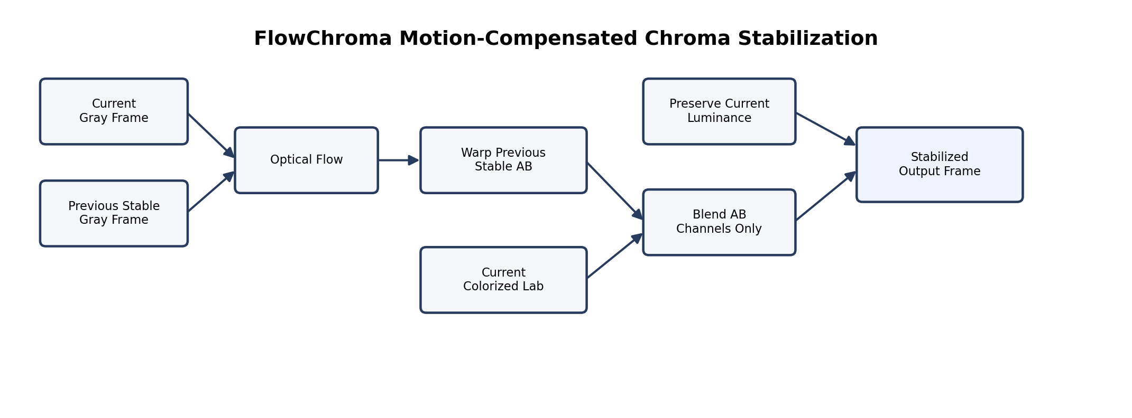
Figure 5. FlowChroma motion-compensated chroma stabilization concept.
The key design choice is that only chroma is blended. Luminance stays current-frame sharp.

10.4 Why flow_chroma Is Better
Compared with naive RGB averaging, flow_chroma:
- respects motion better,
- preserves detail more effectively,
- and reduces flicker without the same degree of smear.
Its cost is additional computation, but the cost is justified when temporal consistency matters.

10.5 What Smoothing Cannot Fix
This limitation is essential:
Temporal smoothing does not fix semantically wrong colors.
If the base model paints:
- sand blue,
- faces gray,
- or buildings with the wrong hue,
the smoother can only stabilize that wrong answer over time.
Therefore:
- base inference quality and
- temporal stability
must be treated as separate technical problems.

11. Experimental Methodology

11.1 Why the Benchmark Changed
The project intentionally stopped relying on noir-heavy clips as the main quality benchmark. Those clips are artistically biased and are not fair universal tests for ordinary grayscale colorization. To make the evaluation more honest, the second term created a fresh-source benchmark suite.

11.2 Benchmark Scene Categories
The benchmark suite includes four scene categories:
- nature
- urban
- people
- animation
Each category was selected because it exposes different strengths and weaknesses:
- nature tests outdoor priors,
- urban tests large surfaces and warm reflections,
- people tests skin, hair, and clothing,
- animation tests stylized non-photoreal content.

11.3 Benchmark Procedure
Each benchmark clip was:
- selected in color,
- shortened to a controlled sample,
- converted to grayscale with FFmpeg,
- colorized by all four backends,
- passed through flow_chroma with strong settings,
- and summarized in contact-sheet and JSON form.
This is important because the benchmark does not use a separate “special” script unrelated to the application. It measures the same system architecture used in ordinary project operation.

11.4 Runtime Measurement Strategy
Runtime was measured separately for:
- raw colorization,
- and the flow_chroma post-pass.
This distinction is necessary because smoothing cost should not be confused with model inference cost.

12. Results and Comparative Analysis

12.1 Runtime Summary
Table 9 summarizes average runtime over the fresh-source benchmark scenes.
Model | Average raw colorization (s) | Average flow_chroma pass (s)
ChromaNet v3 | 5.658 | 3.571
InstColorization | 4.245 | 2.866
Zhang SIGGRAPH17 | 23.485 | 2.961
Enhanced Zhang | 5.763 | 2.781
These values reveal a clear pattern:
- Zhang SIGGRAPH17 is the slowest raw backend by a large margin.
- Enhanced Zhang is close to ChromaNet and InstColorization in practical speed.
- flow_chroma adds cost, but far less than the raw SIGGRAPH17 inference burden.

12.2 Scene-Wise Best Current Backend
Table 10 summarizes the current best backend by scene class in the benchmark.
Scene | Best current backend | Observed reason
Nature short | Enhanced Zhang | Best sky and branch warmth recovery
Urban short | ChromaNet v3 | Least bad on warm sunset reflection in this sample
People short | Enhanced Zhang | Best skin, hair, shirt, and indoor object recovery
Animation short | Enhanced Zhang | Best stylized hint recovery, though still incomplete

12.3 Nature Results
Nature is currently the easiest benchmark category because the models’ priors align relatively well with outdoor landscapes. Enhanced Zhang performs best by recovering:
- blue sky,
- outdoor warmth,
- and more believable vegetation-related color hints.
ChromaNet remains too conservative, and InstColorization stays weak in this category.
Benchmark artifact path:
- reports/benchmark_suite_20260622_fresh_sources/nature_short_contact_sheet.jpg

12.4 Urban Results
Urban scenes remain one of the hardest current categories. Reflective surfaces, large structures, and sunset warmth expose weaknesses in all models. In this specific sample:
- ChromaNet is the least bad,
- but none of the backends is convincingly strong.
This is useful because it prevents the report from overclaiming success on all scene types.
Benchmark artifact path:
- reports/benchmark_suite_20260622_fresh_sources/urban_short_contact_sheet.jpg

12.5 People Results
The people clip is one of the most important benchmark assets because it directly exposes the gap between:
- general-scene priors,
- and person-aware color recovery.
Enhanced Zhang currently gives the best skin, hair, and clothing recovery. SIGGRAPH17 is close behind. ChromaNet and InstColorization are too gray in the current repository state.
This result strongly supports the documented recommendation to add people-focused training data as a supplement rather than blindly adding more epochs on the same distribution.
Benchmark artifact path:
- reports/benchmark_suite_20260622_fresh_sources/people_short_contact_sheet.jpg

12.6 Animation Results
Animation reveals realism bias in all current models. The models were trained mainly on natural-image priors, so stylized content remains difficult. Enhanced Zhang still performs best in this category, but even it remains incomplete.
This is academically useful because it demonstrates a failure class that is not explained simply by “too few epochs.” It is also a distribution and domain problem.
Benchmark artifact path:
- reports/benchmark_suite_20260622_fresh_sources/animation_short_contact_sheet.jpg

12.7 Practical Interpretation
The benchmark leads to a simple present-day recommendation:
- use Enhanced Zhang for general showcase clips,
- use ChromaNet when explaining the custom model and training path,
- keep SIGGRAPH17 as a reference baseline,
- and treat InstColorization as an alternative experimental branch rather than the safest final default.

13. Limitations, Risks, and Failure Analysis

13.1 Summary Table
Table 11 summarizes the most important present-day risks.
Risk or limitation | Impact | Practical mitigation
Weak face and skin recovery in ChromaNet | Poor person-centered demos | Use Enhanced Zhang for final demos; improve people-aware training later
Noir or heavily stylized grayscale inputs | Implausible or unstable color casts | Avoid using them as primary benchmark evidence
Warm sunset / reflective urban scenes | Flat or incorrect reconstruction | Treat as known high-risk scene class
Smoothing cannot fix wrong base hues | Stable but wrong color | Improve base inference or change backend
Disk-heavy pipeline | I/O overhead and spiky utilization | Future queue-based in-memory pipeline

13.2 Faces and Clothing
The most persistent weakness in the custom path is person-centered colorization. When the model is uncertain, it often retreats toward:
- gray,
- beige,
- or weakly tinted output.
This is not a smoothing failure or an FFmpeg issue. It is a training-distribution issue combined with current checkpoint maturity.

13.3 Authentic Noir and Stylized Black-and-White Sources
Old noir-style footage is difficult because the input is not a neutral grayscale version of a normal scene. Contrast and exposure are often manipulated artistically. Therefore the model sees a domain-shifted input and may respond with:
- warm false color,
- flat color,
- or implausible hue assumptions.
This is exactly why the project moved away from noir-heavy clips as the main benchmark basis.

13.4 Urban Warm Reflection Scenes
The benchmark’s urban sample shows that even when the system is operational, some scene classes remain weak. Large neutral surfaces with warm reflected light are still hard for all current backends. This failure category is important because it proves the project must still make demo-safe scene choices rather than assuming universal robustness.

13.5 Why More Smoothing Is Not the Main Fix
It is tempting to assume that stronger smoothing will solve the remaining quality issues. That is incorrect. Smoothing can:
- reduce flicker,
- and stabilize neighboring frames,
but it cannot:
- invent missing semantic understanding,
- recover correct skin color if the base model lacks it,
- or fully fix scene-specific hue mistakes.
Therefore, future improvement must continue to separate:
- temporal consistency work,
- from semantic base-model improvement.

14. Conclusion and Future Work

14.1 Final Technical Assessment
The second term produced a significantly more mature system than the first-term baseline. VideoRasterization now provides:
- a full end-to-end video processing pipeline,
- four integrated AI backends,
- a custom trainable model,
- organized checkpoint handling,
- duplicate-frame acceleration,
- motion-aware temporal smoothing,
- and benchmark artifacts that support evidence-based discussion.
This means the project can now be defended as a real technical framework rather than a set of disconnected experiments.

14.2 Future Work Priorities
Table 12 summarizes the most important future directions.
Priority | Future-work item | Expected benefit
High | Queue-based in-memory pipeline | Less disk I/O and better stage overlap
High | People-aware dataset supplementation | Better face, skin, and clothing recovery
Medium | Integrate stronger teammate models into same harness | Broader comparison and safer demos
Medium | Expand fixed-scene benchmark suite | More reliable longitudinal model comparison
Medium | Refine temporal controls and history tuning | Better consistency on moderate-motion scenes

14.3 Queue-Based In-Memory Pipeline Direction
One of the most important future engineering plans is to move away from the current disk-heavy stage separation and toward a bounded queue architecture. The idea is not to remove modularity, but to preserve modularity while reducing unnecessary disk I/O and stage starvation.
The intended future design would:
- keep extraction, model inference, smoothing, and reconstruction as separate conceptual modules,
- but allow them to communicate through in-memory queues,
- with bounded capacity and pause/resume logic between producers and consumers.
This should improve utilization and reduce the spiky “work / wait / work / wait” behavior seen in the current disk-based flow.

14.4 Dataset and Model Improvement Direction
The benchmark evidence strongly suggests that the most impactful semantic improvement for ChromaNet would come from better people-aware dataset balancing. More blind training on the same general distribution will likely improve some categories only marginally. If the target weakness is faces and clothing, the data itself must be adjusted.
The project should therefore:
- keep COCO as the main semantic backbone,
- keep DIV2K as a detail helper,
- and add people-focused data as a weighted supplement.

14.5 Final Demo Recommendation
For a final presentation or user-facing demo:
- Enhanced Zhang is the safest general-purpose backend,
- ChromaNet should be emphasized when explaining custom training and architecture,
- and difficult scene classes should be chosen carefully.
This is not a compromise in the weak sense. It is a disciplined engineering decision that separates:
- the strongest current practical result,
- from the most academically important custom development path.

15. Source Alignment With Latest Project State
This final report was aligned with the latest pushed repository state available during preparation. The most important current implementation facts reflected in the report are:
- the main CLI runs the sequence of input selection, frame extraction, model selection, CUDA check, colorization, temporal smoothing, report generation, and video reconstruction;
- the README documents current features including FFmpeg extraction, four AI backends, duplicate-frame skipping, FlowChroma smoothing, preview reporting, and final video rebuild with audio;
- video_pipeline/colorization.py performs global exact duplicate-frame reduction before AI inference and restores skipped frames after colorization;
- tools/TemporalSmoothing/smoother.py implements both legacy_average and flow_chroma modes;
- the current ChromaNet config targets 512x512 fine-tuning with batch size 3, mixed precision, BF16, and a conservative learning rate.
This section is included to make clear that the report is not only a cleaned version of the Codex-generated Markdown file. It was also checked against the current repository behavior and updated where the repository had moved forward.

16. Project Run Outputs

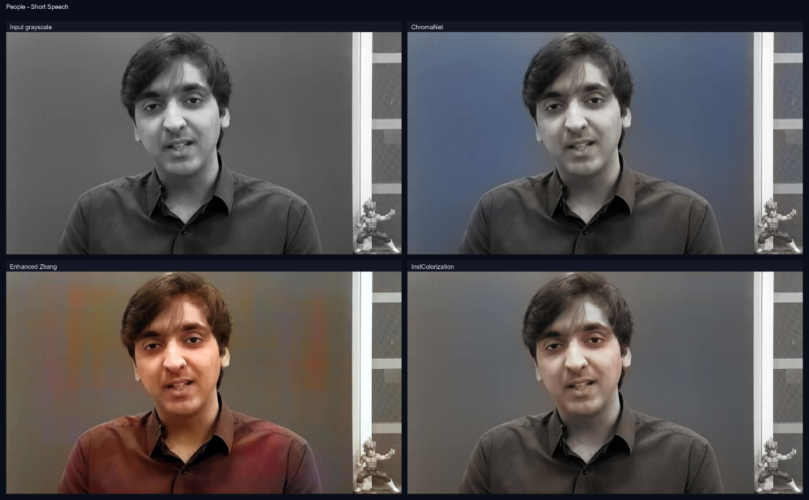
Figure 6. Project run contact sheets comparing grayscale input with ChromaNet, Enhanced Zhang, and InstColorization outputs.

17. References
- R. Zhang, P. Isola, and A. A. Efros, “Colorful Image Colorization,” in European Conference on Computer Vision, 2016.
- T.-Y. Lin et al., “Microsoft COCO: Common Objects in Context,” in European Conference on Computer Vision, 2014.
- E. Agustsson and R. Timofte, “NTIRE 2017 Challenge on Single Image Super-Resolution: Dataset and Study,” in CVPR Workshops, 2017.
- G. Farneback, “Two-Frame Motion Estimation Based on Polynomial Expansion,” in Scandinavian Conference on Image Analysis, 2003.
- Local repository source files:
  - main.py
  - video_pipeline/colorization.py
  - video_pipeline/frame_deduplication.py
  - tools/TemporalSmoothing/smoother.py
  - tools/model_selector.py
- Local ChromaNet source files:
  - ChromaNet_v3_complete/chromanet_v3/model/chromaNet.py
  - ChromaNet_v3_complete/chromanet_v3/training/trainer.py
  - ChromaNet_v3_complete/chromanet_v3/configs/default.yaml
- Benchmark evidence:
  - reports/benchmark_suite_20260622_fresh_sources/README_BENCHMARK.md
  - reports/benchmark_suite_20260622_fresh_sources/benchmark_results.json
- Dataset note:
  - docs/training_datasets.md

Appendix A. Benchmark Artifact Notes

A.1 Nature Benchmark
The nature clip demonstrates that outdoor palettes are the most mature category in the current repository. This should not be interpreted as proof of universal quality, but it does provide a strong example of how nature priors are currently easier for the models than close human identity cues.

A.2 Urban Benchmark
The urban clip is a valuable “hard scene” because it resists flattering interpretation. It contains lighting behavior and structural surfaces that the current models do not reconstruct well. It is therefore a stronger honesty check than an easy scenic clip.

A.3 People Benchmark
The people clip is the strongest evidence for the dataset-bias argument. It makes visible the exact gap between:
- general semantic coverage,
- and person-centered color recovery.

A.4 Animation Benchmark
The animation clip exists to prevent the project from overclaiming photoreal robustness as universal robustness. Stylized content remains weak in all current models, though Enhanced Zhang performs best among them.

Appendix B. Repository Walkthrough
Table 13 maps key repository files to their technical role.
Path | Purpose
main.py | Interactive CLI orchestration of the whole pipeline
video_pipeline/colorization.py | Backend orchestration, duplicate-frame handling, and output restoration
video_pipeline/frame_deduplication.py | Exact duplicate detection and expansion logic
video_pipeline/smoothing.py | Hook between colorized output and temporal smoother
tools/TemporalSmoothing/smoother.py | legacy_average and flow_chroma implementations
tools/model_selector.py | Backend aliasing, discovery, and dispatch
ChromaNet_v3_complete/chromanet_v3/model/chromaNet.py | Custom ChromaNet v3 architecture
ChromaNet_v3_complete/chromanet_v3/training/trainer.py | Training loop, checkpoint logic, preview generation, validation
docs/training_datasets.md | Dataset rationale and tradeoffs
reports/benchmark_suite_20260622_fresh_sources | Benchmark outputs, contact sheets, and JSON summaries

B.1 main.py
main.py is intentionally compact. It proves that the project’s top-level workflow is readable and does not require over-engineered orchestration just to understand the stage order.

B.2 video_pipeline/colorization.py
This module is one of the most important in the repository. It is where:
- duplicate-frame logic,
- backend selection,
- and worker-parameter tuning
meet in one place.

B.3 video_pipeline/frame_deduplication.py
This file implements the exact-match duplicate-frame optimization that works globally across backends. It is small, but strategically important.

B.4 tools/TemporalSmoothing/smoother.py
This module is effectively a subsystem. It contains:
- import guards,
- legacy_average,
- flow_chroma,
- grayscale luminance handling,
- optical-flow warping,
- and write-back logic.

B.5 chromaNet.py and trainer.py
These two files form the strongest academic core of the custom-model path:
- chromaNet.py explains architecture,
- trainer.py explains actual learning behavior.

Appendix C. Operational Commands
Table 14 records representative operational commands and actions.
Task | Representative command or action | Notes
Train ChromaNet | python train.py --config configs/default.yaml --resume latest --epochs N | N is the final target epoch, not “extra epochs”
Run main pipeline | python main.py | Interactive video path, backend, and smoothing selection
Train InstColorization | scripts/train_instcolorization_full_256.ps1 | Separate backend-specific training path
Smoke test a backend | Run a short frame-wise test through the shared pipeline | Preferred over full video when comparing one scene quickly
Review benchmark evidence | Inspect reports/benchmark_suite_20260622_fresh_sources | Contact sheets and JSON summaries are stored there

C.1 Practical Command Notes
- ChromaNet training is epoch-target based, not “add N more epochs” based.
- The main CLI doubles as both demo entrypoint and experimental harness.
- InstColorization keeps its own training route but still feeds the same benchmark logic.
- Benchmark folders should be treated as evidence, not only as scratch output.

Appendix D. Checkpoint and Dataset Notes

D.1 Unified Checkpoint Organization
The second term reorganized checkpoint storage so that model-family weights live in one predictable root with subfolders. This improves:
- human understanding,
- teammate handoff,
- smoke-test repeatability,
- and documentation consistency.
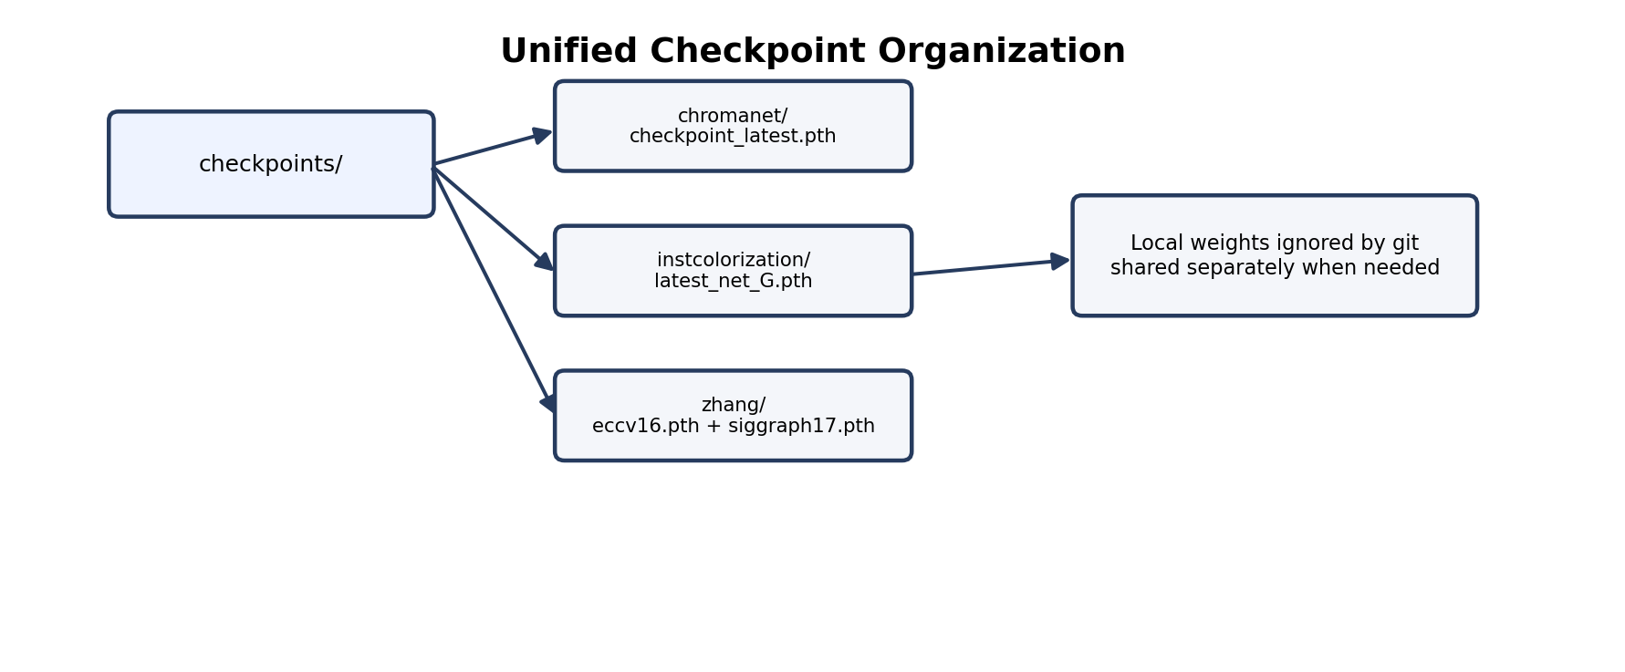
Figure A1. Unified local checkpoint organization used by the project.

D.2 ChromaNet Checkpoints
ChromaNet checkpoints are the most academically meaningful because they contain:
- custom model state,
- optimizer and scheduler state,
- AMP scaler state,
- best PSNR,
- history,
- and configuration data.

D.3 InstColorization and Zhang Checkpoints
InstColorization and Zhang-family weights remain important because they provide:
- practical alternative inference paths,
- stable baselines,
- and comparison anchors against which ChromaNet can be discussed.

D.4 Dataset Note Importance
The repository dataset note is important because it codifies a real lesson learned through experiments:
- COCO is a good general backbone,
- DIV2K helps detail,
- people-focused data is the missing lever for a major current weakness.

Appendix E. Glossary

Backend
A selectable AI colorization model path integrated into the shared repository pipeline.

Chroma
Color information separated from luminance, represented here mainly through Lab a and b channels.

Graphical User Interface (GUI)
The desktop application named ChromaStudio that bridges the HTML/CSS/JavaScript frontend with the VideoRasterization Python backend via pywebview. It provides a five-state workflow interface covering file loading, pipeline configuration, comparison preview, live processing monitoring, and result review.

Contact Sheet
A single image containing comparable model outputs side by side.

Duplicate-Frame Middleman
The exact-match stage that removes redundant consecutive frames before inference and restores them afterward.

flow_chroma
The motion-compensated temporal smoothing method that warps previous stabilized chroma into the current frame and preserves current luminance.

Full-Resolution Luminance Preservation
The second-term fix that combines original-resolution grayscale luminance with upscaled predicted chroma instead of enlarging a low-resolution RGB result.

Semantic Color Memory
A learned ChromaNet module that augments the bottleneck with reusable color priors.

Scene Conditioner
A ChromaNet module that injects scene-class information into the bottleneck representation.

Smoke Test
A short targeted test used to verify that a backend works correctly before longer experiments.

Temporal Consistency
The property that adjacent frames preserve stable color over time rather than flickering or drifting.

Repository Link:

CyberBonk/VideoRasterization: Converting Greyscale vids into Colorful Life with AI

