Internship Report
Task 2: Introduction to Web Application Security
Cyber Security Intern | Redynox | Mudasir | GitHub: CyberBros435
1. Introduction
This report covers Task 2 of my Redynox Cyber Security internship. The goal was to learn how common web vulnerabilities work by testing a live vulnerable web application through a proxy. I used Altoro Mutual (demo.testfire.net), IBM's public demo banking site built for exactly this kind of testing, together with Burp Suite Community Edition as the proxy/scanner. No installation of a new vulnerable app was needed since Altoro Mutual is hosted, and Burp Suite was already available on my Kali Linux VM.
2. Task Overview
2.2 Task 2: Introduction to Web Application Security
Objective
Scan a web application, identify SQL Injection, Cross-Site Scripting (XSS) and Cross-Site Request Forgery (CSRF), exploit each with basic manual techniques, and recommend mitigations.
Tools and Methods Used
- Target: Altoro Mutual demo bank — http://demo.testfire.net (public, intentionally vulnerable, legal to test)
- Burp Suite Community Edition (proxy, site map, HTTP history) on Kali Linux
- Burp's built-in browser for all testing
- Method: browse through proxy → review site map/history → manually test each vulnerability class → document → mitigate
Steps Taken
Step 1: Setup and reconnaissance
I opened Burp Suite Community Edition with a temporary project and default settings, then used its built-in browser to visit demo.testfire.net. Browsing a few pages populated Burp's Target > Site map, which lists every page and request the application makes.
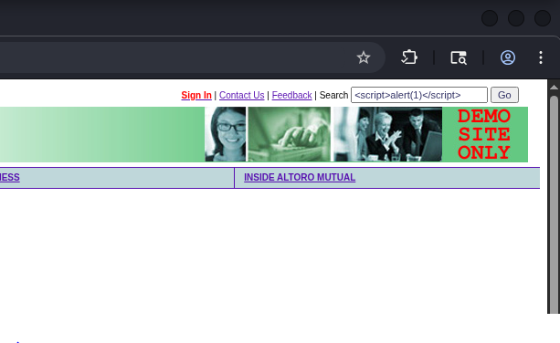
Figure 1: Burp Suite Site map / Target tree for demo.testfire.net
Step 2: SQL Injection
Altoro Mutual's login form passes the username directly into a backend SQL query without sanitising it. On the login page I entered the username admin' -- with any password. The trailing -- comments out the rest of the SQL query, including the password check, so the query effectively becomes "select where username = 'admin'" and logs in without a valid password.
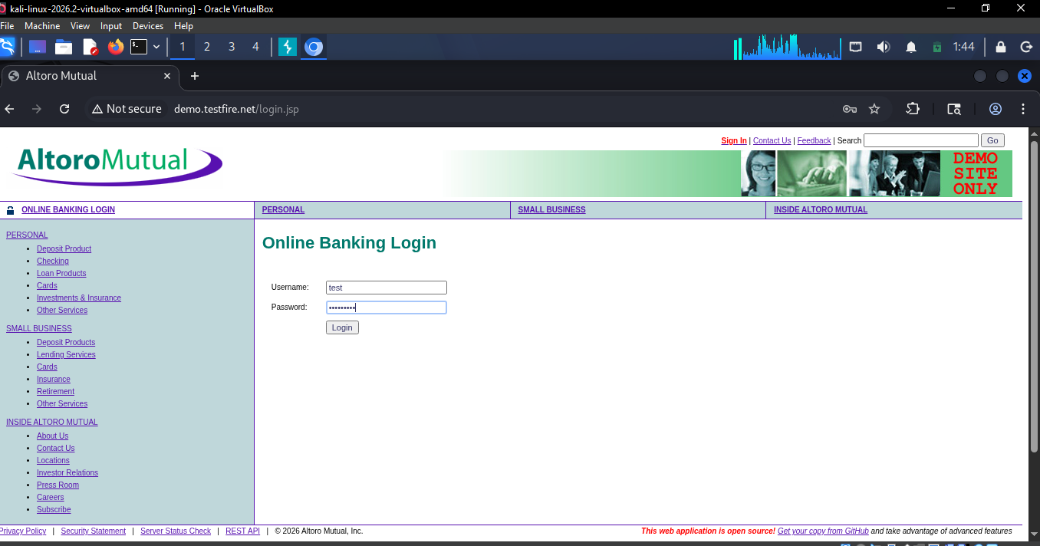
Figure 2: Login form with the SQL injection payload admin' -- entered in the username field
With Burp's proxy running, the login request itself was visible in Proxy > HTTP History, showing the raw POST request carrying the payload to the server.
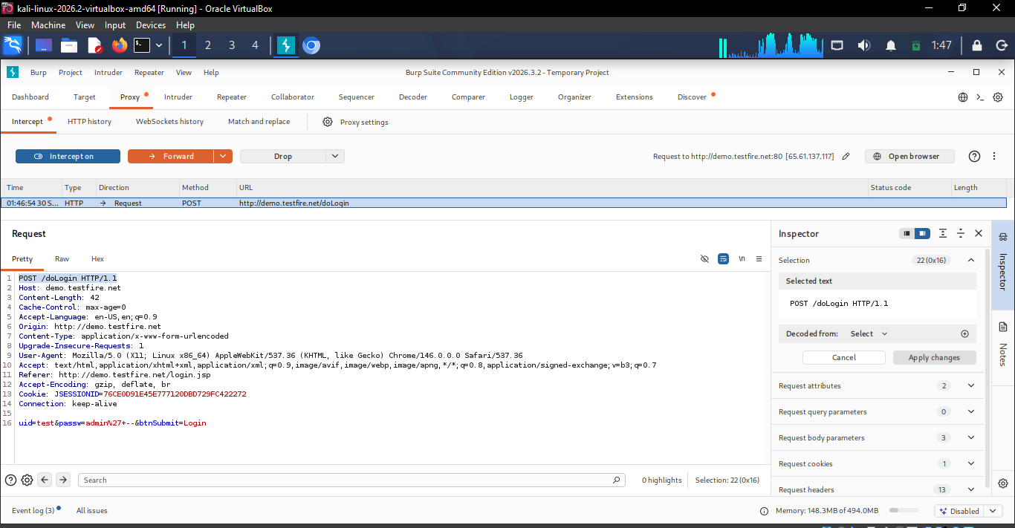
Figure 3: Burp HTTP History showing the intercepted login POST request with the SQLi payload
The result: the application logged me straight in as Admin User with no valid password, confirming the injection worked and returned an authenticated session.
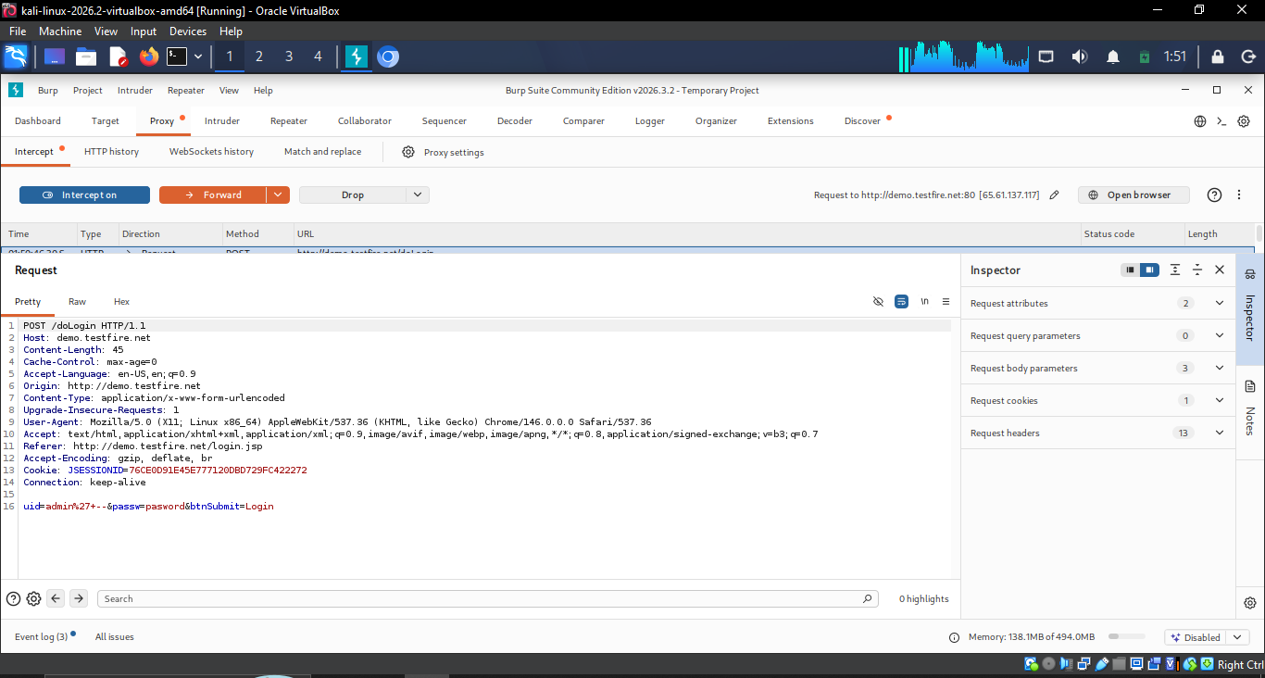
Figure 4: Successful login as Admin User using the SQL injection payload, no real password needed
Step 3: Cross-Site Scripting (XSS)
The site's search feature reflects the search term back into the results page without encoding it. I entered <script>alert(1)</script> into the search box and submitted it.
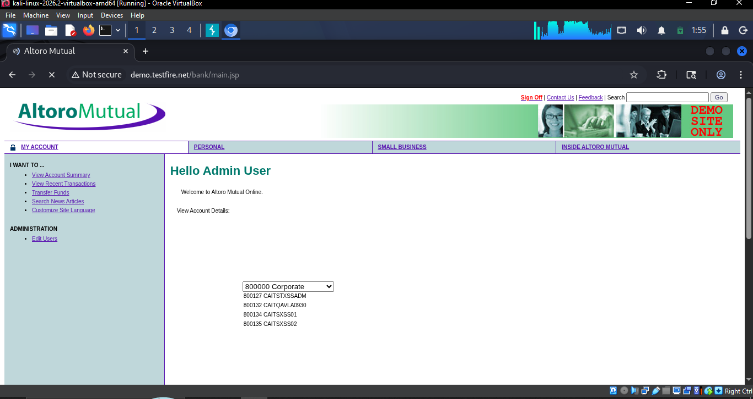
Figure 5: Search box containing the reflected XSS payload <script>alert(1)</script>
The payload executed immediately as JavaScript in the browser, popping up an alert box, which proves the input is rendered as live HTML/JS rather than plain text.
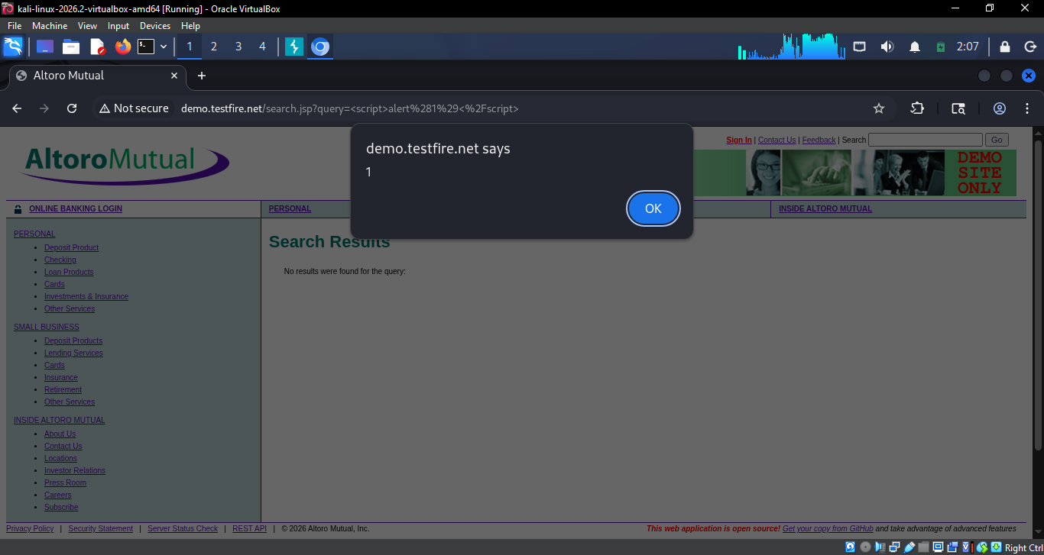
Figure 6: JavaScript alert box firing from the reflected XSS payload
Step 4: Cross-Site Request Forgery (CSRF)
After logging in as Admin, I opened the account administration pages (Add Account, Change Password, Add New User). These forms submit sensitive actions using only the logged-in session cookie, with no hidden anti-CSRF token field anywhere in the form or in the resulting POST request. That means a malicious page could auto-submit an identical form in a victim's browser and the server would accept it, since it cannot tell the request apart from a real one.
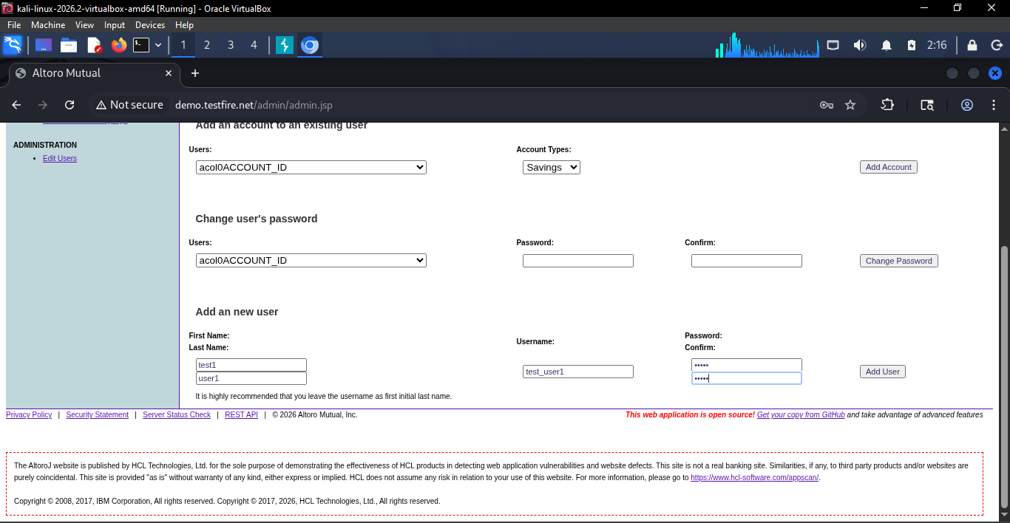
Figure 7: Administration page (add account / change password / add user) with no CSRF token field in any form
Step 5: Mitigations
Vulnerability | Recommended fixes
SQL Injection | Use parameterised queries/prepared statements instead of building SQL from raw input; apply least-privilege DB accounts; never trust client input.
XSS | Encode all output for its context (HTML/attribute/JS); validate input; add a Content-Security-Policy; set cookies HttpOnly and Secure.
CSRF | Add a unique anti-CSRF token to every state-changing form and verify it server-side; set cookies SameSite=Strict/Lax; re-authenticate for sensitive actions.

Challenges Faced and How I Overcame Them
- My first target, testphp.vulnweb.com, would not connect on port 80 from my network (confirmed with curl), so I switched to demo.testfire.net, which worked.
- I have limited storage and could not install ZAP or WebGoat, so I used Burp Suite (already on Kali) against a hosted demo app instead of a local one — same learning outcome with zero extra installs.
Results and Outcomes
I found and exploited one real instance each of SQL Injection, XSS and CSRF on a legal test target, captured the exact request/response evidence in Burp, and matched each finding to a concrete fix. This showed me that these three vulnerability classes are still common in real-feeling applications and that a proxy tool is essential for seeing exactly what the browser is sending.
3. Conclusion
This task taught me how attackers abuse unsanitised input and missing request validation, and how basic secure-coding practices close each gap. It reinforced a repeatable workflow — intercept, test manually, document, recommend a fix — that applies directly to bug bounty and SOC analyst work.
4. Closing Remarks
Thank you to the Redynox team for the task. Confirming that a target site is reachable before starting would save time for future interns with limited setups.

