Internship Report
Task 1: Introduction to Network Security Basics
Cyber Security Intern | Redynox | Mudasir | GitHub: CyberBros435
1. Introduction
During my Cyber Security internship at Redynox I worked through three tasks. This report covers Task 1, where the aim was to understand common network threats and put basic protections in place on a small network. I built a simple lab (my home Tenda router, a Windows host and a Kali Linux VM), hardened it, and then watched its traffic in Wireshark to learn what normal and suspicious activity looks like.
2. Task Overview
2.1 Task 1: Introduction to Network Security Basics
Objective
Learn the main types of network threats, apply basic security measures (firewall, strong credentials, Wi-Fi encryption) and use Wireshark to capture and analyse traffic.
Tools and Methods Used
- Windows Defender Firewall (with Advanced Security)
- Wireshark for packet capture and analysis
- Router admin panel (Tenda) for Wi-Fi and password settings
- Kali Linux VM in VirtualBox as the capture machine
- Method: research first, then hands-on configuration, then capture and analysis
Steps Taken
Step 1: Researching network threats
Threat | How it works | How to defend
Virus | Malicious code attached to a legitimate file; spreads when the infected file is run or shared. | Antivirus, avoid unknown attachments, keep software updated.
Worm | Self-replicating malware that spreads over the network by itself, without user action (e.g. WannaCry via SMB). | Patching, firewall, disabling unused services, segmentation.
Trojan | Malware disguised as useful software; opens a backdoor or steals data once installed. | Download from trusted sources only, application allow-listing, EDR/AV.
Phishing | Fake emails, SMS or sites that trick users into giving credentials or running malware. | User awareness, MFA, email filtering, checking URLs and sender.

Basic security concepts I studied: a firewall filters traffic using rules (allow/deny by port, protocol, direction); encryption (WPA2/WPA3 for Wi-Fi, TLS for web) keeps data unreadable to anyone sniffing the network; and a secure configuration means no default passwords, no unnecessary services and the least access needed.
Step 2: Setting up the network and hardening it
- Lab: home Tenda router, my Windows host (firewall and router settings) and a Kali Linux VirtualBox VM (Wireshark capture on eth0).
- Confirmed Windows Defender Firewall was ON for the Domain, Private (active) and Public network profiles.
- Created a custom rule named port 80 block in Windows Defender Firewall with Advanced Security to block port 80 traffic, and confirmed it is listed and enabled under Outbound Rules.
- Changed the router admin password from the default to a long unique one and changed the default Wi-Fi name/password.
- Set Wi-Fi security to WPA/WPA2-PSK on the Tenda router, renamed the network and set a Wi-Fi password. I also noted that WPA2 or WPA3 only mode is stronger when all devices support it.
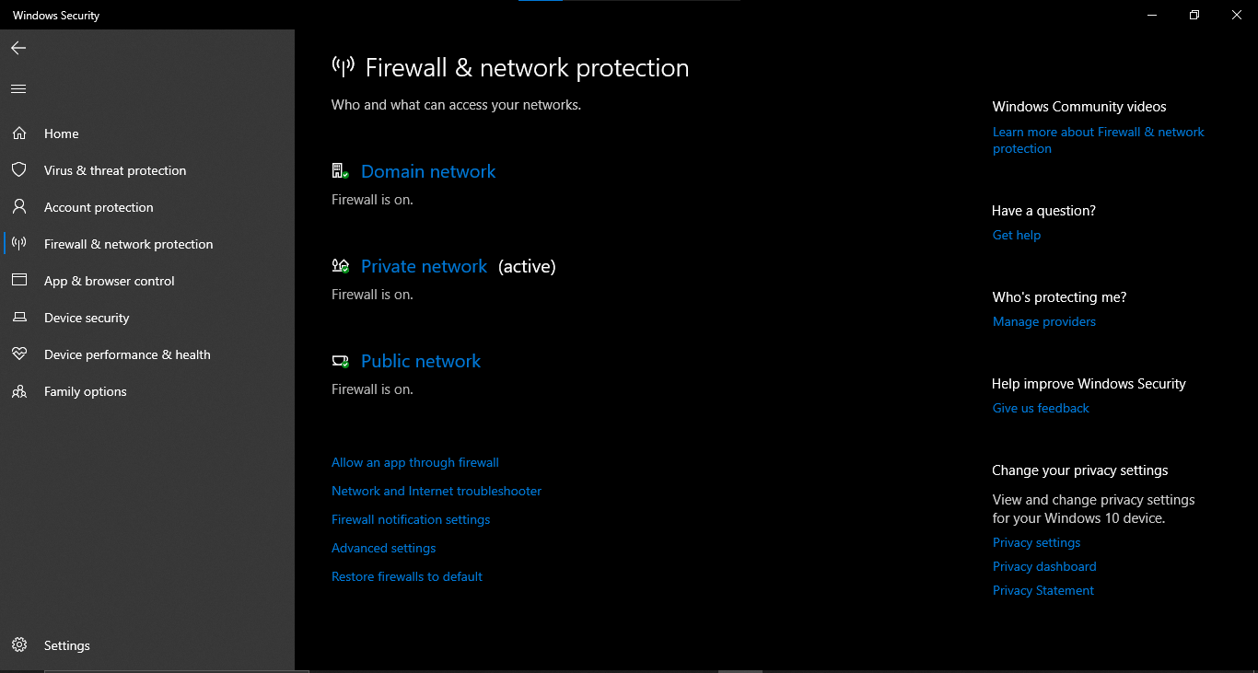
Figure 1: Windows Defender Firewall: Domain, Private and Public profiles ON
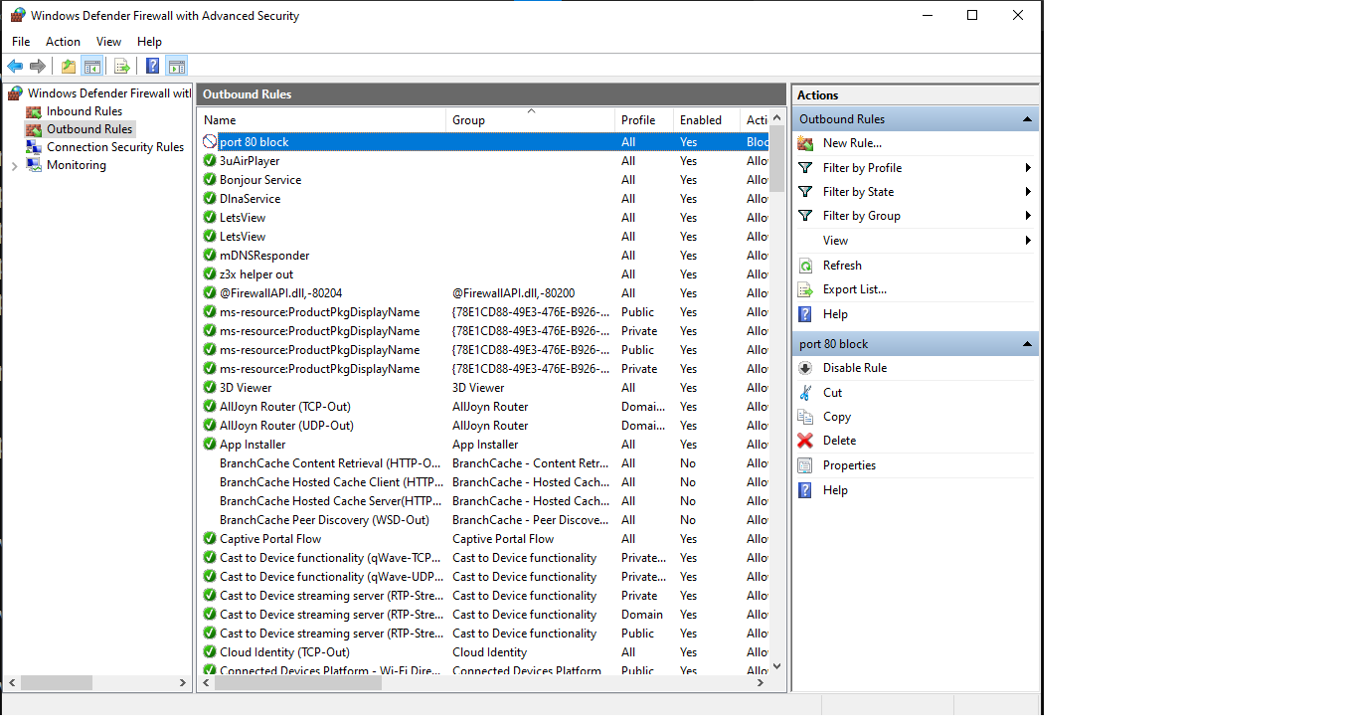
Figure 2: Custom block rule (port 80) in Windows Defender Firewall with Advanced Security
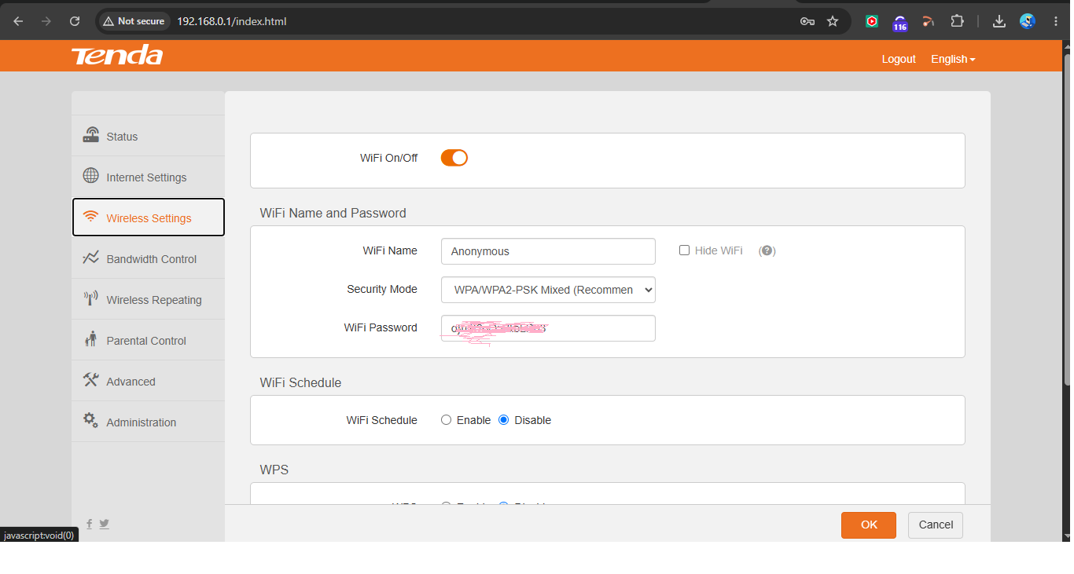
Figure 3: Router Wireless Settings showing WPA/WPA2-PSK security
Step 3: Monitoring traffic with Wireshark
I started a capture on the eth0 interface of my Kali Linux VM while browsing normally, then used display filters to separate protocols:
Filter | What it shows / what I learned
dns | Name lookups (UDP 53). Every site visit starts with a query and a response giving an IP address.
http | Unencrypted web traffic. Requests, headers and content are readable in plain text, which is why HTTPS matters.
tls | Encrypted HTTPS. I could see the handshake and server name but not the content.
tcp.flags.syn==1 && tcp.flags.ack==0 | Connection attempts (first packet of the TCP handshake). Many of these to different ports = possible port scan.
arp | Maps IP to MAC on the local network. Repeated conflicting replies can indicate ARP spoofing.
icmp | Ping traffic. Useful to check reachability; large volumes can indicate scanning or flooding.

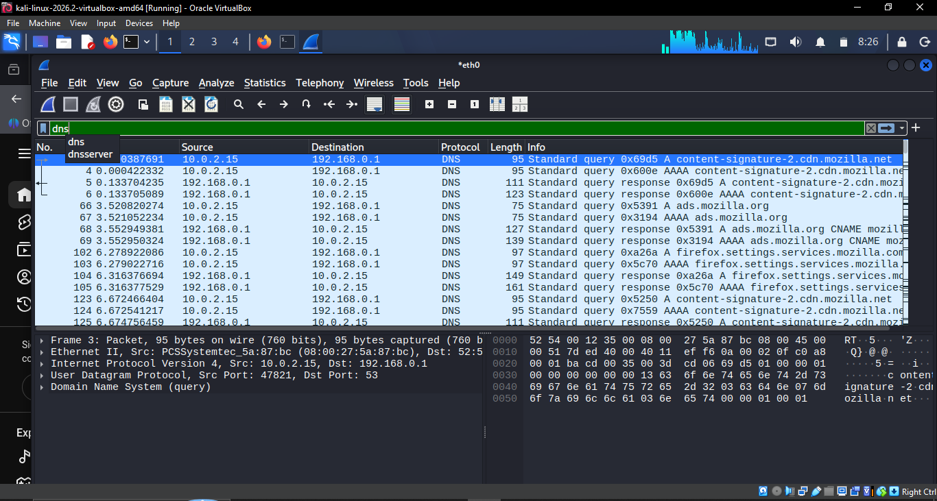
Figure 4: Wireshark filtered by dns: queries and responses
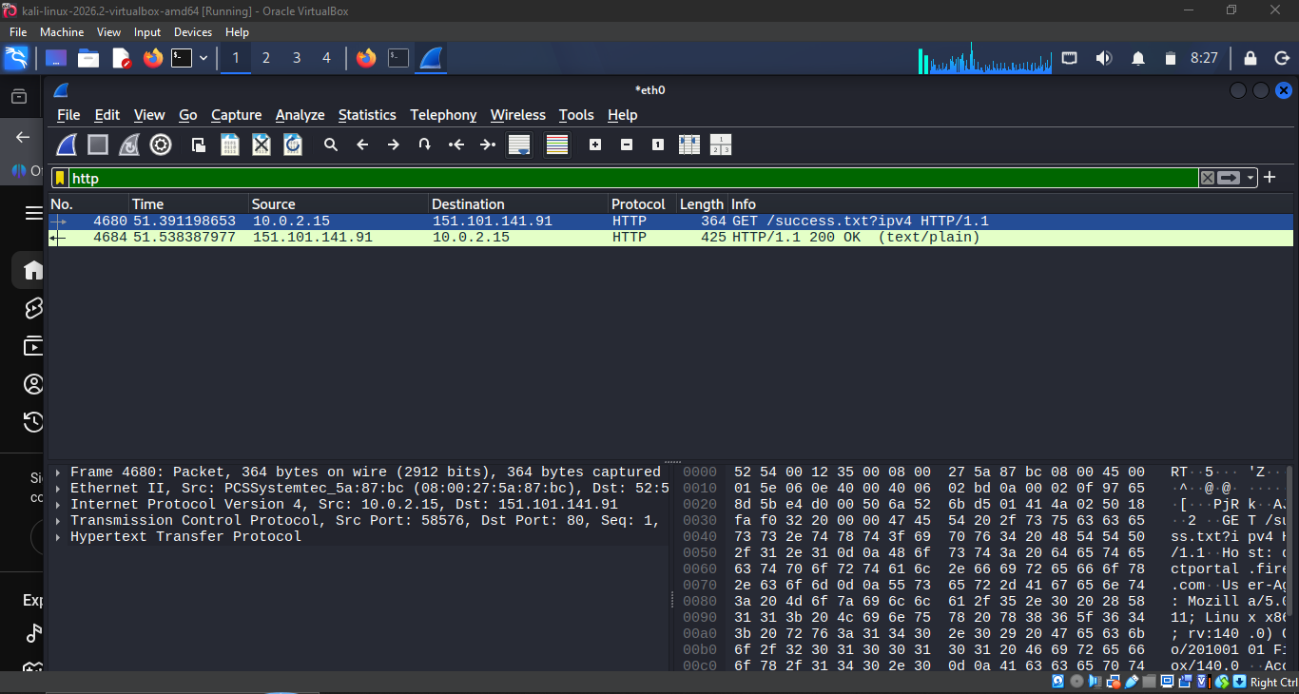
Figure 5: Wireshark filtered by http: readable GET request and 200 OK
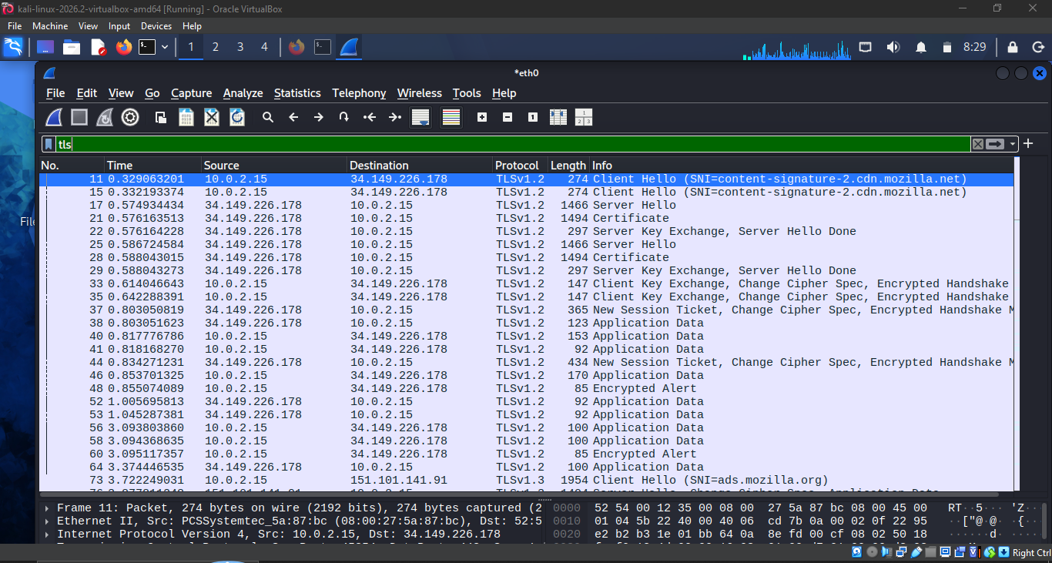
Figure 6: Wireshark filtered by tls: handshake and encrypted data
How I would spot suspicious traffic
- Many SYN packets from one host to many ports in a short time (port scan).
- Very long or random-looking DNS names, or a huge number of DNS queries (possible DNS tunnelling or malware).
- Connections repeating at fixed intervals to an unknown external IP (beaconing).
- Credentials or sensitive data visible in cleartext HTTP, FTP or Telnet.
- Duplicate or conflicting ARP replies for the same IP (ARP spoofing).
- Unexpected outbound traffic on unusual ports, or traffic at odd hours.
The tcp filter shows a normal connection: the three-way handshake (SYN, SYN-ACK, ACK) followed by the TLS Client Hello. A port scan looks different because it produces many SYN packets to many different ports with no follow-up traffic, which is why I filter for SYN without ACK when looking for scans.
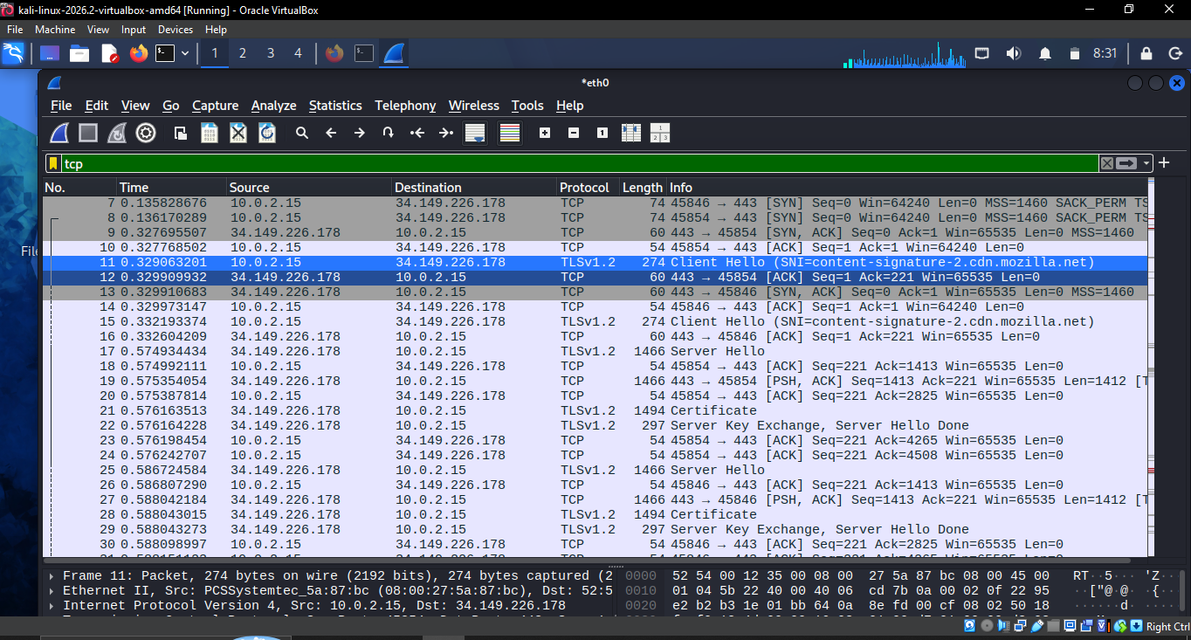
Figure 7: Wireshark filtered by tcp: normal three-way handshake followed by TLS
Challenges Faced and How I Overcame Them
- HTTPS hides content, so there was little to read. I used the plain-HTTP test page and the TLS handshake details to compare readable and encrypted traffic.
- [Add any real problem you hit here, e.g. router UI differences, Npcap install, firewall rule not applying]
Results and Outcomes
The firewall is active on all profiles with a custom block rule, the router uses password-protected WPA/WPA2 encryption, and I could identify DNS, HTTP, TLS, ARP and ICMP traffic in Wireshark and explain what each means. These measures protect the network by limiting who can connect, encrypting data over the air, and shrinking the attack surface.
Reflection: Best Practices for Larger Networks
In a larger network I would add network segmentation (VLANs) so a compromised device cannot reach everything, an IDS/IPS, centralised logging in a SIEM, VPN for remote access, multi-factor authentication, regular patching and vulnerability scans, least-privilege access, and regular backups.
To educate others, I would explain it in everyday terms: a router password is the key to the front door, so keep it unique; update your devices like you lock your windows; and if a message creates urgency or asks for a password, stop and verify before clicking. Short demos, like showing readable HTTP traffic next to encrypted HTTPS, make the risk real for non-technical people.
3. Conclusion
This task gave me practical experience with the basics every network defender needs: understanding threats, configuring simple defences and reading real traffic. Seeing packets myself made concepts like handshakes, DNS and encryption much clearer, and it is a solid foundation for SOC analyst work.
4. Closing Remarks
Thank you to the Redynox team for the structured task. A short reference list of sample captures would help future interns.

