DAILY FINDINGS REPORT
Practical 1 — Basic ICMP Capture (Ping)
Cybersecurity Tool Of The Week
Date | 20 August 2026
Analyst | Emmanuel Aidoo
Practical Note | First Practical of the week
Objective / Scope | Capture and read a live ICMP echo request/reply exchange with tcpdump, as a baseline follow-up to the DNS/ICMP incident case study.
Tools Used | tcpdump, ping
Environment | Ubuntu (lab host), interface eth0

1. Objective
Capture and correctly interpret a live ICMP echo request/reply exchange using tcpdump, in order to build baseline packet-reading skills before tackling more complex protocol failures. Specifically: confirm that request and reply packets can be correctly paired using their id and seq fields, and establish what a clean, error-free ICMP exchange looks like at the packet level.

2. Commands / Steps Taken
Two terminals were used: one running the tcpdump capture, the other generating ICMP traffic with ping.

Terminal 1 — Capture
sudo tcpupdump -i eth0 icmp # typo, corrected below
sudo tcpdump -i eth0 icmp
The first attempt had a typo (“tcpupdump”), caught immediately by the shell’s “command not found” error and corrected on the next line — kept in the record as an honest example of real terminal work.

Terminal 2 — Generating traffic
ping -c 10 8.8.8.8
10 echo requests sent to Google's public DNS resolver (8.8.8.8), chosen purely as a reliable, always-on ping target.

3. Evidence
Figure | File / Description | What It Shows
Fig. 1 | icmp-ping-capture-fictionalized.png | Side-by-side terminal capture: tcpdump ICMP output (left) and ping session (right). Hostname and local IP fictionalized.
Figure 1 — Fictionalized terminal capture
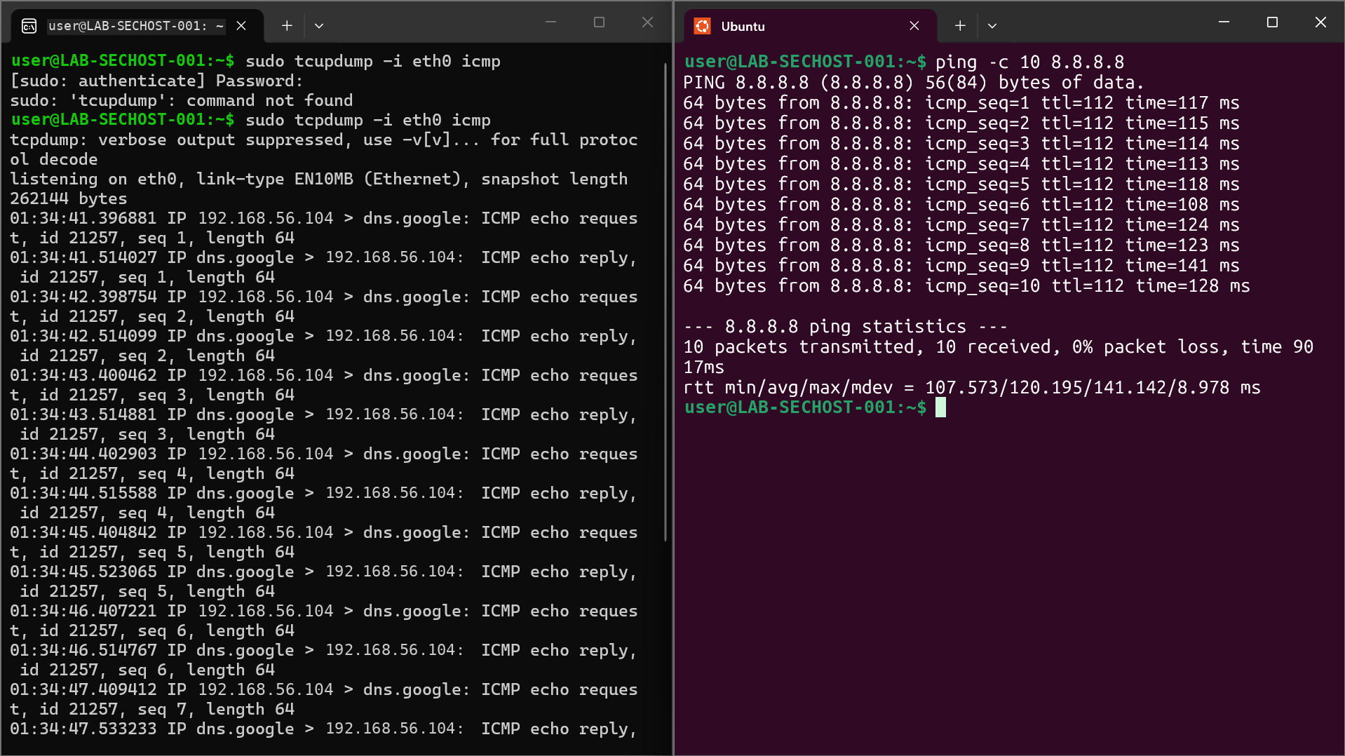

4. Findings / Analysis
Each ICMP echo request line in the tcpdump capture has a matching echo reply roughly 100–140 ms later — consistent with the round-trip times ping itself reported. The two tools describe the same underlying exchange from two different vantage points: ping shows summary statistics, tcpdump shows the raw packets underneath.

Key Observations
- Source: the lab host, sending each echo request. Destination: dns.google (8.8.8.8), used purely as a reliable ping target, not itself under investigation.
- id 21257 stayed constant across all 10 packets, identifying every ping in this run as belonging to the same ping process/session.
- seq 1 through seq 10 incremented by exactly 1 each packet, confirming every request received a matching reply, in order, with none dropped or out of sequence.
- Result: 10/10 packets transmitted and received, 0% packet loss — a clean, healthy ICMP exchange with no errors, retries, or unreachable messages.

5. Conclusion
The capture confirms a fully healthy ICMP path between the lab host and 8.8.8.8: every request was answered, in sequence, within a consistent latency range (rtt min/avg/max/mdev = 107.573/120.195/141.142/8.978 ms). This session's primary value is as a baseline — a reference point for what normal, error-free ICMP traffic looks like in tcpdump.
- Verified that tcpdump's packet-level view and ping's own summary statistics describe identical underlying traffic, useful for cross-checking evidence from two tools in a report.

