CYBERSECURITY TOOLS · WEEKLY LEARNING TRACK
Nmap Reference Documentation
Module 3 — Target Specification & Host Discovery

Prepared by Emmanuel Aidoo
Kali Linux · Nmap 7.98
September 14, 2026

Contents
1 Single IP Address Scan 3
2 Multiple Host Scanning 3
3 CIDR Range Scan 4
4 Verbose Scan & Timing Behaviour 5
5 Key Takeaways 6

This module covers scanning single targets, multiple targets, and CIDR-notation ranges, plus a look at Nmap's scan phases and internal timing/retransmission behaviour on a real-world host.

1 Single IP Address Scan
A scan against one target IP with default Nmap settings (SYN scan, top 1000 ports).
● ● ●
$ nmap 173.230.138.70
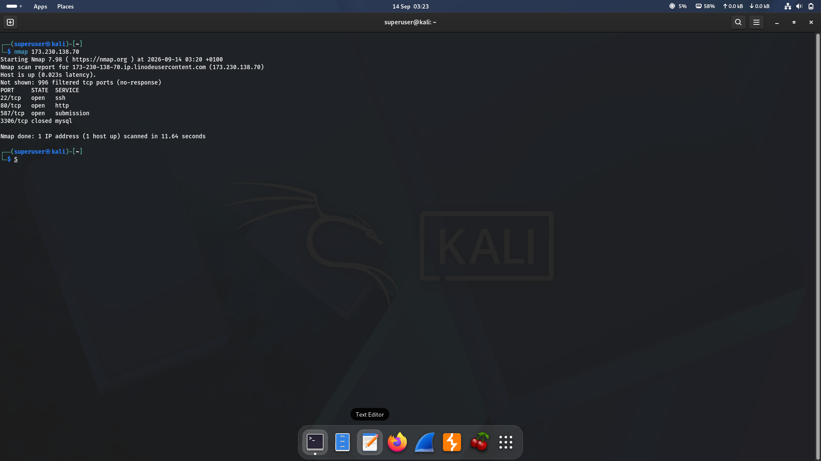
Figure 1 · Default scan of a single host (173.230.138.70)
Result summary
Port | State | Service
22/tcp | open | ssh
80/tcp | open | http
587/tcp | open | submission
3306/tcp | closed | mysql

Observation
996 of the 1000 scanned ports were filtered (no response). The host resolved to 173-230-138-70.ip.linodeuscontent.com, confirming it's a Linode-hosted server. Total scan time: 11.64 seconds.

2 Multiple Host Scanning
Nmap accepts more than one target in a single invocation — just separate them with spaces. Each target is scanned independently and reported in its own block.
● ● ●
$ nmap 8.8.8.8 173.230.138.70
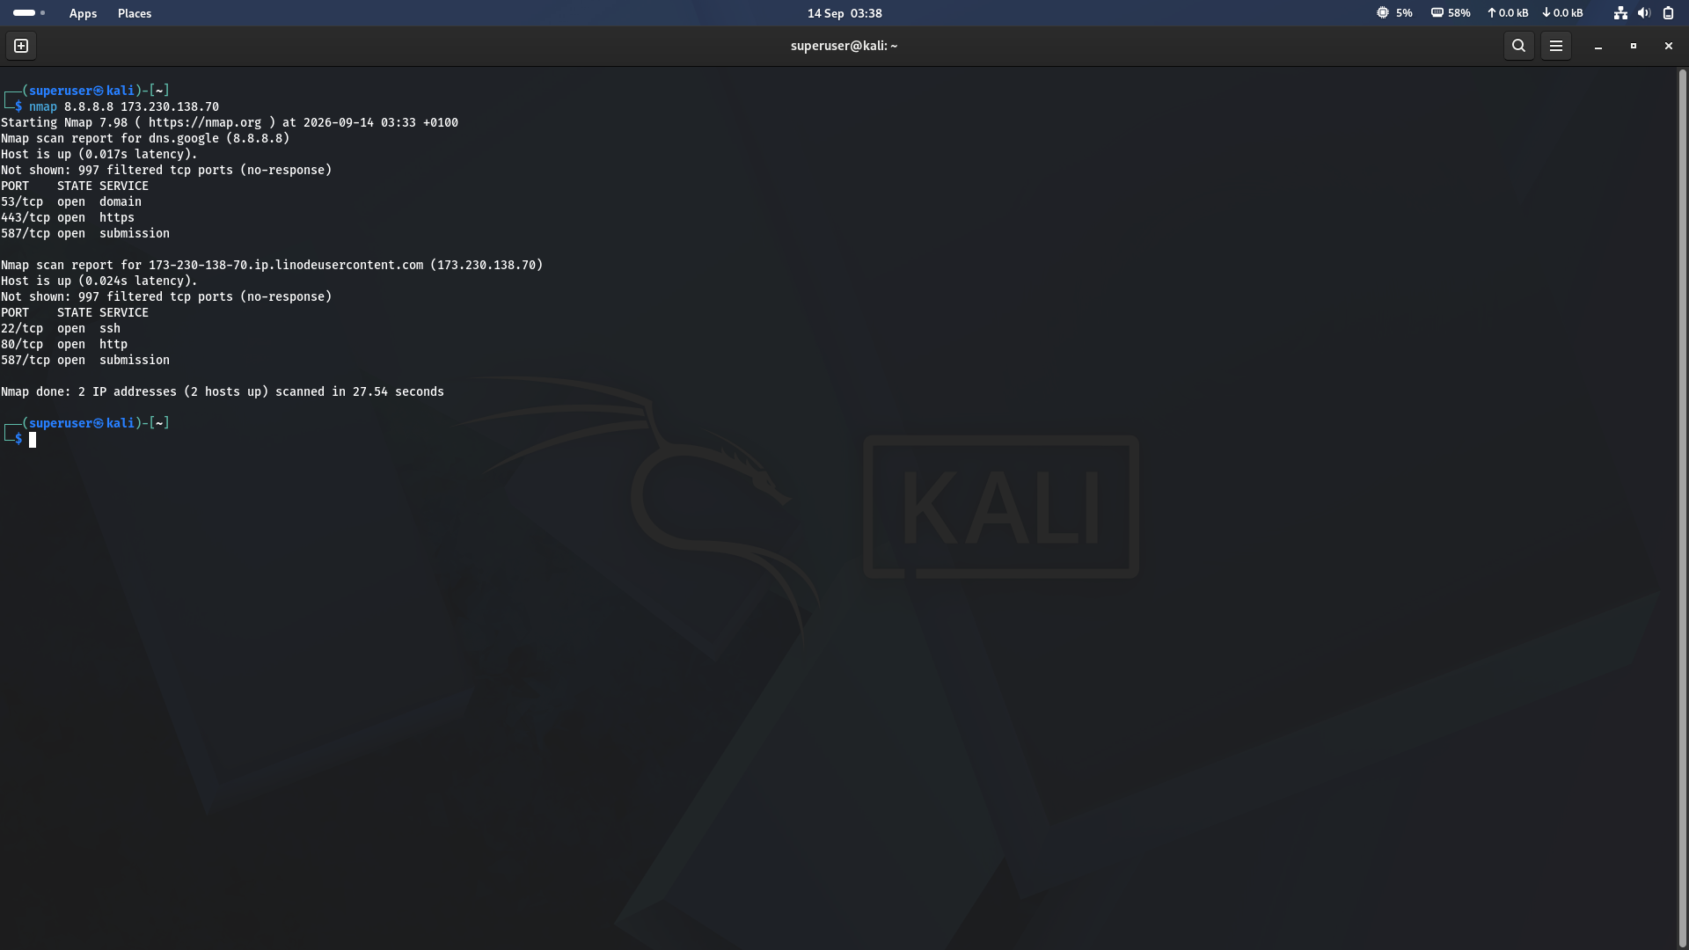
Figure 2 · Scanning two unrelated hosts in one command
Result summary
Host | Open Ports | Notes
8.8.8.8  (dns.google) | 53, 443, 587 | Google public DNS resolver
173.230.138.70 | 22, 80, 587 | Same Linode host as Section 1

Observation
Nmap ran the two scans back-to-back and reported “2 IP addresses (2 hosts up) scanned in 27.54 seconds” — roughly double the time of the single-host scan, since each target still gets its own full port probe.

3 CIDR Range Scan
Appending a CIDR suffix (e.g. /24) tells Nmap to expand the target into every address in that subnet and scan each one that responds. This is the fastest way to sweep a whole local network.
● ● ●
$ nmap 10.0.2.15/24
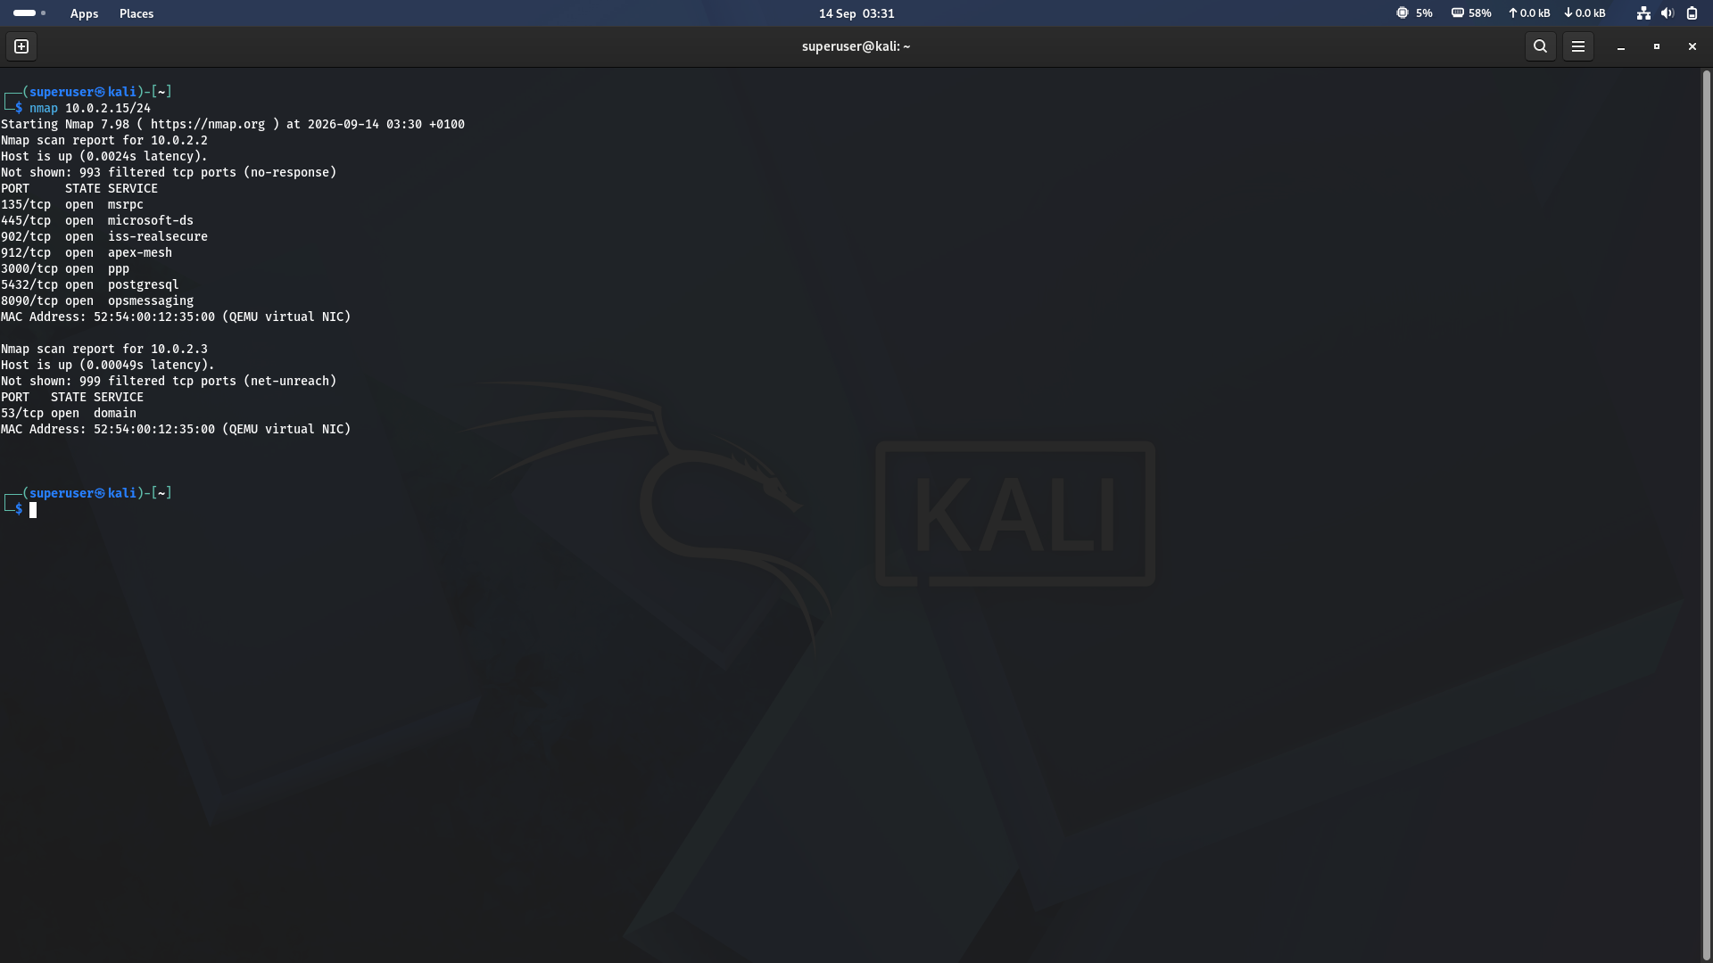
Figure 3 · CIDR sweep of the 10.0.2.0/24 lab network
Result summary
Host | Open Ports | Notes
10.0.2.2 | 135, 445, 902, 912,  3000, 5432, 8090 | Likely the VMware/VirtualBox NAT gateway — a wide service mix (RPC, SMB, VMware tools, Postgres) is typical of the host machine's NAT interface, not a real endpoint
10.0.2.3 | 53 (domain) | The NAT DNS relay provided by the hypervisor

Key insight
Both hosts share the same MAC address (52:54:00:12:35:00), confirming they're virtual interfaces on the same QEMU/KVM NAT segment rather than separate physical machines — consistent with the VMware NAT false-positive behaviour logged in Module 2.

4 Verbose Scan & Timing Behaviour
Running a scan against Nmap's public test host, scanme.nmap.org, surfaces the scan phases and timing engine that are normally hidden in quiet output.
● ● ●
$ nmap scanme.nmap.org
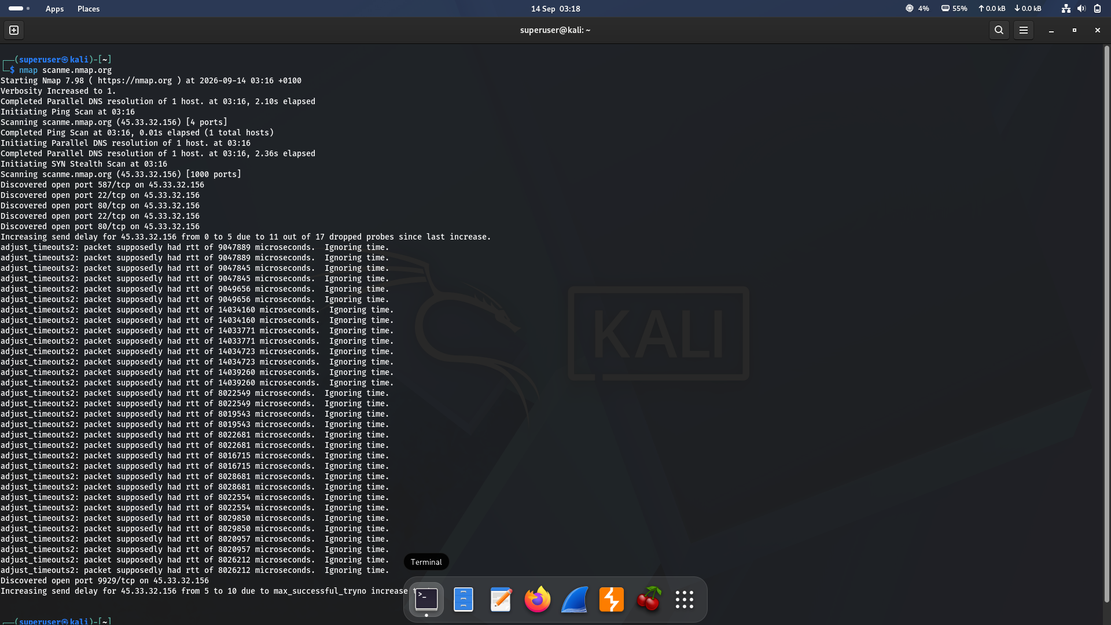
Figure 4 · Scan phases and adaptive timing against scanme.nmap.org

Scan phases observed
- DNS resolution — scanme.nmap.org resolved to 45.33.32.156 before any probing started.
- Ping Scan — a quick host-discovery pass confirmed the target was up (1 host, 4 ports probed) before committing to a full port scan.
- SYN Stealth Scan — the main 1000-port probe. Ports 22, 80, 587 and later 9929 were discovered open.

Adaptive timing & packet-loss handling
The repeated ‘adjust_timeouts2’ lines show Nmap's round-trip-time estimator reacting to inconsistent or dropped responses over the internet link (as opposed to the near-zero latency of the local lab network in Section 3). Because 11 of 17 probes were dropped, Nmap automatically increased its per-probe send delay from 0 to 5 (and later 5 to 10) to avoid overwhelming the path and reduce further loss — a built-in congestion-control behaviour, not an error.
Takeaway
Scans against real internet hosts are noisier and slower than scans on a local subnet, and Nmap's timing engine — not a fixed delay you set — adapts automatically to keep the scan reliable.

5 Key Takeaways
- A bare IP, hostname, list of targets, or CIDR block are all valid ways to specify what Nmap scans — the syntax scales from one host to a whole subnet.
- Filtered vs. closed vs. open all mean different things: filtered = no response (likely firewalled), closed = host responded but nothing is listening, open = a service is listening.
- Shared MAC addresses across ‘different’ hosts is a strong signal you're looking at virtual NAT infrastructure, not distinct machines.
- Nmap's timing/retransmission engine self-adjusts based on real network conditions — this is normal and expected on higher-latency or lossy links.

