CYBERSECURITY TOOLS · WEEKLY LEARNING TRACK
Nmap Reference Documentation
Module 5 — Service, Version & OS Detection

Prepared by Emmanuel Aidoo
Kali Linux · Nmap 7.98
September 20, 2026

Contents
1 Service & Version Detection (-sV) 3
2 Tuning Detection Depth (--version-intensity) 4
3 Aggressive Scan & OS Detection (-A) 5
4 Key Takeaways 6

This module moves beyond port states into what's actually running behind them: service/version detection with -sV, tuning how hard Nmap tries with --version-intensity, and the -A aggressive scan that bundles version detection, OS fingerprinting, default scripts, and a traceroute into one pass.

1 Service & Version Detection (-sV)
-sV goes a step past a plain SYN scan: for every open port, Nmap tries to actively identify the exact service and version running — not just guess from the port number, but actually probe it and match the response against its service-fingerprint database.
● ● ●
$ nmap -sV 10.0.2.15
$ nmap -sV 173.230.138.70
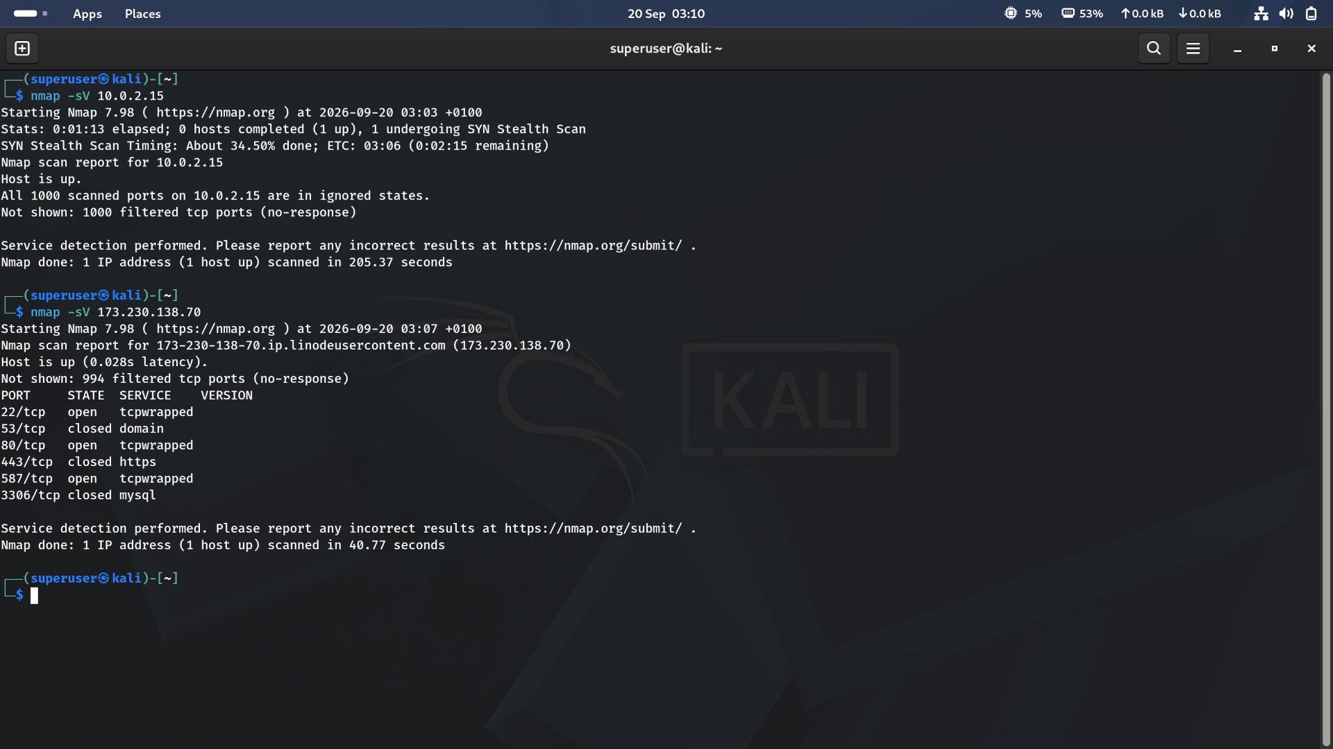
Figure 1 · Version detection run against the lab Kali box and the Linode-hosted target
Result summary
Target | Result | Notes
10.0.2.15 | All 1000 ports filtered, none open | Scanning the Kali box's own external-facing address returned nothing but silence — took 205.37 seconds, since version detection retries filtered ports more patiently than a plain SYN scan does
173.230.138.70 | 22, 80, 587 open; 53, 443, 3306 closed | Every open port reported VERSION as tcpwrapped instead of a real service name — completed in 40.77 seconds

What “tcpwrapped” actually means
It's not a service name — it's Nmap's way of saying the port accepted a connection but then closed it without sending any data back, a pattern historically associated with the TCP Wrappers access-control library. In practice it usually just means something between the scanner and the service (a firewall, rate-limiter, or the app itself) is refusing to hand over a banner to an unrecognized client, not that nothing is running there.

2 Tuning Detection Depth (--version-intensity)
--version-intensity controls how many version-probe attempts Nmap makes per port, on a scale of 0 (lightest) to 9 (every probe in the database, slowest). It takes a required numeric argument — leaving it out is a syntax error, not a request for the default.
● ● ●
$ sudo nmap -sV --version-intensity 173.230.138.70
$ sudo nmap -sV --version-intensity 9 173.230.138.70
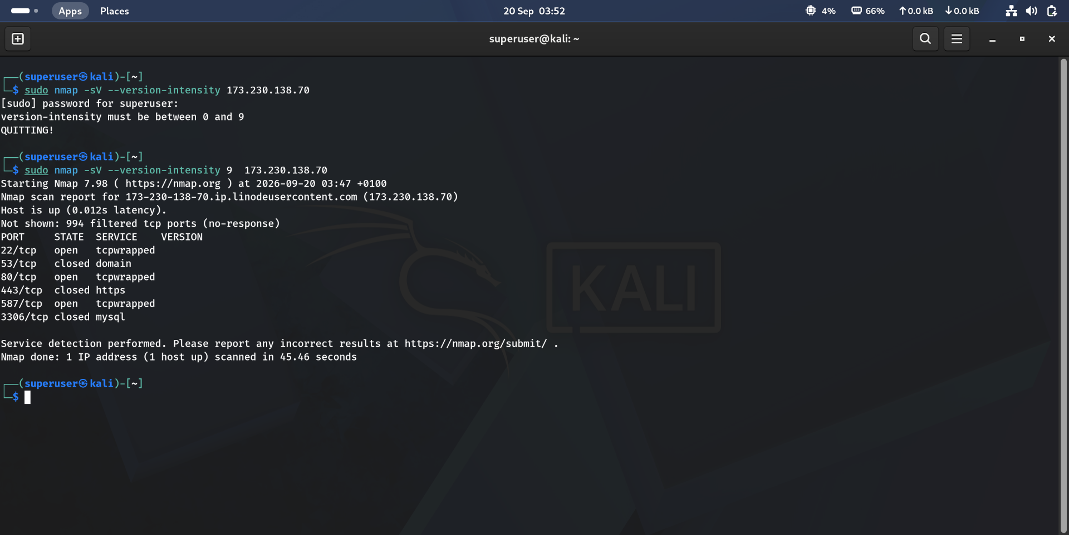
Figure 2 · A missing intensity value fails fast, then intensity 9 runs to completion
What happened
Attempt | Outcome
--version-intensity 173.230.138.70 | Nmap read “173.230.138.70” as the intensity value, rejected it (“version-intensity must be between 0 and 9”), and quit before scanning anything
--version-intensity 9 173.230.138.70 | Valid syntax — ran the most thorough version probe set available, in 45.46 seconds

Maximum intensity still hit the same wall
Even at intensity 9 — Nmap's most exhaustive version-probing setting — ports 22, 80, and 587 still came back tcpwrapped, with identical results to the plain -sV scan in Section 1. This confirms the earlier read: the ambiguity here isn't Nmap giving up early, it's the target actively withholding banners regardless of how many probes are thrown at it.

3 Aggressive Scan & OS Detection (-A)
-A is a shortcut that enables several detection features in one flag: OS fingerprinting (-O), version detection (-sV), default NSE script scanning (-sC), and a traceroute — turning one command into a full reconnaissance pass.
● ● ●
$ nmap -A 173.230.138.70
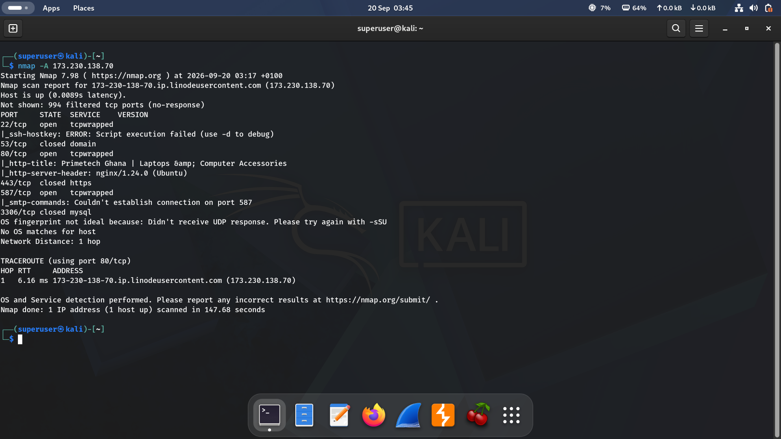
Figure 3 · Aggressive scan combining version detection, default scripts, OS fingerprinting, and traceroute
What the extra detection revealed
Port | Script output
22/tcp (tcpwrapped) | ssh-hostkey script failed outright: “Script execution failed (use -d to debug)” — consistent with the port refusing to hand over any banner
80/tcp (tcpwrapped) | http-title and http-server-header scripts still succeeded, identifying the site as “Primetech Ghana | Laptops & Computer Accessories” running on nginx/1.24.0 (Ubuntu)
587/tcp (tcpwrapped) | smtp-commands script failed: “Couldn't establish connection on port 587”

tcpwrapped doesn't mean unidentifiable
This is the most useful result in the module: even though port 80 was still labeled tcpwrapped in the VERSION column, the http-title script reached straight past that and confirmed the real application — a live Primetech Ghana storefront. The lesson is that a generic port-level label like tcpwrapped only describes the banner-grab step; protocol-aware NSE scripts can still identify what's actually running by talking the target's own application protocol instead of waiting for a banner.

OS detection didn't fare as well: Nmap reported “OS fingerprint not ideal because: Didn't receive UDP response. Please try again with -sSU” and found no OS matches at all. The traceroute showed a Network Distance of just 1 hop, with the only hop being the target itself — typical of a routing path where intermediate hops don't respond to traceroute probes, rather than proof the server is on the same local network. The full scan, combining all of this, took 147.68 seconds.

4 Key Takeaways
- -sV actively probes open ports for real banners instead of guessing from the port number — and it's noticeably slower than a plain SYN scan, especially against ports that don't respond.
- tcpwrapped means the port completed a TCP handshake but wouldn't hand over an identifiable banner — it is not the same as closed, and doesn't mean nothing is running there.
- --version-intensity takes a required 0–9 value; a missing argument is a hard syntax error, not a fallback to defaults.
- Maximum intensity (9) doesn't guarantee a real service name — if the target withholds its banner, more probing attempts won't change that.
- -A bundles OS detection, version detection, default scripts, and traceroute into one scan — and its NSE scripts can identify a service (like a web server's actual title) even when the raw port scan alone would only report tcpwrapped.
- OS fingerprinting can fail outright (“No OS matches for host”) when Nmap doesn't get the UDP responses it needs — that's a data-gap in the fingerprint, not necessarily an unusual host.

