

Final Report

**Music Website - Muxix**

As per project work for course

I**NTERNET PROGRAMMING (CSE 326)**

BY

Section: **K19UW**  Project Group: **29**

|  |  |  |  |  |
| --- | --- | --- | --- | --- |
| Sr. No. | Registration No. | Name | Roll No. | Marks Obtained |
| 1 | 11917030 | Mukul Pramanik | 43 |  |
| 2 | 11916921 | Sahil Dhadwal | 44 |  |
| 3 | 11916969 | Karanveer Singh | 45 |  |

Submitted to Ms. Ishatpreet Kaur

**Music Website -Introduction**

**What is an online music website?**

An online music website is a platform where a user/subscriber may listen to music of his interest. Music streaming services may be free or paid. However, online music stores generally offer partial streaming previews of songs, with some songs even available for full length listening. Online music stores typically show a picture of album art or of the performer or band for each song.

**All about Muxix**

Our music website: **Muxix** is a platform where one can stream music without any hesitance. This project is piece of immense hard work and a good team work.

**Brief description along with the code:**

1. The very first thing in this project is the login page, which supports email login and sign up. The login page interface is a pane like design having boxes for login credentials, sign up for new subscribers and forget password for those who didn’t remember it. Keys like submit is also used.

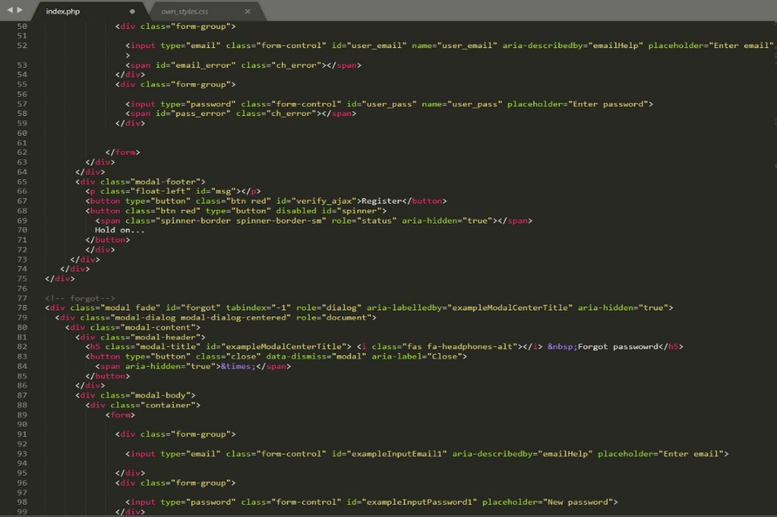zoom in for proper view of codes

this is the code for log in page

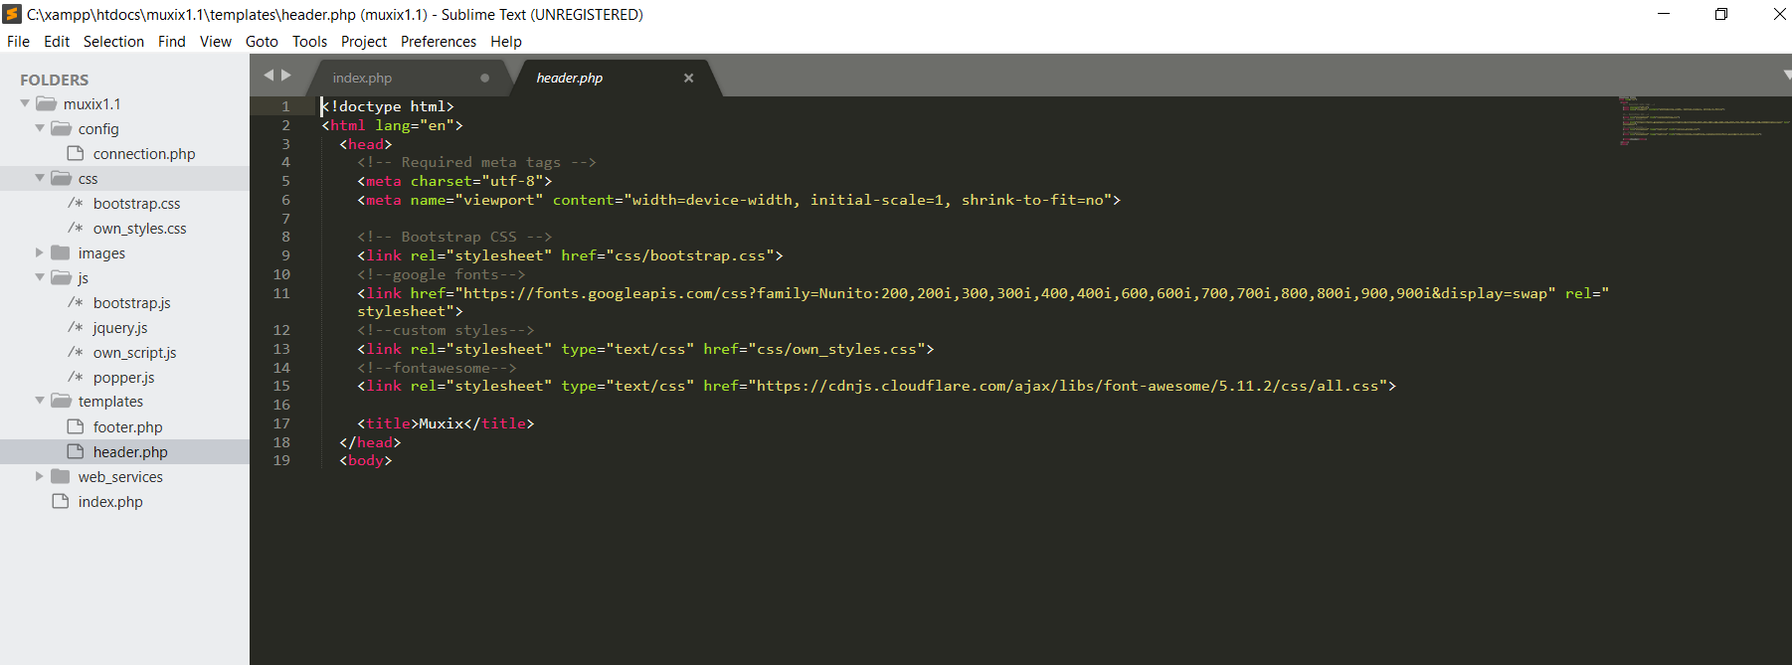this is the code for header part

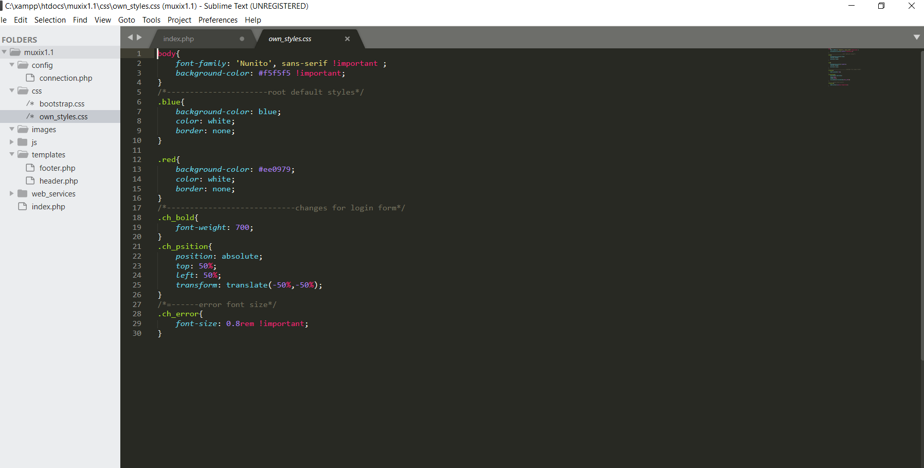this code is for the styling and formatting of the log in page using css

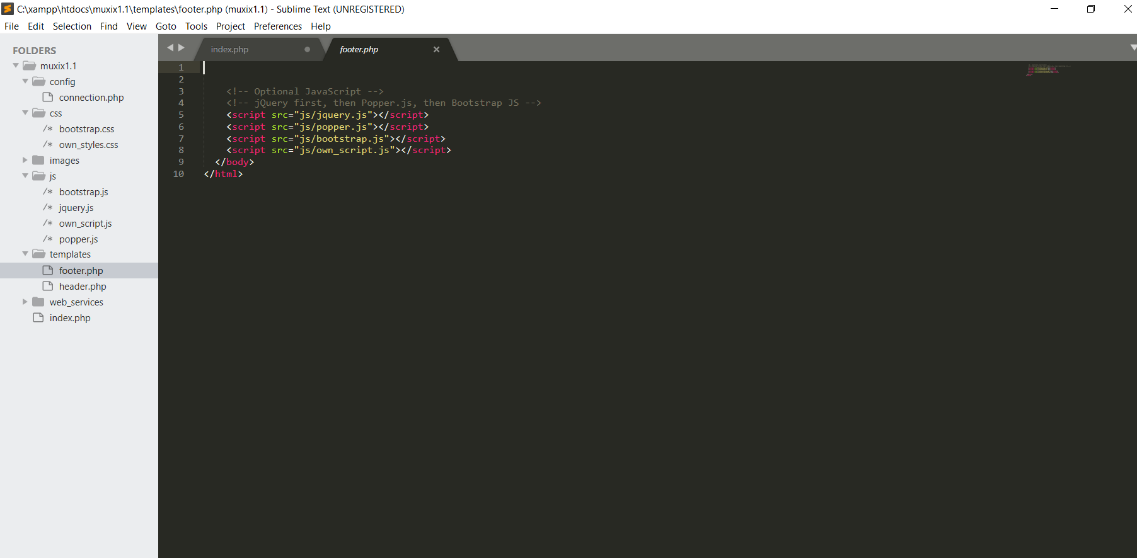for footer this is the code

1. Second, but the easier part of our Muxix streaming page is where a user can listen to various chategorized music. This page contains icons of different songs, playlist in different languages and the most interesting is the music player.

To create this page we have used:

* Internal css
* Jquery
* Bootstrap

Each music is given with the name of the singer.

Each music file (eg. Hindi) is in the form of array i.e, each section is in the categorized form.

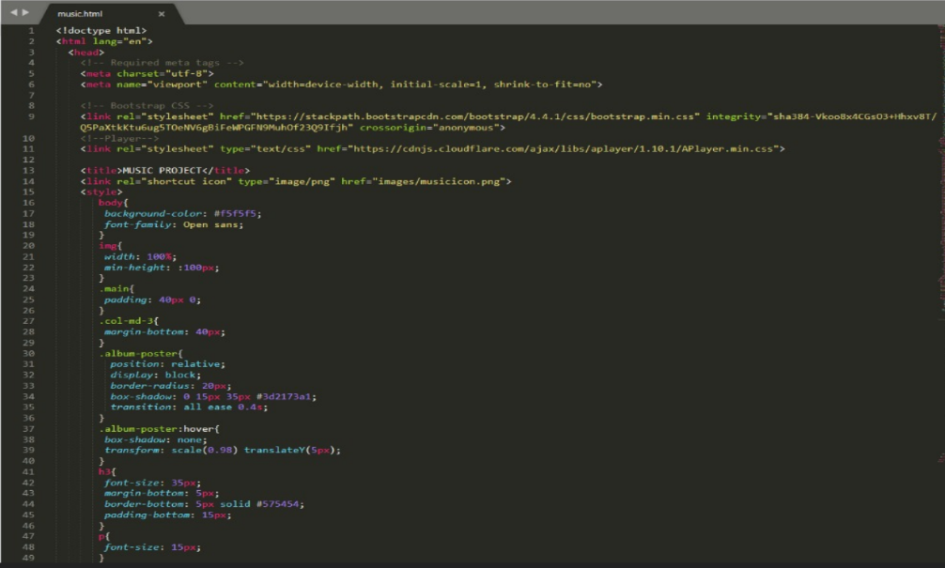following are the codes for main page:

this is the code for internal css

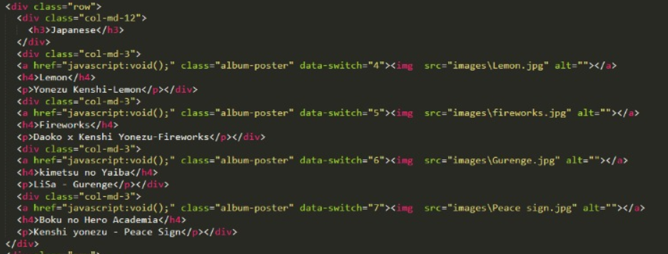categorizing songs in different languages

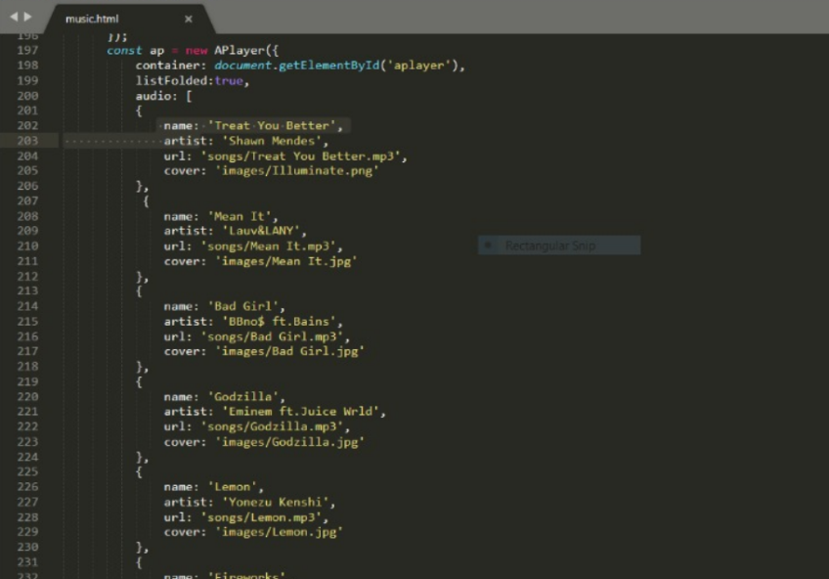this is array for different songs in a particular category

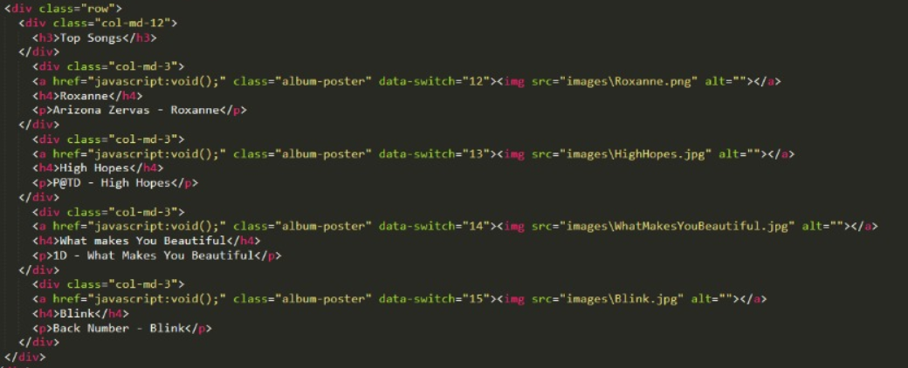this is how we have added image, title and artist name along with the styling

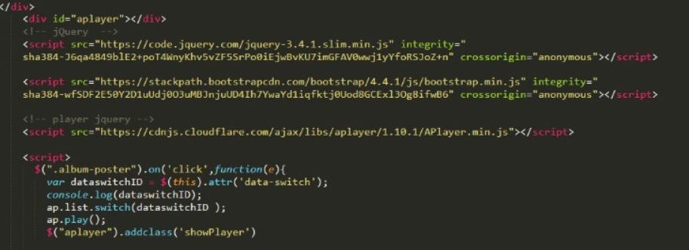

This is the code for the music player

These all coding lead us to the final outcome of out music website: **Muxix**

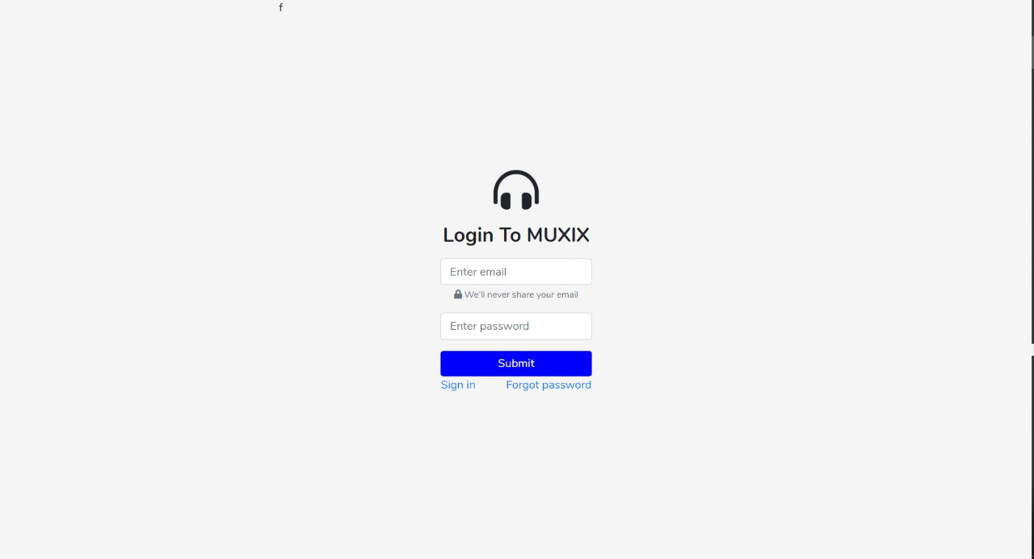

**Final webpage**

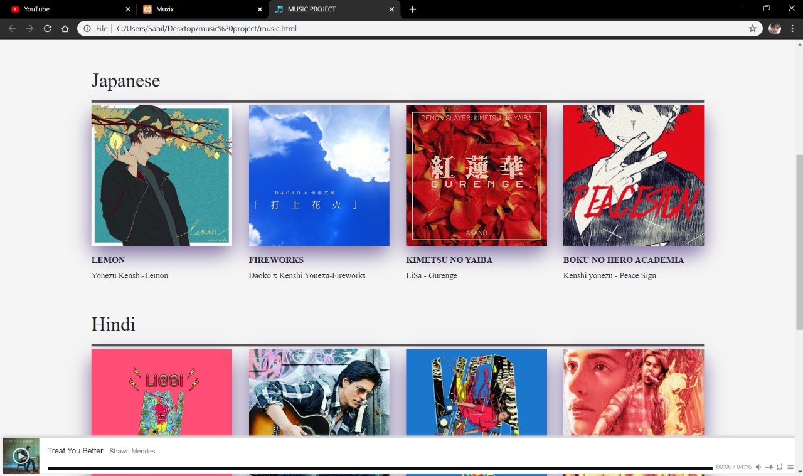

Music player

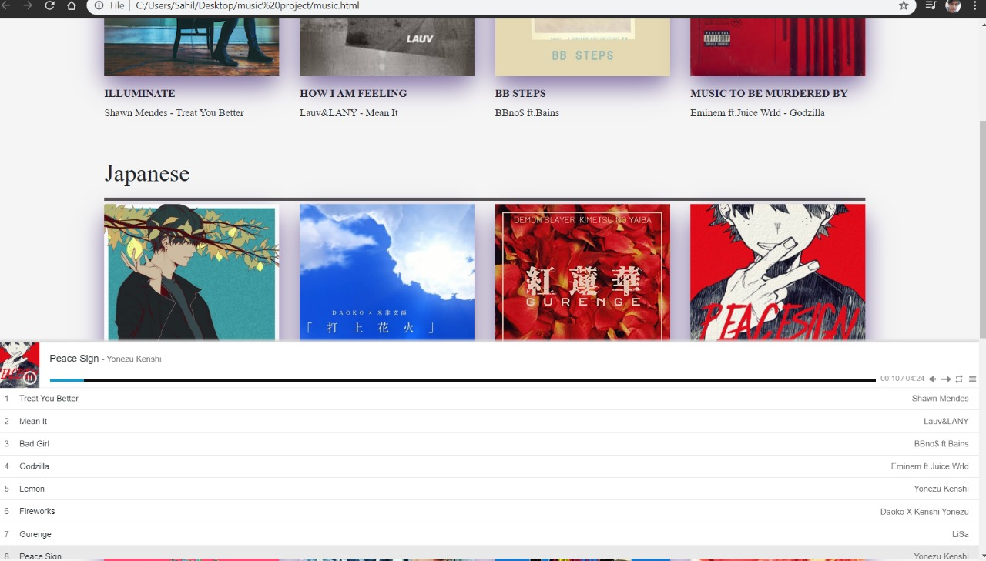

**Reference**

* [**www.google.com**](http://www.google.com)
* **Freecodecamp**
* **W3schools**
* **HTMLDogs**