Database Changes

Added lookup tables for Month and DayOfWeek as well as PK FK relationships.

Updated InsertClientFamilyRecord, and InsertClientFamilyRecordWithAddress to reflect the changes I made to the database last week.

Created a Function that calls up AllActualHours for a VolunteerScheduleID. I intend to update it to use the values from the LU tables at some point.

If you have tips on changing the Driver Procedure I created I would appreciate it. What I have works fine for a single insert, but not multiple inserts.

Next week I want to make a driver procedure of a select insert to statement from the Person.Person into the volunteer contacts table. I may need to make another function for that.

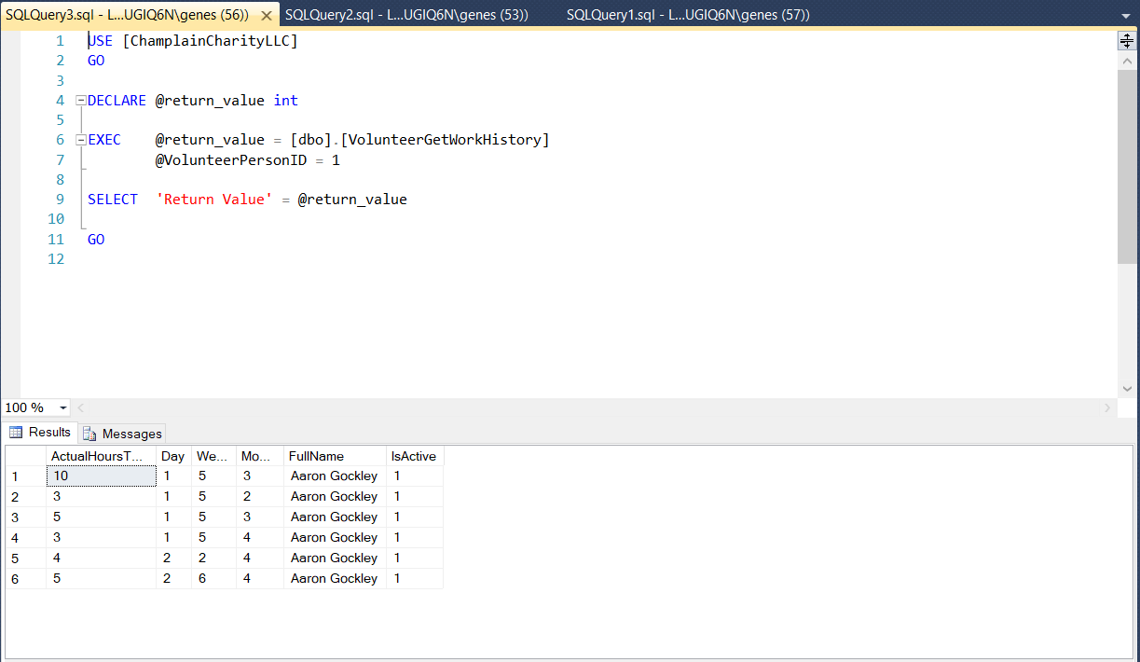This performs as I expect it to. The stored procedure executes the function. The function takes the Volunteer Person ID and returns their volunteer history. The stored procedure then adds in some extra information for readability I intend to alter the function to be more readable. Switching out the Day and Month values for their names instead of ids.

This also works as well as it can with how I entered it. With @@Identity I take the Identity populated in the previous SP and use it as a value in the next one. It chains so you auto-increment all of the IDs. So far it only works with one set of values. I am thinking there must be a way to use something other than @@Identity, but I could not figure anything out. 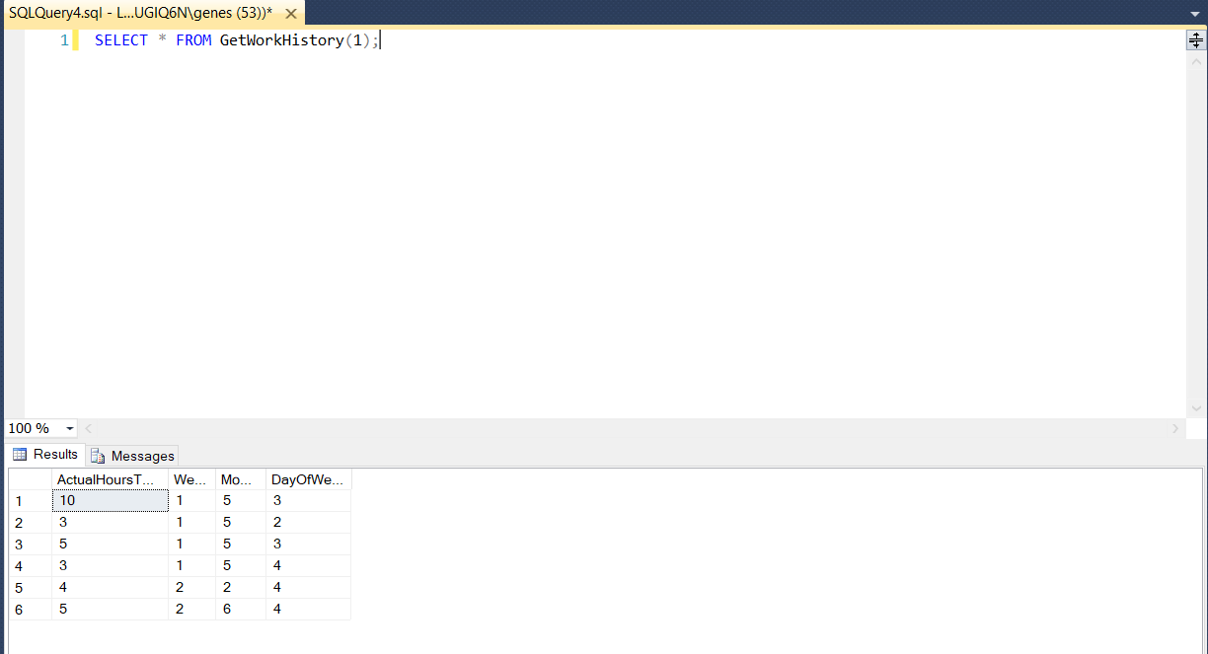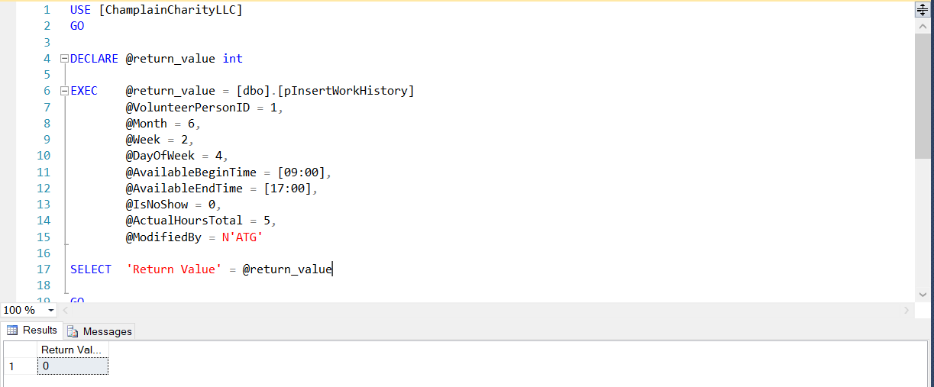

This is also working completely as intended I want to do some tweaking for readability.