**Scheduling Logic**

The basic structure of the scheduling system is laid out in the procedure I have been working on. The expansion I want to add is checks on the inputs. I want the system to check if there is an input of data for a section of the procedure. If there is input for it, it will run. So a check if there is information entered in Volunteer Month, Week, or Day. I also want to allow for inputs by a user to only apply to certain tables. So someone can manually enter a month id so they can add more weeks scheduled in. I also want to add one more SP at the end to use the DayTimeID to put an entry into the Jobs table. This will give all the information on a person. I will also then alter the WorkHistory SP using my function to call up the job people did. I think I can use a series of if-else statements for doing the different transactions, it will be relatively straightforward if not a little tedious.

**Changes to Database**

Added contactId to pInsertVolunteerContactInfo procedure so it actually works, the column is listed as not null and is required for an insert. (I only discovered this by forcing the system to print the actual error, not just generic failed/rollback.) Also forced an insert of VolunteerPersonID as the column is not Identity, so it now works properly.

Made VolunteerTypeID a PK and a PK-FK relationship between VolunteerType and VolunteerContactInformation on the volunteer type column.

Changed VolunteerJobs table to accept ScheduleDayTimeID instead of VolunteerPersonID. I want to have a specific id for what each person did. I added a PK-FK relationship to reflect this change.

Added Primary Key to LUVolunteerJobType and a PK-FK relationship between LUVolunteerJobTypeID and Job in VolunteerJobs. I had to alter the Jobs column to INT and had to delete my test inserts for this to work.

Altered Function GetWorkHistory to display values from the LUtables created last week. I also fixed some value issues in the Stored Procedure calling this function. Week, Day, and Month should now be showing proper values. There is no Week called May or Month called Sunday.

**Screenshots**

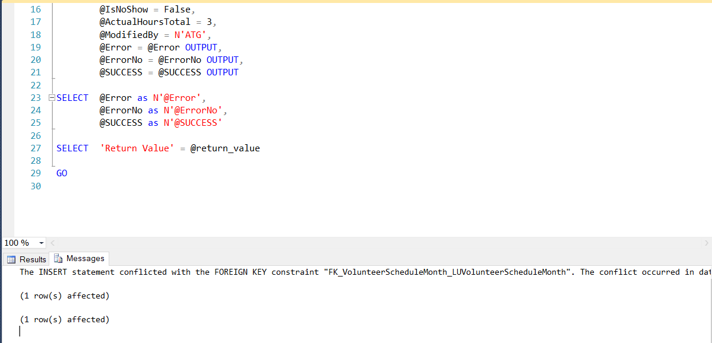

This screenshot shows the error handling works on my driver SP. I entered an invalid MonthID and so it prints that it is an invalid month ID. I explain in a comment in the code that this is using the base ERROR_MESSAGE() as that provides the best information on what happens in my opinion.

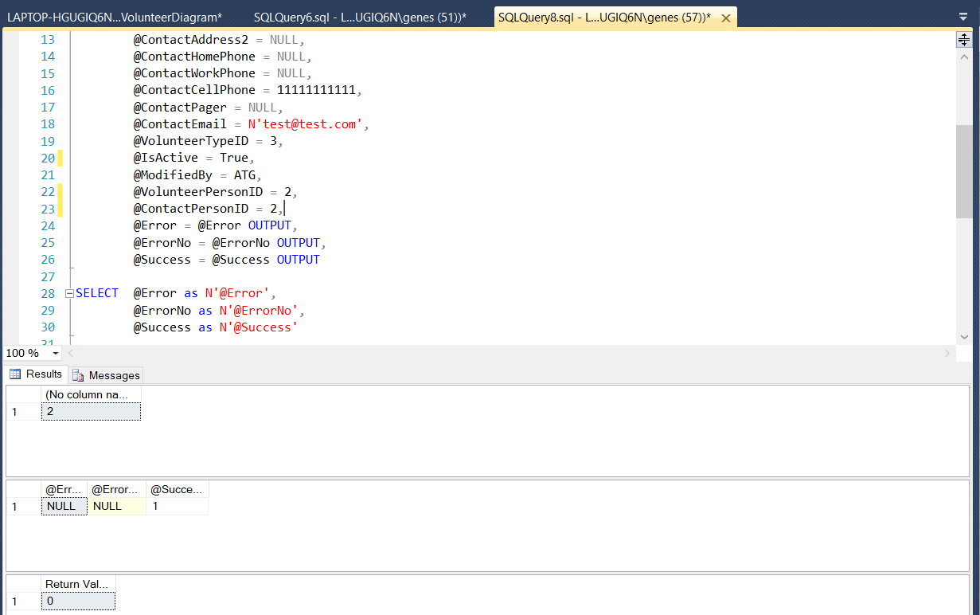

This shows that the pInsertVolunteerContactInformation procedure now works. As stated above I fixed the problems in the procedure and it now works perfectly.

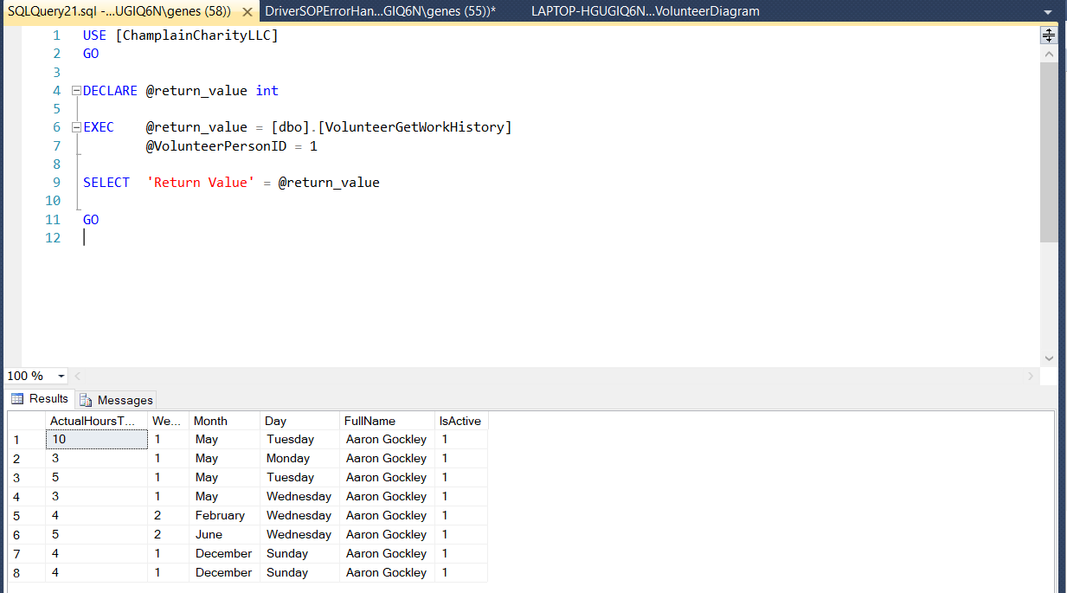

This is the VolunteerGetWorkHistory with the updates I said I would make to it last week. I will definitely be adding which job the volunteer is doing at some point. The dual inputs at the end are the result of some testing for something else, I, unfortunately, do not remember what the test was.