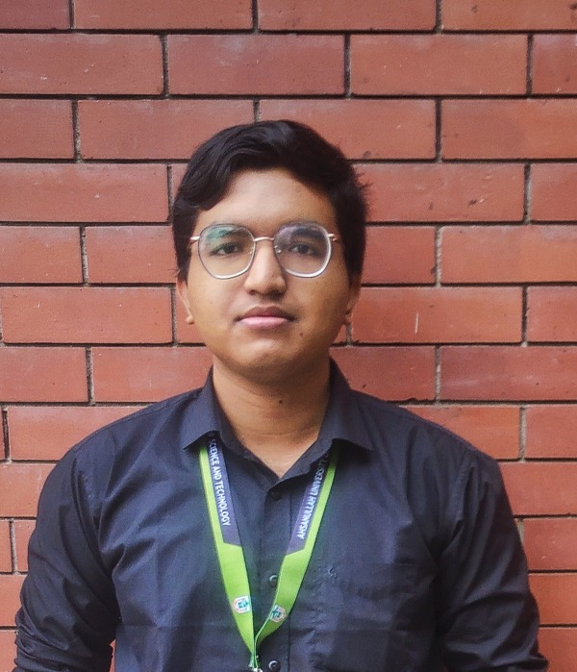  MASRAFI  IQBAL  FULL-STACK DEVELOPER  CONTACT  Dhaka, Bangladesh  +880 1789-722133  masrafiiqbal1@gmail.com  github.com/CyberFlare141  linkedin.com/in/masrafi-iqbal  SKILLS  Languages  C, C++, Python, Java, PHP, Prolog, HTML5, CSS  Frameworks & Libraries  React, Laravel, Node.js, FastAPI  Databases  MySQL, PostgreSQL, MongoDB  Tools & Platforms  Git, GitHub, Docker, Postman, Linux, Azure, Jupyter, Colab, Figma  EDUCATION  B.Sc. in Computer Science & Engineering  Ahsanullah University of Science and Technology  2023 – Present • CGPA 3.40  Higher Secondary Certificate  Dhaka City College  2022 • GPA 5.00  Secondary School Certificate  Jatrabari High School and College  2020 • GPA 5.00  LANGUAGES  Bangla, English, Hindi  STRENGTHS  Problem solving, teamwork, adaptability, consistency, time management | PROFESSIONAL SUMMARY  Computer Science and Engineering student and full-stack developer who ships practical web applications end to end with React, Laravel, Node.js, and FastAPI, backed by relational and NoSQL databases. Drawn to dependable software and intelligent systems, with growing interest in MLOps and turning real-world requirements into products people actually use.  PROJECTS  ParKar — Parking Automation System GitHub ↗  Laravel · React · MySQL · Python · FastAPI · AI API  - Built a semester-based parking access platform that lets universities manage eligibility and access-control workflows end to end.  - Developed a Laravel REST API paired with a React client, plus a FastAPI-based AI assistance layer that supports administrative decision-making.  Bank Management Application GitHub ↗  Laravel · React · PostgreSQL  - Created a full-stack banking application that simplifies account operations and administrative workflows for staff and customers.  - Applied PostgreSQL transactions and ACID guarantees to keep financial data reliable and consistent under concurrent use.  Blood Donation Management System GitHub ↗  React · Node.js · MongoDB  - Developed a web platform connecting blood donors with recipients and streamlining donation requests.  - Implemented donor registration, authentication, request management, and real-time data handling.  FOCUS AREAS  Full-stack web development, REST API design, relational & NoSQL data modeling, and applying AI/ML tooling (FastAPI-based services, MLOps fundamentals) to support real decision-making workflows.

