Kyle Hughes
CSD325
Assignment 2.2

Breakpoint set, Run Debug:
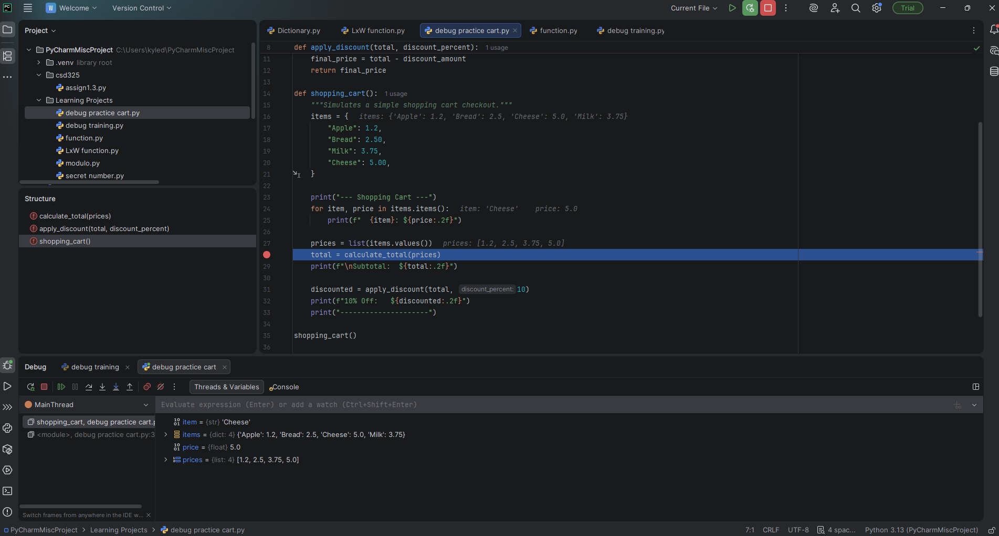

Step Into Function:
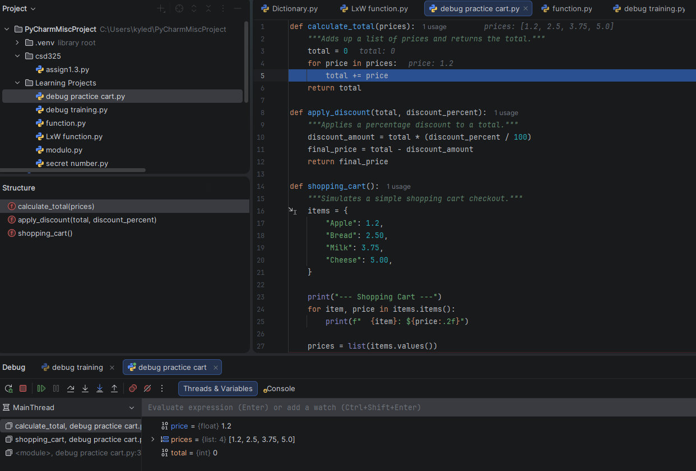

Added Error : Replace price of cheese(int) with string(“Free”)
