Kyle Hughes
3/14/26
CSD325 Advanced Python
Assignment 1.3

Flowchart:
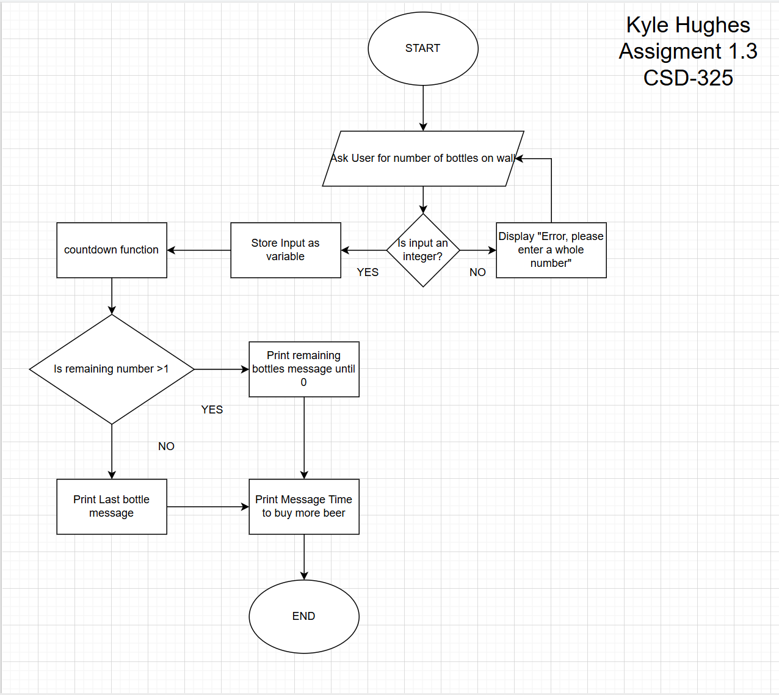

Python code:

#Kyle Hughes
#3/14/26
#Assignment 1.3
#Short code using user input and loops to repeat message until complete.
def countdown(bottles):
while bottles > 1:
print(f"{bottles} bottles of beer on the wall, {bottles} bottles of beer.")
bottles = bottles - 1
print(f"Take one down and pass it around, {bottles} bottle(s) of beer on the wall.")
print()
# Last bottle message
print(f"1 bottle of beer on the wall, 1 bottle of beer.")
print(f"Take one down and pass it around, 0 bottle(s) of beer on the wall.")
print()
# Main program
while True:
try:
bottles = int(input("Enter number of bottles: "))
if bottles < 1:
print("Please enter a number greater than 0.")
else:
break
except ValueError:
print("Invalid input. Please enter a whole number.")
countdown(bottles)
print("Time to buy more bottles of beer.")
#Kyle Hughes
#3/14/26
#Assignment 1.3
#Short code using user input and loops to repeat message until complete.
def countdown(bottles):
while bottles > 1:
print(f"{bottles} bottles of beer on the wall, {bottles} bottles of beer.")
bottles = bottles - 1
print(f"Take one down and pass it around, {bottles} bottle(s) of beer on the wall.")
print()
# Last bottle message
print(f"1 bottle of beer on the wall, 1 bottle of beer.")
print(f"Take one down and pass it around, 0 bottle(s) of beer on the wall.")
print()
# Main program
while True:
try:
bottles = int(input("Enter number of bottles: "))
if bottles < 1:
print("Please enter a number greater than 0.")
else:
break
except ValueError:
print("Invalid input. Please enter a whole number.")
countdown(bottles)
print("Time to buy more bottles of beer.")

