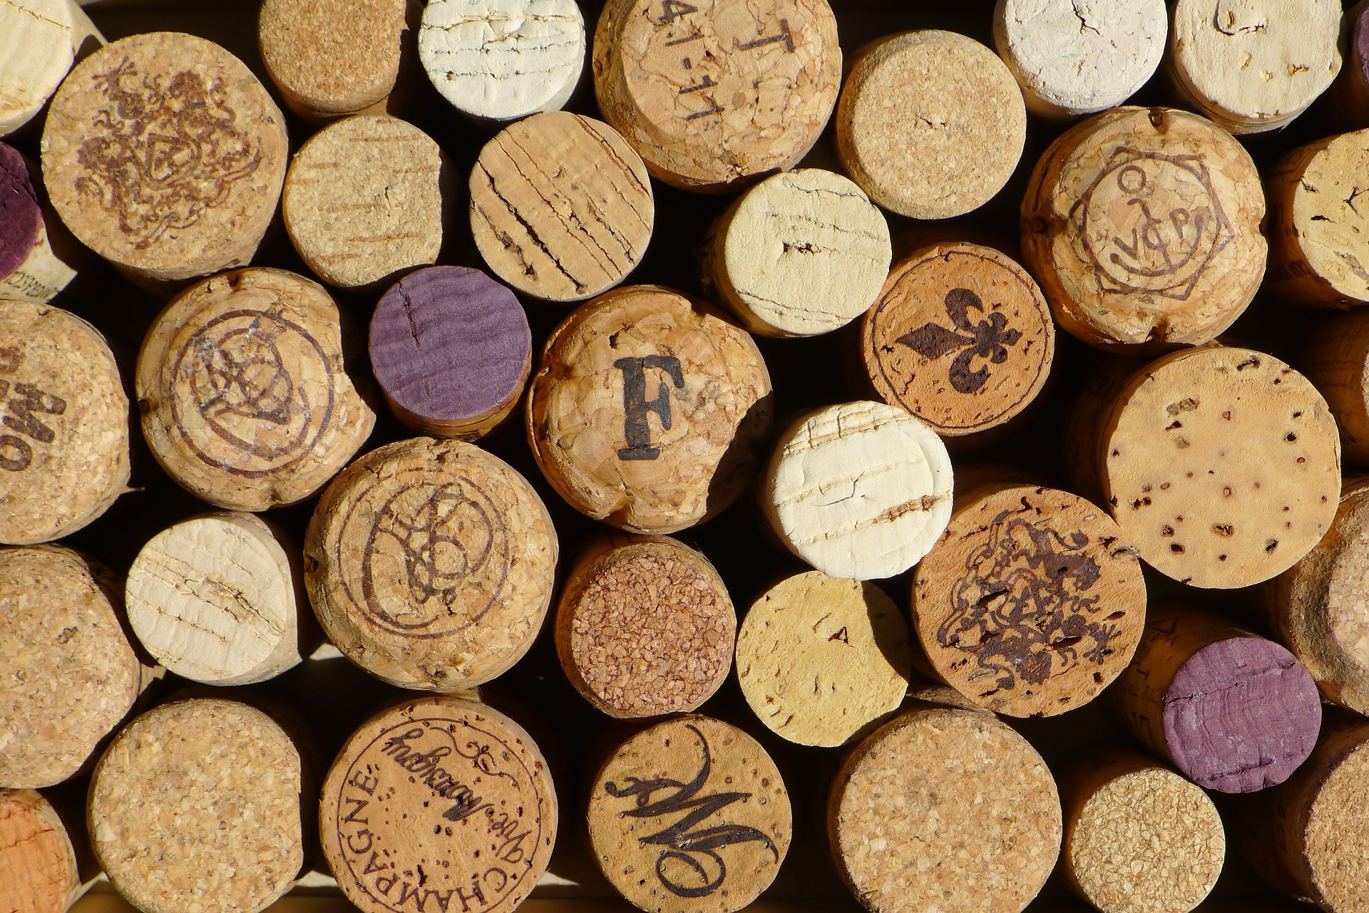

4SB Admin Android Application User Guide

2018

|  |
| --- |
|  |
|  |
| June 9  BSc Computer and System Development  Authored by: Amy Falconer |



Contents

Product Introduction 3

User Interface 3

Home Screen 3

Navigation 4

Settings 4

App Features 4

Online Orders and Table Reservations 4

Notifications 4

Create/Read/Update/Delete Order 4

Modifying Content 5

Create Content 5

Allergens 5

Reports 6

# Product Introduction

Figure 1 - Your Dashboard

The 4SB admin app aims to provide full control of your android application from the content, the analytical data and the visual imagery provided. Intended to be simple and fluid, this app will allow for seamless integration with current business practices. Encompassing features such as:

# User Interface

## Home Screen

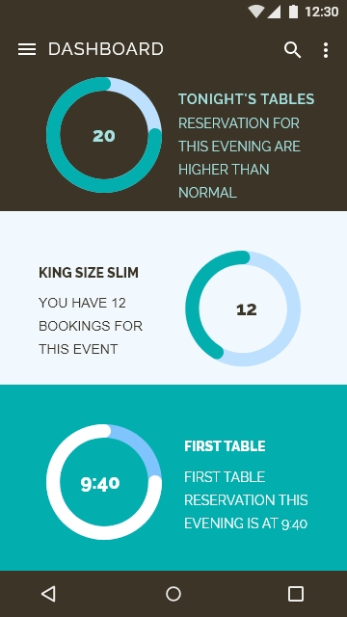 After successful login, you’ll be directed to your dashboard. From here, you’ll have quick access to your most used features shown in figure 1. Check out orders and reservations as they come in or create your own. Click on any of the inventory to update your content or scroll down to see a summary of your reports shown in figure 2.

` This real time data aims to give you the support needed when adding features such as online reservation and takeaways to your business. You’ll know if you have a busy night ahead of you which can aid business decision making in relation to stock and staffing.

Not only will the reporting aid your business, you’ll never miss a table or an order with the 4SB notification capability. Set up a manager to receive notifications directly to their device as they come in.

Figure 2 - Summary of Reports

## Navigation

We’ve kept the navigation in the same styles as your device to aid simplicity and get you moving round the app quickly. Click the side menu icon of 3 lines in the top left corner to see a list view of all the app features. Click anywhere else on the screen to close the side menu. See figure 3 for the screen example.

## Settings

The settings for your account can be found by clicking the top right icon (the 3 dots) which will show a drop down where you can access you profile settings.

Figure 3 - Navigation side menu

# App Features

## Online Orders and Table Reservations

### Notifications

Notifications will appear like other application notifications with the icon appearing in your system tool bar at the top of the screen. Disable these in profile settings.

### Create/Read/Update/Delete Order

Figure 4 shows you the screen where you can manage your content. Orders, Items, Events, and Menus will each have their own version of figure 4.

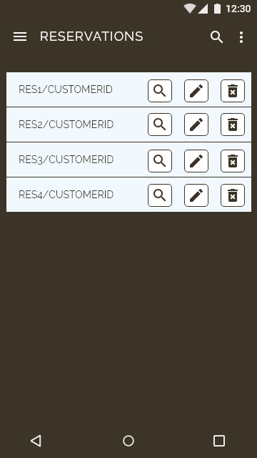

Figure 4 - Reservation list for modifying

## Modifying Content

### Create Content

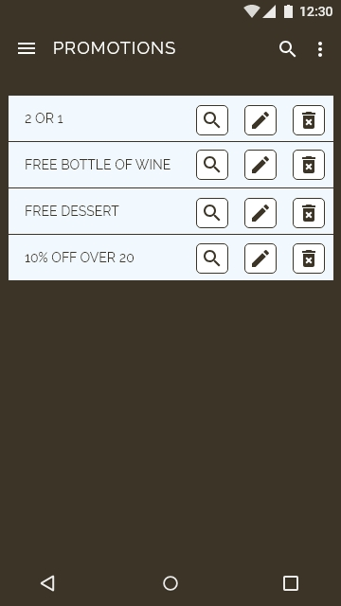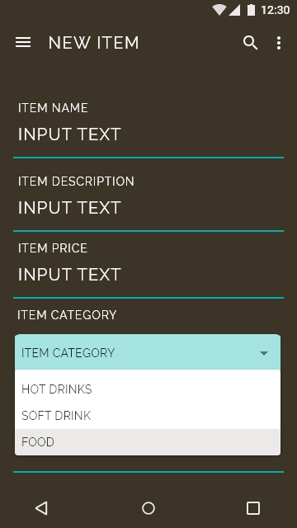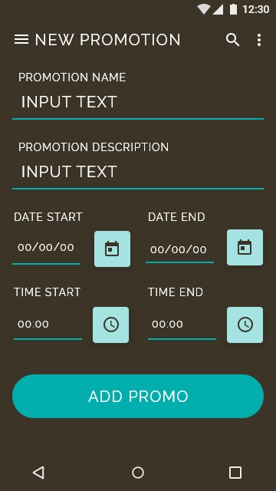 To create new content, simply press the icon of the content you would like to modify and that will promptly take you the input screen where you can add the inventory as required. Figure 5 shows this process.

Figure 5 - Modifying content

## Allergens

With allergens being such a major priority for 4 Seasons Brasserie, we have implemented an allergen page with all the information. This way you can link each allergen with any inventory item with a description. See figure 6.

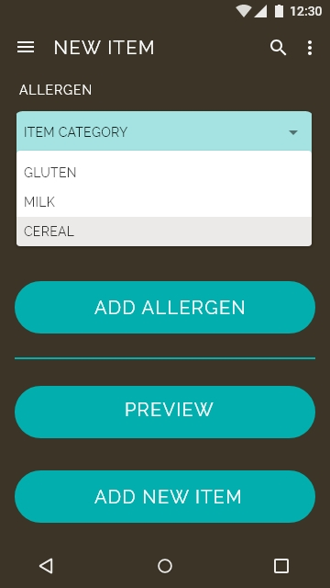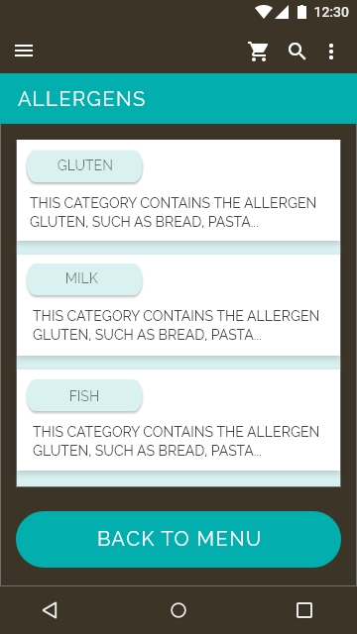

Figure 6 - Allergens

# Reports

The reporting aspect of the 4SB application will allow you to see trends and busy periods in real time. Visual representation in the forms of graphs and tables. See figure 7 for more illustration.

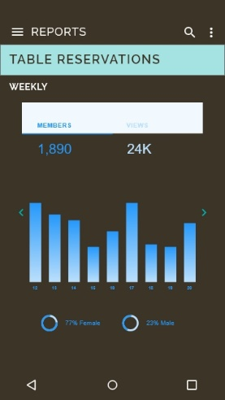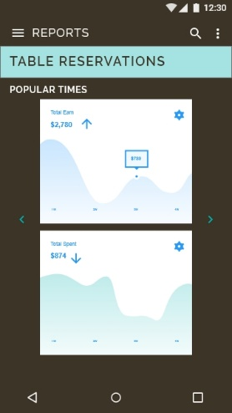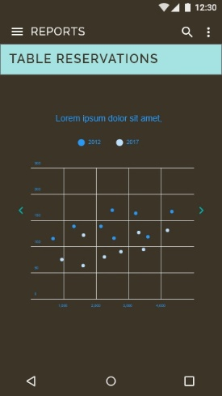

Figure 7 - Reporting