Name:- xyz

Class:- classssss Roll No:- 11111111

Subject:- Fundamentals of Java Programming (Lab Assignment)

Experiment No :- 1a. To Find Factorial of a Number

**Program: -**

**package** as1;

**import** java.util.*;

**public** **class** Factorial

{

**public** **static** **void** main(String[] args) {

Scanner in=**new** Scanner(System.***in***);

System.***out***.print("Enter the no :");

**int** n=in.nextInt();

**int** fact=1;

**for**(**int** i = 1; i <= n; i++)

fact = fact * i;

System.***out***.println("Result is :" + fact);

in.close();

}

}

**Output:-**

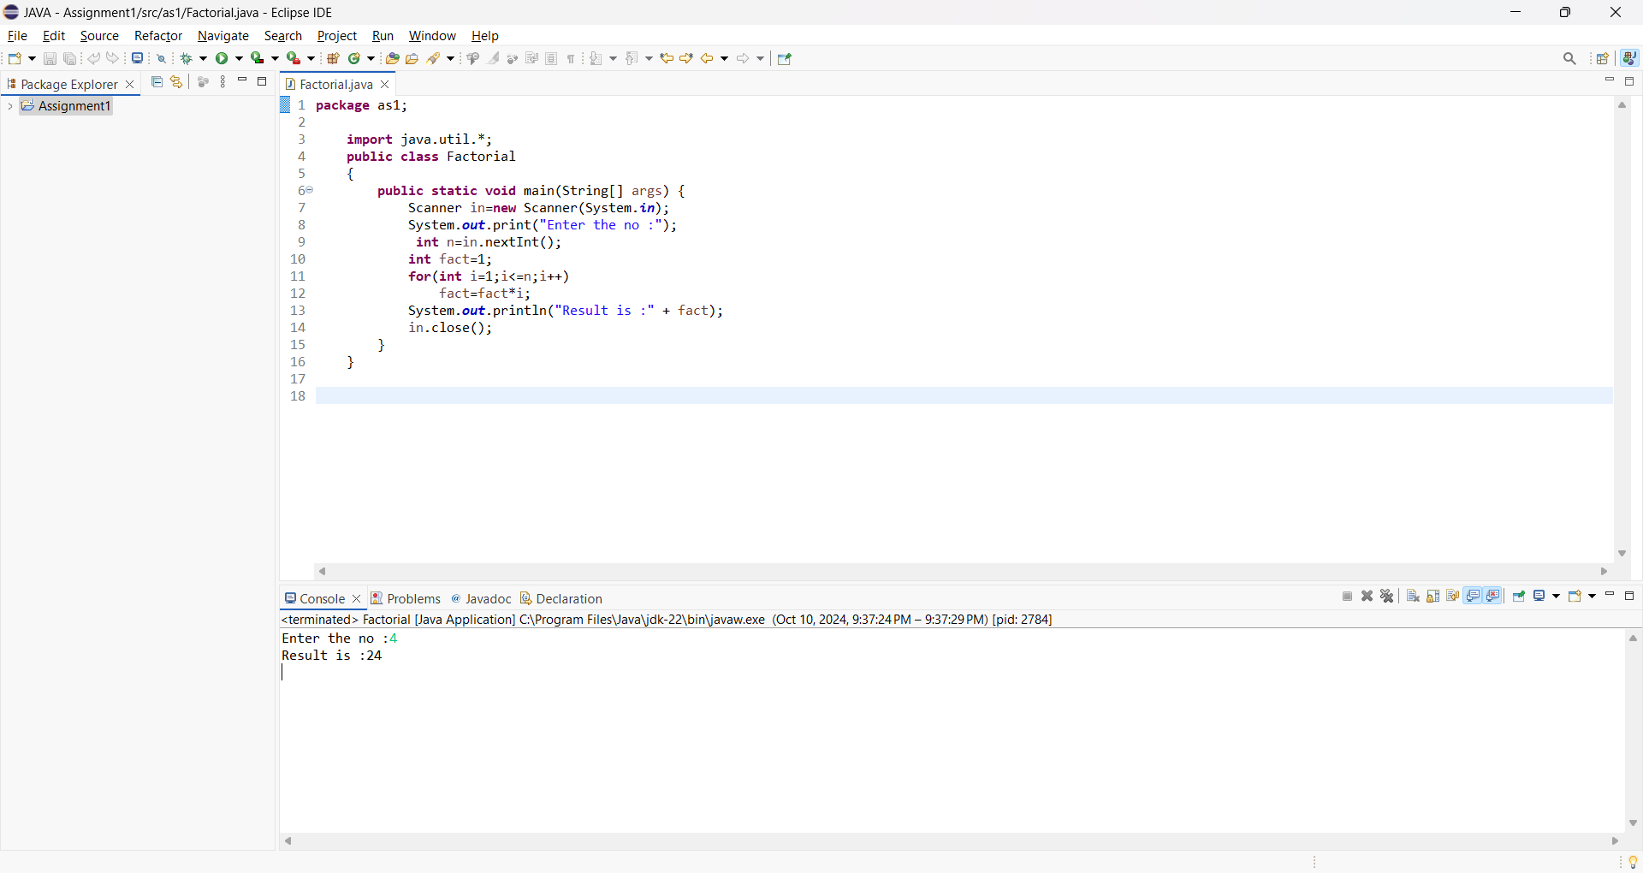

Name:- xyz

Class:- classssss Roll No:- 11111111

Subject:- Fundamentals of Java Programming (Lab Assignment)

Experiment No :- 1b. To Display first 50 Prime Numbers

**Program: -**

**package** as1;

**public** **class** primeNumber {

**public** **static** **void** main(String[] args) {

**int** primeCount = 0;

**int** currentNumber = 2;

**int** totalPrimesToFind = 50;

System.***out***.println("First " + totalPrimesToFind + " Prime Numbers:");

**while** (primeCount < totalPrimesToFind) {

**int** divisorCount = 0;

**for** (**int** divisor = 1; divisor <= currentNumber; divisor++) {

**if** (currentNumber % divisor == 0) {

divisorCount++;

}

}

**if** (divisorCount == 2) {

System.***out***.print(currentNumber + ", ");

primeCount++;

}

currentNumber++;

}

}

}

**Output:-**

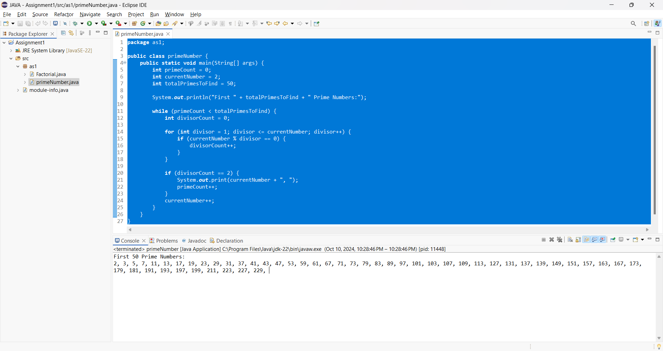

Name:- xyz

Class:- classssss Roll No:- 11111111

Subject:- Fundamentals of Java Programming (Lab Assignment)

Experiment No :- 1c. To Find sum and average of n Numbers

**Program: -**

**package** as1;

**import** java.util.Scanner;

**public** **class** sumAvg {

**public** **static** **void** main(String[] args) {

Scanner in = **new** Scanner(System.***in***);

**double** no, sum = 0, avg;

**int** n;

System.***out***.print("How many Numbers you want to Enter: ");

n = in.nextInt();

**for** (**int** i = 1; i <= n; ++i) {

System.***out***.print("Enter the No: ");

no = in.nextDouble();

sum += no;

}

avg = sum / n;

System.***out***.println("Avg of " + n + "number is " + avg);

}

}

**Output:-**

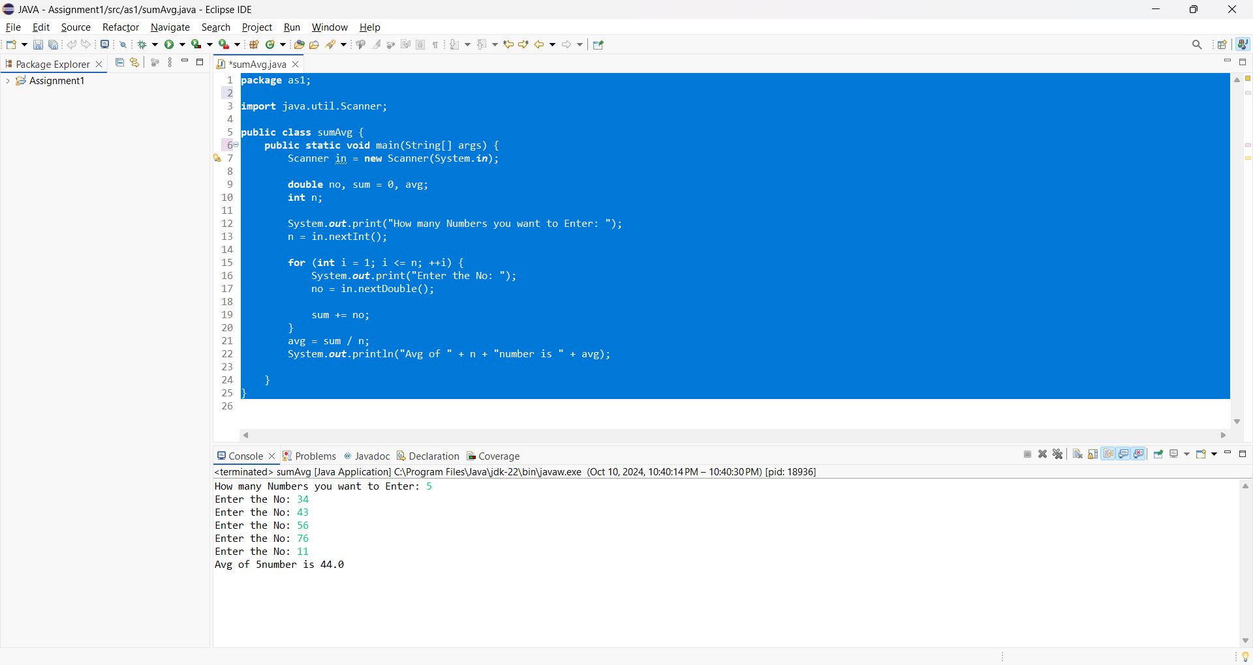

Name:- xyz

Class:- classssss Roll No:- 11111111

Subject:- Fundamentals of Java Programming (Lab Assignment)

Experiment No :-2. Write a program in Java to implement a Calculator with simple arithmetic operations such as add, subtract, multiply, divide, factorial etc. using switch case and other simple java statements.

**Program: -**

**package** calc;

**import** java.util.Scanner;

**class** Calc {

**private** **double** firstNo;

**private** **double** secondNo;

**public** **void** getFirstNo() {

System.***out***.print("Enter the first number: ");

Scanner in = **new** Scanner(System.***in***);

firstNo = in.nextDouble();

}

**public** **void** getSecondNo() {

System.***out***.print("Enter the second number: ");

Scanner in = **new** Scanner(System.***in***);

secondNo = in.nextDouble();

}

**public** **double** addition() {

**return** (firstNo + secondNo);

}

**public** **double** subtract() {

**return** (firstNo - secondNo);

}

**public** **double** multiply() {

**return** (firstNo * secondNo);

}

**public** **double** division() {

**if** (secondNo != 0) {

**return** (firstNo / secondNo);

} **else** {

System.***out***.println("Cannot divide by zero.");

**return** Double.***NaN***;

}

}

**public** **int** factorial(**int** n) {

**int** fact = 1;

**for** (**int** i = 1; i <= n; i++)

fact = fact * i;

**return** fact;

}

}

**public** **class** Calculator {

**public** **static** **void** main(String[] args) {

Calc obj = **new** Calc();

obj.getFirstNo();

obj.getSecondNo();

Scanner in = **new** Scanner(System.***in***);

**int** choice;

**do** {

System.***out***.println("1. Addition\n2. Subtraction\n3. Multiplication\n4. Division\n5. Factorial");

System.***out***.print("Enter your choice: ");

**int** ch = in.nextInt();

**switch** (ch) {

**case** 1:

System.***out***.println("Result is: " + obj.addition());

**break**;

**case** 2:

System.***out***.println("Result is: " + obj.subtract());

**break**;

**case** 3:

System.***out***.println("Result is: " + obj.multiply());

**break**;

**case** 4:

System.***out***.println("Result is: " + obj.division());

**break**;

**case** 5:

System.***out***.println("Enter a number for the factorial:");

**int** n = in.nextInt();

**if** (n >= 0) {

System.***out***.println("Result is: " + obj.factorial(n));

} **else** {

System.***out***.println("Factorial is not defined for negative numbers.");

}

**break**;

**default**:

System.***out***.println("Invalid choice. Please try again.");

**break**;

}

System.***out***.print("Do you want to continue? Enter 1 for Yes or 0 for No:");

choice = in.nextInt();

} **while** (choice == 1);

in.close();

}

}

**Output:-**

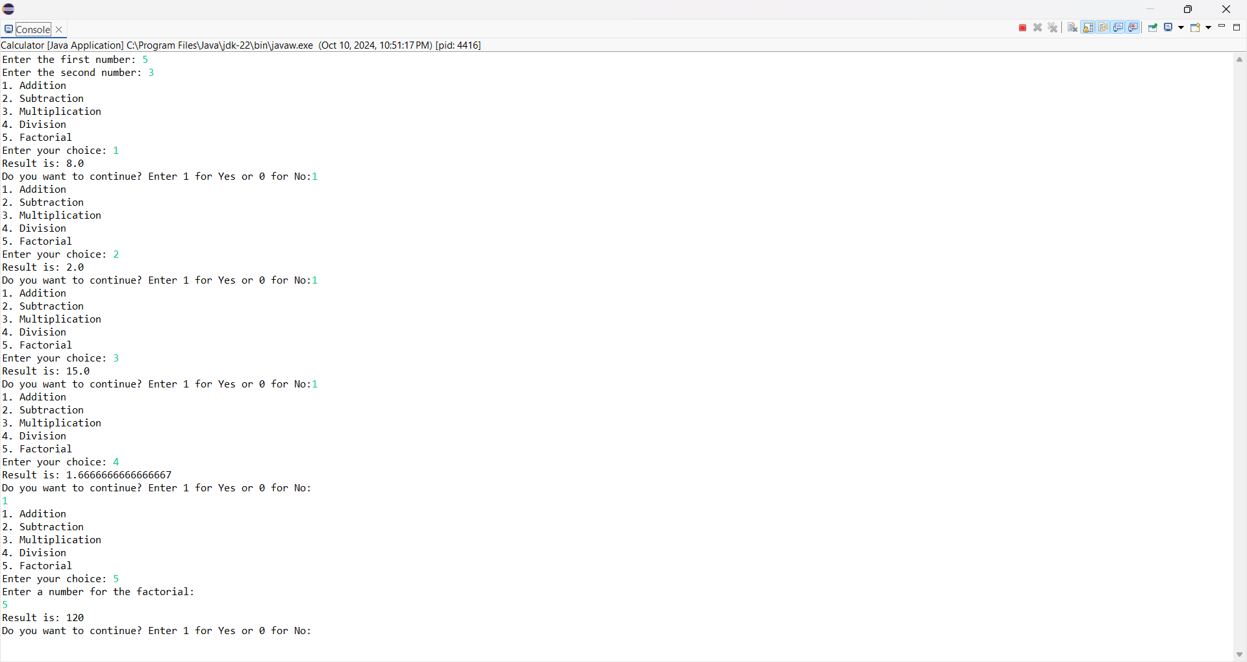

Name:- xyz

Class:- classssss Roll No:- 11111111

Subject:- Fundamentals of Java Programming (Lab Assignment)

Experiment No :-3. Write a program in Java with class Rectangle with the data fields width, length, area and color. The length, width and area are of double type and color is of string type.

**Program: -**

**package** ass3;

**import** java.util.Scanner;

**public** **class** Rectangle {

**double** length, width, area;

String color;

Scanner s = **new** Scanner(System.***in***);

**void** getLength() {

System.***out***.print("Enter length:");

length = s.nextDouble();

}

**void** getWidth() {

System.***out***.print("Enter width:");

width = s.nextDouble();

}

**double** findArea() {

area = length * width;

**return** area;

}

String getColor() {

System.***out***.print("Enter color:");

color = s.next();

**return** color;

}

**public** **static** **void** main(String[] args) {

Rectangle R1 = **new** Rectangle();

Rectangle R2 = **new** Rectangle();

System.***out***.println("Enter the details for 1st rectangle:");

R1.getLength();

R1.getWidth();

String str1 = R1.getColor();

System.***out***.println("Enter the details for 2nd rectangle:");

R2.getLength();

R2.getWidth();

String str2 = R2.getColor();

**if** (R1.findArea() == R2.findArea() && str1.equals(str2)) {

System.***out***.println("Matching Rectangle");

} **else** {

System.***out***.println("Not matching Rectangles");

}

}

}

**Output:-**

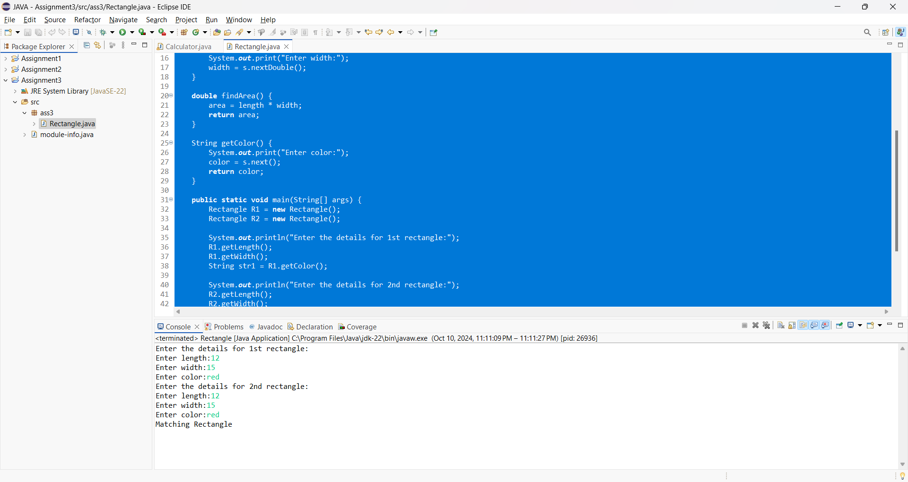

Name:- xyz

Class:- classssss Roll No:- 11111111

Subject:- Fundamentals of Java Programming (Lab Assignment)

Experiment No :- 4. Write a Program in Java to demonstrate method and construct overloading.

**Program: -**

**package** ass4;

**class** Addition {

**double** num1, num2, num3;

Addition(**double** a, **double** b, **double** c) {

num1 = a;

num2 = b;

num3 = c;

}

Addition(**double** a, **double** b) {

num1 = a;

num2 = b;

num3 = 0;

}

Addition() {

num1 = num2 = num3 = 0;

}

Addition(**double** value) {

num1 = num2 = num3 = value;

}

**double** add() {

**return** num1 + num2 + num3;

}

**double** add(**double** num1, **double** num2) {

**return** num1 + num2;

}

**public** **static** **void** main(String[] args) {

Addition sum1 = **new** Addition(10, 20, 50);

Addition sum2 = **new** Addition();

Addition sum3 = **new** Addition(7);

Addition sum4 = **new** Addition(7, 101);

**double** total;

total = sum1.add();

System.***out***.println("Addition is: " + total);

total = sum2.add();

System.***out***.println("Addition is: " + total);

total = sum3.add();

System.***out***.println("Addition is: " + total);

total = sum4.add();

System.***out***.println("Addition is: " + total);

}

}

**Output:-**

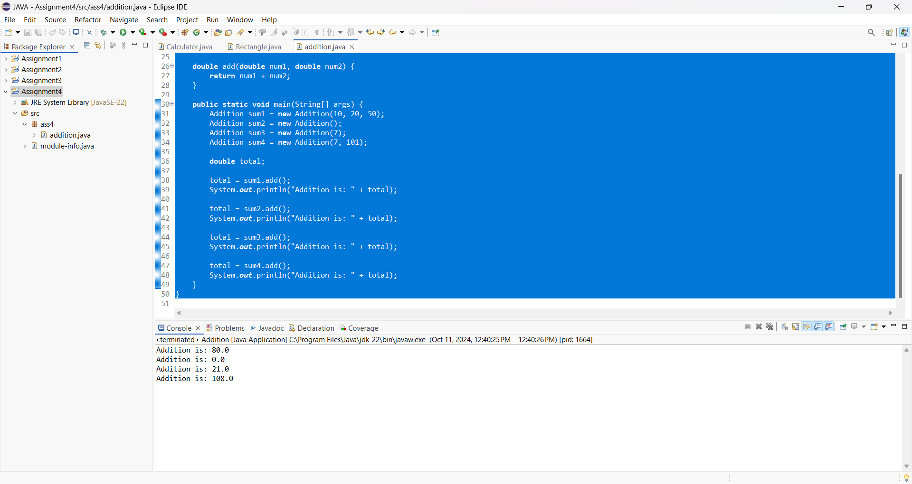

Name:- xyz

Class:- classssss Roll No:- 11111111

Subject:- Fundamentals of Java Programming (Lab Assignment)

Experiment No :- 5. Write a Programs in JAVA to sort i)List of Integers ii)List of names

**Program: -**

**package** ass5;

**import** java.util.Scanner;

**class** Sort {

**void** sortInterger(**int** a[]) {

**for** (**int** i = 0; i < a.length; i++) {

**for** (**int** j = i + 1; j < a.length; j++) {

**if** (a[i] > a[j]) {

**int** temp = a[i];

a[i] = a[j];

a[j] = temp;

} } } }

**void** sortString(String str[]) {

String temp;

**for** (**int** i = 0; i < str.length; i++) {

**for** (**int** j = i + 1; j < str.length; j++) {

**if** (str[i].compareTo(str[j]) > 0) {

temp = str[i];

str[i] = str[j];

str[j] = temp;

} } } }

**public** **class** sortIntName {

**public** **static** **void** main(String[] args) {

Sort obj = **new** Sort();

Scanner in = **new** Scanner(System.***in***);

**int** choice;

**do** {

System.***out***.println(" 1.Sort Integer\n 2.Sort String");

System.***out***.print("Enter the choice: ");

**int** ch = in.nextInt();

**switch** (ch) {

**case** 1:

System.***out***.print("Enter the size of Array:");

**int** n = in.nextInt();

System.***out***.println("Enter the Numbers :");

**int** arr[] = **new** **int**[n];

**for** (**int** i = 0; i < n; i++)

arr[i] = in.nextInt();

obj.sortInterger(arr);

System.***out***.println("Sorted Numbers :");

**for** (**int** i = 0; i < n; i++)

System.***out***.print(arr[i] + " ");

**break**;

**case** 2:

String names[] = { "ram", "shyam", "seeta", "geeta", "reeta" };

obj.sortString(names);

**for** (**int** i = 0; i < names.length; i++)

System.***out***.print(names[i] + " ");

**break**;

}

System.***out***.println("\nDo U want to continue 1 or 0?");

choice = in.nextInt();

} **while** (choice == 1);

}

}

**Output:-**

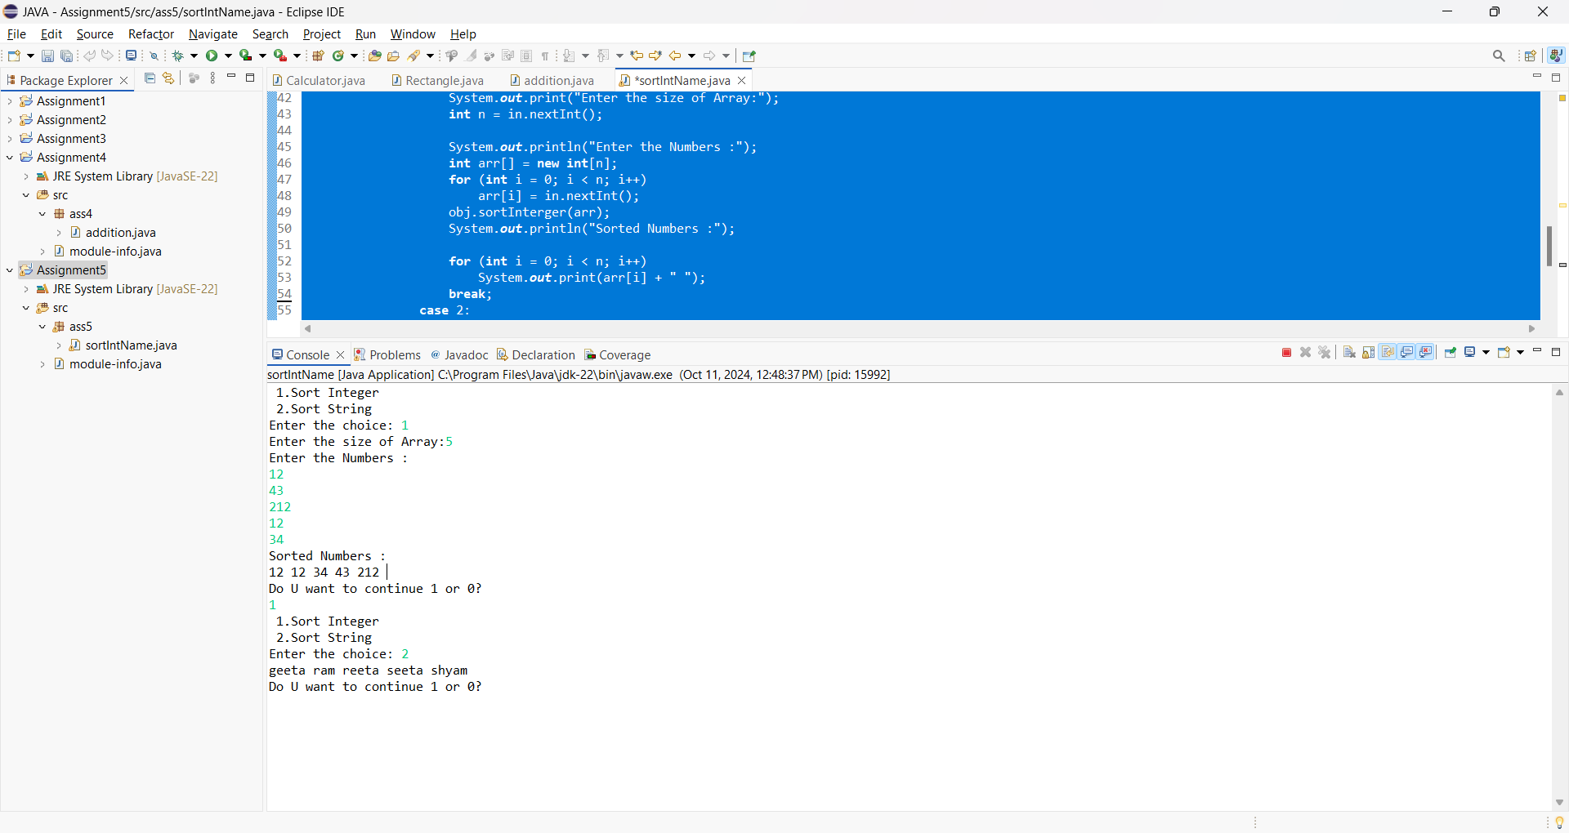

Name:- xyz

Class:- classssss Roll No:- 11111111

Subject:- Fundamentals of Java Programming (Lab Assignment)

Experiment No :- 6. Addition of Two Matrices to learn the concept of Two dimensional Arrays in Java

**Program: -**

**package** ass6;

**import** java.util.Scanner;

**public** **class** addMatrics {

**public** **static** **void** main(String[] args) {

Scanner s = **new** Scanner(System.***in***);

System.***out***.print("Enter number of rows: ");

**int** rows = s.nextInt();

System.***out***.print("Enter number of columns: ");

**int** columns = s.nextInt();

**int**[][] a = **new** **int**[rows][columns]; // First matrix array

**int**[][] b = **new** **int**[rows][columns]; // Second matrix array

System.***out***.println("Enter the first matrix:");

**for** (**int** i = 0; i < rows; i++) {

**for** (**int** j = 0; j < columns; j++) {

a[i][j] = s.nextInt();

}

}

System.***out***.println("Enter the second matrix:");

**for** (**int** i = 0; i < rows; i++) {

**for** (**int** j = 0; j < columns; j++) {

b[i][j] = s.nextInt();

}

}

**int**[][] c = **new** **int**[rows][columns];

**for** (**int** i = 0; i < rows; i++) {

**for** (**int** j = 0; j < columns; j++) {

c[i][j] = a[i][j] + b[i][j];

}

}

System.***out***.println("The sum of the two matrices is:");

**for** (**int** i = 0; i < rows; i++) {

**for** (**int** j = 0; j < columns; j++) {

System.***out***.print(c[i][j] + " ");

}

System.***out***.println();

}

s.close();

}

}

**Output:-**

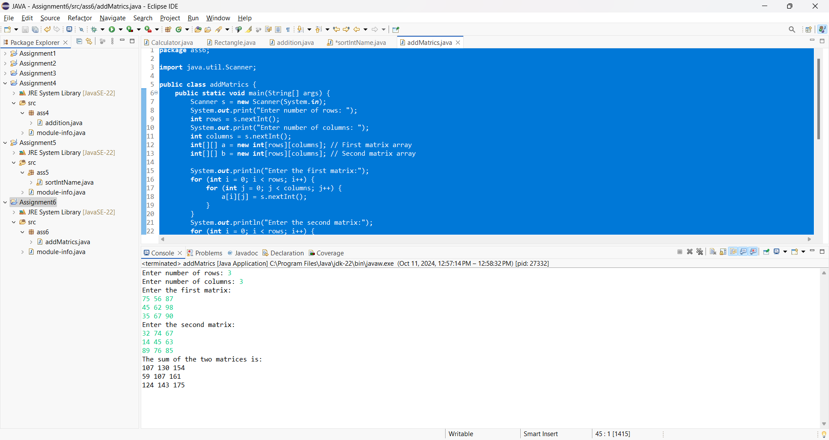

Name:- xyz

Class:- classssss Roll No:- 11111111

Subject:- Fundamentals of Java Programming (Lab Assignment)

Experiment No :- 7. Write a program in Java to create a player class. Inherit the classes Cricket_player, Football_player and Hockey_player from player class.

**Program: -**

**package** ass7;

**import** java.util.Scanner;

**class** Player {

String name;

**int** age;

String gameName;

**int** noOfGamesPlayed;

String address;

String type;

Scanner in = **new** Scanner(System.***in***);

**void** getDetails() {

System.***out***.println("Enter the details: Name, Age, Address, Name of Game, No of Games Played, and Type:");

name = in.nextLine();

age = in.nextInt();

in.nextLine(); // Consume newline character

address = in.nextLine();

gameName = in.nextLine();

noOfGamesPlayed = in.nextInt();

in.nextLine(); // Consume newline character

type = in.nextLine();

}

**void** display() {

System.***out***.println("Name: " + name);

System.***out***.println("Age: " + age);

System.***out***.println("Game Name: " + gameName);

System.***out***.println("Total Matches: " + noOfGamesPlayed);

System.***out***.println("Address: " + address);

System.***out***.println("International/National: " + type);

}

}

**class** Cricket_Player **extends** Player {

**int** totalRuns;

**int** totalWickets;

**void** getDetails() {

**super**.getDetails();

System.***out***.println("Enter the Total Runs and Wickets:");

totalRuns = in.nextInt();

totalWickets = in.nextInt();

}

**void** display() {

**super**.display();

System.***out***.println("Total Runs: " + totalRuns);

System.***out***.println("Total Wickets: " + totalWickets);

}

}

**class** FootBall_Player **extends** Player {

**int** noOfGoals;

**void** getDetails() {

**super**.getDetails();

System.***out***.println("Enter the total number of Goals:");

noOfGoals = in.nextInt();

}

**void** display() {

**super**.display();

System.***out***.println("Total Goals: " +noOfGoals);

}

}

**class** Hockey_Player **extends** Player {

**int** noOfGoals;

**void** getDetails() {

**super**.getDetails();

System.***out***.println("Enter the total number of Goals:");

noOfGoals = in.nextInt();

}

**void** display() {

**super**.display();

System.***out***.println("Total Goals: " +noOfGoals);

}

}

**public** **class** InheritanceClass {

**public** **static** **void** main(String[] args) {

Cricket_Player cp = **new** Cricket_Player();

cp.getDetails();

cp.display();

System.***out***.println();

FootBall_Player fp = **new** FootBall_Player();

fp.getDetails();

fp.display();

System.***out***.println();

Hockey_Player hp = **new** Hockey_Player();

hp.getDetails();

hp.display();

}

}

**Output:-**

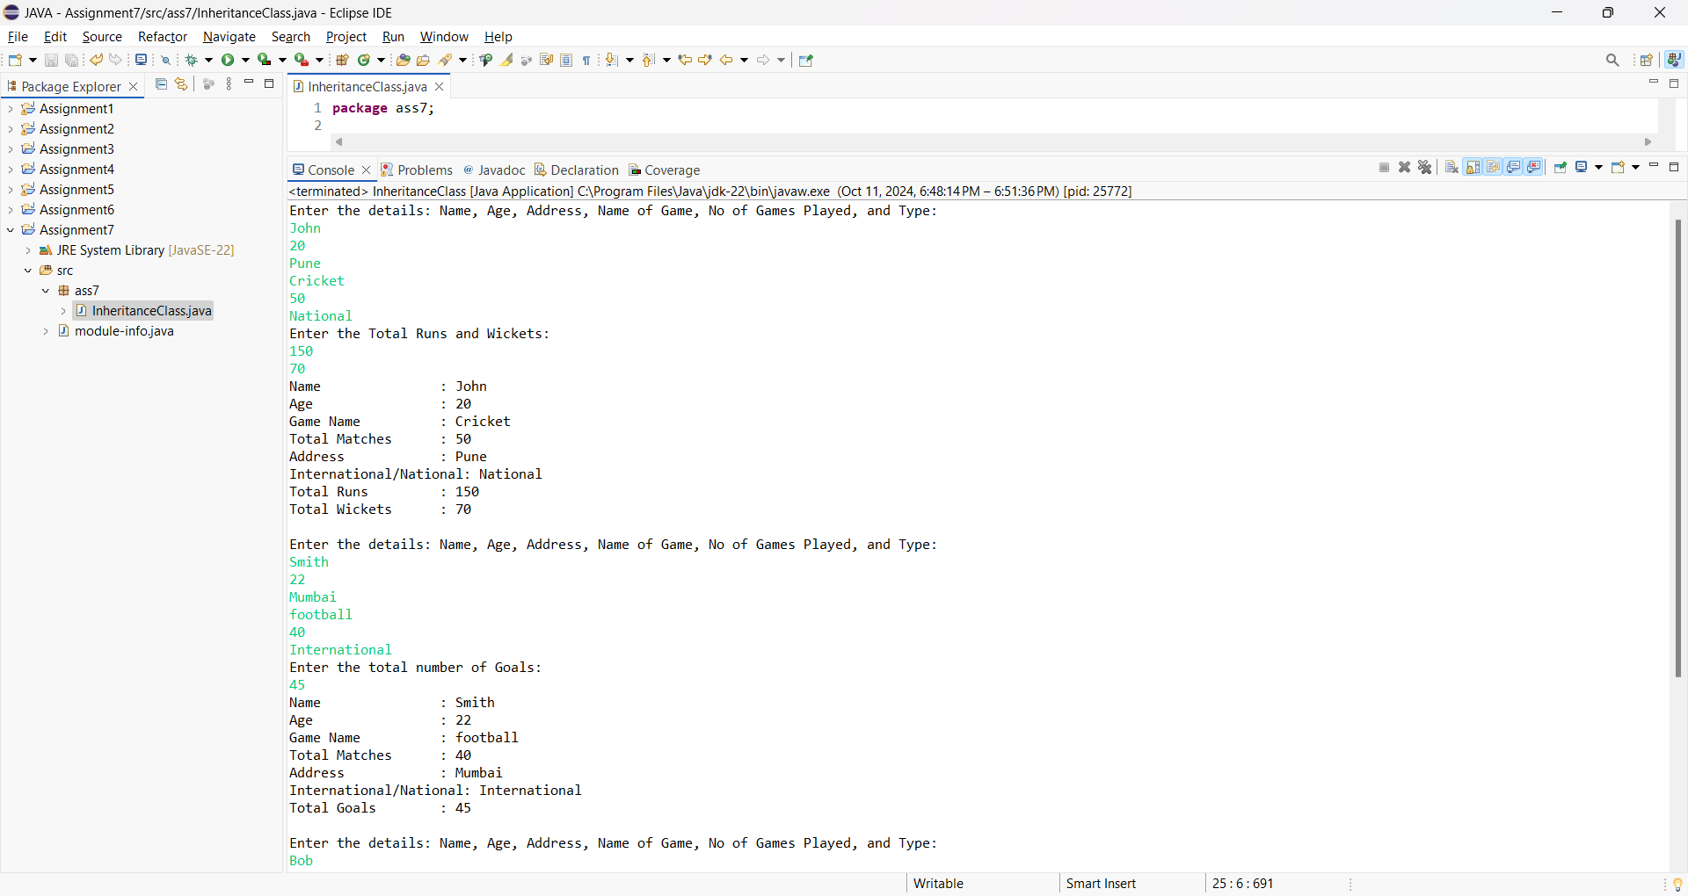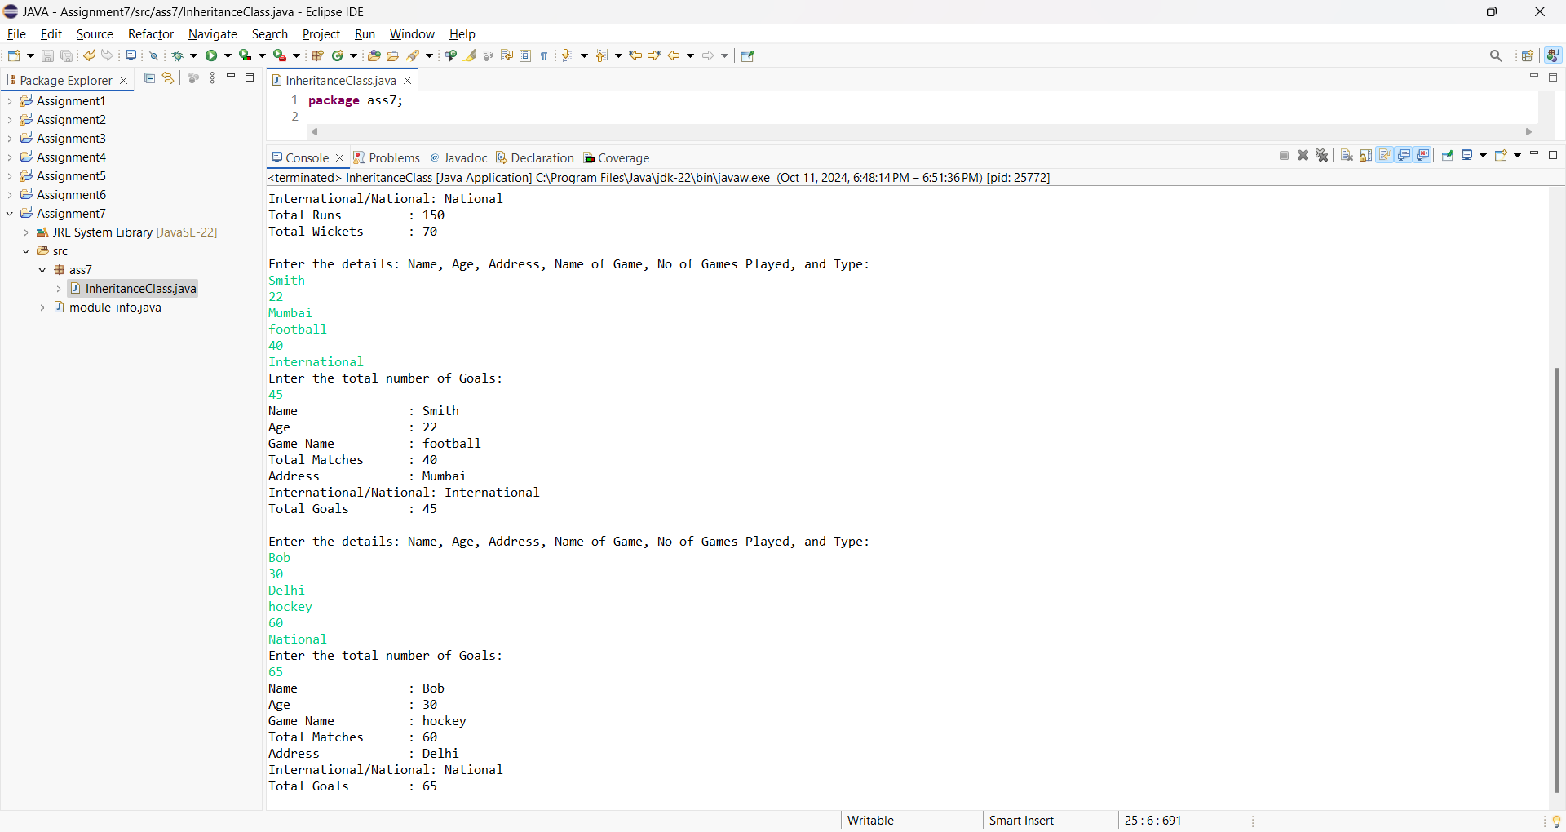



Name:- xyz

Class:- classssss Roll No:- 11111111

Subject:- Fundamentals of Java Programming (Lab Assignment)

Experiment No :- 8. Write a JAVA program which imports user defined package and uses members of the classes contained in the classes

**Program: -**

**Program for First Package-**

**package** packageproject;

**public** **class** packageclass {

**public** **int** x, y;

**public** **void** display() {

System.***out***.println("Welcome to package project - PackageClass");

}

**public** **int** add(**int** x, **int** y) {

**return** x + y;

}

}

**Program for First Package-**

**package** mypackage;

**import** packageproject.*;

**public** **class** mypackageclass {

**public** **static** **void** main(String[] args) {

packageclass p1 = **new** packageclass();

p1.display();

System.***out***.println("Addition is = " + p1.add(10, 20));

}

}

**Output:-**

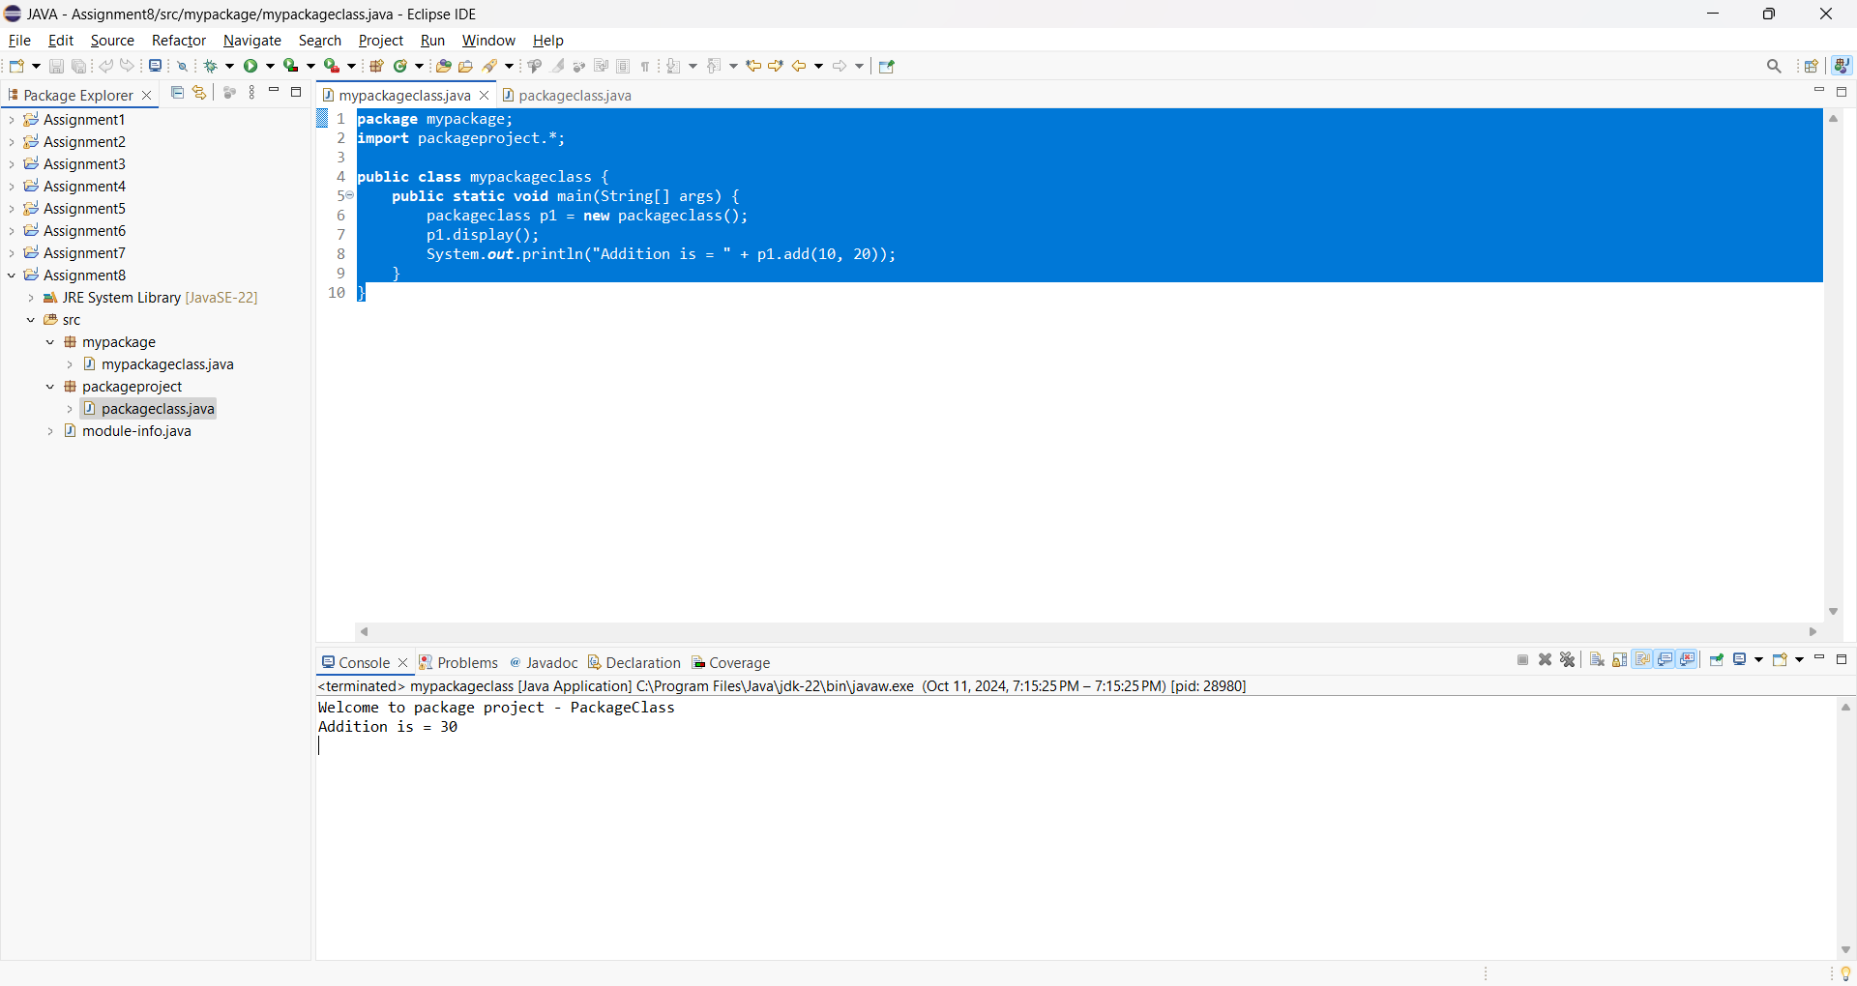

Name:- xyz

Class:- classssss Roll No:- 11111111

Subject:- Fundamentals of Java Programming (Lab Assignment)

Experiment No :- 9. Write a JAVA Program which Implement Interface

**Program: -**

**package** ass9;

**interface** Area {

**final** **static** **float** ***PI*** = 3.14f;

**float** compute(**float** x, **float** y);

}

**public** **class** InterfaceClass **implements** Area {

**public** **float** compute(**float** x, **float** y) {

**return** (***PI*** * x * y);

}

**public** **static** **void** main(String[] args) {

InterfaceClass p1 = **new** InterfaceClass();

System.***out***.println("Area = " + p1.compute(20.00f, 20.0f));

}

}

**Output:-**

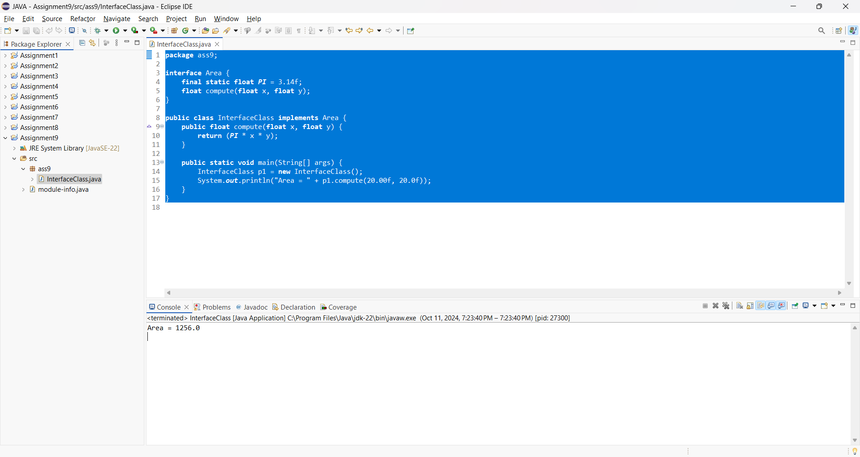

Name:- xyz

Class:- classssss Roll No:- 11111111

Subject:- Fundamentals of Java Programming (Lab Assignment)

Experiment No :- 10. Write a JAVA Program which use try and catch for exception handling.

**Program: -**

**package** ass10;

**public** **class** ExceptionHandling {

**public** **static** **void** main(String[] args) {

**int** num1 = 15, num2 = 0, result = 0;

**try** {

result = num1 / num2;

System.***out***.println("The result is: " + result);

}

**catch** (ArithmeticException e) {

System.***out***.println("Can't be divided by Zero: " + e);

}

}

}

**Output:-**

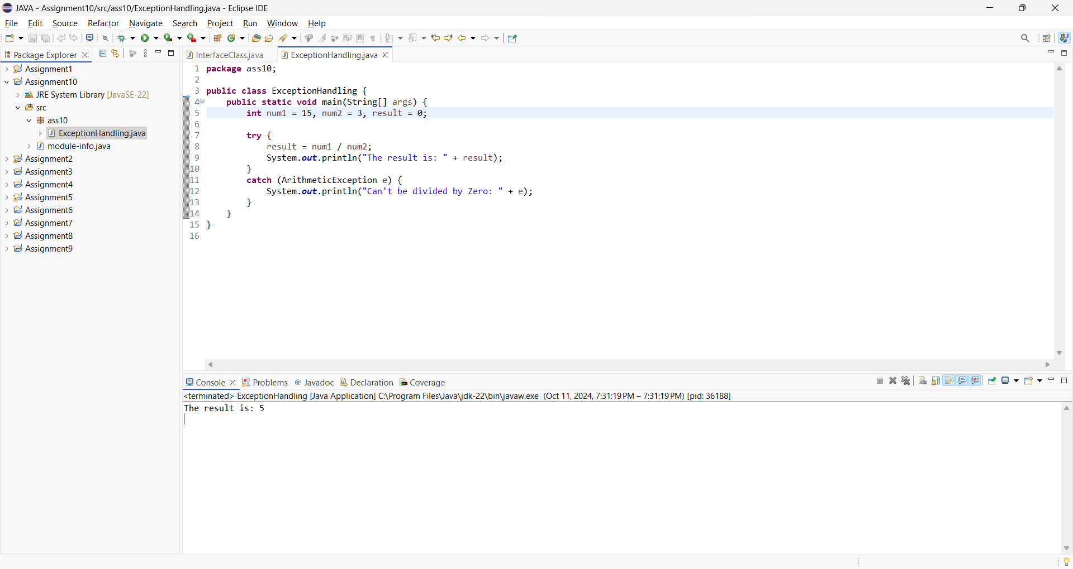

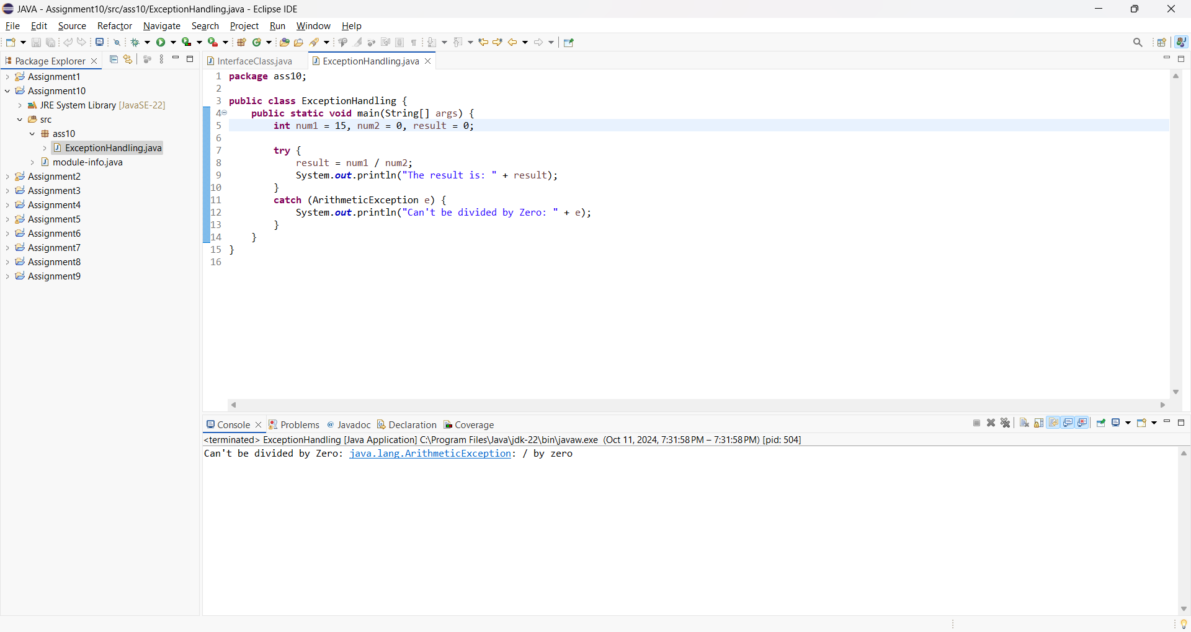

Name:- xyz

Class:- classssss Roll No:- 11111111

Subject:- Fundamentals of Java Programming (Lab Assignment)

Experiment No :- 11. Write a JAVA Program to draw oval, rectangle, line, text using graphics class.

**Program: -**

**package** ass11;

**import** java.applet.Applet;

**import** java.awt.Color;

**import** java.awt.Graphics;

**public** **class** AppletClass **extends** Applet {

**public** **void** paint(Graphics g) {

//g.drawString("Hello APPLETS", 10, 50);

//g.setColor(Color.blue);

g.fillOval(170, 200, 30, 30);

//g.drawArc(90, 150, 30, 30, 30, 270);

//g.fillArc(270, 150, 30, 30, 0, 180);

//g.drawLine(21, 31, 20, 300);

//g.drawRect(70, 100, 30, 30);

//g.fillRect(170, 100, 30, 30);

//g.drawOval(70, 200, 30, 30);

}

}

**Output:-**

Name:- xyz

Class:- classssss Roll No:- 11111111

Subject:- Fundamentals of Java Programming (Lab Assignment)

Experiment No :- 12. Write a JAVA Program in which data is read from one file and should be written in another file line by line.

**Program: -**

**Output:-**