SIES GRADUATE SCHOOL OF TECHNOLOGY
(Autonomous College) — University of Mumbai

A PROJECT REPORT ON

ML VIRTUAL LAB
A Browser-Native Interactive Virtual Laboratory for Machine Learning

Submitted in partial fulfilment of the requirements for
CSC701 — Machine Learning Laboratory
B.E. (Computer Engineering) — Semester VII

Live Deployment: https://machine-learning-siesgst.vercel.app

Department of Computer Engineering
SIES Graduate School of Technology, Nerul, Navi Mumbai

Certificate
This is to certify that the project titled “ML Virtual Lab — A Browser-Native Interactive Virtual Laboratory for Machine Learning” has been carried out as part of the CSC701 Machine Learning Laboratory course, Semester VII, Department of Computer Engineering, SIES Graduate School of Technology (Autonomous), University of Mumbai, and satisfactorily presents the design, implementation and verification of the system described herein.
______________________ Faculty In-Charge
______________________ Head of Department
______________________ External Examiner

Acknowledgement
We would like to express our sincere gratitude to the Department of Computer Engineering, SIES Graduate School of Technology, for the opportunity to design and build this virtual laboratory as part of the CSC701 Machine Learning course. We thank our faculty in-charge for their guidance on the syllabus mapping and evaluation rubric, and the University of Mumbai curriculum committee for the CSC701 course structure that this lab implements end-to-end.

Abstract
ML Virtual Lab is a browser-native interactive laboratory that implements the complete University of Mumbai CSC701 (Machine Learning) syllabus as ten hands-on programming experiments, following the eight-section Virtual Labs pedagogical format — Aim, Theory, Pretest, Procedure, Simulation, Posttest, Further Readings and Feedback. Its central engineering contribution is running an authentic CPython interpreter, compiled to WebAssembly via Pyodide, directly inside the student's browser tab — executing real NumPy, SciPy, scikit-learn, pandas and matplotlib code with no server-side execution, no account, and no installation. A shared runtime layer classifies every import before execution, so packages that cannot exist in WebAssembly (for example PyTorch or TensorFlow) are refused pre-flight with actionable guidance rather than crashing; tracebacks are rewritten to point at the student's own source lines; and matplotlib figures are captured whether or not the student calls plt.show(). Each experiment ships a VS Code-style IDE (Monaco editor) with a starter scaffold and a worked solution, auto-graded pretest/posttest quizzes, and further-reading references. The system was verified through a three-tier automated suite — headless Node.js execution of all twenty code blocks, sixteen behavioural correctness checks, and a full Playwright browser sweep across all ten experiments in both light and dark themes — and is deployed publicly at https://machine-learning-siesgst.vercel.app.

Keywords
WebAssembly, Pyodide, Client-Side Python Execution, Virtual Laboratory, Machine Learning Education, Next.js, Monaco Editor, Browser-Native Compute.

Table of Contents
1. Introduction
2. Problem Statement & Objectives
3. Literature Survey / Existing Systems
4. System Requirements
5. System Architecture
6. Technology Stack
7. Implementation Details
8. Modules — The Ten Experiments
9. Testing & Verification
10. Results & Screenshots
11. Deployment
12. Conclusion & Future Scope
13. References

1. Introduction
Machine Learning laboratory courses traditionally require students to install and configure a Python scientific stack — NumPy, SciPy, scikit-learn, matplotlib — on their own machines before any learning can begin. In a classroom of thirty-plus students running different operating systems, Python versions and permission levels, this setup step alone consumes a disproportionate share of lab time and introduces failure modes unrelated to the subject matter.
ML Virtual Lab removes that friction entirely by running the Python interpreter itself inside the browser. Using Pyodide — a distribution of CPython compiled to WebAssembly — the application executes genuine, unmodified scikit-learn and NumPy code on the client machine, with no server in the execution path and no code ever transmitted anywhere. The result is a laboratory that opens in a single browser tab, on any device, in seconds, and behaves exactly like a local Python installation from the student's point of view.
The system follows the IIT Virtual Labs pedagogical format, giving every experiment eight consistent sections — Aim, Theory, Pretest, Procedure, Simulation, Posttest, Further Readings and Feedback — so that theory, practice and assessment live in one continuous flow rather than three disconnected documents (a PDF manual, a separate IDE, and a paper quiz).

2. Problem Statement & Objectives
Design and implement a web-based virtual laboratory that delivers the complete CSC701 Machine Learning syllabus as interactive, auto-graded, zero-installation programming experiments, while guaranteeing that the code students write and run is genuine, unmodified Python executing against real scientific libraries — not a simulation, subset, or server-side sandbox.

Objectives
- Implement all ten CSC701 lab experiments as real, runnable Python code covering regression, classification, ensemble learning, clustering and dimensionality reduction.
- Run every experiment entirely client-side, in the browser, with no server-side code execution and no account required.
- Reproduce the full eight-section Virtual Labs structure for each experiment, including auto-graded pretest and posttest quizzes with per-question explanations.
- Detect, before execution, any import that cannot run in a WebAssembly Python runtime, and explain the alternative rather than crashing or hanging.
- Provide a professional, VS Code-equivalent code editing experience (syntax highlighting, resizable panes, starter/solution toggling) rather than a bare textarea.
- Verify correctness through automated, reproducible tests rather than manual spot-checks, across both the Node.js execution environment and a real browser.

3. Literature Survey / Existing Systems
System | Execution Model | Key Limitation Addressed by ML Virtual Lab
IIT Virtual Labs | Server-side simulations / applets | No live Python editing; fixed parameter sliders, not free-form code
Jupyter Notebook (local) | Local kernel | Requires local installation; environment drift between students
Google Colab | Cloud VM, server-side | Requires a Google account; code executes on Google's servers, not the student's machine
Replit / online IDEs | Server-side containers | Network-dependent; execution cost and latency scale with concurrent users
ML Virtual Lab (this project) | Client-side WebAssembly (Pyodide) | Zero server execution cost, zero account, works after first load, full IDE

The comparison shows a consistent pattern: existing platforms either sacrifice code freedom (fixed simulations) or push execution cost and privacy exposure onto a server. Running the interpreter client-side via WebAssembly resolves both trade-offs at once.

4. System Requirements

Hardware Requirements (Client)
- Any device capable of running a modern web browser (desktop, laptop, Chromebook, or tablet).
- Minimum 4 GB RAM recommended for smooth WebAssembly execution of the scientific stack.
- No GPU required — all ten experiments use classical ML algorithms, not deep learning.

Software Requirements
Component | Requirement
Browser | Any modern evergreen browser with WebAssembly support (Chrome, Edge, Firefox, Safari)
Internet | Required only for the first load per experiment (~25 MB, cached afterwards)
Server | None — static hosting only (Vercel)
Account / Login | None required

Development Environment
Layer | Technology
Framework | Next.js 15 (App Router), React 19, TypeScript
Styling | Tailwind CSS 3.4
Code Editor | Monaco Editor (@monaco-editor/react)
Python Runtime | Pyodide 314.0.5 (Python 3.14.2)
Testing | tsx + pyodide (Node), Playwright (browser)
Hosting | Vercel

5. System Architecture
The system is deliberately server-less at the execution layer. The Next.js application is statically generated and served from Vercel's edge network; the browser downloads the page, then — on the student's first Run — downloads and boots the Pyodide WebAssembly runtime once, caching it for the remainder of the session. All subsequent code execution, state, and figure rendering happens entirely inside that browser tab.

Execution Flow
- Student opens an experiment page; Next.js serves the pre-rendered Aim/Theory/Procedure content.
- Student opens the Simulation tab; the Pyodide engine is lazily loaded and initialised.
- Student's source is scanned for imports and classified: standard library, bundled in the Pyodide distribution, installable via micropip from PyPI, or unsupported.
- If any import is unsupported, execution is refused before running, with an explanation and a suggested alternative.
- Otherwise, the code runs inside a preamble that captures stdout/stderr, rewrites tracebacks to reference the student's own line numbers, and intercepts matplotlib figures as base64 PNGs.
- Console output and any figures are rendered in the Output panel; nothing leaves the browser.

Shared Runtime Layer
A single LabRuntime class implements this entire pipeline and is consumed identically by the React UI in the browser and by the Node.js verification scripts, guaranteeing that what is tested in CI is exactly what a student's browser executes — not an approximation of it.

6. Technology Stack
Category | Technology | Purpose
Frontend Framework | Next.js 15 / React 19 | App Router, static generation, client components
Language | TypeScript | Type-safe application and runtime code
Styling | Tailwind CSS 3.4 | Utility-first styling, light/dark theme system
Code Editor | Monaco Editor | Same editor engine that powers VS Code
Python Runtime | Pyodide 314.0.5 | CPython 3.14.2 compiled to WebAssembly
Scientific Libraries | NumPy, SciPy, pandas, scikit-learn, matplotlib, networkx | Bundled inside the Pyodide distribution
Package Installer | micropip | On-demand install of pure-Python PyPI packages (e.g. seaborn)
Testing (Node) | tsx + pyodide npm package | Headless verification of every code block
Testing (Browser) | Playwright | End-to-end verification across all experiments and both themes
Hosting | Vercel | Static hosting and global edge delivery

7. Implementation Details

7.1 Compiler-Like Execution Guarantees
- : exception frames are trimmed and rewritten so the student sees their own source line, not an internal wrapper frame.Line-accurate tracebacks
- : the matplotlib backend is monkey-patched so any open figure is captured at the end of execution, regardless of whether the student called plt.show().Figure capture without plt.show()
- : stray Jupyter-style %magics and !shell commands are stripped rather than raising a SyntaxError, since students often paste code from notebooks.Notebook-syntax stripping
- : imports are statically scanned (with string/comment literals excluded, so print('import torch') is not a false positive) and classified before any code runs, so an unsupported package fails predictably and instantly — not mid-run.Deterministic pre-flight blocking
- : the Python namespace persists across runs within a session, matching REPL-like expectations, and can be explicitly reset.State persistence

7.2 Package Support Policy
Every import is resolved against one of four categories: (a) Python standard library modules (194 modules for Python 3.14), (b) modules already bundled in the Pyodide 314.0.5 distribution (304 module→package mappings, generated from the official pyodide-lock.json), (c) pure-Python packages installable on demand via micropip — including seaborn, plotly, imbalanced-learn, mlxtend and others — and (d) packages that fundamentally cannot run in WebAssembly, such as PyTorch and TensorFlow (which require a native, non-WASM backend). Category (d) imports are refused before execution with a specific, actionable explanation — for example, instructing the student to use scikit-learn's TfidfVectorizer in place of a transformer-based tokenizer inside this lab, or to run PyTorch locally instead.

7.3 The Simulation IDE
Each experiment's Simulation tab opens a dedicated, VS Code-styled full-screen interface: an activity bar toggles Aim/Theory/Procedure/Further-Reading reference panels without leaving the editor; the Monaco editor provides real Python syntax highlighting and a resizable split against a Console/Plots output panel; and a toolbar switches between the Starter scaffold (TODO markers for the student to complete) and a complete worked Solution. The entire interface respects a site-wide light/dark theme toggle, including the editor's own colour theme.

7.4 Auto-Graded Assessment
Each experiment carries five authored Pretest questions (checking prerequisite understanding before the student starts) and five Posttest questions (referencing output and plots only visible after actually running the code), each with a worked explanation shown after submission — one hundred questions in total across the ten experiments.

8. Modules — The Ten Experiments
Every experiment implements three approaches side by side wherever the syllabus calls for it — a from-scratch closed-form/direct implementation, an iterative implementation (e.g. Gradient Descent or Expectation Maximization written by hand), and the equivalent scikit-learn call — so a student sees both the underlying mathematics and the production-grade library usage in the same file.
# | Experiment | Category | Lab Outcome
1 | Simple Linear Regression | Regression | LO1
2 | Multiple Linear Regression | Regression | LO1
3 | Multivariate Linear Regression | Regression | LO1
4 | Logistic Regression | Classification | LO2
5 | Ensemble Learning: Random Forest | Ensemble Learning | LO2
6 | Ensemble Learning: AdaBoost | Ensemble Learning | LO2
7 | Support Vector Machine (SVM) | Classification | LO2
8 | Graph-Based Clustering: Divisive Clustering (MST) | Clustering | LO2
9 | Model-Based Clustering: Expectation Maximization (GMM) | Clustering | LO3
10 | Dimensionality Reduction: PCA | Dimensionality Reduction | LO3

Lab Outcomes
Code | Outcome
LO1 | Implement an appropriate machine learning model for a given application.
LO2 | Implement ensemble techniques and classification models to combine predictions.
LO3 | Implement dimensionality reduction techniques.

9. Testing & Verification
Correctness is established through automated evidence, not manual assertion, across three independent tiers that each catch a different class of failure.
Tier | Tool | What it Verifies
1. Headless Execution | tsx + pyodide (Node) | All 20 code blocks (10 starter + 10 solution) run to completion; declared packages match actual imports; solutions produce output and a figure.
2. Behavioural Suite | tsx + pyodide (Node) | 16 specific guarantees — line-accurate tracebacks, SyntaxError surfacing, pre-flight blocking of torch, figure capture with/without plt.show(), state persistence, on-demand package install, and more.
3. Browser Sweep | Playwright + Chromium | Every section of every experiment renders; the Pretest grades correctly; a Solution run produces a real console output and matplotlib figure with zero uncaught JS errors, across all 10 experiments and both light/dark themes.

Representative results from the latest full verification run against this build:
- verify (headless execution): 20 / 20 passed
- verify:behaviour (correctness guarantees): 16 / 16 passed
- verify:browser (end-to-end, all experiments, both themes): 31 / 31 passed

10. Results & Screenshots
The following screenshots were captured directly from the live public deployment at https://machine-learning-siesgst.vercel.app.
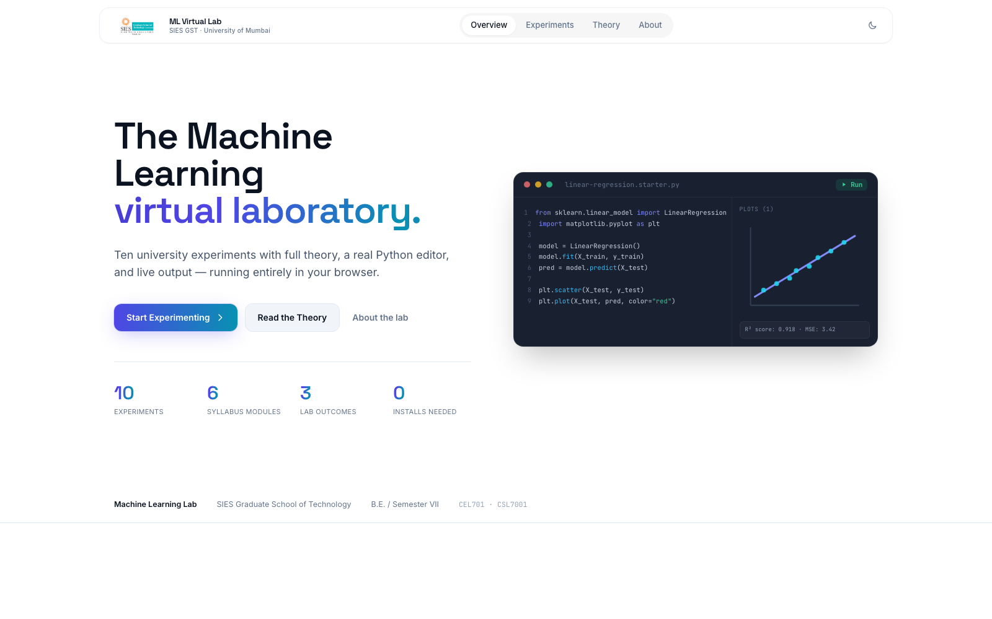
Fig. 10.1 — Landing page: overview, live stats, and the syllabus module index.
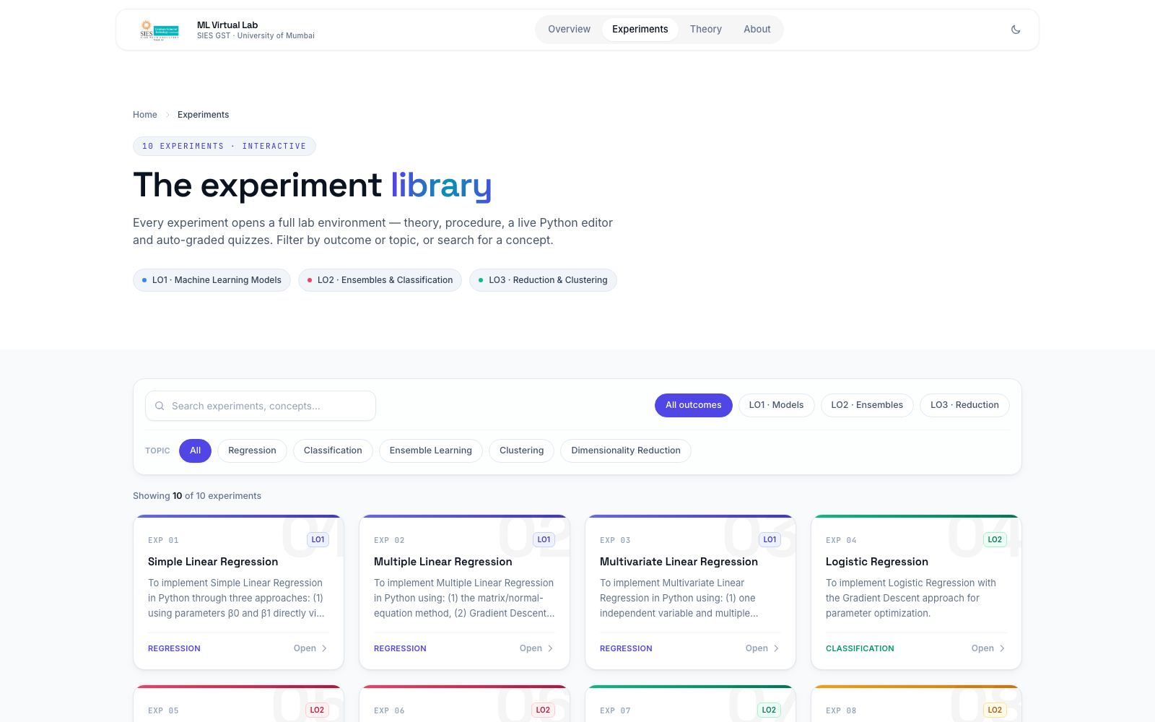
Fig. 10.2 — Experiment library, filterable by lab outcome and topic.
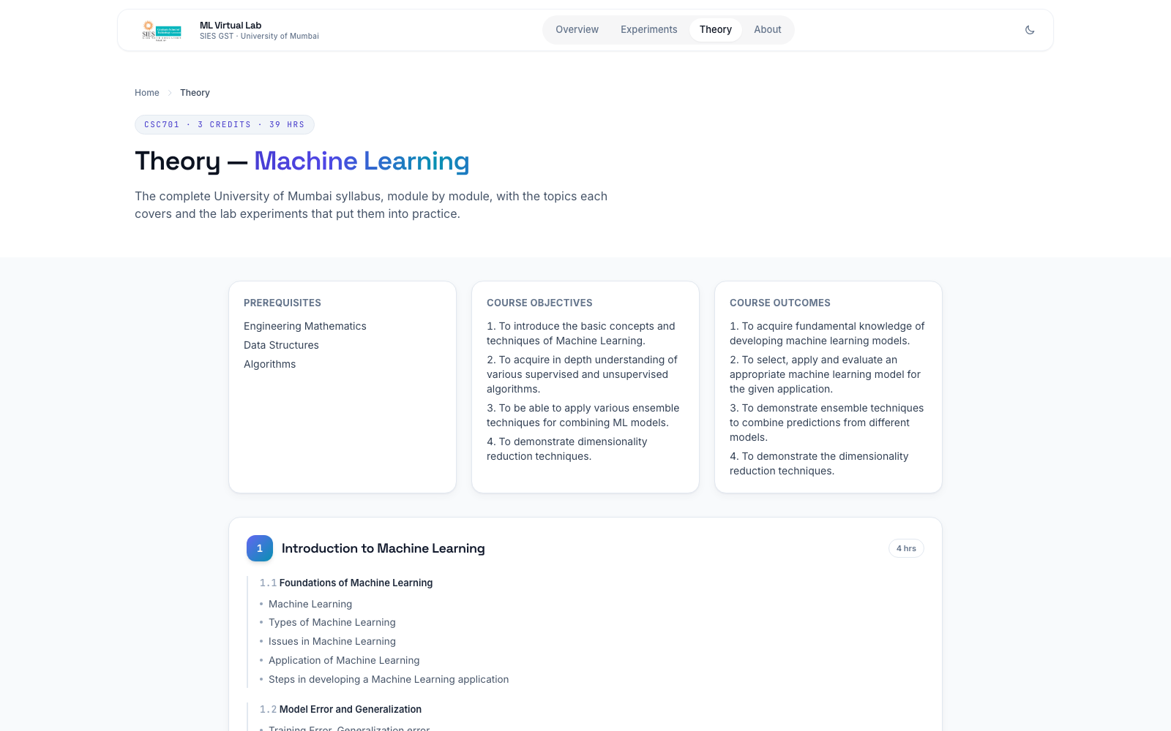
Fig. 10.3 — Theory page: the full CSC701 syllabus, mapped module-by-module to experiments.
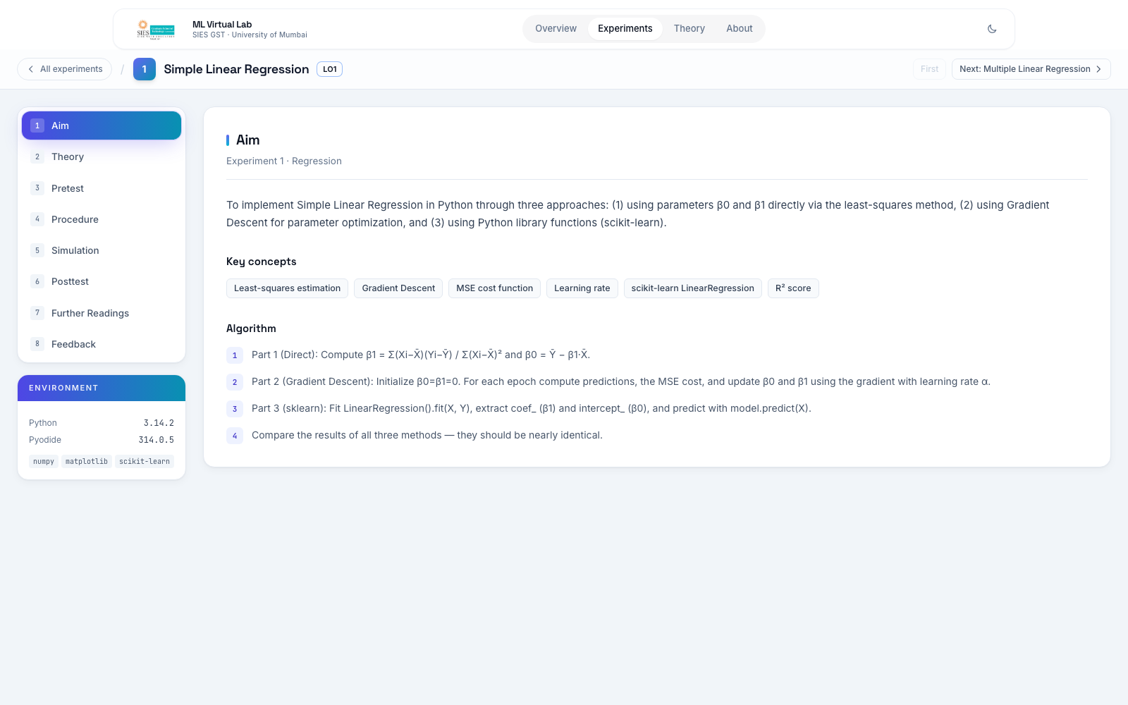
Fig. 10.4 — An experiment's Aim section, with the 8-section spine on the left.
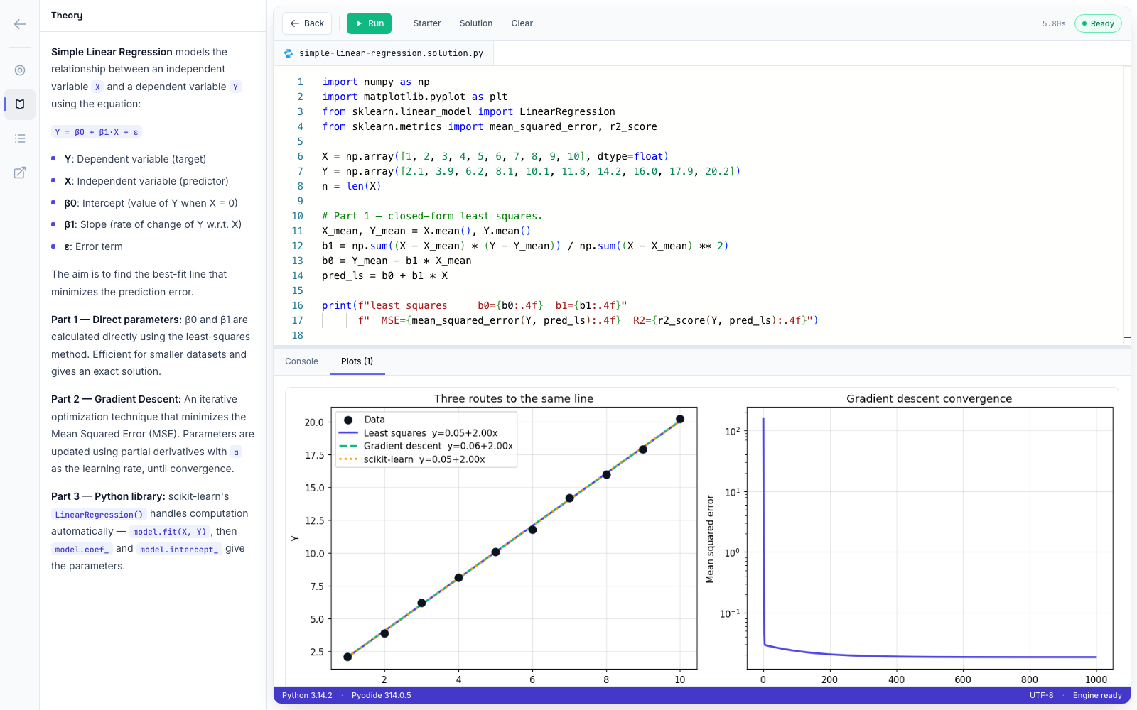
Fig. 10.5 — The Simulation IDE after Run: real console output and a live matplotlib figure.

11. Deployment
The application is deployed as a static-first Next.js site on Vercel, which builds and serves every experiment page ahead of time and delivers it from Vercel's global edge network. Because all ML execution happens client-side, the hosting cost and scaling characteristics are those of a static site regardless of how many students are running Python simultaneously — there is no server-side compute to provision for the lab workload itself.
Live URL: https://machine-learning-siesgst.vercel.app

12. Conclusion & Future Scope

Conclusion
ML Virtual Lab demonstrates that a full university Machine Learning laboratory course can be delivered with zero installation friction while preserving complete code authenticity — students write and execute real, unmodified Python against real scientific libraries, not a simulated or restricted subset. By combining a WebAssembly Python runtime with a professional code-editing experience and the standard Virtual Labs pedagogical structure, the system removes the single largest barrier to hands-on ML education — environment setup — without compromising on what students actually get to do once they arrive.

Future Scope
- Execution timeout / interruption for runaway or infinite-loop student code.
- GPU-backed deep learning experiments via WebGPU as browser support matures.
- Instructor dashboard aggregating pretest/posttest performance across a cohort.
- Downloadable per-student progress reports (currently feedback and quiz results are browser-local only, by design, for privacy).
- Additional experiment tracks beyond CSC701 (e.g. Deep Learning, NLP) using the same runtime.

13. References
- University of Mumbai, CSC701 — Machine Learning Syllabus, B.E. Semester VII, Rev-2019 “C” Scheme.
- T. Hastie, R. Tibshirani, J. Friedman, The Elements of Statistical Learning, 2nd ed., Springer, 2009.
- G. James, D. Witten, T. Hastie, R. Tibshirani, An Introduction to Statistical Learning, Springer, 2013.
- T. M. Mitchell, Machine Learning, McGraw-Hill, 1997.
- C. M. Bishop, Pattern Recognition and Machine Learning, Springer, 2006.
- L. Breiman, “Random Forests,” Machine Learning, vol. 45, pp. 5–32, 2001.
- Y. Freund, R. E. Schapire, “A Decision-Theoretic Generalization of On-Line Learning and an Application to Boosting,” Journal of Computer and System Sciences, vol. 55, 1997.
- C. Cortes, V. Vapnik, “Support-Vector Networks,” Machine Learning, vol. 20, pp. 273–297, 1995.
- A. P. Dempster, N. M. Laird, D. B. Rubin, “Maximum Likelihood from Incomplete Data via the EM Algorithm,” Journal of the Royal Statistical Society, Series B, vol. 39, 1977.
- C. T. Zahn, “Graph-Theoretical Methods for Detecting and Describing Gestalt Clusters,” IEEE Transactions on Computers, vol. C-20, 1971.
- Pyodide Development Team, “Pyodide: Python with the scientific stack, compiled to WebAssembly,” pyodide.org.
- IIT Bombay et al., Virtual Labs Project, Government of India — vlab.co.in (pedagogical format reference).

