Software Requirements Specification
for
Student Information Management System
Version 1.0 approved
Prepared by
12180005 Choki Wangchuk
12180015 Jarna Gurung
12180031 Pema Namgay
12180038 Rinzin Dorji

Gyalpozhing College of Information Technology
22/10/2020

Table of Contents
Table of Contents ii
Revision History ii
1. Introduction 1
1.1 Purpose 1
1.2 Document Conventions 1
1.3 Intended Audience and Reading Suggestions 1
1.4 Product Scope 1
1.5 References 1
2. Overall Description 2
2.1 Product Perspective 2
2.2 Product Functions 2
2.3 User Classes and Characteristics 2
2.4 Operating Environment 2
2.5 Design and Implementation Constraints 2
2.6 User Documentation 2
2.7 Assumptions and Dependencies 3
3. External Interface Requirements 3
3.1 User Interfaces 3
3.2 Hardware Interfaces 3
3.3 Software Interfaces 3
3.4 Communications Interfaces 3
4. System Features 4
4.1 System Feature 1 4
4.2 System Feature 2 (and so on) 4
5. Other Nonfunctional Requirements 4
5.1 Performance Requirements 4
5.2 Safety Requirements 5
5.3 Security Requirements 5
5.4 Software Quality Attributes 5
5.5 Business Rules 5
6. Other Requirements 5
Appendix A: Glossary 5
Appendix B: Analysis Models 5
Appendix C: To Be Determined List 6

Revision History
Name | Date | Reason For Changes | Version

Introduction
The Student Information Management System can deal with all the details regarding a student. The details include school details, class details, students individual details, academic details and attendance. The Student Information Management System is an automated variant of manual student information management system.

Purpose
The purpose of this document is to build an online Student Information Management System to manage the student information. The SRS document contains the all software requirements for the Student Information Management System and depicts the design decision, architectural design and expected to execute the system. The system will be used to ease the management of the student information such as academic records, attendance and individual details of a student.

Document Conventions
Following are the typographical conventions that were followed while writing this SRS:
- Font used: Times New Roman
- Main Headings font size : 18
- Sub Heading font Size: 14
- Main Headings and Sub Headings are in Bold
- Line Spacing : 1
- Diagrams are provided wherever necessary

Following tabulation gives a list Abbreviations that are followed in this document.

Serial Number | Abbreviations/Acronyms | Definition
1 | DB | Database
2 | IMS | Information Management System
3 | CRUD | Create, Read, Update, Delete
4 | IEEE | The Institute of Electrical and Electronic Engineers, Inc.
5 | OS | Operating System
6 | Admin | Administrator
7 | SRS | Software Requirement Specification

Intended Audience and Reading Suggestions
While the software requirement specification (SRS) document is written for a more broad audience, however the intended user of this documents are the designers of the site, system analyst and site admin. This document need not be read sequentially; clients are encouraged to jump to any part they find pertinent details. The following is a concise overview of each aspect of the document.

- Section 1 (Introduction)
  - This section offers a summary of the Student IMS project, including the aims, objectives, purpose, product scope and document conventions.
- Section 2 (Overall Description)
  - This section contains the description of product perspective, functions, user of the system and also highlights on non-functional requirements.
- Section 3 (External Interface Requirements)
  - User who are interested to know about the user, hardware software and communication interface may refer this section.
- Section 4 (System Features)
  - This section of the document describes all the functional requirements of the system in detail.

- Section 5 (Other nonfunctional requirements)
  - This section covers all of the details related to the performance requirements, safety requirements, security requirements, Software quality attributes and business rules.
- Section 6 (Appendices)
  - This section includes any additional information which may be useful to the readers.

Any proposed changes on the requirements recorded on this document should be recorded for its last version so it can be a reference to developing and validation teams.

Product Scope
Student Information Management System is a comprehensive web-based Student-IMS software that is developing for general purpose and used to replace the old pen and paper based administration.
It will be designed for better management of students data. With this web-based Student-IMS the aim of this project is :-
- To introduce digitized system for registration and report generation of student details, and
- To store student details by replacing paper-based system
Following are the objectives of the proposed system:-
- Ensure data integrity and security,
- Enhanced productivity,
- Reduces redundancy,
- Monitoring and viewing, recording/archieve the progress of students academic matters.

References
Aggarwal, K. , K., & Singh, Y. (2008). Software Engineering. New Age International.

IEEE Std 830-1998. (1998).

Pressman, R. , S. (2010). Software Engineering: A Practitioner’s Approach. McGraw-Hill Science, Engineering & Mathematics.

RAJIB, M. (2018). FUNDAMENTALS OF SOFTWARE ENGINEERING, FIFTH EDITION. PHI Learning Pvt. Ltd.

Software Requirements Specification document with example . Retrieved October 22, 2020,from https://krazytech.com/projects/sample-software-requirements- specificationsrs-report-airline-database

Overall Description

Product Perspective
The proposed system shall be developed as a replacement of the current pen and paper based framework. The system is solely built in order to reduce the workload of admin and to make easy management of student details in a school.

Managing student details in manual system is a long process whereby student information management proposes fast,easy,simple and effective means of managing individual’s detail in student database. We will be using client/server architecture which is compatible with Microsoft Windows Operating System.

Product Functions
Following are the product functions of the system:
- Student Registration: Student Registration Feature allows the student to register to a school and Student needs to enter the personal details.. If the account is not approved student cannot login.
- Teacher Account Management: The Teacher account management system features enables the admin to create and delete an account for a class teacher. When creating the account, a teacher is assigned a group of student.
- Student Personal Detail Management: The student personal detail management is a feature that allows the different users to manage the student details.
- Student Result processing: This features allows different users such as Admin, class teacher to manage or edit and the student to view the academic progress of the student.
- Student Attendance Management: The student attendance management feature enables the class teacher to manage the attendance of a student.
- Student Statement Management: Student Statement Management feature allows to create, view and delete the statement of a student i.e. it is a written document to keep records of a student disciplinary action.
- User Authentication: A different users such as admin, class teacher and student needs to log into the system.

User Classes and Characteristics
The system has 3 user classes and along with its characteristics in the developing system: Student, Admin, and Class Teacher.

Student is the user or actor in Student-IMS. Perhaps, this is because the developing system will be focused on managing the students details. The details include students individual details, academic details and attendance. The student class will have view to manage its own details.

Admin is a class which will have the highest level of privilege among the user classes involved in this developing system. The privilege may refer to the ability to perform an operation such as accessing, deleting, updating and creating a new student records.

Teacher is a user class with a subset privilege of an admin class. The subset privilege includes keeping track of student records. The privilege of this class is limited to the student that belongs to his/her division/section only.

Operating Environment
Following are the environment in which the software will operate:-
- Hardware platform
Monitor with a screen resolution of at least 360 x 640 or above.
- Operating System and versions
The web-based application is cross-platform OS compatible as long as the browsers available are JavaScript enabled. Following are the OS that will be commonly used as a operating environment for the system:- Linux, Mac OS, Windows, Android, and IOS.
- Other software/ Application
Student Information Management System is a web-based application that will be compatible on a JavaScript enabled browsers.
The browsers may include but not limited to Google Chrome Version 85.0.4183.121 (Official Build) (64-bit/32-bit) and Mozilla Firefox 81.0.2 (Official Build).

Design and Implementation Constraints
After the system has been developed, the product has the following constraints:
- The size of the database increases yearly.
- The application should be running 24 hours a day, user has to access from any computer that should be supporting internet capabilities and an internet connection
- Users should be having correct user names and passwords in order to enter into their respective accounts in order to perform the necessary actions.

User Documentation
Alongside with the software product, a client manual would be composed to assist individuals to help people understand the working methodology and usage of the developed system. It would be written mainly for nontechnical users. The client manual would basically consists of purpose, scope of the product along with key system features and operations i.e. step-by-step instructions for using the system.

Assumptions and Dependencies
Assumptions:
- Class teacher will have only one class
- Administrator will be site admin
- A student belongs to only one class
- The student will be assigned to only one class
- Every student will have student code number as a unique identifier
- Result format will be same for all standard
Dependencies:
- A device must be connected to the internet

External Interface Requirements

User Interfaces
The Student information management system will have following user-friendly and menu driven interfaces:
- Login screen: The login screen will allow user to login to the system.
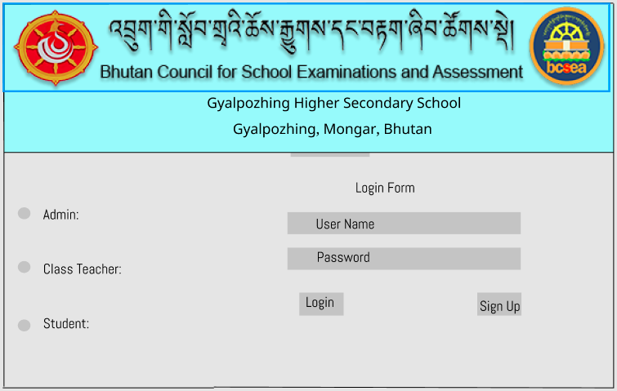
- Registeration Screen: Enables user to register.
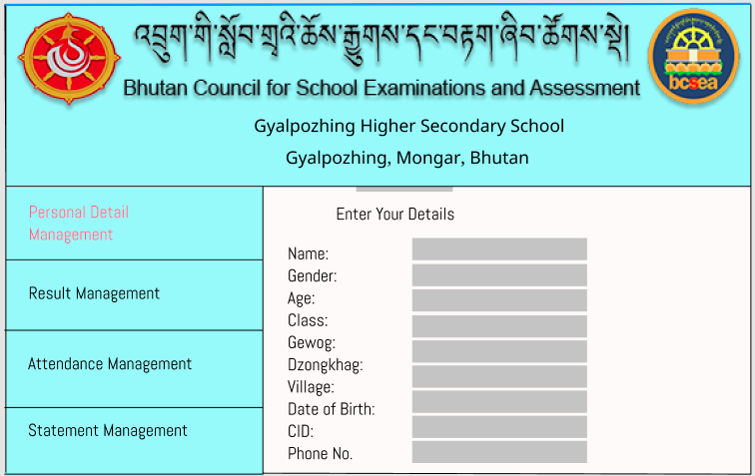
- Class Teacher Dashboard:
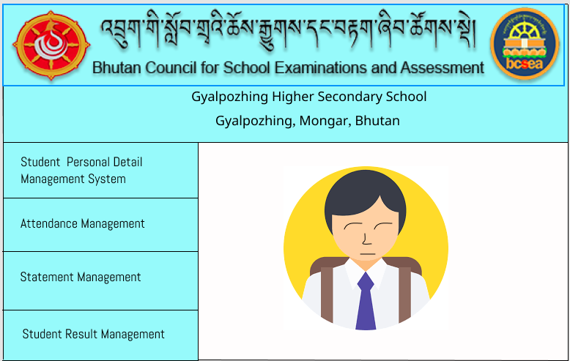
- Student Dashboard screen: The school detail feature will maintain details of the respective school.
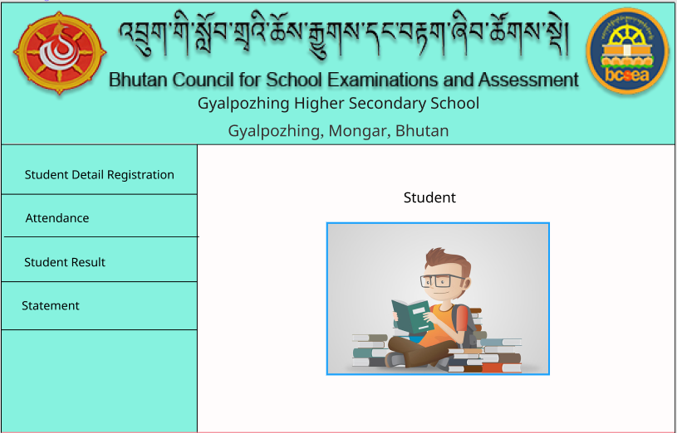

- Admin Dashboard screen: The program detail feature will maintain the details of the subjects.

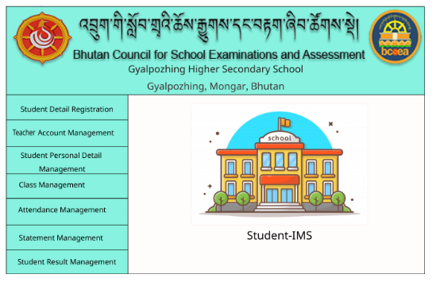

- Statement screen: It will record the statement of individual students who has code of misconduct
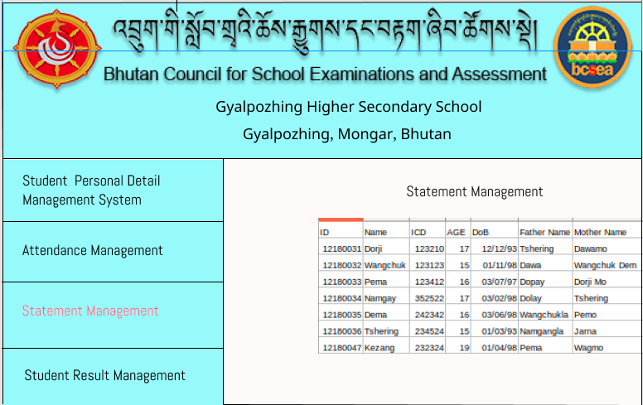
- Attendance management Screen: This feature will record the attendance of each student monthly.
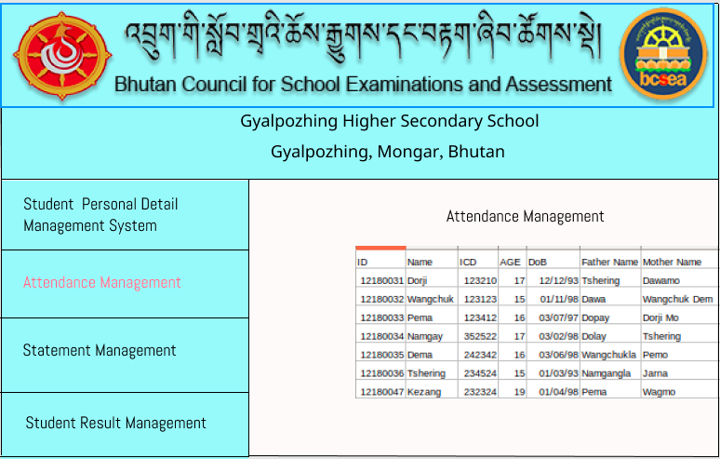
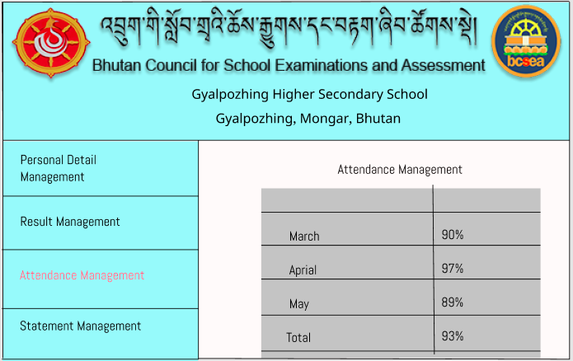

Hardware Interfaces
Following are the hardware interfaces which the system will be requiring in order to develop the proposed system:
- Internet connection
- System with P4 processor; 1GB RAM
- Screen resolution of at least 640 x 480
- Network interface card, Ethernet
- Keyboard and mouse

Software Interfaces
Following are the software interfaces which will be used for developing the software:
- Integrated Development Environment- Sublime text
- Laravel framework
- Windows XP or higher Operating system
- XAMPP server

Communications Interfaces
Following are the communication interfaces used:
- Communication standards: HTTPS
- Synchronization communication:
  - When details of students such as academic, personal, attendance details changes it should be visible to all the users
- System Features
4.1 Student Registration
4.1.1 Description and Priority
Student Registration Feature allows the student to register to a school. Student needs to enter the personal details such as first name, middle name, last name, class, Date of birth, age, sex, citizenship identity card number, House number, Thram Number, Village, Gewog, Dzongkhag, Name of the Previous School, Father’s Name, Father’s contact number, Father’s current Address, Mother’s Name, Mother’s Contact Number, Mother’s Current Address, Relationship status of the student with student guardian, Occupation of the student guardian, Address of the student guardian, Contact number of the student guardian, password and a username in order to register. The students are approved by the admin. If the account is not approved student cannot login. The group of the student is assigned by the admin during the approval
4.1.2 Stimulus/Response Sequences
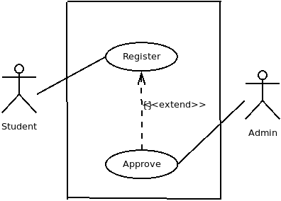
Daigram-1: Student registration use case
User Action: Student registers with the system.
Response: The student details are recorded in pending data base and are kept for approval

User Action: Admin assigns a group to the student and clicks the approve button
Response: Student details are approved and stored in a database

User Action: Admin clicks the reject button.
Response: Student record is not recorded in the database

4.1.3 Functional Requirements
REQ-1: Student can register with the School
Description: Student needs to enter the personal details such as first name, middle name, last name, class, Date of birth, age, sex, citizenship identity card number, House number, Thram Number, Village, Gewog, Dzongkhag, Name of the Previous School, Father’s Name, Father’s contact number, Father’s current Address, Mother’s Name, Mother’s Contact Number, Mother’s Current Address, Relationship status of the student with student guardian, Occupation of the student guardian, Address of the student guardian, Contact number of the student guardian, password and a username in order to register.
Input: Student personal details.
Output: Message that will read as “You Registration is Pending”
REQ-2: Admin can approve the students
Description: Once a student have registered with the system, its approval is in pending. So admin can approve or reject the student. When approving the student the group of the student is assigned.
State: student have registered and is not approved yet.
Input: group of the student and approval option selection
Output: Change in the approve button color to green.
REQ-3: Admin can reject the students
Description: The admin can disapprove the registration of a student to the school. The admin selects the reject option and the student is removed from the database.
State: student have registered and is not approved yet.
Input: Reject option selection
Output: change in the reject button color to red.
This feature is transferred to class teacher.
Student will register with a particular class and class teacher should approve student to their respective class/section.
4.2 Class teacher account management
4.2.1 Description and Priority
The Class Teacher account management system features enables the admin to create and delete an account for a class teacher. When creating the account, a teacher is assigned a group of student.
4.2.2 Stimulus/Response Sequences.
User action: admin clicks on the create account option
Response: the account of the class teacher is created
User action: admin clicks on the delete option
Response: user account deleted
User action: Class teacher logs in
Response: Class teacher account is displayed
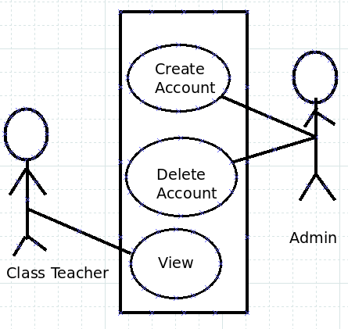
Need to add edit action for admin
Diagram-2: Teacher account management use case4.2.3
Functional Requirement
REQ-1: Admin can create an account for a class teacher.
Description: the class teacher alone cannot create an account for him/her self. But this requirement allows the admin to create an account for a teacher and assign a class group to the teacher.
Input: Create account option selection
Output: A message showing the successful account creation
REQ-2: Admin can delete the account of a class teacher
Description: The admin can delete an account of a teacher.
Input: delete account option selection.
Output: A message showing the successful account deletion.

4.3 Student Personal Detail Management
4.3.1 Description and Priority
The student personal detail management is a feature that allows the different user class to manage the student details. Student-IMS makes it easy to view student details, and delete student details.
4.3.2 Stimulus/Response Sequences.
User Action: Student clicks the View Detail
Response: The user is presented with his/her complete personal details

User Action: Student clicks on the update details
Response: The updated personal detail of the student is presented to the student.

User Action: Admin clicks on the view option.
Response:The Admin is presented with the student personal details.

User Action: Admin clicks on the delete option.
Response: Admin prompted to confirm the deletion.
User Action: Admin confirms the deletion.
Response: A successful deletion message is displayed.

User Action: Class Teacher clicks on the view option.
Response: Presented with the student personal Details.

Figure.1- Use case diagram for student detail Management
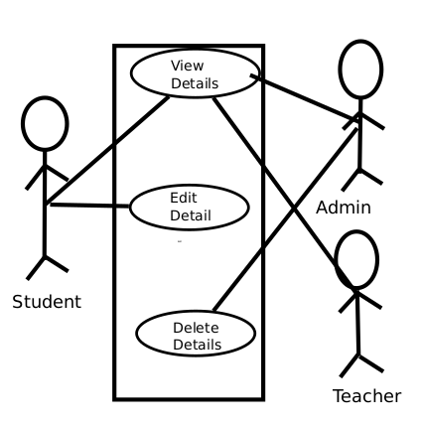
Need to add use case to admin: edit student detail.
Need to add use case to student: create student detail.
4.3.3 Functional Requirements
REQ-1: Student can view his/her details
State: The Student has logged in. A brief personal details and the main menu has been displayed.
Input: “View” option selection.
Output: The personal details of student such as first name, middle name, last name, class, Date of birth, age, sex, citizenship identity card number, House number, Thram Number, Village, Gewog, Dzongkhag, Name of the Previous School, Father’s Name, Father’s contact number, Father’s current Address, Mother’s Name, Mother’s Contact Number, Mother’s Current Address, Relationship status of the student with student guardian, Occupation of the student guardian, Address of the student guardian, Contact number of the student guardian are displayed.
REQ-2: Student can edit his/her details
State: The Student has logged in and have selected the edit option.
Input: The updated personal details of student such as first name, middle name, last name, class, Date of birth, age, sex, citizenship identity card number, House number, Thram Number, Village, Gewog, Dzongkhag, Name of the Previous School, Father’s Name, Father’s contact number, Father’s current Address, Mother’s Name, Mother’s Contact Number, Mother’s Current Address, Relationship status of the student with student guardian, Occupation of the student guardian, Address of the student guardian, Contact number of the student guardian.
Output: The user is presented with the update personal details.
Process: The student personal records are updated in the database.
REQ-3:Admin can view the details of a particular student
Description: The admin can view the personal details of individual student by searching for the student using the student code number.
State: The admin has logged in, the main menu is displayed.
Input: Unique student code number.
Output: Personal detail of the student is displayed.
REQ-4: Admin can delete the account of any student
Description: The admin can delete the personal details of a any student.
Input: Student code number
Output: A message indicating the successful deletion or unsuccessful deletion
REQ-5: Class teacher can view the personal detail of individual student
State: The class teacher is logged in to the system and a list of all student personal details that belong to the group are displayed.
Description: The class teacher enter the unique student code number to view the personal details of a student.
Input: Student code number.
Output: The student personal detail are presented to the teacher.

4.4 Student Result Processing
4.4.1 Description and Priority
This features allows different user classes such as Admin, class teacher and the student to manage the academic progress of the student. The priority is Medium.
4.4.2 Stimulus/Response Sequences
User Action: Class Teacher clicks the create result option.
Response: The result is created template or form

User Action: Class Teacher clicks the View result option
Response: The result of the student is displayed.

User Action: Class Teacher clicks on the update option student wise.
Response: Class Teacher is presented with updated result of the student.

User Action: Class Teacher Clicks on the Delete option student-wise
Response: A prompt for confirming to delete is displayed.

User Action: Class teacher confirms to delete the result, student-wise.
Response: A message is displayed to show the successful/unsuccessful deletion of the result.

User Action: Student Clicks on View result option.
Response: Student is presented with his or her result.

User Action: Admin clicks on view result.
Response: The result of the student is displayed.

User Action: Admin clicks on the delete result, student-wise option
Response: A prompt for confirming to delete is displayed.

User Action: Admin confirms to delete the result.
Response: A message is displayed to show the successful/unsuccessful deletion of the result.
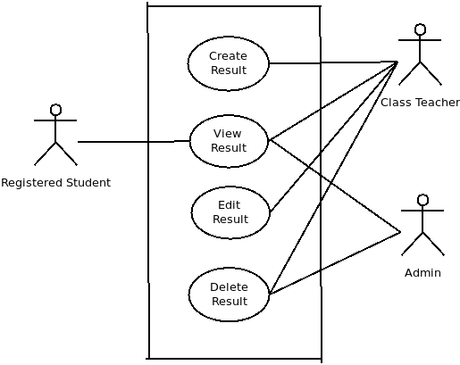
Diagram-4: Result processing use case
4.4.3 Functional Requirements
REQ-1: Student can view the result
Description: Student can view his or her result.
State: The student is logged in and a menu is displayed.
Input: View option selection.
Output: The result of the student is presented.
REQ-2: Class Teacher can create a student result
Description: A class teacher can prepare result of a student that belongs to the group. Following are the fields that will be present in the result: the marks of every subject obtained by the student. the The marks obtained by the student is entered by the teacher.
Input: Marks obtained by the student.
REQ-3: Class Teacher can view a student result
Description: A class teacher can view the result of a student that belongs to the group.
State: Class teacher is logged in and a list of student name that belongs to the class teachers group are displayed.
Input: Student code number
Output: Result of the student is displayed.
REQ-4: Class teacher can edit the result of a student
Description: A class teacher can edit the result of a student that belongs to the group.
Input: Sudent code number, student details
Output: Update result of the student.
REQ-5: Class teacher can delete the result of a student
Description: A class teacher can delete the result of a student that belongs to the student. If the student result is deleted successfully, a success message is displayed and if not successful, a failure message is displayed.
Input: Student code number
Output: success message

REQ-6: Admin can view the Result of any student
Description: Admin can view the result details of any student. Admin enter a student code as an input and a result is displayed.
Input: Student Code number
Output: Student Result
REQ-7: Admin can delete the result of any student
Description: admin can delete the result of any student. If the student result is deleted successfully, a success message is displayed and if not successful, a failure message is displayed.
Input: Student code number
Output: success message is displayed.
4.5 Student Attendance Management
4.5.1 Description and Priority
The student attendance management feature enables the system to manage the attendance of a student. A class teacher can give an attendance to a student that belongs to his or her group on a particular date. The priority is medium.
4.5.2 Stimulus/Response Sequences
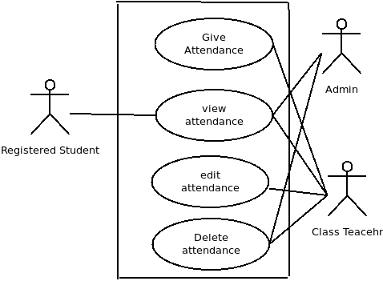

Diagram-5: Attendance management use case
User Action: Class Teacher gives an attendance to the student.
Response: The attendance is recorded.

User Action: The class teachers selection view option
Response: The attendance of the class is displayed.

User Action: The class teacher edits the attendance of the student.
Response: The attendance is updated

User Action: Admin deletes the attendance of a class.
Response: The attendance is deleted.

User Action:Class Teacher deletes the attendance of a class
Response: The attendance is deleted.

User Action: Admin can view the attendance of any class
Response: The attendance is displayed.

User action: students clicks on view
Response: The attendance is displayed

4.5.3 Functional Requirements
REQ-1: Class teacher can give an attendance to the class student on a particular date.
Input: save option selection
Output: the attendance of the student is displayed
REQ-2: Class teacher can view the attendance of his or her class
Input:view attendance option selection
Output: attendance of the class student is displayed
REQ-3: Class teacher can edit the attendance of any student date wise.
Description: The class teacher can edit the attendance of any student that belongs to his or her group. The class teacher will be able to edit the attedance of the class of a particular date.
State: The attendance of all the student is displayed.
Input: The edited attendance of the student.
Output: The updated attendance of the student is displayed.
REQ-4: Admin can view the attendance of any class
Description: The admin can view the attendance of the any class.
A list of all the class is displayed. The admin selects the particular class and the attendance is displayed.
State: A list of all the class is displayed.
Input: The view option selection.
Output: the attendance of the class is displayed.
REQ-5: Admin can delete the attendance of any class
Description: admin can delete the attendance of any class.
Input: Delete option selection.
Output: a success message that reads “Deleted Successfully”.
REQ-6: Student can view his or her attendance
Input: view attendance selection
Output: The attendance of the student is displayed.
4.6 Student Statement Management
4.6.1 Description and Priority
Student Statement Management feature allows to create, view and delete the statement of a student. Student statement are usually written to keep records of a student disciplinary action. The priority is low.
4.6.2 Stimulus/Response Sequences
Action: Student creates a statement
Response: the statement is recorded into a system.

Action: Student clicks on the view option
Response: all the statement of the student is displayed.

Action: Admin clicks on view statement
Response: all the names of the student with statement are displayed

Action: Admin clicks on one of the student to view the statement
Response: All the statement of the student is displayed

Action: Class Teacher clicks on view statement
Response: all the names of the student that belong to the group with statement are displayed

Action: class teacher clicks on one of the student
Response: All the statement of the student is displayed
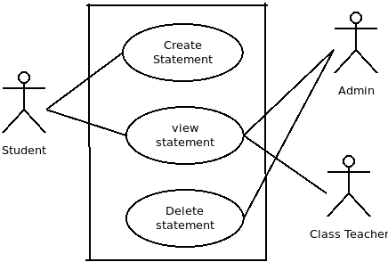
Diagram-6: Statement management use case4.6.3
Functional Requirements
REQ-1: Student can create statement
Description: A student can create a statement by entering the statement details such as statement text, the name of the person to whom the student is writing the statement and the date on which the student wrote the statement. The statement is displayed to the student.
Input: Statement details
Output: Statement
REQ-2: Student can view his or her statement
Description: A student can view his or her statement
Input: View statement option selection.
Output: student statement is displayed.
REQ-3: Admin can view the statement of a student
Description: admin can view the statement of a student. A list of student with a statement is displayed to the admin.
State: The admin is logged in and a list of student is displayed who have created a statement.
Input: view option selection.
Output: Statement of the students is displayed.
REQ-4: Admin can delete a statement of the student
State: the statement of the student is displayed and a delete option is displayed next to every statement.
Input: delete option selection
Output: A success/failure message displayed.

4.7 User Authentication
4.7.1 Description and priority
A different user class such as admin, class teacher and student needs to log into the system.
4.7.2 Stimulus/Response
User Action: Student Log in to the system.
Response: Student is presented with his dashboard.
User Action: Admin logs in to the system.
Response: Admin is presented with main menu.
User Action: Class Teacher logs into the system.
Response: Presented with list of all student that belongs to the class teacher group.
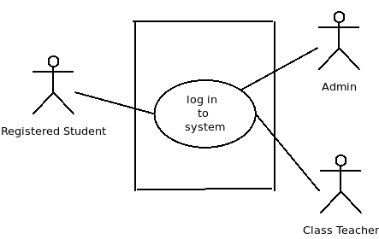
Diagram-7: User authentication use case 4.7.2
Functional Requirements

REQ-1: Student can log in to the system
Description: Student enters login credentials, that is student code number and password to login. After the login student is presented with his brief personal details such as name, student code number and profile picture.
Input: Student credentials.
Output: Student brief personal details.
Processing: Password validation, retrieve the student personal detail and present to the student.
Next function: REQ-2 if the password is invalid.
REQ-2: Admin can login to the system
Description: The Admin can login to the system by providing the login credentials such as user name and password.
Input: login credentials
Output: Admin Dashboard.
Processing: Password validation.
REQ-3: Class Teacher can Login to the system
Description: The class teacher can login to the system by providing the user name and password.
Input: User name and password.
Output: Class teacher profile.
Processing: Password validation

Other Nonfunctional Requirements
In case of non functional requirements, it relates to requirements which involves system’s performance, flexibility, availability, security, maintainability and usability.

Performance Requirements
The software should be able to handle the following tasks:
- At least 20 instructor/staff can log in on an average of four hours a day for five days a week.
- At least 100 students can log into their accounts for 3 hours in a day
- It should be able to handle the MYSQL database of 100 instructors and 1500 students
- Users should be able to get the display within 1-5 seconds and system should be able to perform user’s their tasks within the 5-10 seconds

Safety Requirements
On occurance of physical damages in the system, followings are the safety requirements which will be undertaken:
- Establishment of multiple servers as a back up for storing the student details

Security Requirements
The software will enable the followings:
- Access control:Unauthorized users will be limited to access to data
- Authentication: Confidential data will be authenticated whenever a user logs in.

Software Quality Attributes

Following are the software quality attributes:
- Portability: Paper based system occupies large physical space however the proposed system is portable in nature. It requires no physical space to store the student information and it consumes less memory to store the details. The product will be accessible from any device i.e. andriod or laptop. Hence, it is easier for the customers and developers to maintain the information of the students using Student information management system.
- Data Security: Users can secure their details digitally whereby data can be retrieved any time. Even in occurrence of damages, data can be secured. Furthermore, only authorized users will be able to retrieved the details. Hence, it allows the users to keep their data confidential from others.
- Correctness: Existence of same piece of data in multiple places and human errors in entering data in the manual system lead to incorrectness of the data. Validation of data will be done for all the user input forms. Hence, it will allow administrator and users to handle student’s information correctly.

Business Rules
Following are the operating principles for registration criteria:
Rule 1: Student, Class Teacher and admin needs to login to access the system.
Rule 2: Student’s account will be approved by the administrator only then he or she will be able to perform the required operations.
Rule 3: A class teacher will be assigned only one class.
Rule 4: A class will have maximum of 40 students.
Rule 5: Class teacher alone will manage the students attendance.
Rule 6: A student only belongs to one class.
Rule 7: The result of the student is prepared(create) by the class teacher alone.
Rule 8: Student must provide his personal detail in order to register for the school.
Rule 9: The account of the class teacher are created by the admin.

Appendix A: Glossary
Appendix B: Analysis Models
Appendix C: To Be Determined List

