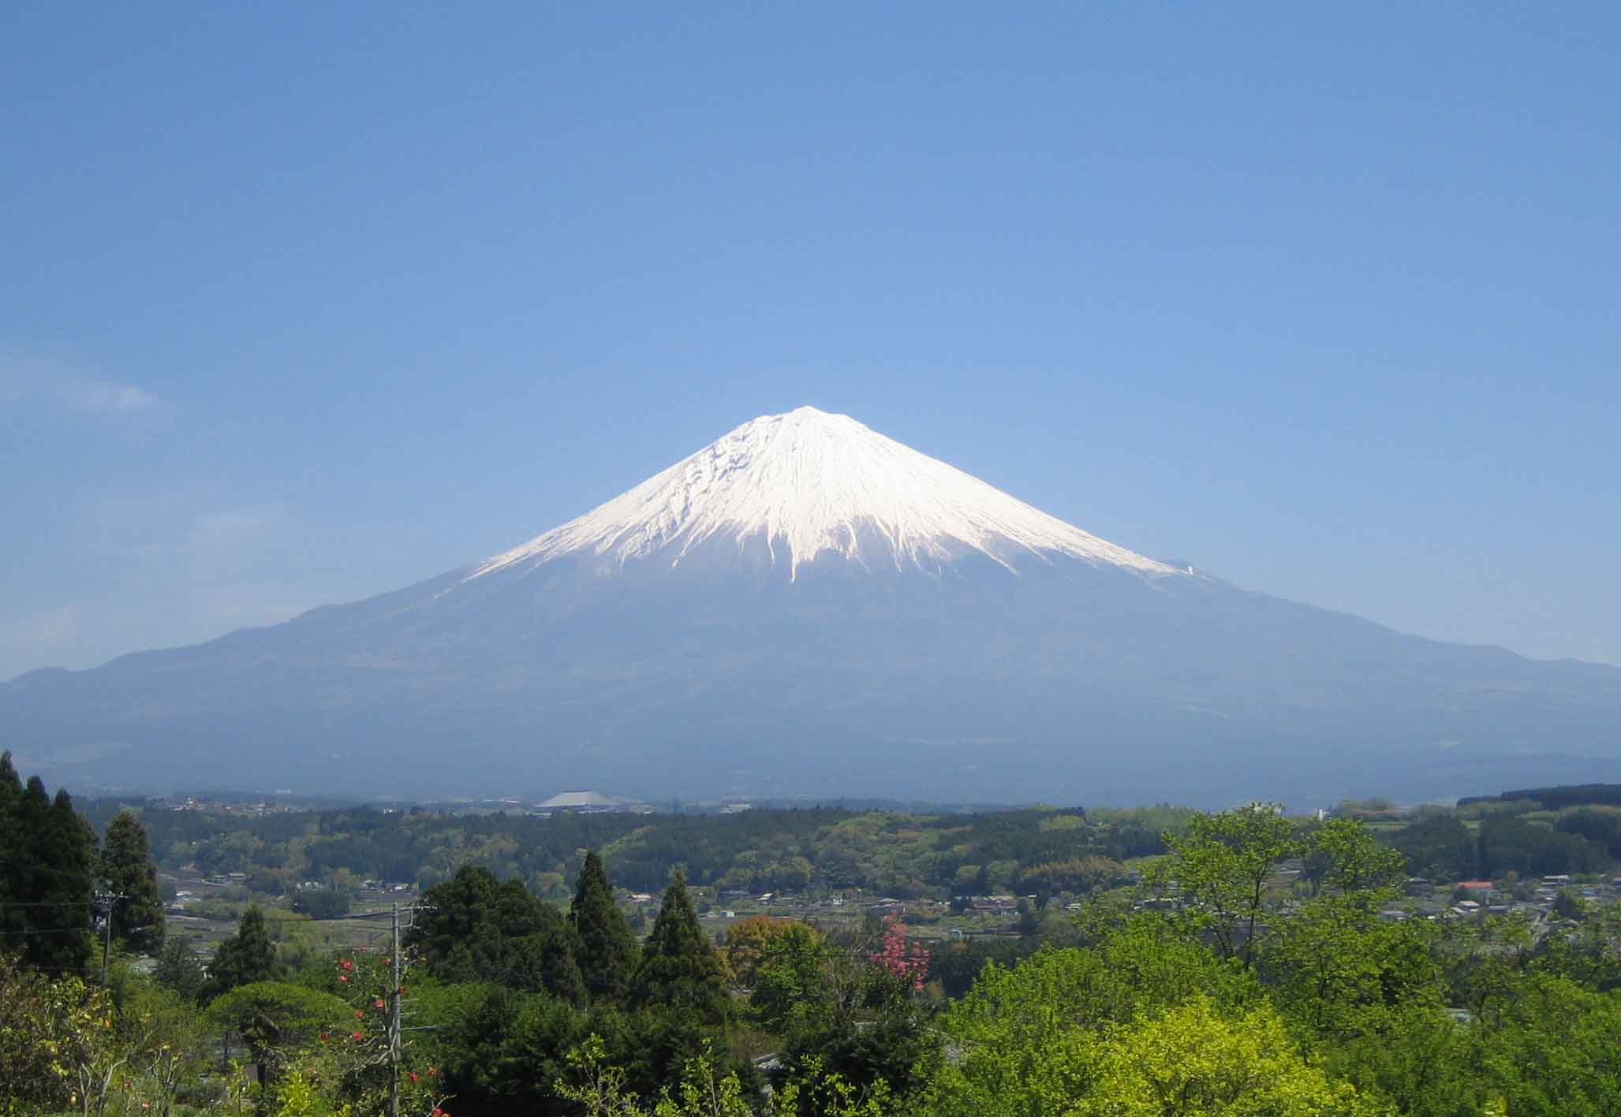FLAG{HELLO_FUJI_MOUNTAIN}