**WEED DETECTION**

**Synopsis**

**Bachelor of Technology**

**Computer Science and Engineering**

Submitted By

SAYAN DAS (13000117053)

SAYAK DAS (13000117054)

SATYAKI SETT (13000117055)

NILAY CHOWDHURY (13000117083)

Under the guidance of:

Prof. Utpal Das

July 2020



Techno Main Salt Lake

EM 4/1, Salt Lake, Sector V, Kolkata-700091

**1 Problem Definition**

We are making a ML model with the implementation of computer vision such that it will identify weeds in an image from an agricultural field. Such a model which can identify weeds in a field without human intervention will help further work of developing a robot that will traverse throughout the field and pluck out the weeds. But in our project we are mainly focused about creating the computer vision (detection of weeds) only.

**2 Problem Domain**

Our project is based on Machine Learning and Image processing.

**3 Background**

For our project, we have studied several research papers and gathered knowledge regarding the topic.

* **Machine vision system for weed detection using image filtering in vegetable crops.** [**[1]**](http://www.scielo.org.co/scielo.php?script=sci_arttext&pid=S0120-62302016000300124)

1. From this paper, we got to know about the flowchart of image processing using computer vision.
2. The whole detection algorithm in this paper is based on area covered by the green plant. Moreover, this research work didn't use machine learning to train any data on weeds.

* **Digital image processing techniques for detecting, quantifying and classifying plant diseases.** [**[2]**](https://springerplus.springeropen.com/articles/10.1186/2193-1801-2-660)
* **Weed detection using image processing.** [**[3]**](https://www.irjet.net/archives/V3/i3/IRJET-V3I3260.pdf)

1. In this paper edge detection is performed on the image and after detection take place detection result is compared with weed frequency range

* **Weed detection using image processing under different illumination for site-specific areas spraying.** [**[5]**](https://www.sciencedirect.com/science/article/pii/S0168169915003981)

1. The algorithm depends a lot on the weather status (sunny, cloudy) of that day and the images are needed to be converted into grayscale.

**4 Proposed Solution**

Alternative Solutions:

1. Using image processing without any learning algorithm. [**[1]**](http://www.scielo.org.co/scielo.php?script=sci_arttext&pid=S0120-62302016000300124)
2. Using edge detection technique on grayscale image and match with weed frequency range. [**[3]**](https://www.irjet.net/archives/V3/i3/IRJET-V3I3260.pdf)
3. Train a model to detect grey scale image with large weed image data set. [**[5]**](https://www.sciencedirect.com/science/article/pii/S0168169915003981)
4. Use tensorflow object detection algorithms To train images of different kinds of plants and predict weed. [**[6]**](https://ieeexplore.ieee.org/abstract/document/8473331)

Recommended Solution:

Using TensorFlow object detection to create a machine learning model that can identify all kinds of plants in general and a set of “*target plant*” specifically. In this way a test image will give result target plants identified as both specific plant with name and generalized plant and all other plants will only be identified as generalized “*plants*” only. Hence we will be able to conclude that the generalized plants are not required in the field and can be tagged as weed for that particular field.

We have considered potato plant as our target plant, so all other plants are considered as weeds.

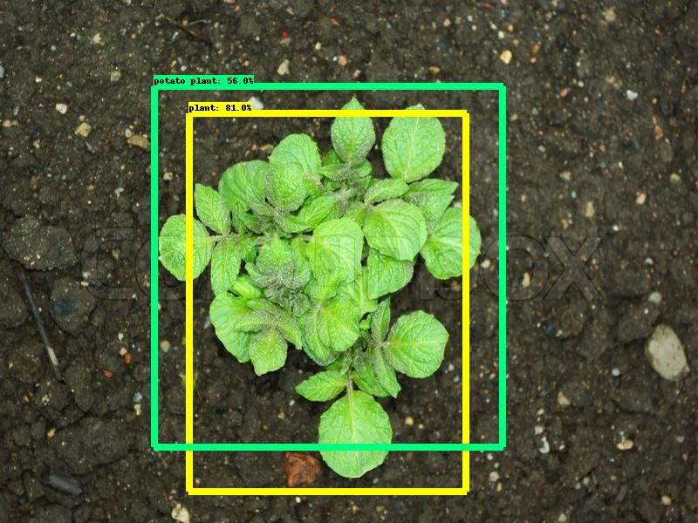

**Figure 1**

From the above demo, we can see that pictures of potato plants (Figure 1) is detected as “**potato plants**”.

**5 Project Benefits**

In a larger picture, it can be used widely in agricultural projects to remove the weeds from the field using a robot. With current technology scenario, such a robot has not yet been prepared that will detect and remove the weeds without human intervention. But if our project is treated as an add-on over an existing robot, then the robot can detect and pluck the weeds without human intervention. Thus, it will have a great value in the market.

**6 Conclusion**

In this project, we are going detect the weed in an image by using Machine Learning via Computer Vision. We are going to use object detection module of TensorFlow. If the image has the target plant then it gets labeled as target plant, otherwise it just gets labeled as “*plant*”.

**7 References**

* [Machine vision system for weed detection using image filtering in vegetable crops.](http://www.scielo.org.co/scielo.php?script=sci_arttext&pid=S0120-62302016000300124) [[1]](http://www.scielo.org.co/scielo.php?script=sci_arttext&pid=S0120-62302016000300124)
* [Digital image processing techniques for detecting, quantifying and classifying plant diseases](https://springerplus.springeropen.com/articles/10.1186/2193-1801-2-660). [[2]](https://springerplus.springeropen.com/articles/10.1186/2193-1801-2-660)
* [Weed detection using image processing.](https://www.irjet.net/archives/V3/i3/IRJET-V3I3260.pdf) [[3]](https://www.irjet.net/archives/V3/i3/IRJET-V3I3260.pdf)
* [Weed detection using image processing under different illumination for site-specific areas spraying](https://www.sciencedirect.com/science/article/pii/S0168169915003981). [[5]](https://www.sciencedirect.com/science/article/pii/S0168169915003981)
* [Objects Talk - Object detection and Pattern Tracking using TensorFlow .](https://ieeexplore.ieee.org/abstract/document/8473331) [[6]](https://ieeexplore.ieee.org/abstract/document/8473331)

* [Training Custom object detector](https://tensorflow-object-detection-api-tutorial.readthedocs.io/en/latest/training.html) [[7]](https://tensorflow-object-detection-api-tutorial.readthedocs.io/en/latest/training.html)