**WEED DETECTION**

Submitted by

SAYAN DAS (13000117053)

SAYAK DAS (13000117054)

SATYAKI SETT (13000117055)

NILAY CHOWDHURY (13000117083)

Submitted for the partial fulfillment for the degree of Bachelor of Technology in Computer Science and Engineering



Techno Main Salt Lake,

EM 4/1, SaltLake, Sector V, Kolkata – 700 091

Contents

1. Introduction 3

1.1 Abstract 3

1.2 Problem Statement: 4

1.3 Related Studies: 5

1.4 Glossary 7

2 Study Findings 8

2.1 Study Coverage: 8

2.2 Solution Alternatives 10

2.3 Recommendation 11

2.4 Requirements 12

2.5 Prototype: 13

3 Conclusion 15

4 References 16

# 1. Introduction

## 1.1 Abstract

The project deals with identification of weed in dedicated agricultural field. We will be using machine learning to check the presence of weed in an agricultural field so that it can be removed to ensure no further draining of nutrition. In an agricultural land, weeds drain in the nutrition from the ground and the application of weedicides can hamper the fertility of the field. The only way to detect these weeds is by human interaction. We are looking for a model that will detect weeds. We are looking forward to create a model using computer vision to detect weeds without human interaction. Our idea is to capture image in agricultural field, process the images and determine if any other plants other than the target plant of the field is present in that frame or not. Project benefits are if the weeds are removed then the whole nutrition of the soil will be fed to the main plant and since the weeds will be removed, no weedicides will have to be used so the fertility will remain intact.

## 1.2 Problem Statement:

We are making a ML model with the implementation of computer vision such that it will identify weeds in an image from an agricultural field. Such a model which can identify weeds in a field without human intervention will help further work of developing a robot that will traverse throughout the field and pluck out the weeds. But in our project we are mainly focused about creating the computer vision (detection of weeds) only.

## 1.3 Related Studies:

Agriculture in India plays a significant part in employing more than 50% of the Indian workforce and contributing around 17.5% to the country’s GDP[[6]](https://www.prsindia.org/policy/discussion-papers/state-agriculture-india" \l ":~:text=The agriculture sector employs nearly,prices in 2015-16).). Due to the semitropical nature of the land pests and weeds are significant threat to our crops leading to droughts, famine and most importantly suicides of farmers[[7]](http://employmentnews.gov.in/NewEmp/MoreContentNew.aspx?n=SpecialContent&k=196).

Weeds drain in the nutrition from the ground and prevalent weedicides are often rendered incapable of removing these threats due to their evolution. This affects the production of the crops and also reducing the quality of the fodder and the land itself. If the target plants are ever consumed by any human than there are chances that the dangerous weedicides used will also cause harmful effects on human body[[8]](https://medlineplus.gov/ency/article/002838.htm).

* **Machine vision system for weed detection using image filtering in vegetable crops.** [**[1]**](http://www.scielo.org.co/scielo.php?script=sci_arttext&pid=S0120-62302016000300124)

1. From this paper, we got to know about the flowchart of image processing using computer vision.
2. The whole detection algorithm in this paper is based on area covered by the green plant. Hence it is detecting all the small plants as weeds and all the comparatively bigger plants as non weeds. Moreover, this research work didn't use machine learning to train any data on weeds.

* **Digital image processing techniques for detecting, quantifying and classifying plant diseases.** [**[2]**](https://springerplus.springeropen.com/articles/10.1186/2193-1801-2-660)
* **Weed detection using image processing.** [**[3]**](https://www.irjet.net/archives/V3/i3/IRJET-V3I3260.pdf)

1. In this paper, the weeds are classified into two types:

(i) Weeds with narrow leaves

(ii) Weeds with wide leaves

1. To detect weeds, the model in this paper uses edge detection.
2. Once edge detection takes place, it is then checked if the edge appears within the weed frequency range and then it is divided into blocks of certain size.

* **Weed detection using image processing under different illumination for site-specific areas spraying.** [**[5]**](https://www.sciencedirect.com/science/article/pii/S0168169915003981)

1. The algorithm depends a lot on the weather status (sunny, cloudy) of that day.
2. The images are needed to be converted into grayscale.

## 1.4 Glossary

**Target plant**: The plant that is grown in a particular field. For demonstration purpose, we have considered potato plants as our target plant.

# 2 Study Findings

## 2.1 Study Coverage:

|  |  |  |
| --- | --- | --- |
| **SL** | **Type** | **Materials** |
| **1** | Research Paper | 1. [Machine vision system for weed detection using image filtering in vegetable crops.](http://www.scielo.org.co/scielo.php?script=sci_arttext&pid=S0120-62302016000300124) 2. [Digital image processing techniques for detecting, quantifying and classifying plant diseases](https://springerplus.springeropen.com/articles/10.1186/2193-1801-2-660). 3. [Weed detection using image processing.](https://www.irjet.net/archives/V3/i3/IRJET-V3I3260.pdf) 4. [Objects Talk - Object detection and Pattern Tracking using TensorFlow.](https://ieeexplore.ieee.org/abstract/document/8473331) 5. [Weed detection using image processing under different illumination for site-specific areas spraying](https://www.sciencedirect.com/science/article/pii/S0168169915003981). 6. [Weed growth and intrusion detection](https://ieeexplore.ieee.org/document/8080025) |
| **2** | Tutorials | 1. [Training Custom object detector](https://tensorflow-object-detection-api-tutorial.readthedocs.io/en/latest/training.html) 2. [TensorFlow Object Detection](https://www.youtube.com/watch?v=wh7_etX91ls) 3. [How to train an object detection classifier using TensorFlow (GPU) on windows](https://www.youtube.com/watch?v=Rgpfk6eYxJA). |
| **3** | Articles | 1. [Object Detection: Current and Future Directions](https://www.frontiersin.org/articles/10.3389/frobt.2015.00029/full) |
| **4** | Python Modules | 1. Numpy: **NumPy** is a **python** library used for working with arrays. It also has functions for working in domain of linear algebra, fourier transform, and matrices.   1. Six: **Six** is a Python 2 and 3 compatibility library. It provides utility functions for smoothing over the differences between the Python versions with the goal of writing Python code that is compatible on both Python versions. 2. TensorFlow: **TensorFlow** is an open source software library for dataflow and differentiable programming across a range of tasks. We will be using Object detection algorithm from TensorFlow. 3. Matplotlib: **Matplotlib** is a comprehensive library for creating static, animated, and interactive visualizations in Python. 4. Pillow: **Pillow** is a free and open-source additional library for Python that adds support for opening, manipulating, and saving many different image file formats. 5. Object_Detection: Object detection is the python Package that comes with TensorFlow and consists of all necessary tools for object detection and training of a TensorFlow model, generating inference graph and testing of generated model. 6. Opencv-Python: It is open source python library to handle images and videos from both camera and computer memory. |

## 2.2 Solution Alternatives

* From [**[1]**](http://www.scielo.org.co/scielo.php?script=sci_arttext&pid=S0120-62302016000300124), we could have used this algorithm which is based on area covered by the green plant, but this algorithm does not include any learning algorithm. Hence, the dataset cannot be trained.
* From [**[3]**](https://www.irjet.net/archives/V3/i3/IRJET-V3I3260.pdf), we could have used edge detection but did not use this since it uses edge detection which may lead to data loss in comparison to the normal image.
* From [**[5]**](https://www.sciencedirect.com/science/article/pii/S0168169915003981), we could have used this detection model but it depends on weather status and the conversion of image into grayscale may cause data loss.
* From [**[10]**](https://ieeexplore.ieee.org/abstract/document/8473331), we are using object detection algorithm from TensorFlow, to detect the target plants.

## 2.3 Recommendation

With this project we are aiming to detect weeds, but there are a huge different sets of weeds which will lead to huge dataset and also may require different algorithms in ML. And moreover it will exert immense pressure on the training and testing procedures with scattered outputs.

Thus, we have decided to detect the plants of agricultural field rather than weeds, such that everything else remaining other the target plant is considered to be weed.

We are using object detection algorithm from TensorFlow, to detect the target plants.

But such a dataset of high magnitude is not available and Google images may lead to lower accuracy due to different qualities. Thus we have to create our own dataset of plant images by visiting agricultural fields.

## 2.4 Requirements

|  |  |  |  |
| --- | --- | --- | --- |
| **SL** | **Requirement** | **Purpose** | **Prototyping Flag** |
| 1. | Dataset of 500 labeled pictures | The dataset will be used to perform the training and testing operation. | No |
| 2. | Resizing of images | To create the training data, we need pictures of same resolution. | Yes |
| 3. | Image labeling | Annotations are necessary for training the dataset | Yes |
| 4. | XML to CSV converter | For each image file, one XML file is generated during labeling. To centralize all the data from the images, one CSV file is required. | Yes |
| 5. | CSV to TF record | The TF record format is used for storing a sequence of binary record. Binary data takes up less space and less time to copy and can be read much more efficiently from disk. | Yes |
| 6. | Label Map | The label Map maps each of the used labels to an integer value. | Yes |
| 7. | Config File | Training configuration file is required to start the training, which will have all the records of training set and test set such as training directory location and several other settings required for the training. | Yes |
| 8. | Pre-trained model to apply transfer learning (SSD MobileNet v1) | An existing model on which we will apply transfer learning so that our required model is obtained. | No |

## 2.5 Prototype:

We have considered potato plant as our target plant, so all other plants are considered as weeds.

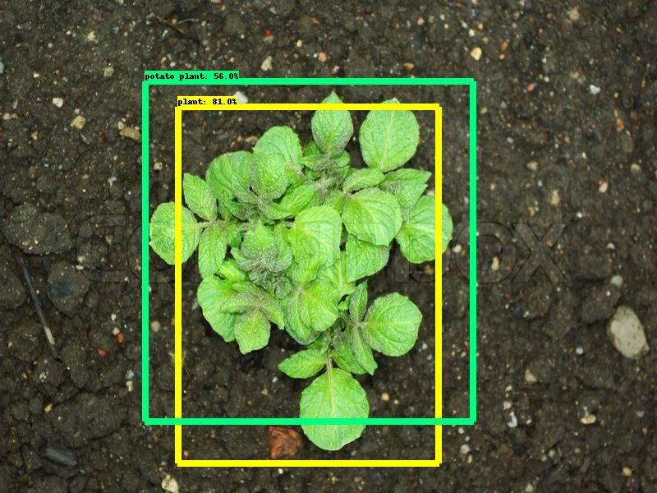

**Figure 1**

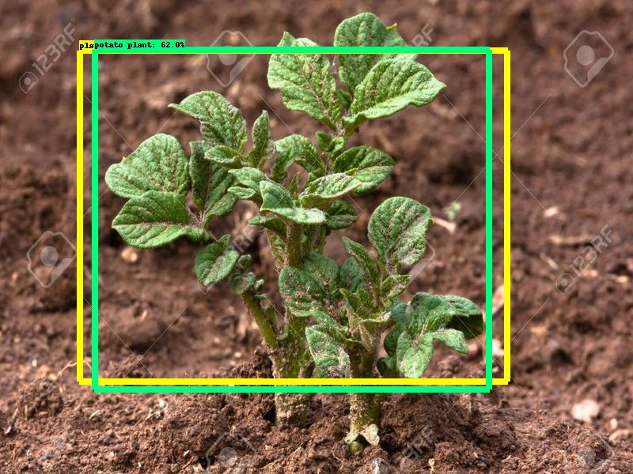

**Figure 2**

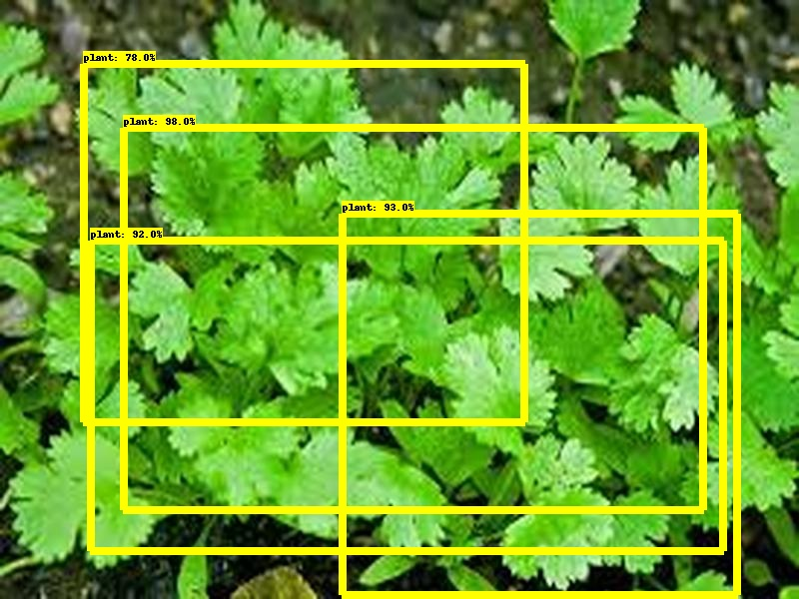

**Figure 3**

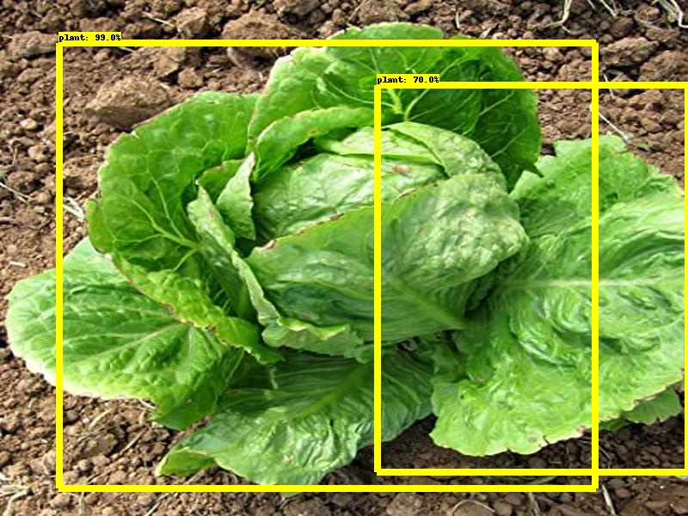

**Figure 4**

From the above demo, we can see that pictures of potato plants(Figure 1 and figure 2) are detected as “**potato plants**”, but pictures of all other plants(Figure 3 and figure 4) are detected as just ”**plants**”.

# 3 Conclusion

In this project, we have detected the weed in an image by using Machine Learning via Computer Vision. We have used object detection module of TensorFlow. If the image has the target plant then it gets labeled “*Potato plant*”, otherwise it just gets labeled as “*plant*”.

In a larger picture, it can be used widely in agricultural projects to remove the weeds from the field using a robot. With current technology scenario, such a robot has not yet been prepared that will detect and remove the weeds without human intervention. But if our project is treated as an add-on over an existing robot, then the robot can detect and pluck the weeds without human intervention. Thus, it will have a great value in the market.

# 4 References

* [Machine vision system for weed detection using image filtering in vegetable crops.](http://www.scielo.org.co/scielo.php?script=sci_arttext&pid=S0120-62302016000300124) [**[1]**](http://www.scielo.org.co/scielo.php?script=sci_arttext&pid=S0120-62302016000300124)
* [Digital image processing techniques for detecting, quantifying and classifying plant diseases](https://springerplus.springeropen.com/articles/10.1186/2193-1801-2-660). [**[2]**](https://springerplus.springeropen.com/articles/10.1186/2193-1801-2-660)
* [Weed detection using image processing.](https://www.irjet.net/archives/V3/i3/IRJET-V3I3260.pdf) [**[3]**](https://www.irjet.net/archives/V3/i3/IRJET-V3I3260.pdf)
* [Objects Talk - Object detection and Pattern Tracking using TensorFlow [10].](https://ieeexplore.ieee.org/abstract/document/8473331)
* [Weed detection using image processing under different illumination for site-specific areas spraying](https://www.sciencedirect.com/science/article/pii/S0168169915003981). [**[5]**](https://www.sciencedirect.com/science/article/pii/S0168169915003981)
* [Training Custom object detector](https://tensorflow-object-detection-api-tutorial.readthedocs.io/en/latest/training.html) [[4]](https://tensorflow-object-detection-api-tutorial.readthedocs.io/en/latest/training.html)
* [https://www.prsindia.org/policy/discussion-papers/state-agriculture-india#:~:text=The%20agriculture%20sector%20employs%20nearly,prices%20in%202015%2D16](https://www.prsindia.org/policy/discussion-papers/state-agriculture-india" \l ":~:text=The agriculture sector employs nearly,prices in 2015-16)). [[6]](https://www.prsindia.org/policy/discussion-papers/state-agriculture-india" \l ":~:text=The agriculture sector employs nearly,prices in 2015-16)
* <http://employmentnews.gov.in/NewEmp/MoreContentNew.aspx?n=SpecialContent&k=196> [[7]](http://employmentnews.gov.in/NewEmp/MoreContentNew.aspx?n=SpecialContent&k=196)
* <https://medlineplus.gov/ency/article/002838.htm> [[8]](https://medlineplus.gov/ency/article/002838.htm)
* Deep Learning Pipeline: Building A Deep Learning Model With TensorFlow.