Task 1

The program can be build using the makefile, for example
make all: build the program and generate the executable

The program accepts 2 arguments the first one is the type of simulation or in this case the strategy the input should be a string:

- “stay” to simulate stay strategy where the player always stays with their initial choice of door.
- “switch” to simulate switch strategy where the player always switches their choice of door after a non-prize door is revealed.
- “both” to simulate both strategies
The second one argument is the number of games to run or simulations.

- Running from terminal after build:
- Running using make:

Task 2

Part a)

Procedure:

- Understand the code, this code is a string splitter program in C that splits a string into individual words based on a delimiter (space).
The program takes an string as argument from command line, then split into individual words and prints in a new line each word.
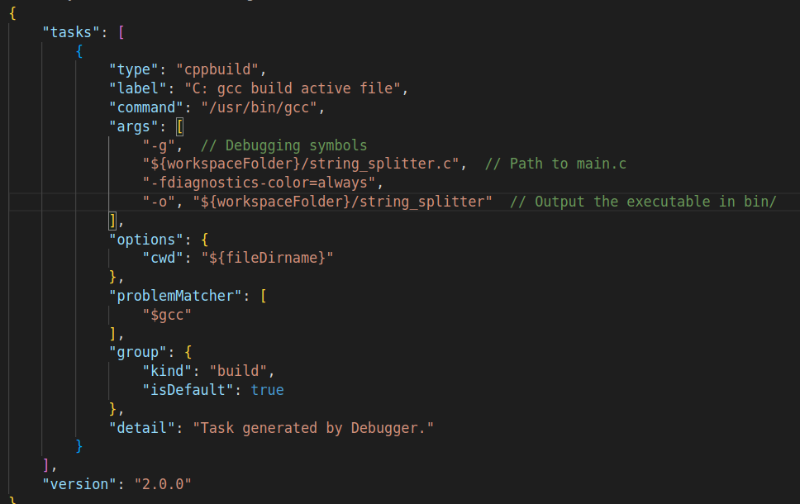
- Reproduce the bug:
To reproduce the code I configure the environment with Visual studio code using GCC compiler:

and launch with the example:
- Locate the error. In this case shows a error related with the memory
- Warning were enabled during compilation time, but it does not show nothing.

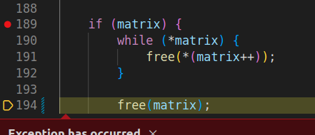
- The next step was use GNB debugger on Visual Studio Code, here the error was located in the function matrixfree()

Bug 1:
Analyzing the function, it was designed to free memory dynamically allocated matrix, The function goes through each row of a dynamically allocated matrix, then, frees each row, and then moves on to the next row.

The error shows above is “Corruption out ” due free(matrix), it is attempting to free an invalid pointer, the pointer beyond the last element in the matrix.

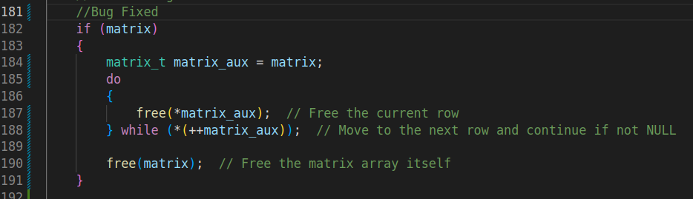
This is happening here because the operation priority:
matrix++ first returns the current value of the pointer, and then increments matrix to point to the next element, it means before it is incremented the dereferencing operator (*) is applied to the value of matrix.
Solution:
To avoid the bug it is necessary keep the original pointer matrix before incrementing it. In this way when free the array the pointer in line 190, it refer to the original memory address and not the incremented pointer.

Bug 2:

For find out the bug 2 was necessary test the application with different inputs, for example a large test, only numbers, character specials, a text without spaces...etc.
Finally the application fail if it has space as input:
The application fail in the function matrixdup due copy has not memory allocated because it never enter to the for loop because *matrix is NULL
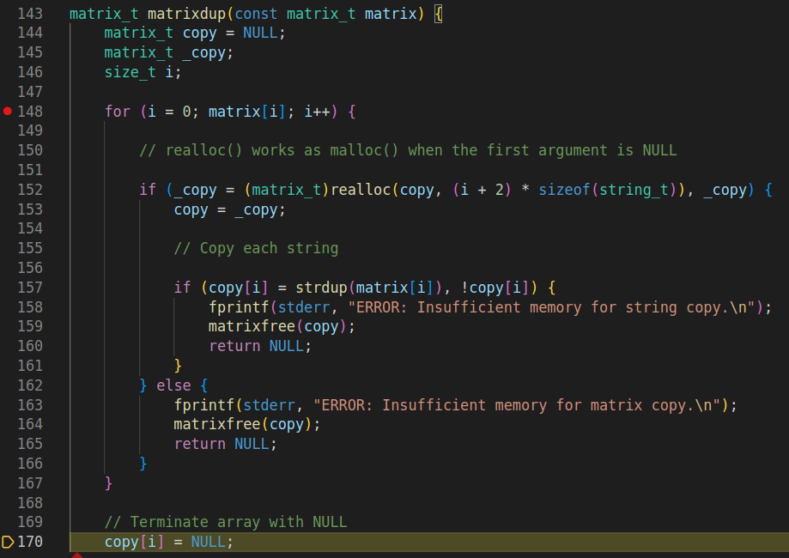

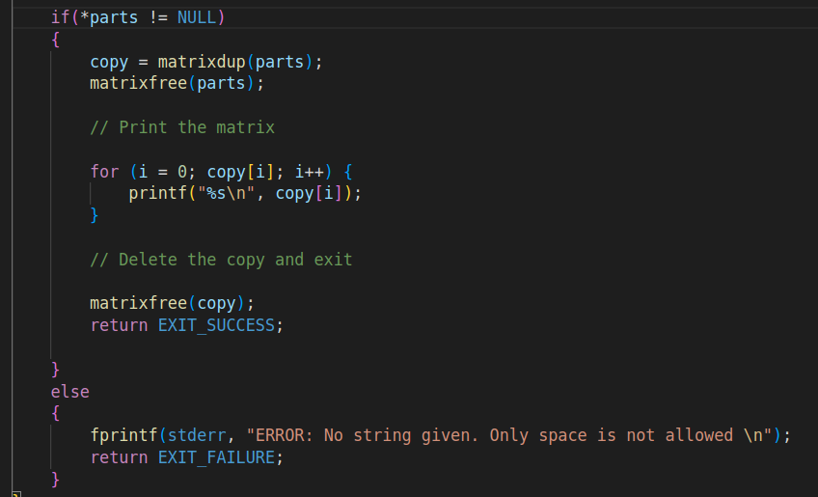
Solution:
In order to avoid this bug, I added a conditional to check pointer matrix, and letting know to the user about only text is allowed.

Part b)
For this case I tested similar as the code on the part a, with a variety of inputs, but after several attempts, I was unable to break the application, so I decided to investigate in depth the code. Take into account the conditions in the comments
* 1. str points to a valid string.
* 2. That string is zero-terminated.
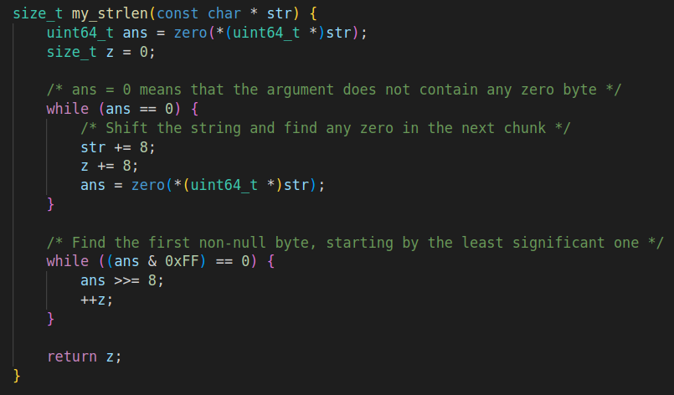
This function may not be meeting the condition, for example it might be added a condition to check that the string is properly null-terminated before processing it.
Continue with this idea a proper checking to avoid accessing memory beyond the allocated string buffer might be added too.
This is solved adding the following lines:
// Check for early null-termination
if (*str == '\0') return 0;

and ensure string is null-terminated:
if (*str == '\0') return z; // Null-terminated string.
In addition investigating more about the architecture x86-64 little-endian architecture where is intended to run on, This highlights that it does not require strict alignment for data, one reason there is not exist a checking if the pointer is aligned to 8 bytes.
But it can ensure proper alignment before casting the pointer to a uint64_t*
adding the following line:
while ((uintptr_t)str % 8 != 0) {
if (*str == '\0') return str - str; // Stop if a null byte is found
str++;
}

