Classwork 20261016

2026-Oct-16
Answer the following questions about linked lists and text file processing.
The marks for each question are shown in brackets [ ]. Total marks: 100.
Write your answers in the answer boxes. For all programming questions, write Python code.

Question 1 - Linked list implemented using arrays (30 marks)
A simplified linked list is used to store the names of fruits in alphabetical order. It is implemented using two 1D arrays:
Fruit stores the names of the fruits.
NextPointer stores the pointer to the next fruit name in the list.
HeadPointer indicates the index of the first fruit name in the linked list.
HeadPointer 3
When the end of the linked list is reached, the next pointer has the value of 0.
The following table shows the initial content of the arrays.
Index | Fruit | NextPointer
-------+------------+------------
1 | Mango | 6
2 | Damson | 7
3 | Apricot | 5
4 | Lemon | 1
5 | Banana | 9
6 | Nectarine | 0
7 | Elderberry | 10
8 | Grape | 4
9 | Cherry | 2
10 | Fig | 8

HeadPointer = 3

(a) Four fruit names have been deleted from the linked list. These are shaded in the following table.
Complete the table to show the new values of HeadPointer and NextPointer to keep the remaining fruit names in alphabetical order. [9]
HeadPointer 5
Index | Fruit | NextPointer
1 | Mango | -
2 | Damson | 7
3 | Apricot | -
4 | Lemon | 6
5 | Banana | 2
6 | Nectarine | 0
7 | Elderberry | 8
8 | Grape | 4
9 | Cherry | -
10 | Fig | -

(b) Complete the pseudocode algorithm so that it achieves the following when applied to the arrays:
The fruit name is input.
The linked list is searched, in order, for the fruit name.
If the fruit name is found, an appropriate message is output to indicate it has been found.
If the fruit name is not found, an appropriate message is output to indicate it has not been found.
The algorithm terminates when the next pointer value is 0.
Complete the pseudocode. [15]
Pointer ← HeadPointer
Found ← 0
OUTPUT "Enter a fruit name "
INPUT FruitName
WHILE Pointer <> 0
IF Fruit[Pointer] = FruitName THEN
Found ← Pointer
Pointer ← 0
ELSE
Pointer ← NextPointer[Pointer]
ENDIF
ENDWHILE
IF Found <> 0 THEN
OUTPUT Fruit[Found], " is found"
ELSE
OUTPUT FruitName, " is not found"
ENDIF

(c) Explain how the simplified linked list structure could be improved so that the storage space used by deleted fruit names can be reused. [6]
Maintain a free list of unused array positions, using their NextPointer values to link them. FreePointer stores the first free position; 0 means there is no free space.
When deleting a node, change its predecessor's pointer (or HeadPointer) to bypass it. Set NextPointer[Deleted] to FreePointer, then set FreePointer to Deleted.
When inserting, check FreePointer is not 0. Take NewPointer = FreePointer and advance FreePointer to NextPointer[NewPointer]. Store the new fruit there, then update NextPointer and the predecessor's pointer (or HeadPointer) to insert it in alphabetical order.

Question 2 - Reading and processing a text file (70 marks)
A program sorts a list of colour names using different sorting methods.
The text file Colours.txt stores the colour names. Each colour name is on a new line in the text file. The text file is provided with this paper.
(a) The text file Colours.txt stores 50 colour names, each on a new line.
The function ReadData():
has a local array of strings that can store 50 items
reads each line of data and stores it in the array
returns the array.
Write program code for ReadData(). [19]
def ReadData():
Colours = [""] * 50
with open("Colours.txt", "r") as File:
for Index in range(50):
Colours[Index] = File.readline().rstrip("\n")
return Colours

(b) (i) The function FormatArray() takes an array of strings as a parameter. It concatenates the contents of the array into one string with a space between each array element. The function returns the concatenated string.
Write program code for FormatArray(). [6]
def FormatArray(Data):
Result = ""
for Index in range(len(Data)):
if Index > 0:
Result = Result + " "
Result = Result + Data[Index]
return Result

(ii) The main program:
calls ReadData() and stores the returned array
calls FormatArray() with the returned array and outputs the returned string.
Write program code for the main program. [10]
Colours = ReadData()
print(FormatArray(Colours))

(iii) Test your program.
Take a screenshot of the output and paste it into the box below. [3]
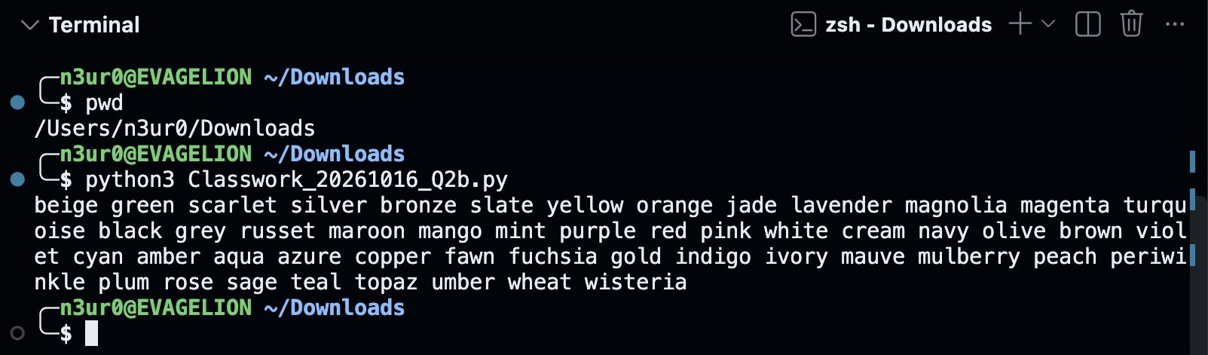

(c) The function CompareStrings():
takes two strings as parameters
compares each string, one character at a time, to identify which string comes first alphabetically. If the first two characters are the same, the second character of each string is compared. This continues until the two characters are different.
The function:
returns 1 if the first parameter comes before the second alphabetically
returns 2 if the second parameter comes before the first alphabetically.
Write program code for CompareStrings().
Assume that all strings are in lower case.
Assume that a difference between two strings will always be identified before the end of one string is reached.
Do not use an in-built string comparison function.
The strings must be compared one character at a time. [13]
def CompareStrings(String1, String2):
Index = 0
while String1[Index] == String2[Index]:
Index = Index + 1
if ord(String1[Index]) < ord(String2[Index]):
return 1
else:
return 2

(d) (i) The function Bubble() takes an array of strings as a parameter and sorts the data into ascending alphabetical order, using a bubble sort. The bubble sort uses CompareStrings() to compare each string. The function returns the sorted list.
Write program code for Bubble(). [10]
def Bubble(Data):
for Pass in range(len(Data) - 1):
for Index in range(len(Data) - 1 - Pass):
if CompareStrings(Data[Index], Data[Index + 1]) == 2:
Temp = Data[Index]
Data[Index] = Data[Index + 1]
Data[Index + 1] = Temp
return Data

(ii) Write program code to amend the main program to:
call Bubble() with the unsorted array as a parameter
call FormatArray() with the sorted array and output the returned string. [6]
Colours = ReadData()
print(FormatArray(Colours))
Colours = Bubble(Colours)
print(FormatArray(Colours))

(iii) Test your program.
Take a screenshot of the output and paste it into the box below. [3]
