Classwork 20261023

2026-Oct-23
Answer the following question about object-oriented programming and file handling.
The marks for each question are shown in brackets [ ]. Total marks: 100.
Write your answers in the answer boxes. For all programming questions, write Python code.
The text file CardValues.txt is provided with this paper.

Question 1 - Object-oriented programming and file handling (100 marks)
A programmer is designing a computer game that uses a set of cards.
Each card has a number and a colour. The cards are saved in the text file CardValues.txt.
The program has a class named Card. The class has the following attributes and methods.
Card
Number : INTEGER the number of the card
Colour : STRING the colour of the card

Constructor() takes two values as parameters and sets
them to the private attributes
GetNumber() returns the number of the card
GetColour() returns the colour of the card

(a) The constructor takes the number and colour of the card as parameters and sets them to the private attributes.
Write program code to declare the class Card and its constructor. Do not write any other methods.
Use your programming language's appropriate constructor.
All attributes should be private.
If you are writing in Python, include attribute declarations using comments. [19]
class Card:
def __init__(self, NumberP, ColourP):
# __Number : INTEGER
# __Colour : STRING
self.__Number = NumberP
self.__Colour = ColourP

(b) The two get methods return the associated attribute.
Write program code for the get methods GetNumber() and GetColour(). [11]
def GetNumber(self):
return self.__Number

def GetColour(self):
return self.__Colour
These two methods are placed inside class Card.

(c) The text file CardValues.txt stores the data for 30 cards, in the order: number, colour.
For example, the first card in the text file:
3
blue

3 is the number and blue is the colour. Each card takes two lines: the number on the first line and the colour on the second.
A 1D array of type Card is declared to store all the cards read in from CardValues.txt.
Write the main program to:
declare an array of type Card with 30 elements
read in the data for the 30 cards from CardValues.txt and assign each to the array.
Write program code for the main program. [26]
# Cards : ARRAY[0:29] OF Card
Cards = [None] * 30
with open("CardValues.txt", "r") as CardFile:
for Index in range(30):
Number = int(CardFile.readline().strip())
Colour = CardFile.readline().strip()
Cards[Index] = Card(Number, Colour)

(d) The program needs to allow all players (maximum of 5) to select 4 cards from the 30 available. A card can only be selected once, so the program needs to record which cards have already been selected.
The function ChooseCard():
takes as input an integer to represent an array index from 1 to 30
validates that the value is between 1 and 30 inclusive
checks if the card is available (it has not already been selected)
loops until an available card is selected
returns the index of the card if it is available.
Amend the program to store which cards have already been selected and write program code for the function ChooseCard(). [22]
# Selected : ARRAY[0:29] OF BOOLEAN
Selected = [False] * 30

def ChooseCard():
while True:
try:
Choice = int(input("Choose a card (1-30): "))
except ValueError:
print("Please enter an integer.")
continue
if Choice < 1 or Choice > 30:
print("Enter a number between 1 and 30.")
continue
if Selected[Choice - 1]:
print("That card has already been selected.")
continue
Selected[Choice - 1] = True
return Choice
ChooseCard() returns an index from 1 to 30. Subtract 1 when accessing a Python list. The shared Selected array keeps each card unavailable to all later selections.

(e) The main program needs to allow one player to select all their 4 cards.
(i) Amend the main program to:
create an array, Player1, for player 1 of type Card
ask player 1 to input 4 integers using the function from part (d)
store the cards in Player1
output the number and colour of the 4 cards in Player1.
Write the amended main program. [18]
def main():
global Selected
# Cards : ARRAY[0:29] OF Card
Cards = [None] * 30
with open("CardValues.txt", "r") as CardFile:
for Index in range(30):
Number = int(CardFile.readline().strip())
Colour = CardFile.readline().strip()
Cards[Index] = Card(Number, Colour)

Selected = [False] * 30
# Player1 : ARRAY[0:3] OF Card
Player1 = [None] * 4
for Index in range(4):
Choice = ChooseCard()
Player1[Index] = Cards[Choice - 1]

for PlayerCard in Player1:
print(PlayerCard.GetNumber(), PlayerCard.GetColour())

main()
Run from the folder containing CardValues.txt. The Card class and ChooseCard() are defined above.

(ii) Test your program with the following test data:
Test 1: 1 5 9 10

Test 2: 2 2 3 4 4 5

Take a screenshot to show the output and paste it into the box below. [4]
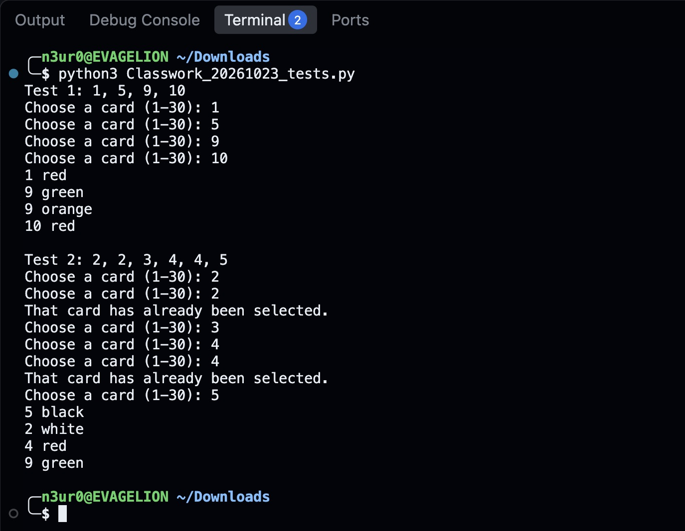
Both tests use the supplied CardValues.txt and start with all cards available. In Test 2, the repeated choices 2 and 4 are rejected, leaving cards 2, 3, 4 and 5.

