Homework assignment 04

Due 2026-Oct-15
Answer the following questions about object-oriented programming and abstract data
types (linked list and binary tree).
The marks for each question are shown in brackets [ ]. Total marks: 100.
Write your answers in the answer boxes. For all programming questions, write Python code.

Question 1 - Object-oriented programming (32 marks)
A car park charges for parking by the hour. A program stores data about the cars
using the class Car. The class is described below.
Car
RegNumber : String the registration number, e.g. "AB12 CDE"
HoursParked : Integer whole hours the car was parked
IsMember : Boolean True if the driver is a member

Constructor(...) initialises the three attributes
GetRegNumber() returns the registration number
SetHours(newHours) stores newHours if 1 <= newHours <= 24
CalcCharge() calculates the parking charge

All attributes are private.

(a) State what is meant by an attribute and by a method, and give one example of each from the class Car. [4]
An attribute is a data item that stores a property or state of an object; for example, RegNumber stores the registration number of a Car.
A method is a procedure or function defined in a class that acts on its objects; for example, GetRegNumber() returns a Car object's registration number.

(b) Write program code to declare the class Car, its constructor, GetRegNumber() and SetHours(newHours). Do not declare CalcCharge(). All attributes must be private. [12]
class Car:
def __init__(self, RegNumber, HoursParked, IsMember):
self.__RegNumber = RegNumber
self.__HoursParked = HoursParked
self.__IsMember = IsMember

def GetRegNumber(self):
return self.__RegNumber

def SetHours(self, newHours):
if 1 <= newHours <= 24:
self.__HoursParked = newHours

(c) CalcCharge() calculates and returns the parking charge. The charge is 2.00 for each whole hour the car was parked. If the driver is a member of the car park, 25% is taken off the total charge. Write program code for CalcCharge(). [5]
def CalcCharge(self):
charge = self.__HoursParked * 2.00
if self.__IsMember:
charge = charge * 0.75
return charge
This method is added inside class Car at the same indentation level as SetHours().

(d) Write program code for the main program that:
declares a local array Cars with space for 3 elements
takes as input the registration number, the number of hours parked and whether the driver is a member, for each of three cars
repeats the input of the number of hours until it is between 1 and 24 inclusive
creates an instance of Car for each car and stores it in the array
outputs the registration number and the charge for each car [7]
def main():
Cars = [None] * 3
for index in range(3):
regNumber = input("Registration number: ")
hours = int(input("Hours parked (1-24): "))
while hours < 1 or hours > 24:
print("Hours must be between 1 and 24.")
hours = int(input("Hours parked (1-24): "))
member = input("Member (Y/N): ").upper() == "Y"
Cars[index] = Car(regNumber, hours, member)

for car in Cars:
print(car.GetRegNumber(), f"{car.CalcCharge():.2f}")

main()

(e) Test your program and take a screenshot of the output. Paste the screenshot into the box below. [4]
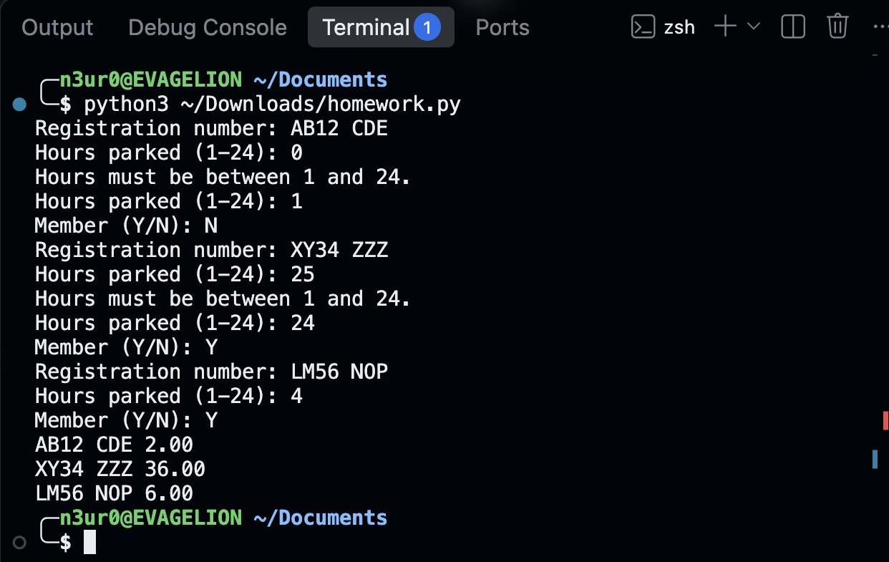
VS Code terminal running ~/Downloads/homework.py. The test rejects hours 0 and 25 and outputs charges 2.00, 36.00 and 6.00.

Question 2 - Linked list (28 marks)
A linked list is stored in two parallel 1D arrays. The variable startPointer holds the index of the first node in the list and heapStartPointer holds the index of the first free node. A null pointer is represented by -1.
DECLARE myLinkedList : ARRAY[0:7] OF INTEGER
DECLARE myLinkedListPointers : ARRAY[0:7] OF INTEGER
DECLARE startPointer : INTEGER
DECLARE heapStartPointer : INTEGER
CONSTANT nullPointer = -1

Index | myLinkedList | myLinkedListPointers
0 | 18 | 3
1 | | 4
2 | | 5
3 | 29 | 6
4 | | 2
5 | | -1
6 | 41 | 7
7 | 55 | -1

startPointer = 0 heapStartPointer = 1

(a) State the four values that are currently stored in the linked list, in order, and state which array indices are free. [4]
Values in order: 18, 29, 41, 55.
Free indices: 1, 4, 2, 5 (the free-list order from heapStartPointer).

(b) Write program code for the function getValues() that returns a list containing all of the data values stored in the linked list, in the order in which they appear in the list. [10]
def getValues():
values, currentPointer = [], startPointer
while currentPointer != nullPointer:
values.append(myLinkedList[currentPointer])
currentPointer = myLinkedListPointers[currentPointer]
return values

(c) Write program code for the function searchValue(target) that returns the number of nodes that were visited before the item was found. If the item is not in the list, the function returns -1. [8]
def searchValue(target):
currentPointer, visited = startPointer, 0
while currentPointer != nullPointer:
visited = visited + 1
if myLinkedList[currentPointer] == target:
return visited
currentPointer = myLinkedListPointers[currentPointer]
return -1
This counts the matching node (18 gives 1; 41 gives 3). To count only nodes before it, use return visited - 1 instead.

(d) Explain why searching this linked list takes longer than searching a sorted array that contains the same four values. In your answer, state the time complexity of each search. [6]
A linked list follows pointers sequentially and cannot jump directly to a middle node. It may visit all n nodes, giving O(n) worst-case time. A sorted array supports direct indexed access and binary search, which halves the remaining interval after each comparison, giving O(log n) worst-case time.

Question 3 - Binary tree (32 marks)
A binary search tree is implemented using an array of nodes. The array is declared as follows.
TYPE node
DECLARE item : INTEGER
DECLARE leftPointer : INTEGER
DECLARE rightPointer : INTEGER
ENDTYPE

DECLARE myTree[0:8] OF node
DECLARE rootPointer : INTEGER
DECLARE nextFreePointer : INTEGER
CONSTANT nullPointer = -1

The tree currently stores six values.

Index | item | leftPointer | rightPointer
0 | 50 | 1 | 2
1 | 30 | 3 | 4
2 | 70 | 5 | -1
3 | 20 | -1 | -1
4 | 40 | -1 | -1
5 | 65 | -1 | -1
6 | | 7 | -1
7 | | 8 | -1
8 | | -1 | -1

rootPointer = 0 nextFreePointer = 6

(a) Draw the binary search tree that is stored in the array. [4]
50
/ \
30 70
/ \ /
20 40 65

(b) Complete the pseudocode for the function find(itemSearch) that searches the tree. The function returns the array index of the node that contains itemSearch, or -1 if the item is not in the tree. [12]
FUNCTION find(itemSearch) RETURNS INTEGER
DECLARE itemPointer : INTEGER
itemPointer <- ............
WHILE ............ DO
IF myTree[itemPointer].item = itemSearch THEN
RETURN ............
ELSE
IF myTree[itemPointer].item > itemSearch THEN
itemPointer <- ............
ELSE
itemPointer <- ............
ENDIF
ENDIF
ENDWHILE
RETURN ............
ENDFUNCTION

1. rootPointer 2. itemPointer <> nullPointer
3. itemPointer 4. myTree[itemPointer].leftPointer
5. myTree[itemPointer].rightPointer 6. nullPointer

(c) The function call find(40) is made. Complete the trace table below to show the value of itemPointer at the start of each iteration, the value that is compared with itemSearch, and which branch is taken. [6]
Iteration | itemPointer | Value compared | Branch taken
1 | 0 | 50 | Left to index 1
2 | 1 | 30 | Right to index 4
3 | 4 | 40 | Equal; return 4

(d) Explain why searching this binary search tree is usually faster than searching the linked list in Question 2. State also the maximum number of comparisons that find() would make for the tree shown above. [6]
At each node, the binary search tree uses the ordering of the values to choose only the left or right subtree; the other subtree can be ignored. A reasonably balanced tree has height O(log n), so its search usually takes O(log n) time, compared with O(n) for a sequential linked-list search. An unbalanced tree can still take O(n) time.
For this tree, the longest root-to-leaf path contains 3 nodes, so at most 3 node values are examined (for example, 50, 30, 40). If the individual = and > tests in the supplied code are counted separately, the maximum is 5 tests for a successful search or 6 for an unsuccessful search, excluding loop-condition tests.

(e) The function find(45) is now called. The value 45 is not stored in the tree. Describe what the function does and state the value that it returns. [4]
The function starts at index 0 (50). Since 45 < 50, it follows the left pointer to index 1 (30). Since 45 > 30, it follows the right pointer to index 4 (40). Since 45 > 40, it follows that node's right pointer, which is -1. The loop ends because itemPointer equals nullPointer, and the function returns -1.

Question 4 - Abstract data types (8 marks)
(a) State what is meant by an abstract data type, and give one example. [3]
An abstract data type specifies a collection of data and the operations allowed on it, including how those operations behave, independently of the details of its implementation. For example, a stack supports push and pop using last-in, first-out (LIFO) order; it may be implemented using an array or a linked list.

(b) A queue can be implemented as a linear queue or as a circular queue. Explain one reason why a circular queue is often preferred. [3]
A circular queue wraps its pointers from the end of the array back to the start. This reuses spaces freed by dequeuing earlier items. In a simple linear queue, the rear pointer may reach the end even though there are free spaces at the front; reusing them would require shifting items or resetting the queue. A circular queue reuses those spaces without shifting the remaining items.

(c) State what is meant by a directed graph. [2]
A directed graph consists of vertices (nodes) joined by directed edges (arcs). Each edge has a specified direction from one vertex to another; an edge from A to B does not automatically imply an edge from B to A.

