

**Web App for Online Booking**

**SUBMITTED BY:**

Bhavya Pandya



XXX



Mumbai



bhavyapandya07@gmail.com



+91 XXXXXXXXXX



**❏ Introduction:**

Online Bus Booking is a one-stop shop for convenient and hassle-free bus reservations. It provides a wide range of bus options, including luxury coaches, sleeper buses, and regular buses. Customers can compare prices, select their preferred seats, and make payments using our user-friendly website. With the help of our real-time tracking system, customers can keep track of the location of their bus and make sure they get there on schedule. Online Bus Booking System is a web-based application that operates on a centralised network and offers the ability to reserve seats for various types of inquiries that call for an immediate reservation.

Buses can be used for scheduled bus transportation, scheduled coach transportation, school transportation, private hire, or tourism. Political campaigns may use promotional buses, and some buses are privately operated for a variety of uses.

**This project is modularized as the following:**

* Management of Route
* Trip Details
* Bus Details
* Bus Ticketing

**1. Management of Routes:** This module contains information on how to manage the routes for a specific bus service, so in the case of the module on route management, we need to be aware of the specifics of the route number, stops, fare stages, and running time of the specific bus in addition to being able to manipulate and store this information successfully.

**2. Information about the trip:** Every journey is classified as a trip. Each ticket must include the trip number so that it is simple to calculate the number of passengers. We want to know the bus route number and start time in this section. This information can be successfully manipulated and stored.

**3. Bus Detail:** All bus information is stored and managed in this module, which also includes the minimum fare, type, depot, fare increment, bus number, and the passenger's state (child or adult).

**4. Bus Ticketing:** This project's most crucial module, which utilises all of the tables to calculate fare for passengers, is ticketing. The route number, bus type, start stop, end stop, ticket number, person (Adult/Child) rate, date, and time are used when venting the tickets. We also want to print all of this information. Data from stops, buses, trips, and routes must be gathered in order to perform the calculation. To create the tickets, the Venter enters the states and the number of passengers.

**❏ Requirements Specifications:**

**Software requirements:**

For the development of the system, we will require the following software and tools:

* **Visual Studio**
* **.NET Core**
* **Operating system**
* **Database (SQL Server Management Studio)**
* **User Interface**

**Visual Studio:** Visual Studio is an integrated development environment (IDE) from Microsoft. It's employed in the creation of computer programs, websites, web operations, web services, and mobile operations. Visual Studio provides developers with a comprehensive set of tools to create applications for Windows, Android, iOS, and the web. A code editor, a debugger, a compiler, a profiler, and other tools are included in the IDE. Visual Studio also supports a wide range of programming languages, such as C#, C++, F#, JavaScript, Python, and more. Visual Studio is available in both paid and free versions.

**.NET Core:** .NET Core is a free, open-source, cross-platform, and modular framework for building modern cloud-based web applications, mobile back-ends, and IoT applications. It is a cross-platform version of the .NET platform that runs on Windows, macOS, and Linux and can be used to build applications for Android, iOS, and other operating systems. .NET Core is highly performant, and it provides a set of libraries and runtime environments for building applications in a variety of languages, including C#, F#, and Visual Basic.

**Operating system:** A web app can be hosted on any operating system, such as Windows, Linux, or macOS, but most web apps are hosted on Linux.

**Database (SSMS):** SQL Server Management Studio (SSMS) is a user interface tool developed by Microsoft for managing SQL Server databases. It provides a centralised environment for managing database objects, running queries, importing and exporting data, and generating reports. SSMS supports various versions of SQL Server and is widely used by developers, database administrators, and analysts for managing SQL Server databases.

**User Interface:** A user-friendly user interface must be created for the web application. This includes designing the user interface, navigation, and layout. UI is made using HTML and CSS.

**❏ Minimum Hardware Requirements:**

| **Processor (CPU)** | **Intel® Core™ i3-6100 Processor 3.70 GHz or Faster CPU** |
| --- | --- |
| **RAM** | **4 GB of RAM or More** |
| **Graphics Processing Unit (GPU)** | **Integrated 1GB Graphics card or More** |
| **Operating System** | **Windows 10/11** |
| **Web Browser** | **Chrome, Edge, Opera, etc…** |

**❏ Methodology on Online Bus Booking:**

The waterfall model is a sequential approach to software development where the project is broken down into phases that must be finished before moving on to the next phase. The rigid and linear order of the phases that make up the waterfall model is distinctive, and planning, documentation, and control are given considerable weight. The waterfall model can be used to create an online bus reservation system, as shown in the following description:

1. **Requirements Analysis:** Analysis of Requirements The needs for the online bus reservation system are gathered and analysed in this phase. Choosing the features and capabilities the system ought to have, such as the capacity to look up bus routes and operators, choose seats, make payments, and get confirmation, is a part of this process.
2. **Design:** Based on the requirements gathered in the previous phase, the design of the online bus reservation system is developed in this phase. The design consists of the system's overall architecture, user interface, database schema, and other technical specifics.
3. **Implementation:** Work on the online bus reservation system is actually done during this stage. Writing code, building databases, designing user interfaces, and fusing various modules all fall under this category.
4. **Testing:** During this phase, the online bus reservation system is tested to make sure it complies with the specifications and runs properly. Functional requirements, usability, performance, security, and other standards are all tested in this process.

**Advantages of Online Bus Booking:**

1. **Convenience:** Instead of physically going to a bus terminal or travel agency, users can book their tickets on online bus booking websites while at home or on the go. This results in a hassle-free experience while saving time and effort.
2. **Discounts and Offers:** Many online bus reservation websites provide discounts and deals on bus tickets, particularly during off-peak hours or during special events. Users can benefit from these deals to reduce their travel expenses.
3. **Easy Payment Options:** Online bus booking websites provide a variety of convenient payment methods, such as credit/debit cards, net banking, mobile wallets, and UPI, making it simple for customers to send money online securely.
4. **24/7 Availability:** Online bus reservation websites are accessible around-the-clock, enabling customers to make reservations whenever they want. This is particularly helpful for last-minute reservations or urgent travel arrangements.
5. **Real-time Tracking:** Numerous online bus reservation websites provide real-time bus tracking, enabling customers to monitor the whereabouts of their bus and predict the time of arrival. Travellers who want to plan their itinerary appropriately can benefit from this.

**Disadvantages of Online Bus Booking:**

1. **Technical Problems:** Online bus reservation websites occasionally experience technical problems, such as server outages or slow loading times, which can cause delays or unsuccessful transactions. Users who are attempting to quickly book their tickets may find this to be frustrating.
2. **Security Concerns:** Online purchases run the risk of fraud or unauthorised access, which could jeopardise the security of users' financial and personal data. Prior to engaging in any online transactions, users should make sure the website they are using is secure and reliable.
3. **Limited Availability:** Especially during the busiest travel times, online bus booking websites may not always have availability for all bus routes or times. Users may have fewer options and may need to consider other forms of transportation as a result.
4. **Lack of Flexibility:** Users who need to change their travel plans may find it difficult to do so because some online bus booking websites have strict cancellation or rescheduling policies.
5. **Language Barrier:** Websites for online bus reservations might only be available in a few languages, which could make them inaccessible to users who don't speak those languages.

**❏ System Design details:**

**Waterfall Model Flowchart:**

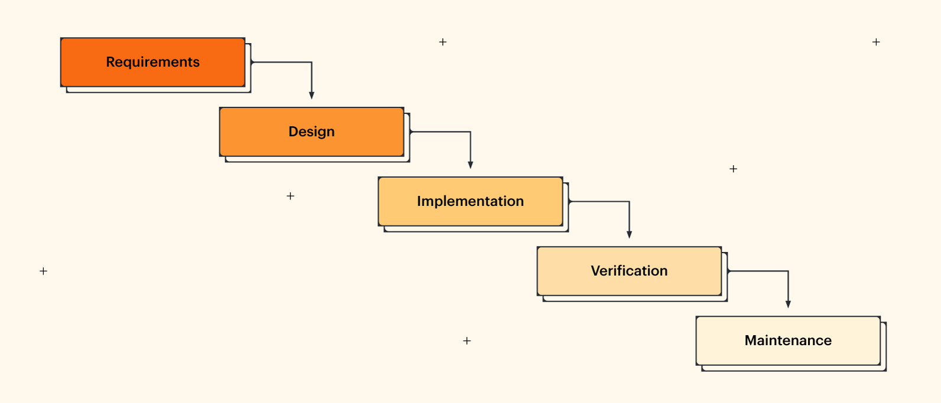

**Project Flowchart:**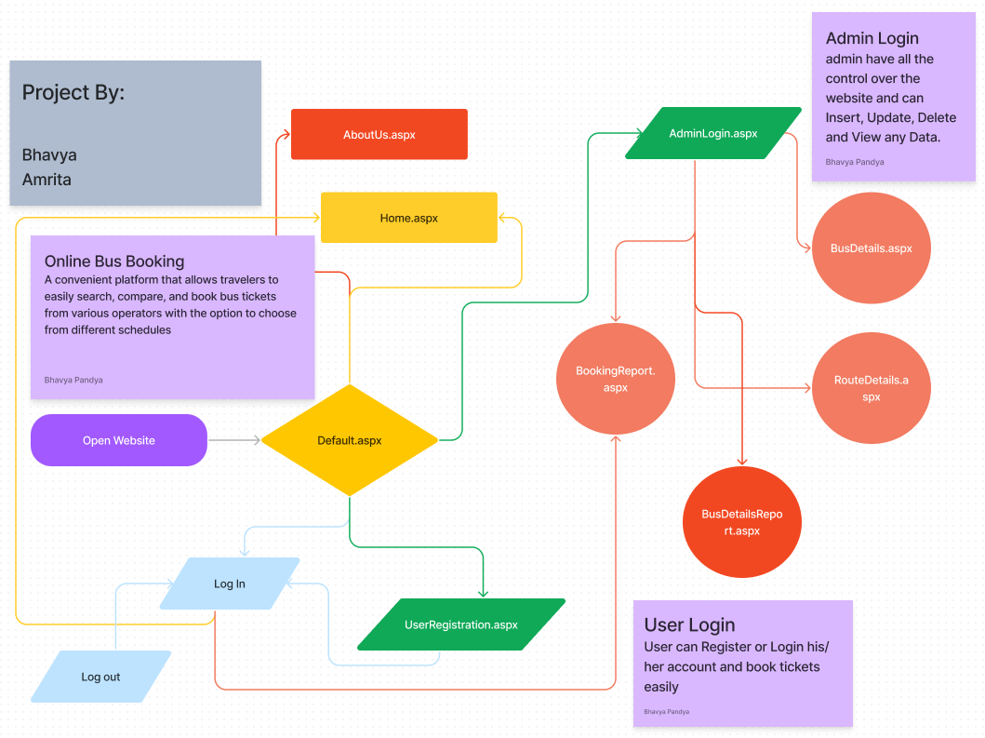

**❏ Results:**

**Home page:**

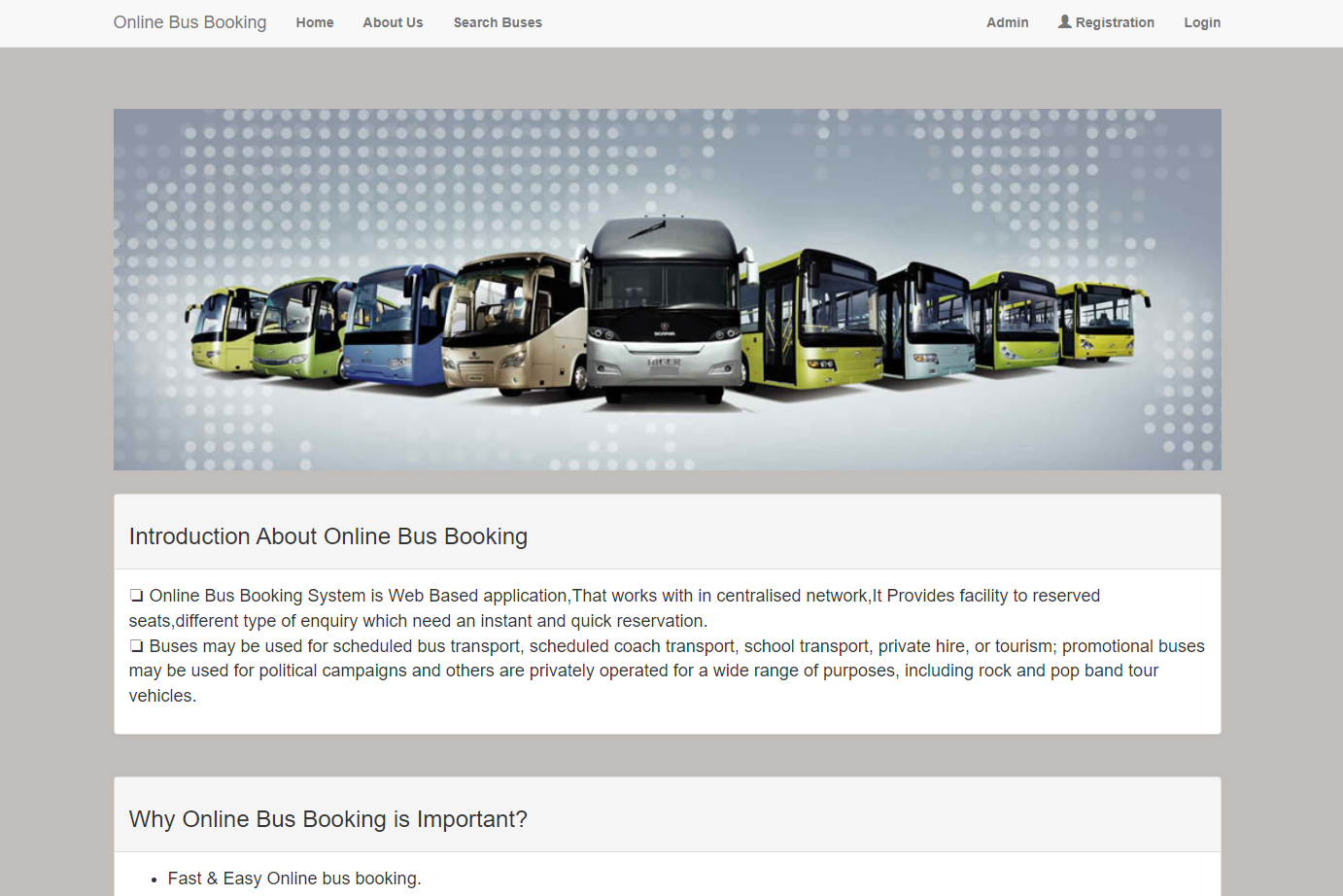

**Search for Buses:**

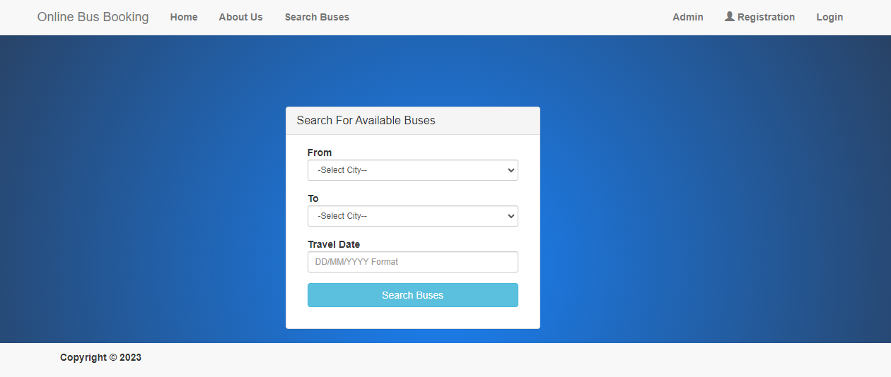

**Admin Controls:**

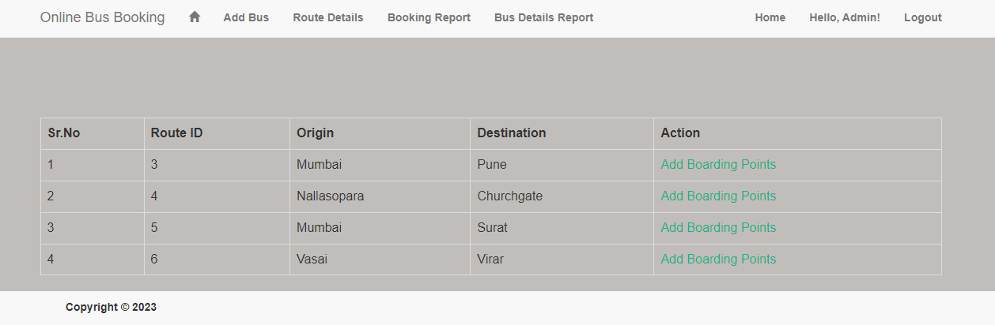

**User Controls:**

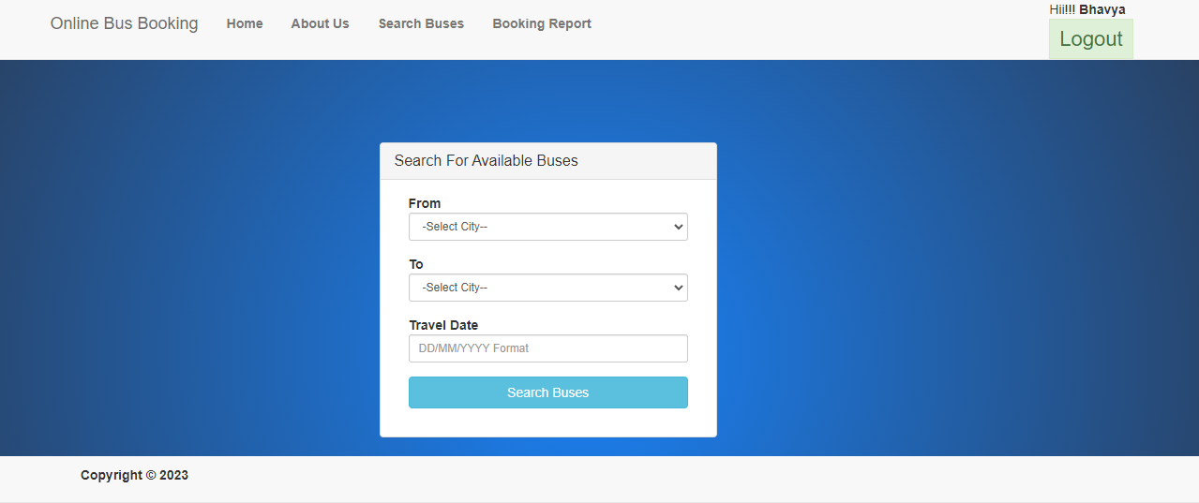

**❏ Conclusion and Future scope:**

In conclusion, a website for online bus reservations is a practical and effective way for travellers to organise their travel plans and purchase bus tickets from the comfort of their homes. These websites have become a necessary resource for travellers looking to save time and effort when planning their trips thanks to the rising popularity of e-commerce and online booking.

Travellers can easily compare prices, departure and arrival times, and amenities on an online bus booking website because it gives them access to a variety of bus operators and schedules. Additionally, these websites frequently feature special offers and discounts that lower the cost of bus travel for customers.With people relying more and more on technology and the internet, online bus booking websites give users a simple way to plan trips, purchase tickets, and manage their bookings. It gives users a secure and dependable platform to buy tickets and offers a hassle-free alternative to conventional booking methods like going to a bus station or travel agency.

An online bus reservation website has a bright and expansive future. The need for online booking platforms will grow as society becomes more technologically advanced and interconnected.

1. **Mobile App Development:** Since the majority of travellers access the internet and make reservations using their smartphones, creating a mobile app for an online bus booking website can greatly expand its usability and reach.
2. **Integration with Other Travel Services:** By integrating with other travel services like hotels, flights, and car rentals, an online bus booking website can increase the range of products it offers. Travellers may benefit from having a one-stop shop where they can plan and book every aspect of their trip.
3. **Enhanced Personalization:** An online bus booking website can provide tailored recommendations and promotions to individual users based on their booking history and preferences by utilising data analytics and machine learning algorithms.
4. **Integration of Virtual Reality:** As virtual reality technology develops, online bus booking websites may offer virtual tours of bus interiors so that customers can get a sense of the bus before making a reservation.
5. **Blockchain Technology:** By enhancing the security and transparency of transactions, blockchain technology can give users more confidence in online travel agencies.

**❏ References:**

Citation

The web-based online bus ticket reservation system operates within a centralised network. This project reviews the "Online Bus Ticket Reservation System" software program as it should be used in a bus transportation system, including a feature for reserving seats, cancelling reservations, and various types of route inquiries for quick reservations. The traditional database, ticket ordering, and bus and travel booking are all computerised by OBTRS. It keeps track of every customer detail as well as bus and reservation information. Imo Transport Company (ITC) was picked as a case study because of its strategic significance to Imo State in order to realise the design. It was decided to use the Structured Systems Analysis and Design Methodology (SSADM). Furthermore, PHP supports hypertext. The front end of the software was created using the preprocessor (PHP) language, and MySQL was used to create the back end. The developed software has the potential to enhance ITC operations' handling of customers and relationship management. It is advised that in addition to the designed software's current functionality, the system be expanded to allow for online credit card or debit card payments as well as the use of email to send tickets and notifications to customers. Additionally, in order to improve the system, other ITC operations like the courier services should also be integrated.

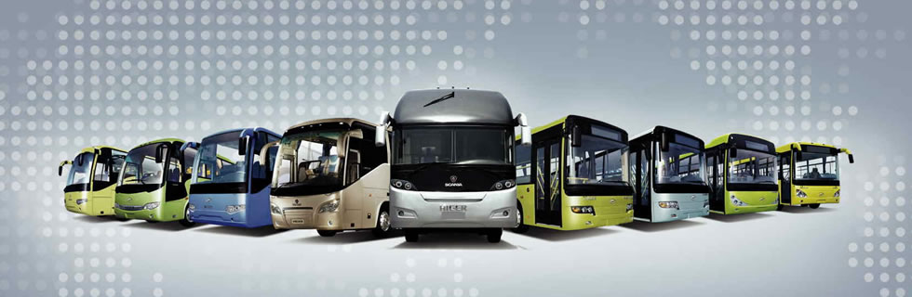

**”Book your journey with ease, hop on a bus and travel at breeze!”**

* <https://www.ijraset.com/research-paper/online-quick-bus-ticket-reservation-system>
* <https://straitsresearch.com/report/online-bus-ticket-service-market>
* <https://www.researchgate.net/publication/326468848_Online_Bus_Ticket_Reservation_System>