LINUX SECURITY LAB — SCREENSHOT EVIDENCE
Figure 1 — auditd status check and package installation verification
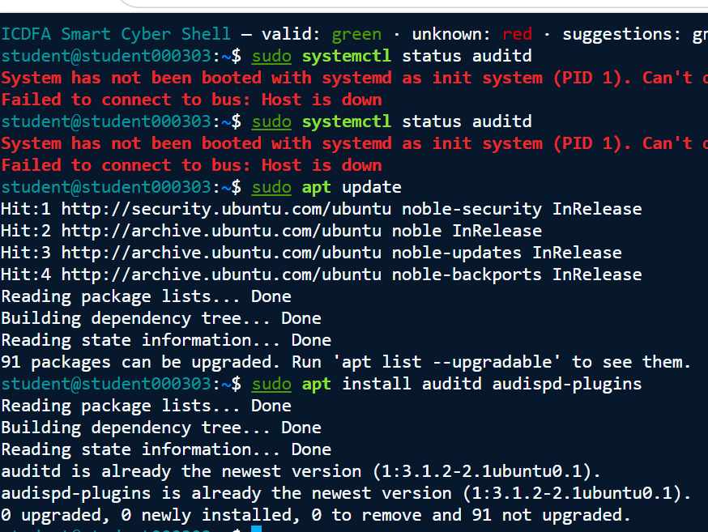
Evidence note: The environment did not use systemd as PID 1, while package output confirmed auditd and audispd-plugins were installed.

Figure 2 — auditd foreground execution showing restricted operation
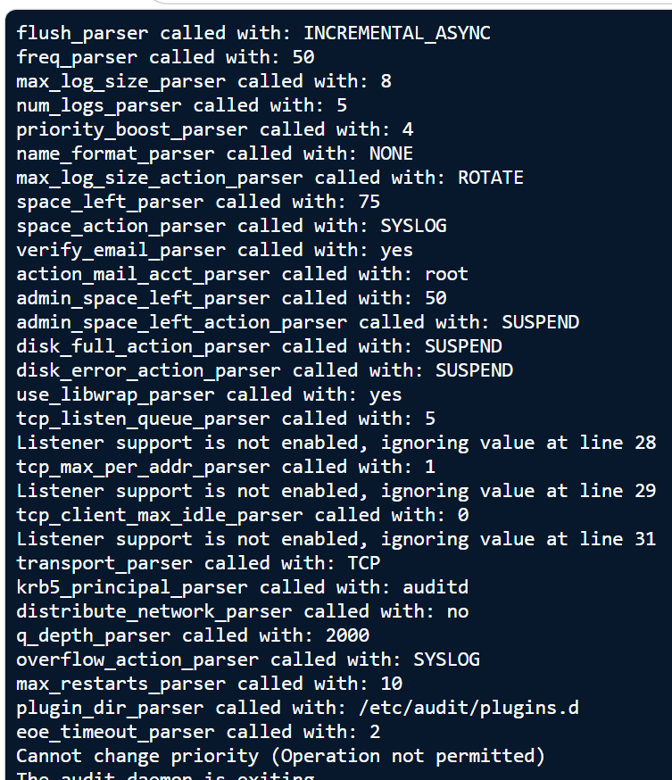
Evidence note: The audit daemon could not operate with the required privileges; the output records the operation-not-permitted condition and daemon exit.

Figure 3 — journalctl and journalctl --since "today" showing no journal files
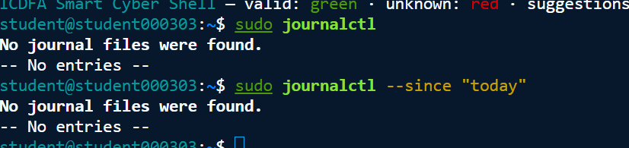
Evidence note: The assigned environment contained no journal files for journalctl to review.

Figure 4 — /var/log review and confirmation that /var/log/auth.log is unavailable
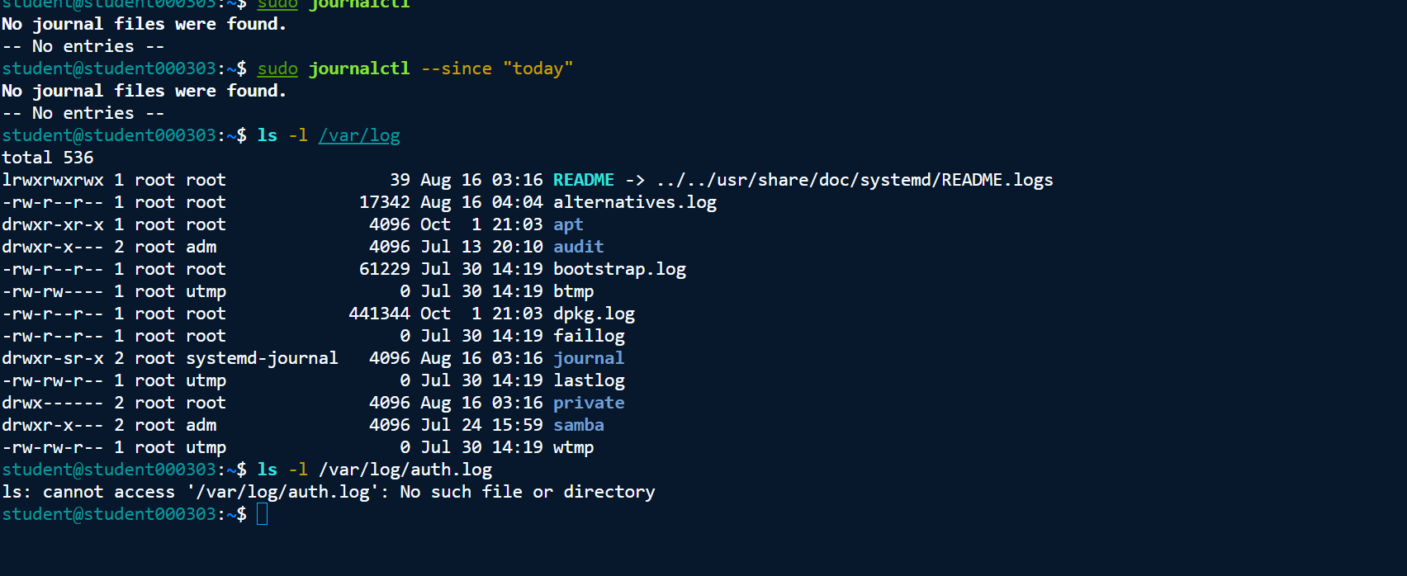
Evidence note: Available /var/log sources were reviewed, and the expected /var/log/auth.log file was not present.

Figure 5 — auditd configuration output ending with operation-not-permitted and daemon exit
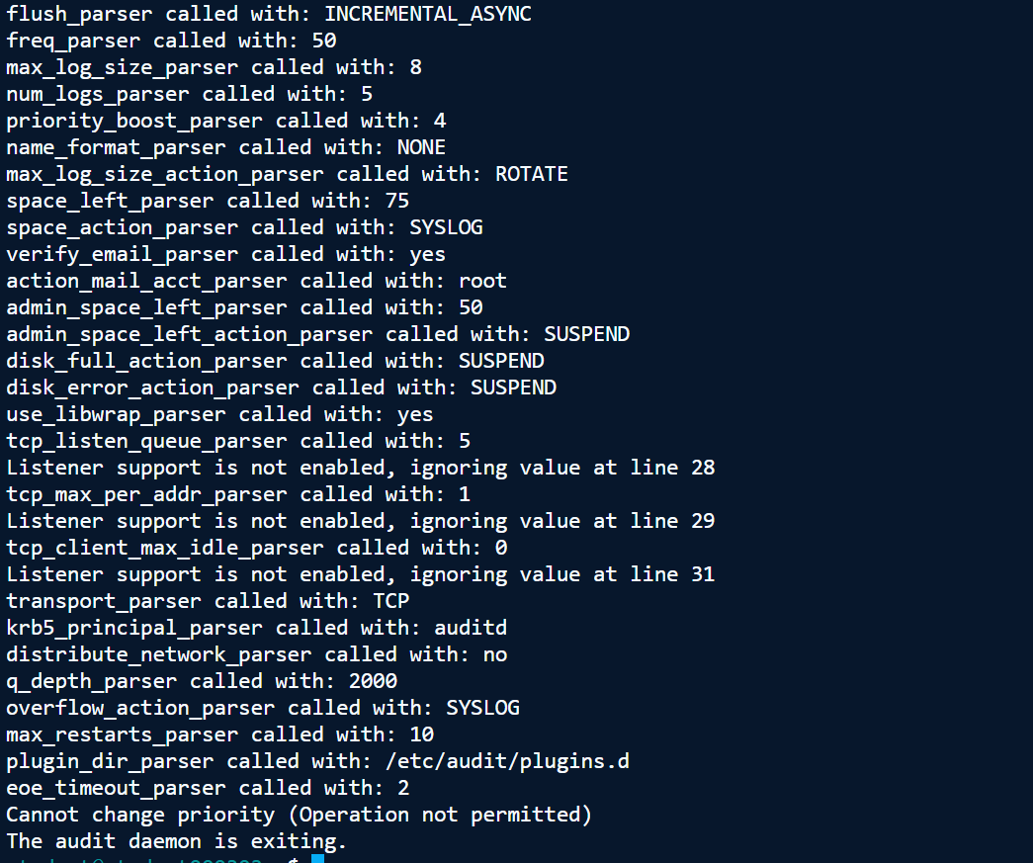
Evidence note: The audit daemon could not operate with the required privileges; the output records the operation-not-permitted condition and daemon exit.

Figure 6 — Lynis 3.0.9 audit completion, modules and report/log locations
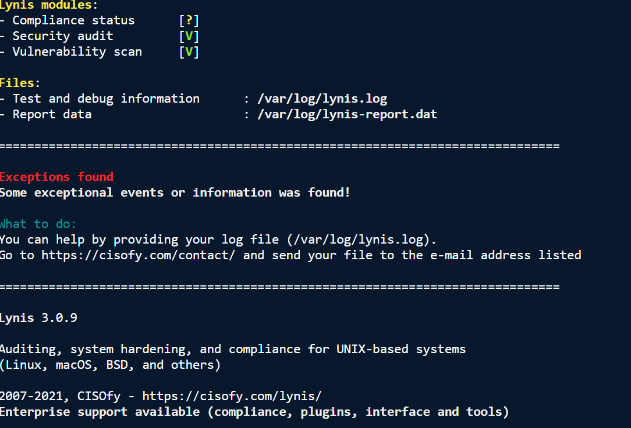
Evidence note: Lynis version 3.0.9 completed its security-audit and vulnerability-scan modules and identified its log/report locations.

Figure 7 — Lynis security-hardening suggestions and control findings
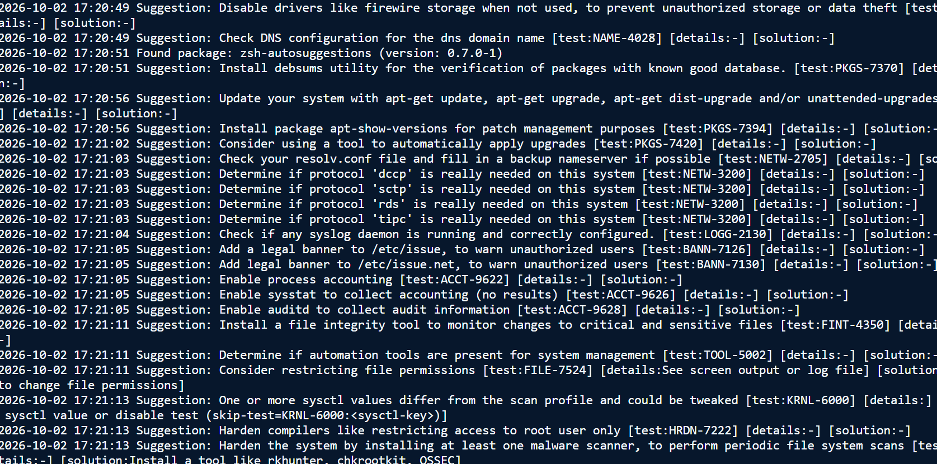
Evidence note: The Lynis output records multiple hardening recommendations, including audit logging, syslog, file-integrity monitoring, update management and warning-banner controls.

