**RecruitmentCTF**

**Challenge Name:** Escape Rooms

**Author:** Abhinav Mehta

**Domain:** Cryptography

**Challenge Description:**

While enjoying the fair, Ravi noticed a mysterious escape room challenge and decided to give it a try. After navigating through various puzzles and challenges, he finally reached the last door. In front of him was a locked door and a single image hanging on the wall. The image seemed to hold the key to the final passcode.

Ravi knew that decoding the hidden message within the image was the only way to unlock the door and escape.

Can you help Ravi decipher the image and discover the passcode to unlock the door?

**Solution:**

1. 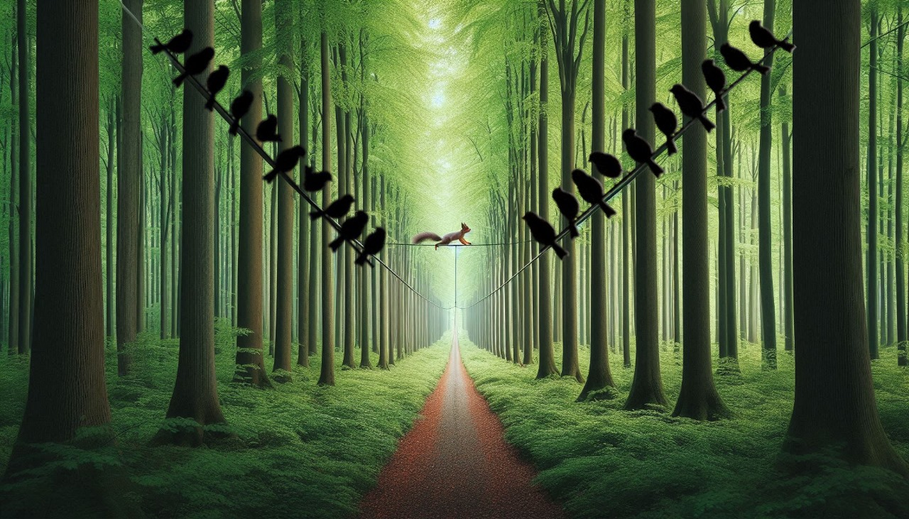The birds sitting on the wires carry some meaning and are created using Bird-Wire Cypher.  
   You can check the cypher on dcode.fr
2. Entering the right-side birds as the text you get the flag i.e.  
   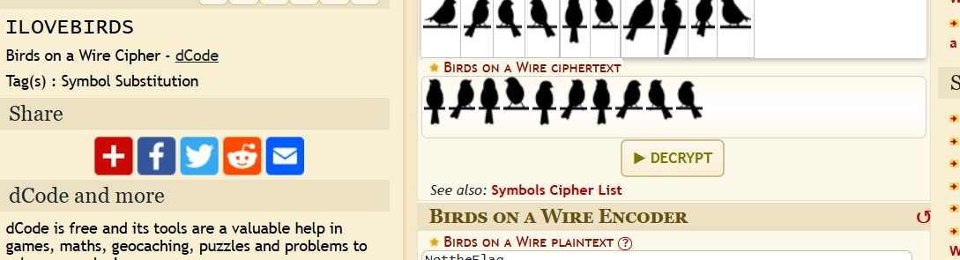

Therefore the passcode is : ILOVEBORDS

And the Final Flag is : RecruitmentCTF{ILOVEBIRDS}